Assignment 1:

Implementation, Evaluation, and Comparison of

Basic and Advanced Recommendation Systems

on Amazon Reviews Dataset

Anjani Sirivella
501373950
Department of Computer Science, Toronto Metropolitan University
CP8339: Recommender Systems
Professor Cherie Ding
Oct 11, 2025

Contents
Objective 4
Exploratory Data Analysis & Pre-Processing 4
Data Description & Statistics 4
Data Cleaning 4
Univariate Non-Graphical EDA 6
Univariate Graphical EDA 7
Multivariate Non-Graphical EDA 8
Multivariate Graphical EDA 9
Observations 10
Data Reduction 10
Environmental Setup 11
Hardware Configuration 11
Software Packages 11
Evaluation Metrics 11
Basic Models 13
User-based Collaborative Filtering 13
Basic KNN 13
KNN with Means 14
Item-based Collaborative Filtering 15
Basic KNN 15
Matrix Factorization 16
SVD 16
Observation 16
Advanced Models 17
Neural Collaborative Filtering 17
Results And Comparison 19
Future Work 21
Conclusion 22

Objective
In this assignment, I aim to compare basic recommendation systems with advanced recommendation systems using the All Beauty subset of the 2023 Amazon Review Dataset. This dataset contains only ratings that users gave to items. To implement, evaluate, and compare the recommendation systems models, I performed an exploratory data analysis to better understand the data distribution. Alongside, I performed the data preprocessing steps, which includes checking for missing data, reducing the dataset size, and splitting the data into training and testing datasets. Next, I ran baseline recommendation models, namely user-based collaborative filtering (basic userKNN and userKNN with means), item-based collaborative filtering (basic itemKNN), and matrix factorization (SVD). Then, I implemented an advanced model, Neural Collaborative Filtering (NCF), using Keras, a high-level API of the TensorFlow platform. Finally, I evaluated and compared the results of each model using error metrics (RMSE, MAE) and ranking metrics (precision@k, recall@k).

Exploratory Data Analysis & Pre-Processing

Data Description & Statistics
I selected a 0-core Pure IDs dataset of All Beauty category. The category was chosen as it is one of the smallest categories. Further, I chose 0-core dataset as it is closer to the real-world distribution of data. The differences between the 0-core and 5-core dataset are shown in Table 1.

Data Cleaning
I removed the unwanted column “timestamp” and renamed “parent_asin” to “item_id” for better readability.

Table. Differences between 0-Core and 5-Core dataset
 | Pros | Cons
0-Core | - Comprehensive data  - Maximum diversity  - Rich context  - Potential form  - Generalization | - Data noise  - Large size and high resource demands  - Quality variability  - Imbalanced distribution
5-Core | - Higher quality reviews  - Reduced noise  - Balanced distribution  - Computational efficiency | - Limited diversity  - Misalignment with original data distribution  - Loss of context  - Generalizability  - Limited data size for scaling up

Table. Basic Dataset Information
Dataset | Information
Category Name | All_Beauty
Size (Compressed) | 20.9 MB
Total Number of Users | 632.0K
Total Number of Items | 112.6K
Total Number of Ratings | 693.9K

The raw schema of the dataset contained the following columns, along with their definitions:
Table. Column Information
Column Name (data type) | Column Description
user_id (str) | ID of the reviewer
parent_asin (str) | Parent ID of the product*
rating (float) | Rating of the product (from 1.0 to 5.0)
timestamp (int) | Time of the review (unix time)

*Note: Products with different colors, styles, sizes usually belong to the same parent ID. The “asin” in previous Amazon datasets is actually parent ID. Here, it is considered as item_id.

Univariate Non-Graphical EDA
I explored the shape of the dataset and the distribution of the values within it. The dataset has 3 columns and 693929 rows. None of the rows are empty nor duplicated. The average rating is 3.96, showing the skewed nature of the data. Further, the distribution of the data is highly skewed. Only 25% of the data has less than 3 for ratings - since the 75th percentile and median are both 5, more than half the ratings are exactly 5 stars. I can infer that the users that tend to give a rating are users that view the item highly positively.
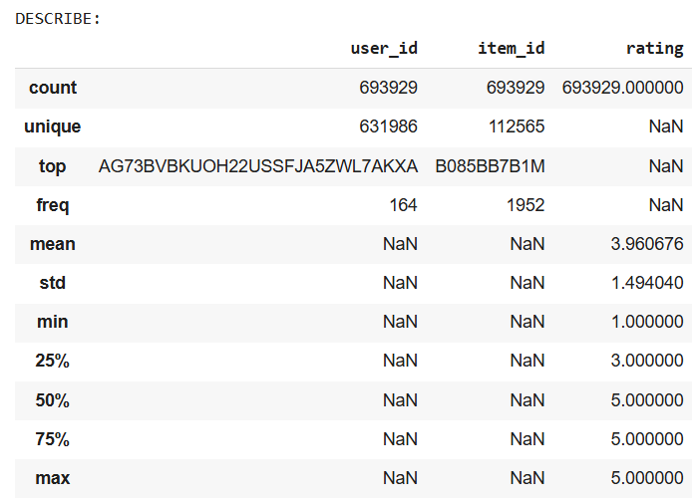
Table: Statistical Analysis of the Dataset

Furthermore, the distribution of the items that get more than 5 ratings in total is skewed. Out of 112565 items, the number of items that have more than 5 ratings is 22606 – only 20% of the dataset. Similarly, out of 631986 users, only 968 users gave ratings more than 5 times, leaving 99.84% of the user with less than 5 ratings.
The sparsity of the matrix is high, with only 0.000975% of the matrix filled. This is a common problem in recommendation systems, as the item universe is extremely large and the user only interacts with a small subset of the all the existing items.
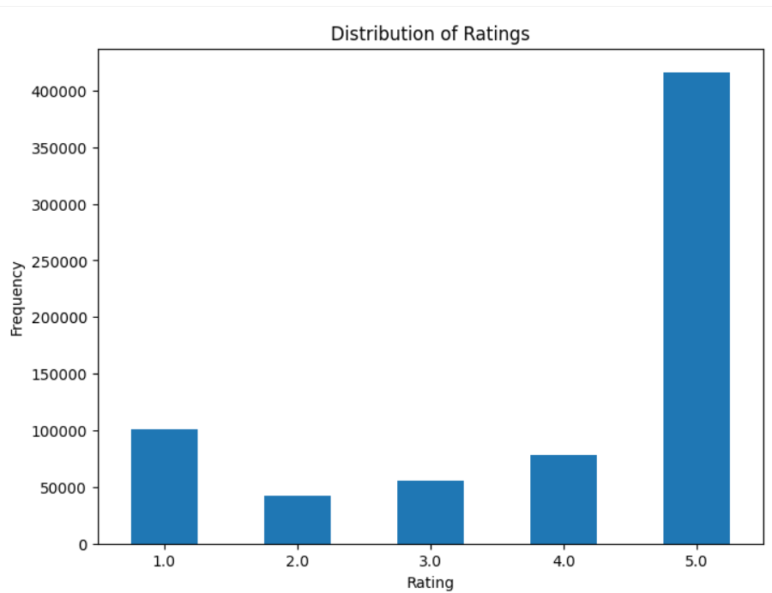
Figure. Frequency Distribution of Rating

Univariate Graphical EDA
Using a bar graph to visualize the distribution of ratings, I observe that there is a clear right-skewedness of the dataset. Interestingly, the second most frequent rating is 1-star, which occur at roughly one-fourth the frequency of 5-star ratings.
The Hexbin plot showing the relationship between the number of ratings and average rating per item. I chose this over the scatterplot, as the dataset is so huge that is quicker and clearer to user density than individual points. In the plot, most items have very few ratings, as the density is higher on the left side of graph, and many of these have a rating of 5, indicating rating inflation.
Figure. Hexbin Plot of Average Item Rating vs Number of Ratings

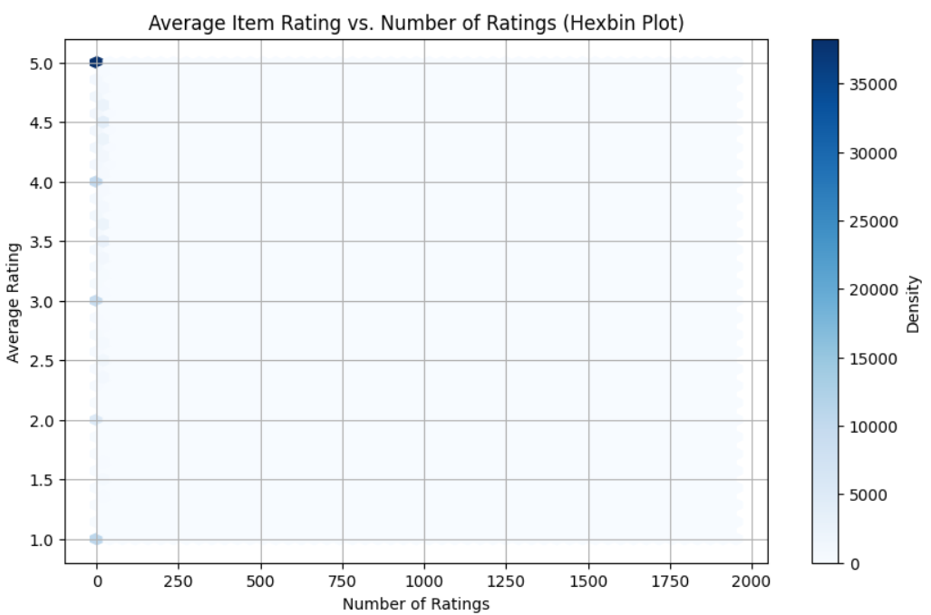

Multivariate Non-Graphical EDA
I couldn’t perform the contingency table analysis due to its computational expense, so I used a random sampling of user-item interactions to understand the relationship between the two variables. The sparsity of the matrix is represented in the heatmap. When an interaction does exist, it is highly likely to be positive. Also, there is no observable pattern, or there are extremely isolated patterns. This means that user-based collaborative filtering would result in suboptimal performance, as it is challenging to discern similarity between users.

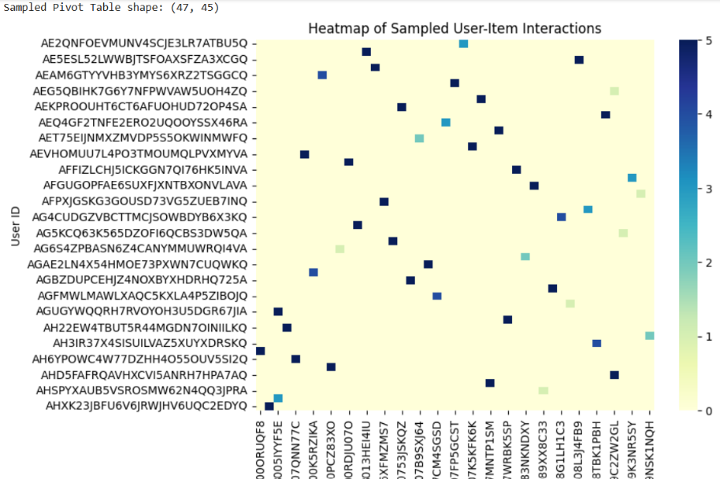
Figure. Heatmap of Randomly Sampled User-Item Interaction

Multivariate Graphical EDA
Observing the relationship between users and ratings in the histogram reveals the long-tail nature of the distribution. This figure shows the number of ratings each user has given over the lifetime of recording. Most users have rated only 1 to 3 items, alerting to the presence of many cold-start users in the database.
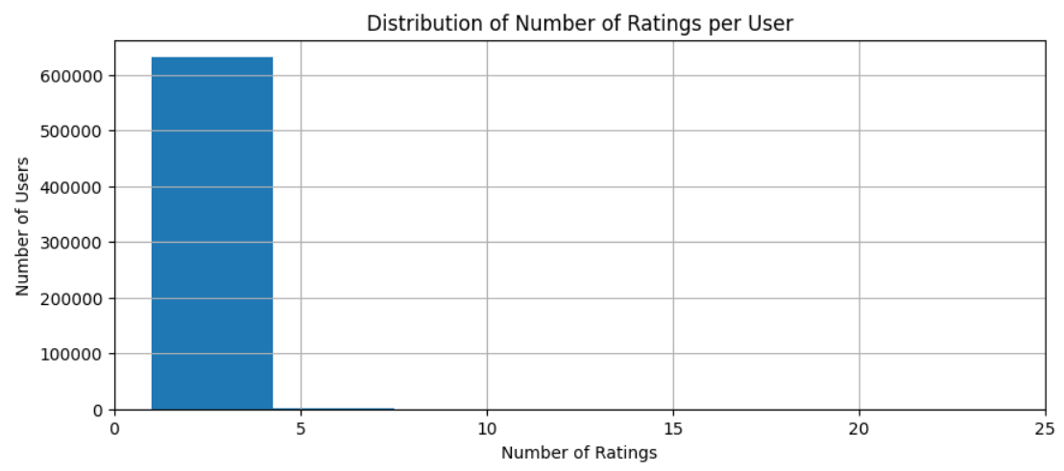
Figure. Histogram of Number of Ratings Given per User

Observations
Some key observations are as follows:
- The high sparsity (lots of user-item pairs with only one or two interactions) presents a challenge for collaborative filtering, as there are many cold-start cases.
- The skew towards 5 -rating means rating prediction models may default toward higher predictions. Bias can be accounted for by using:
  - Baseline corrections (like Pearson baseline similarity in KNN)
  - Mean normalization (SVD or KNN With Means)
- As sparsity affects KNN-based methods more than matrix factorization or neural models like NCF (which can still learn latent patterns despite missing data), I expect that the KNN-based methods will perform more poorly than the other methods.

Data Reduction
Due to hardware limitations, I reduced the dataset size. As the number of users and items with fewer than 5 ratings is too large, I decided to do stratified random sampling, i.e., keep the distribution of ratings the same in the newly reduced dataset created by random sampling. Later, as the error for Neural Collaborative Filtering is high, I experiment the user-stratified sampling. As random sampling can break the connection between user and the item,increasing the cold-start problem in train-test phase of the model creation, I attempted to perform a user-stratified split to ensure each user has at least one interaction in the training set. I was unable to run it due to the hardware issues. This was a potential solution explore to reduce the high RMSE value for NCF.

Environmental Setup

Hardware Configuration
Feature | Device Information
OS | Windows 11 Home
Processor | Intel(R) Core(TM) i5-9300H CPU @ 2.40GHz (2.40 GHz)
Installed RAM | 16.0 GB (15.8 GB usable)
Graphics Card | 6 GB NVIDIA GeForce GTX 1660 Ti
System type | 64-bit operating system, x64-based processor

Even with a dedicated RAM of 6GB, the dataset is too computationally expensive to run the dataset comfortably on my laptop. Due to the hardware limitations, I had to reduce the dataset size to 5% of the original size.

Software Packages
This analysis was implemented with Python version 3.10+ on Google Colab.
The libraries used are: pandas, numpy (v1.26.4), datasets (v3.6.0), matplotlib.pyplot, seaborn, surprise, tensorflow.keras, sklearn (scikit-learn).

Evaluation Metrics
I want to evaluate both the prediction accuracy and recommendation relevance of the models. The best metrics to check those are to use Root Mean Squared Error (RMSE), Mean Squared Error (MSE), Precision@K, and Recall@K. The definitions are below:

Mean Squared Error (MSE) measures the average of the squared differences between the predicted and actual ratings:
$$MSE=\frac{1}{N}\sum_{i=1}^{N}{}(r_{i}-{\hat{r}}_{i})^{2}$$
It is useful as it penalizes large deviations heavily, allowing the detection models that produce occasional large errors in rating prediction.

Root Mean Squared Error (RMSE) is the square root of MSE:
$$RMSE=\sqrt{\frac{1}{N}\sum_{i=1}^{N}{}(r_{i}-{\hat{r}}_{i})^{2}}$$
RMSE is preferred as it simplifies interpretation of results by keeping the original rating scale (1–5). I use it check how closely the predicted ratings align with users’ true preferences. Lower RMSE values signify higher predictive accuracy, but the cutoff value is subjective.

Precision@K measures the fraction of relevant recommendations of all the top K recommendations, ensuring a faon of top-K recommended items that are actually relevant (with rating ≥ 3.5 as the threshold value). It is defined as:
$$Precision@K=\frac{∣\text{Relevant}∩\text{Recommended@K}∣}{∣\text{Recommended@K}∣}$$
As users tend to look only at the K recommendations, this evaluation metric is crucial for real-life scenarios. This metric measures the accuracy of the top recommendations.

Recall@K measures the fraction of relevant items that appear within the top-K recommendations:
$$Recall@K=\frac{∣\text{Relevant}∩\text{Recommended@K}∣}{∣\text{Relevant}∣}$$
It describes the model’s ability to retrieve all the relevant items. High recall means the system successfully identifies most items that the user would rate positively. Having a high recall is relatively significant in this case, as the user loses trust in the recommendation system if too many irrelevant recommendations are given.

I chose these evaluation metrics because RMSE and MSE quantify numerical prediction accuracy, while Precision@K and Recall@K evaluate the quality of ranking and the usefulness of recommendations. These are useful in a scenario where a model may have a low RMSE yet fail to recommend relevant items; therefore, combining these complementary metrics provides a holistic evaluation of performance across both dimensions of recommendation quality.

Basic Models

User-based Collaborative Filtering
The User-based Collaborative Filtering (UCF) algorithm finds similarities between users based on their rating patterns. They are outlined in the following sections.

Basic KNN
I used the Surprise `KNNBasic` algorithm with `pearson_baseline` similarity, as it considers the variance and bias between users. Many users gave high ratings regardless of the product. Pearson baseline will adjust for this by removing user-level bias before computing similarity. I used k=5 for computational feasibility, threshold=3.5 as a starting value, and a user-based flag was set to True, meaning the algorithm will create a similarity matrix between users, as opposed to items. The Basic User-KNN achieved an RMSE of 1.49 and MAE of 1.25, indicating bad accuracy for rating prediction.
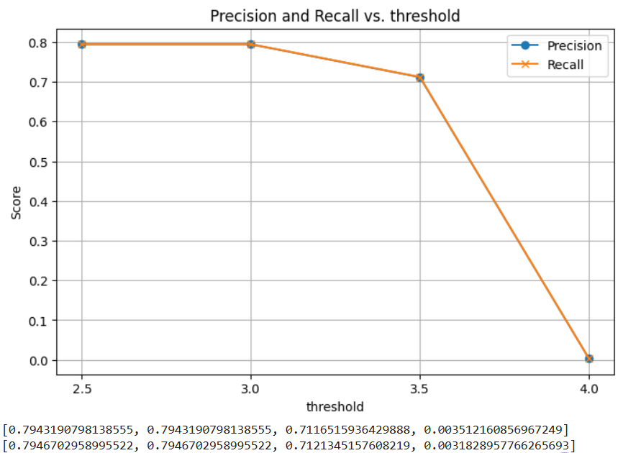
Figure. Plotting the Relationship of threshold to Precision and Recall Score

Precision@10 and Recall@10 were both 0.71, meaning that the model makes moderately good predictions, even with the sparsity and limited overlap between user profiles. I also created a graph that plots the change in Precision and Recall values at different k values, and threshold values. After the threshold of 3.5, both precision and recall drop to zero. This indicates that the model does not classify any rating above 4 as a relevant recommendation. This happens due to the usage of sigmoid-based regressors, which compress the predicted rating range of the model to around the mean.

KNN with Means
I chose to implement the User-based KNN with Means algorithm next, as it is an enhancement of the standard KNN approach for collaborative filtering. In basic KNN, predicted ratings are calculated based on the weighted average of the ratings given by similar users. But these weighted averages do not take into account the individual rating biases, as some tend to rate products consistently higher or lower than others. This leads to systematic prediction errors if these biases are not normalized. KNN with Means addresses this problem by subtracting each user’s mean rating before computing similarities and predictions. This process of centering the mean ensures that the model compares users based on their relative preferences rather than absolute rating scales.
I ran the model with default k values and user_based=True, to implement collaborative filtering based on user–user similarity. I used the pearson_baseline similarity metric in this model to maintain consistent parameters across all KNN models, ensuring a fair and reliable comparison of their performance. The User-KNN with means achieved an RMSE of 1.49 and MAE of 1.25, Precision@10 and Recall@10 were both 0.71, showing no change from the basic User-KNN algorithm.

Item-based Collaborative Filtering

Basic KNN
The Item-based CF model compares items instead of users. Items are more stable over time since their attributes remain fixed, while user preferences fluctuate. I used `KNNBasic` with default k values, `pearson_baseline` similarity, and `user_based=False`. The basic Item-KNN achieved an RMSE of 1.49 and MAE of 1.25, Precision@10 and Recall@10 were both 0.71, showing no change from both of the User-KNN algorithms.

Matrix Factorization

SVD
The SVD algorithm achieved an RMSE of 1.09 and MAE of 0.90, showing marginal improvement from the KNN algorithms. Precision@10 and Recall@10 were both 0.70, showing negligible improvement from the neighbourhood-based algorithms. In theory, SVD should outperform KNN algorithms by capturing latent user and item factors. However, in this project, the lack of user–item interactions prevented SVD from uncovering these relationships, and its performance metrics remain in the same strata as the simpler models. This result shows the importance of data density and diversity for matrix factorization methods to realize their full predictive potential.

Observation
During evaluation, all baseline models (User-KNN, User-KNN with Means, Item-KNN, and SVD) produced identical metric values across RMSE, MAE, Precision@K, and Recall@K. This indicates that the models effectively learned and were evaluated on the same underlying rating predictions, due to many factors.
One significant factor is the sparsity of data. With less than 0.000975% of the user–item matrix filled, and most users have only one or two ratings in the training set, this data is the kryptonite for neighbourhood-based methods. These models end up predicting the global mean rating (approximately 3.96 in this dataset), resulting in nearly identical predictions.
Furthermore, I used stratified random sampling reduce the dataset, causing some users and items in the test set to possibly not appear in the training set. This further exacerbated the cold-start problem that existed due the sparsity of the matrix. Again, the Surprise library predicts mean rating for all missing user–item pairs, resulting in identical results across models. The results highlight the limitations of the basic recommender models, especially in the case of data sparsity and cold-start scenarios.

Advanced Models

Neural Collaborative Filtering
Using TensorFlow.Keras, I implemented the Neural Collaborative Filtering (NCF) model with two embeddings that represent the users and items. I used the default size of 50 for the embedding vector, to balance the efficiency with the computational complexity and avoid overfitting. The embeddings are helpful as they convert highly complex data (in this case, categorical data) into lower-level numerical vectors that the neural networks can understand.
This layer was then passed through a fully connected dense layer, the penultimate layer in the model. I chose to use 128 neurons with ReLU activation, which outputs the input directly if it is positive, else output is zero. This is the default method, which I decided to retain because it is computationally efficient.
Finally, the sigmoid output layer produced the final rating predictions that are bounded to the [0,1] range. The model was trained using the Adam (Adaptive Moment Estimation) optimizer with its default learning rate (0.001). As the optimizer is prone to overfitting, I monitored the output for high error rates or above-average accuracy metrics. I used Mean Squared Error (MSE) as the loss function over 10 epochs and a batch size of 32. MSE is selected as it punishes large errors more heavily as the value is squared, and the resulting model will avoid making extremely inaccurate recommendations. The combination of ReLU activation with the Adam optimizer enables the model to converge quickly and achieve stable, low-error predictions.
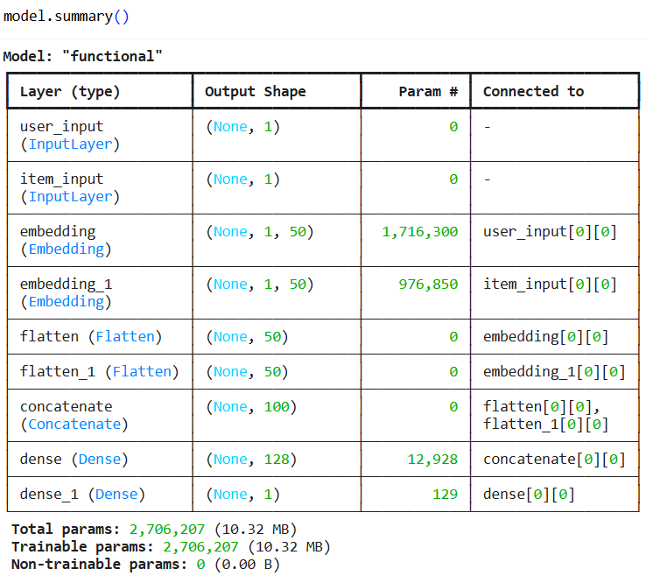
Figure. Summary of the Neural Collaborative Filtering Model

During preprocessing, ratings were scaled between 0 and 1 using MinMaxScaler to stabilize training and ensure compatibility with the sigmoid output. Further, user and item IDs were mapped to integer indices, and the data was split into 67% training and 33% testing.
The results from evaluating the Neural Collaborative Filtering (NCF) model implementation was astounding. It achieved an impressive RMSE of 0.38 and MAE of 0.34, demonstrating a marked improvement over all the basic algorithms tested, including both neighbourhood-based and matrix factorization algorithms. Additionally, the model with a threshold of 3.5 achieved Precision@10 = 0.73 and Recall@10 = 0.61, demonstrating both high accuracy and the ability to provide relevant recommendations.
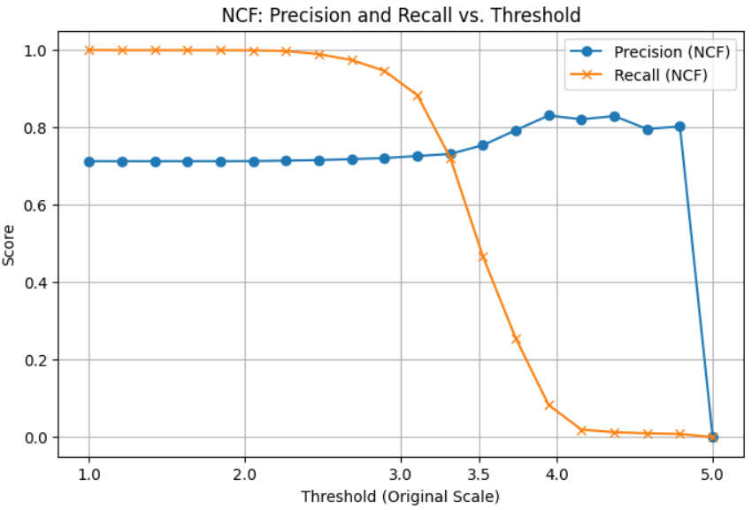
Figure. Precision-Recall Relationship over Threshold

The precision-recall tradeoff graph with changing threshold values confirmed that NCF follows similar trends to the basic models. Still, NCF’s curve extends into higher recall zones, making it more practical for commercial recommender systems where missing relevant items is more costly.
This significant reduction in error metrics indicates that the neural network successfully captured interactions between users and items that traditional linear models could not. These results suggest that NCF’s learned embeddings and dense hidden layers enabled it to model subtle user–item relationships that basic algorithms cannot.

Results And Comparison
Neighbourhood-based algorithms produced nearly identical results across all metrics, indicating that due to the extreme sparsity of the dataset, these models ended up relying more on the global mean rating than any uncovered meaningful user–item similarities. The matrix factorization method, SVD model, achieved a small improvement in accuracy, with a reduction of the RMSE score from approximately 1.49 to 1.10 and MAE from 1.25 to 0.90. This confirms that matrix factorization is able to uncover latent factors that represent general user–item preferences even when direct overlap is low. However, the improvements of SVD over the KNN models were moderate, as the limited number of user-item interactions still constrained the latent representations in SVD.
The NCF model outperformed all baselines by a significant margin, achieving an RMSE of 0.39 and MAE of 0.36, over a 60% reduction in error compared to SVD. Its Precision@10 of 0.75 demonstrates that it generated more relevant top recommendations. Although its Recall@10 (0.49) was slightly lower than that of the simpler models, this signals that the model has higher recommendation quality over quantity. As the deep learning model learns both linear and nonlinear user–item interaction patterns, which allows it to generalize beyond co-occurrence patterns, CNF was able to make predictions even with the sparse dataset.

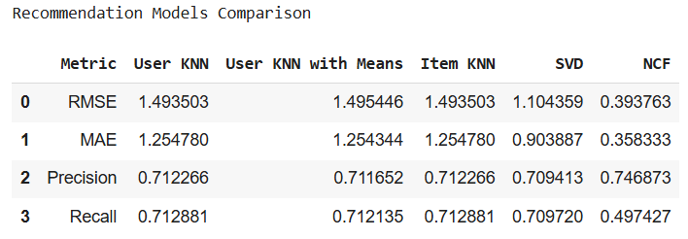
Table. Comparing All Models Evaluation Metrics

Figure. Comparing the Evaluation Metrics of Recommendation Models
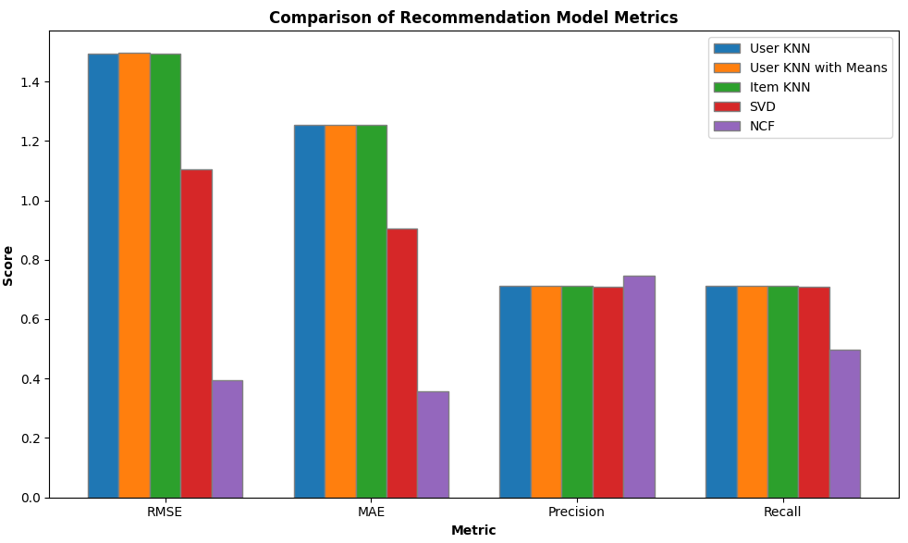
Overall, the dataset’s extreme sparsity (0.000975% density) and rating skew (over half are 5-star) significantly influenced the performance of the recommendation system models. Traditional KNN methods suffered most, as they depend on intersecting interactions. SVD mitigated this by learning latent features, while NCF surpassed all the others, as it performed well in relevance-based metrics due to its ability to create both nonlinear and linear representations. Another key finding was the cold-start effect. Models relying on user similarity underperformed due to few active users. SVD and NCF handled this better by leveraging latent features, with NCF outperforming all other models with its lower error values and high accuracy metrics.

Future Work
Despite having the highest recall by NCF compared to the other models, its slightly higher RMSE stems from over-generalization, caused by the sigmoid output compression to a set range, which reduces numeric accuracy. In future work, hyperparameter tuning can result in lowering the RMSE error rate by tweaking embedding sizes and batch sizes to achieve better generalization.
Another direction involves using the 5-core Amazon Review datasets, where every user and item has at least five interactions. This would help address the problem of sparsity while keeping any meaningful user–item relationships, resulting in more accurate evaluation of the models.
Additionally, future research can explore hybrid recommender systems by combining two or more recommendation techniques, like integrating collaborative filtering with content-based filtering. More accurate and robust suggestions would be provided as the limitations of each individual method are overcome, such as the cold-start problem.

Conclusion
In this project, I systematically implemented and compared multiple recommender system algorithms, including Basic User-based KNN, User-based KNN with Means, Basic Item-based KNN, SVD, and Advanced Neural Collaborative Filtering (NCF). Using the All_Beauty subset of the Amazon Reviews 2023 dataset, I conducted exploratory data analysis, preprocessing, and evaluation using RMSE, MAE, Precision@10, and Recall@10 across all the recommender systems within the scope of this project.
A key observation was that data sparsity and user bias significantly impacted model performance, specifically for neighbourhood-based algorithms, and moderately for the matrix factorization methods. The performance of KNN-based algorithms broke down under extreme sparsity, as similarities between users and items were difficult to establish. SVD marginally improved prediction accuracy by uncovering latent factors, but it was still constrained by a limited number of user–item interactions. In contrast, the Neural Collaborative Filtering model significantly outperformed all baselines. These results exemplify the advantages of deep learning models for capturing complex patterns that traditional algorithms fail to capture, and can overcome the cold-start problem.
In conclusion, this project reveals that, while traditional collaborative filtering algorithms remain useful and perform well, Neural Collaborative Filtering is a clear advancement over the older techniques with its higher predictive accuracy and stronger recommendation relevance.

