RTL DESIGN WORKSHOP
Original Structured Study & Lab Report
Verilog RTL • Simulation • Synthesis • Optimization • Coding Styles

Prepared from the supplied RTL workshop reference package

Document type | Structured workshop report / study material
Coverage | Modules 1–5
Primary tools | Icarus Verilog, GTKWave, Yosys, SKY130 library
Approach | Concepts, practical flow, observations, and visual evidence

Contents
- Module 1 — RTL Foundations and the Simulation-to-Synthesis Path
- Module 2 — Sequential RTL, Constant Multiplication, and Hierarchy
- Module 3 — Synthesis Optimization and Sequential Logic Reduction
- Module 4 — Coding Style, Mux Inference, Blocking Assignments, and GLS
- Module 5 — Case/If Completeness, Generate Constructs, and Mux/Demux Design
- Workshop-wide observations
- Practical checklist

Module 1 — RTL Foundations and the Simulation-to-Synthesis Path
The first module establishes the complete RTL workflow. A hardware idea is expressed in Verilog, checked with a testbench, simulated to obtain signal transitions, inspected with GTKWave, and then passed to synthesis. The central example is a 2:1 multiplexer, which is simple enough to understand while still demonstrating the important boundary between functional verification and hardware implementation.

Learning objectives
- Understand the difference between synthesizable RTL and a verification-only testbench.
- Follow the Icarus Verilog → VCD → GTKWave simulation sequence.
- Recognize how a 2:1 mux can be described behaviorally in Verilog.
- Understand the role of Yosys in turning RTL into a gate-level representation.
- Understand why a Liberty (.lib) standard-cell library matters during technology mapping.

Conceptual discussion

1. RTL design and verification flow
RTL is the hardware description at a register-transfer level. The design describes what hardware should exist, while the testbench supplies stimulus and checks the resulting behavior. A typical lab cycle is: write RTL → write testbench → compile → simulate → inspect waveform → synthesize → inspect the netlist. Keeping simulation and synthesis as separate checkpoints makes debugging much easier.

2. 2:1 multiplexer
A 2:1 multiplexer has two data inputs, one select input, and one output. When the select line is low, the first input reaches the output; when it is high, the second input is selected. This behavior can be written with an always block or a conditional operator. The important point is that the description represents combinational logic, so every relevant input change must be able to affect the output.

3. Icarus Verilog and GTKWave
Icarus Verilog compiles the RTL and testbench into a simulation executable. During simulation, signal changes are written to a VCD file. GTKWave then displays those changes against time. The waveform is the practical evidence that the RTL responds to the testbench as intended.

4. Yosys and synthesis
Yosys reads the RTL, elaborates the design, performs logic transformations and optimization, and can map the result onto cells from a technology library. The output is a netlist rather than a waveform. This distinction is fundamental: simulation asks whether the description behaves correctly, while synthesis asks what hardware structure can implement that description.

5. Standard-cell library
A Liberty file describes cells that the synthesis flow is allowed to use, including logic functions and timing-related information. Technology mapping uses this information to replace generic logic with actual library cells. Therefore, the same RTL can produce different mapped netlists when the target library changes.

Suggested practical flow
1. Create or inspect the RTL module.
2. Create a testbench that changes each input condition.
3. Compile with Icarus Verilog and run the simulation.
4. Open the generated VCD in GTKWave and verify the output.
5. Run Yosys synthesis and inspect the resulting netlist.
6. Compare functional behavior with the synthesized structure.

Visual evidence from the supplied module
The following figures are retained from the corresponding Module 1 folder and placed here as visual evidence. They are accompanied by newly written explanations rather than reproducing the reference README wording.
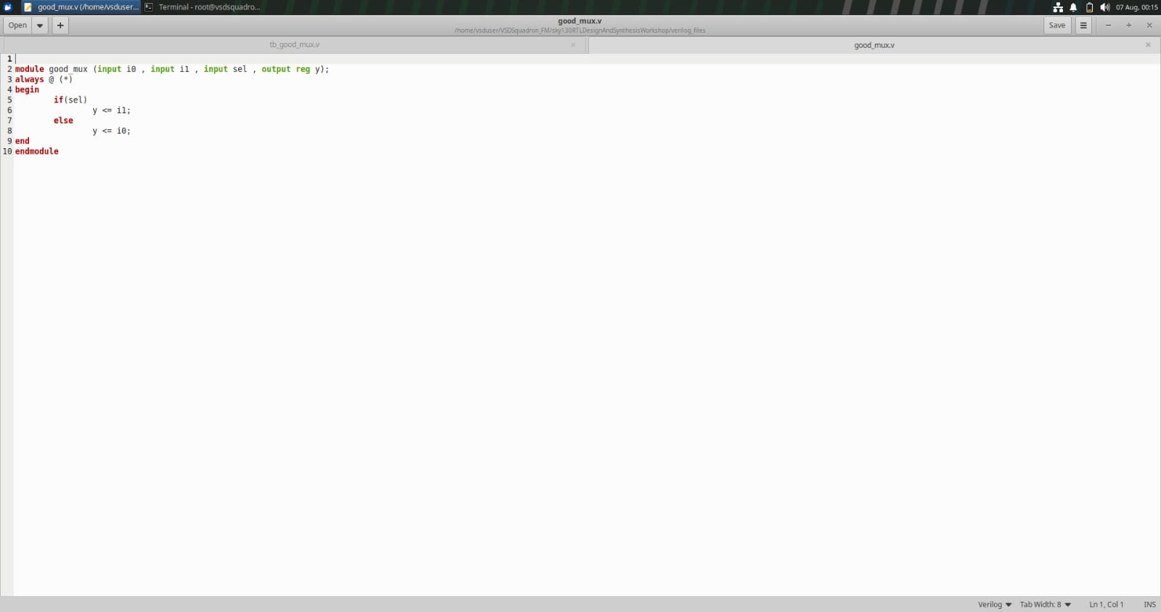
Module 1 figure 1: Design.png
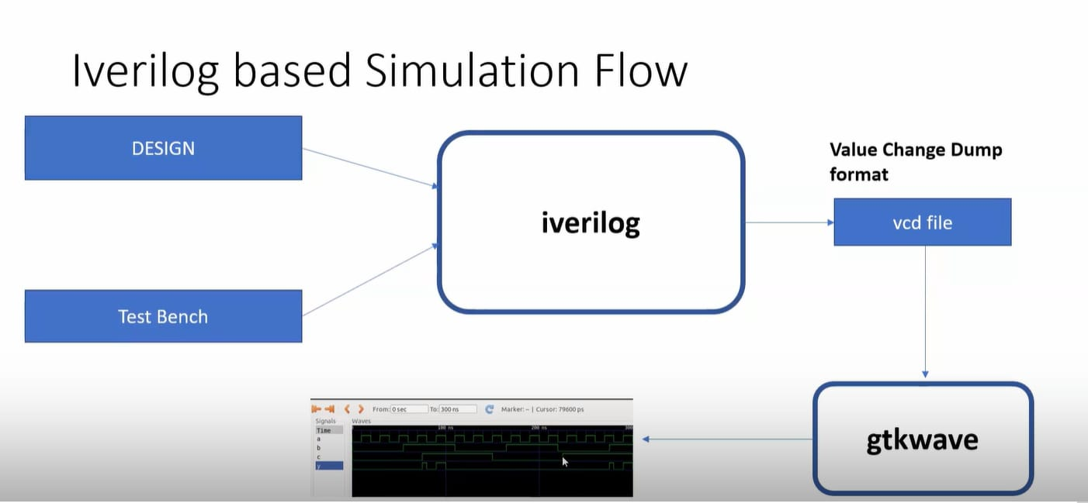
Module 1 figure 2: Iverilog based simulation flow.png

[Image could not be embedded: Synthesiser yosys.png]
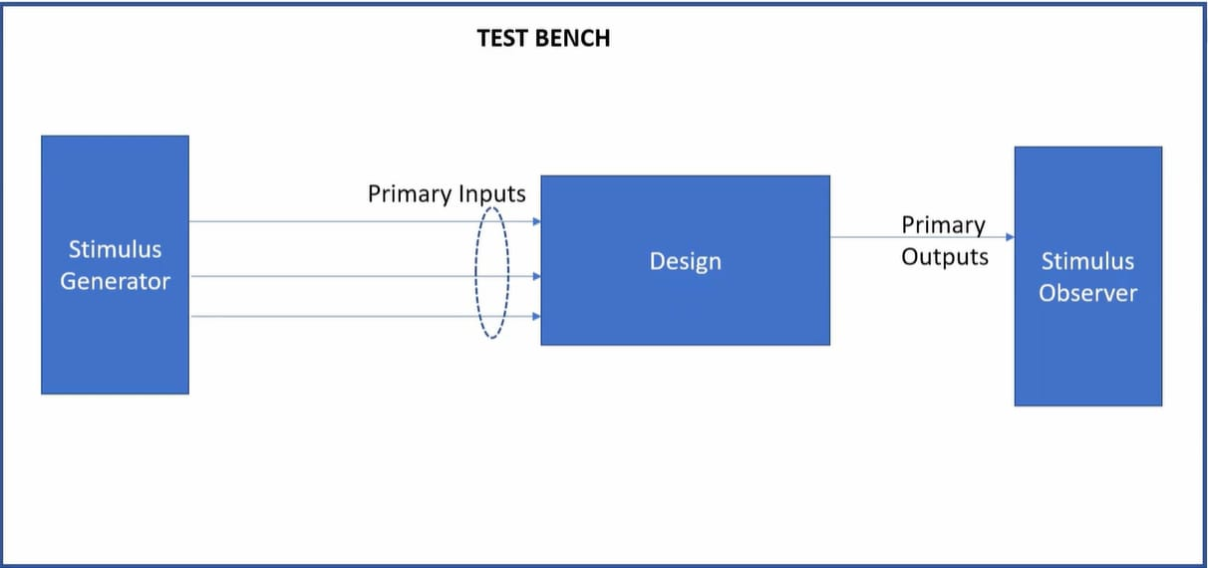
Module 1 figure 4: Test bench.png

[Image could not be embedded: What is lib.png]
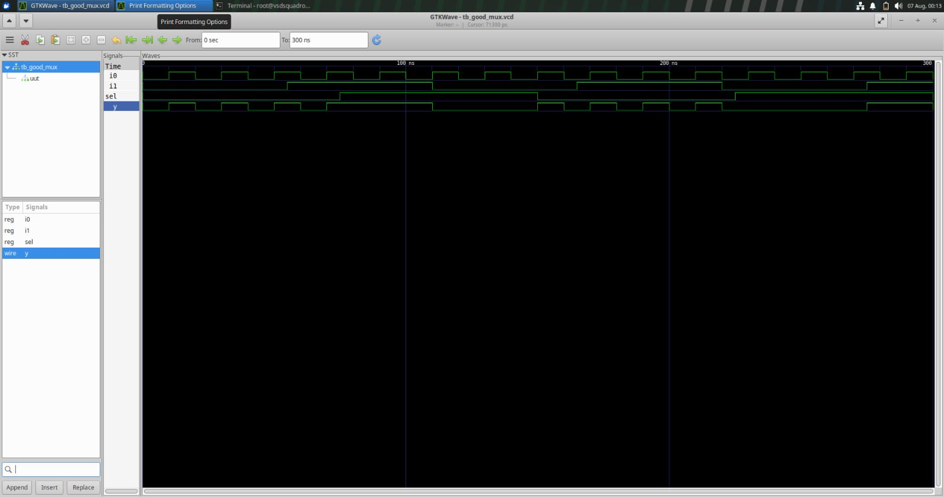
Module 1 figure 6: goodmuxwave.png

Module 1 figure 7: image.png

Module 1 figure 8: muxcode.png

[Image could not be embedded: yosys setup.png]

Module summary
The first module builds the basic mental model for every later experiment: RTL is written for hardware intent, the testbench verifies behavior, simulation provides time-based evidence, and synthesis converts the intent into an implementation-oriented netlist.

Module 2 — Sequential RTL, Constant Multiplication, and Hierarchy
This module extends the flow into clocked logic and larger RTL structures. It examines synchronous reset, asynchronous set/reset behavior, synthesis of multiplication by powers of two, and the effect of preserving or removing module hierarchy.

Learning objectives
- Distinguish synchronous reset from asynchronous reset/set.
- Understand why asynchronous controls appear in a sequential block's event control.
- Observe how synthesis maps inferred flip-flops to standard cells.
- Recognize that multiplication by 2, 4, 8, etc. can become wiring shifts.
- Compare hierarchical and flattened netlists.

Conceptual discussion

1. Synchronous versus asynchronous controls
A synchronous reset is sampled on the active clock edge, so the state changes because of the clocked process. An asynchronous reset or set can force the storage element to a specified state independently of the clock. This behavioral difference changes the event controls used in RTL and also influences the kind of library flop selected by synthesis.

2. Flip-flop synthesis
RTL synthesis first recognizes the sequential behavior and infers a generic flip-flop. A dedicated flip-flop mapping stage can then choose a compatible cell from the target library. Polarity differences are important: if the RTL expresses an active-high control but the available cell uses an active-low pin, synthesis may introduce an inverter so that the final circuit preserves the requested behavior.

3. Constant multiplication
Multiplication by a power of two is equivalent to a left shift. For example, multiplying an unsigned binary value by 8 moves every bit three positions toward the most significant side and fills the lower positions with zeros. A good synthesis result can therefore reduce such an operation to connections rather than a general multiplier.

4. Hierarchical design
A top-level module can instantiate smaller modules. This improves readability and allows reusable blocks to be developed independently. The supplied visual evidence shows a small chain of submodules where one block feeds another.

5. Flattening
Flattening removes module boundaries and combines the implementation into a single logical level. The Boolean function should remain the same, but the structure visible in the netlist changes. Flattening can increase the optimizer's scope, while hierarchy can make debugging and design organization easier.

Suggested practical flow
1. Simulate each sequential variant separately.
2. Exercise clock, reset/set, and data inputs in the testbench.
3. Inspect the waveform around reset transitions.
4. Run synthesis and observe the mapped flip-flop cell.
5. Synthesize the constant multipliers and inspect whether gates are needed.
6. Compare hierarchical and flattened netlists.

Visual evidence from the supplied module
The following figures are retained from the corresponding Module 2 folder and placed here as visual evidence. They are accompanied by newly written explanations rather than reproducing the reference README wording.
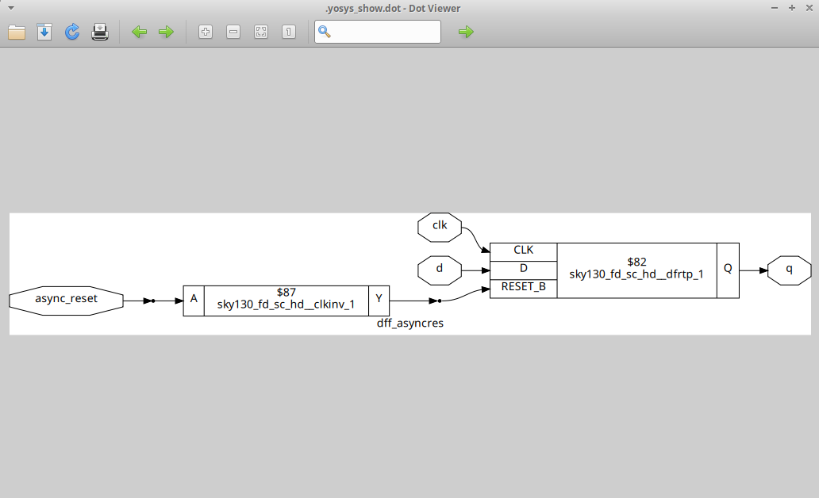
Module 2 figure 1: asyncresdiag.png
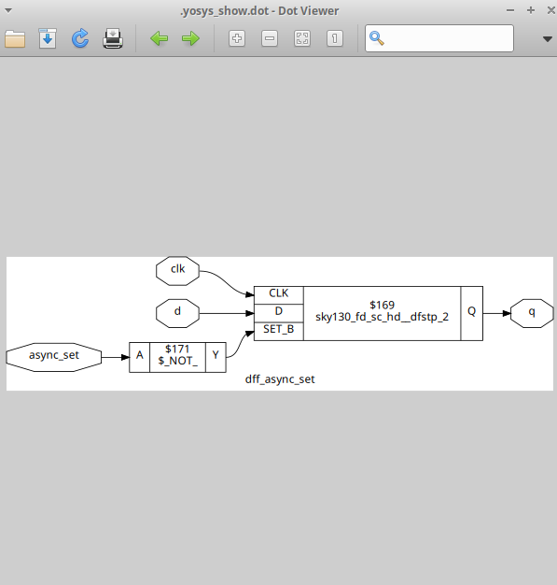
Module 2 figure 2: asyncsetdiag.png
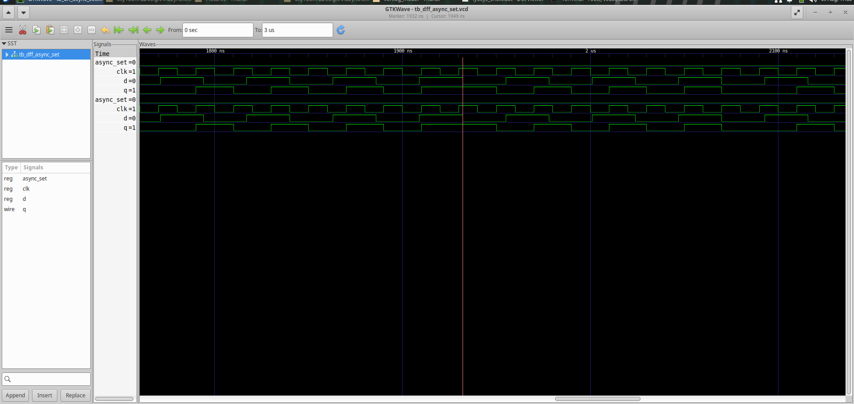
Module 2 figure 3: asyncsetwave-1.png
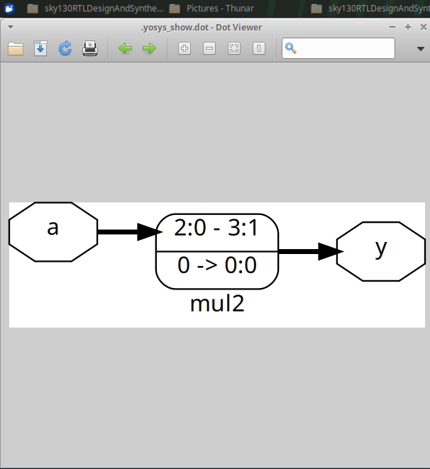
Module 2 figure 4: mul2.png
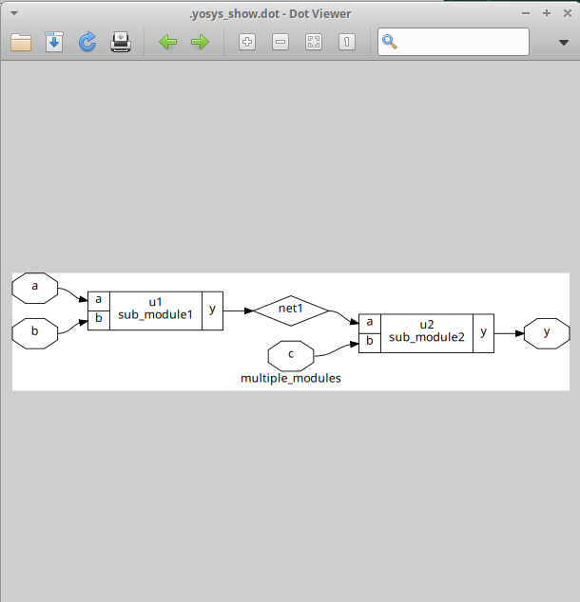
Module 2 figure 5: multimodules.png

Module summary
Sequential RTL requires careful treatment of clock and reset semantics. The module also demonstrates that synthesis is not a literal translation of source text: constant arithmetic can collapse into wiring, and structural hierarchy can be changed without changing functionality.

Module 3 — Synthesis Optimization and Sequential Logic Reduction
The third module focuses on what synthesis does after RTL is understood. The supplied evidence contains several constant-driven DFF examples, optimized counter structures, and technology-mapped logic diagrams. The main lesson is that synthesis removes unnecessary hardware and replaces general RTL descriptions with simpler equivalent structures.

Learning objectives
- Understand constant propagation in sequential logic.
- See how redundant state or logic can disappear after optimization.
- Recognize common optimized structures produced for counters and mux-like logic.
- Compare RTL/source views with synthesized views and waveforms.
- Use synthesis diagrams as evidence of how the tool interpreted the RTL.

Conceptual discussion

1. Constant-driven flip-flops
When a flip-flop's D input is permanently tied to a constant, the stored value may no longer need a full general-purpose data path. Depending on reset and enable behavior, synthesis can simplify the structure substantially. The supplied DFF screenshots illustrate several variations and their resulting waveforms/netlists.

2. Optimization checks
Optimization check diagrams show that Yosys can replace a larger expression with a smaller library implementation when the Boolean behavior permits it. These diagrams are useful for learning how source-level constructs map onto actual standard cells.

3. Counter optimization
Counter logic normally contains state, arithmetic, and control. The supplied counter diagrams show a synthesized structure in which the tool has reorganized the logic around the state elements and next-state calculation. The important learning point is to compare the functional behavior rather than expect the synthesized picture to resemble the RTL text.

4. Waveform verification
Waveforms accompanying the DFF and counter examples provide a second layer of evidence. A simplified netlist is acceptable only when it preserves the intended state transitions. Thus, waveform inspection remains important even after optimization.

5. Reading a synthesis diagram
Start at inputs, identify storage elements, follow combinational paths, and locate constants or control signals. Then compare the observed structure with the RTL behavior. This method is more reliable than trying to match every graphical symbol one-to-one with the source code.

Suggested practical flow
1. Identify constants and repeated state logic in the RTL.
2. Run synthesis and inspect the optimized diagram.
3. Compare the optimized structure with the original intent.
4. Check the corresponding waveform for functional equivalence.
5. Record which parts disappeared, merged, or became simpler.

Visual evidence from the supplied module
The following figures are retained from the corresponding Module 3 folder and placed here as visual evidence. They are accompanied by newly written explanations rather than reproducing the reference README wording.
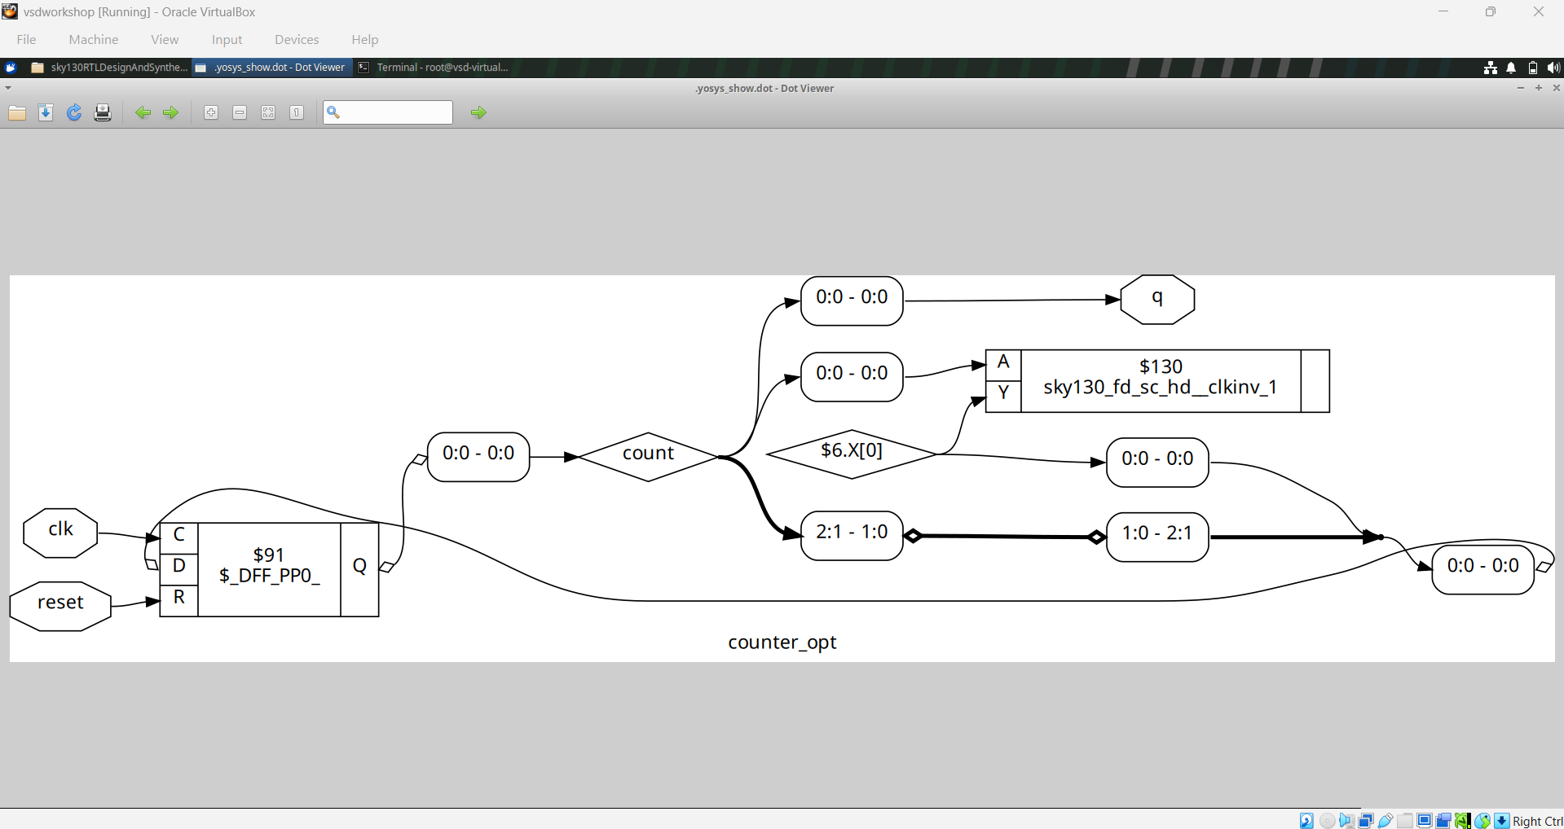
Module 3 figure 1: counter_opt.png
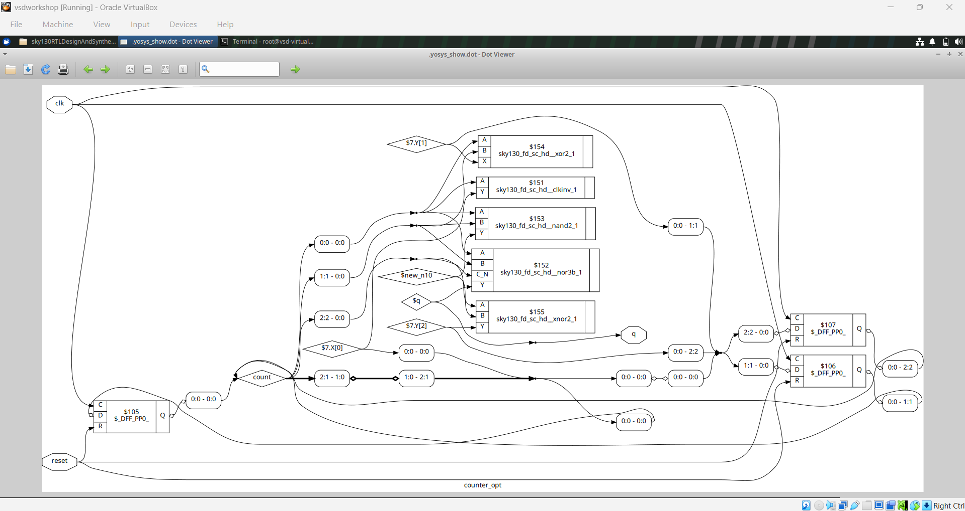
Module 3 figure 2: counter_opt2.png
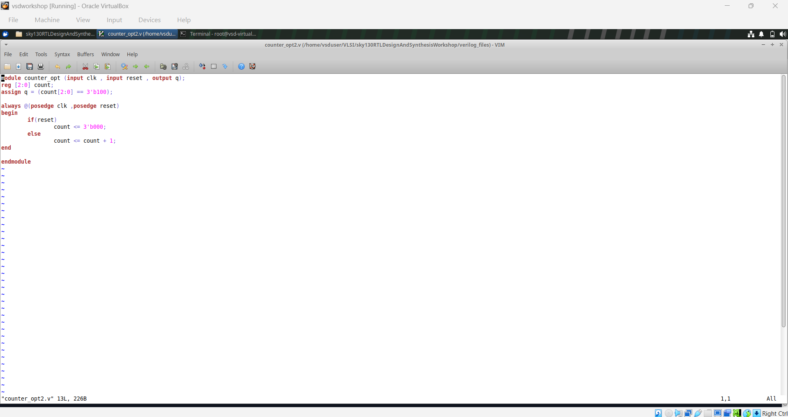
Module 3 figure 3: counter_opt2_code.png
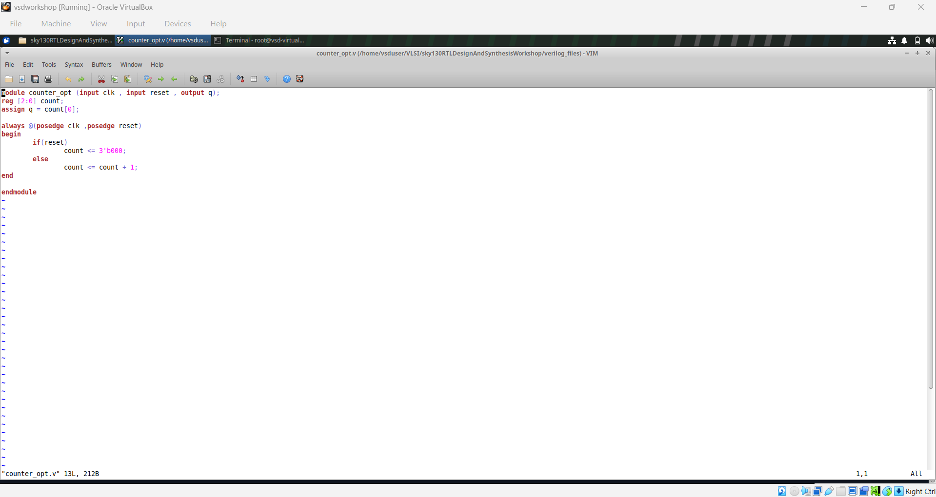
Module 3 figure 4: counter_opt_code.png
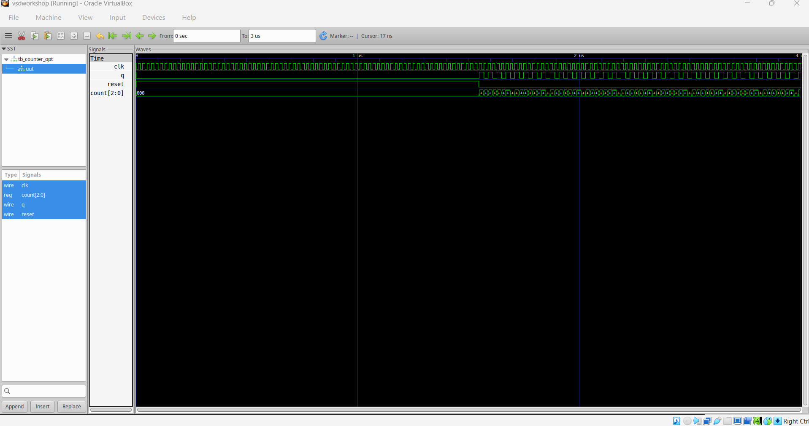
Module 3 figure 5: counter_opt_waveform.png
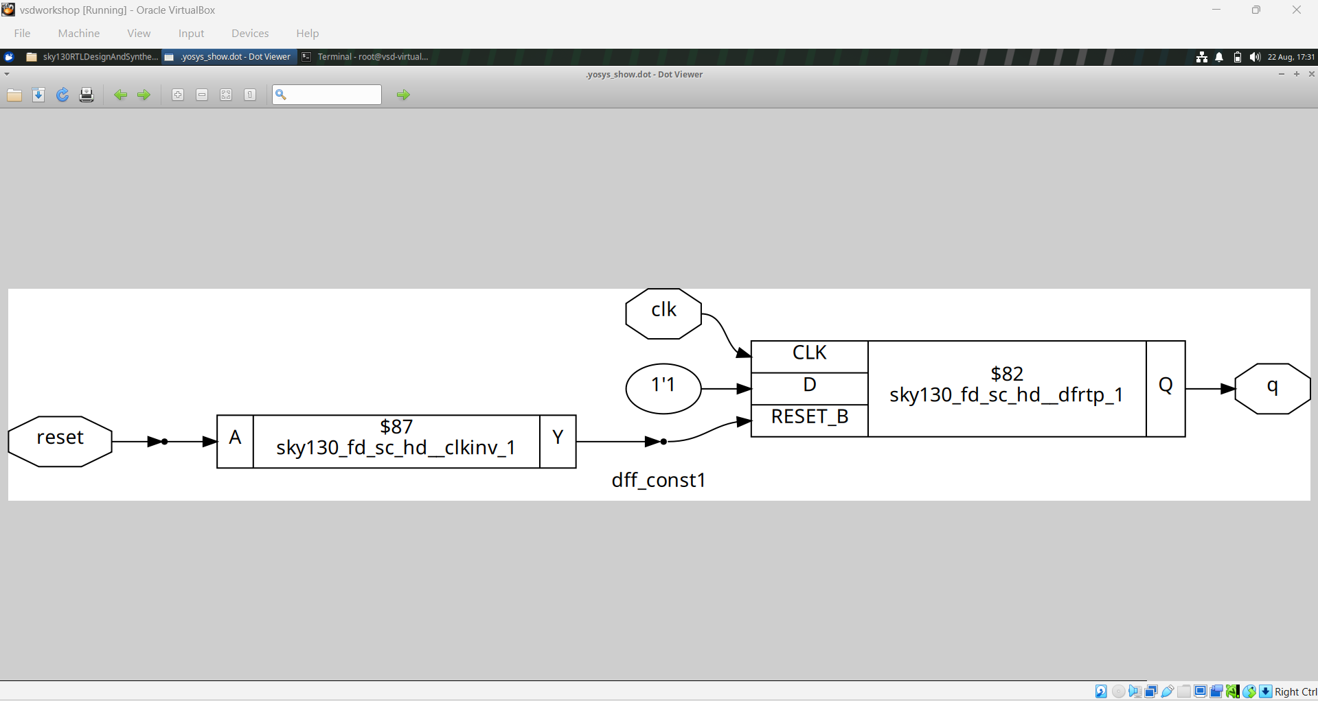
Module 3 figure 6: dff_const.png
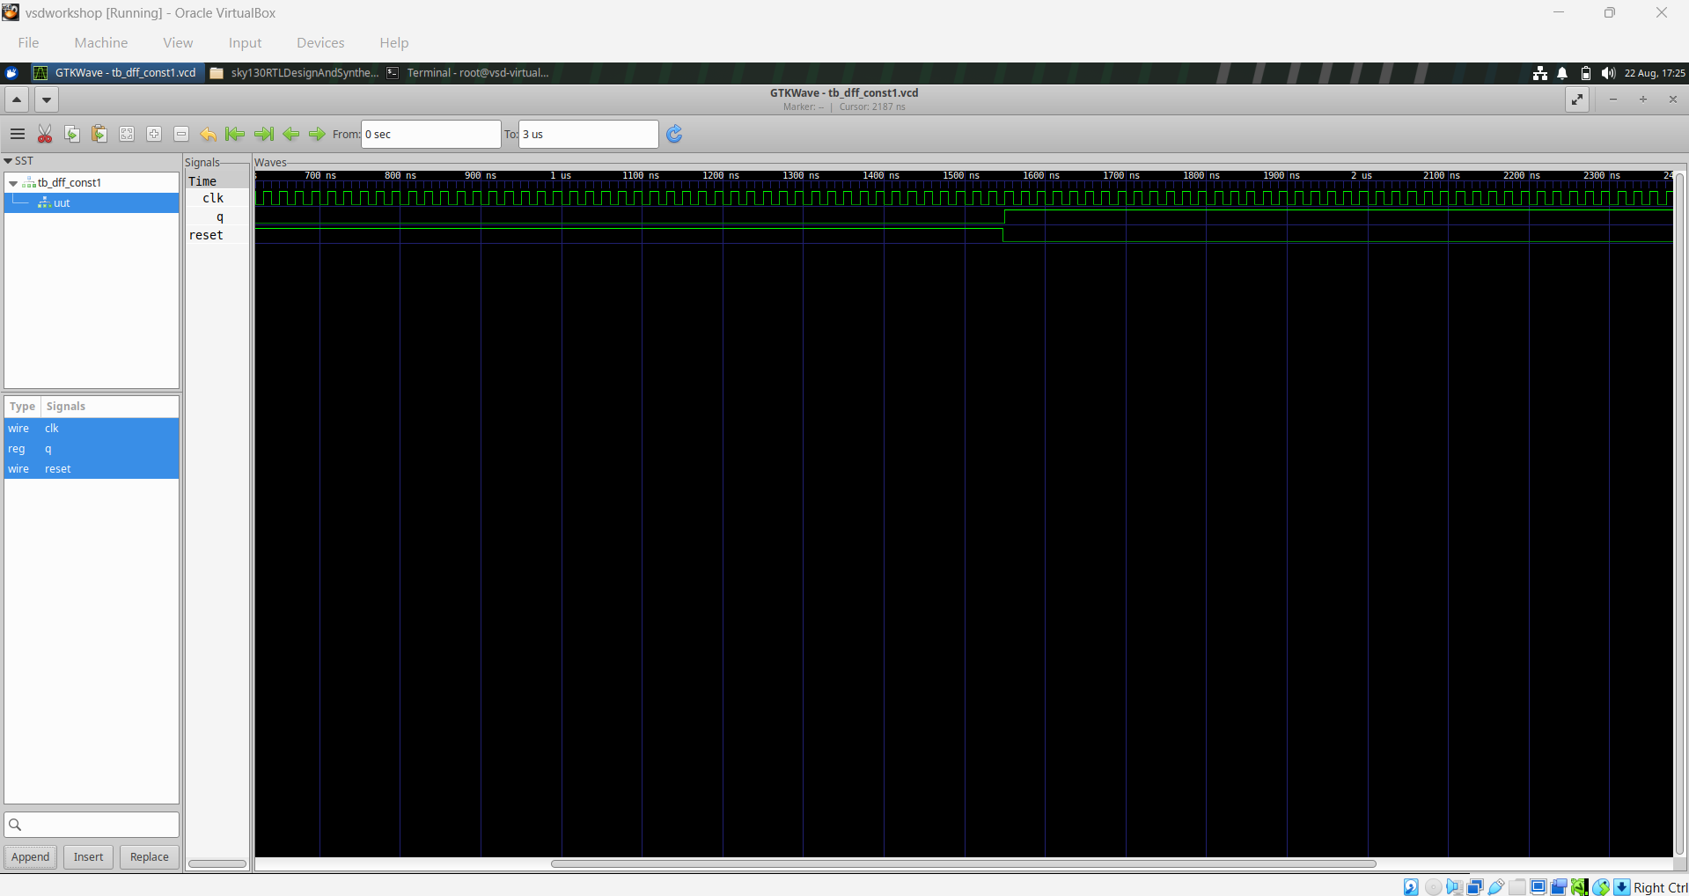
Module 3 figure 7: dff_const1_waveform.png
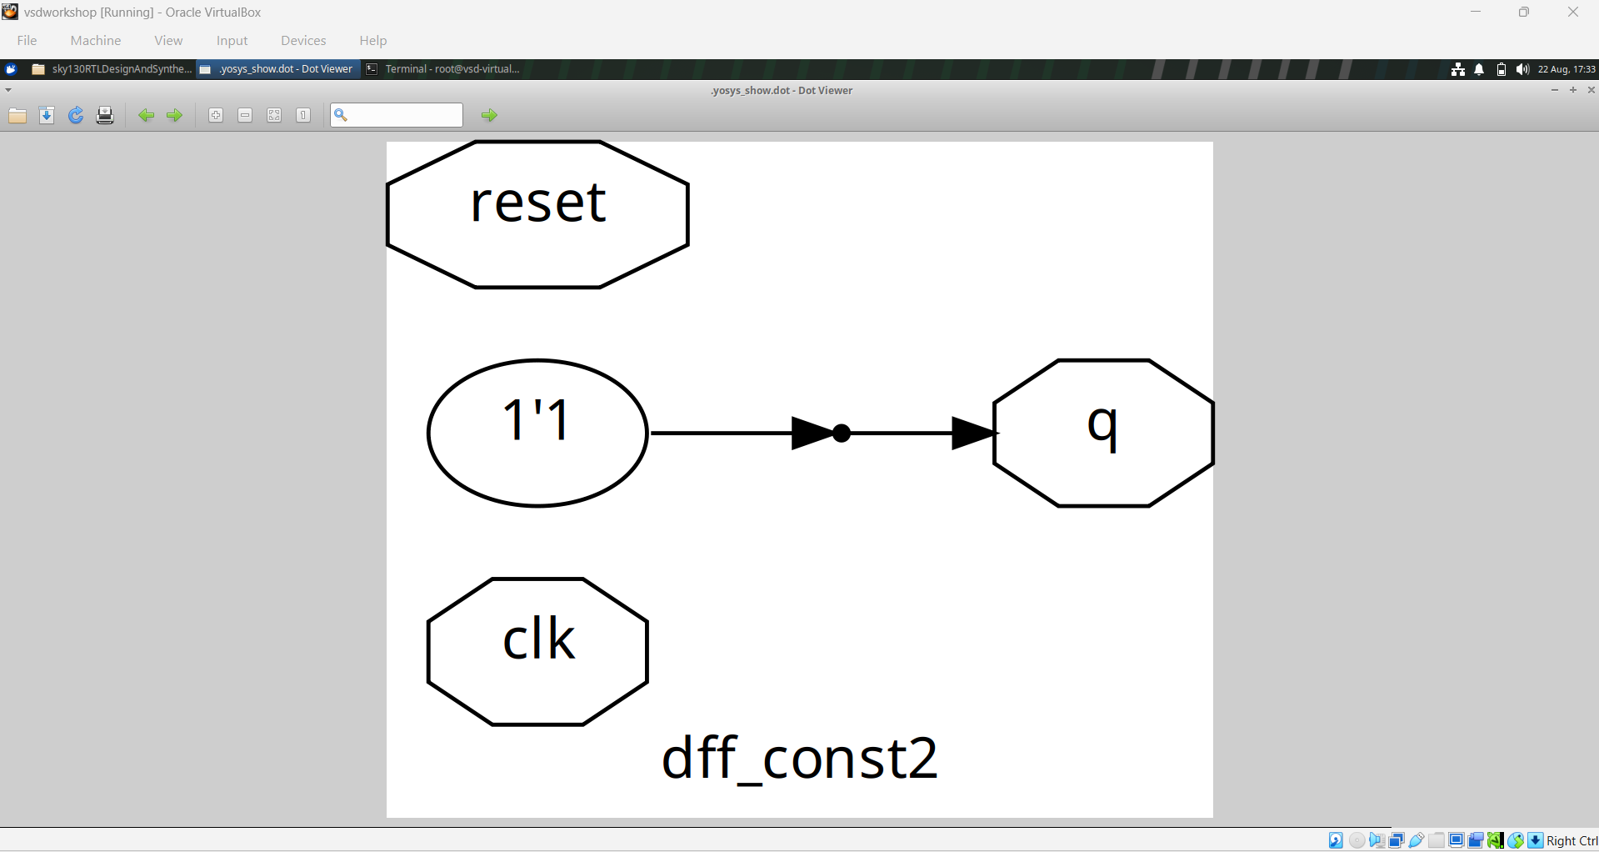
Module 3 figure 8: dff_const2.png
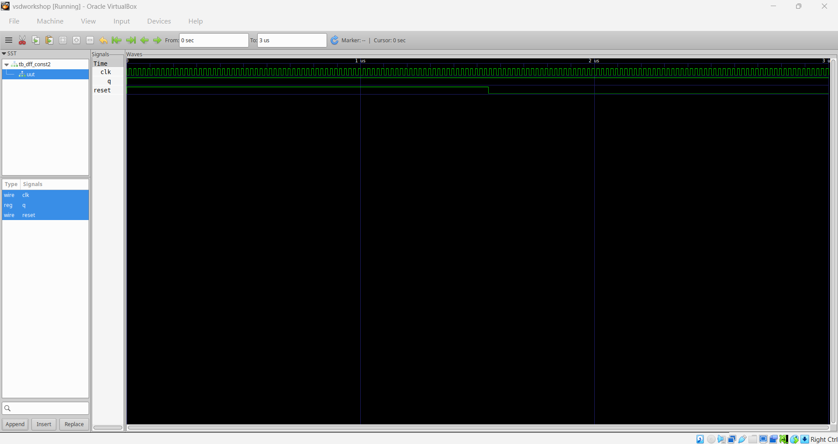
Module 3 figure 9: dff_const2_waveform.png
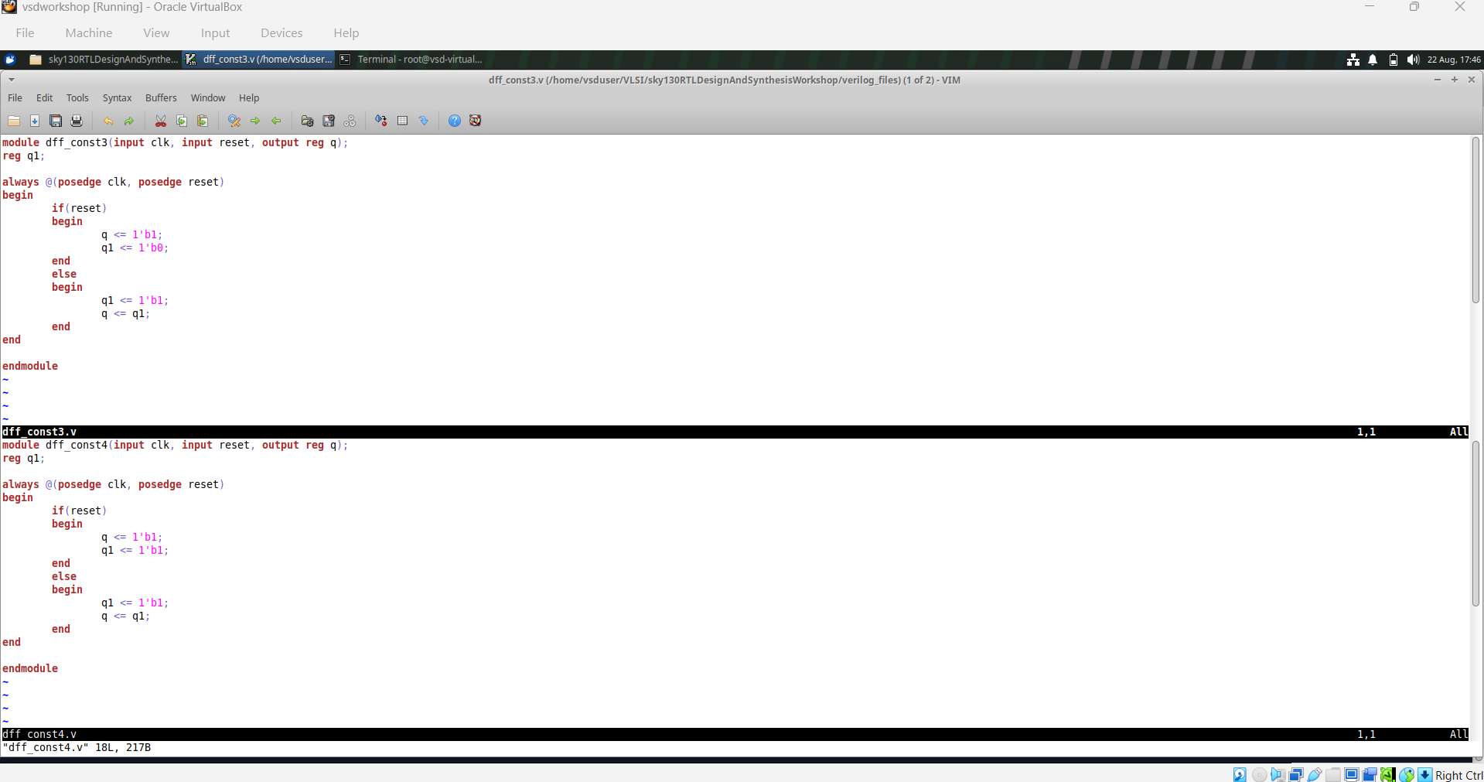
Module 3 figure 10: dff_const3&4_code.png
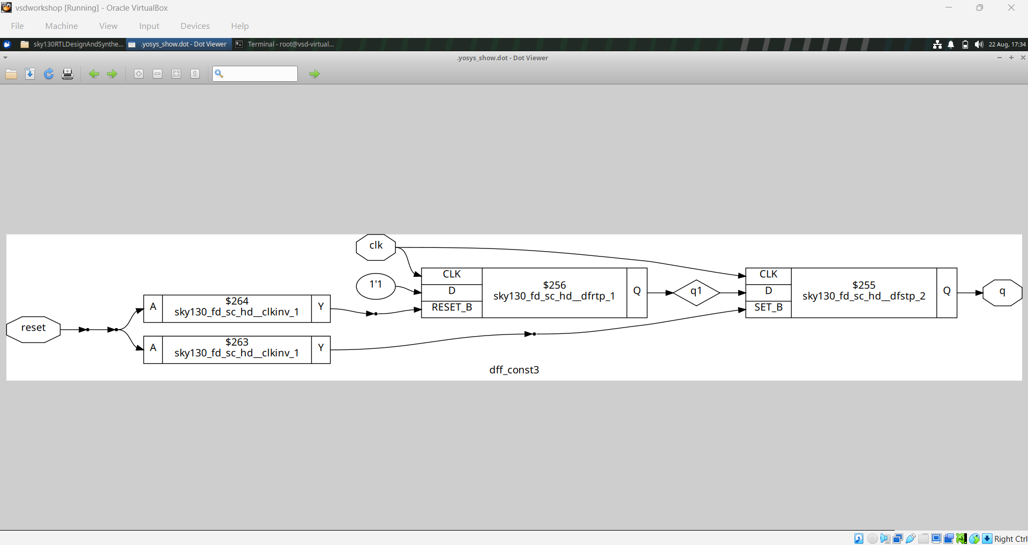
Module 3 figure 11: dff_const3.png
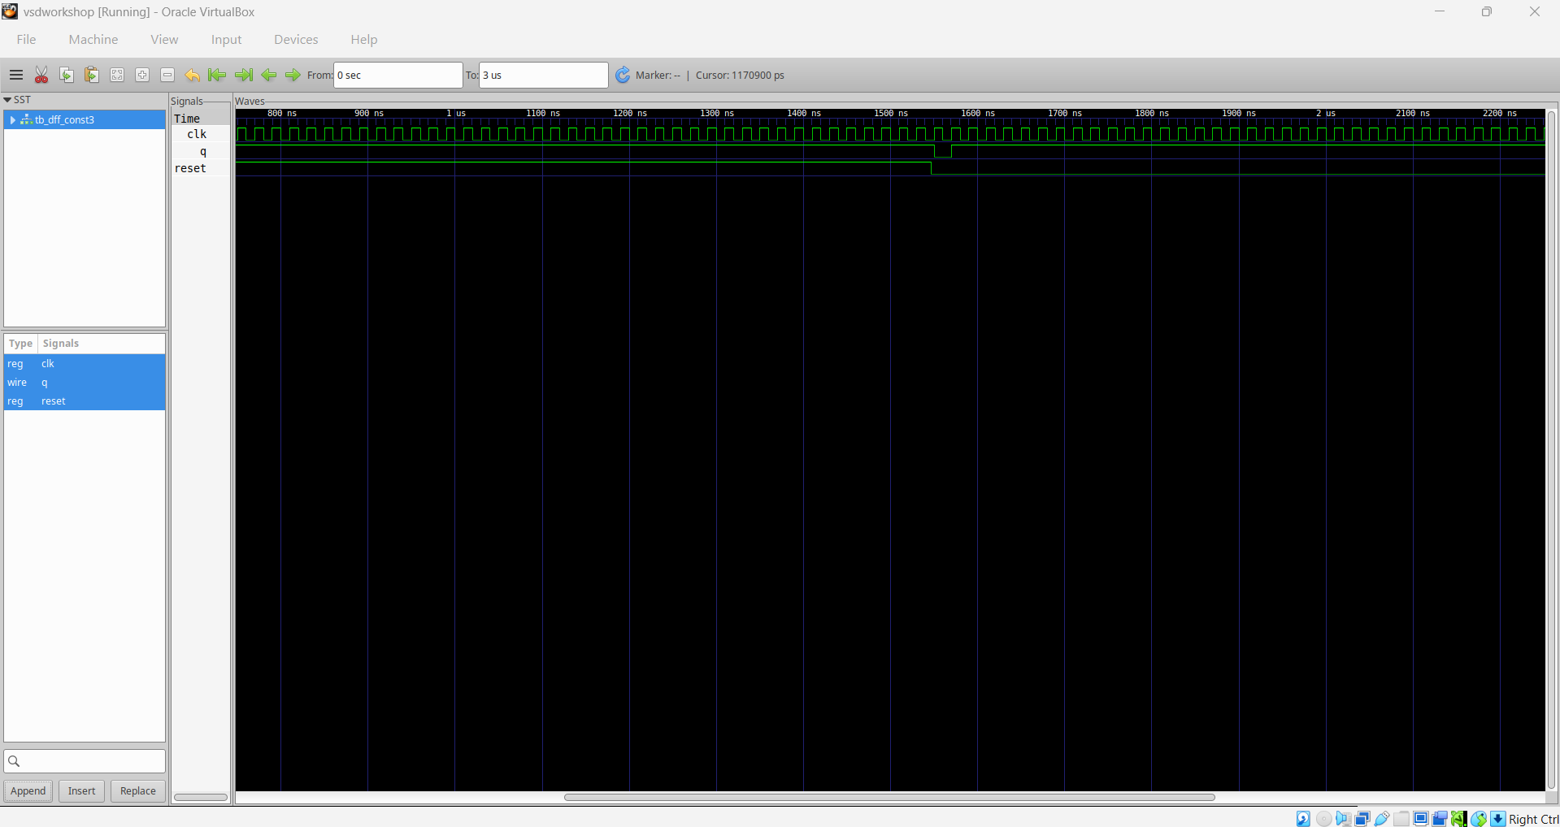
Module 3 figure 12: dff_const3_waveform.png
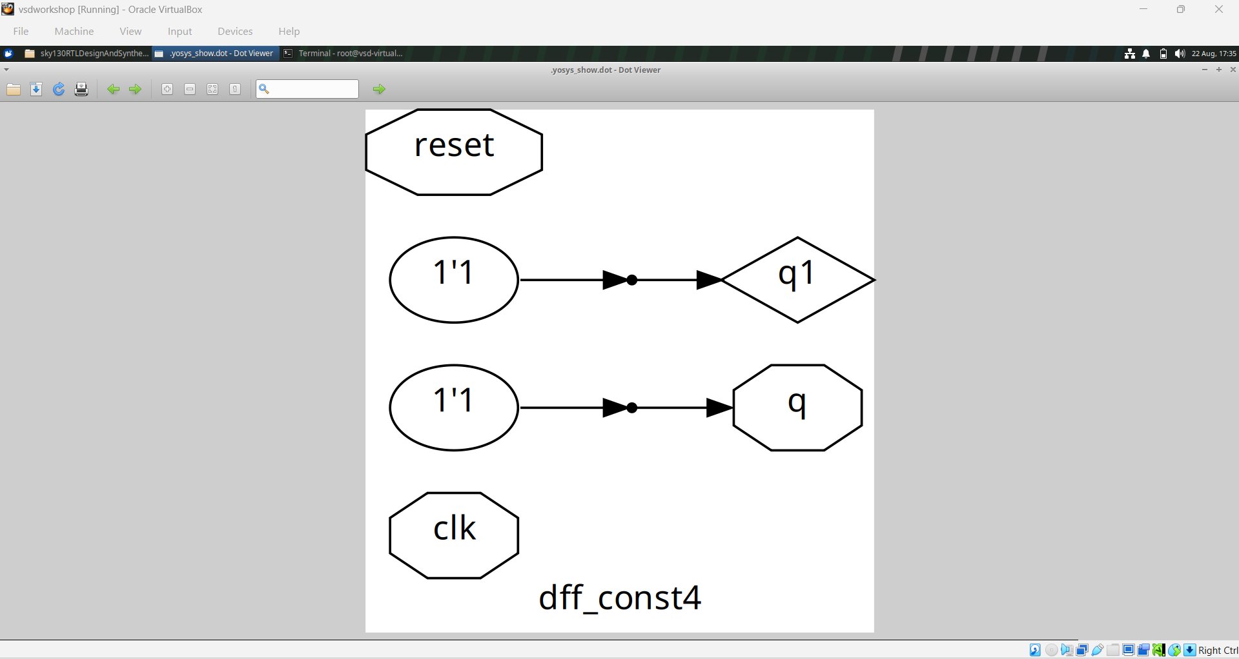
Module 3 figure 13: dff_const4.png
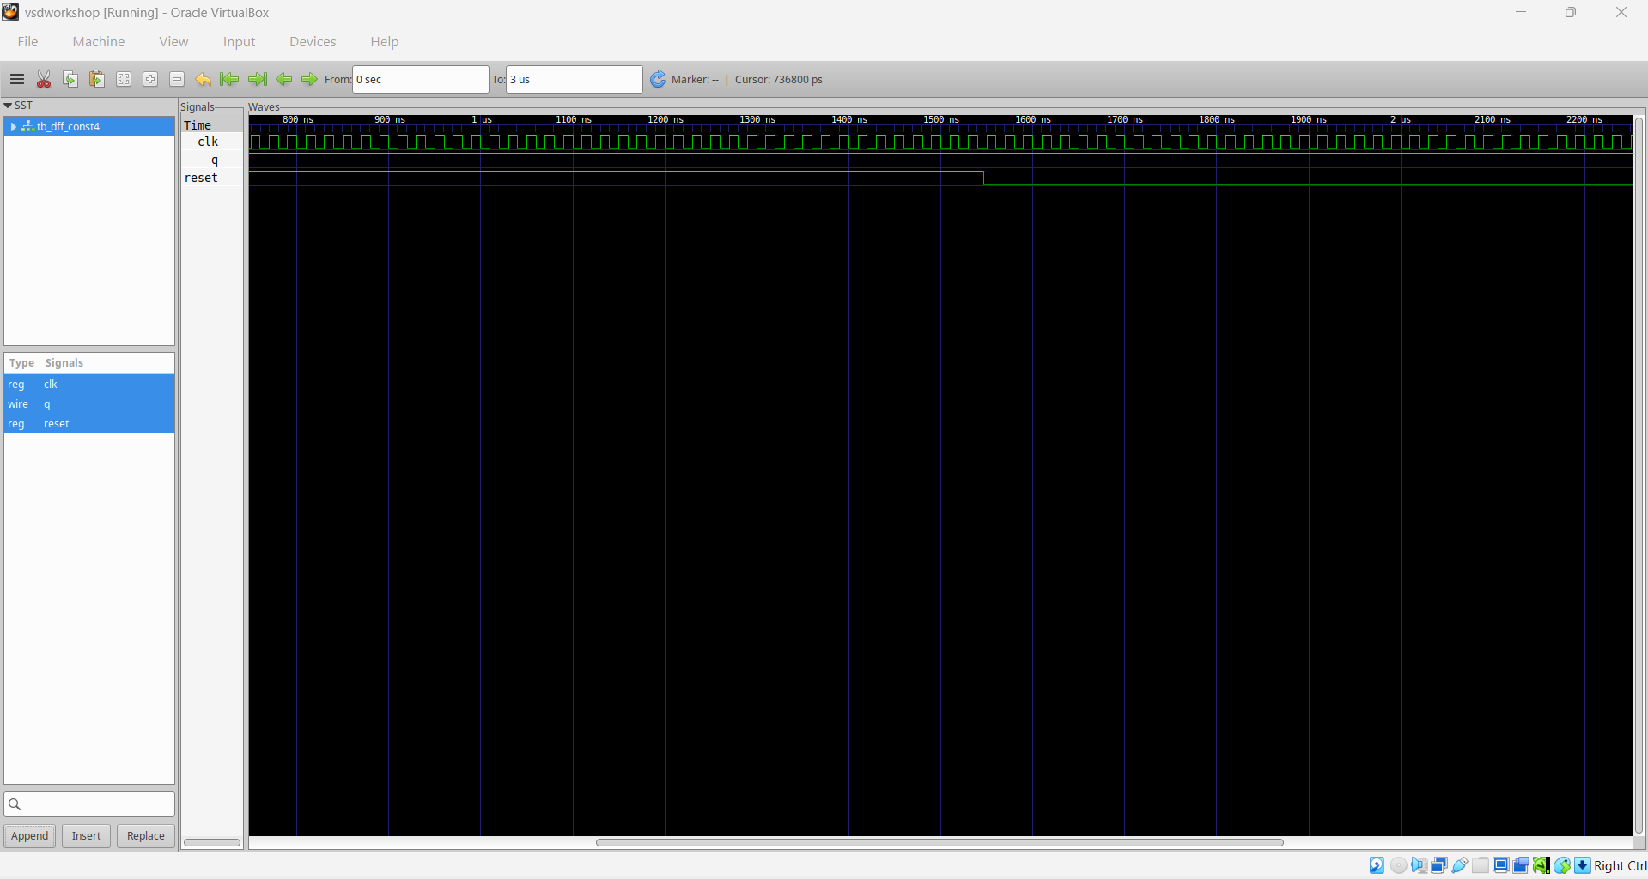
Module 3 figure 14: dff_const4_waveform.png
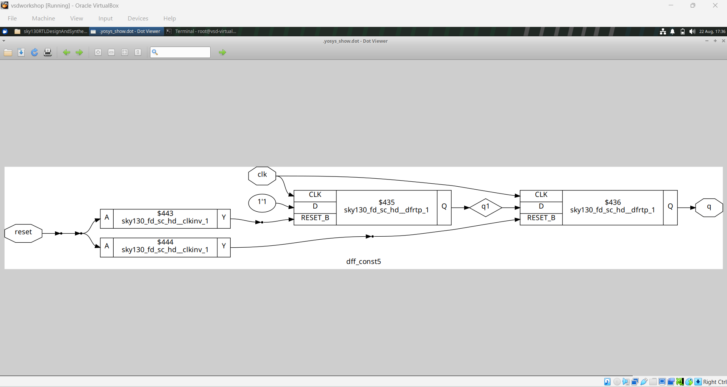
Module 3 figure 15: dff_const5.png
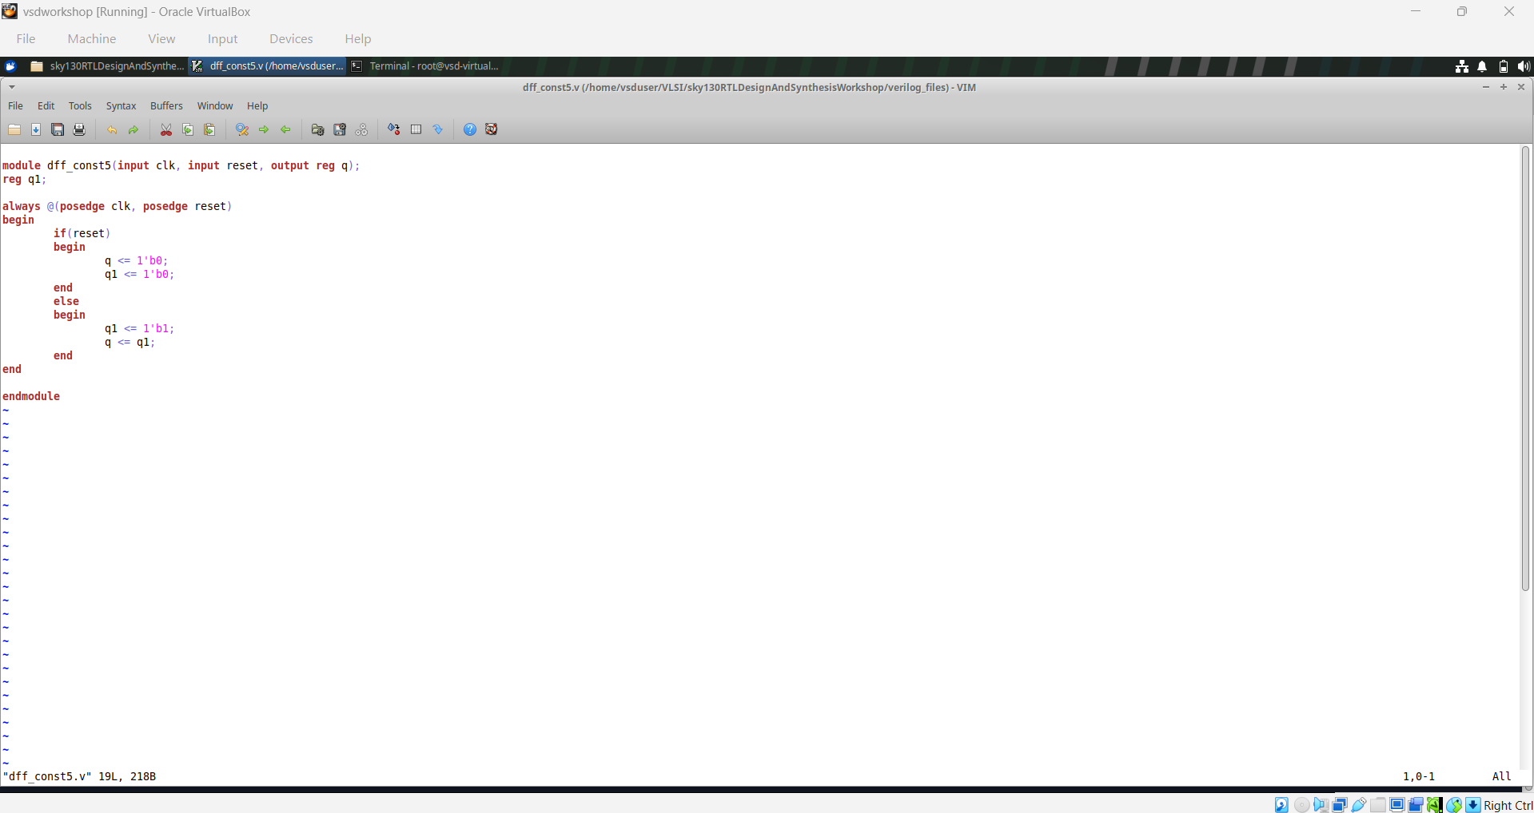
Module 3 figure 16: dff_const5_code.png
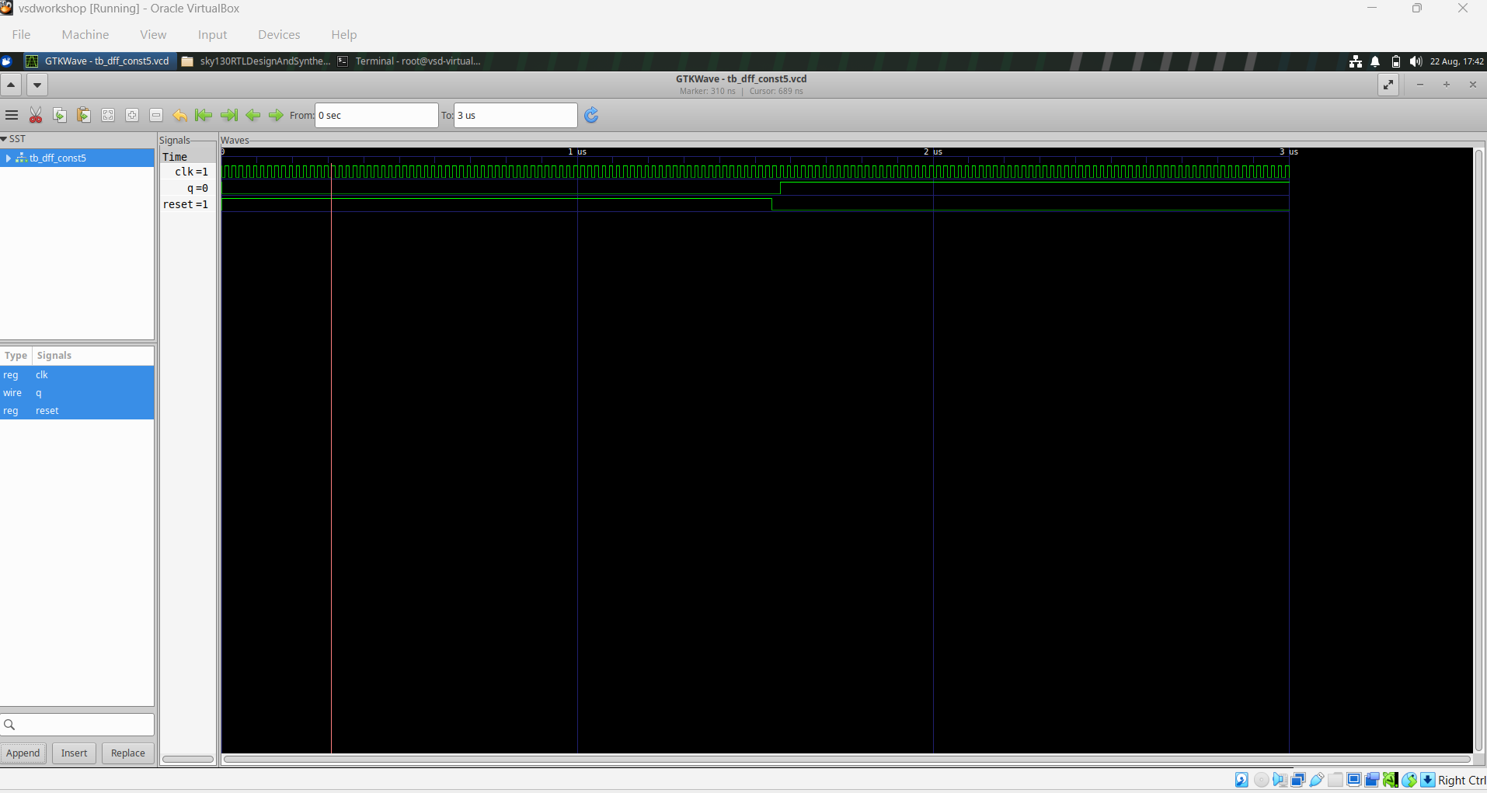
Module 3 figure 17: dff_const5_waveform.png
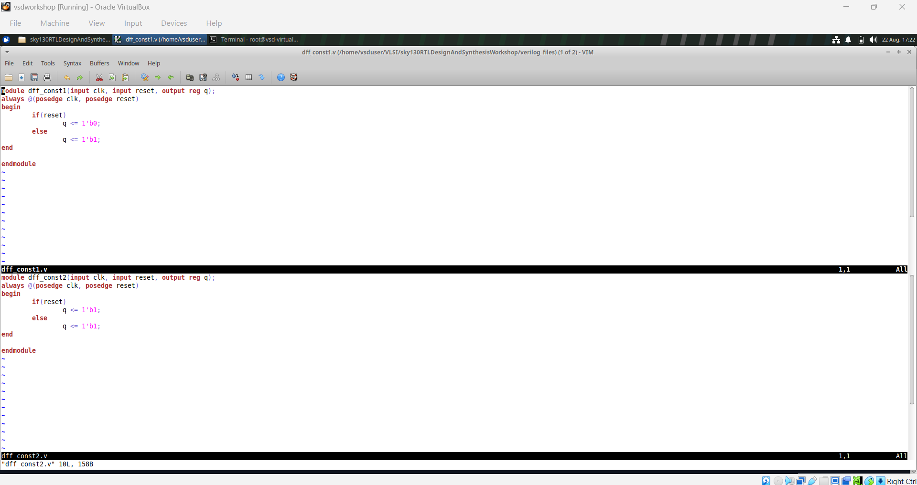
Module 3 figure 18: dff_const_1&2_code.png
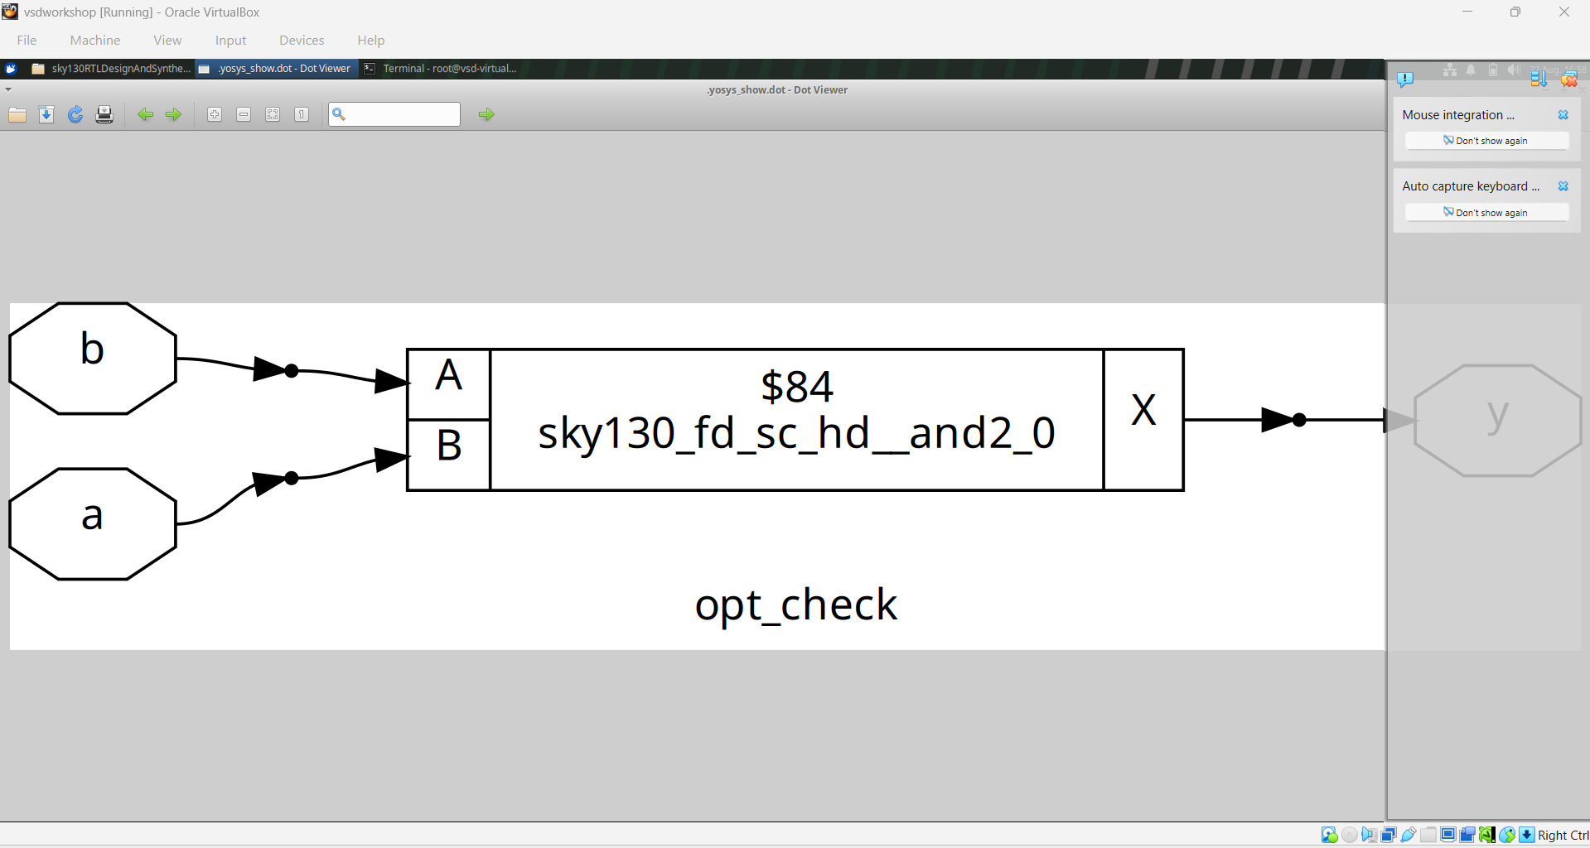
Module 3 figure 19: opt_check.png
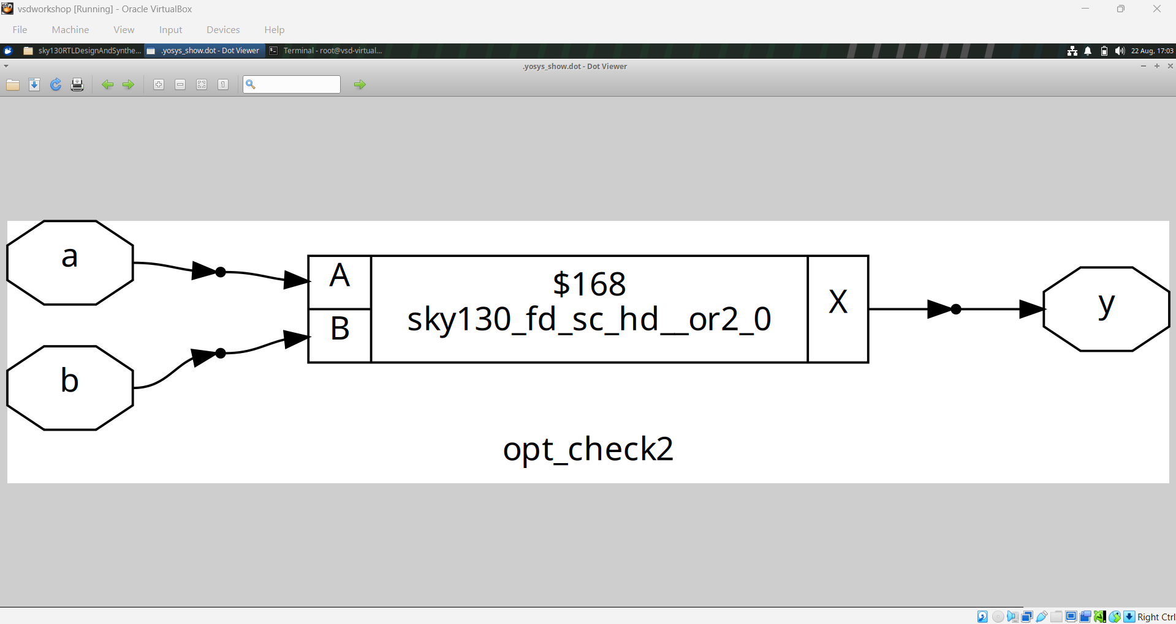
Module 3 figure 20: opt_check2.png
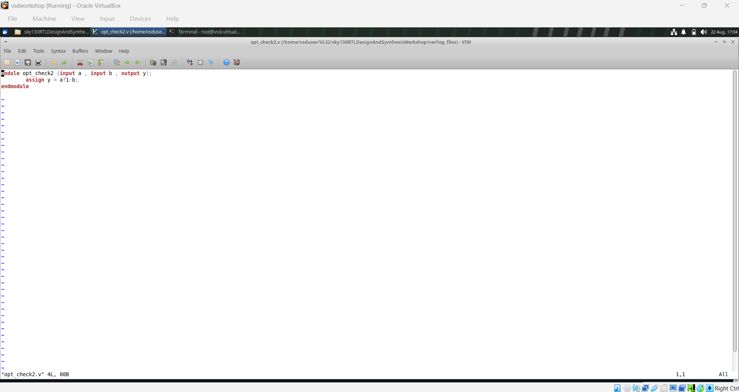
Module 3 figure 21: opt_check2_code.png
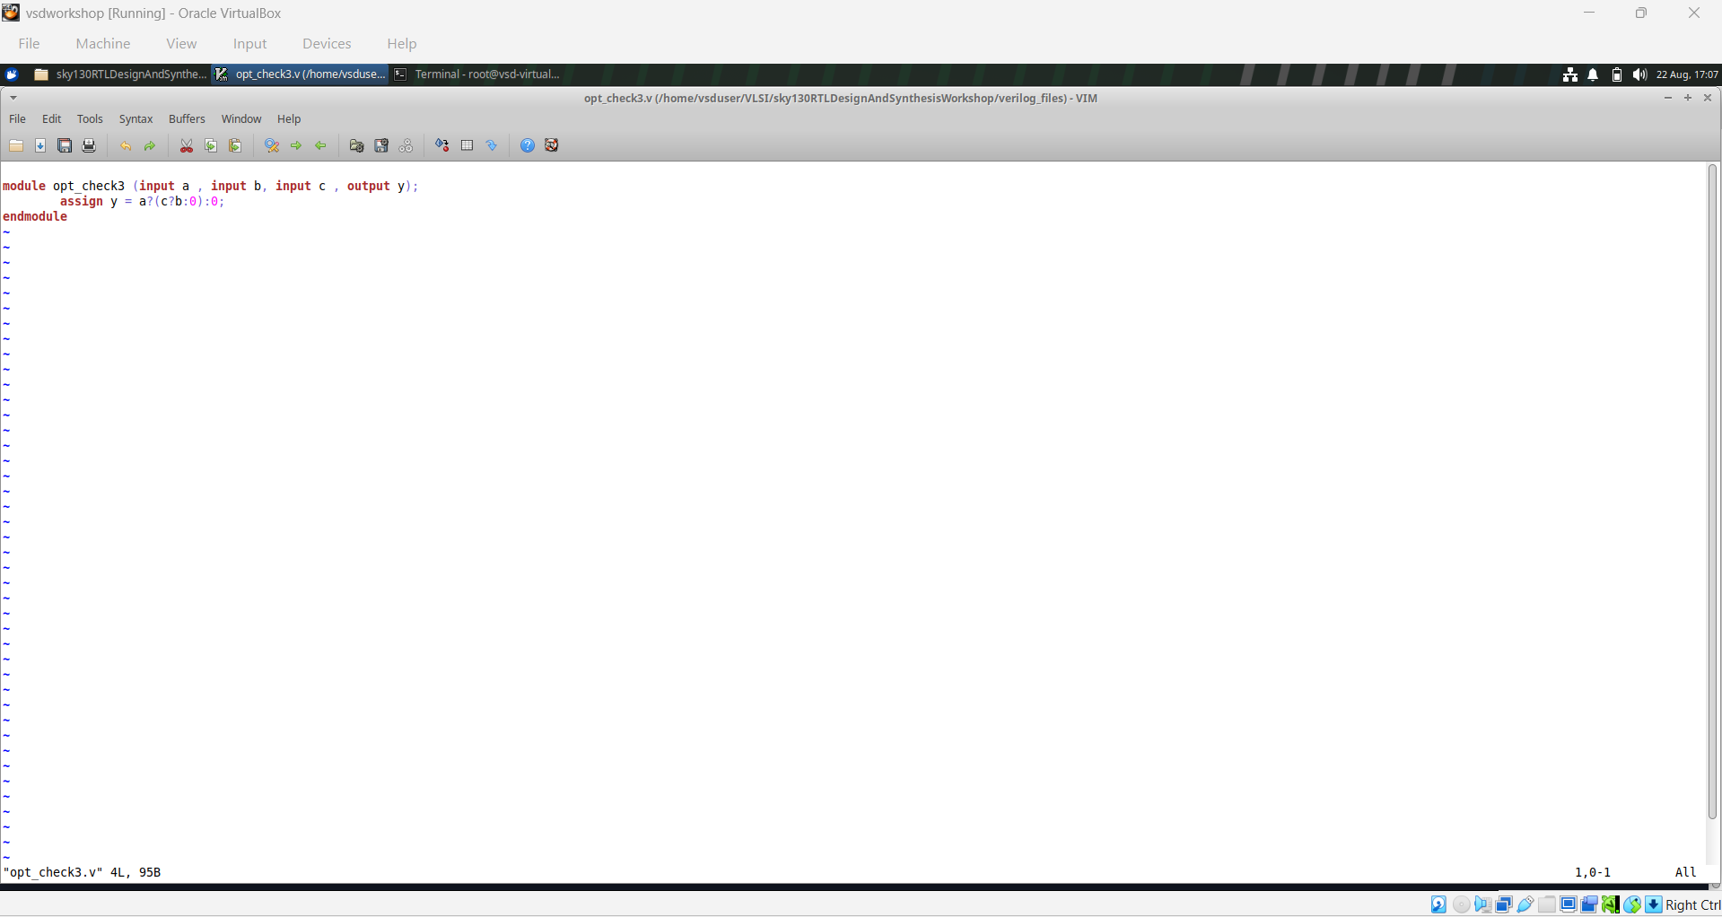
Module 3 figure 22: opt_check3_code.png
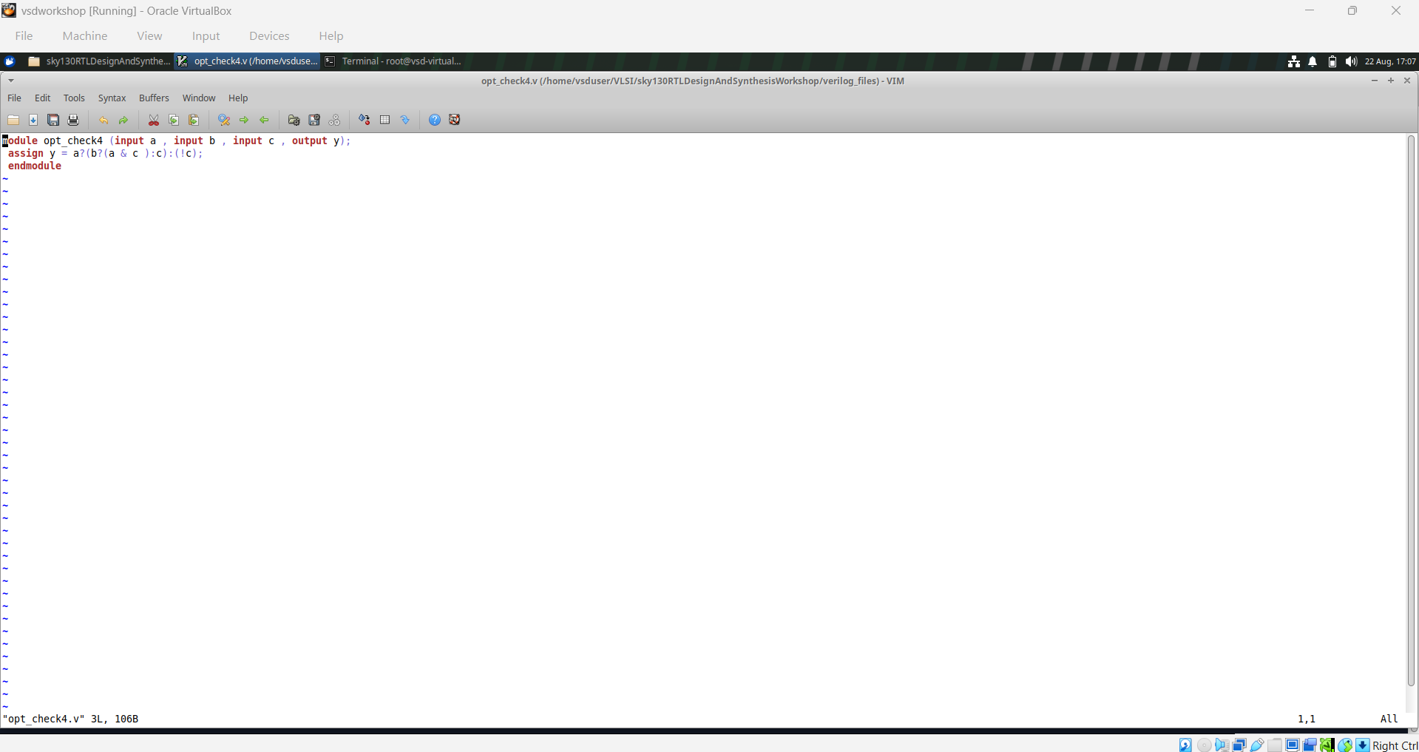
Module 3 figure 23: opt_check4_code.png
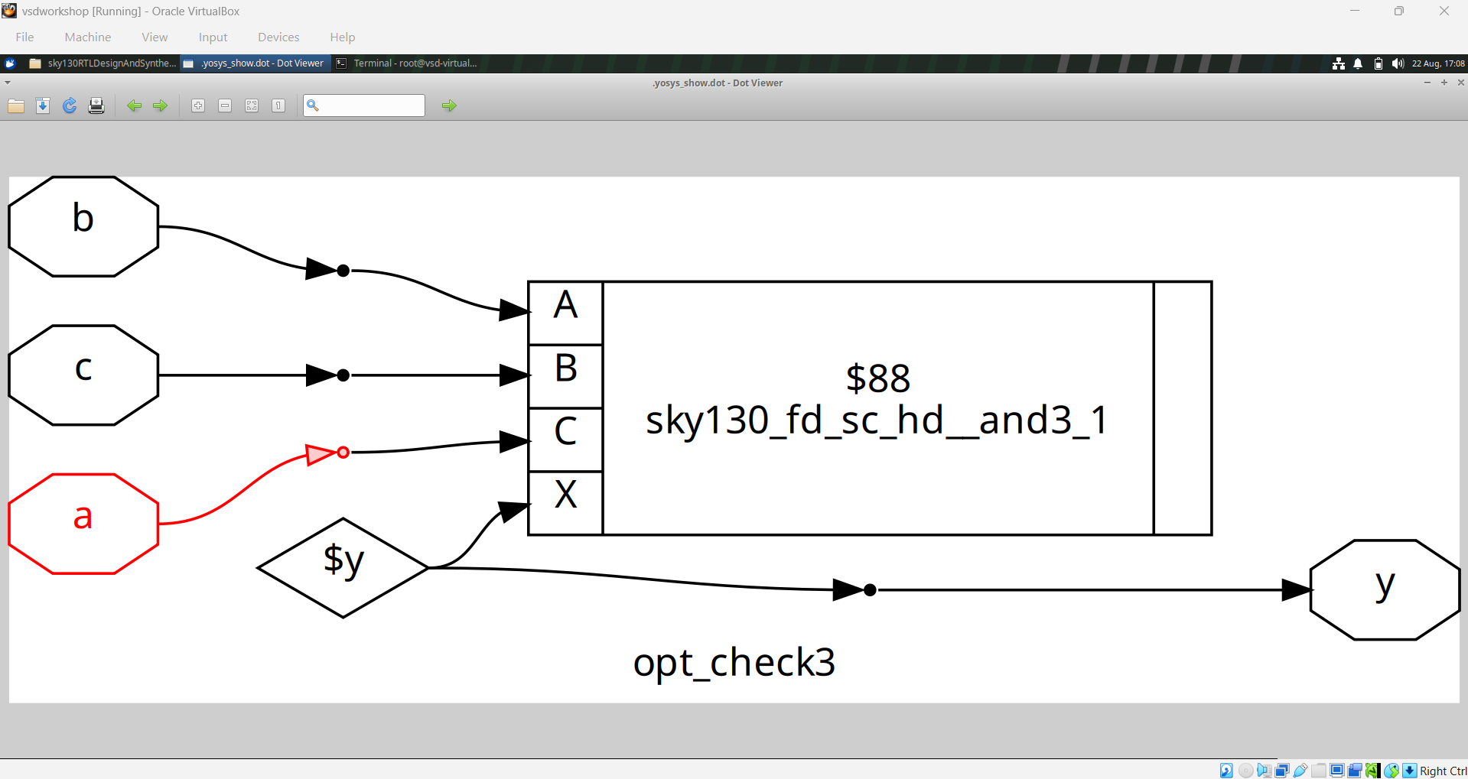
Module 3 figure 24: opt_check_3.png
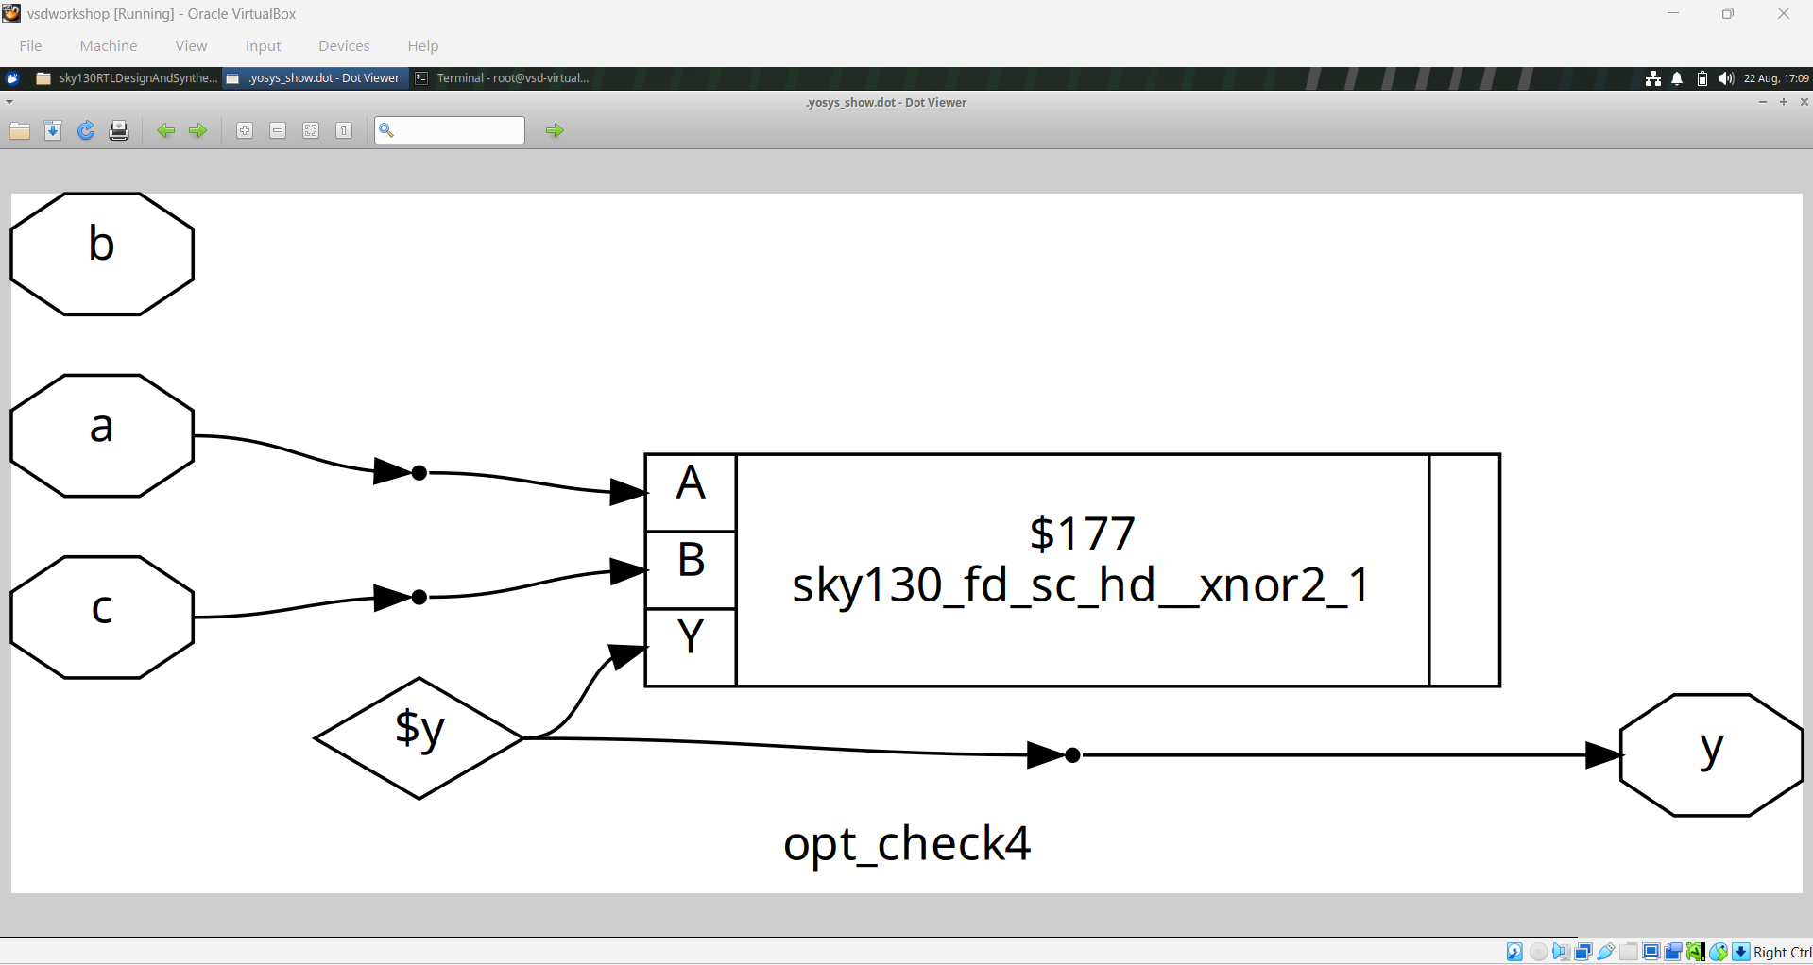
Module 3 figure 25: opt_check_4.png
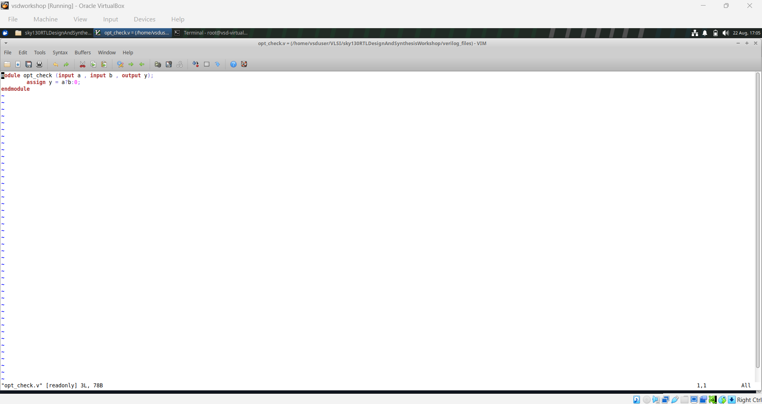
Module 3 figure 26: opt_check_code.png

Module summary
Optimization is a functional-preserving transformation. A longer RTL description does not necessarily imply a larger circuit. Constants, redundant conditions, and simple arithmetic often allow synthesis to produce a much smaller implementation.

Module 4 — Coding Style, Mux Inference, Blocking Assignments, and Gate-Level Simulation
This module explores how RTL coding style affects the structure inferred by synthesis. The evidence includes mux examples, a blocking-assignment caveat, and a gate-level simulation waveform. These experiments show why a designer must think about both functional intent and how a synthesis tool interprets that intent.

Learning objectives
- Understand how conditional RTL becomes mux hardware.
- Compare a direct/ternary mux description with an equivalent synthesized mux.
- Recognize hazards caused by careless use of blocking assignments in sequential logic.
- Understand the purpose of gate-level simulation (GLS).
- Compare RTL simulation behavior with post-synthesis behavior.

Conceptual discussion

1. Multiplexer inference
A conditional assignment naturally suggests a mux because the output must choose between alternative data paths. The supplied diagrams show mapped SKY130 mux cells. Seeing the mux cell in the netlist confirms that synthesis recognized the intended selection function.

2. Ternary operator
The ternary form expresses a two-way choice compactly: condition ? value1 : value2. For a combinational mux, this can be a clear representation of the hardware intent. The accompanying waveform and synthesized diagram can be used to verify both behavior and implementation.

3. Blocking-assignment caveat
Blocking assignments update a variable immediately within procedural execution. This is useful for combinational calculations, but using blocking assignments carelessly in clocked logic can create ordering-dependent behavior that does not match the intended hardware model. Sequential RTL is generally clearer when non-blocking assignments are used for state updates.

4. Gate-level simulation
After synthesis, the mapped netlist can be simulated again. This checks whether the synthesized implementation still produces the expected behavior and can expose issues that were not obvious in the original RTL simulation. The supplied GLS waveform demonstrates this post-synthesis verification stage.

5. Practical comparison
A useful workflow is to run RTL simulation first, synthesize second, and then perform GLS. If the RTL waveform is correct but GLS differs, investigate synthesis assumptions, initialization, reset behavior, timing constructs, or mismatches between the testbench and the synthesized model.

Suggested practical flow
1. Write the mux using a clear combinational style.
2. Simulate the RTL and verify all select/data combinations.
3. Synthesize and identify the mapped mux cell.
4. Run gate-level simulation using the synthesized model.
5. Compare RTL and GLS waveforms and investigate any mismatch.

Visual evidence from the supplied module
The following figures are retained from the corresponding Module 4 folder and placed here as visual evidence. They are accompanied by newly written explanations rather than reproducing the reference README wording.
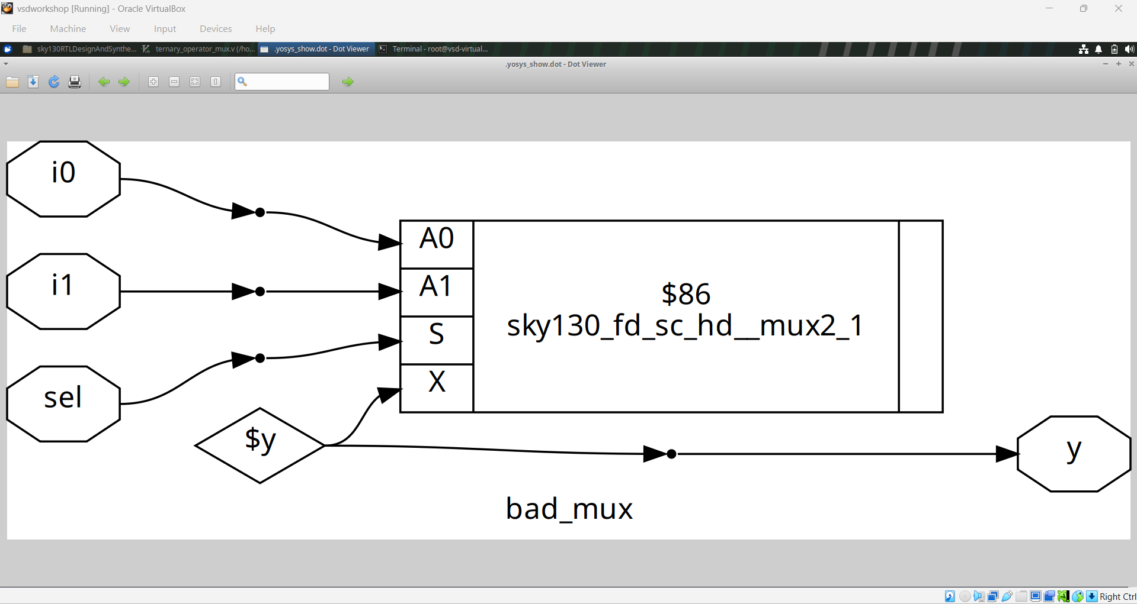
Module 4 figure 1: bad_mux.png
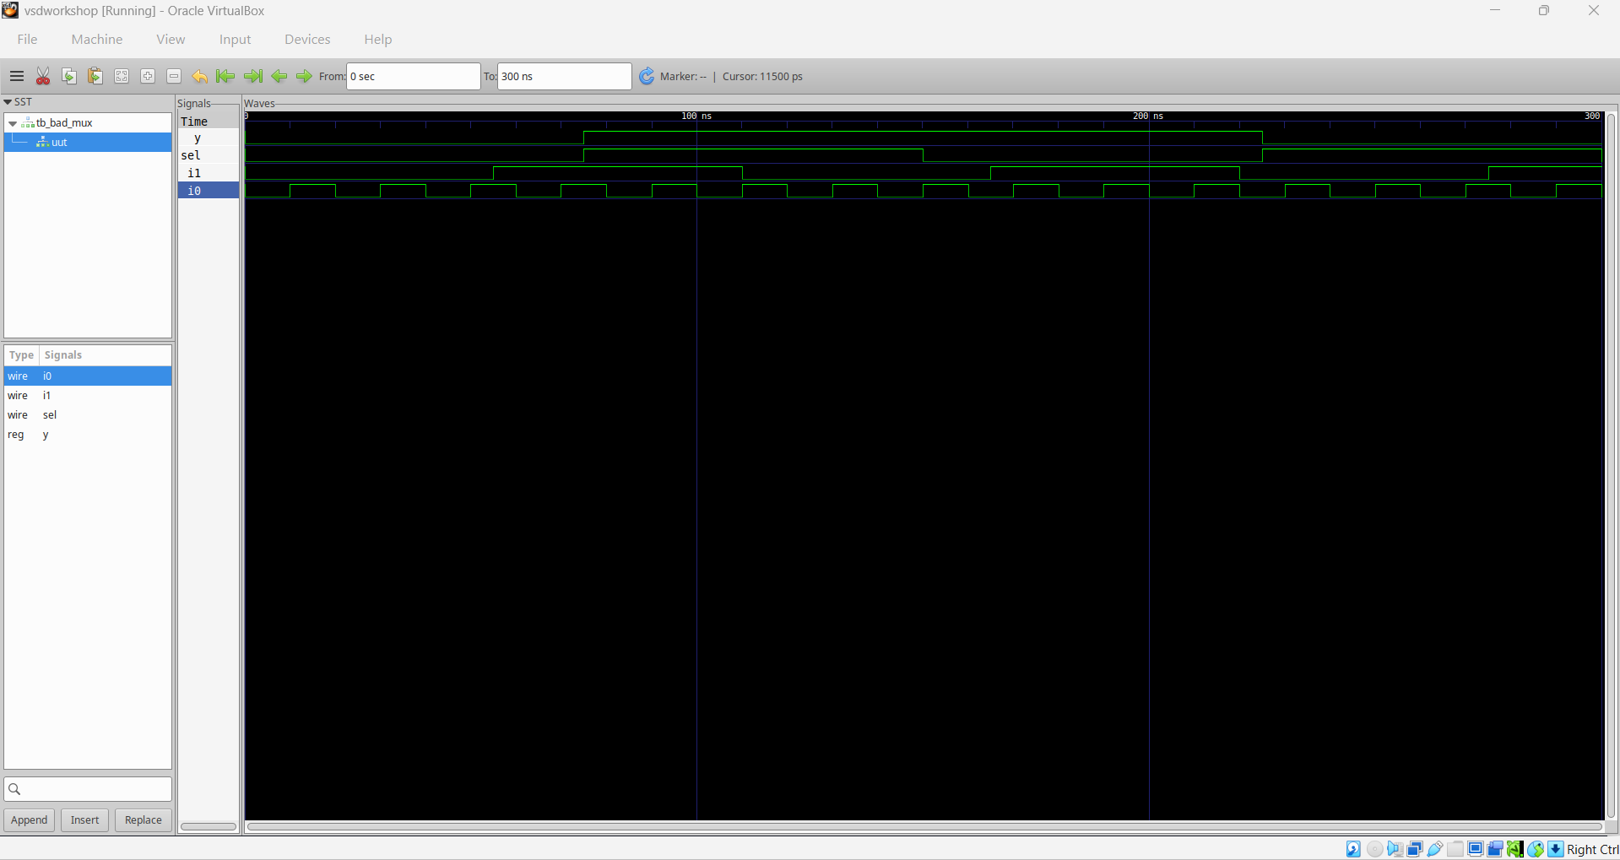
Module 4 figure 2: bad_mux_waveform.png
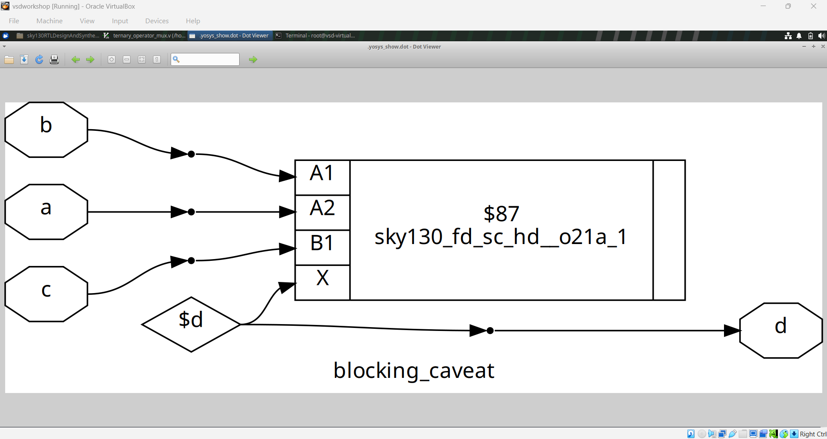
Module 4 figure 3: blocking_caveat.png
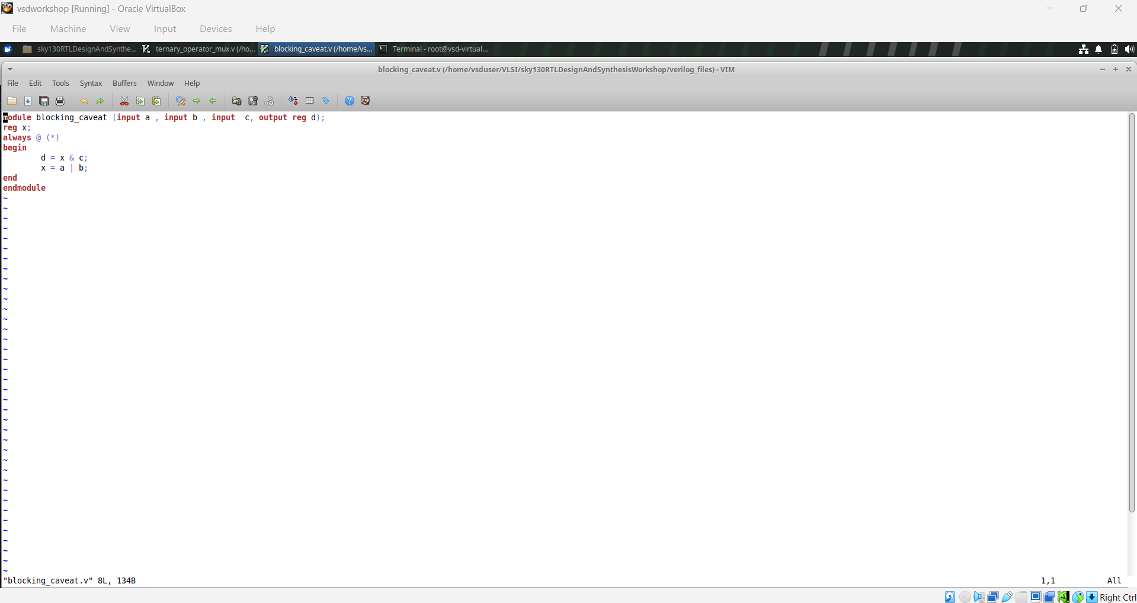
Module 4 figure 4: blocking_caveat_code.png
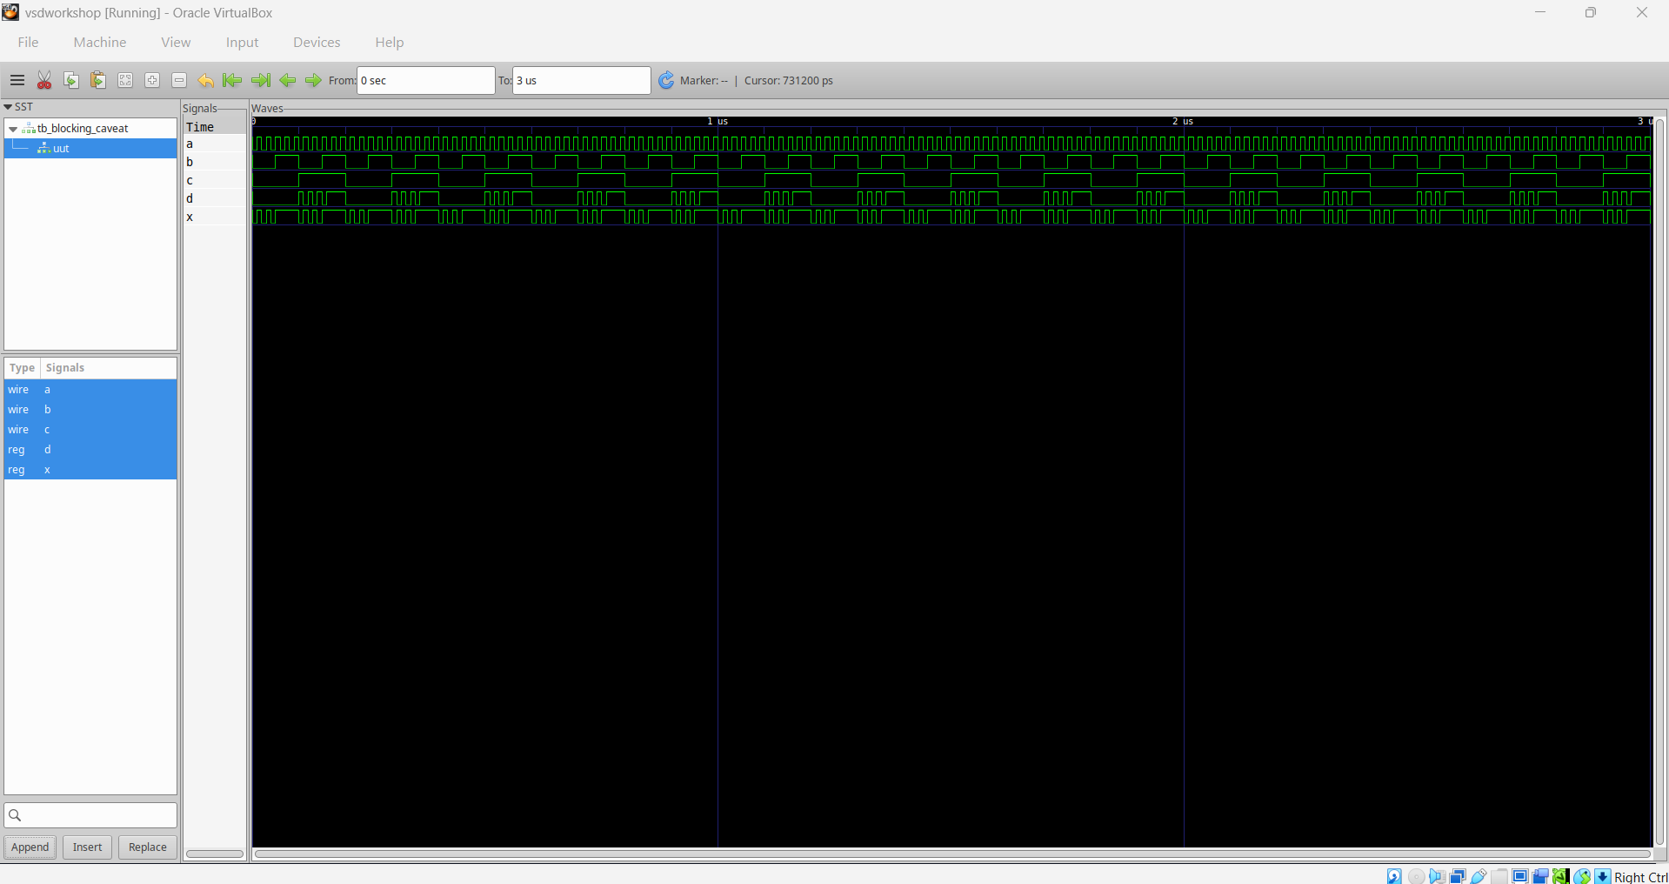
Module 4 figure 5: blocking_caveat_waveform.png
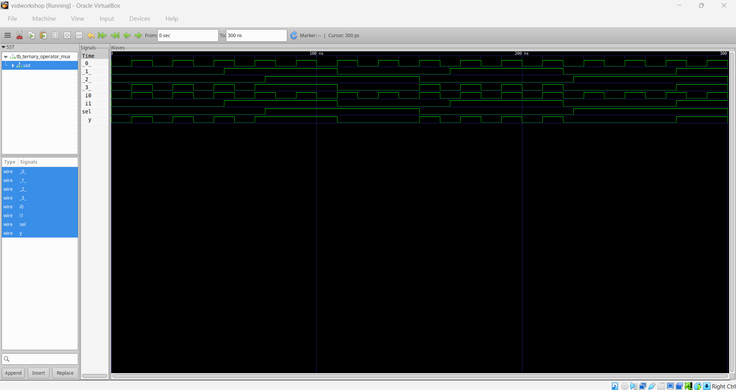
Module 4 figure 6: gls_waveform.png
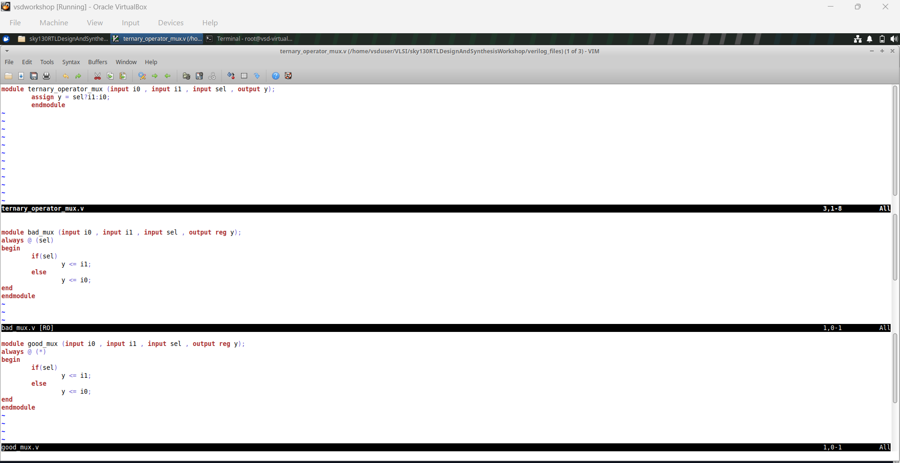
Module 4 figure 7: t_g_b_mux_code.png
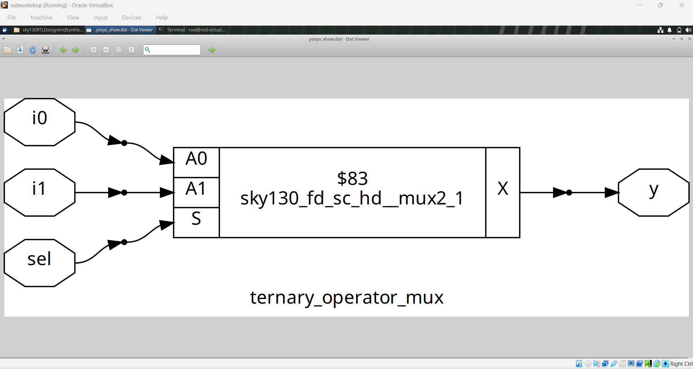
Module 4 figure 8: ternary_mux.png
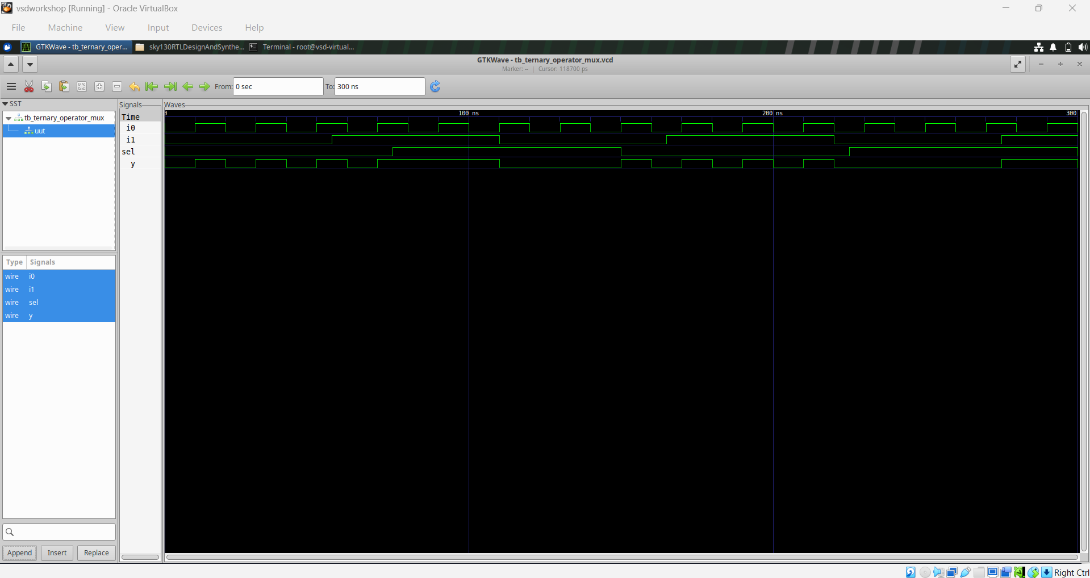
Module 4 figure 9: ternary_mux_waveform.png

Module summary
Good RTL is not only about writing code that simulates. It should express hardware intent clearly enough that synthesis can infer the desired structure. GLS then provides a final functional check of the synthesized representation.

Module 5 — Case/If Completeness, Generate Constructs, and Mux/Demux Design
The final module concentrates on combinational coding styles and the ways incomplete assignments can create unintended storage. It also uses case statements and generate constructs to build larger mux/demux structures. The many source, netlist, and waveform images provide practical evidence of these alternatives.

Learning objectives
- Understand complete versus incomplete combinational assignments.
- Recognize how case and if statements can infer mux hardware.
- Understand why a missing assignment may imply storage/latch behavior.
- Use generate constructs to describe repeated hardware structures.
- Compare mux and demux implementations and their waveforms.

Conceptual discussion

1. Complete combinational assignments
For combinational logic, every output must receive a value for every relevant input condition. If some branch leaves an output unchanged, the tool may infer storage to preserve that previous value. A common defensive technique is to assign a default value before entering conditional logic and then override it in the required branches.

2. Case statements
A case statement can represent a selection network clearly when there are several possible input conditions. The supplied complete and incomplete case examples illustrate why branch coverage matters. A complete case description can synthesize as pure combinational logic, whereas incomplete descriptions can lead to unintended storage or implementation differences.

3. If statements and muxes
An if/else chain also represents selection logic. The synthesized diagrams in the supplied material show standard-cell implementations that correspond to these choices. The key is not the keyword itself, but whether the assignments fully describe the intended combinational function.

4. Generate constructs
Generate blocks are useful when the same structural pattern must be instantiated repeatedly. Instead of manually writing many nearly identical blocks, a generate loop can create a family of hardware instances. This is especially useful for wider mux/demux structures.

5. Multiplexer and demultiplexer
A mux selects one input and forwards it to one output. A demux performs the opposite distribution: one input is directed toward one of several outputs based on select signals. The supplied diagrams and waveforms show both generated and case-based implementations.

6. Verification of incomplete logic
The waveform screenshots are particularly useful here. Unexpectedly retained output values or gaps in response to input changes are warning signs that the RTL did not fully specify combinational behavior. Always inspect the waveform in addition to the synthesized schematic.

Suggested practical flow
1. Create complete and deliberately incomplete conditional examples.
2. Simulate each version with a testbench that exercises every branch.
3. Inspect waveforms for retained or unexpected output values.
4. Synthesize case/if and generated mux/demux versions.
5. Compare the resulting structures and confirm functional behavior.

Visual evidence from the supplied module
The following figures are retained from the corresponding Module 5 folder and placed here as visual evidence. They are accompanied by newly written explanations rather than reproducing the reference README wording.
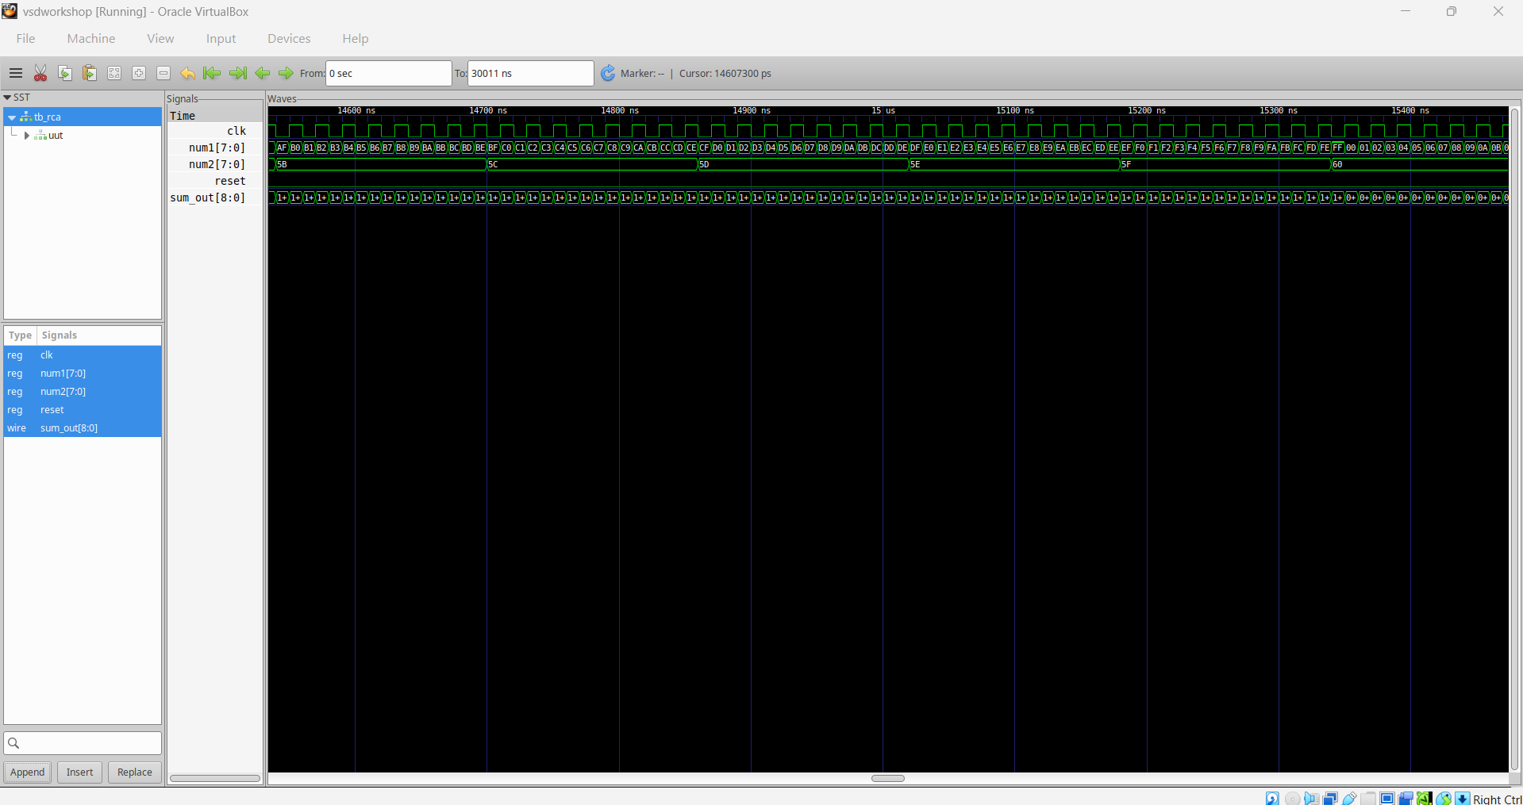
Module 5 figure 1: Screenshot 2026-08-22 193955.png
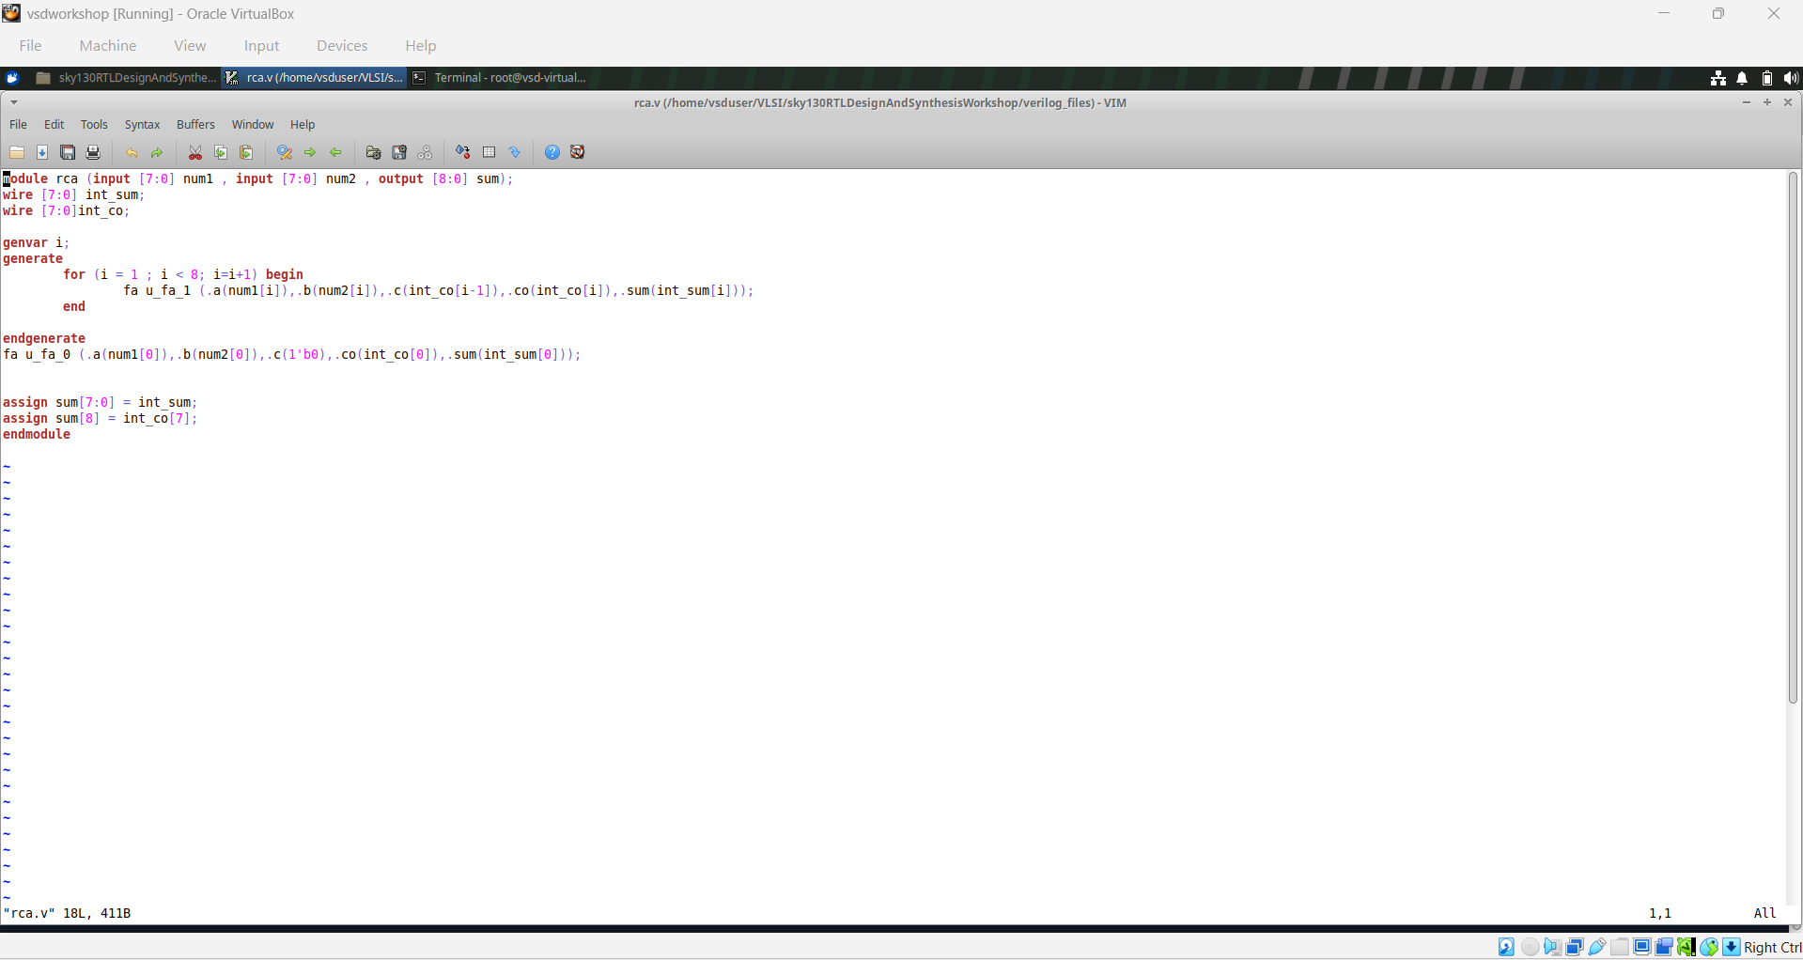
Module 5 figure 2: Screenshot 2026-08-22 194042.png
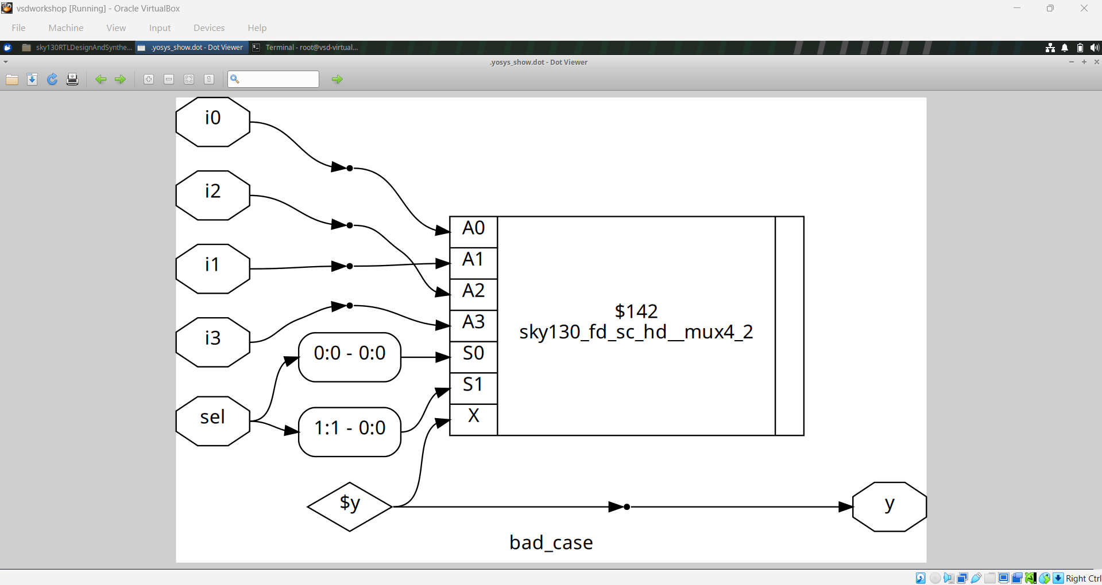
Module 5 figure 3: bad_case.png
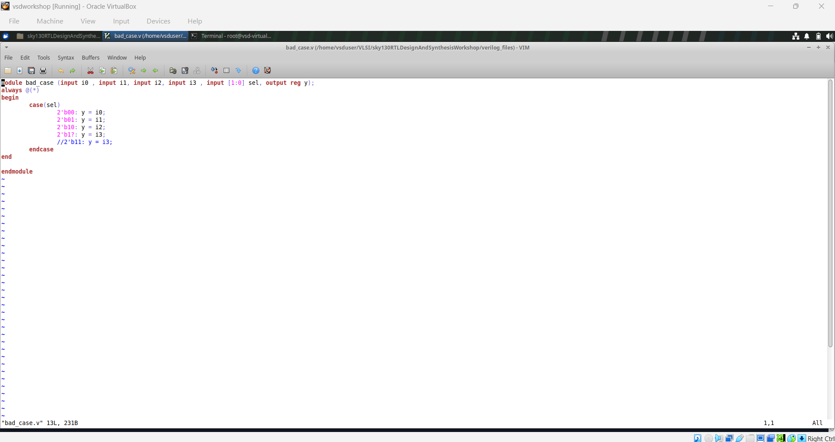
Module 5 figure 4: bad_case_code.png
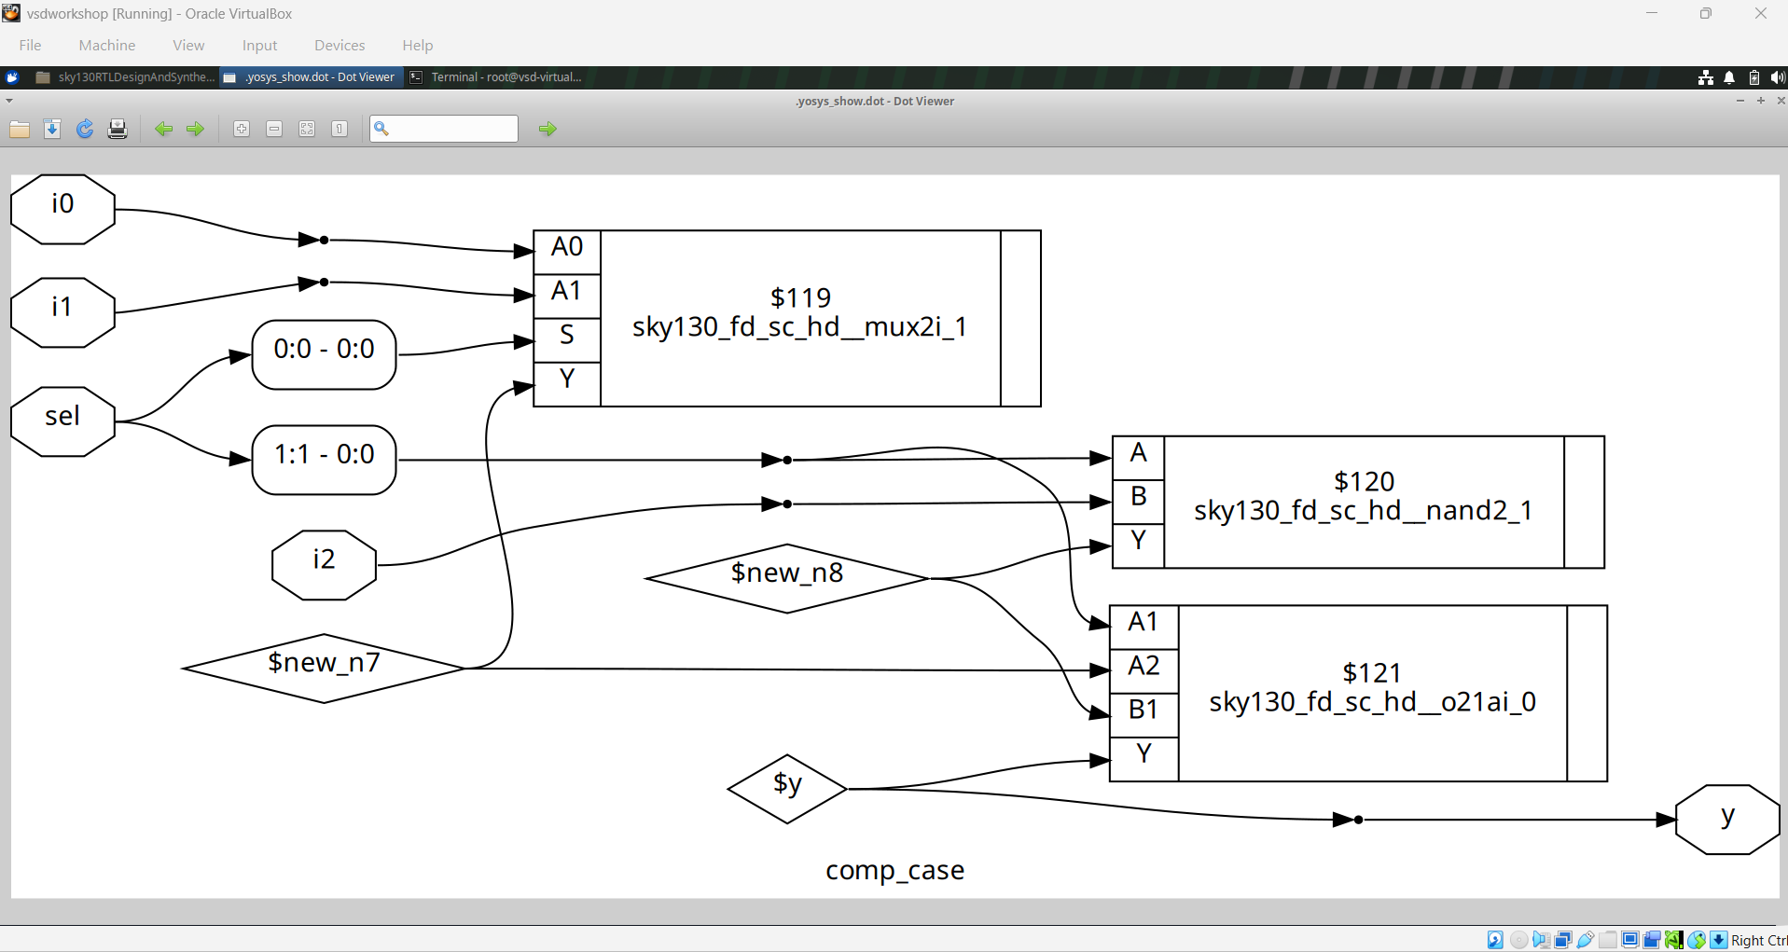
Module 5 figure 5: comp_case.png
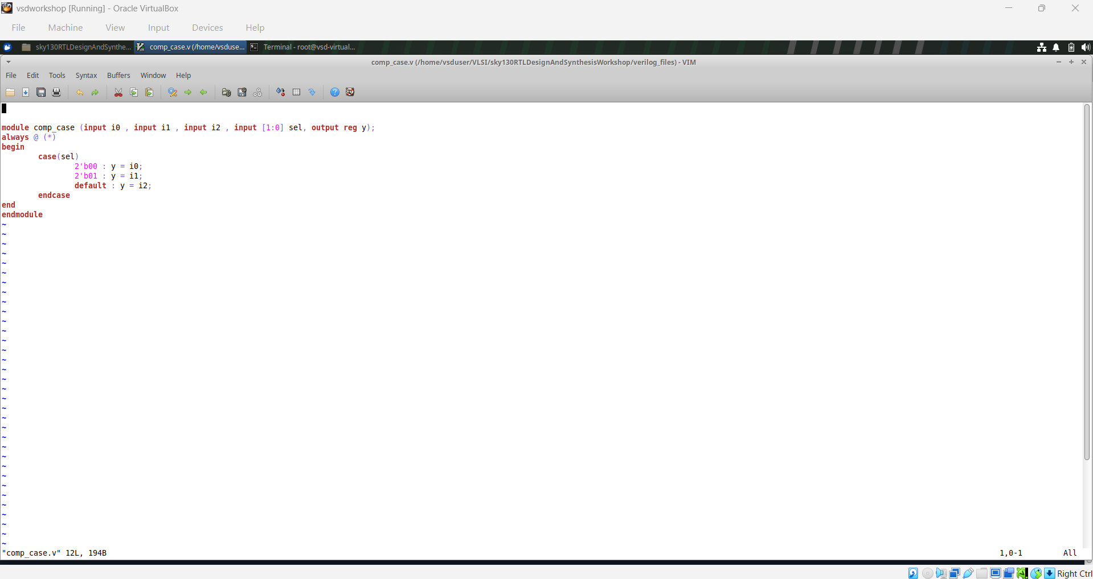
Module 5 figure 6: comp_case_code.png
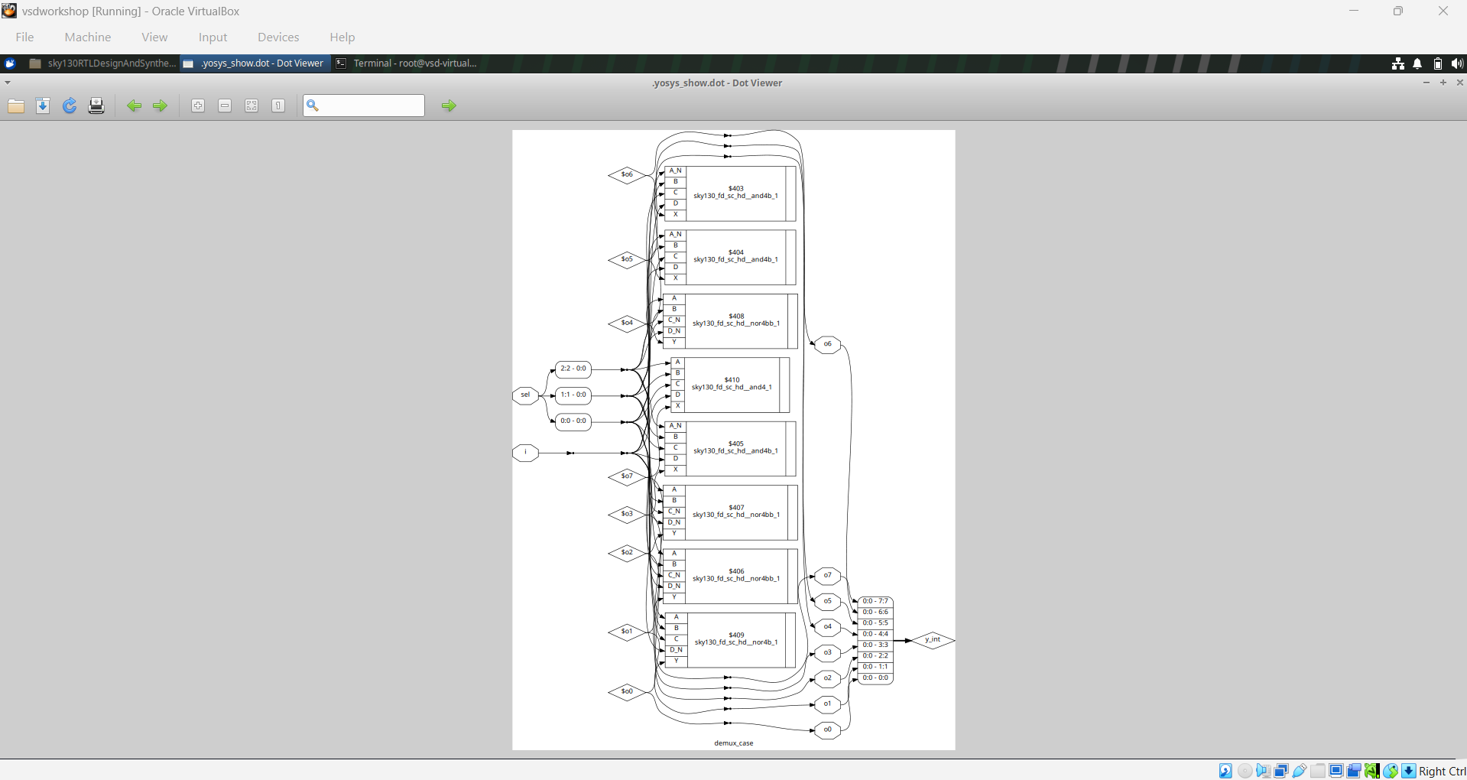
Module 5 figure 7: demux_case.png
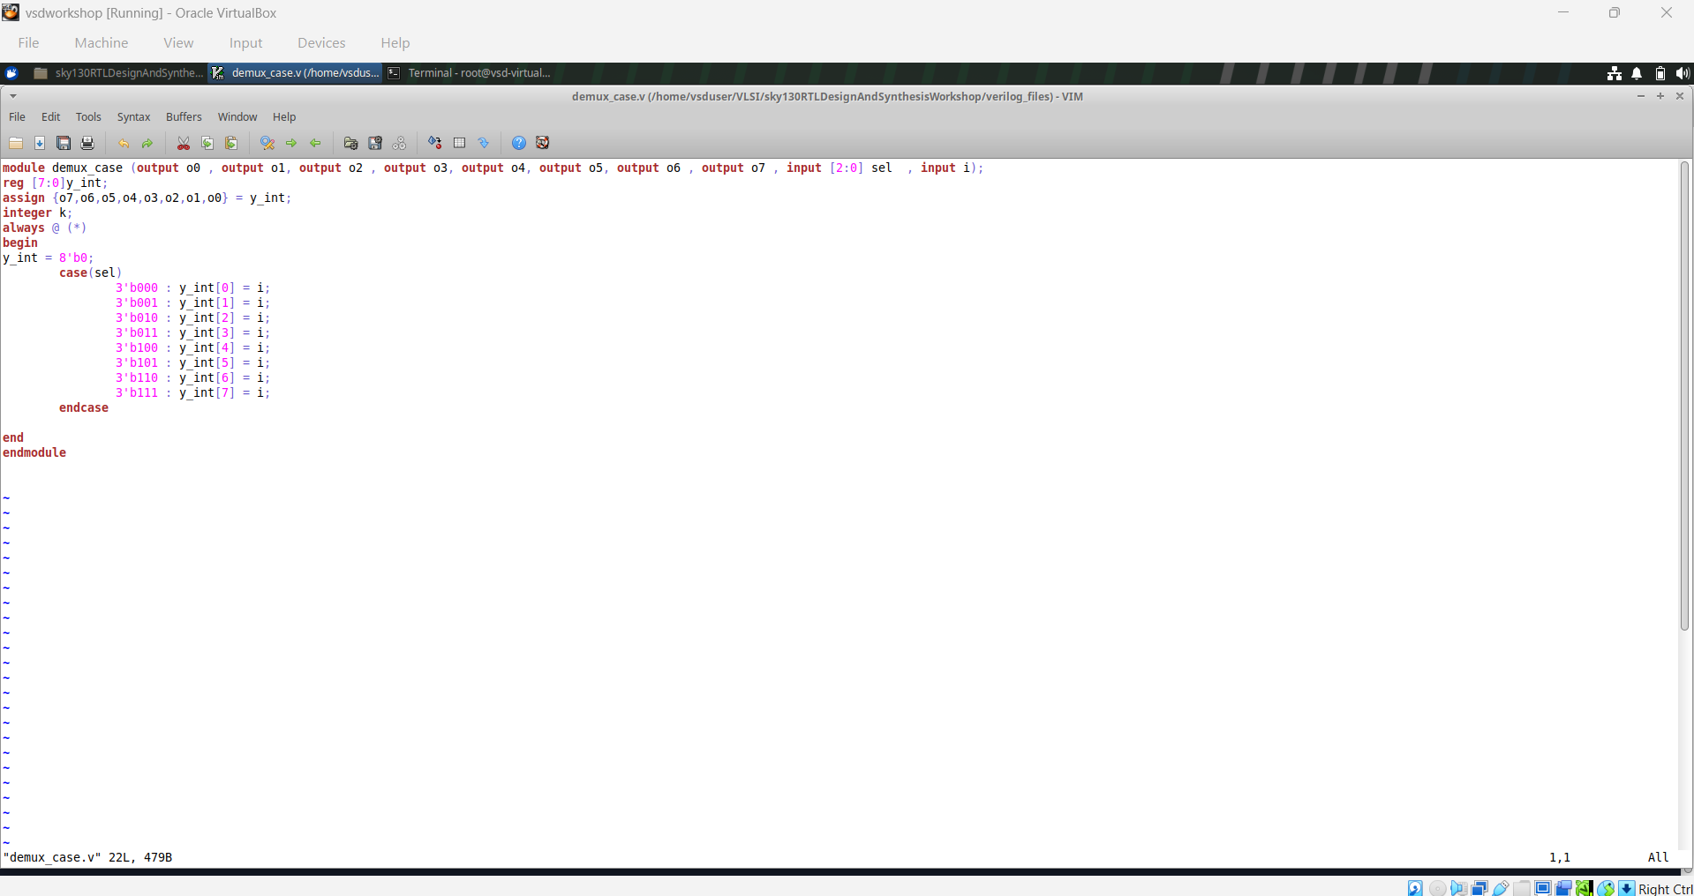
Module 5 figure 8: demux_case_code.png
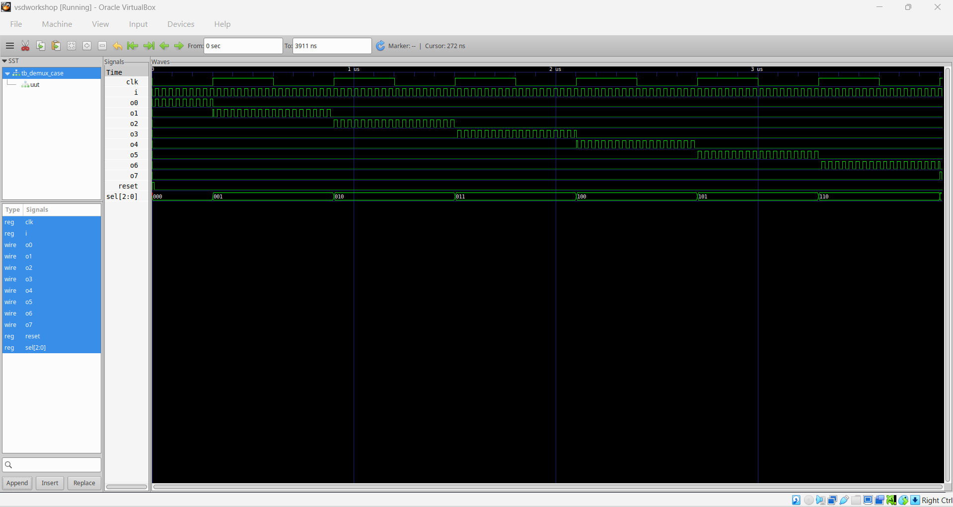
Module 5 figure 9: demux_case_waveform.png
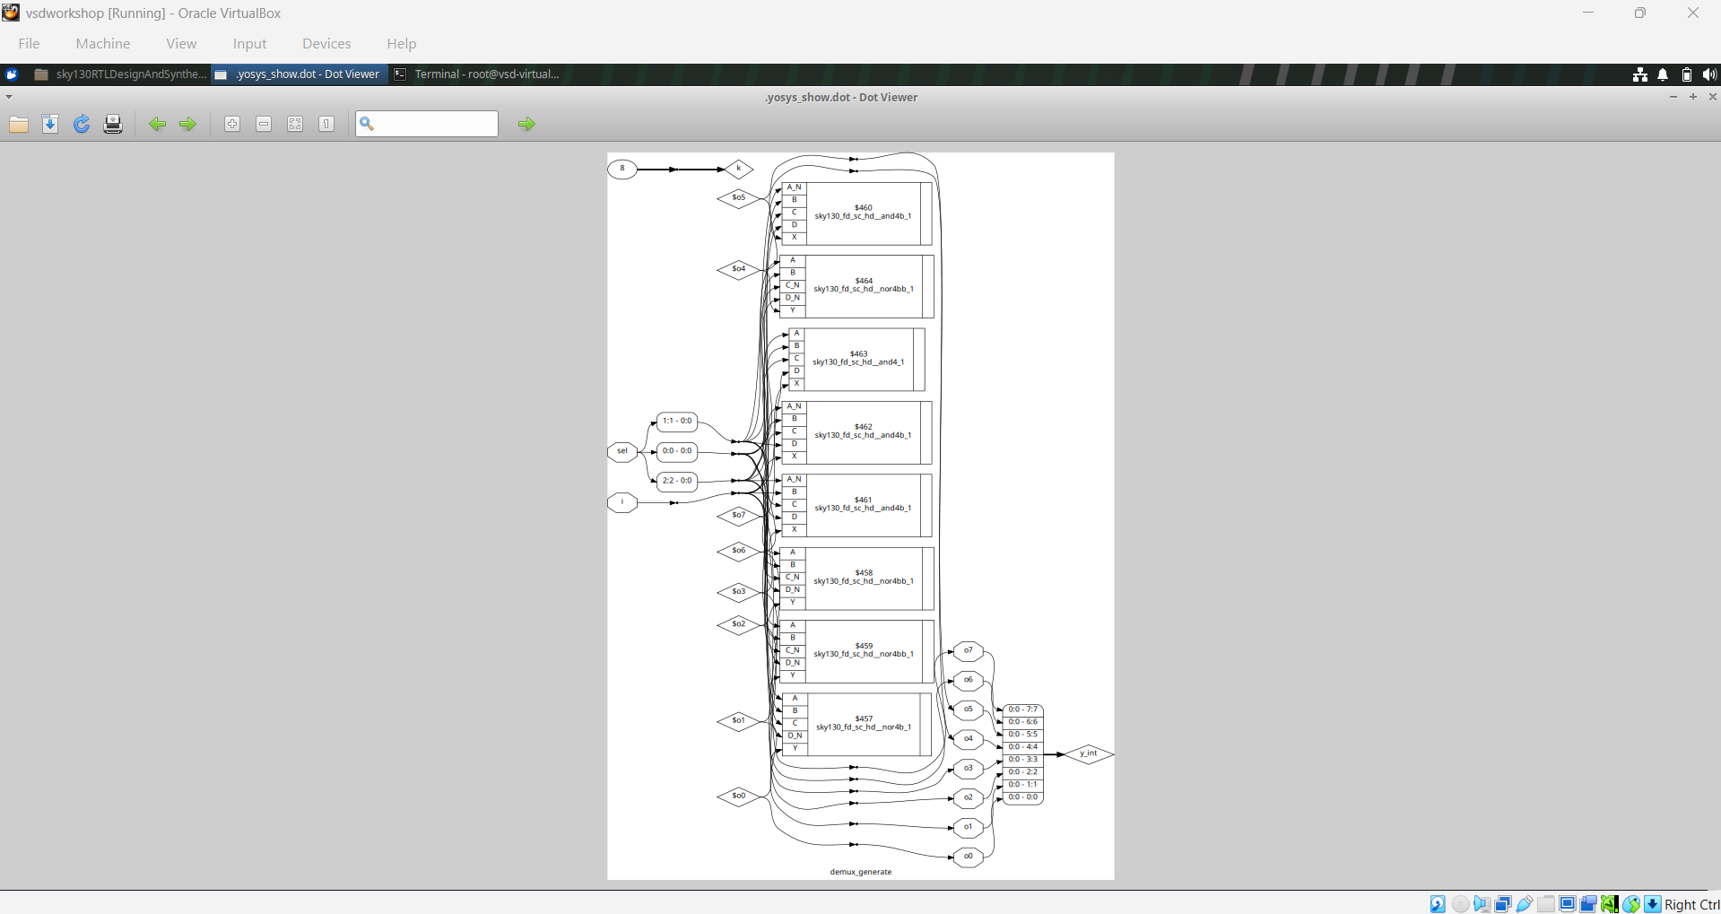
Module 5 figure 10: demux_generate.png
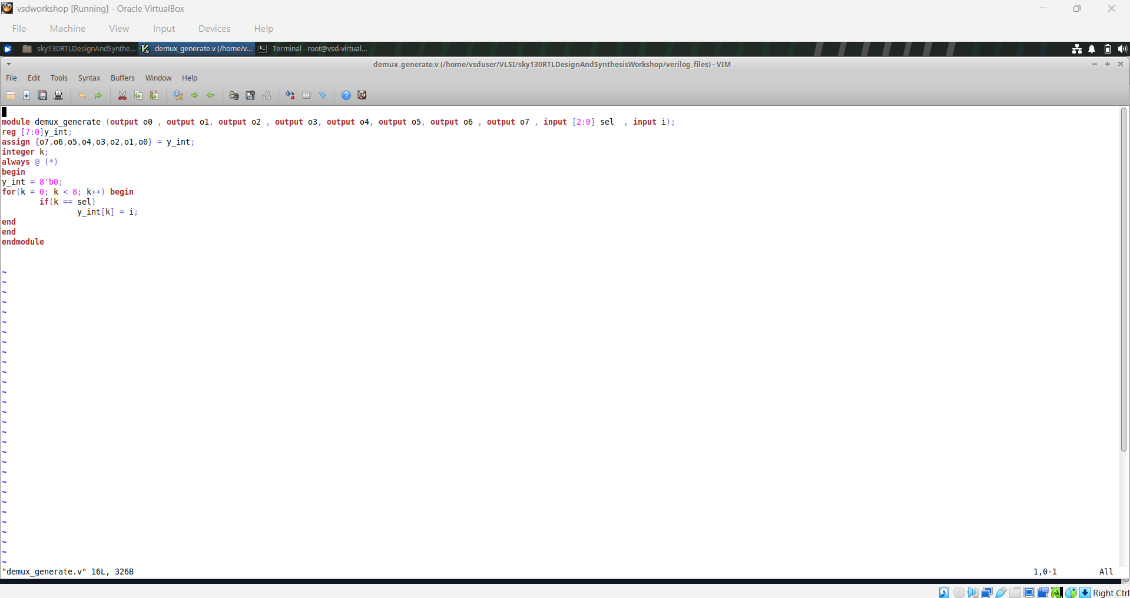
Module 5 figure 11: demux_generate_code.png
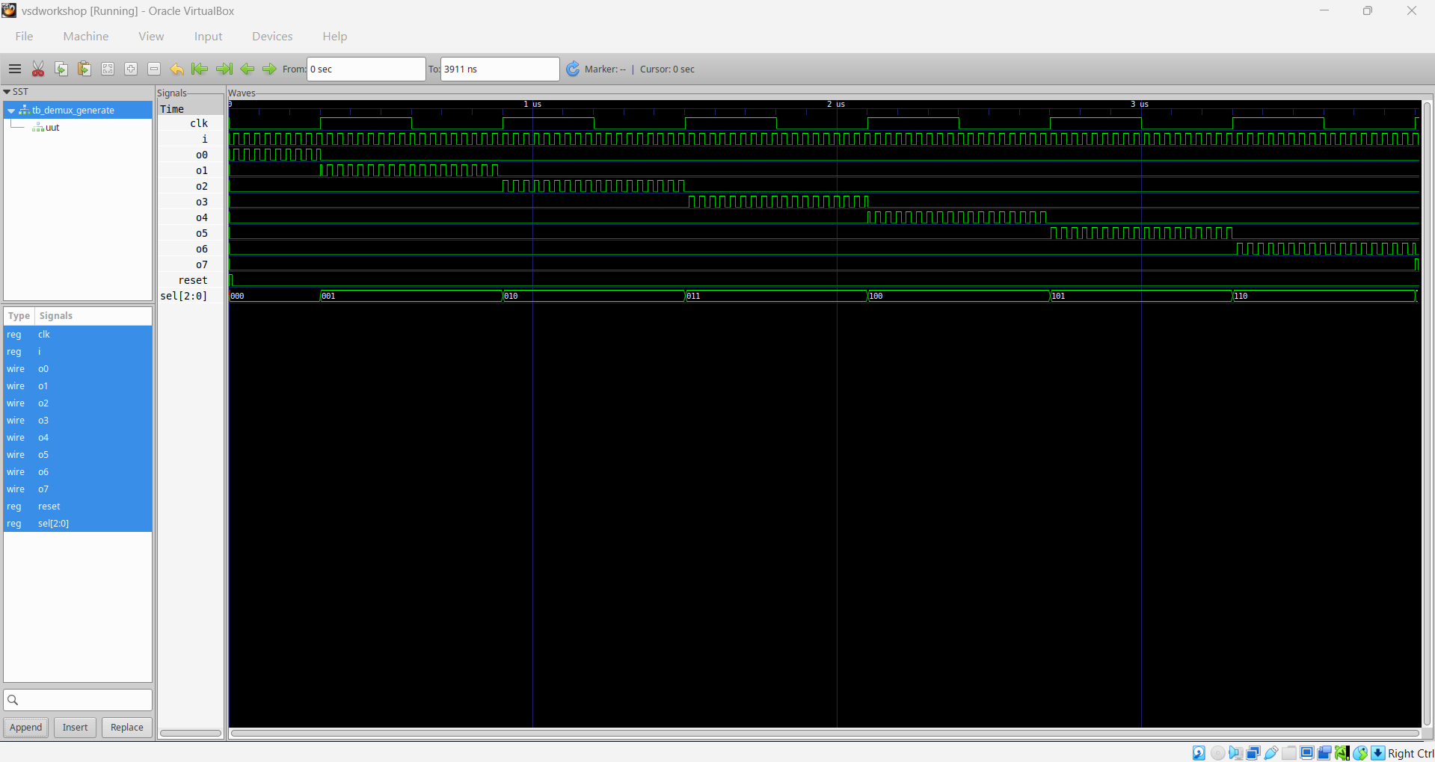
Module 5 figure 12: demux_generate_waveform.png
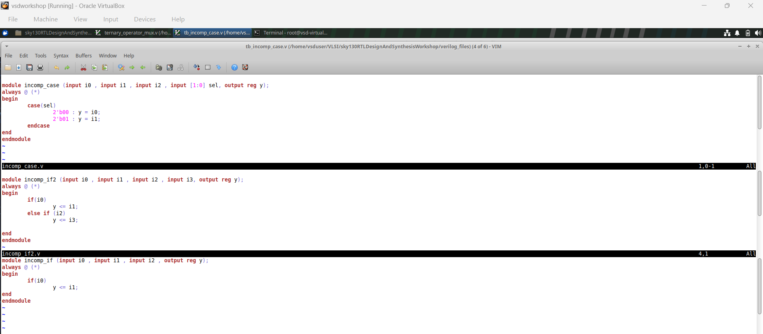
Module 5 figure 13: incomp_1&2&3_code.png
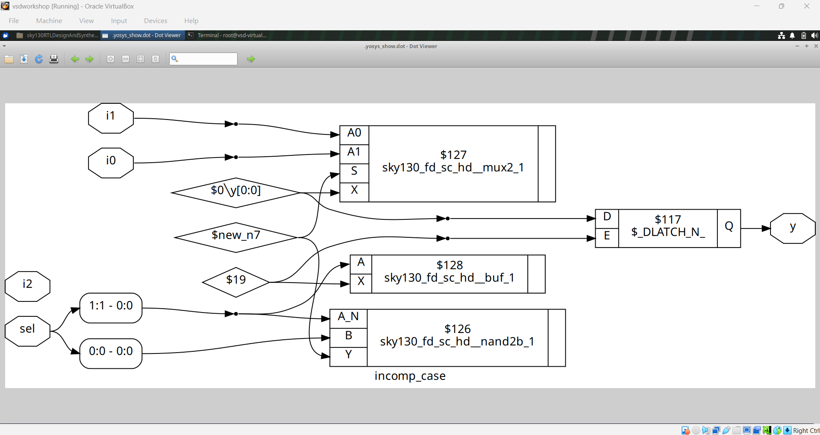
Module 5 figure 14: incomp_case.png
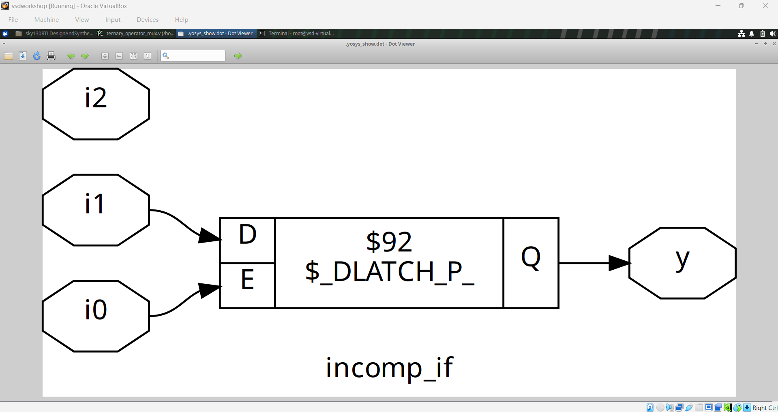
Module 5 figure 15: incomp_if.png
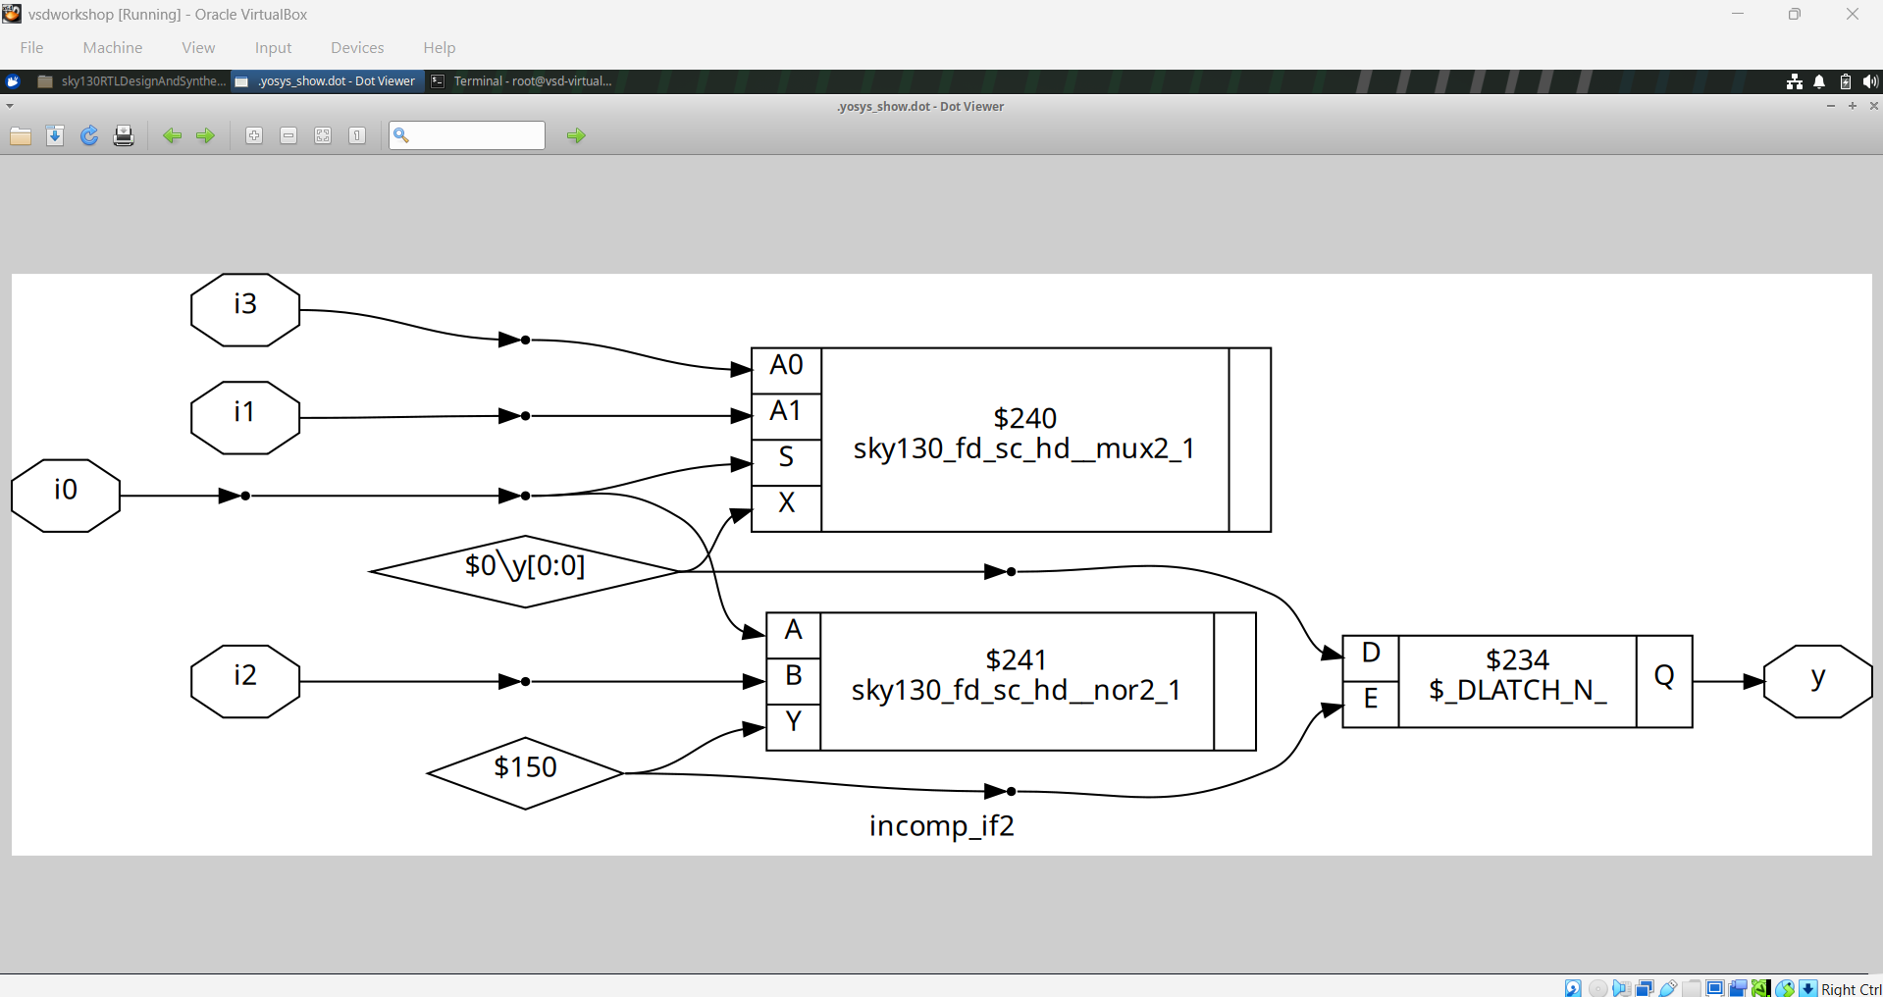
Module 5 figure 16: incomp_if2.png
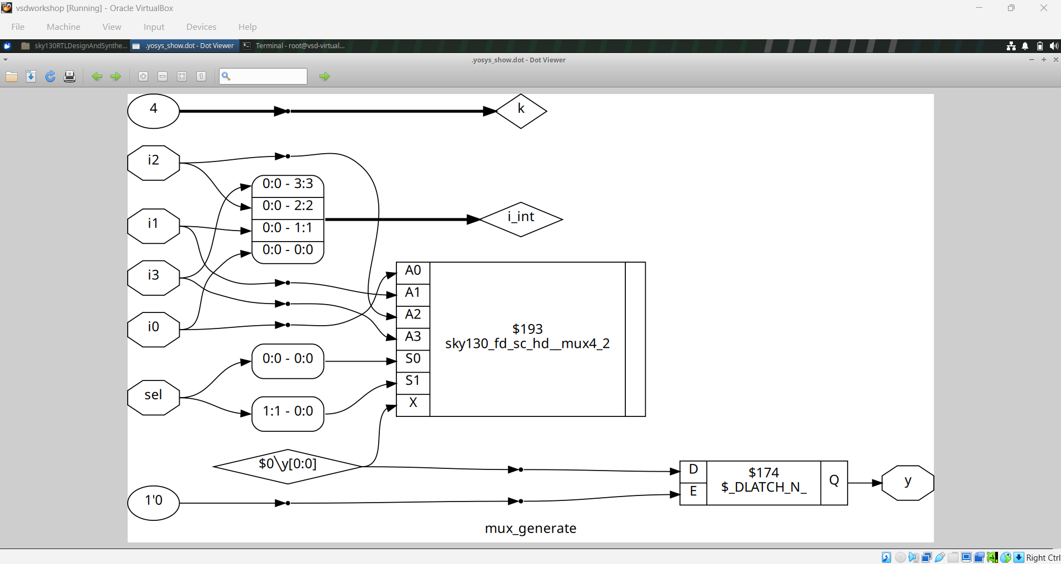
Module 5 figure 17: mux_generate.png
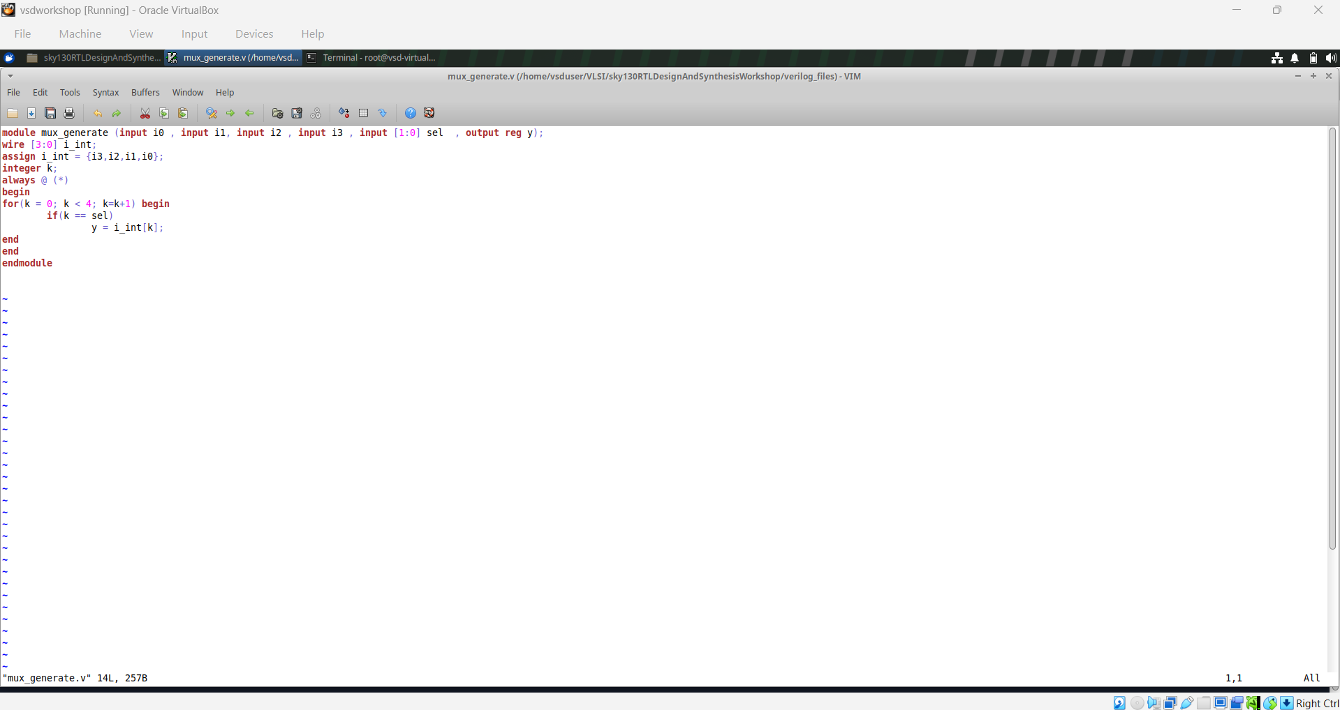
Module 5 figure 18: mux_generate_code.png
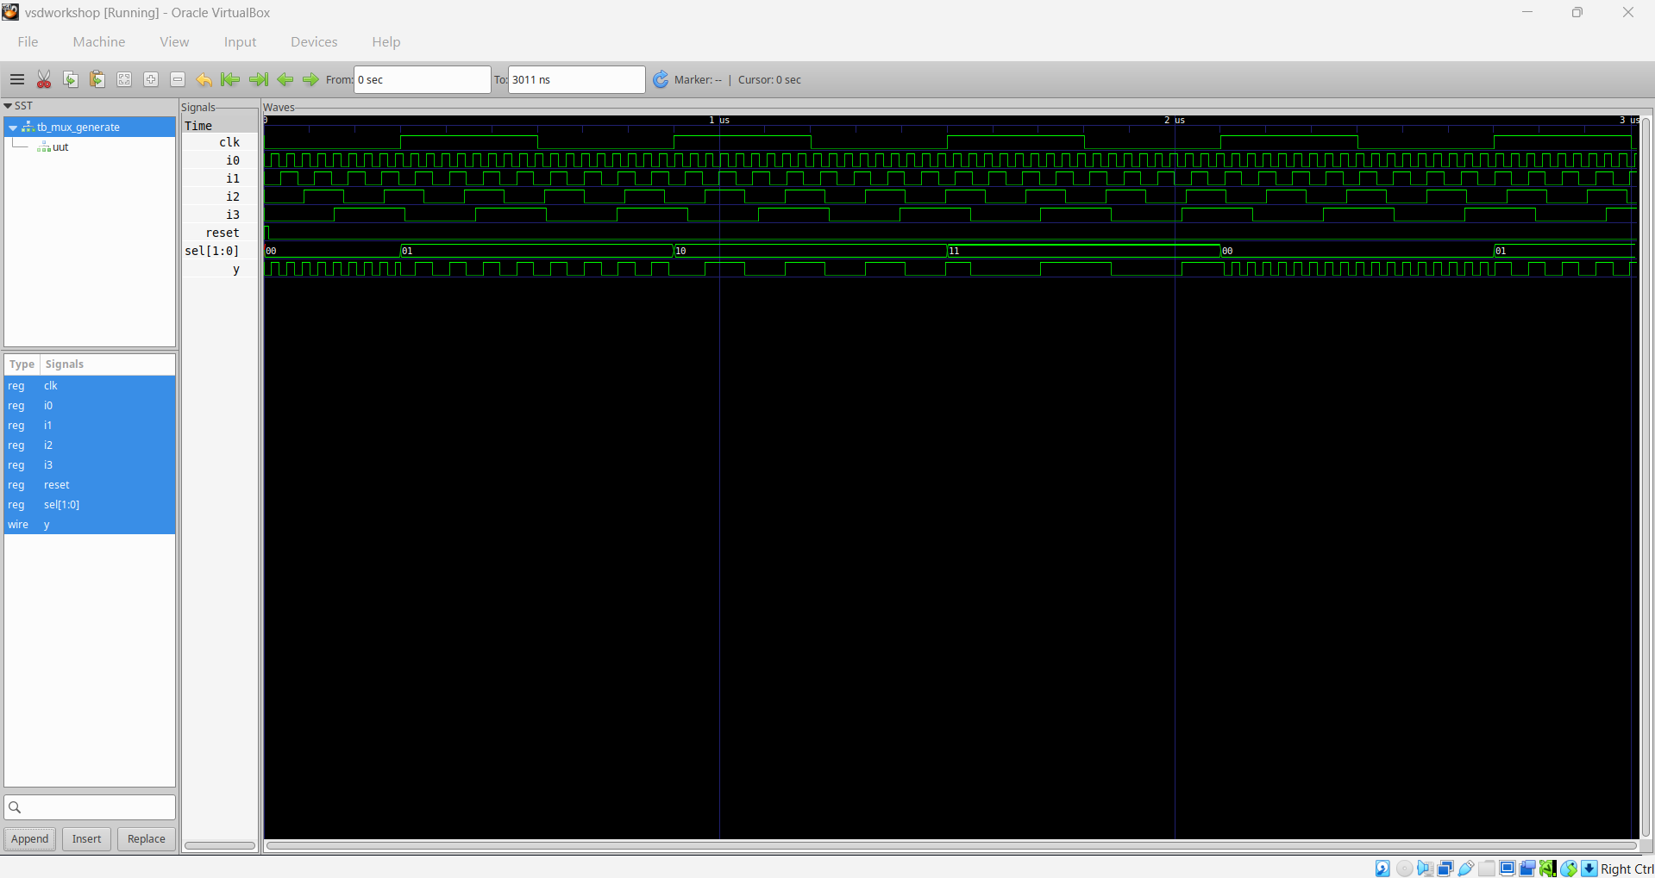
Module 5 figure 19: mux_generate_waveform.png
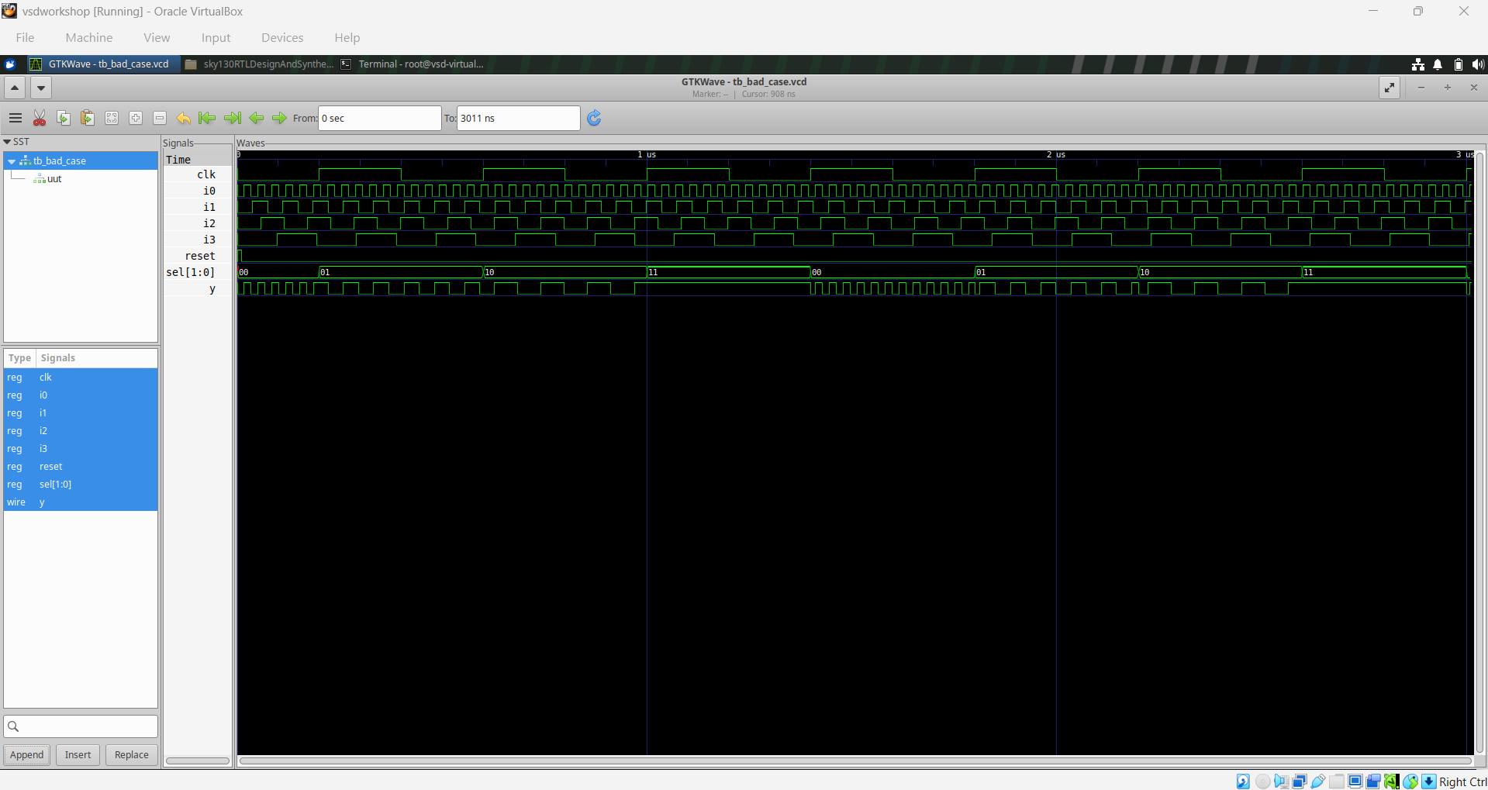
Module 5 figure 20: tb_bad_case_waveform.png
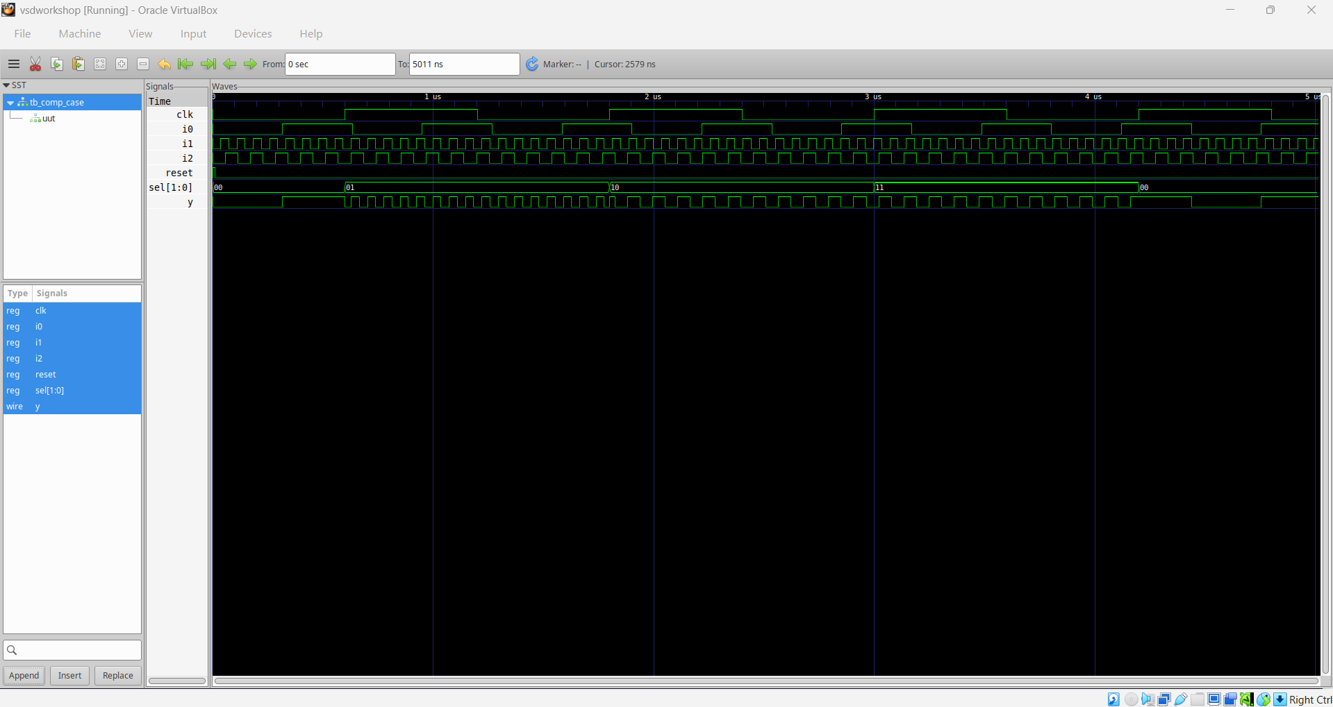
Module 5 figure 21: tb_comp_case_waveform.png
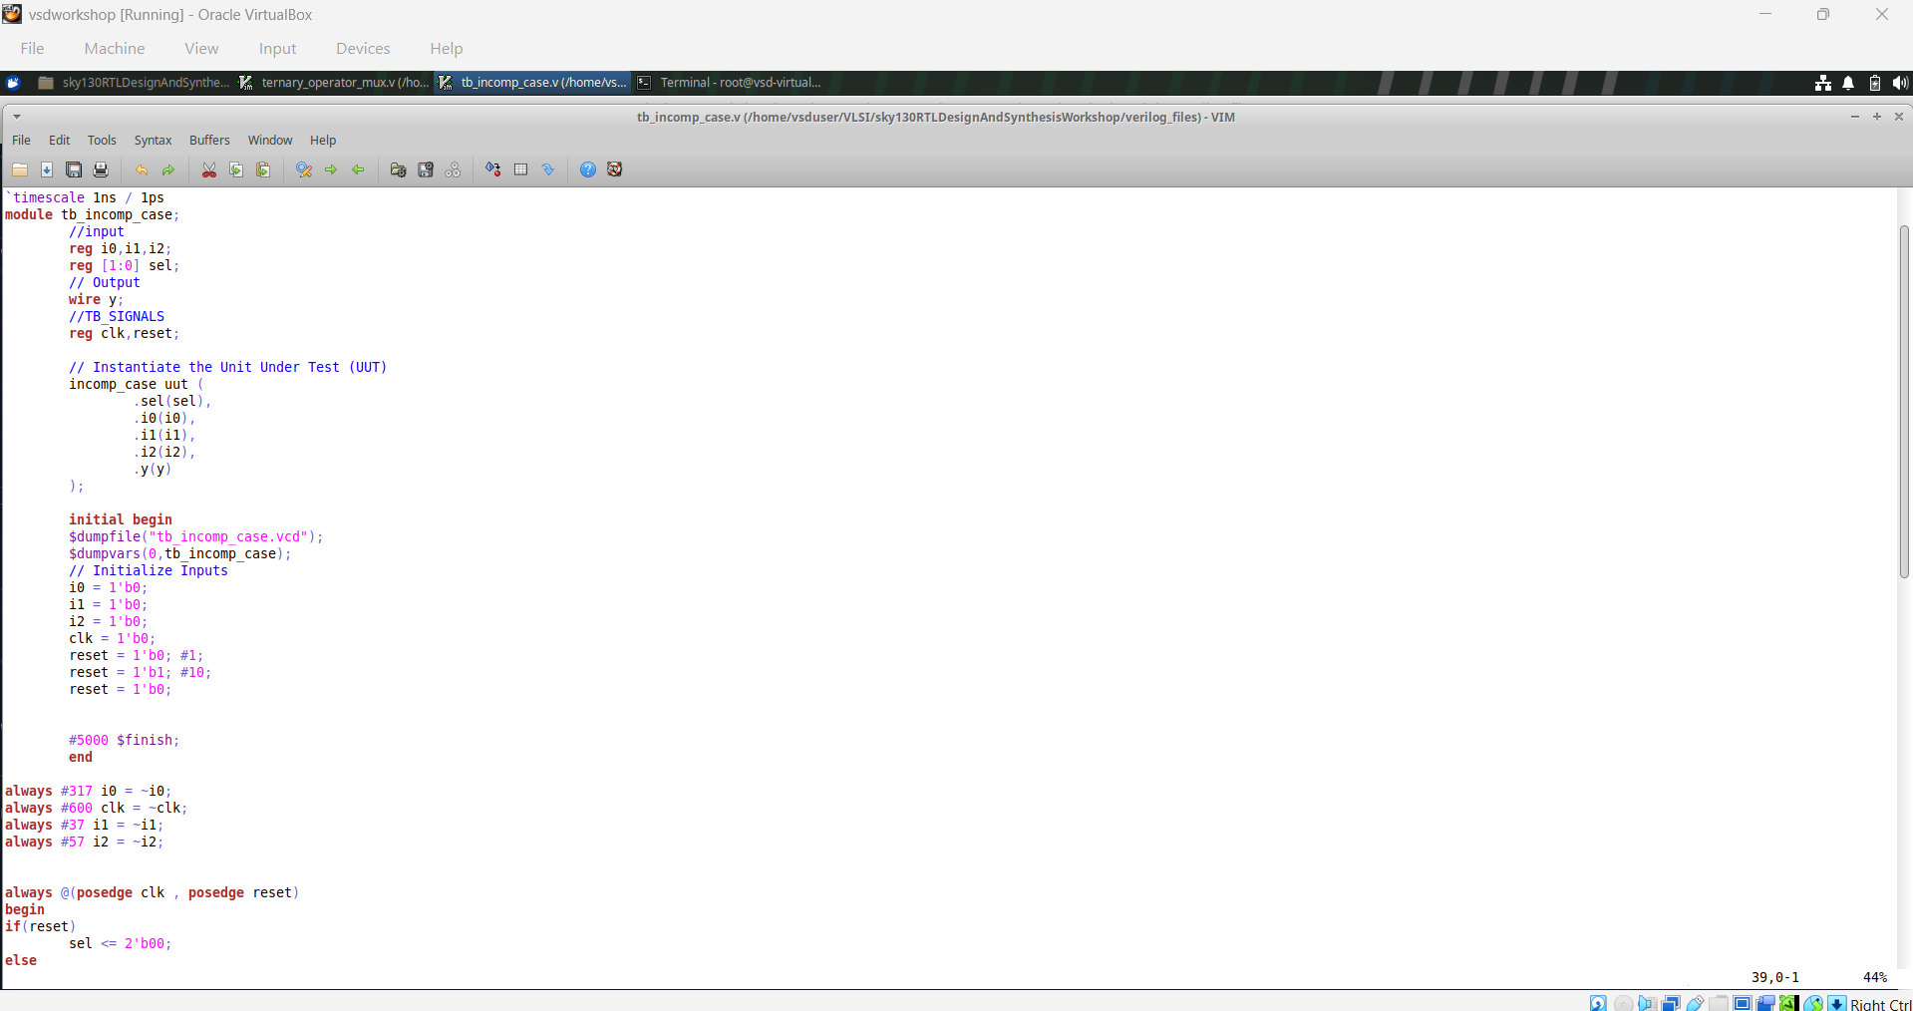
Module 5 figure 22: tb_incomp_case_code.png
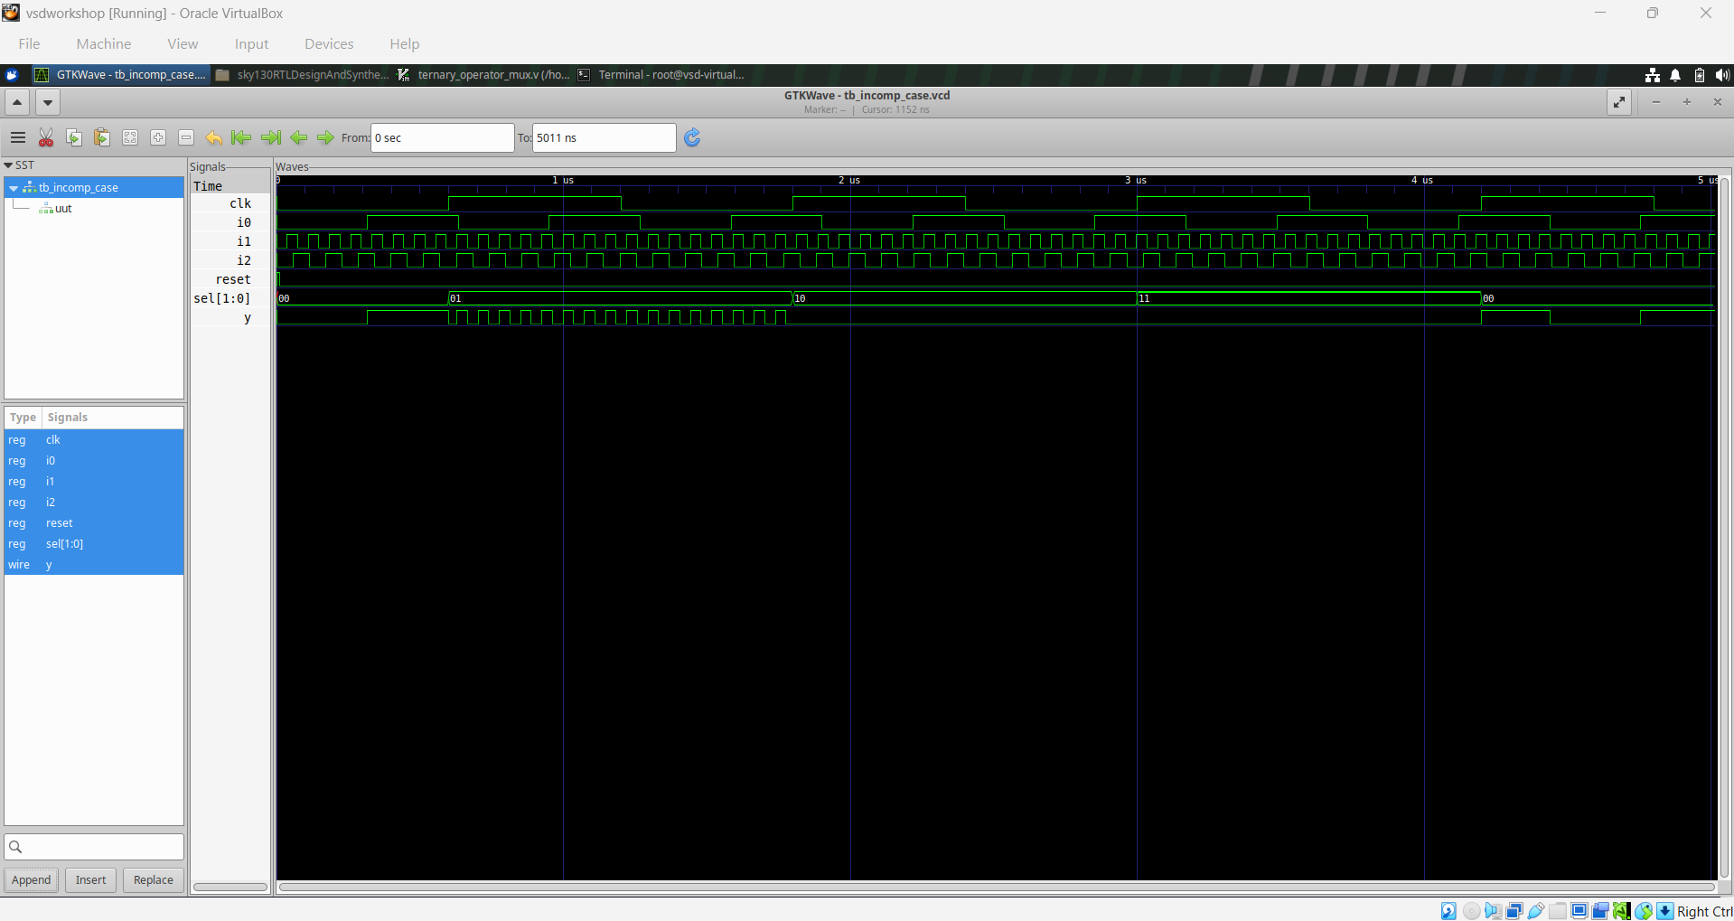
Module 5 figure 23: tb_incomp_case_waveform.png
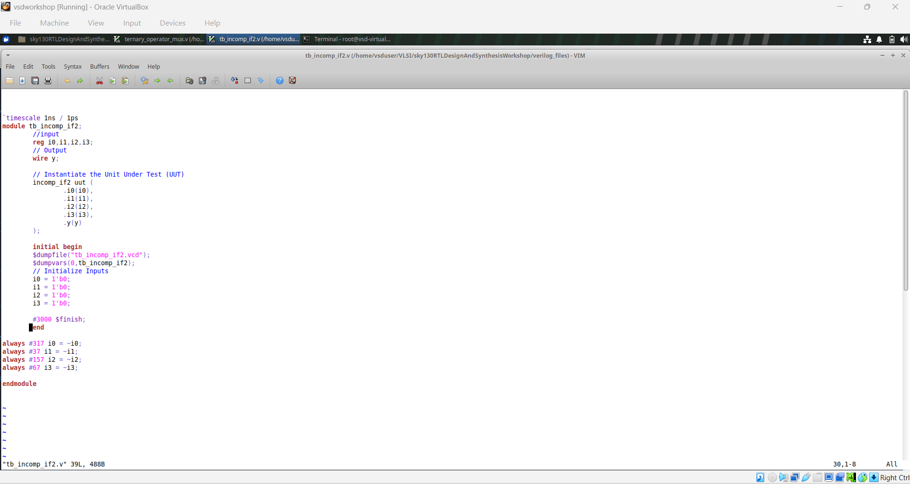
Module 5 figure 24: tb_incomp_if2_code.png
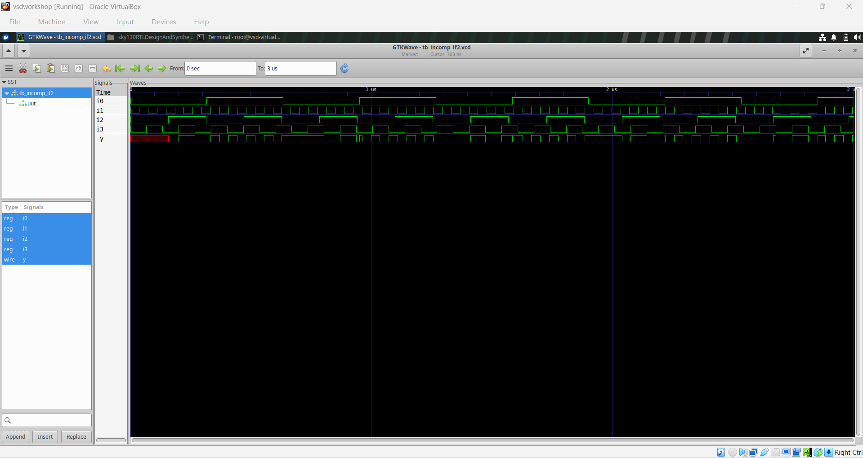
Module 5 figure 25: tb_incomp_if2_waveform.png
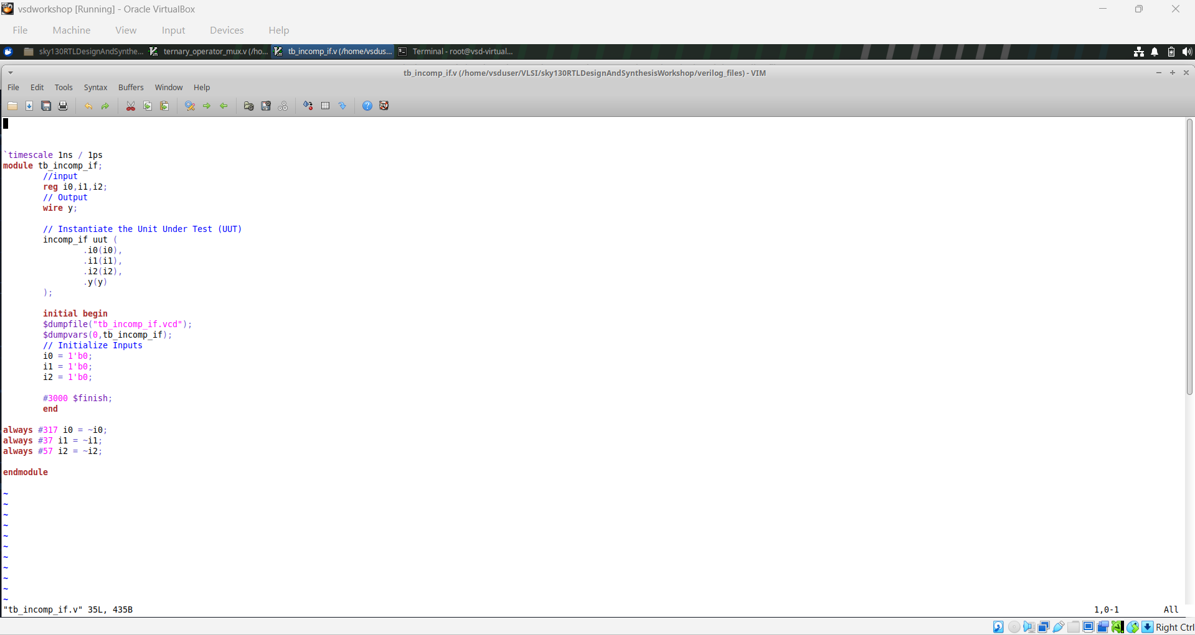
Module 5 figure 26: tb_incomp_if_code.png
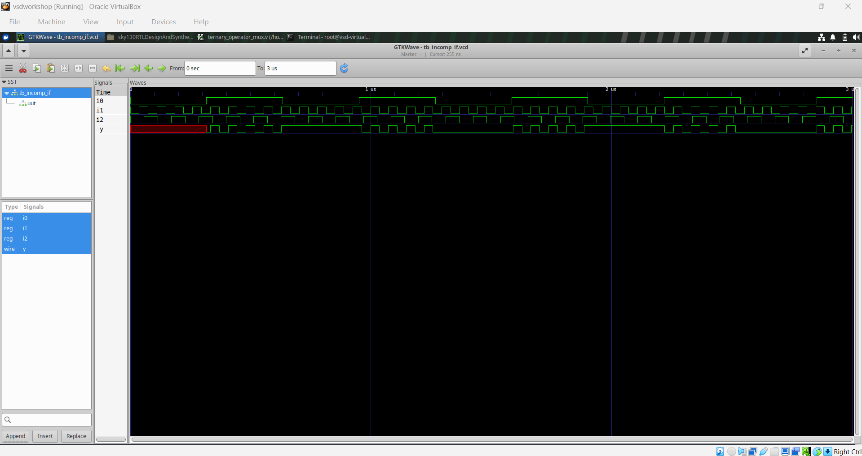
Module 5 figure 27: tb_incomp_if_waveform.png

Module summary
The most important rule in this module is completeness. For combinational RTL, every output should have a defined value for every relevant condition. Case, if, ternary, and generate constructs are all useful, but the coding style must match the intended hardware.

Workshop-wide observations
- Simulation and synthesis answer different questions. A correct waveform proves functional behavior for the tested cases; a synthesized netlist shows how that behavior was implemented.
- RTL structure and synthesized structure do not have to look alike. Optimization, constant propagation, technology mapping, and hierarchy handling can dramatically change the diagram.
- Sequential logic depends on clock/reset semantics. Small changes in sensitivity and assignment style can change the inferred hardware.
- Combinational RTL should be complete. Every output needs a defined value for all relevant conditions to avoid unintended storage.
- Standard-cell libraries are part of implementation. The target library determines which physical logic cells are available for mapping.
- Gate-level simulation is a useful final confidence check because it evaluates the synthesized representation rather than only the original RTL.

Practical checklist
- Define the intended hardware behavior before writing RTL.
- Keep the testbench separate from synthesizable design code.
- Exercise all important input combinations in simulation.
- Inspect the waveform, not only the simulator's compile result.
- Check synthesis warnings and confirm that the intended top module was selected.
- Look for unintended latches or unexpected sequential elements in combinational designs.
- Compare the synthesized structure with the intended architecture.
- Run gate-level simulation when the flow requires post-synthesis verification.
- Document observations in your own words and label screenshots clearly.

Conclusion
Across the five modules, the workshop progresses from a small combinational design to sequential logic, hierarchical structures, optimization, coding-style effects, and post-synthesis verification. The supplied screenshots provide practical evidence of simulation waveforms, RTL views, synthesized standard-cell structures, and generated hardware. The report intentionally uses a different organization and fresh explanatory text so it can serve as an independent study/report document rather than a copy of the original README files.

