05/07/2023

ClassWork#3 report.

a. original picture

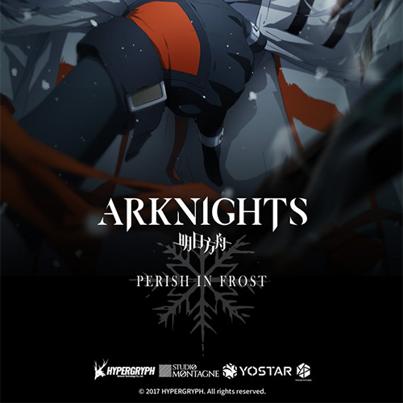

b. picture with noise



c. Cancelled noise picture.

d. Source code

import cv2 as cv

import random

import numpy

img = cv.imread("img1.png", cv.IMREAD_GRAYSCALE)

def seasoning(img):

    density_salt = 0.1

    density_pepper = 0.1

    #set salt pix

    number_of_salt = int(density_salt * (img.shape[0] * img.shape[1]))

    #add some salt

    for i in range(number_of_salt):

        y_coord = random.randint(0, img.shape[0]-1)

        x_coord = random.randint(0, img.shape[1]-1)

        img[y_coord][x_coord] = 255

    #set salt pix

    number_of_pepper = int(density_pepper * (img.shape[0] * img.shape[1]))

    #add some salt

    for i in range(number_of_pepper):

        y_coord = random.randint(0, img.shape[0]-1)

        x_coord = random.randint(0, img.shape[1]-1)

        img[y_coord][x_coord] = 0

    return img

sp_img = seasoning(img)

cv.imwrite("sp_img.png", sp_img)

median = cv.medianBlur(sp_img, 5)

cv.imwrite("medien.png", median)