Prompt: (1girl:1.0), <lora:tachi-e:1> <lora:thickline_fp16:1> <lora:眼睛双:1.2> <lora:Vivid_Impactful_Style_locon_v4h:1.25>, top body focus, (cyber punk:1.6), ((vivid light)), magenta neon light, [Girl:Mech part:15]

Negative prompt: badhandv4 By bad artist -neg easynegative ((negative_hand-neg)) ng_deepnegative_v1_75t verybadimagenegative_v1.3

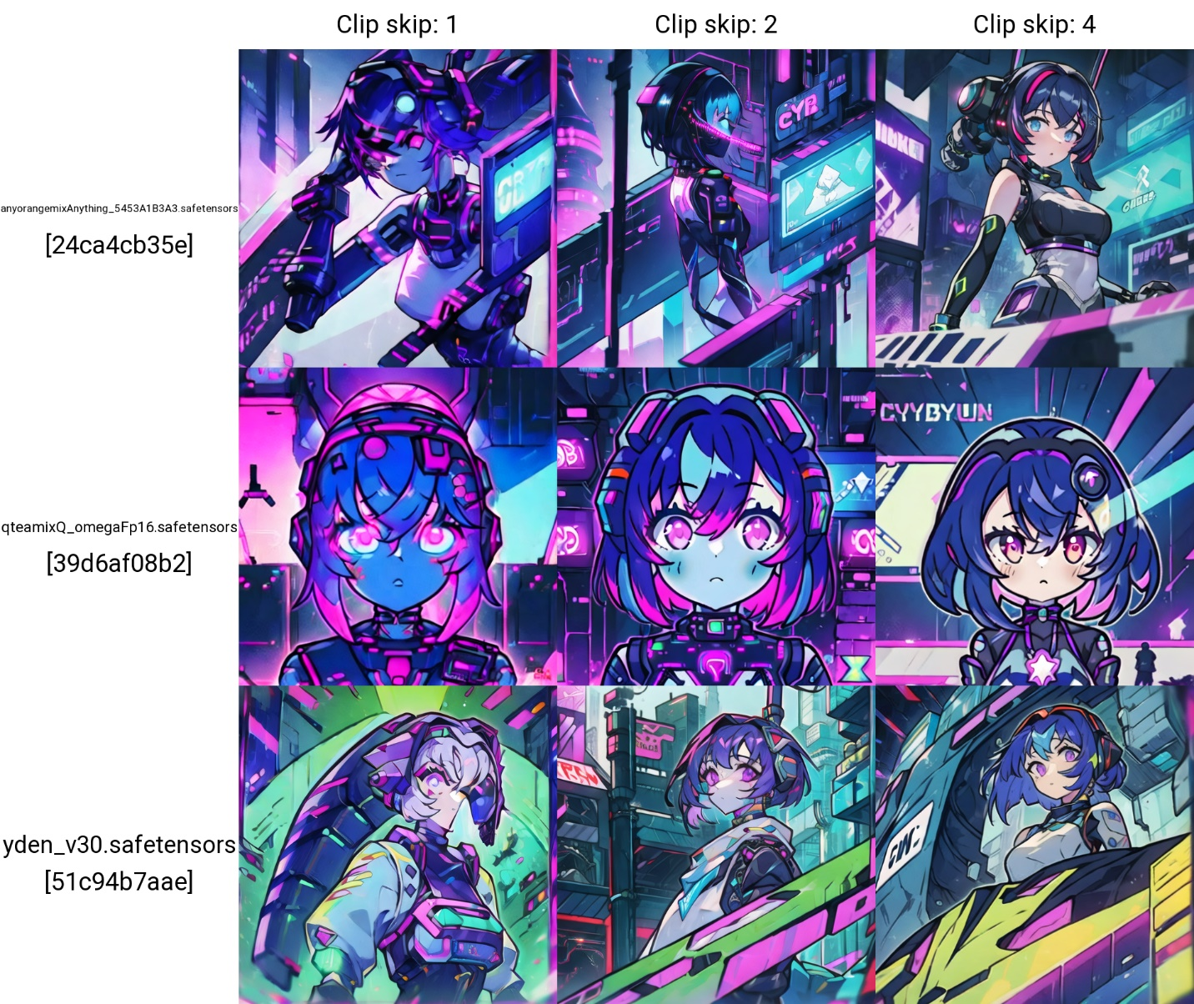

Size: 512*512

CFG Scale: 7

Sampling Method: DPM++ SDE Karras

Seed: 2827689260

Lora:

<https://civitai.com/models/13910/thicker-lines-anime-style-lora-mix>

<https://civitai.com/models/13090/gacha-splash-lora>

<https://civitai.com/models/21722/vivid-impactful-style-yoneyama-mai-style-likeness-loralocon>