**AMAJIS FUNDAMENTALS CO. INT’L**

**PROPOSAL**

**TO**

**TARABA STATE MINISTRY OF EDUCATION**

**JALINGO**

**SUSTAINABLE SOFTWARE FOR GOVERNMENT (PUBLIC) SCHOOLS IN TARABA STATE: DEPLOYMENT FOR AMAJIS STUDENT INFORMATION SYSTEM (ASIS).**

**2016**

**RESTRICTION, DISCLOSURE AND PENALTIES FOR THIS DOCUMENT**

This document is written by Amajis Fundamentals Co. Int’l, and protected under the copyright laws of Nigeria. This document contains information that is proprietary and confidential to Amajis Fundamentals Co. Int’l and shall not be disclosed outside or duplicated or used in whole or in part for any purpose other than to evaluate Amajis Fundamentals Co. Int’l suitability to carry out work detailed within. Any use or disclosure in whole or in part of this information without the express written permission of Amajis Fundamentals Co. Int’l is prohibited.

If a contract is awarded to Amajis Fundamentals Co. Int’l, as a result of, or in connection with, the submission of this document, any right to duplicate, use, or disclose the data will be to the extent provided in the resulting agreement. Recipient agrees that no license is being granted by Amajis Fundamentals Co. Int’l and further agrees that all confidential and proprietary information contained in this document shall remain the sole property of Amajis Fundamentals Co. Int’l.

**EXECUTIVE SUMMARY:**

**PREAMBLE:**

The status of computer application in schools is growing with increase in awareness of role of computer in education. Many schools now see it as necessity to introduce computer in their various departments for the effective and efficient dispensation of their services.

For the time being, teachers find it difficult to process the results of students within a reasonable time hindering their ability to issue students with result before vacation.

This software when designed would help secondary schools in quick and error free result processing.

Students result serves as a medium through which academic performance are measured. It is also used to measuring students capabilities in each subject offered. Without an adequate result processing system the aim for which results are produced may not be achieved as mistake are often time made via the manual processing system and seldom discovered. A computer system is aimed at ensuring an effective, efficient and error free results processing and would aid proper running of the schools system.

Amajis Fundamentals Co. Int’l conducted an interview among selected staff and students of both Government and private schools in Taraba State and it has revealed that the manual method adopted in result processing (both terminal and annual result processing) and Student information is characterized with the under listed lapses:

1. ***POOR SECURITY OF DOCUMENTATION:*** Printed documents may get lost during data processing. At times the documents get eaten by termite and other insets, some are taken away by intruders while others are easily misplaced by those in charge of it. Students may also have access to their result sheets and increase their scores.
2. ***UNTIMELY PROCESSING OF RESULT*:** The period of time available for the processing of results make the job tough for teachers. This short period of time which range from the end of exams to the day of vacation makes teachers work around the clock to make sure vacation comes true, but most times, teachers find it impossible to cope with this short period of time as a result of this, results becomes ready in some instances weeks after vacation.
3. ***PRODUCTION OF INACCURATE RESULT:*** Most at times, mistakes are being made by teachers during the calculations of scores of a student in a particular subject, average scores and grades of students, this lead to the production of inaccurate results.
4. ***PRODUCTION OF ANNUAL SCORE SHEET:*** During the production of annual score sheets, a lot of mistake are being made. Most teachers usually make mistake during annual report processing, this mistakes occur due to the misplacement of original report sheet, error in calculations etc. Trying to fix it, much time are wasted and more mistake keep on occurring.

All these analysis where made ranging from result processing, Time Table Scheduling, Staff data management, Students score sheet, Annual result processing, creating of report etc. and a useful solution is here to alleviate the manual processing of results in Government Secondary Schools.

Considering the processing speeds, storage and retrieval of information facilities, computer becomes indispensable in result processing.

Amajis Fundamentals Co. Int’l. Design a software ASIS (Amajis Student Information System) using the latest Technology in the world to set error free and solve the problem encounter from manual system in schools today. Amajis Fundamentals Co. Int’l. is here with this solution.

***IMPLEMENTATION***

The wide appeal of the Amajis Fundamentals Co. Int’l. Solution for Government, Schools, profitable and non-profitable organization or any establishments has led to diverse implementations dynamic automated systems with each secondary school having its own peculiar method of processing. Leveraging our multi-faceted experience garnered over multiple, Amajis Fundamentals Co. Int’l have created a best-of-class implementation methodology, namely the **Amajis Student Information System**.

Deploying a technology-driven, student information service delivery model ensures we are positioned to be within easy reach of our clients in a timely manner. The use of our standard methodology is to manage student information and record on a large scale and reduce risk, while also eliminating the delay and error handling student’s information’s and records. Amajis Fundamentals Co. Int’l teams deliver real value in the rollout phases of its product, allowing them to anticipate issues, analyze errors and avoid data redundancy plans. The advantage of this methodology will be brought to bear on this method of managing student information’s and records. This will thus be achievable and profitable, with lower overall risk and real economies of scale.

This approach enable schools to move quickly in meeting requirements on the short- to medium-term, while producing student information and report. The Amajis Fundamentals Co. Int’l Project Implementation Methodology is therefore sets out to avoid the possible shortcomings of this manual system. It is a deliverables-based methodology that consists of Modules of critical processes.

*This methodology and implementation aims to*

1. Eradicate the frustration students undergo when one students result is given to another or when a student result is miscalculated due to manual error.
2. Eliminate the length of time spent trying to process student’s result.
3. Data redundancy.
4. Staff reducing marks from school score sheet.
5. Untimely processing of result
6. Production of inaccurate result.
7. Poor security of documentation etc.

***Futures***

1. Manage students information
2. Manage staff information
3. Manage students score sheet
4. Manage student result
5. Manage school student annual result Sheet
6. Manage school timetable
7. Create report base on subject offered in the school.
8. Grade students base on subject
9. Grade students base on class
10. Create psychomotor scheme report
11. Promote student who pass their exams meeting school standard
12. MANAGING OF STUDENT INFORMATION: This modules manage students data provide capabilities for registering student, transferring student and creating documentations.

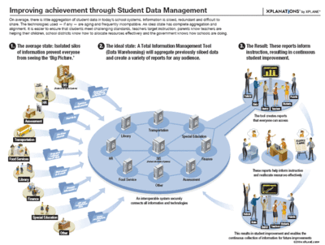

The diagram above is shows the importance and result of well thought out student data management.

1. ***MANAGE STUDENT SCORE SHEET:*** this module collect together all the students result base on subject and classes and grade them accordingly.
2. ***GRADE STUDENT BASE ON SUBJECT:*** Each student is required to know their score in a particular subject they offer, so when they realizes their weakness in a subject, they do not need to be informed about their performances in that particular subject.
3. ***GRADE STUDENT BASE ON THEIR CLASSES:*** This system of automated grading, allow the grading of student base on their classes. Each student is entitle to know his/her score position in a class.
4. ***CREATING PSYCHOMOTOR SCHEME REPORT***: psychomotor scheme is the accreditation of student base of behaviors, sport, performance, healthiness, attendance etc. this accreditation is done every term of the academic session of a school.
5. ***PROMOTING OF STUDENT AUTOMATICALLY:*** This module goes through all the student which result or data have being entered for three terms and automatically promotes which meets the requirement. This is done to eradicate and avoid the method of re-registering a student after academic session.

***SYSTEM DESCRIPTION:***

Administrator:

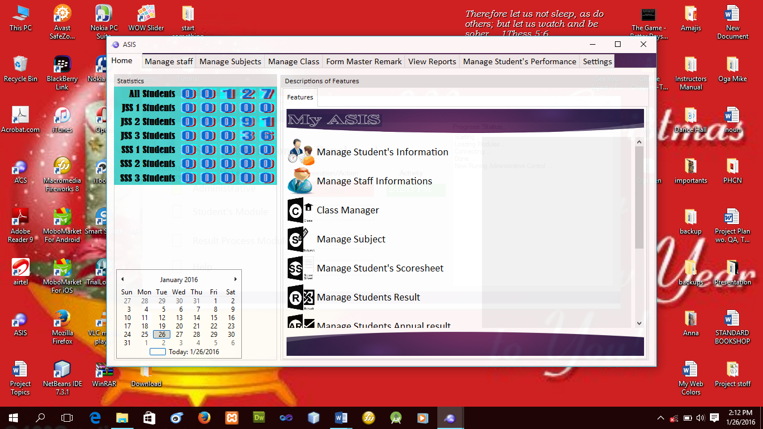The administrator is always in charge of all processing

The **Administrative panel** main menu contains all the available commands and serves as a link to all other modules in the program and each modules contains sub modules and are herein controlled by the administrator.

This modules are Manage Staff, Manage Subject, Manage class, Form masters remark, View report, manage student performance and settings.

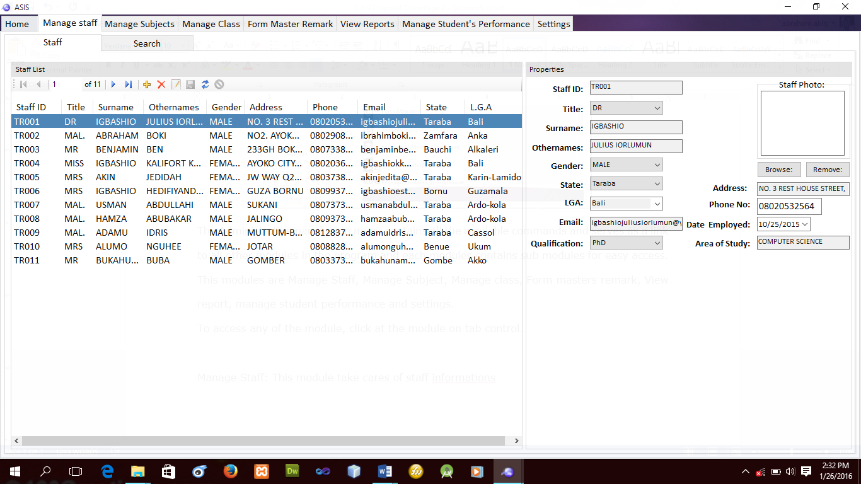

**Manage Staff:** This module take cares of staff information such as registering, Updating, Deleting and searching for a particular staff in the school.

This registration of staff is very important as it will be used for the assignment of subjects, form masters etc.

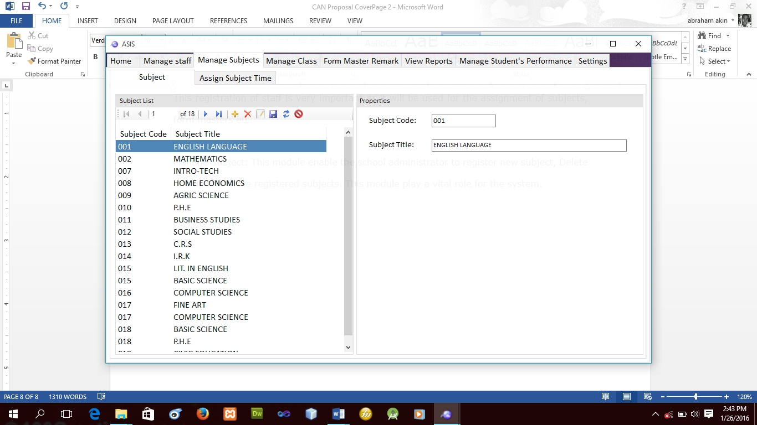

**Manage Subject:** This module enable the school administrator to register new subject, Delete and update those registered subjects the module also take cares of time table scheduling. This module play a vital role for the system.

Report Module: This module take care of all school report such as:

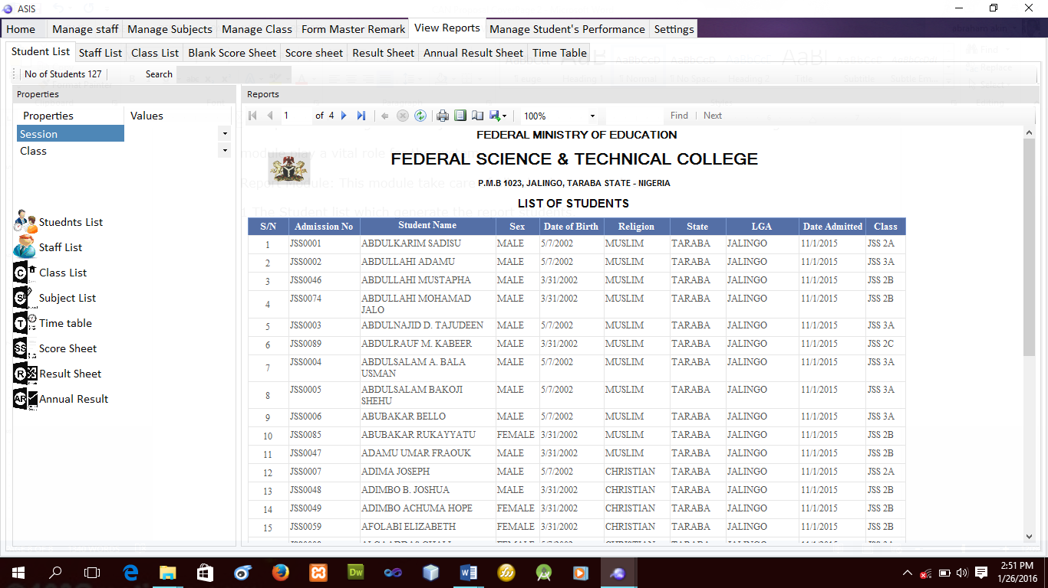1. The Student list which generate the report students as showed below.

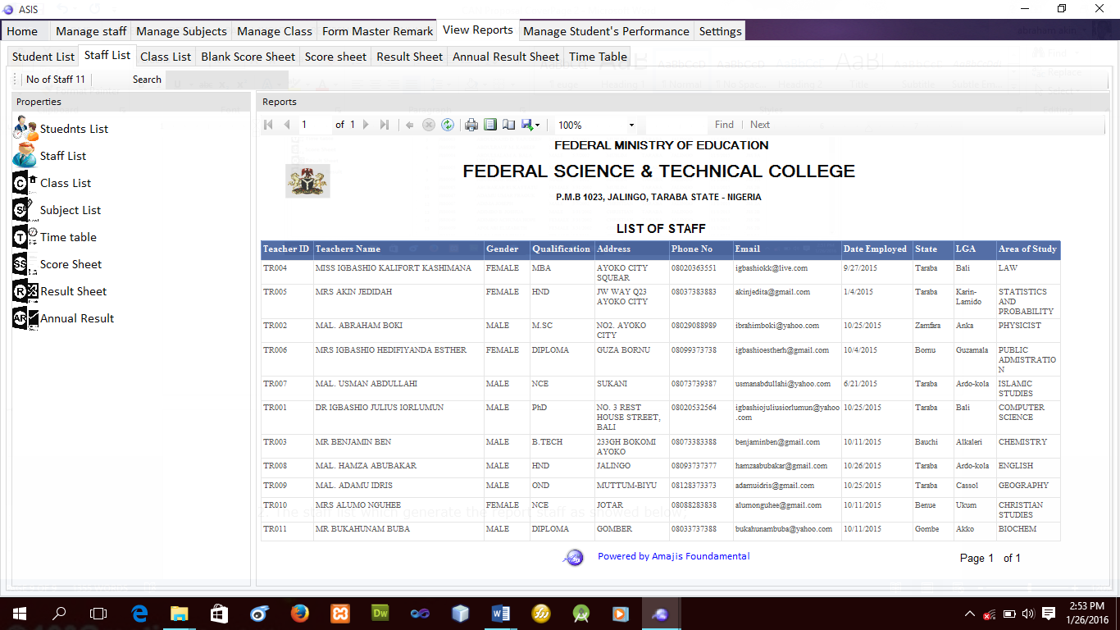2. The staff list which generate the report staff as showed below;

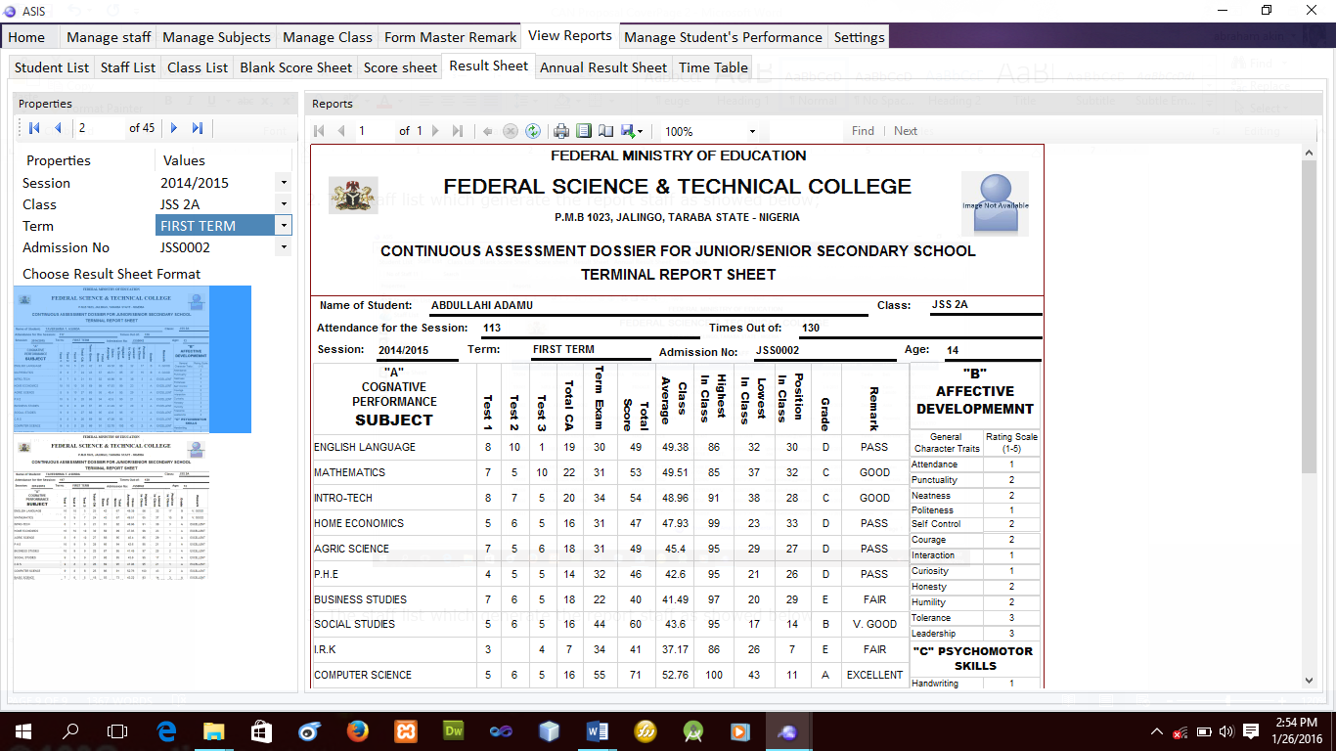3. The Result sheet which generate the report student at the end of term as showed below

1. The annual result Report.
2. The time Table report.
3. The Score sheet report.
4. The class list report etc.

Settings Module: this module enable the administrator to configure the system (Software).

Manage Student performance Module: This module take care of student performance in the class, with this module it determine whether the student is being promoted or not.

Form Master Remark Module: this module take care of all students’ effective development and psychomotor scheme and the number of times the students attended the school in term (Attendance).

***INFORMATION SECURITY AND USER FRIENDNESS***

For better management of this software, Amajis Fundamentals Co. Int’l make records security management a key component of the software by calling all these modules from different part of the system, involving information security management access require (username/password) as part of the software. And this security code can be change, in addition to this, this implementation is pictorially and graphically (GUI) Oriented and user friendly.

**COST ESTIMATE:**

|  |  |  |  |  |
| --- | --- | --- | --- | --- |
| **S/N** | **PRODUCT** | | | **AMOUNT** |
| 1 | Software | | | **N6,000,000.00** |
| **TESTING MATERIALS** | | | | |
| **S/N** | **Materials** | **Description** | **Qty** | **Amount** |  |
| 1 | Desktop Computer | Without O/S (i.e empty system) | 1 | N100,000.00 | With a licensed O/S  **N140,000.00** |
| 2 | Printer | Hp: LaserJet Pro p1102w | 1 | N28,000.00 | N28,000.00 |
| 3 | Scanner | Hp: Scanjet 500 | 1 | N25,000.00 | N25,000.00 |
| 4 | UPS | R5000 | 1 | N20,000.00 | N20,000.00 |
| 5 | Desk | A Desk and chair | 1 | N25,000.00 | N25,000.00 |
| **Total** | | | | **N198,000.00** | **N248,000.00** |
| **Grand Total** | | | | **N6,198,000.00** | **N6,248,000.00** |

**COMPANY PROFILE:**

Amajis Fundamentals Co. Int’l is an Nigerian Company that offers Computer Programming/Networking, Website & Software Design/Development, Computer Equipment etc. This Company is proudly owned by Mr. Biem Abraham Anyor from Sarti Gashaka Local Government Area and Mr. Igbashio Julius Iorlumun, from Bali Local Government Area, both from Taraba State Nigeria.

**PROFESSIONAL QUALIFICATIONS:**

**BIEM ABRAHAM ANYOR**

|  |  |  |  |
| --- | --- | --- | --- |
| Federal Polytechnic Bali | National Diploma in Computer | 2011 | 2013 |
| Federal Science and Technical College Jalingo | Computer Craft Studies | 2008 | 2011 |
| Magami Government Secondary School Jalingo | Secondary Education | 2005 | 2008 |
| CRI Nursery and Primary Takum | Primary Education | 1999 | 2005 |

**OTHER PROFESSIONAL BODIES:**

|  |  |
| --- | --- |
| Nigerian Association of Computer Science Students (NACOSS) | Ex-Member |
| Nigeria Computer Society | Student Member |

**IGBASHIO JULIUS IORLUMUN**

|  |  |  |  |
| --- | --- | --- | --- |
| **Name of Schools and Colleges Attended** | **Qualification Obtained** | **From** | **To** |
| Federal Polytechnic Bali | National Diploma in Computer | 2011 | 2013 |
| Government Technical Training School Bali | ICT | 2006 | 2008 |
| Government Technical Training School Bali | Secondary Education | 2003 | 2006 |

**OTHER PROFESSIONAL BODIES:**

|  |  |
| --- | --- |
| Nigerian Association of Computer Science Students (NACOSS) | Ex-General Sec. |
| Nigeria Computer Society | Student Member |

The Company is built with the following mission and vision:

**Mission**

**To build a strong communication protocol, using advanced computer technology, and interpreting it for more knowledge of the society and the Government at large.**

**Vision**

**Building a means of communication between the schools, thus providing relevant materials such as ASIS with the latest state of technology to achieve the 5th generation of computer (Artificial intelligence).**

**COMPANIES ADDRESS:**

No. #3 NTA, The Young Shall Grow Joint,

Opp. Maijidah Plaza, Jalingo Taraba

Phone: 08135959118/08129440835/08184439123.

Company Email: amajisfundamentalscointl@gmail.com

Email: abrahamanyor@yahoo.com/jigbashio@gmail.com