Chatgpt

LDAP domain: int.worldskills.org
Tạo users & attributes
User | UID | Password | OU | Mail
Jamie Oliver | jamie | Skill39@Lyon | Employees | jamie.oliver@dmz.worldskills.org
Peter Fox | peter | Skill39@Lyon | Employees | peter.fox@dmz.worldskills.org
Administrator | admin | Skill39@Lyon | (root) | –

dc=int,dc=worldskills,dc=org
├── ou=Employees
│ ├── uid=jamie
│ └── uid=peter
└── cn=admin

PART 1: Internal Network

1. LDAP
Cài đặt LDAP:
sudo apt update
sudo apt install slapd ldap-utils -y
Tạo OU Employees:
dn: ou=Employees,dc=int,dc=worldskills,dc=org
objectClass: organizationalUnit
ou: Employees
Tạo User jamie:
dn: uid=jamie,ou=Employees,dc=int,dc=worldskills,dc=org
objectClass: inetOrgPerson
objectClass: posixAccount
objectClass: shadowAccount
cn: Jamie Oliver
sn: Oliver
uid: jamie
uidNumber: 10000
gidNumber: 10000
homeDirectory: /home/jamie
loginShell: /bin/bash
mail: jamie.oliver@dmz.worldskills.org
userPassword: {SSHA}HASH
Tạo password: slappasswd
Kiểm tra lại: ldapsearch -x -b dc=int,dc=worldskills,dc=org

2. CA
Root CA: ClearSky Root CA
Sub-CA: Services
Cấp chứng chỉ cho:
- www.dmz.worldskills.org
- mail.dmz.worldskills.org
Copy certificate vào:
/opt/grading/ca/
├── ca.pem
├── services.pem
├── web.pem
└── mail.pem

Tạo Root CA
openssl genrsa -out rootCA.key 4096
openssl req -x509 -new -nodes \
-key rootCA.key \
-sha256 -days 3650 \
-out ca.pem \
-subj "/CN=ClearSky Root CA"
Tạo Sub-CA (Services)
openssl genrsa -out services.key 4096
openssl req -new -key services.key -out services.csr
openssl x509 -req -in services.csr \
-CA ca.pem -CAkey rootCA.key \
-CAcreateserial -out services.pem \
-days 1825 -sha256

Certificate cho Web
openssl genrsa -out web.key 2048
openssl req -new -key web.key -out web.csr \
-subj "/CN=www.dmz.worldskills.org"

openssl x509 -req -in web.csr \
-CA services.pem -CAkey services.key \
-CAcreateserial -out web.pem \
-days 825 -sha256

Certificate cho Mail
openssl genrsa -out mail.key 2048
openssl req -new -key mail.key -out mail.csr \
-subj "/CN=mail.dmz.worldskills.org"

openssl x509 -req -in mail.csr \
-CA services.pem -CAkey services.key \
-out mail.pem -days 825 -sha256

Copy đúng chỗ
mkdir -p /opt/grading/ca
cp ca.pem services.pem web.pem mail.pem /opt/grading/ca/

3. Samba – File Server
Users: jamie
Shares:
- /public:
  - Read: everyone (guest OK)
  - Write: authenticated only
- /internal:
  - Read/Write: authenticated
  - Guest: NO

Cài Samba & User
apt install samba -y
useradd jamie
passwd jamie
smbpasswd -a jamie
Thư mục
mkdir /public /internal
chmod 2775 /internal
chmod 2777 /public
Cấu hình /etc/samba/smb.conf
[global]
workgroup = WORLDSKILLS
security = user
map to guest = Bad User
[public]
path = /public
read only = yes
guest ok = yes
write list = jamie
[internal]
path = /internal
read only = no
guest ok = no
Khởi động samba: systemctl restart smbd

4. Internal DNS
Zone: int.worldskills.org
Sync dmz.worldskills.org từ DMZ DNS (zone transfer)
Cài BIND9: apt install bind9 -y
Cấu hình named.conf.options
options {
directory "/var/cache/bind";
recursion yes;
allow-recursion { any; };
dnssec-validation no;
};
Cấu hình Zone int.worldskills.org
zone "int.worldskills.org" {
type master;
file "/etc/bind/db.int.worldskills.org";
};
DMZ zone – Slave
zone "dmz.worldskills.org" {
type slave;
masters { 10.1.20.21; };
file "/var/cache/bind/db.dmz.worldskills.org";
};

Demo
apt update
Nếu apt update bị lỗi
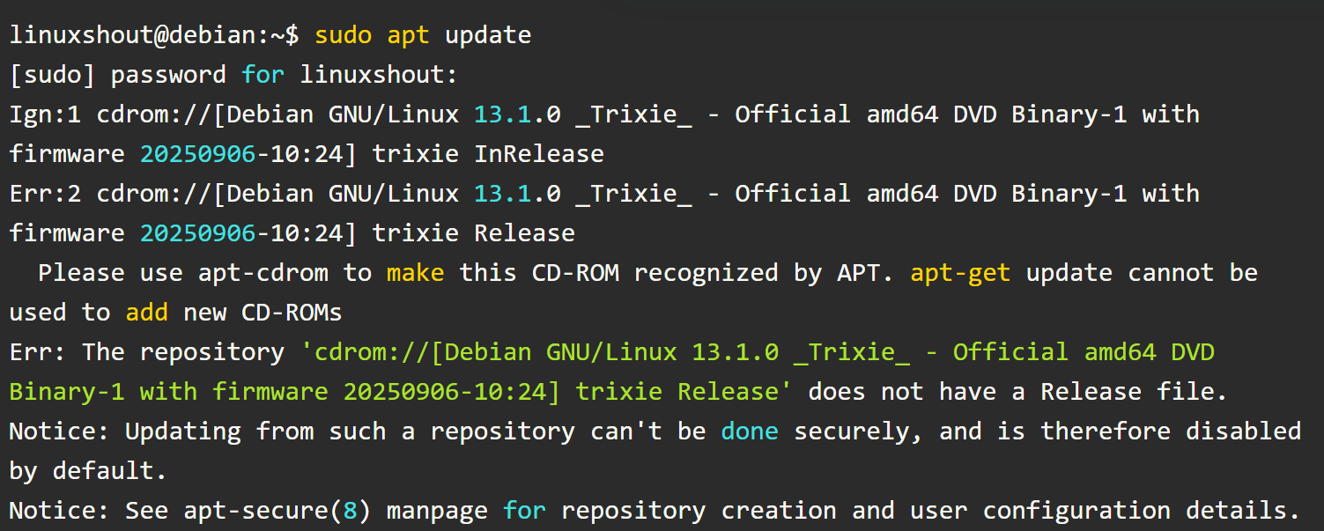
Cách sửa lỗi:
Truy cập tập tin sources.list
nano /etc/apt/sources.list
Vô hiệu hóa CDROM source
Thêm dấu thăng (#) trước dòng này.
# deb cdrom:[Debian GNU/Linux 13.1.0 _Trixie_ - Official DVD ...
Thêm 3 dòng sau:
deb http://deb.debian.org/debian trixie main contrib non-free-firmware
deb http://deb.debian.org/debian-security trixie-security main contrib non-free-firmware
deb http://deb.debian.org/debian trixie-updates main contrib non-free-firmware
Lưu và thoát khỏi tập tin.

Sua loi apt update
1. Edit Debian 13 Source repository
On your command terminal, run the following command as root (or with sudo):
sudo nano /etc/apt/sources.list

2. Disable the CD-ROM source
First, we need to disable the default line in the repository file that points APT to fetch packages from the DVD instead of online from the official repositories. So, find the line as shown below:
deb cdrom:[Debian GNU/Linux 13.1.0 _Trixie_ - Official DVD ...
And comment it out by adding a # at the beginning:
# deb cdrom:[Debian GNU/Linux 13.1.0 _Trixie_ - Official DVD ...

3. Add official Debian repositories
After commenting it out, add the official Debian 13 repositories listed below to your file, as without them, the system won’t be able to download updates and packages. Hence, make sure these lines exist in your sources.list file:
deb http://deb.debian.org/debian trixie main contrib non-free-firmware
deb http://deb.debian.org/debian-security trixie-security main contrib non-free-firmware
deb http://deb.debian.org/debian trixie-updates main contrib non-free-firmware
These provide access to the main, contrib, and non-free-firmware components.

LDAP, Samba, NFS, SSH, DHCP, FTP, DNS, Certbot, Web apache, VPN, Haproxy, PHP, MariaDB, Postfix, Dovecot, Roundcube, Thunderbird, iftop, tcpdump, tshark, vnstat

Kiểm tra các gói đã cài đặt, ví dụ kiểm tra ldap đã cài hay chưa
root@debian:~# dpkg -l | grep slapd

Cài LDAP
root@debian:~# apt install -y slapd ldap-utils

Cài Samba
root@debian:~# apt install -y samba smbclient

Cài NFS
root@debian:~# apt install -y nfs-kernel-server

Cài SSH
root@debian:~# apt install -y openssh-server

Cài DHCP
root@debian:~# apt install -y isc-dhcp-server

Cài FTP
root@debian:~# apt install -y vsftpd

Cài DNS
root@debian:~# apt install -y bind9 bind9utils bind9-dnsutils

Cài Certbot (công cụ xin SSL miễn phí)
root@debian:~# apt install -y certbot

Cài Web Apache (apache2)
root@debian:~# apt install -y apache2

Cài VPN (WireGuard)
root@debian:~# apt install -y wireguard wireguard-tools

Cài PHP
root@debian:~# apt install -y php php-cli php-fpm php-mysql php-curl php-gd php-mbstring php-xml php-zip php-intl libapache2-mod-php

Cài MariaDB:
root@debian:~# apt install -y mariadb-server mariadb-client

Cài Postfix + Dovecot
root@debian:~# apt install -y postfix dovecot-core dovecot-imapd

Cai Haproxy
apt install -y haproxy

Cài Roundcube (webmail)
root@debian:~# apt install roundcube roundcube-core roundcube-mysql -y

Cai Thunderbird
apt install thunderbird -y

Phân tích lưu lượng mạng
Gói iftop
apt install iftop
Gói tcpdump, tshark: bắt gói tin
apt install tcpdump
apt install tshark
vnStat: thống kê lưu lượng, lịch sử traffic
apt install vnstat

Hướng dẫn cấu hình cơ bản LDAP
1. LDAP là gì?
OpenLDAP (Lightweight Directory Access Protocol) dùng để lưu trữ thông tin người dùng, nhóm, thiết bị trong hệ thống mạng.
LDAP thường dùng cho:
- Xác thực user cho Linux servers
- SSO nội bộ (Single Sign-On: cho phép người dùng chỉ cần đăng nhập một lần nhưng có thể truy cập nhiều hệ thống hoặc ứng dụng khác nhau mà không cần đăng nhập lại)
- Quản lý tài khoản tập trung
- Kết hợp với Samba, VPN, Mail server
2. Mô hình ví dụ
Server Debian
Hostname: ldap-server
IP: 192.168.1.10
Domain: example.com
LDAP Base DN: dc=example,dc=com
Admin DN: cn=admin,dc=example,dc=com
3. Cấu hình OpenLDAP
Chạy cấu hình lại:
sudo dpkg-reconfigure slapd
Chọn như sau:
Omit OpenLDAP server configuration? → No
DNS domain name → example.com
Organization name → Example
Administrator password → password
Database backend → MDB
Remove database when slapd purged → No
Move old database → Yes
Allow LDAPv2 protocol → No
Sau khi xong, LDAP sẽ có:
Base DN: dc=example,dc=com
Admin: cn=admin,dc=example,dc=com
Kiểm tra LDAP hoạt động
ldapsearch -x -LLL -H ldap:/// -b dc=example,dc=com
Nếu hoạt động sẽ thấy output dạng:
dn: dc=example,dc=com
objectClass: top
objectClass: dcObject
objectClass: organization
o: Example
dc: example
4. Tạo cấu trúc OU (Organizational Unit)
Tạo file:
base.ldif
dn: ou=People,dc=example,dc=com
objectClass: organizationalUnit
ou: People
dn: ou=Groups,dc=example,dc=com
objectClass: organizationalUnit
ou: Groups

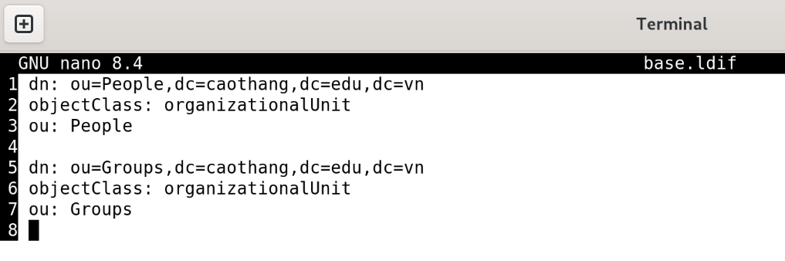

Import:
ldapadd -x -D cn=admin,dc=example,dc=com -W -f base.ldif
5. Tạo user LDAP
Tạo file:
user.ldif
dn: uid=user1,ou=People,dc=example,dc=com
objectClass: inetOrgPerson
objectClass: posixAccount
objectClass: shadowAccount
cn: Tran Van An
sn: An
uid: user1
uidNumber: 10000
gidNumber: 10000
homeDirectory: /home/user1
loginShell: /bin/bash
mail: user1@example.com
userPassword: password

dn: uid=user2,ou=People,dc=example,dc=com
objectClass: inetOrgPerson
objectClass: posixAccount
objectClass: shadowAccount
cn: Le Van Binh
sn: Binh
uid: user2
uidNumber: 10001
gidNumber: 10001
homeDirectory: /home/user2
loginShell: /bin/bash
mail: user2@example.com
userPassword: password

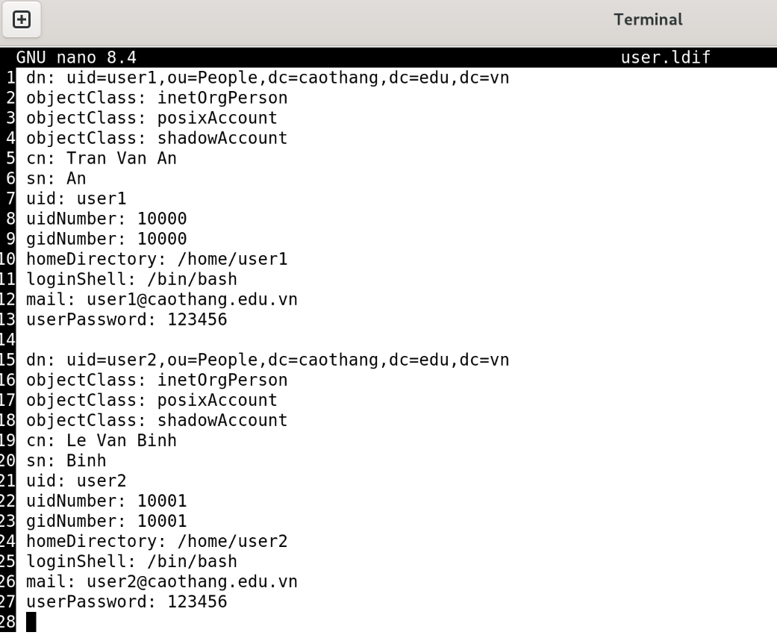
Thêm user:
ldapadd -x -D cn=admin,dc=example,dc=com -W -f user1.ldif

6. Kiểm tra user LDAP
ldapsearch -x -b dc=example,dc=com "(uid=user1)"
Output ví dụ:
dn: uid=user1,ou=People,dc=example,dc=com
cn: Tran Van An
uid: user1
mail: user1@example.com

7. Tạo group
File:
group.ldif
dn: cn=developers,ou=Groups,dc=example,dc=com
objectClass: posixGroup
cn: developers
gidNumber: 10000
memberUid: user1
memberUid: user2

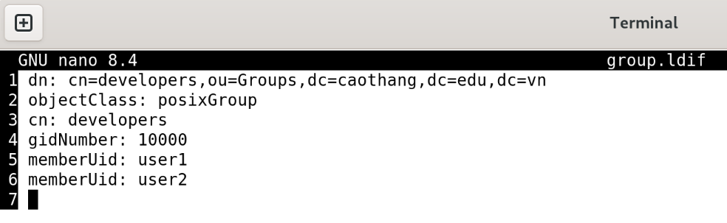
Add group:
ldapadd -x -D cn=admin,dc=example,dc=com -W -f group.ldif
8. Kiểm tra cấu trúc LDAP
ldapsearch -x -b dc=example,dc=com
Cây LDAP sẽ như sau:
dc=example,dc=com
├── ou=People
│ └── uid=user1
└── ou=Groups
└── cn=developers

9. Test đăng nhập LDAP
ldapwhoami -x -D uid=user1,ou=People,dc=example,dc=com -W
Nếu đúng:
dn:uid=user1,ou=People,dc=example,dc=com

