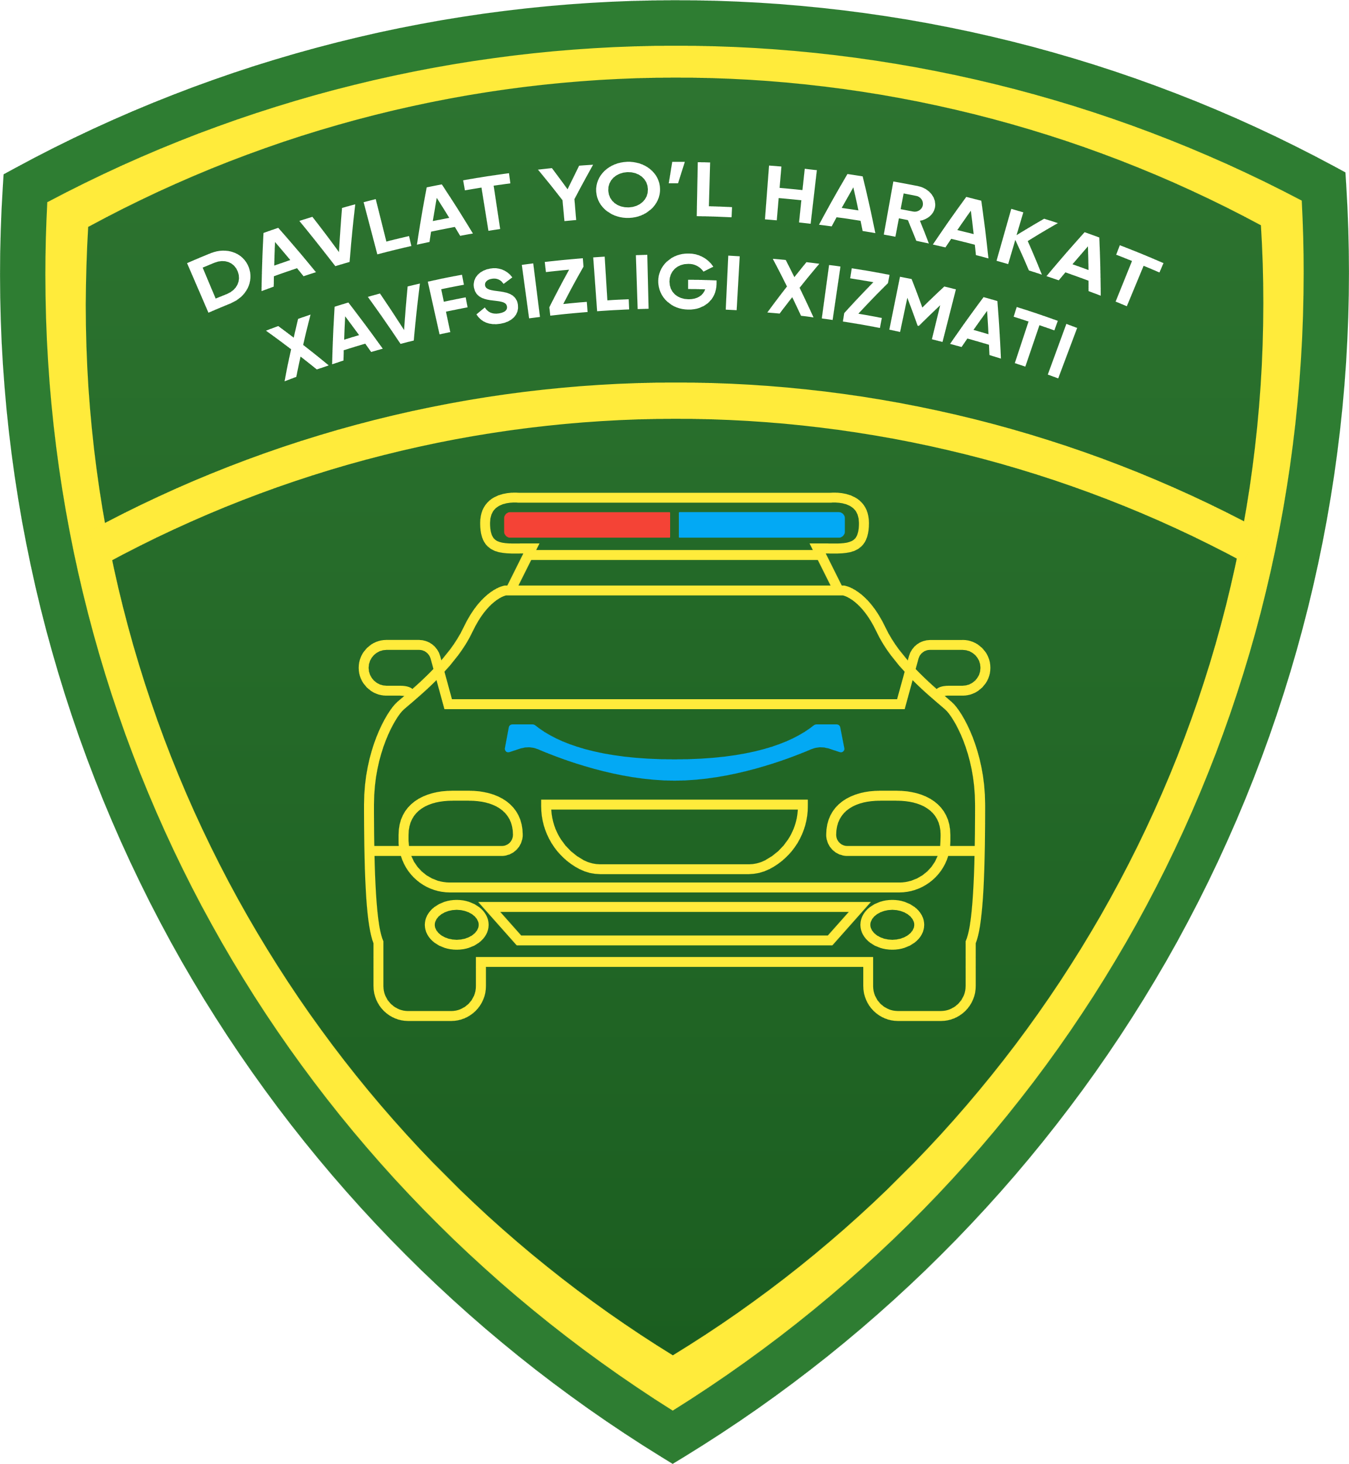

**Shaxsiy transport vositalari uchun**

**{{section.title}} ga**

{{user.region.title}}, {{user.district.title}}, {{user.mfy.title}}, {{user.address}}da istiqomat qiluvchi, {{birthday}} yilda tug’ilgan, {{user.issue_by_whom}} tomonidan berilgan, seriyasi {{user.passport_seriya}} soni {{user.passport_number}} passport, fuqaro {{user.last_name|upper}} {{user.first_name|upper}} {{user.middle_name|upper}}

(tel: +998{{user.phone}}) dan

**ARIZA**

Mengа **XADYA SHARTNOMASI** ga asosan sotib olgan, **{{car.model}}** rusumli, t\v turi **{{car.type.title}}** bo’lgan, yoqilg’i turi **{%if fuel_types%}{{fuel_types}}{%endif%}**, kuzov turi **{{car.body_type}}**, dvigatel quvvati **{{car.engine_power}}** ot kuchi**,** dvigatel raqami **{{car.engine_number}}**, kuzov raqami **{{car.body_number}}**, {%if car.chassis_number%} shassi raqami **{{car.chassis_number}}{%endif%}**, to’la vazni {%if car.full_weight%} **{{car.full_weight}} kg{%endif%}**, yuksiz vazni {%if car.empty_weight%} **{{car.empty_weight}} kg{%endif%}**, **{{car.color}}** rangdagi, **{{made_year}}** yilda ishlab chiqarilgan avtomobilni (mototsiklni, tirkamani) ro’yhatga olishni, qayta ro’yhatlashni, {%if lost_technical_passport %}yo’qolgan qayd etish guvohnomasi{% else %} qayd etish guvohnomasi{%endif%} {%if car.lost_number%} va yo’qolgan davlat raqam belgisi{%else%} davlat raqam belgisi{%endif%} o’rniga yangi qayd etish guvohnomasi va davlat raqam belgisi berishingizni so’rayman.

Ishlab chiqargan zavod: **{{local}}**

Alohida begilar: **{% if devices %}{{devices}}{% endif %}**

Avtomobildagi davlat raqami: **{{old_number}}**

Qayd etish guvohnomasi: **{{old_technical_passport}}**

**Arizaga quyidagilarni ilova qilaman:**

1. **XADYA SHARTNOMASI**, **№ {{state}}**
2. **PASSPORT**
3. **TO’LOVLAR**

{{now_date}} y _________________

imzo

--------------------------------------------------------------------------------------------------

**YHXB QAYDNOMASI**

**Arizada ko’rstailgan avtomashinaning (mototsiklning) dvigatel, shassi (rama), kuzov (kajava) raqam belgilari hisobga olish hujjatlariga to’g’ri keladi.**

“___” ________ 20__-yil YHXB noziri______________________

Berilgan davlat raqam belgisi: **{% if given_number %}{{given_number}}{%endif%}**__________________________

Berilgan qayd etish guvohnomasi: **{%if given_technical_passport %}{{given_technical_passport}}{%endif%}**

“___” ________ 20__-yil YHXB noziri______________________