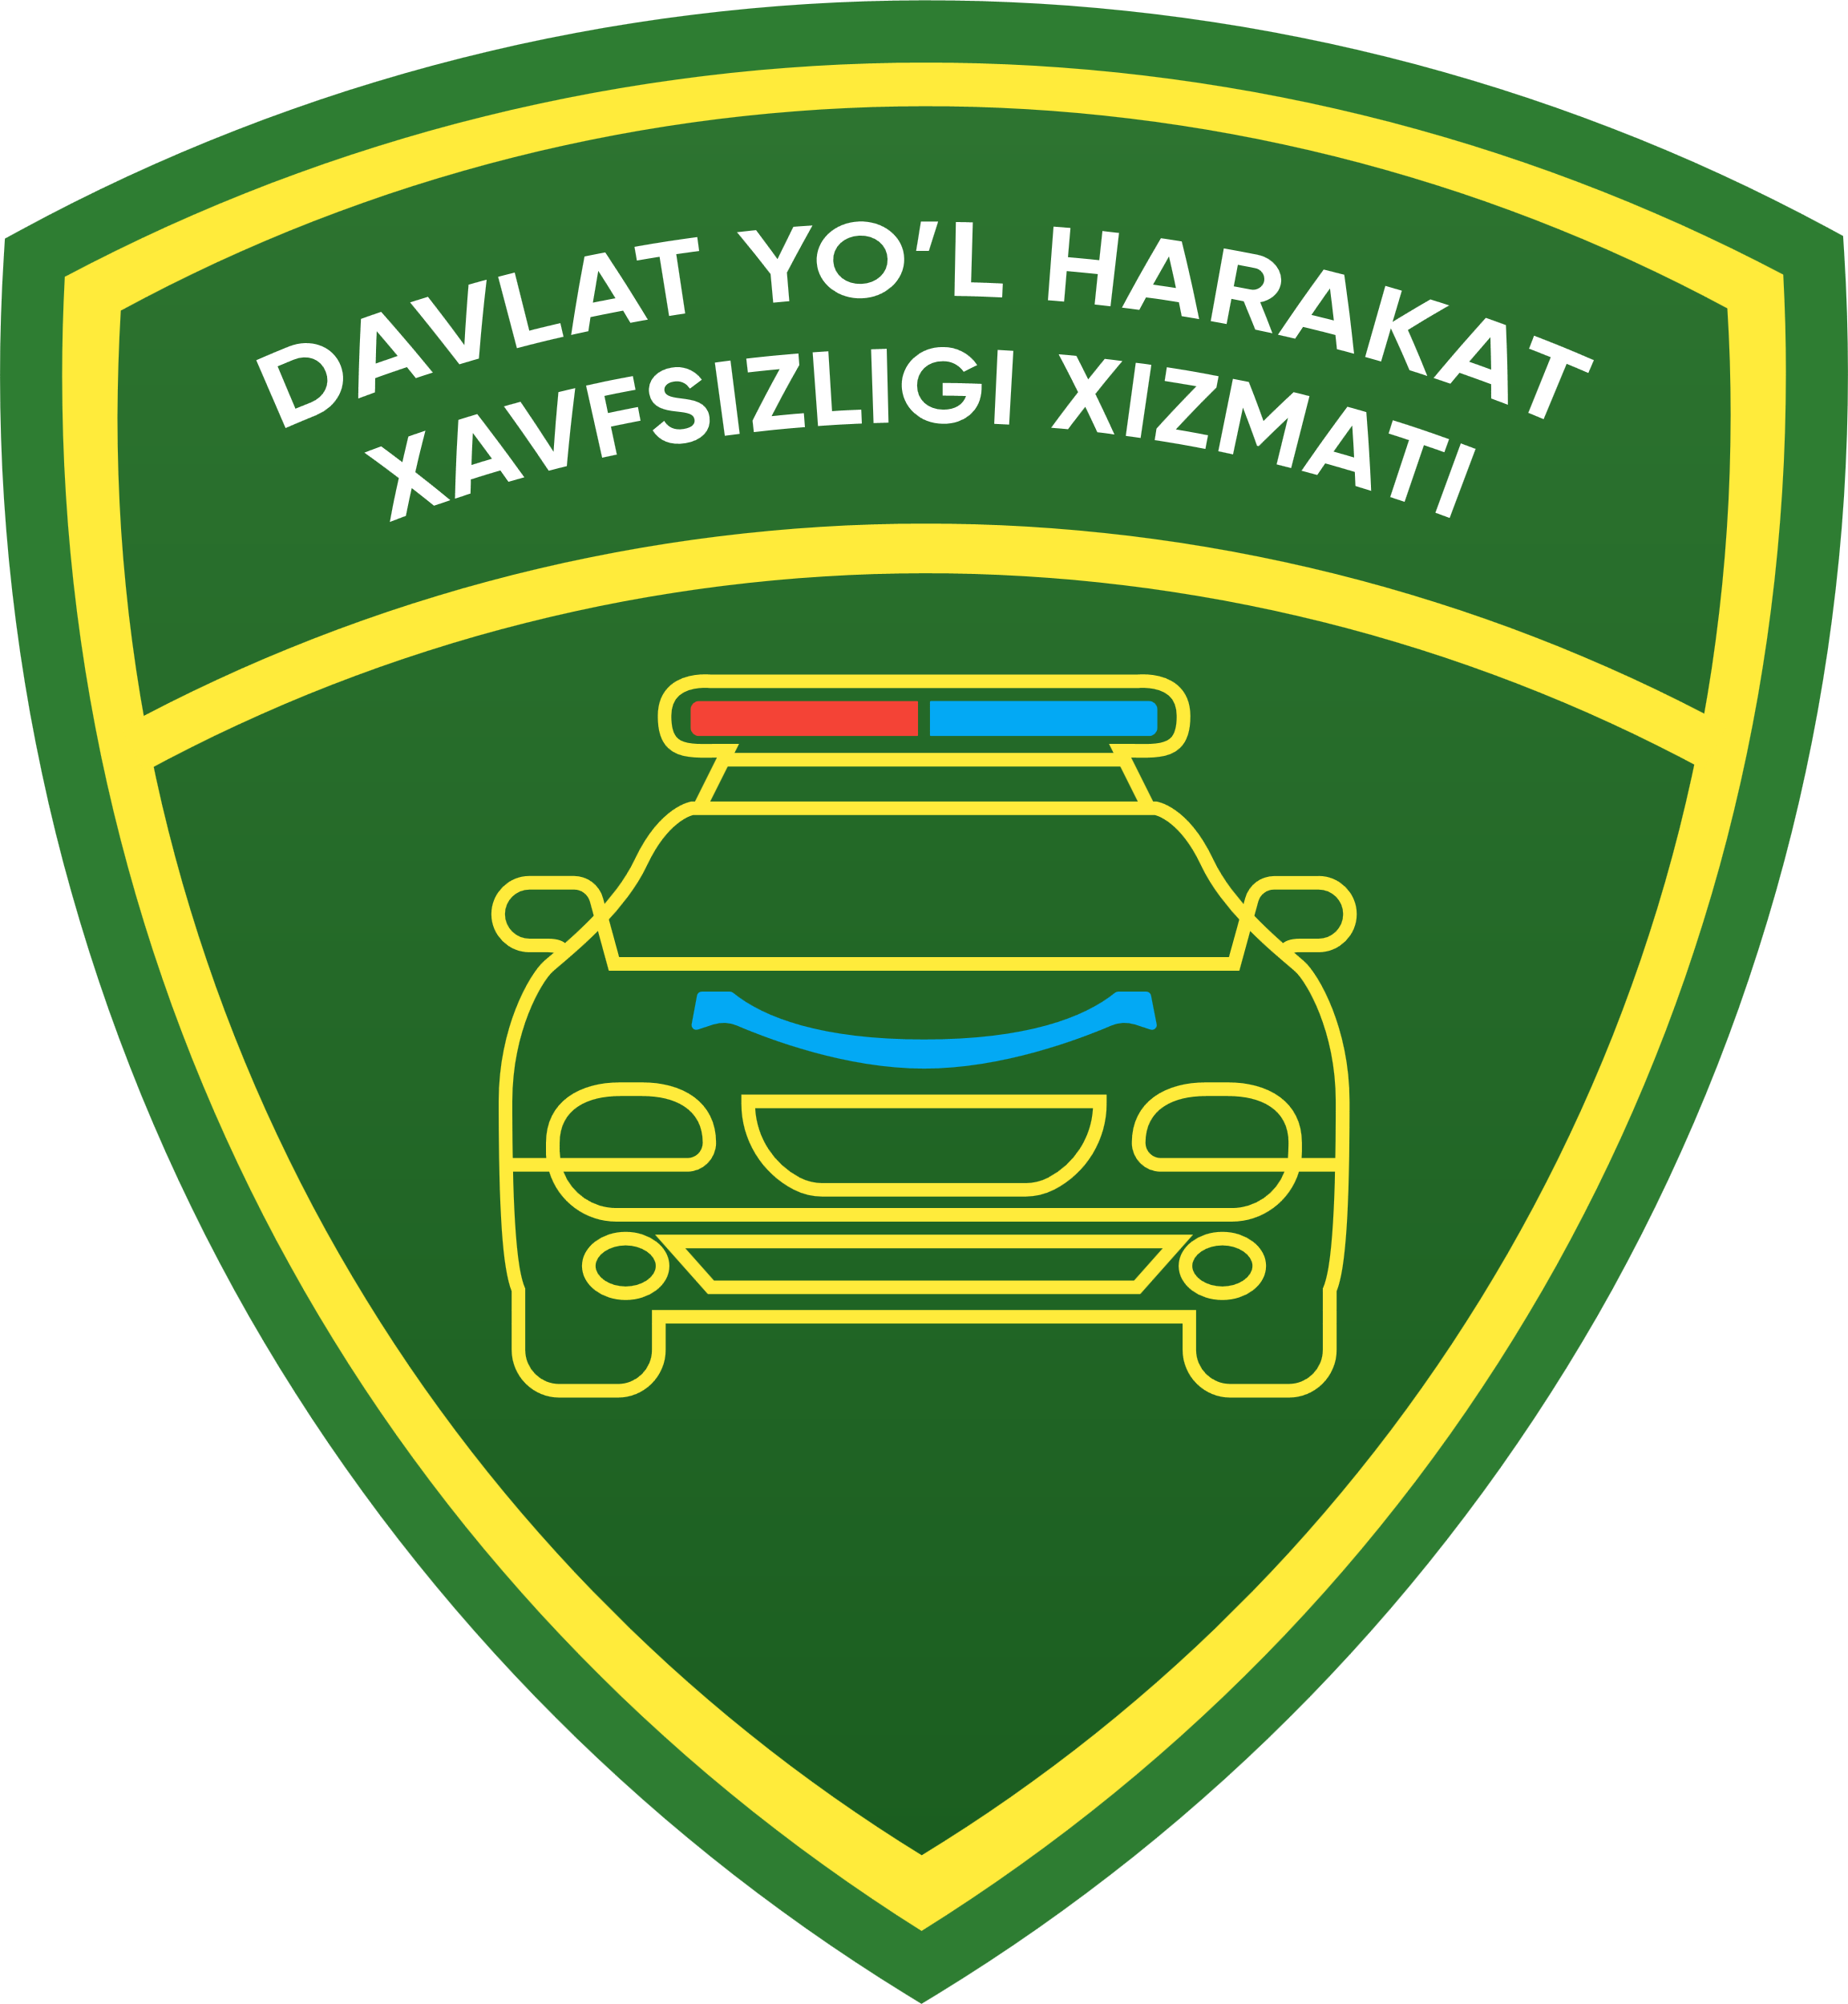

**{{org.title}} dan**

**{{section.title}} ga**

**ARIZA**

Tashkilot manzilgohi: {{legal_address}},

Mashina turadigan joy (garaj) manzilgohi: {{org.address_of_garage}}

Bizdan quyidagi hujjatlar ilova qilinadi:

1. **ME’ROS SHARTNOMASI** **№ {{state}}**
2. **TO’LOVLAR**
3. **RO’YHATGA QO’YISH**

asosida avtomobilni (mototsiklni, tirkamani) ro’yhatga olishni, qayta ro’yhatlashni, {%if lost_technical_passport %}yo’qolgan qayd etish guvohnomasi{% else %} qayd etish guvohnomasi{%endif%} {%if car.lost_number%}va yo’qolgan davlat raqam belgisi{%else%} davlat raqam belgisi{%endif%} o’rniga yangi qayd etish guvohnomasi va davlat raqam belgisi berishingizni so’rayman.

**Avtomobilning (mototsiklning, tirkamaning) ro’yhat belgilari:**

1. T\v rusumi: **{{car.model}}**

2. T\v turi: **{{car.type.title}}**

3. Alohida begilar: **{% if devices %}{{devices}}{% endif %}**

4. Kuzov turi: **{{car.body_type.title}}**

5. Yoqilg’i turi: **{%if fuel_types%}{{fuel_types}}{%endif%}**

6. Ishlab chiqargan zavod: **{{local}}**

7. Ishlab chiqarilgan yili: **{{made_year}}**

8. Shassi raqami: **№** {%if car.chassis_number%}**{{car.chassis_number}}{%endif%}**

9. Kuzov raqami: **№ {{car.body_number}}**

10. Dvigatel raqami: **№ {{car.engine_number}}**

11. Dvigatel quvvati: **{{car.engine_power}} ot kuchi**

12. Rangi: **{{car.color.title}}**

13. To’la vazni {%if car.full_weight%}**{{car.full_weight}} kg{%endif%}**

14. Yuksiz vazni {%if car.empty_weight%}**{{car.empty_weight}} kg{%endif%}**

15. Avtomobildagi davlat raqami: **{{old_number}}**

16. Qayd etish guvohnomasi: **{{old_technical_passport}}**

YHXB bo’limida mashinani rasmiylashtirish uchun tashkilot nomidan ishonchli shaxs {{user}}.

Korxona Ishonchli shaxs imzosi:________________________

М.O’ Korxona boshlig’i imzosi______________________

Bosh hisobchi imzosi__________________________

{{now_date}} y

--------------------------------------------------------------------------------------------------

**YHXB QAYDNOMASI**

**Arizada ko’rstailgan avtomashinaning (mototsiklning) dvigatel, shassi (rama), kuzov (kajava) raqam belgilari hisobga olish hujjatlariga to’g’ri keladi.**

“___” ________ 20__-yil YHXB noziri______________________

Berilgan davlat raqam belgisi: **{% if given_number %}{{given_number}}{%endif%}**__________________________

Berilgan qayd etish guvohnomasi: **{%if given_technical_passport %}{{given_technical_passport}}{%endif%}**

“___” ________ 20__-yil YHXB noziri______________________