Computer programming

Final Project

Report

I.E.S. San Vicente
San Vicente del Raspeig (Alicante)
2017/2018

Teachers:
José Ignacio Cabanes / Ignacio Iborra

Student:
Víctor Tébar Juan

1. Introduction
Project name
Roomba Warfare

Made by
Víctor Tébar Juan

Short description of the project
2d Shooter where multiple players connect to a server and shoot each other.
It is a graphical application that uses SDL2 C++ wrapper for C#.

2. Functionality of the project
After entering the application, a Main screen / Welcome screen Will be displayed where the user can choose between:

-Play the game.
-Change the IP and Port of the server that the game will connect to.
-Exit the game.

If the user chooses to play the game, a Character select screen will be displayed. In this screen the player will be able to choose between different
Characters with different base statistics. Once the user has chosen the character it will try to connect to the server. Once the player is in the server
It will be able to choose its team (Red team, Blue team or Spectator Mode). Whenever all the players in a team dies, a new round will start. Each team spawns in a different spot of the map. When a player dies it wont respawn until the next round, but it will be able to see what its team mates see. Once all the rounds has ended, the server will send which team is the winner and kick the players.

On the server side, it will be a windows forms application. It’ll has different options such as the port number, max number of player, tick-rate, number of rounds…
Before starting a game, we’ll have to load the map, which will be a text file
and will be send to the players when they connect.
Once we start the server, it will accept incoming connections and broadcast the game state to all players connected as well as receive client commands.

3. Screen prototype
The game screen will look like this:

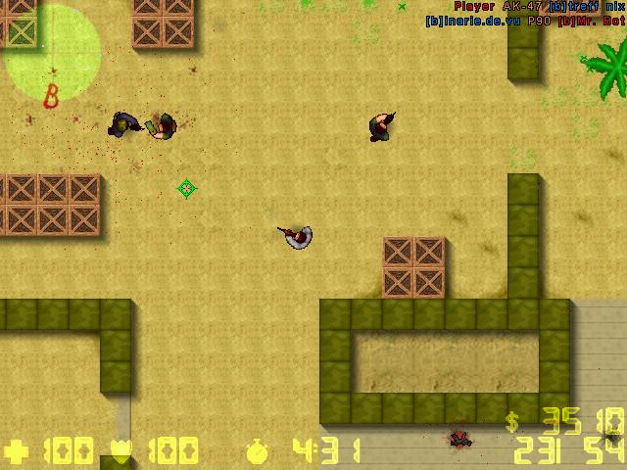

4.Analysis

4a. Requisites
Requisite | Date achieved
The program will be able to load images and render them in a screen. | X
The program will allow the player to change the address of the server. | X
The program will allow the user to select the type of player and connect to the server. The server will accept its connection. | X
The program will allow the user to move through different screens freely. The main screen will show 3 buttons, one to change the address, another one to exit the application, and the other one to play the game. | X
The main game will start showing and the player will be able to change teams.
The player will be able to move freely through the map on the game and see other players. The server will broadcast basic game state.
The player will be able to see other players moving and he will collide with the map entities.
The player will be able to shoot and see other players shooting.
Whenever all the players in a team are dead, a new round will start.
Player will have a hud where he can see its stats and the game will have sounds.

4b. Basic pseudocode

Program body:
Display welcome screen
Wait for user to press a key
If key = ESC, quit program
If key = 1, start one player game
…

One player game:
Display level selection screen
Wait for user to press a key
If key = ESC, return
…

…

4c. Classes diagram
Server
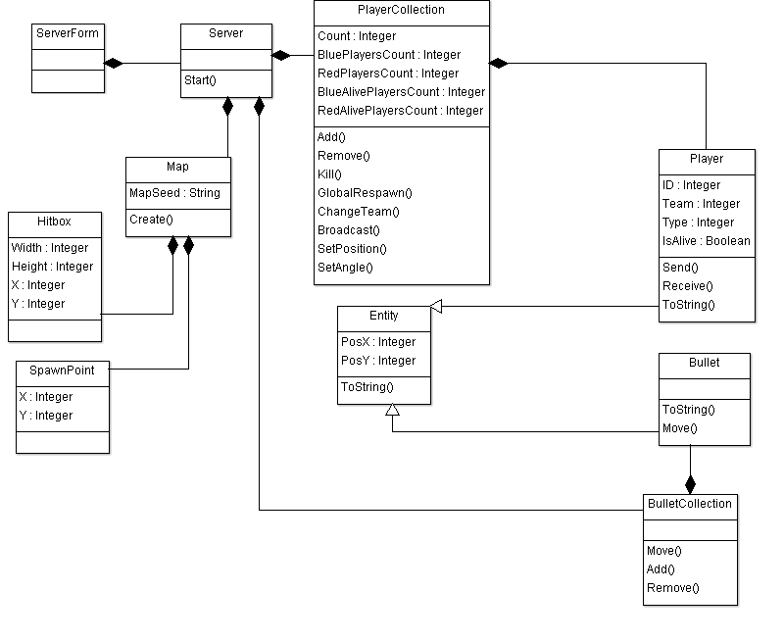
Client

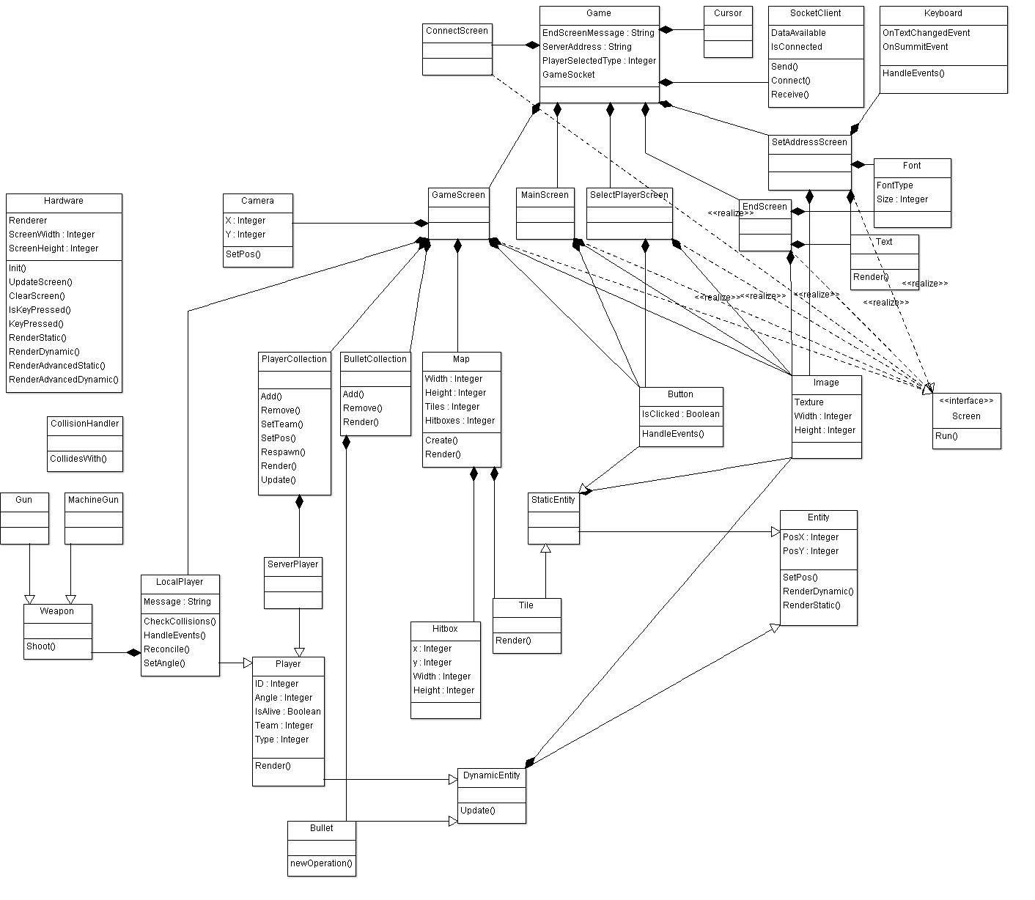

5. Initial planning and expected deliveries

5a. Expected deliveries
- Version 1: Classes main structure, enumerations and basic rendering classes implementation(Hardware,Image) and Text rendering. *
- Version 2: Basic screen structure implementation. Fully functional SetAddressScreen and Button classes. Entities basic structure and entity rendering functions.
- Version 3: Implementation of the SelectPlayerScreen( Four buttons with the different kind of players). Server main classes structures. Server being able to load a map from a file and create it. Class cursor implementation.
- Version 4: On client side: Player basic structure and functions. Server Broadcast and Physics loop functions using Tasks (Both not functionally yet but with capped frame rate, Physics loop at 60 fps and Broadcast loop based on the Tick-rate of the server). Server being able to accept clients asynchronously (using async and await keywords). *
- Version 5: Client able to connect to the server (ConnectScreen). Server SendInitialData function (Sends the map seed, all the players connected to the server, bullets…). Client map creation(Based on tiles) based and PlayerCollection basic implementation.
- Version 6: MainScreen and EndScreen (Interchangeable delivery).
- Version 7: Camera implementation (Scroll). Client being able to translate or interpret the data sent by the server. Player related classes as well as player movement. Sever broadcasting basic game state.
- Version 8: Game Screen basic structure. Game Screen game loops basic implementation. Player being able to change team (Only while in spectator mode or dead). Server rounds implementation (When all the players on a team are dead, the round will end (Adding a victory point to the team that has survived) and the next round will start, respawning all the players on their spawn points).
- Version 9: Client able to send update commands (At the moment, mainly movement commands). Client basic collision with the map. Server movement command interpretation in the Physics loop.
- Version 10: Client being able to receive and translate data (The new movement commands on the local player as well as on the other players). Server reconciliation. Handling disconnections properly.
- Version 11: Entity interpolation on client side. Client collision with the map (On server side). Weapon classes implementation.
- Version 12: Client being able to send shoot commands. Server being able to create bullets based on client commands and broadcast the changes. Other clients being able to translate these new commands and create the bullets on its game side. Bullet prediction on client side.
- Version 13: Bullets moving on server side. Bullet collision detection on server side. Players being able to get hurt and die. Server broadcasting the changes.
- Version 14: Client Hud implementation (Hp bar, Current ammo / Total ammo bar…) Adding sounds to the game depending on where the players are (The closer a player is, the louder its shots sounds).
- Version 15: Map hitbox improvement, both client and server side (Instead of creating a single hitbox for every block, if there are several blocks together, create a single hitbox for all the blocks). Player hitbox improvements.

5b. Real deliveries
- Version 1: As expected: Classes main structure, some enumerations, basic rendering classes implementation(Hardware,Image) and Text rendering. Furthermore button class implementation, SetAddressScreen partially done.
- Version 2: As expected: SetAddressScreen fully functional, as well as practically all render functions and entity basic structure and some player functions. Basic screen structure as well done. SelectPlayerScreen partially done. Ignore the server project is only the windows form (and is not done yet).
- Version 3: As expected: SelectPlayerScreen fully functional. Server basic structure done too, as well as server being able to load a map. Added a new class Cursor with changes the mouse icon on the game. Furthermore some player basic functions and server broadcast and physics loop basic implementation (Not working yet but with capped frame rate). Some windows form basic functions.
- Version 4: I was going to do the version 6. End screen partially done.
- Version 5: As expected: Server being able to accept clients asynchronously as well as server main structure done. Client connect screen done, and server SendInitialData function.
- Version 6: As expected client map creation(Based on tiles) and PlayerCollection basic implementation, End screen done too. Improved buttons, now they have animations. Camera class done. Some minor improvements on server class.
- Version 7: The camera implementation was done in the last session. As expected server broadcast the game state. Client being able to translate basic data done too. Player related classes done too. Main screen (menu) done too. Basic structure of the GameScreen.
- Version 8: Game screen game loops basic implementation done. Player being able to change team done too. Server round implementation almost done(It starts the round but doesn’t end it when all the players all dead and doesn’t score a point). Lots of bug fixes.
- Version 9: As expected client able to send basic update commands. Client basic collision with the map done too. Server movement command interpretation done too. Handling disconnection properly done. Server round implementation when all players die still not done yet because the players cant die until version 13.
- Version 10: Client translating the commands send from the server done. Basic hud implementation client side (Health bar and Ammo bar). Player position reconciliation with the server done too.
- Version 11: Added a log file to the server class that saves when the clients connects and disconnects to the server. Improved map collision detection on client side. Client basic interpolation done. Client collision with the map on server side done too. Weapon class implementation partially done. -Fixed a reconciliation bug.
- Version 12: Weapon class implementation from last session done. Client being able to send shoot commands and server and client creating the bullets done too. Client bullet prediction done too. Added a new class for the spectator mode, that allows do user to control the camera freely with the mouse (pressing f to activate or disable this mode).
- Version 13: Bullets moving in server side and bullet collision.

6. File formats

6a. Plain files format
The map is loaded in the server from a txt file. Its format is like this:
File name: Does not matter as long as its extension is .map
First line: Width + Space + Height
All the other lines are like: TileType + Space + TileType + Space + TileType …
Every line defines a set of tiles.
Example:
640 640
H1 H1 H1 H1 H1 H1 H1 H1 H1 H1
BS G1 G1 G1 G1 G2 G2 G1 G1 RS
G1 G2 G1 G2 G1 G3 G4 G2 G3 G4
G1 G2 G1 G2 G1 G3 G4 G2 G3 G4
G1 G2 G1 G2 G1 G3 G4 G2 G3 G4
G1 G2 G1 G2 G1 G3 G4 G2 G3 G4
G1 G2 G1 G2 G1 G3 G4 G2 G3 G4
G1 G2 G1 G2 G1 G3 G4 G2 G3 G4
BS G1 G1 G1 G1 G2 G2 G1 G1 RS
H1 H1 H1 H1 H1 H1 H1 H1 H1 H1

Usually the ones that starts with G are ground tile (The difference between G1 and G2 are just the tile sprite, Same with hitboxes), the ones that starts with H are hitboxes and BS is a blue spawnpoint and RS is a red spawnpoint.

The server saves too a log file. It’s a txt file and at the moment it only saves the player connections and disconnections.

6b. Entity-Relationship Diagram (If needed)
(…)

7. Problems found and solutions
First problem I found was when I was doing Version 8. The problem was some sort of deadlock where the player only could receive the game status when sends data. This was because I was locking a BinaryFormatter on two functions, the function to send the data and the function to receive the data. The receive data function was always executing so the only time the lock was free was when the player was receiving data. The solution to the problem was instead of using one BinaryFormatter locked to serialize the data sent and the data received, use two BinaryFormatter differents without a lock.

8. Improvements or restrictions to the starting design

9. Screenshots of the final project
(…)

10. Source code of the final project
(…)

