Sample Exam 1 Phys 111 _______________
1. V_{x} is the velocity of a particle moving along the x axis as shown. If x = 2.0 m at t = 1.0 s, what is the position of the particle at t = 6.0 s?
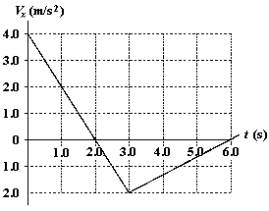

a. | −2.0 m
b. | +2.0 m
c. | +1.0 m
d. | −1.0 m
e. | 6.0 m

2. A particle moving along the x axis has a position given by x = (24t – 2.0t³) m, where t is measured in s. What is the magnitude of the acceleration of the particle at the instant when its velocity is zero?

a. | 24 m/s²
b. | zero
c. | 12 m/s²
d. | 48 m/s²
e. | 36 m/s²

3. An automobile traveling along a straight road increases its speed from 30.0 m/s to 50.0 m/s in a distance of 180 m. If the acceleration is constant, how much time elapses while the auto moves this distance?

a. | 6.00 s
b. | 4.50 s
c. | 3.60 s
d. | 4.00 s
e. | 9.00 s

4. John throws a rock straight down with speed 12 m/s from the top of a tower. The rock hits the ground after 2.37 s. What is the height of the tower? (air resistance is negligible)
a. 4.8 m
b. 19.6 m
c. 27.5 m
d. 38.4 m
e. 56.0 m

5. Two vectors and are given by and . If these two vectors are drawn starting at the same point, what is the angle between them?
a. | 106°
b. | 102°
c. | 110°
d. | 113°
e. | 97°

6. Vectors and are shown. What is the magnitude of a vector if ?

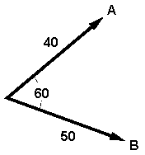

a. | 46
b. | 10
c. | 30
d. | 78
e. | 90

7. The three forces shown act on a particle. What is the direction of the particle’s acceleration

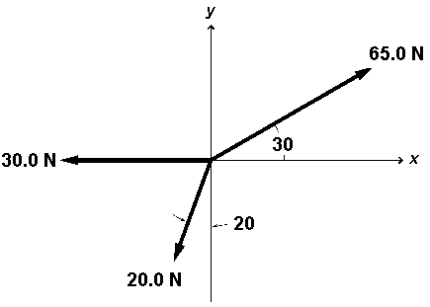
a. | 35°
b. | 45°
c. | 65°
d. | 55°
e. | 85°

8. Two vectors and are given by and . If these two vectors are drawn starting at the same point, what is the angle between them?
a. | 106°
b. | 102°
c. | 110°
d. | 113°
e. | 97°

9. At t = 0, a particle leaves the origin with a velocity of 12 m/s in the positive x direction and moves in the xy plane with a constant acceleration of . At the instant the y coordinate of the particle is 18 m, what is the x coordinate of the particle?
a. | 30 m
b. | 21 m
c. | 27 m
d. | 24 m
e. | 45 m

10. In 2.0 s, a particle moving with constant acceleration along the x axis goes from x = 10 m to x = 50 m. The velocity at the end of this time interval is 10 m/s. What is the acceleration of the particle?
a. | +15 m/s²
b. | +20 m/s²
c. | −20 m/s²
d. | −10 m/s²
e. | −15 m/s²

11. A ball is thrown horizontally from the top of a building 0.10 km high. The ball strikes the ground at a point 65 m horizontally away from and below the point of release. What is the speed of the ball just before it strikes the ground?

a. | 43 m/s
b. | 47 m/s
c. | 39 m/s
d. | 36 m/s
e. | 14 m/s

12. A bird, accelerating from rest at a constant rate, experiences a displacement of 28 m in 17 s. What is the final velocity after 11 s?

a. 0.19 m/s
b. 1.6 m/s
c. 3.3 m/s
d. 2.1 m/s
e. 5.1 m/s

13 A ball is thrown at an angle of θ = 30 deg from the top of a building 0.10 km high. If the magnitude of ball’s initital velocity is 20 m/s, how long is the ball in air?
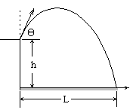
- 1.2 s
- 4.8 s
- 5.7 s
- 12.6 s
- 18.0 s

14. The initial speed of a cannon ball is 200 m/s. If the ball is to strike a target that is at a horizontal distance of 3.0 km from the cannon, what is the minimum time of flight for the ball?
a. 16 s
b. 21 s
c. 24 s
d. 14 s
e. 19 s
15 A 3.00-kg mass undergoes an acceleration given by a = (2i+5j ) m/s². The magnitude of the net force is

a. 2.0 N
b. 4.0 N
c. 6.0 N
d. 12.0 N
e. 16.0 N

16. A 10-kg block on a horizontal plane is connected by a cord over a massless, frictionless pulley to a second block of mass m. What hanging mass m is needed so that the 10-kg block can move at acceleration of 2.8 m/s² ?

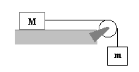a. 1 kg
b. 2 kg
c. 3 kg
d. 4 kg
e. 5 kg

17. The horizontal surface on which the block slides is frictionless. If F = 20 N and M = 5.0 kg, what is the magnitude of the resulting acceleration of the block?

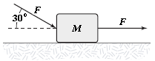

a. | 5.3 m/s²
b. | 6.2 m/s²
c. | 7.5 m/s²
d. | 4.7 m/s²
e. | 3.2 m/s²

18. At an instant when a 4.0-kg object has an acceleration equal to m/s², one of the two forces acting on the object is known to be N. Determine the magnitude of the other force acting on the object.
a. | 2.0 N
b. | 13 N
c. | 18 N
d. | 1.7 N
e. | 20 N

19. The tension in a string from which a 4.0-kg object is suspended in an elevator is equal to 28 N. What is the acceleration of the elevator?
a. | 11 m/s² upward
b. | 1.2 m/s² upward
c. | 1.2 m/s² downward
d. | 10 m/s² upward
e. | 2.8 m/s² downward

