SAMPLE PROBLEMS -- Exam 3 -- Physics 111 FALL 2013
REVIEW SESSION with Prof. Opyrchal – Thursday 11/21 1-2:30 409Tiernan
REVIEW SESSION with Prof. Federici – Wednesday 11/20 2:30-4:00 408T

1. A merry-go-round rotates from rest with an angular acceleration of 1.56 rad/s². How long does it take to rotate through the first 2 rev?

A) 2 s
B) 4 s
C) 6 s
D) 8 s
E) 10 s

2. A wheel, with radius R = 0.5 m, initially has an angular velocity of 2.5 rev/s, and is slowing down at a rate of 2 rad/s². By the time it stops spinning about its center, what distance will a point on the outer rim have traveled?

A) 12 m
B) 18 m
C) 24 m
D) 31 m
E) 47 m

3. An electric motor can accelerate a 4-kg grinding wheel in a form of a solid disk of radius 0.2 m from rest to 75 rad/s in 15 s. Find the torque generated by the motor.

A) 0.05 N.m
B) 0.10 N.m
C) 0.20 N.m
D) 0.30 N.m
E) 0.40 N.m

4. A small coin is placed on a horizontal, rotating turntable at a distance of 30 cm from its center. The coin’s mass is 12 g and the coefficient of static friction between the coin and the turntable is 0.44. Find the maximum angular velocity that the turntable can have if coin is to remain stationary relative to the turntable.

A) 0.2 rev/s
B) 0. 4 rev/s
C) 0.6 rev/s
D) 0.8 rev/s
E) 1.0 rev/s

5. A uniform cylinder of radius R, mass M , and length L rotates freely about a horizontal axis parallel and tangent to

the cylinder, as shown below. The moment of inertia of the cylinder about this axis is
A) 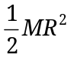.
B) 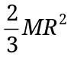.
C) 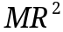
D) 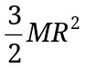.
E) 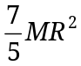.

6. A puck on a frictionless air hockey table has a mass of 0.5 kg and is attached to a cord passing through a hole in the surface as in the figure. The puck is revolving at a distance 2.0 m from the hole with an angular velocity of 0.40 rev/s. What is the kinetic energy of the puck?

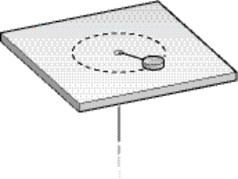
A) 2.4 J
B) 4.8 J
C) 6.3 J
D) 12.6 J
E) 18.4 J

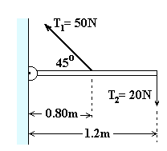
7. What is the magnitude of the net torque produced by two tension forces T₁ and T₂ about the hinge?

A) 4.3 Nm
B) 18.5 Nm
C) 28.7 Nm
D) 43.5 Nm
E) 52.3 Nm

8. A solid ball of mass of 0.25 kg and radius 0.1 m rolls without slipping 4 m down an incline that makes an angle of 25⁰ a with a horizontal. The angular acceleration of the ball is

A) 10 rad/s²
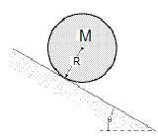
B) 20 rad/s²
C) 30 rad/s²
D) 40 rad/s²
E) 50 rad/s²

9. A solid cylinder of mass of 0.25 kg rolls without slipping 4 m down an incline that makes an angle of 25⁰ a with a horizontal. If it starts from rest, what is its angular velocity at the bottom of the incline ?

A) 1.1 m/s
B) 2 .8 m/s
C) 0.75 m/s
D) 6.8 m/s
E) 4.7 m/s

10. The rigid body shown is rotated about an axis perpendicular to the paper and through the point P. If M = 0.40 kg, L = 60 cm, what is the kinetic energy of this object when its angular speed about this axis is equal to 48.0 rev/min? Neglect the mass of the connecting rods and treat the masses as particles.
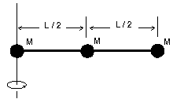

A) | 2.9 J
B) | 2.3 J
C) | 3.1 J
D) | 3.4 J
E) | 1.6 J

11. A basketball is rolling without slipping along a horizontal surface with total kinetic energy 20 J. How much energy (in Joules) is due to the rotational kinetic energy of the ball about its center of mass? Basketballs are hollow shells. (I = 2/3 mr².)

A) 10
- 8
C) 13.3
D) 4
- 12

12. A thin uniform rod (length = 1.2 m, mass = 2.0 kg) is pivoted about a horizontal, frictionless pin through one end of the rod. The rod is released when it makes an angle of 25° with the horizontal. What is the angular acceleration of the rod at the instant it is released?

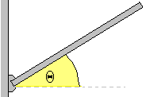A) 11.1 rad/s²
B) 7.4 rad/s²
C) 8.4 rad/s²
D) 5.9 rad/s²
E) 6.5 rad/s²

13. A 3 kg thin rod 45 cm long, initially at rest is free to rotate about its center in horizontal plane.. If it accelerates under the action of torque of 0.85 Nm what work is done on the disk during 10 sec?

A) 95.0J
B) 714 J
C) 320 J
D) 240 J
E) 150 J

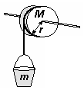
14. A solid cylindrical pulley with a radius of r = 0.35 m is used to lower a bucket with a mass of m = 12 kg into a well, 5 m deep. If the rotational inertia of the pulley is 2 kgm², what is speed of the bucket at the bottom of the well ?

A) 4.6 m/s
B) 2 .8 m/s
C) 0.75 m/s
D) 6.8 m/s
E) 4.7 m/s

15. In the instant of the figure, two particles move in an xy plane. Particle P₁ has mass 2.5 kg and speed 4.2 m/s, and it is at distance d₁ =2.0 m from point O. Particle P₂ has mass 6.0 kg and speed 3.5 m/s, and it is at distance d₂ =1.5 m from point O. What are the magnitude (in kgm²/s) and the direction of the net angular momentum of the two particles about O?

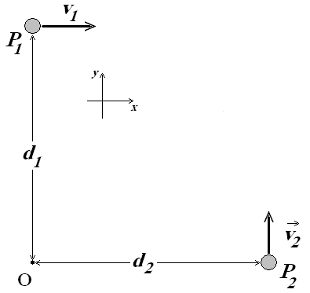
A) L = - 8 i + 2 j

A
B) L = -10.5 k
C) L = 0
D) L = 52.5 k
E) L = 10.5k

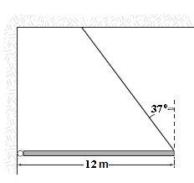
16. A uniform 120-N beam is supported in a horizontal position by a pin and cable as shown in the figure. What is the tension in the cable?

A) | 94 N
B) | 88 N
C) | 63 N
D) | 75 N
E) | 150 N

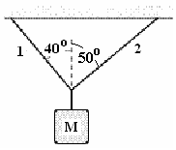
17. In the figure, if the tension in string 1 is 34 N, what is the mass of the object shown?
A) 7.3 kg
B) 5.5 kg
C) 1.8 kg
D) 3.7 kg
E) 4.5 kg

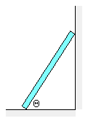
18. A ladder of weight 346 N is placed against a smooth frictionless wall. The base of the ladder makes an angle of 60º with the horizontal ground surface. The ladder is stable and in equilibrium. The friction force (in N) acting on the base of the ladder is:

A) 100
B) 173,
C) 200
D) 299
E) 346.

19. A cylindrical pulley of moment of inertia of 0.25 kgm² and radius of 20 cm is used to lower a bucket with a mass of 2.2 kg into a well. The angular acceleration of the pulley is

A) 12.75 rad.s²
B) 9.82 rad/s²
C) 6.45 rad/s²
D) 4.75 rad/s²
E) 3.92 rad/s²

20. A cylinder rotating about its axis with a constant angular acceleration of 1.6 rad/s2 starts from rest at t = 0. At the instant when it has turned through 0.40 radian, what is the magnitude of the total linear acceleration of a point on the rim (radius = 13 cm)?
A) 0.31 m/s2
B) 0.27 m/s2
C) 0.35 m/s2
D) 0.39 m/s2
E) 0.45 m/s2

21. A thin rod of mass M = 1.2 kg and length L = 2m is struck at one end by a ball of clay of mass m = 150 g, moving with speed v=7.5 m/s as shown in the figure. The ball sticks to the rod. After the collision, the angular momentum of the clay-rod system about A, the midpoint of the rod, is
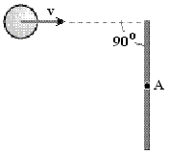
A) 0.5 rad/s
B) 1.1 rad/s
C) 2.0 rad/s
D) 2.8 rad/s
E) 4.0 rad/s

22. A uniform beam of length 5.5 m and mass 12 kg supports a 25 kg mass as shown in the figure. The beam is attached to the ball by a pivoting pin at an angle of 50 degrees with the wall. Find the magnitude of the force that the pin exerts on the beam.

A) 146 N
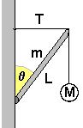B) 292 N
C) 580 N
D) 762 N
E) 820 N

Two blocks, m₁ = 10.0 kg and m₂ = 2.0 kg, are connected by a light string as shown in the figure. The radius of the pulley is 1.0 m and its moment of inertia is 5.0 kg⋅m²
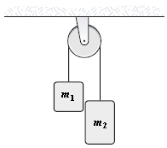

23. Fins the acceleration of the system

A) 4.6 rad/s²
B) 7.4 rad/s²
C) 8.4 rad/s²
D) 5.9 rad/s²
E) 6.5 rad/s²

24. Find the velocity of m₁ after falling a distance 0.8 m..

A) 1.1 m/s
B) 4 .8 m/s
C) 0.75 m/s
D) 6.8 m/s
E) 2.7 m/s

