**UNIVERSITY INSTITUTE OF COMPUTING**

**CASE STUDY REPORT**

**ON**

**PARTICULAR CASE STUDY**

Program Name: BCA

Subject Name/Code: Database Management System (23CAT-251)

**Submitted by: Submitted to:**

**Name:** Piyush Grover **Name: Mr. Arvinder Singh**

**UID:23BCA**10724 **Designation: Professor**

**Section:4’a’**

ABSTRACT

* Introduction:

The **Employee Management System (EMS)** is a comprehensive platform designed to manage employee records and streamline administrative tasks related to human resources (HR). Using a **Database Management System (DBMS)**, the EMS enables the efficient storage, retrieval, and manipulation of data related to employee information, roles, payroll, attendance, performance, and more. This system is intended to improve operational efficiency, reduce human errors, and facilitate better decision-making within the HR department.

#### **Key Features:**

* **Employee Information Management:** Store and manage detailed employee profiles, including personal details, job history, and contact information.
* **Attendance Tracking:** Track employee attendance, including working hours, leaves, and absences.
* **Payroll Management:** Handle salary calculation, deductions, and bonuses based on attendance and performance.
* **Leave Management:** Record and track leave applications, including paid leave, sick leave, and other types.
* **Performance Management:** Evaluate and track employee performance, set goals, and provide feedback.
* **User Access Control:** Role-based access to ensure that only authorized personnel can access sensitive data.
* Technique:

The **Employee Management System (EMS)** utilizes a **relational database management system (RDBMS)** to manage and organize the vast amounts of data related to employees, attendance, payroll, performance, and more. The technique focuses on designing a structured, scalable, and efficient system that supports various HR processes. The following techniques and methodologies are used in building the system:

#### **1. Relational Database Design (RDBMS):**

* The system uses a **relational model** to store data in tables, each with rows and columns.
* **Primary keys** are used to uniquely identify records, ensuring each employee and other entities (like attendance, payroll) can be uniquely referenced.
* **Foreign keys** create relationships between different tables. For example, the employee_id in the **Attendance** table links to the employee_id in the **Employees** table. This ensures that the data integrity is maintained across different sections of the system.
* **Normalization** techniques are employed to reduce redundancy and ensure data consistency across the database. Tables are designed to minimize data duplication while ensuring the relational links between them are clear and optimized.

#### **2. Entity-Relationship (ER) Modeling:**

* **ER Diagrams** are used to visually represent the structure of the database and the relationships between different entities. Entities like Employee, Department, Attendance, Payroll, and Leave are represented as entities in the ER diagram, with lines representing the relationships between them.
* The ER diagram provides a clear and logical representation of how data is related and flows within the system, making it easier to design the database structure and relationships.

#### **3. SQL Queries for Data Manipulation:**

* The system relies heavily on **SQL (Structured Query Language)** to manipulate and retrieve data. Queries are written to handle common tasks like:
  + **CRUD operations** (Create, Read, Update, Delete) for managing employee records, attendance, payroll, and performance data.
  + **Aggregating data** for reporting purposes (e.g., total salary calculations, average performance ratings).
  + **Joining tables** to retrieve data from multiple related tables at once (e.g., joining Employee, Attendance, and Payroll to calculate the employee's salary for a given period).
  + **Filtering and Sorting** employee data based on specific parameters, such as department, job title, or performance ratings.

#### **4. User Authentication and Role-Based Access Control (RBAC):**

* **Authentication** ensures that users (HR personnel, employees, managers) can only access the system using secure login credentials.
* **Role-based access control (RBAC)** is implemented to assign different levels of access to different users. For instance:
  + **Admins** have full access to the system, including employee data, payroll, attendance, and performance reviews.
  + **Managers** may have access to only their department’s data, including performance reviews and attendance.
  + **Employees** typically have access to their own data (attendance, payroll, leave records) but cannot access others’ information.

#### **5. Automation and Scheduling:**

* **Automated Attendance Tracking**: The system can integrate with **biometric devices** or **time tracking systems** to automate the process of recording employee attendance. This reduces human error and ensures that attendance data is always accurate and up-to-date.
* **Payroll Calculations**: Payroll generation is automated based on predefined rules such as salary, bonus, deductions, and attendance. The system calculates the net salary of each employee, factoring in overtime, leave, and tax deductions automatically.
* **Leave Management**: Employees can apply for leave through the system, and managers can approve or reject requests, all within the system’s workflow. The system automatically updates the leave balance and attendance records when leave is taken.

#### **6. Reporting and Analytics:**

* The EMS supports the generation of **reports** and **dashboards** to provide insights into various aspects of employee management, such as:
  + **Attendance Reports**: Detailing employee attendance patterns, leave balances, and overall attendance percentages.
  + **Payroll Reports**: Showing salary breakdowns, deductions, and bonuses for all employees.
  + **Performance Reports**: Summarizing performance reviews, ratings, and feedback for each employee.
* These reports can be generated on-demand or scheduled to be sent automatically to HR personnel or management.

#### **7. Data Integrity and Security:**

* **Data validation** ensures that only correct and relevant information is entered into the system, preventing issues like incorrect salary calculations or missing attendance data.
* **Encryption** is used to secure sensitive information, especially in the **Login** and **Payroll** tables, ensuring that personal and financial data is protected from unauthorized access.
* Regular **backup procedures** are implemented to ensure that all data is recoverable in case of a system failure or security breach.

#### **8. Web Interface and User Experience (UI/UX):**

* The **user interface** is designed to be intuitive and easy to use, allowing HR managers, employees, and supervisors to navigate the system with ease.
* **Responsive design** ensures that the system is accessible from various devices, such as desktops, tablets, and smartphones, giving users flexibility in accessing the EMS.
* **Interactive dashboards** provide real-time insights into key metrics like employee attendance, performance, and payroll, allowing HR managers and supervisors to make data-driven decisions quickly.
* System Configuration:

The **Employee Management System (EMS)** requires a robust and scalable infrastructure to ensure its performance, security, and reliability. Below is the recommended system configuration, covering both hardware and software requirements for optimal operation.

### **1. Hardware Requirements:**

#### **Server Configuration:**

To run the EMS effectively, the server hosting the application should meet the following specifications:

* **Processor (CPU):**
  + Minimum: Intel Core i5 or equivalent
  + Recommended: Intel Xeon or AMD Ryzen 7 (for scalability and higher performance)
* **Memory (RAM):**
  + Minimum: 8 GB RAM
  + Recommended: 16 GB RAM or higher (for handling larger datasets and concurrent users)
* **Storage:**
  + Minimum: 500 GB SSD (Solid State Drive) for faster read/write operations
  + Recommended: 1 TB SSD or higher for scalability and future growth
* **Network Connectivity:**
  + Minimum: 1 Gbps Internet connection for smooth access and operations
  + Recommended: 10 Gbps (if the system is used by a large number of employees and requires high bandwidth)

#### **Client Configuration:**

End users (employees, managers, and administrators) accessing the EMS through a web interface require the following configurations:

* **Processor (CPU):**
  + Minimum: Intel Core i3 or equivalent
  + Recommended: Intel Core i5 or higher for a smoother experience
* **Memory (RAM):**
  + Minimum: 4 GB RAM
  + Recommended: 8 GB RAM for optimal performance with multiple browser tabs open
* **Storage:**
  + Minimum: 50 GB of free storage for operating system and local files
  + Recommended: 100 GB or higher, depending on local data storage needs
* **Operating System:**
  + Windows 10 or later
  + macOS 10.15 or later
  + Linux (Ubuntu or CentOS recommended)
* **Browser:**
  + Latest versions of **Google Chrome**, **Mozilla Firefox**, or **Microsoft Edge**
  + Ensure that the browser supports **JavaScript**, **HTML5**, and **CSS3** for full system functionality

### **2. Software Requirements:**

#### **Backend Software:**

The backend of the **Employee Management System (EMS)** can be built using a combination of programming languages and technologies to support database management, security, and server-side logic.

* **Programming Languages:**
  + **PHP**, **Python**, **Java**, or **Node.js** (depending on the chosen backend framework)
  + For Python: Django or Flask
  + For Java: Spring Boot
  + For Node.js: Express.js
* **Database Management System (DBMS):**
  + **MySQL**, **PostgreSQL**, or **Oracle** for managing employee data, attendance, payroll, etc.
  + Ensure **ACID** properties (Atomicity, Consistency, Isolation, Durability) for transaction integrity.
* **Web Server:**
  + **Apache HTTP Server** or **Nginx** for handling HTTP requests and serving the web application
  + Support for **SSL/TLS encryption** to ensure secure connections (HTTPS)

#### **Frontend Software:**

The frontend is responsible for providing an intuitive user interface (UI) for users to interact with the EMS.

* **Markup and Styling:**
  + **HTML5**: Structure and content of web pages
  + **CSS3**: Styling and layout of pages, including responsive design for mobile compatibility
  + **SASS/SCSS**: For more efficient and manageable CSS
  + **Bootstrap** or **Tailwind CSS** for responsive design and UI components
* **JavaScript and Frameworks:**
  + **JavaScript**: For dynamic content and interactive features (e.g., form validation, modals, real-time updates)
  + **React.js**, **Vue.js**, or **Angular** for building dynamic, single-page applications (SPA)
  + **jQuery** (optional, for simpler DOM manipulation)
* **Browser Compatibility:**
  + Ensure the system works seamlessly across major browsers (Chrome, Firefox, Edge, Safari)

#### **Security Software:**

The EMS must be secured against unauthorized access and data breaches.

* **SSL/TLS Certificates**: Ensure **HTTPS** encryption for secure data transmission between client and server
* **Two-Factor Authentication (2FA)**: Add an extra layer of security for employee login access
* **Firewalls**: Configure firewalls to prevent unauthorized access to the system
* **Antivirus/Antimalware**: Ensure that the server hosting the system is protected against malware attacks

#### **Backup and Recovery Software:**

To ensure data integrity and prevent loss of data in case of system failure, regular backups are essential.

* **Backup Tools**: Use solutions like **MySQL Enterprise Backup**, **pgBackRest**, or **rsync** (for file-based backups)
* **Cloud Backup Services**: Implement services like **Amazon S3**, **Google Cloud Storage**, or **Microsoft Azure Blob Storage** for cloud-based backups

#### **Other Software:**

* **Email Service Provider**: For sending notifications (e.g., employee leave approval, salary updates) via **SMTP** (e.g., Gmail API, SendGrid)
* **Reporting/Analytics Tools**: Use **Tableau**, **Power BI**, or **Google Data Studio** for advanced reporting and data analytics

### **3. Security Configurations:**

* **Role-Based Access Control (RBAC)**: Different user roles (admin, employee, manager) should have specific permissions to ensure data security.
  + **Admin**: Full access to all features, including employee records, payroll, and attendance.
  + **Manager**: Limited access to data relevant to their department.
  + **Employee**: Only access to personal data (attendance, payroll, leave).
* **Encryption**:
  + **Data Encryption**: Sensitive data such as passwords, salary details, and personal information should be encrypted using **AES-256** or equivalent standards.
  + **Password Hashing**: Use hashing algorithms like **bcrypt** or **PBKDF2** for secure password storage.
* **User Authentication**:
  + Implement **OAuth2.0** or **JWT (JSON Web Token)** for token-based user authentication.
  + **Captcha** for login protection to avoid bot attacks.
* **Audit Trails**:
  + Enable **audit logging** to track changes made in the system (e.g., employee data edits, payroll adjustments).
  + Logs should be regularly reviewed to detect and prevent suspicious activities.

### **4. Performance Configuration:**

* **Load Balancing**:
  + Set up **load balancers** (e.g., **HAProxy**, **AWS Elastic Load Balancing**) to distribute incoming traffic across multiple servers for better performance and scalability.
* **Caching**:
  + Use caching techniques like **Redis** or **Memcached** to store frequently accessed data, reducing the load on the database and improving response time.
* **Database Optimization**:
  + **Indexing**: Use proper indexing on frequently queried columns (e.g., employee_id, attendance_date) to speed up query performance.
  + **Query Optimization**: Write optimized SQL queries and avoid using SELECT * to reduce unnecessary data retrieval.
* **Scalability**:
  + Use a **cloud-based infrastructure** (e.g., AWS, Azure, Google Cloud) for scalability. Services like **Amazon RDS** or **Google Cloud SQL** can scale database storage dynamically as the number of employees and data grows.

### **5. Deployment Configuration:**

* **Development Environment:**
  + **Local Development**: Developers can use tools like **XAMPP**, **WAMP**, or **Docker** for local testing.
  + **Version Control**: Use **Git** for version control and collaboration, with repositories hosted on platforms like **GitHub** or **GitLab**.
* **Production Environment**:
  + **CI/CD Pipelines**: Implement **Continuous Integration/Continuous Deployment** pipelines using tools like **Jenkins**, **GitHub Actions**, or **GitLab CI** to automate testing and deployment.
  + **Containerization**: Use **Docker** for containerized environments, making the EMS more portable and easier to manage across different servers.
* INPUT:

The **Employee Management System (EMS)** requires a variety of input data to function effectively. These inputs are collected from different sources such as employees, HR personnel, and system-generated data. The input data drives all operations like employee registration, attendance tracking, payroll generation, leave management, and performance evaluation.

The inputs can be categorized into the following sections:

### **1. Employee Information:**

This is the primary input data used to create and manage employee records within the system.

* **Employee Details:**
  + **Employee ID** (Primary Key): A unique identifier assigned to each employee.
  + **First Name**: Employee’s first name.
  + **Last Name**: Employee’s last name.
  + **Gender**: Male/Female/Other.
  + **Date of Birth**: Employee's date of birth.
  + **Email Address**: Employee’s official email address.
  + **Phone Number**: Employee’s contact number.
  + **Address**: Employee’s home address (could include city, state, zip code).
  + **Emergency Contact Details**: Emergency contact person name, relationship, and phone number.
  + **Social Security Number/Tax Identification Number**: For tax and legal purposes.
  + **Nationality**: Employee’s nationality.
  + **Date of Joining**: Date when the employee joined the organization.
  + **Job Title/Position**: The designation of the employee in the company.
  + **Department**: The department to which the employee belongs.
  + **Salary/Compensation**: The employee’s pay structure (fixed salary, bonuses, etc.).

### **2. Attendance Information:**

Attendance data is necessary to track when an employee is present or absent, which directly influences payroll calculations.

* **Attendance ID** (Primary Key): Unique identifier for the attendance record.
* **Employee ID** (Foreign Key): References the employee’s unique ID.
* **Date**: The specific day of attendance (e.g., YYYY-MM-DD).
* **Clock In/Out Time**: Time at which the employee logs in and logs out from the system.
* **Status**: Presence status (e.g., Present, Absent, On Leave, Late, Overtime).
* **Working Hours**: The total hours worked by the employee on a specific day.
* **Overtime Hours**: Additional hours worked beyond regular working hours.
* **Leave Type**: Type of leave taken, if applicable (e.g., Sick Leave, Annual Leave, Personal Leave).

### **3. Payroll Information:**

Payroll input consists of the employee’s salary and various deductions and bonuses that make up the final payroll calculation.

* **Employee ID** (Foreign Key): References the employee’s unique ID.
* **Basic Salary**: Employee's base salary.
* **Allowances**: Various allowances such as travel allowance, housing allowance, etc.
* **Bonus**: Additional payments based on performance or incentives.
* **Deductions**: Any deductions like tax, provident fund, insurance, etc.
* **Net Salary**: The final salary after adding allowances and subtracting deductions.
* **Payment Date**: Date when the salary is paid.

### **4. Leave Information:**

Employees may apply for various types of leave (sick, vacation, etc.), and this information is crucial for the system to process requests and track leave balances.

* **Leave ID** (Primary Key): Unique identifier for each leave record.
* **Employee ID** (Foreign Key): References the employee’s unique ID.
* **Leave Type**: Type of leave (Sick Leave, Vacation, Maternity, etc.).
* **Leave Start Date**: Date the leave begins.
* **Leave End Date**: Date the leave ends.
* **Number of Days**: Total number of leave days requested.
* **Leave Status**: Leave status (approved, pending, rejected).
* **Leave Balance**: Remaining leave days after approval.

### **5. Performance Evaluation Information:**

Employee performance evaluations provide insight into their work quality and effectiveness and are essential for promotions, salary hikes, and other rewards.

* **Employee ID** (Foreign Key): References the employee’s unique ID.
* **Review Date**: The date on which the performance review is conducted.
* **Performance Rating**: A numerical or descriptive rating of the employee's performance (e.g., 1-5, Excellent, Good, Needs Improvement).
* **Manager Comments**: Feedback from the employee's supervisor/manager on their performance.
* **Goals**: The goals set for the employee during the review period.
* **Achievements**: Key achievements or accomplishments during the review period.

### **6. System-Generated Data:**

The system itself generates data based on the inputs above, which can be used for analysis, reporting, or generating outputs.

* **Total Attendance**: The total number of days the employee was present.
* **Leave Balance**: The total number of leave days remaining after leave applications are processed.
* **Salary Calculation**: Based on the attendance, overtime hours, and leave taken.
* **Performance Analysis**: Reports and metrics showing employee performance over time.

### **7. Input for HR and Administrator Operations:**

HR personnel and administrators also input data related to employee management, including:

* **Job Posting**: Data regarding open job positions, descriptions, and requirements.
* **Recruitment**: Data on candidates applied, selected, or rejected for open positions.
* **Promotions/Transfers**: Information about internal promotions, transfers, and departmental changes.
* **Termination/Resignation**: Information about employee termination, resignation, or retirement.

### **Data Input Workflow:**

1. **HR personnel/administrator** enters basic employee details into the system during onboarding.
2. Employees log in to update their personal data, attendance records, and apply for leave.
3. Managers approve or reject leave requests, provide performance feedback, and approve payroll.
4. The system processes the inputs, calculates payroll, tracks attendance, and generates performance reports.

* ER DIAGRAM:

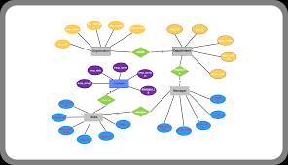

* TABLE REALTION:

In the **Employee Management System (EMS)**, different tables are created to store data in a structured and organized manner. These tables are linked together using **foreign keys**, establishing relationships between them. The relationships ensure data integrity and allow for efficient querying and reporting across different data entities.

Below are the key tables and their relationships:

### **1. Employees Table:**

This table stores basic information about each employee in the system.

| **Column Name** | **Data Type** | **Description** |
| --- | --- | --- |
| employee_id (PK) | INT | Unique identifier for the employee (Primary Key) |
| first_name | VARCHAR(50) | Employee’s first name |
| last_name | VARCHAR(50) | Employee’s last name |
| gender | VARCHAR(10) | Employee’s gender (e.g., Male, Female) |
| date_of_birth | DATE | Employee’s date of birth |
| email | VARCHAR(100) | Employee’s email address |
| phone_number | VARCHAR(15) | Employee’s contact number |
| address | TEXT | Employee’s home address |
| emergency_contact_name | VARCHAR(50) | Emergency contact’s name |
| emergency_contact_phone | VARCHAR(15) | Emergency contact’s phone number |
| date_of_joining | DATE | Date when the employee joined the company |
| job_title | VARCHAR(100) | Employee’s job title |
| department_id (FK) | INT | References the Department table (Foreign Key) |
| salary | DECIMAL(10, 2) | Employee’s salary |

### **2. Departments Table:**

This table stores information about the different departments within the company.

| **Column Name** | **Data Type** | **Description** |
| --- | --- | --- |
| department_id (PK) | INT | Unique identifier for the department (Primary Key) |
| department_name | VARCHAR(100) | Name of the department (e.g., HR, Finance, IT) |
| manager_id (FK) | INT | Employee ID of the department manager (Foreign Key) |

### **3. Attendance Table:**

This table records the attendance data for each employee, tracking whether they were present, late, or absent.

| **Column Name** | **Data Type** | **Description** |
| --- | --- | --- |
| attendance_id (PK) | INT | Unique identifier for each attendance record (Primary Key) |
| employee_id (FK) | INT | References the Employees table (Foreign Key) |
| date | DATE | Date of the attendance record |
| clock_in_time | TIME | Time the employee clocks in |
| clock_out_time | TIME | Time the employee clocks out |
| status | VARCHAR(20) | Attendance status (Present, Absent, Late, On Leave, etc.) |
| working_hours | DECIMAL(5, 2) | Total working hours for the day |

### **4. Payroll Table:**

This table stores payroll-related data, including salary details, deductions, and bonuses.

| **Column Name** | **Data Type** | **Description** |
| --- | --- | --- |
| payroll_id (PK) | INT | Unique identifier for the payroll record (Primary Key) |
| employee_id (FK) | INT | References the Employees table (Foreign Key) |
| basic_salary | DECIMAL(10, 2) | Employee’s basic salary |
| allowances | DECIMAL(10, 2) | Allowances added to the employee’s salary (e.g., travel) |
| deductions | DECIMAL(10, 2) | Deductions (e.g., tax, insurance) |
| bonus | DECIMAL(10, 2) | Bonus payments |
| net_salary | DECIMAL(10, 2) | Final salary after deductions and additions |
| payment_date | DATE | Date when the salary was paid |

### **5. Leave Table:**

This table records leave requests and approvals for each employee.

| **Column Name** | **Data Type** | **Description** |
| --- | --- | --- |
| leave_id (PK) | INT | Unique identifier for the leave record (Primary Key) |
| employee_id (FK) | INT | References the Employees table (Foreign Key) |
| leave_type | VARCHAR(50) | Type of leave (e.g., Sick Leave, Vacation, Maternity) |
| leave_start_date | DATE | Start date of the leave |
| leave_end_date | DATE | End date of the leave |
| leave_status | VARCHAR(20) | Leave status (approved, pending, rejected) |
| leave_days | INT | Total days of leave taken |

### **6. Performance Table:**

This table tracks the performance evaluations for each employee.

| **Column Name** | **Data Type** | **Description** |
| --- | --- | --- |
| performance_id (PK) | INT | Unique identifier for the performance record (Primary Key) |
| employee_id (FK) | INT | References the Employees table (Foreign Key) |
| review_date | DATE | Date of the performance review |
| performance_rating | INT | Rating of the employee's performance (e.g., 1-5) |
| manager_comments | TEXT | Comments from the manager regarding performance |
| goals_set | TEXT | Goals set for the employee during the review period |
| achievements | TEXT | Achievements during the review period |

### **Relationships Between Tables:**

1. **Employee and Department**:
   * **Relationship**: One-to-many.
   * **Explanation**: An employee belongs to a specific department. Each department can have multiple employees.
   * **Foreign Key**: department_id in the Employees table references the department_id in the Departments table.
2. **Employee and Attendance**:
   * **Relationship**: One-to-many.
   * **Explanation**: An employee can have multiple attendance records (one for each day).
   * **Foreign Key**: employee_id in the Attendance table references the employee_id in the Employees table.
3. **Employee and Payroll**:
   * **Relationship**: One-to-one.
   * **Explanation**: Each employee has one payroll record (one salary payment per month).
   * **Foreign Key**: employee_id in the Payroll table references the employee_id in the Employees table.
4. **Employee and Leave**:
   * **Relationship**: One-to-many.
   * **Explanation**: An employee can apply for multiple leaves.
   * **Foreign Key**: employee_id in the Leave table references the employee_id in the Employees table.
5. **Employee and Performance**:
   * **Relationship**: One-to-many.
   * **Explanation**: An employee can have multiple performance evaluations.
   * **Foreign Key**: employee_id in the Performance table references the employee_id in the Employees table.

* TABLE CREATION:

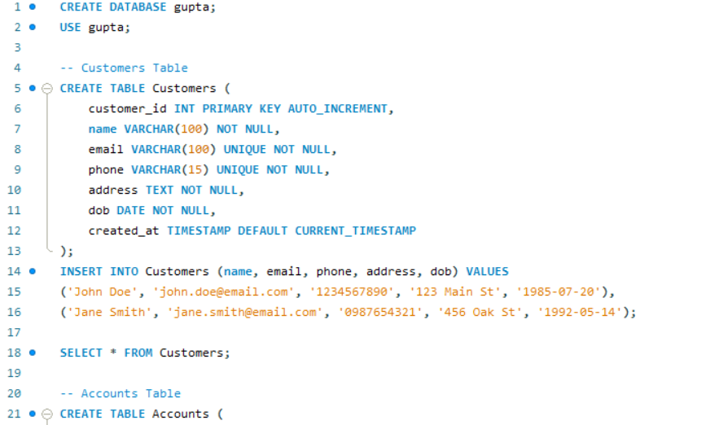

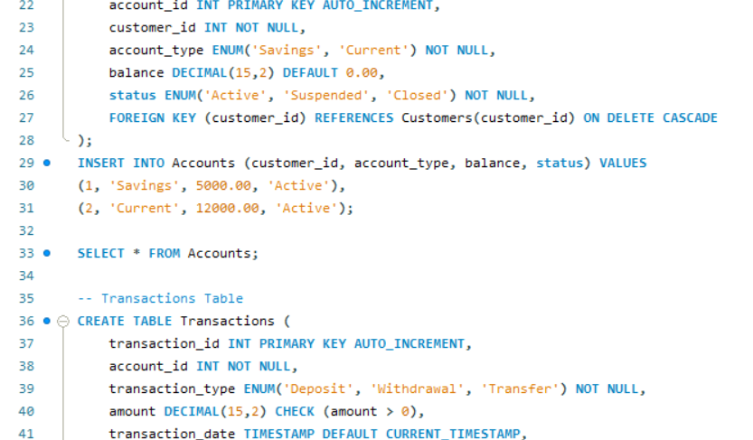

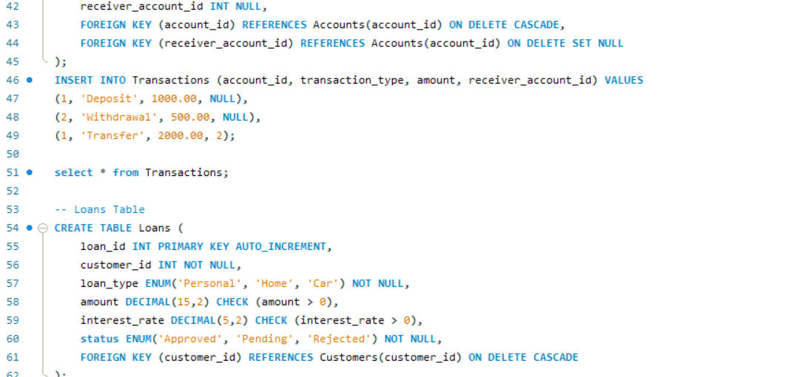

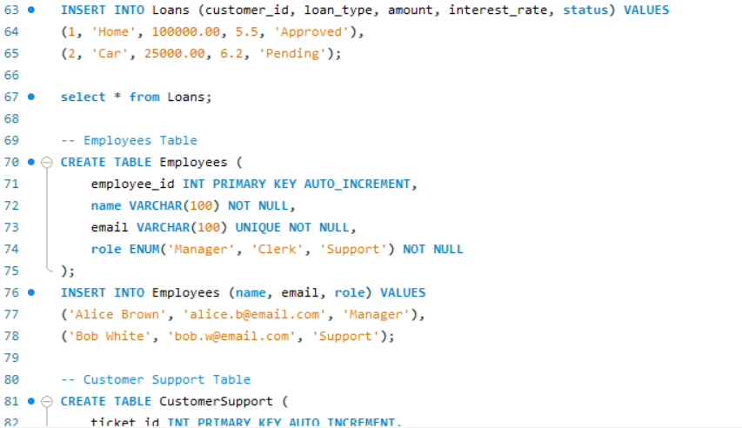

* SQL QUERIES WITH OUTPUT:

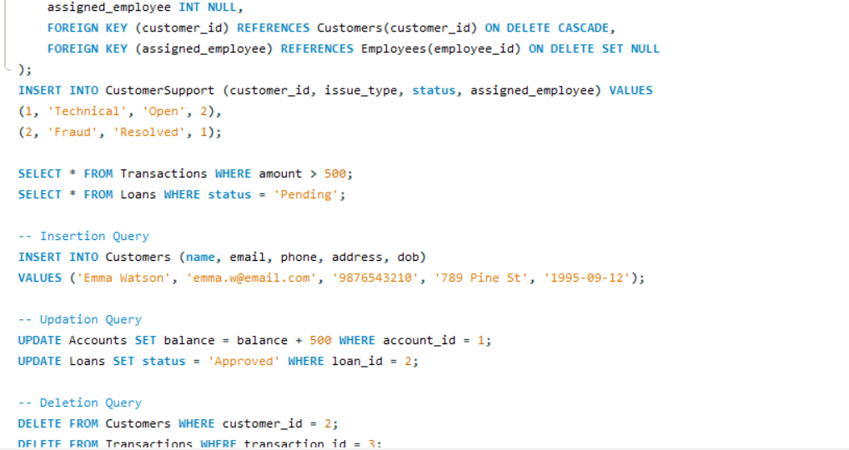

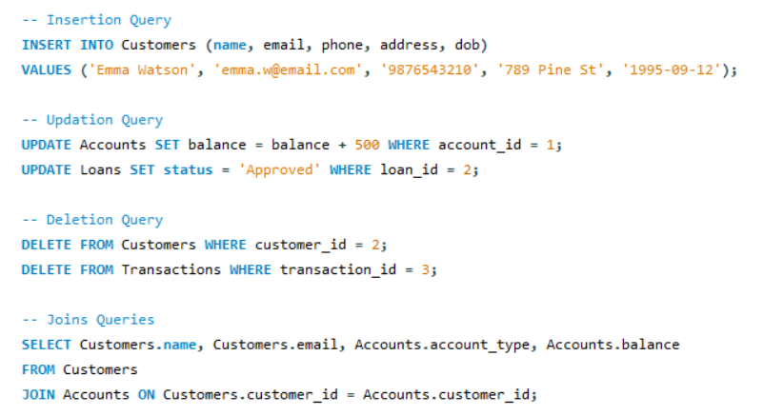

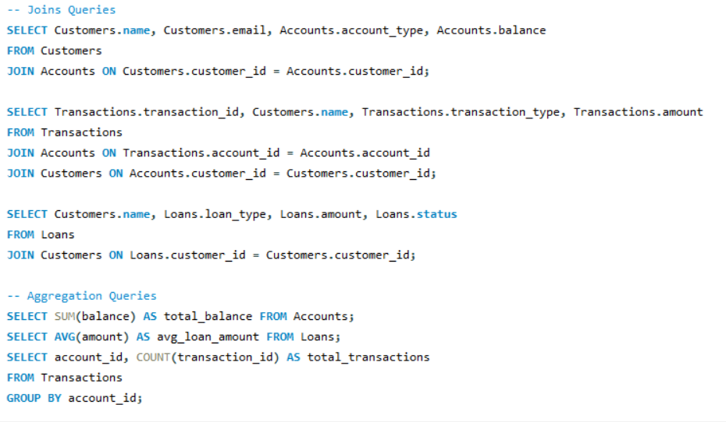

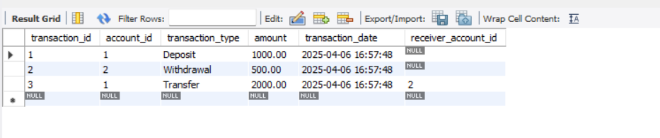

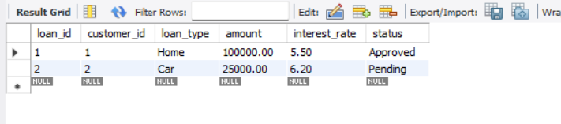

* SUMMARY:

The **Employee Management System (EMS)** is designed to efficiently manage employee-related data, providing an organized and streamlined approach for HR departments to track various employee activities such as attendance, payroll, leave requests, performance evaluations, and department management. The system is built using a relational database management system (RDBMS) where data is stored across multiple interrelated tables.

The core features and functionalities of the **EMS** include:

1. **Employee Information Management:**
   * The **Employees** table stores essential personal and professional details of employees, such as name, job title, department, salary, and contact information. This data serves as the backbone for other features in the system.
2. **Department Management:**
   * The **Departments** table tracks different organizational departments and their respective managers. Employees are linked to departments, providing clarity about their roles and reporting structures.
3. **Attendance Management:**
   * The **Attendance** table helps in tracking employee attendance on a daily basis. This table stores clock-in and clock-out times, attendance status (present, absent, late), and working hours. It is crucial for payroll calculation and employee performance analysis.
4. **Payroll System:**
   * The **Payroll** table handles the generation of employee salaries, taking into account allowances, bonuses, deductions, and taxes. This table ensures accurate salary calculations and timely payment processing.
5. **Leave Management:**
   * The **Leave** table records employee leave requests, including details about leave type, duration, approval status, and remaining leave balance. This helps in efficiently managing employee absences and ensuring compliance with company policies.
6. **Performance Management:**
   * The **Performance** table stores performance evaluations for employees, including ratings, manager comments, and goal achievements. This data assists in making decisions regarding promotions, salary increases, and training programs.
7. **Relational Integrity:**
   * The tables are connected using foreign keys, establishing relationships that ensure data integrity and facilitate easy retrieval of related information. For example, employee data is linked to attendance, payroll, leave, and performance records, providing a comprehensive view of each employee’s status.
8. **User-Friendly Interface:**
   * The system is designed to be user-friendly, providing intuitive dashboards and reports for HR personnel, managers, and administrators to monitor and manage employee data efficiently.
9. **Data Security and Access Control:**
   * Sensitive data such as payroll information and performance reviews are secured within the system with appropriate access controls, ensuring only authorized personnel can access confidential information.

### **Key Benefits of the System:**

* **Efficiency:** Automation of routine HR tasks like attendance tracking, payroll calculation, and leave management saves time and reduces manual errors.
* **Accuracy:** The system ensures accurate record-keeping, especially for payroll calculations and leave balances, avoiding human errors.
* **Centralized Data:** All employee data is stored in one place, making it easier to update, retrieve, and analyze employee-related information.
* **Compliance:** By tracking attendance, leave, and performance data, the system helps ensure that the company complies with labor laws and internal policies.
* **Scalability:** The system can be easily scaled to accommodate the growing number of employees, with the ability to add more departments, employees, and other related features.
* CONCLUSION:

The **Employee Management System (EMS)** offers a robust and efficient solution for managing employee data, streamlining human resources functions, and enhancing organizational productivity. By leveraging a well-structured relational database, the system provides a centralized platform to track and manage various aspects of employee management, including personal information, attendance, payroll, leave, and performance evaluations.

Through the integration of multiple tables and relationships between them, the EMS ensures data consistency, accuracy, and integrity across all aspects of HR operations. The use of foreign keys and relational design allows for seamless data retrieval and analysis, which supports timely decision-making, accurate payroll processing, and effective management of employee performance.

The system brings numerous benefits to organizations, such as:

1. **Efficiency** in managing day-to-day HR tasks, reducing manual work and human errors.
2. **Accuracy** in payroll calculations, leave management, and performance assessments, ensuring fair and consistent treatment of all employees.
3. **Improved Decision-Making** with real-time reports and analytics, allowing HR professionals and managers to make informed decisions regarding promotions, salary hikes, training, and employee retention.
4. **Employee Satisfaction** by providing transparent and accessible records related to their attendance, leave, and performance, contributing to a positive work environment.
5. **Scalability** to accommodate future growth in the workforce, ensuring that the system remains effective as the organization expands.

In conclusion, the **Employee Management System** is a vital tool for modern HR management, fostering a more organized, streamlined, and effective approach to employee data management. By automating and centralizing key HR functions, it helps organizations focus on their strategic goals, while ensuring compliance with legal and internal policies. The EMS is an essential component of any company looking to improve its HR processes and maintain a satisfied and productive workforce.