Steve Guerrero

ECPE 155

Prelab 5

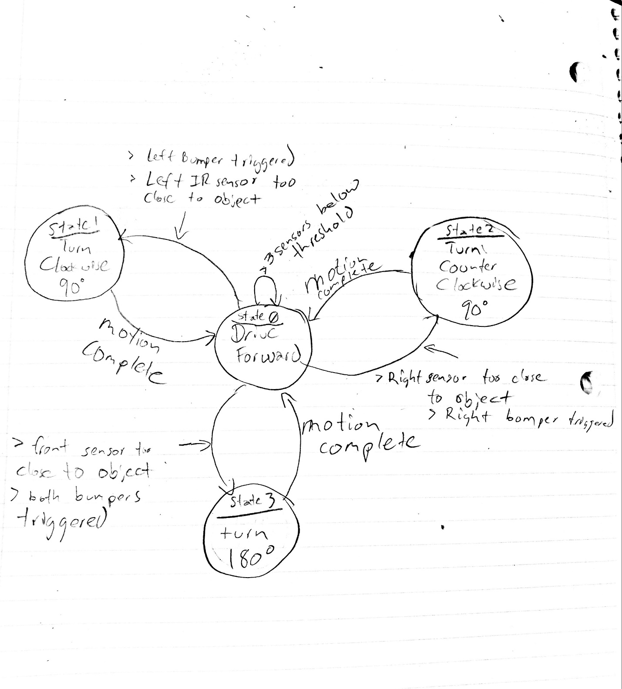

Pseudocode (kinda)

“Assuming” front sensor has an overall lower reading than left or right sensors

if((IR_Front<=1000) && (IR_RIGHT<=2100) && (IR_LEFT<=1950)){

//Keep driving forward until an object is detected

all_FWD(); // both wheels forward

}else if((IR_FRONT>1000) && (IR_RIGHT<=2100) && (IR_LEFT<=1950)){

//Front sensor detects an obstacle, stop bust a U and drive in opposite direction

CW_90(); // rotate clockwise 90 degrees

CW_90(); // rotate clockwise 90 degrees

all_FWD(); // both wheels forward

}else if((IR_FRONT>1000) && (IR_RIGHT>2100) && (IR_LEFT<=1950)){

//Front and Right IR sensor detect obstacle, rotate CCW

CCW_90(); // rotate counter clockwise 90 degrees

all_FWD(); // both wheels forward

}else if((IR_FRONT>1000) && (IR_RIGHT<=2100) && (IR_LEFT>1950)){

//Front and Left IR sensor detect obstacle, rotate CW

CW_90(); // rotate clockwise 90 degrees

all_FWD(); // both wheels forward

}else if((IR_FRONT<=1000) && (IR_RIGHT>3000) && (IR_LEFT<=1950)){

//Robot is driving too close to an obstacle on the Right, rotate CCW

CCW_90(); // rotate counter clockwise 90 degrees

all_FWD(); // both wheels forward

}else if((IR_FRONT<=1000) && (IR_RIGHT<=2100) && (IR_LEFT>3000)){

//Robot is driving too close to an obstacle on the Left, rotate CW

CW_90(); // rotate clockwise 90 degrees

all_FWD(); // both wheels forward

}else{

//Keep driving forward

all_FWD(); // both wheels forward

}