**Name : Vikhyat Yadav**

**Enroll: 9918103204**

**Batch: F7**

**Week 2 OSS**

**Github Link:** [https://github.com/Sirvikhyatyadav/OSS-Lab2](https://github.com/Amanjakhetiya/OSS_LAB_2)

**Q1.**

print("hello, world!\n" * 4)

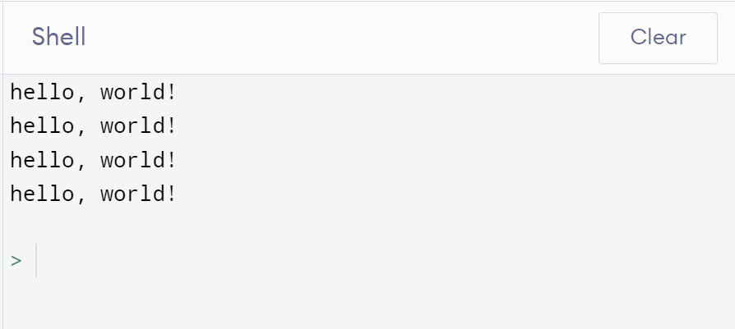

**Q2.**

def Duplicate(l):

l1=[]

for i in l:

if i not in l1:

l1.append(i)

else:

print(i,end=' ')

l = [1,2,3,4,5,5,7,8,8,2,1]

Duplicate(l)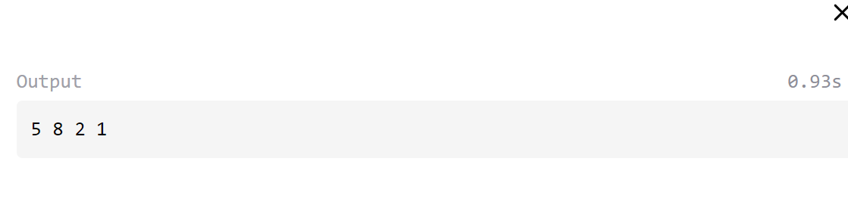

**Q3.**

def Group(l,si):

l1=[]

ans=[]

for i in range(0,len(l)):

k=i%si

if k==0:

if len(l1)==0:

l1.append(l[i])

else:

ans.append(l1)

l1=[]

l1.append(l[i])

else:

l1.append(l[i])

if len(l1)!=0:

ans.append(l1)

return ans

l = [1,2,3,4,5,5,7,8,8,2,1]

final = Group(l,4)

for i in final:

print(i,end=' ')

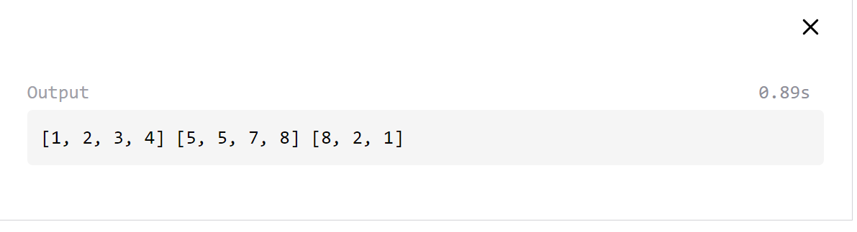

**Q4.**

def Lensort(l):

l = sorted(l,key=len)

for i in l:

print(i,end=' ')

l= ["Vikhyat","Yadav","Ankit"]

Lensort(l)

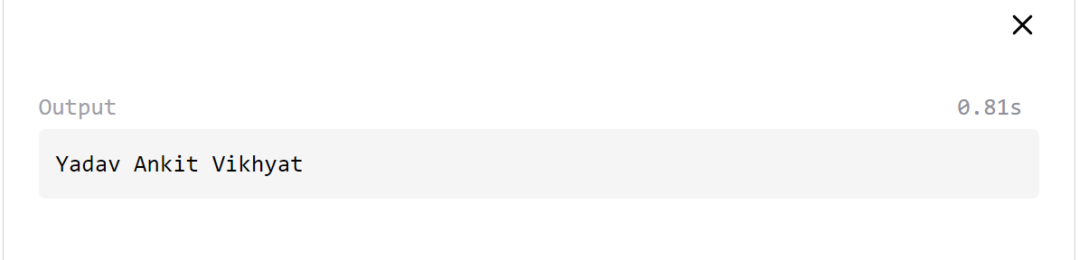

**Q5.**

def Extsort(l):

l = sorted(l,key=lambda x:x.split('.')[1])

print(l)

l = ['a.py','b.exe','c.jpg','d.cpp']

Extsort(l)

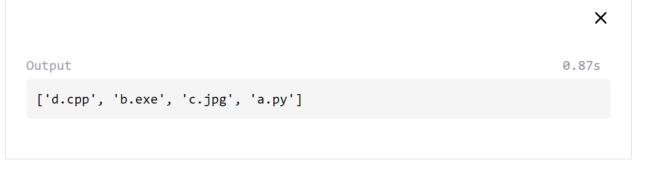

**Q6.**

with open('Intro.txt','r') as W:

#read

print(W.read(),end='\n')

with open('Intro.txt','r') as W:

#readline

print(W.readline(),end='\n')

with open('Intro.txt','a') as W:

#write

W.write('I am in my 3rd year')

# W.writeline('Hello')

# print(W.read(),end='\n')

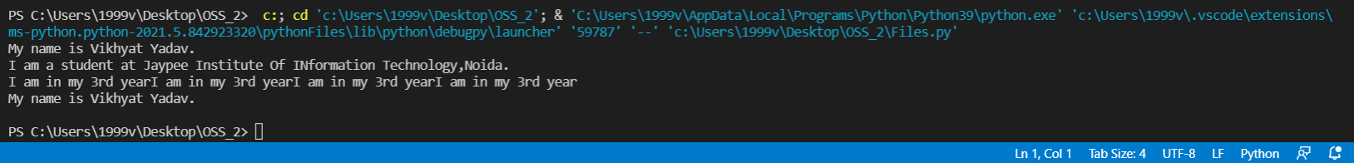

**Q7.**

with open('Intro.txt','r') as W:

no_of_lines=0

no_of_words=0

no_of_characters=0

for line in W:

line=line.strip("\n")

words=line.split()

no_of_words=len(words)

no_of_lines+=1

no_of_characters=len(line)

print("Words:",no_of_words,"Characters:",no_of_characters,"Lines:",no_of_lines)

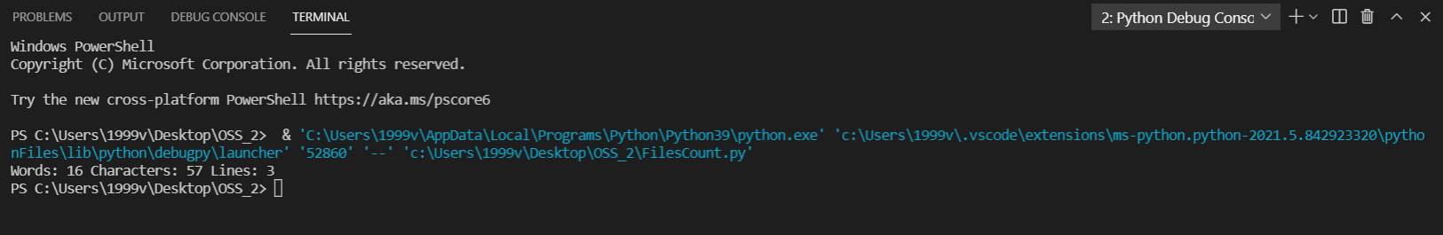

**Q8.**

with open('Intro.txt','r') as W:

k=W.readlines()

t=reversed(k)

for i in t:

print(i.rstrip(),end='\n')



**Q9.**

with open('Intro.txt','r') as W:

k=W.readlines()

k = [i.rstrip()[::-1] for i in k]

print(k)

