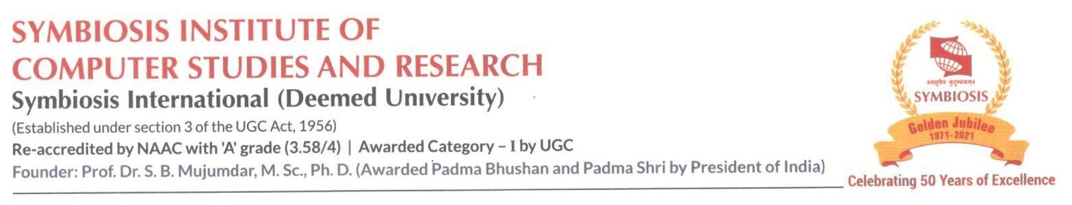

Date : 15th Dec 2022

Permission Letter

Dear Sishir Rijal, 21030121245

With reference to the project topic idea discussion with regards to fulfilling the requirement of the Bachelor of Computer Application batch 2021-2024, Sem IV Project, you have been given permission to undertake a project from Dec 2022 to April 2023 with the topic “Voltaire: Overseas Education Consultancy”. On successful completion of the project, you will receive a certificate from the SICSR. We approve the above-mentioned project title.

We wish you all the best in your project work.

 

Dr.Priti Kulkarni Dr.Priti Kulkarni

Project Guide BCA Program Coordinator