MAKE MY MARRIAGE
API Design Document
Version 1.0 • V1 Implementation Contract

Decision | Finalized Choice
API style | REST over HTTPS
Base path | /api/v1
Backend | Node.js + Express.js on AWS Lambda
Validation | Zod on every public request boundary
Authentication | JWT access token + opaque refresh token in secure cookies
Authorization | Wedding-scoped RBAC + financeAccess
Database | MongoDB Atlas + Mongoose
Media | Cloudflare R2 direct uploads
Email | Resend
Version status | Approved baseline for implementation

Purpose: define the HTTP contract between the Next.js client and the Make My Marriage backend, including security, behavior, errors, permissions and evolution rules.

Contents
1. Purpose and Scope
2. API Design Goals
3. System Context
4. Global API Conventions
5. Authentication and Session Contract
6. Authorization and Tenant Isolation
7. Standard Response and Error Model
8. Query, Pagination, Sorting and Search
9. Concurrency and Idempotency
10. V1 Endpoint Catalog
11. Key Request / Response Contracts
12. Critical API Flows
13. Delete, Restore and Relationship Rules
14. Rate Limiting and Abuse Protection
15. Observability and Auditability
16. API Documentation and Testing
17. Future Version Compatibility
18. Deployment and Gateway Rules
19. Architecture Decisions
20. Recommended Implementation Order

1. Purpose and Scope
This document is the implementation-level API contract for Make My Marriage. It converts the approved product, system architecture and database decisions into a consistent REST interface for the web client. V1 endpoints are implementation targets; V2–V5 endpoints are compatibility plans and may be refined when those versions are designed.
- Covers public HTTP APIs exposed through Amazon API Gateway to the Next.js application.
- Defines authentication cookies, authorization checks, validation, response envelopes, errors, pagination, concurrency, idempotency and soft-delete behavior.
- Defines V1 endpoint inventory for auth, user profile, weddings, members, invitations, events, tasks, checklist, dashboard, activity and media.
- Keeps guests outside the internal dashboard. Guest-facing APIs are introduced later through the public wedding website and RSVP flows.

2. API Design Goals
Goal | Design Rule
Simple to build | Conventional REST; no GraphQL, gRPC or microservice gateway complexity in V1.
Secure by default | Every protected request authenticates the session and verifies wedding membership server-side.
Predictable | Plural resource names, consistent envelopes, status codes, validation errors and pagination.
Safe collaboration | Optimistic concurrency prevents silent overwrites; critical POSTs support idempotency.
Low cost | Serverless-friendly endpoints; direct R2 uploads keep binary traffic away from Lambda.
Future-ready | Wedding ID is explicit in resource paths so multi-wedding support can be added later without redesigning the API.
Backward-compatible | Versioned base path; non-breaking additions preferred within v1.

3. System Context
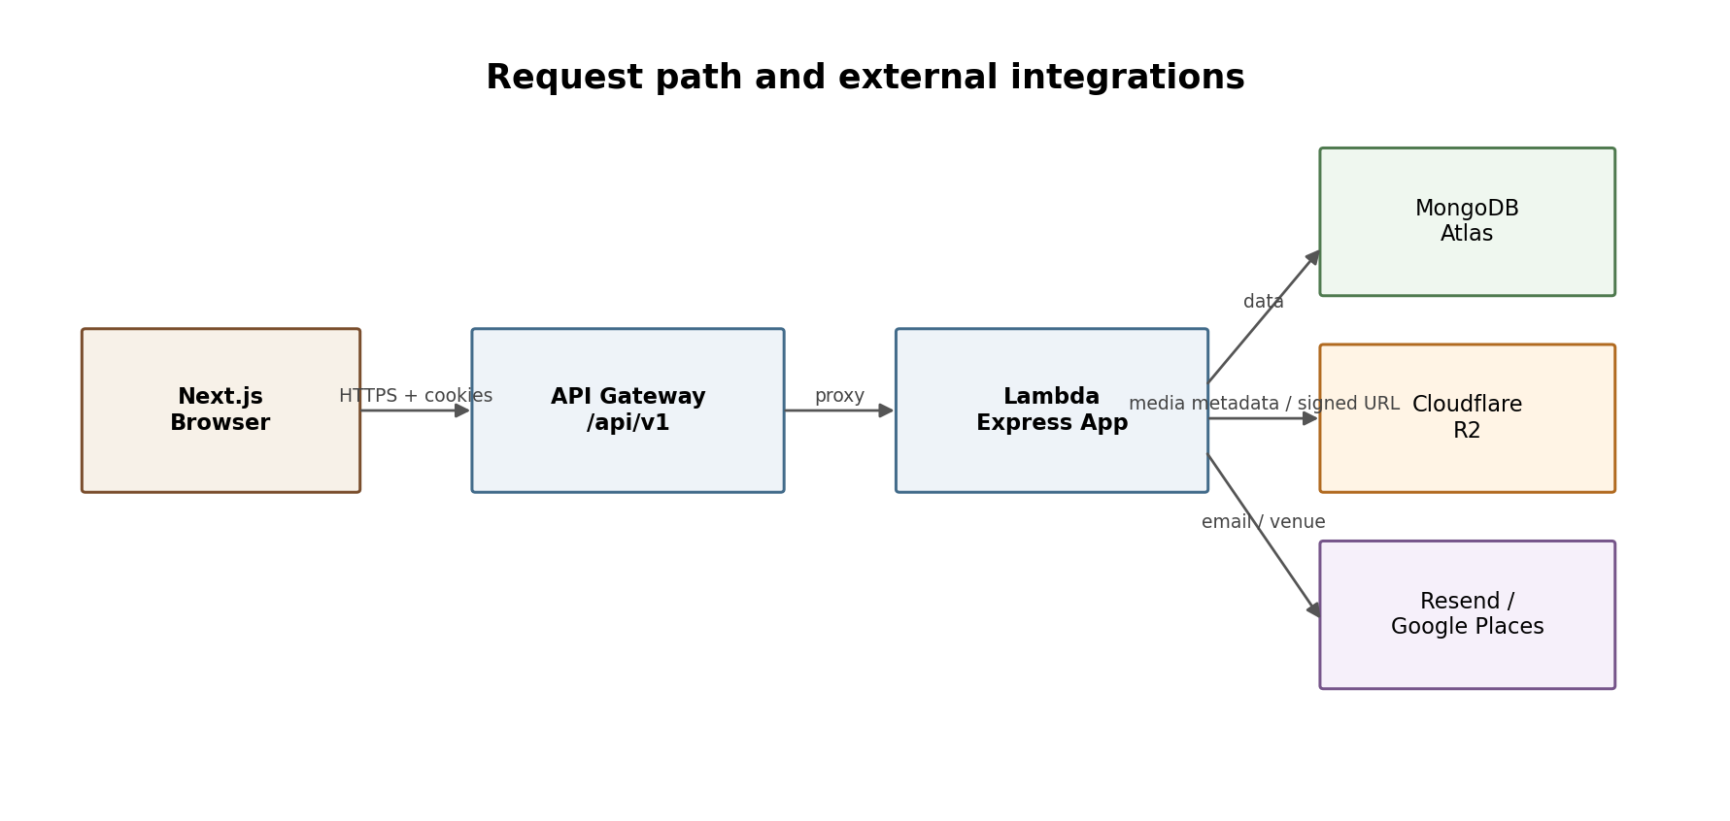
The API is the only trusted business-logic boundary. Frontend validation improves UX but never replaces backend Zod validation, authorization or database constraints.

4. Global API Conventions
Area | Standard
Base URL | https://<api-host>/api/v1
Transport | HTTPS only outside local development
Payload | application/json; UTF-8
Resource naming | Plural nouns; lower-case path segments; IDs use MongoDB ObjectId strings
Dates/times | ISO-8601 strings in UTC; UI converts to wedding/user locale
Money | Integer minor units (paise) in APIs and DB; never floating-point currency
Booleans | true / false only
Nullability | Use null only when absence is meaningful; omit unknown optional input fields
Request IDs | Every response includes x-request-id; client may send x-correlation-id
Versioning | URI versioning with /api/v1
Mutation format | PATCH for partial update; POST for actions; DELETE for soft delete
Unknown fields | Rejected on sensitive write schemas where practical using strict Zod objects

4.1 Resource path pattern
/api/v1/weddings/{weddingId}/events
/api/v1/weddings/{weddingId}/events/{eventId}
/api/v1/weddings/{weddingId}/tasks/{taskId}
Although V1 allows a user to belong to only one wedding, the wedding identifier remains explicit in scoped URLs. This makes authorization boundaries visible and avoids breaking the API if multi-wedding support is added later.

5. Authentication and Session Contract
V1 uses first-party email/password authentication. The backend issues a short-lived JWT access token and a rotating opaque refresh token. Both are delivered through secure HTTP-only cookies; the refresh token is stored only as a hash in MongoDB.
Item | Recommended V1 Behavior
Access token | JWT, approximately 15 minutes; contains userId and sessionId, not mutable role permissions.
Refresh token | Cryptographically random opaque token; ~30-day persistence; rotate on every refresh; store hash only.
Access cookie | HttpOnly, Secure, SameSite=None where staging/prod hosts are cross-site; Path=/api/v1.
Refresh cookie | HttpOnly, Secure, SameSite=None; narrow Path=/api/v1/auth.
CSRF | Double-submit CSRF token + X-CSRF-Token for unsafe methods; also validate Origin/Referer.
CORS | Explicit allow-list for known frontend origins; credentials=true; never wildcard with credentials.
Logout | Revokes current refresh session and clears auth cookies.
Email verification | Required before dashboard access.
Password reset | Single-use expiring token; ~30 minutes; token hash stored server-side.
Member invitation | Single-use token, tied to invited email, expires after 7 days.

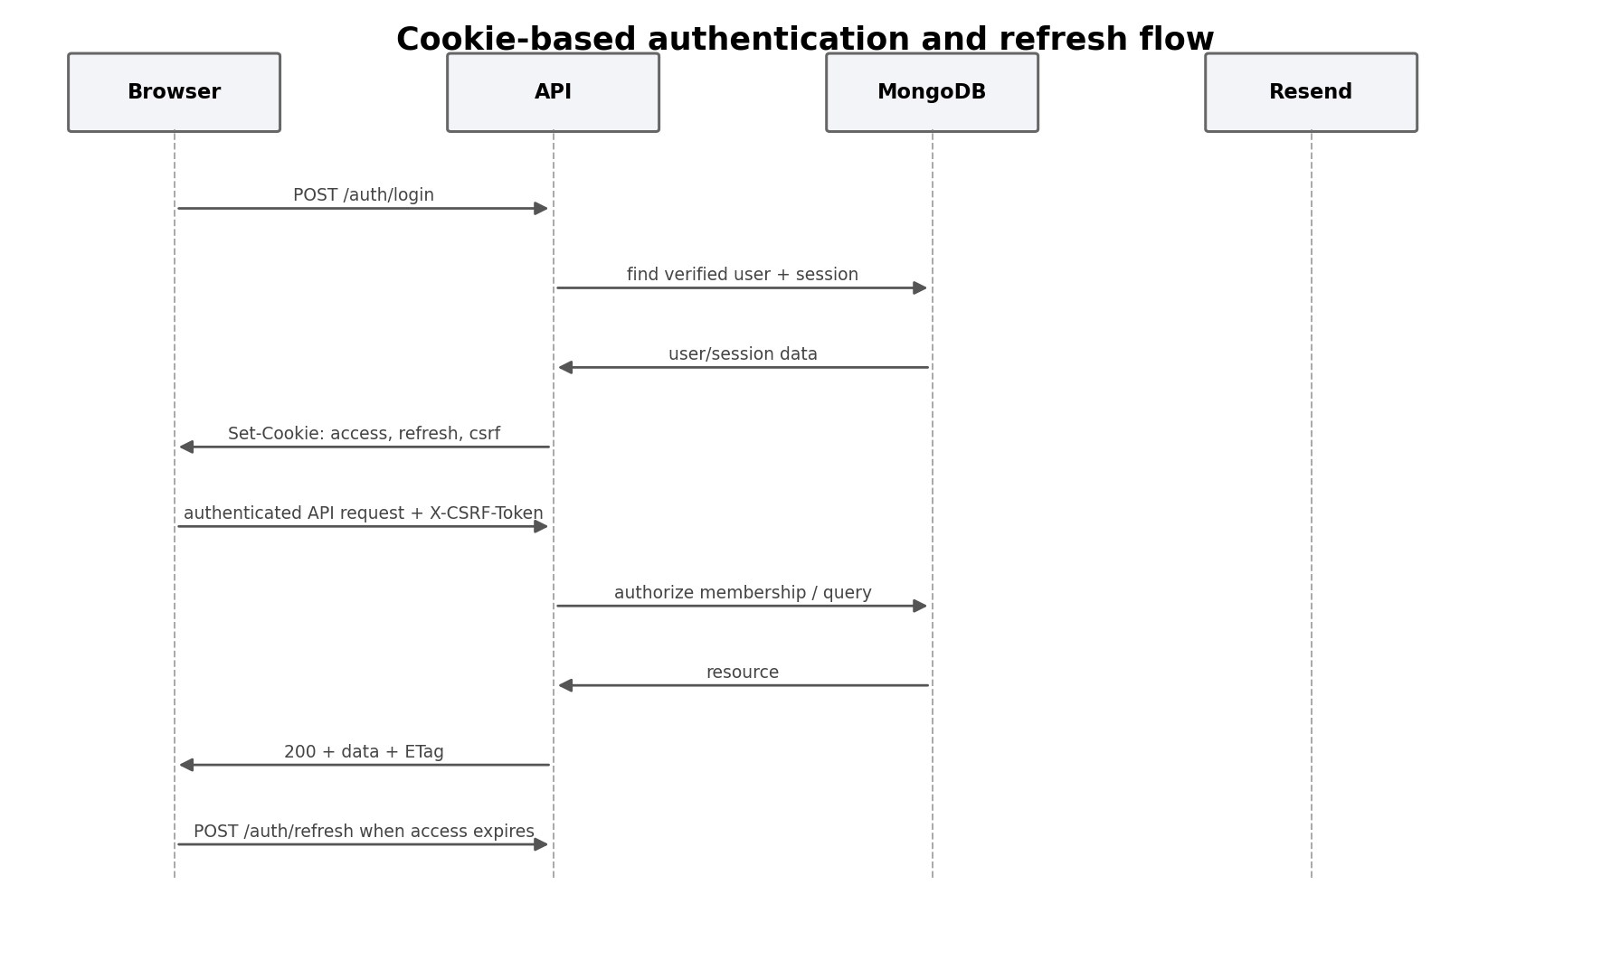

5.1 Auth endpoints
Method | Path | Purpose | Access
POST | /auth/register | Create unverified account and send verification email | Public
POST | /auth/verify-email | Verify email using one-time token | Public
POST | /auth/resend-verification | Issue a new verification email with throttling | Public
POST | /auth/login | Authenticate and create session cookies | Public
POST | /auth/refresh | Rotate refresh token and issue new access token | Refresh cookie
POST | /auth/logout | Revoke current device session | Authenticated
GET | /auth/session | Return current user/session/wedding context | Authenticated
POST | /auth/forgot-password | Send reset link without disclosing whether account exists | Public
POST | /auth/reset-password | Set new password using valid reset token | Public

6. Authorization and Tenant Isolation
Authentication proves identity; authorization is always resolved using current database state. Role changes therefore take effect immediately even if an older access JWT still exists.
Capability | Admin | Family Member | Viewer
Read normal wedding/event/task data | Yes | Yes | Yes
Create/update events and tasks | Yes | Yes | No
Manage members/roles | Yes | No | No
Manage wedding settings | Yes | No | No
Read/manage finance | Yes | Only if financeAccess=true | No
Delete/restore important records | Yes | Limited by resource policy | No

6.1 Required server-side checks
- Validate weddingId format before querying.
- Load active WeddingMember membership for (userId, weddingId).
- Reject soft-deleted wedding/member contexts except dedicated restore flows.
- Check role/financeAccess for the requested action.
- Query child resources with both _id and weddingId to prevent cross-wedding ID tampering.
- Never trust role, weddingId or financeAccess supplied by the client body.

7. Standard Response and Error Model

7.1 Success envelope
{
"success": true,
"data": { ... },
"meta": { ... optional pagination/summary ... }
}

7.2 Error envelope
{
"success": false,
"error": {
"code": "EVENT_VERSION_CONFLICT",
"message": "This event was changed by another member.",
"details": [{ "field": "startAt", "issue": "..." }]
},
"requestId": "..."
}
HTTP | Use
200 | Successful read/update/action
201 | Resource created
202 | Accepted for async work or non-disclosing email action
204 | Successful action with no body when appropriate
400 | Malformed request / invalid action
401 | Not authenticated / expired access with no valid refresh
403 | Authenticated but forbidden
404 | Resource not found in caller wedding context
409 | Conflict: duplicate, state conflict, version conflict
410 | Expired/consumed invitation or recovery window gone
422 | Semantically invalid validated input
429 | Rate limit exceeded
500 | Unexpected server error
503 | Dependency unavailable / temporary service failure

7.3 Stable error codes
Category | Examples
Auth | INVALID_CREDENTIALS, EMAIL_NOT_VERIFIED, SESSION_EXPIRED, CSRF_INVALID
Invitation | INVITATION_EXPIRED, INVITATION_USED, INVITATION_EMAIL_MISMATCH
Wedding | WEDDING_ALREADY_EXISTS, WEDDING_DELETED, LAST_ADMIN_PROTECTED
Validation | VALIDATION_ERROR, EVENT_TIME_INVALID, TASK_DUE_DATE_INVALID
Concurrency | VERSION_CONFLICT
Permissions | FORBIDDEN, FINANCE_ACCESS_REQUIRED
Media | UPLOAD_TYPE_NOT_ALLOWED, UPLOAD_TOO_LARGE, MEDIA_NOT_FOUND

8. Query, Pagination, Sorting and Search
Concern | Convention
Pagination | ?page=1&limit=20; default 20; maximum 100
Sorting | ?sort=dueAt&order=asc; allow-list sortable fields
Search | ?q=keyword; sanitize input and use indexed/searchable fields where practical
Filtering | Explicit query keys such as status, priority, assigneeId, eventId, from, to
Soft delete | Normal list/read excludes deletedAt != null; admin recovery endpoints opt in to deleted data
Empty results | 200 with data: [] and pagination meta; never 404 for empty collections

GET /api/v1/weddings/{weddingId}/tasks?page=1&limit=20&status=IN_PROGRESS&priority=HIGH&assigneeId=...&sort=dueAt&order=asc

9. Concurrency and Idempotency

9.1 Optimistic concurrency
Mutable resources return an ETag derived from the record version. PATCH/DELETE requests for collaborative resources send If-Match. A stale version returns 409 VERSION_CONFLICT instead of silently overwriting another member’s update.
GET /events/123 -> ETag: "7"
PATCH /events/123
If-Match: "7"
If current version is 8 -> 409 VERSION_CONFLICT

9.2 Idempotency
Critical create/action endpoints accept an Idempotency-Key header. The server stores a short-lived key/result record so double-clicks, retries or Lambda/network retries do not create duplicates.
Recommended idempotent actions | Reason
POST /weddings | Prevent duplicate wedding creation
POST member invitation | Prevent duplicate active invitations
POST /checklists/generate | Prevent duplicate generated tasks
POST /media/complete | Prevent duplicate media metadata
Future payment/expense actions | Avoid duplicate financial records

10. V1 Endpoint Catalog
All protected wedding-scoped endpoints require active membership in {weddingId}. “Family+” means Admin or Family Member unless otherwise stated.

10.1 User profile
Method | Path | Purpose | Access
GET | /users/me | Current profile | Authenticated
PATCH | /users/me | Update name/basic profile | Authenticated
DELETE | /users/me/profile-image | Detach profile photo; schedule R2 cleanup | Authenticated

10.2 Wedding
Method | Path | Purpose | Access
POST | /weddings | Create the user’s wedding; creator becomes Admin | Verified user
GET | /weddings/{weddingId} | Read wedding | Member
PATCH | /weddings/{weddingId} | Update wedding settings | Admin
DELETE | /weddings/{weddingId} | Soft delete wedding and start 7-day recovery | Admin
POST | /weddings/{weddingId}/restore | Restore during recovery window | Admin / creator recovery flow
DELETE | /weddings/{weddingId}/cover-image | Detach cover image and queue cleanup | Admin

10.3 Members and invitations
Method | Path | Purpose | Access
GET | /weddings/{weddingId}/members | List members | Member
PATCH | /weddings/{weddingId}/members/{memberId} | Change role / financeAccess | Admin
DELETE | /weddings/{weddingId}/members/{memberId} | Remove member; protect last Admin | Admin
GET | /weddings/{weddingId}/invitations | List active/history invitations | Admin
POST | /weddings/{weddingId}/invitations | Create invite + send via Resend | Admin
POST | /weddings/{weddingId}/invitations/{id}/resend | Rotate/resend invite token | Admin
DELETE | /weddings/{weddingId}/invitations/{id} | Revoke active invitation | Admin
GET | /member-invitations/{token} | Preview invitation metadata | Public token
POST | /member-invitations/{token}/accept | Accept after login/register; email must match | Authenticated

10.4 Events and activities
Method | Path | Purpose | Access
GET | /weddings/{weddingId}/events | List/filter events | Member
POST | /weddings/{weddingId}/events | Create event | Family+
GET | /weddings/{weddingId}/events/{eventId} | Event details | Member
PATCH | /weddings/{weddingId}/events/{eventId} | Partial update with If-Match | Family+
DELETE | /weddings/{weddingId}/events/{eventId} | Soft delete; no cascade deletion | Admin / policy
POST | /weddings/{weddingId}/events/{eventId}/restore | Restore deleted event | Admin
POST | /weddings/{weddingId}/events/{eventId}/activities | Add lightweight activity | Family+
PATCH | /weddings/{weddingId}/events/{eventId}/activities/{activityId} | Update activity | Family+
DELETE | /weddings/{weddingId}/events/{eventId}/activities/{activityId} | Remove activity | Family+

10.5 Tasks
Method | Path | Purpose | Access
GET | /weddings/{weddingId}/tasks | List/search/filter tasks | Member
POST | /weddings/{weddingId}/tasks | Create task; optional recurrence | Family+
GET | /weddings/{weddingId}/tasks/{taskId} | Task details | Member
PATCH | /weddings/{weddingId}/tasks/{taskId} | Update status, assignees, due date etc. | Family+
DELETE | /weddings/{weddingId}/tasks/{taskId} | Soft delete task | Family+
POST | /weddings/{weddingId}/tasks/{taskId}/restore | Restore task | Admin / creator policy
GET | /weddings/{weddingId}/tasks/my | Current user’s assigned tasks | Member

10.6 Checklist
Method | Path | Purpose | Access
GET | /checklist-templates | List available generic templates | Authenticated
POST | /weddings/{weddingId}/checklists/generate | Generate normal tasks from selected template | Admin / Family
GET | /weddings/{weddingId}/checklists/generations | Generation history / source metadata | Member

10.7 Dashboard and activity
Method | Path | Purpose | Access
GET | /weddings/{weddingId}/dashboard | Aggregated countdown, progress, tasks, events, attention items | Member
GET | /weddings/{weddingId}/activity | Paginated audit/activity feed | Member

10.8 Media
Method | Path | Purpose | Access
POST | /weddings/{weddingId}/media/upload-url | Validate type/size and return R2 signed upload URL | Family+ / owner policy
POST | /weddings/{weddingId}/media/complete | Confirm object and persist metadata/ownership | Family+ / owner policy
GET | /weddings/{weddingId}/media/{mediaId} | Read metadata / authorized signed read URL if private | Member / policy
DELETE | /weddings/{weddingId}/media/{mediaId} | Detach/soft delete metadata; async R2 cleanup when orphaned | Owner/Admin policy

11. Key Request / Response Contracts

11.1 Login
POST /api/v1/auth/login
{
"email": "user@example.com",
"password": "********"
}
200
{
"success": true,
"data": {
"user": { "id": "...", "name": "...", "emailVerified": true },
"weddingContext": { "weddingId": "...", "role": "ADMIN", "financeAccess": true }
}
}
// response also sets access, refresh and csrf cookies

11.2 Create event
POST /api/v1/weddings/{weddingId}/events
Idempotency-Key: <uuid>
{
"name": "Reception",
"description": "Evening reception",
"startAt": "2027-02-10T12:30:00Z",
"endAt": "2027-02-10T17:30:00Z",
"status": "PLANNED",
"venue": {
"name": "Example Convention Centre",
"formattedAddress": "...",
"googlePlaceId": "...",
"latitude": 20.0,
"longitude": 85.0,
"city": "Bhubaneswar",
"state": "Odisha"
}
}

11.3 Update task with concurrency protection
PATCH /api/v1/weddings/{weddingId}/tasks/{taskId}
If-Match: "4"
X-CSRF-Token: <token>
{ "status": "COMPLETED" }
200 -> ETag: "5"
409 -> VERSION_CONFLICT if another user already changed version 4

11.4 Dashboard response shape
{
"success": true,
"data": {
"wedding": { "name": "...", "mainDate": "...", "daysRemaining": 92 },
"progress": { "completed": 18, "total": 42, "percent": 43 },
"taskSummary": { "todo": 12, "inProgress": 8, "completed": 18, "overdue": 4 },
"myTasks": [ ... ],
"upcomingEvents": [ ... ],
"attentionRequired": [ ... ],
"recentActivity": [ ... ]
}
}

12. Critical API Flows

12.1 Registration and verification
1. Client submits registration data.
2. API validates, normalizes email, checks uniqueness and hashes password.
3. User is created as unverified; verification token hash is stored.
4. API asks Resend to send a one-time link.
5. Verification endpoint consumes token, marks email verified and invalidates token.
6. Only verified users may enter protected wedding setup/dashboard flows.

12.2 Member invitation
1. Admin creates invitation for an email and role.
2. API prevents duplicate active invitation and signs/generates a secure random token; only hash is stored.
3. Resend sends the invite link; UI can also copy the link.
4. Recipient logs in or registers.
5. Accept endpoint requires authenticated email to match the invited email.
6. Transaction creates WeddingMember and marks invitation consumed.

12.3 Media upload
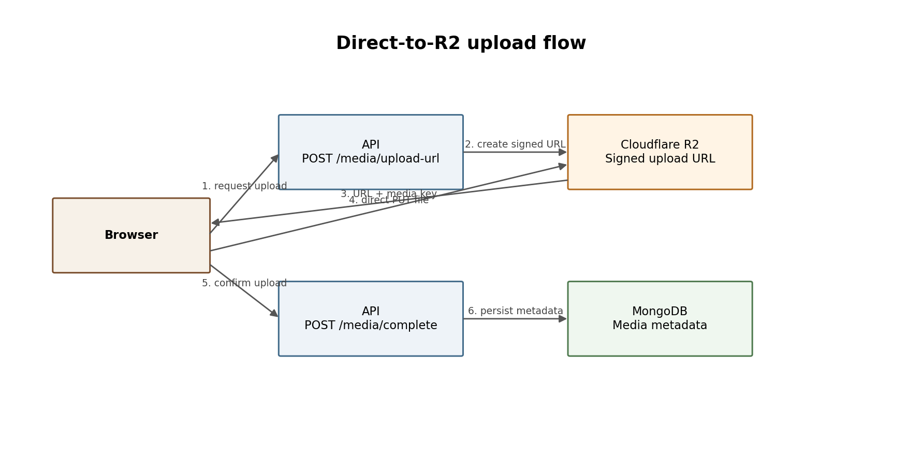
Binary file bytes should not be proxied through Lambda. The API authorizes the upload and owns metadata; the browser uploads directly to R2.

13. Delete, Restore and Relationship Rules
DELETE on important business resources means soft delete unless explicitly documented otherwise. Deleting a parent never blindly cascade-deletes important children or financial/audit history.
Deleted resource | API behavior
Wedding | Mark deleted; block normal access; allow 7-day restore. After recovery window, async purge may hard-delete wedding-owned data and orphaned R2 objects.
Event | Soft delete event. Tasks remain. Guest invitations/RSVP later become inactive/archived for that event. Vendors and expenses remain. Activity records the deletion.
Task | Soft delete task; retain history and source/checklist metadata.
Member | Deactivate/remove membership; unassign/reassign tasks as policy; never delete user account.
Media | Detach business reference; mark metadata deleted; queue physical R2 deletion only when no active reference remains.
Temporary security token | Hard-delete/TTL after expiry or consumption where appropriate.

13.1 Delete-impact preview
Before destructive actions such as deleting an event, the client may request impact metadata or the DELETE response may include counts. The UI should warn the Admin when related records exist.
{
"eventId": "...",
"impact": {
"tasks": 12,
"guestInvitations": 146,
"vendors": 3,
"expenseAmountPaise": 12500000
}
}

14. Rate Limiting and Abuse Protection
Endpoint family | Suggested initial policy
Login | Strict per IP + normalized email; progressive backoff
Forgot password / resend verification | Strict per IP + email; return non-disclosing responses
Invitation create/resend | Per Admin + wedding + target email
Public token endpoints | Per IP/token fingerprint; do not leak token state unnecessarily
Media upload URL | Per user/wedding plus file size/type caps
General authenticated API | Generous user/IP limit; protect against runaway clients

Exact numeric thresholds should be configuration values and tuned after observing normal usage. API Gateway throttling can provide a coarse outer limit; application-level limits protect account- or resource-specific actions.

15. Observability and Auditability
- Generate x-request-id for every request; propagate correlation ID through logs.
- Log route template, method, status, duration, userId/sessionId when authenticated, weddingId when scoped, and error code. Do not log passwords, raw auth tokens, invitation tokens or sensitive cookie values.
- CloudWatch captures Lambda/application logs; structured JSON logs are preferred.
- Business activity events are separate from technical logs and are stored in the Activity collection.
- Unexpected 5xx errors return a safe message and requestId; detailed stack traces remain server-side only.

16. API Documentation and Testing
Area | Decision
Contract format | OpenAPI 3.1 maintained alongside backend; Zod schemas should remain the validation source of truth.
Interactive docs | Swagger/OpenAPI UI may be enabled in local/staging; disable or protect in production.
Unit tests | Services, validation helpers, permission policies, token utilities.
Integration tests | Express routes + Mongo test database using Jest/Supertest.
E2E | Playwright for critical user journeys: register/verify, create wedding, invite member, event/task flows.
Contract tests | Assert response/error envelopes and permission behavior for each role.
Security tests | ID tampering, CSRF, expired token, reused invite, last-admin protection, finance access, soft-deleted resource access.

17. Future Version Compatibility
Future endpoints remain under /api/v1 as long as additions are backward-compatible. They are listed now to preserve naming and resource boundaries, not as immediate implementation scope.
Version | Planned resource families | Example routes
V2 | Guests, guest groups, event invitations, RSVP | /weddings/{id}/guests; /weddings/{id}/guest-invitations; /public/invitations/{token}/rsvp
V3 | Budgets, expenses, payments, vendors, notifications | /weddings/{id}/budget; /expenses; /vendors; /notifications
V4 | Hotels/rooms/guest accommodation assignments | /weddings/{id}/accommodation/hotels; /rooms; /assignments
V5 | Public wedding site, gallery, approvals, livestream link | /public/weddings/{slug}; /weddings/{id}/gallery; /media/{id}/approve

17.1 Public wedding website rule
Guests do not receive authenticated dashboard accounts by default. The public wedding website exposes only curated wedding information. Invitation/RSVP token context determines guest-specific event visibility where needed; internal tasks, members, finance, vendors and activity remain private.

18. Deployment and Gateway Rules
Layer | Rule
API Gateway | HTTP API routes proxy to Lambda/Express. Configure CORS allow-list, throttling and request size limits.
Lambda | Single modular-monolith handler initially; keep DB connection outside handler for reuse between warm invocations.
MongoDB Atlas | Use pooled/reused connection; indexes support wedding-scoped list/filter queries.
Secrets | Use environment-specific secret storage/config; never commit credentials.
Staging/Production | Separate environment variables, database names/credentials, R2 prefixes/buckets as practical, and frontend origins.
AWS SAM | Defines Lambda/API Gateway and supporting AWS resources; deployment changes are reviewable in source control.

19. Architecture Decisions
ADR | Decision | Reason
API-001 | REST + /api/v1 | Simple, conventional and sufficient for the product.
API-002 | Wedding-scoped URLs | Makes tenant boundary explicit and supports future multi-wedding.
API-003 | Cookie auth + CSRF | Supports persistent first-party sessions without exposing tokens to JavaScript.
API-004 | Opaque rotating refresh token | Easy revocation/device sessions and safer DB storage via hash.
API-005 | ETag/If-Match concurrency | Prevents silent collaborative overwrite.
API-006 | Idempotency-Key on critical POSTs | Prevents duplicates from retry/double-submit.
API-007 | Soft delete business data | Supports recovery, audit and relationship safety.
API-008 | Direct R2 upload | Reduces Lambda cost/latency and scales gallery media efficiently.
API-009 | No guest dashboard API | Keep product lighter; guest experience lives on public wedding site.
API-010 | OpenAPI contract | Improves implementation clarity, testing and future client integrations.

20. Recommended Implementation Order
1. Build shared Express foundation: request ID, JSON parser, CORS, Helmet, cookie parser, CSRF, error middleware and Zod validation helper.
2. Implement auth/session/token models and auth endpoints; add Resend verification/reset flows.
3. Implement current-user profile and wedding creation/read/update/delete/restore.
4. Implement membership authorization middleware and Admin/Family/Viewer policy helpers.
5. Implement member invitations and role/financeAccess administration.
6. Implement events and activities with ETag/If-Match concurrency.
7. Implement tasks, assignees, recurrence generation and checklist generation with idempotency.
8. Implement dashboard aggregation and activity feed.
9. Implement generic R2 media upload/complete/delete service and connect profile/cover images.
10. Finalize OpenAPI 3.1 spec, integration/security tests, CloudWatch structured logging and AWS SAM deployment.
API Design v1.0 is intended to be reviewed together with the System Design and Database Design documents. If the database model changes, endpoint payloads and relationship behaviors should be updated here before implementation.

