MAKE MY MARRIAGE
Database Design Document
MongoDB Atlas • Mongoose • V1 Core + Future-Compatible Extension Plan

Version | 1.0
Status | Implementation baseline / reviewable
Database | MongoDB Atlas
Companion document | Make My Marriage System Design & Architecture v1.0

Design principle: keep V1 simple and inexpensive, but choose collection boundaries and indexes that let guest, finance, accommodation and gallery features arrive without rewriting the core model.

1. Purpose and Scope
This document defines the application database design for Make My Marriage. It turns the high-level data model from the system architecture into implementable MongoDB/Mongoose schemas, constraints, indexes, lifecycle rules and query patterns.

1.1 Scope
- Detailed V1 persistence model: authentication, users, weddings, members, events, tasks, recurrence, activity and media metadata.
- Reference-versus-embed rules and aggregate boundaries.
- Indexes for the actual dashboard, event, task, invitation and auth query patterns.
- Soft deletion, 7-day wedding recovery, asynchronous purge and R2 cleanup.
- Optimistic concurrency, idempotency and integrity-sensitive transaction boundaries.
- Compatibility plan for V2 guests/RSVP, V3 finance/vendors, V4 accommodation and V5 public site/gallery.

1.2 Non-goals
- This document does not redesign the already approved product roadmap or system architecture.
- It does not introduce microservices, Redis, Kafka, relational databases or a separate analytics warehouse.
- Future-version collections are compatibility designs, not a commitment to implement them in V1.

2. Database Design Principles
Principle | Decision
Wedding-scoped data isolation | Every protected domain query is constrained by weddingId after membership authorization. Client-supplied IDs never imply ownership.
Reference growing aggregates | Users, weddings, events, tasks, members, sessions and audit entries are separate collections.
Embed bounded snapshots | Venue details and lightweight event activities are embedded because they are small and normally read with the parent event.
No giant Wedding document | Events, tasks, guests, expenses, vendors and photos never accumulate in an unbounded array inside weddings.
UTC instants + explicit local dates | Store timestamps as UTC BSON Date. Store date-only business concepts such as main wedding date and recurrence occurrence date as YYYY-MM-DD strings plus wedding timezone.
Recover before purge | Important business records soft-delete first. Hard deletion and R2 object cleanup happen asynchronously after policy allows.
Query-driven indexes | Indexes are added for concrete access patterns, not speculative coverage.
Secure ephemeral data | Refresh, verification, reset and invitation tokens are never stored in plaintext; only hashes are persisted.
Optimistic concurrency | Use Mongoose versioning on collaborative write-sensitive entities to reject stale updates with HTTP 409.
Free-tier aware | Avoid DB features or data duplication that create unnecessary storage/compute costs during MVP development.

3. Logical Data Model
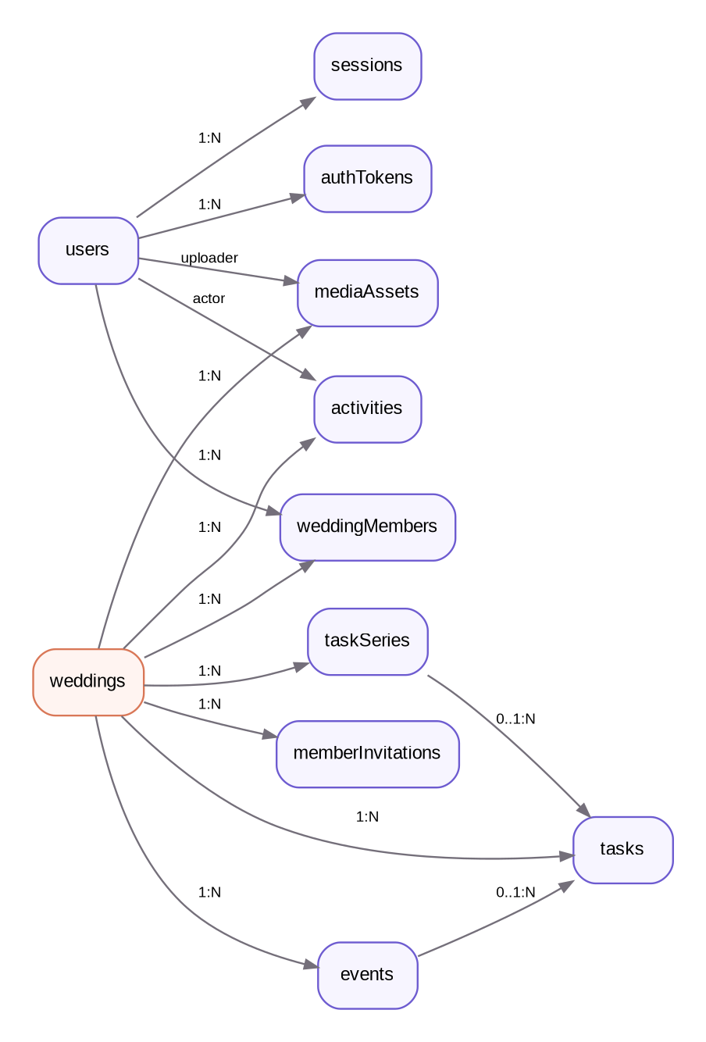
Figure 1. V1 collection relationships. Small bounded event substructures are embedded; growing aggregates are referenced.
The V1 model contains eleven main collections. The wedding is the principal tenant boundary, but not every document is embedded below it. This keeps documents bounded and makes task/event/member queries efficient.

3.1 Collection Inventory
Collection | Scope | Purpose | Lifecycle
users | Global | Account identity and profile | Long-lived
sessions | Global/user | Per-device refresh session | TTL
authTokens | Global/user | Email verification and password reset | TTL
weddings | Wedding root | Wedding profile and core settings | Soft delete + recovery
weddingMembers | Wedding | User membership, role and finance permission | Long-lived
memberInvitations | Wedding | Family/dashboard invitation lifecycle | TTL/terminal state
events | Wedding | Ceremony/event schedule and venue | Soft delete
tasks | Wedding | Actionable planning work | Soft delete
taskSeries | Wedding | Recurring task definitions | Long-lived
activities | Wedding | User-facing audit/activity feed | Append-only
mediaAssets | Wedding/user | R2 object metadata and cleanup state | Soft delete / async purge

3.2 Reference vs. Embed Rules
Data | Strategy | Reason
Wedding → events/tasks/members | Reference | Unbounded growth; independent querying and lifecycle.
Event → venue snapshot | Embed | Small, bounded and historically should not change if Google Places data changes.
Event → activities[] | Embed | Lightweight sub-items normally loaded and edited with the event; impose an application-level cap.
Task → assigneeIds[] | Reference IDs | Small bounded collaborator set; no duplicated user profile data.
Task → eventId | Optional reference | A task can be wedding-wide or event-specific.
Task → source{} | Embed | Small immutable origin metadata for manual/checklist/recurrence generation.
Activity → displaySnapshot{} | Embed | Preserves readable history even if referenced entity is later deleted.
Media → object metadata | Reference R2 key | Binary data stays outside MongoDB; DB stores lifecycle/security metadata only.

4. Cross-Collection Conventions

4.1 IDs and naming
- Use MongoDB ObjectId for internal primary keys.
- Collection names are plural camelCase: weddingMembers, memberInvitations, mediaAssets.
- API exposes IDs as strings; services convert and validate ObjectId values before querying.
- Never use email, slug or phone as an internal foreign key.

4.2 Common audit fields
Field | Type | Usage
_id | ObjectId | MongoDB primary key.
createdAt | Date | UTC timestamp, automatic.
updatedAt | Date | UTC timestamp, automatic where mutable.
createdBy | ObjectId? | Actor for wedding-scoped entities.
updatedBy | ObjectId? | Last actor for mutable business entities.
deletedAt | Date? | Soft-delete timestamp.
deletedBy | ObjectId? | Actor that initiated soft delete.
__v | Number | Mongoose version used for optimistic concurrency on write-sensitive models.

4.3 Date/time storage
- Instant timestamps (event start/end, task due time, createdAt, expiresAt) use BSON Date in UTC.
- Wedding.mainDate is a date-only string YYYY-MM-DD because it represents a calendar date, not midnight in UTC.
- Wedding.timezone defaults to Asia/Kolkata in the initial India-only release.
- TaskSeries occurrenceDate uses YYYY-MM-DD in the wedding timezone; generated Task.dueAt is a UTC Date when a time is applicable.
- Event crossing midnight is valid because startAt/endAt are absolute timestamps; require endAt > startAt.

4.4 Money storage
For V1 estimatedBudget and later finance amounts, store integer minor units (paise) rather than floating-point rupees. Example: ₹12,345.67 is stored as amountMinor=1234567 with currency="INR". This prevents floating-point rounding problems and carries forward cleanly into V3.

5. V1 Collection Specifications

5.1 users
Global identity record. A user may authenticate on multiple devices but, for the initial product rule, may hold only one active wedding membership.
Field | Type | Req. | Design / constraint
email | String | Yes | Original user-facing email; trim.
emailNormalized | String | Yes | Lowercase normalized value; unique.
passwordHash | String | Yes | Argon2id hash only.
emailVerifiedAt | Date | No | Null until verification succeeds.
profile.displayName | String | Yes | Display name used in collaboration UI/activity feed.
profile.phone | String | No | Optional normalized India phone; not used as auth identity in V1.
avatarMediaId | ObjectId | No | Reference to READY mediaAssets purpose=PROFILE_AVATAR.
status | Enum | Yes | ACTIVE | DISABLED. Default ACTIVE.
lastLoginAt | Date | No | Operational convenience only.
createdAt/updatedAt | Date | Yes | UTC timestamps.

Indexes
- Unique: { emailNormalized: 1 }.
- Optional query index: { status: 1 } only if admin/support tooling later needs it.

Integrity / lifecycle rules
- Do not store plaintext password or auth tokens.
- Changing avatar updates avatarMediaId; previous media object is marked for asynchronous cleanup.
- Initial one-wedding rule is enforced in weddingMembers, not by embedding weddingId on users.

Representative shape
{
"_id": "ObjectId(...)" ,
"email": "family@example.com",
"emailNormalized": "family@example.com",
"passwordHash": "<argon2id>",
"emailVerifiedAt": "Date(...)" ,
"profile": { "displayName": "Rahul Das" },
"avatarMediaId": "ObjectId(...)" ,
"status": "ACTIVE"
}

5.2 sessions
One document per logged-in browser/device. Access JWTs remain short-lived; the DB session controls refresh and revocation.
Field | Type | Req. | Design / constraint
userId | ObjectId | Yes | Reference users._id.
refreshTokenHash | String | Yes | Hash of opaque high-entropy refresh token.
tokenFamilyId | String | Yes | Groups rotated refresh tokens for reuse detection.
expiresAt | Date | Yes | Absolute session expiry.
revokedAt | Date | No | Set on logout/revocation.
revokeReason | String | No | LOGOUT | ROTATION_REUSE | SECURITY | PASSWORD_CHANGE.
device.userAgent | String | No | Bounded diagnostic string.
device.label | String | No | Optional derived label such as Chrome on Windows.
lastUsedAt | Date | Yes | Refresh activity timestamp.
createdAt | Date | Yes | UTC.

Indexes
- TTL: { expiresAt: 1 } expireAfterSeconds: 0.
- Index: { userId: 1, revokedAt: 1 }.
- Unique: { refreshTokenHash: 1 }.

Integrity / lifecycle rules
- Normal logout revokes only the current session.
- Refresh rotates the opaque token; old token reuse revokes its token family.
- Do not put refresh token contents in logs or activity feed.

5.3 authTokens
Short-lived one-time tokens for EMAIL_VERIFY and PASSWORD_RESET.
Field | Type | Req. | Design / constraint
userId | ObjectId | Yes | Reference users._id.
type | Enum | Yes | EMAIL_VERIFY | PASSWORD_RESET.
tokenHash | String | Yes | Hash only; raw token exists only in the email URL.
expiresAt | Date | Yes | Verification duration configurable; reset target ~15–30 min.
usedAt | Date | No | Set atomically on successful consumption.
createdAt | Date | Yes | UTC.

Indexes
- Unique: { tokenHash: 1 }.
- TTL: { expiresAt: 1 } expireAfterSeconds: 0.
- Index: { userId: 1, type: 1, usedAt: 1 }.

Integrity / lifecycle rules
- Consumption must verify type, not-used and expiresAt > now in one operation.
- Resending can invalidate prior active token of the same type for that user.

5.4 weddings
Tenant/root record for one wedding. Contains only bounded wedding-level settings, not child aggregates.
Field | Type | Req. | Design / constraint
name | String | Yes | Human-friendly wedding name.
slug | String | Yes | Unique public-safe slug; reserve even before V5 public site.
brideName | String | Yes | Display value.
groomName | String | Yes | Display value.
mainDate | String | Yes | YYYY-MM-DD local calendar date.
timezone | String | Yes | Default Asia/Kolkata.
tradition | String | Yes | Initially ODIA or other supported key; custom can be added.
location.city | String | Yes | Wedding-level primary city.
location.state | String | Yes | State.
location.countryCode | String | Yes | IN initially.
estimatedBudget.amountMinor | Int64 | No | Paise; optional during setup.
estimatedBudget.currency | String | No | INR.
coverMediaId | ObjectId | No | Reference READY WEDDING_COVER media.
mode | Enum | Yes | PLANNING | GALLERY_MODE. Default PLANNING.
createdBy | ObjectId | Yes | Creator user.
deletedAt/deletedBy | Date/ObjectId | No | Soft deletion.
purgeAfter | Date | No | Set to deletedAt + 7 days for deleted wedding.
__v | Number | Yes | Optimistic concurrency.

Indexes
- Unique: { slug: 1 }.
- Index: { createdBy: 1 }.
- Operational cleanup index: { purgeAfter: 1 } sparse/partial.

Integrity / lifecycle rules
- Creating a wedding and initial Admin membership is one integrity-critical workflow.
- Wedding deletion enters 7-day recovery; do not use TTL because related collections and R2 media need coordinated purge.
- Gallery Mode is reversible and does not imply deletion.

5.5 weddingMembers
Links authenticated users to a wedding and is the source of truth for dashboard authorization.
Field | Type | Req. | Design / constraint
weddingId | ObjectId | Yes | Reference weddings._id.
userId | ObjectId | Yes | Reference users._id.
role | Enum | Yes | ADMIN | FAMILY_MEMBER | VIEWER.
financeAccess | Boolean | Yes | Default false; Admin effectively always allowed regardless of flag.
status | Enum | Yes | ACTIVE | REMOVED.
joinedAt | Date | Yes | When invitation/creation membership became active.
createdBy | ObjectId | Yes | Admin/creator responsible.
removedAt | Date | No | Set when removed.
removedBy | ObjectId | No | Actor.
createdAt/updatedAt | Date | Yes | UTC.
__v | Number | Yes | Concurrency guard for role changes.

Indexes
- Unique: { weddingId: 1, userId: 1 }.
- Initial-product partial unique: { userId: 1 } where status="ACTIVE" to enforce one active wedding per user.
- Index: { weddingId: 1, role: 1, status: 1 }.

Integrity / lifecycle rules
- Last remaining ACTIVE Admin cannot be removed or demoted; enforce inside a transaction/atomic integrity workflow.
- financeAccess is ignored for Viewer and is not a separate role.
- Authorization always reads current membership state server-side; stale UI cannot retain privileges.

5.6 memberInvitations
Invitations for authenticated collaborators. This collection is separate from future guest invitations/RSVP.
Field | Type | Req. | Design / constraint
weddingId | ObjectId | Yes | Target wedding.
email | String | Yes | Original display form.
emailNormalized | String | Yes | Must match login/register email.
role | Enum | Yes | ADMIN | FAMILY_MEMBER | VIEWER. Admin grant allowed by product rule.
tokenHash | String | Yes | Hash of secure invitation token.
status | Enum | Yes | PENDING | ACCEPTED | REVOKED | EXPIRED.
expiresAt | Date | Yes | 7 days after issue/resend.
invitedBy | ObjectId | Yes | Admin user.
acceptedAt | Date | No | Success timestamp.
acceptedBy | ObjectId | No | New/existing user.
lastSentAt | Date | Yes | For resend/rate limit.
sendCount | Number | Yes | Starts at 1.
createdAt/updatedAt | Date | Yes | UTC.

Indexes
- Unique: { tokenHash: 1 }.
- Partial unique: { weddingId: 1, emailNormalized: 1 } where status="PENDING".
- Index: { weddingId: 1, status: 1, expiresAt: 1 }.

Integrity / lifecycle rules
- Do not TTL-delete immediately at expiresAt because terminal status/history is useful; an async cleanup policy may purge old records later.
- Acceptance verifies token, email match, invitation state, user one-wedding rule and then creates membership + consumes invitation atomically.
- Resend rotates tokenHash and extends expiresAt; previous raw link becomes invalid.

5.7 events
Wedding ceremonies/events with independent date/time and venue. Event activities are lightweight embedded subdocuments.
Field | Type | Req. | Design / constraint
weddingId | ObjectId | Yes | Tenant/reference.
name | String | Yes | Display name.
type | String/Enum | Yes | ENGAGEMENT, HALDI, MEHENDI, SANGEET, BARAJATRI, WEDDING, RECEPTION, CUSTOM.
description | String | No | Bounded rich/plain text; sanitize output.
startAt | Date | Yes | UTC instant.
endAt | Date | Yes | UTC; must be > startAt.
venue.name | String | No | Venue label.
venue.source | Enum | No | GOOGLE | MANUAL.
venue.googlePlaceId | String | No | Optional external ID.
venue.formattedAddress | String | No | Snapshot.
venue.city/state | String | No | Snapshot.
venue.latitude/longitude | Number | No | Snapshot coordinates.
activities[] | Subdoc[] | No | Bounded items: _id, name, startAt, description.
status | Enum | Yes | PLANNED | CONFIRMED | COMPLETED | CANCELLED.
createdBy/updatedBy | ObjectId | Yes/No | Actors.
deletedAt/deletedBy | Date/ObjectId | No | Soft delete.
__v | Number | Yes | Optimistic concurrency.

Indexes
- Primary list: { weddingId: 1, deletedAt: 1, startAt: 1 }.
- Status view: { weddingId: 1, deletedAt: 1, status: 1, startAt: 1 }.

Integrity / lifecycle rules
- Different events may be in different cities/venues.
- Overlapping events and activities warn but are not blocked.
- Deleting an event does not delete tasks; related task.eventId is cleared asynchronously or during deletion workflow while task history remains.
- Activity array must remain bounded (application cap); if activities become complex later, promote to collection.

5.8 tasks
Primary planning work item. Supports multiple assignees, optional event relation, checklist origin and recurring occurrence origin.
Field | Type | Req. | Design / constraint
weddingId | ObjectId | Yes | Tenant/reference.
eventId | ObjectId | No | Optional events._id.
title | String | Yes | Task title.
description | String | No | Optional notes.
status | Enum | Yes | TODO | IN_PROGRESS | COMPLETED.
priority | Enum | Yes | LOW | MEDIUM | HIGH | URGENT.
assigneeIds[] | ObjectId[] | No | Deduplicated ACTIVE wedding member users.
dueAt | Date | No | UTC; overdue when incomplete and dueAt < now.
completedAt | Date | No | Set/cleared with status.
completedBy | ObjectId | No | Actor.
seriesId | ObjectId | No | taskSeries._id for generated recurrence.
occurrenceDate | String | No | YYYY-MM-DD local date for recurring occurrence.
source.type | Enum | Yes | MANUAL | CHECKLIST | RECURRENCE.
source.templateId/version/itemKey | String | No | Checklist traceability/idempotency.
createdBy/updatedBy | ObjectId | Yes/No | Actors.
deletedAt/deletedBy | Date/ObjectId | No | Soft delete.
__v | Number | Yes | Optimistic concurrency.

Indexes
- Main board: { weddingId: 1, deletedAt: 1, status: 1, dueAt: 1 }.
- My Tasks: { weddingId: 1, assigneeIds: 1, deletedAt: 1, status: 1, dueAt: 1 }.
- Event filter: { weddingId: 1, eventId: 1, deletedAt: 1, dueAt: 1 }.
- Priority/attention: { weddingId: 1, deletedAt: 1, priority: 1, status: 1, dueAt: 1 }.
- Partial unique recurrence: { seriesId: 1, occurrenceDate: 1 } where seriesId exists and deletedAt=null.
- Checklist dedupe unique/guard: weddingId + source.templateId + source.templateVersion + source.itemKey for active CHECKLIST tasks.

Integrity / lifecycle rules
- Unassigned tasks are valid and appear in Attention Required when important.
- Removed members are pulled from assigneeIds or explicitly reassigned; never leave inaccessible user dependency silently.
- Task after wedding date warns but can be saved.
- Search initially uses normalized text/regex with strict limits; do not add Atlas Search until actual need.

5.9 taskSeries
Definition/template for recurring tasks. Each actual occurrence is still a normal tasks document.
Field | Type | Req. | Design / constraint
weddingId | ObjectId | Yes | Tenant.
frequency | Enum | Yes | DAILY | WEEKLY | MONTHLY.
interval | Number | Yes | Positive integer, default 1.
startDate | String | Yes | YYYY-MM-DD in wedding timezone.
endDate | String | No | Stop boundary; normally not beyond wedding date unless explicitly allowed.
template.title | String | Yes | Copied into occurrence.
template.description | String | No | Copied.
template.priority | Enum | Yes | Copied.
template.assigneeIds[] | ObjectId[] | No | Copied, revalidated at generation.
template.eventId | ObjectId | No | Optional.
generationVersion | Number | Yes | Increment only when recurrence generation semantics change.
nextGenerationDate | String | No | Optimization for scheduler.
active | Boolean | Yes | Default true.
createdBy | ObjectId | Yes | Actor.
createdAt/updatedAt | Date | Yes | UTC.

Indexes
- Index: { weddingId: 1, active: 1, nextGenerationDate: 1 }.

Integrity / lifecycle rules
- Generation is idempotent because tasks enforce seriesId + occurrenceDate uniqueness.
- Do not pre-generate an unlimited future history; generate within a bounded planning horizon.
- Changes to series do not silently rewrite completed historical occurrences.

5.10 activities
Append-only user-facing history and audit feed. Separate from CloudWatch engineering logs.
Field | Type | Req. | Design / constraint
weddingId | ObjectId | Yes | Tenant.
actorId | ObjectId | No | Null for system-generated activity.
action | String | Yes | Stable event code e.g. TASK_COMPLETED, EVENT_UPDATED.
entityType | String | Yes | TASK | EVENT | MEMBER | WEDDING | MEDIA etc.
entityId | ObjectId | No | May point to later-deleted entity.
displaySnapshot.label | String | No | Human-readable entity/name snapshot.
metadata | Object | No | Small allowlisted contextual values only.
requestId | String | No | Correlation to operational logs if useful.
createdAt | Date | Yes | UTC. Immutable.

Indexes
- Feed index: { weddingId: 1, createdAt: -1 }.
- Optional entity history: { weddingId: 1, entityType: 1, entityId: 1, createdAt: -1 }.

Integrity / lifecycle rules
- Append-only: normal application code does not update/delete individual activity rows.
- Never copy passwords, tokens, full request bodies or sensitive finance details into metadata.
- Historical snapshot allows “Rahul deleted Reception” even after the event document is soft-deleted.

5.11 mediaAssets
Metadata for Cloudflare R2 objects. MongoDB never stores image/file binary data.
Field | Type | Req. | Design / constraint
weddingId | ObjectId | No | Wedding-scoped media; null for global user avatar if desired.
ownerUserId | ObjectId | No | User owner/uploader context.
eventId | ObjectId | No | Reserved for future event gallery association.
purpose | Enum | Yes | PROFILE_AVATAR | WEDDING_COVER | RECEIPT | CONTRACT | GALLERY.
provider | String | Yes | R2.
bucket | String | Yes | Configured bucket identifier.
objectKey | String | Yes | Opaque generated key; never user-controlled path.
originalFileName | String | No | Sanitized display metadata.
mimeType | String | Yes | Allowlisted server-side.
sizeBytes | Int64 | Yes | Validated against purpose limit.
checksum | String | No | Optional integrity value.
status | Enum | Yes | PENDING_UPLOAD | READY | DELETE_PENDING | DELETED.
uploadedAt | Date | No | Set after upload confirmation.
createdBy | ObjectId | No | Uploader/actor.
deletedAt | Date | No | Logical removal.
purgeAfter | Date | No | Async object cleanup schedule.
createdAt/updatedAt | Date | Yes | UTC.

Indexes
- Unique: { objectKey: 1 }.
- Cleanup: { status: 1, purgeAfter: 1 }.
- Wedding media: { weddingId: 1, purpose: 1, status: 1, createdAt: -1 }.

Integrity / lifecycle rules
- Presign request creates PENDING_UPLOAD metadata; READY only after server verifies expected object exists/metadata is acceptable.
- Profile/cover replacement immediately changes parent reference; old asset becomes DELETE_PENDING and is removed asynchronously.
- R2 key should include environment and opaque IDs, not personal names/emails.

6. Index Strategy and Primary Query Patterns
Indexes below are the initial target set. Before adding an index, confirm it serves a real query and inspect explain() in staging. Too many indexes increase storage and write cost.
Query / invariant | Collection | Supporting index
Dashboard task counts | tasks | weddingId + deletedAt + status
Overdue / attention tasks | tasks | weddingId + deletedAt + status + dueAt
My tasks | tasks | weddingId + assigneeIds + deletedAt + status + dueAt
Upcoming events | events | weddingId + deletedAt + startAt
Event status summary | events | weddingId + deletedAt + status + startAt
Recent activity | activities | weddingId + createdAt desc
Member authorization | weddingMembers | weddingId + userId unique
One active wedding/user | weddingMembers | userId partial unique where ACTIVE
Active collaboration invite | memberInvitations | weddingId + emailNormalized partial unique PENDING
Session refresh | sessions | refreshTokenHash unique
Session cleanup | sessions | expiresAt TTL
Recurring task dedupe | tasks | seriesId + occurrenceDate partial unique
Media cleanup | mediaAssets | status + purgeAfter

6.1 Pagination
- Use cursor/range pagination for high-growth feeds such as activities and later gallery media.
- For V1 task/event tables, page/limit is acceptable at small scale; cap page size (for example <=100).
- Stable sort must include _id as tie-breaker when cursor pagination is introduced.

6.2 Text search
V1 does not need Atlas Search. Normalize searchable task/event names and use bounded, escaped matching only where necessary. If search quality or dataset size later demands it, add Atlas Search without changing the domain schema.

7. Integrity, Transactions and Idempotency

7.1 Operations that deserve transactional protection
- Create wedding + create initial Admin membership.
- Accept member invitation: validate/consume invitation + create membership.
- Remove/demote Admin when enforcing “last Admin” invariant.
- Delete event when clearing dependent task.eventId references and writing activity, if implemented synchronously.
- V3 payment posting when expense paid totals must remain consistent.

7.2 Idempotency guards
Flow | Guard
Invitation accept | Terminal status + unique tokenHash + membership uniqueness.
Checklist generation | Unique active task identity from weddingId + templateId + templateVersion + itemKey.
Recurring generation | Unique seriesId + occurrenceDate.
Media upload completion | READY transition only once for a PENDING_UPLOAD asset/objectKey.
Double-submit create endpoints | Optional request Idempotency-Key stored/checked for high-risk creates; UI also disables submit.

7.3 Concurrency
- Enable Mongoose optimisticConcurrency on Wedding, WeddingMember, Event and Task.
- Client update sends expected version (__v or mapped version). Stale updates return HTTP 409 Conflict with current data metadata.
- Do not use “last write wins” for collaborative edits where silent overwrite would lose another family member’s change.

8. Deletion, Recovery and Retention
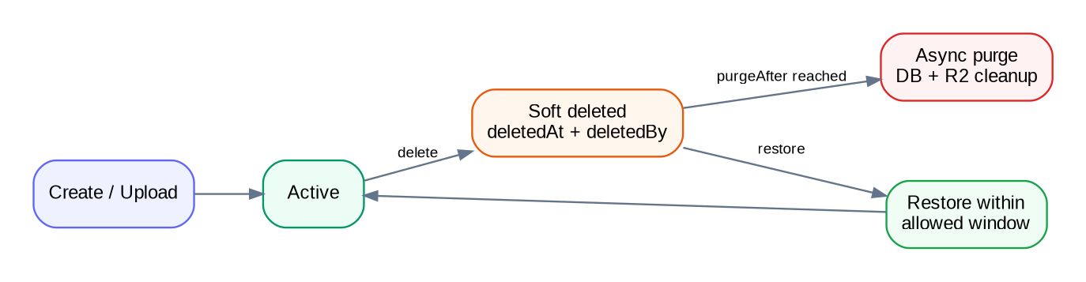
Figure 2. Important business data is recoverable before asynchronous hard purge.
Entity | Delete behavior | Recovery / purge
Wedding | Soft delete; block normal dashboard access. | 7-day recovery. purgeAfter triggers coordinated child + R2 cleanup.
Event | Soft delete. | Restorable while wedding exists; tasks survive and event reference is cleared or treated unavailable.
Task | Soft delete. | Restorable while wedding exists; excluded from normal boards.
Member | Status REMOVED rather than destructive delete. | Historical activity remains; re-invite can reactivate through controlled flow.
Activity | Append-only. | Retained while wedding exists; purged with wedding after recovery window.
Media | DELETE_PENDING / deletedAt. | Async R2 deletion; metadata can mark DELETED after success.
Sessions/tokens | TTL/terminal state. | No recovery required.

8.1 Wedding purge order
- Re-check purgeAfter and that wedding is still deleted.
- Mark purge job/idempotency state to prevent duplicate destructive execution.
- Delete R2 objects referenced by wedding mediaAssets (retry failures safely).
- Delete/expire wedding child collections in controlled batches.
- Delete media metadata and activity records.
- Finally hard-delete the wedding root. Keep operational purge logs in CloudWatch, not in the deleted tenant data.

9. Validation and Security at the Persistence Boundary
- Zod validates API payload shape before service/database logic. Mongoose schemas enforce final persistence constraints.
- Every wedding-scoped repository query requires a trusted weddingId obtained after authorization; repositories should not expose unsafe “findById only” patterns to controllers.
- Normalize email before uniqueness checks. Validate/normalize phone if captured.
- Escape or avoid user-provided regular expressions. Put strict limits on text length, arrays and pagination.
- No plaintext passwords, refresh tokens, reset tokens, verification tokens or invitation tokens in MongoDB.
- Cloudflare R2 bucket remains private; MongoDB stores keys, not public permanent URLs.
- Finance access later is enforced in API authorization; DB collection existence does not grant visibility.
- MongoDB credentials are environment-specific and least-privileged; staging never receives production credentials.

10. Repository / Mongoose Implementation Guidance

10.1 Suggested model organization
src/modules/
auth/models/{user,session,auth-token}.model.js
weddings/models/wedding.model.js
members/models/{wedding-member,member-invitation}.model.js
events/models/event.model.js
tasks/models/{task,task-series}.model.js
activity/models/activity.model.js
media/models/media-asset.model.js

10.2 Model options
- Use timestamps: true for mutable collections.
- Use strict: "throw" or equivalent strict schema discipline for core models so unexpected fields do not silently persist.
- Use optimisticConcurrency: true for collaborative write-sensitive models.
- Expose JSON transforms that remove passwordHash, refreshTokenHash, tokenHash, internal __v where not needed by API; map version deliberately if client concurrency uses it.
- Keep business validation (last Admin, membership checks, cross-document rules) in services—not in Mongoose hooks that are difficult to reason about.

10.3 Repository query rule
// GOOD: tenant constraint is explicit
Task.findOne({ _id: taskId, weddingId, deletedAt: null })
// AVOID in wedding-scoped business code
Task.findById(taskId)

11. Dashboard Aggregation Design
V1 dashboard data can be computed directly from indexed collections. Do not create a separate denormalized dashboard collection until measurements show a need.
Dashboard card | Source/query
Planning progress | tasks: total active vs COMPLETED.
Task status counts | tasks grouped by status.
Overdue | tasks incomplete, dueAt < now.
My Tasks | tasks where assigneeIds contains current user.
Upcoming events | events startAt >= now sorted asc, limit ~3.
Event status summary | events grouped by status.
Recent activity | activities sorted createdAt desc.
Attention Required | combined bounded queries: overdue, urgent unassigned, event missing venue, approaching event.

If dashboard read traffic later becomes high, introduce a cached summary or event-driven projection only after profiling. The current model intentionally avoids premature denormalization.

12. Future-Version Compatibility Model
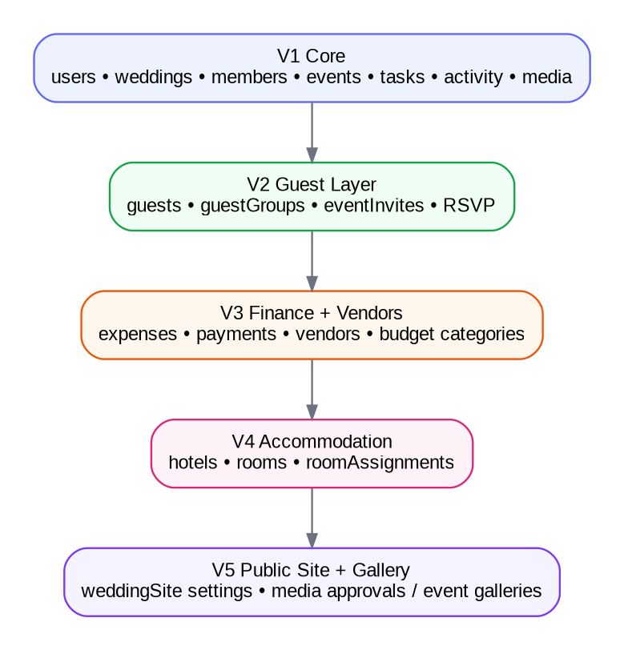
Figure 3. New feature collections extend the wedding boundary rather than changing V1 aggregate ownership.
The following is a compatibility plan. Exact future fields should be finalized when each version is designed.

12.1 V2 Guests, invitations and RSVP
Proposed collection | Purpose / important references
guestGroups | Optional household/group; weddingId, name, side, notes.
guests | weddingId, guestGroupId?, name, email/phone, side, tags[], plusOneAllowance.
guestEventInvitations | weddingId + guestId + eventId; invited flag/context, RSVP YES/NO, attendeeCount, mealPreference, respondedAt.
guestAccessTokens | Hashed public RSVP token tied to guest/group context; no ChatGPT/dashboard account required.

- Unique/guard guest-event pair: { weddingId, guestId, eventId }.
- RSVP can be edited only until corresponding event startAt; enforce in service using event data.
- Duplicate email/phone is warning-only, so do not impose global unique guest contact indexes.
- Guest records never become weddingMembers unless separately invited as authenticated collaborators.

12.2 V3 Budget, expenses and vendors
Proposed collection | Purpose / references
budgetCategories | Wedding-scoped category limits/labels if custom categories are needed.
expenses | weddingId; categoryId?, eventId?, vendorId?; estimate/committed totals in minor units; status.
expensePayments | expenseId; amountMinor; paidAt; method/reference; receiptMediaId?; createdBy.
vendors | weddingId; services[]; contact; status SHORTLISTED/CONFIRMED/COMPLETED/CANCELLED.
vendorDocuments | Can remain mediaAssets with vendorId/expenseId metadata rather than a separate binary store.

Finance endpoints must require Admin or Family Member with financeAccess. Keep payment installments separate from expense totals so history is auditable and overpayment validation is reliable.

12.3 V4 Accommodation
Proposed collection | Purpose / references
hotels | weddingId; property/contact/location; budget expense reference optional.
rooms | hotelId; room identifier/type/capacity/status.
roomAssignments | weddingId; roomId; guestId(s); checkIn/checkOut; status.

Prevent capacity violations and overlapping room assignments through service checks plus supporting indexes. Do not embed all room assignments into hotel documents.

12.4 V5 Public site and gallery
- Public website settings can live in a separate weddingSites collection keyed uniquely by weddingId: published, publicSlug, theme, content sections and contact settings.
- Keep the same mediaAssets collection. Add eventId, approvalStatus, approvedBy/At and uploaderType as gallery requirements arrive.
- Do not expose R2 object keys directly as permanent public access. Generate controlled delivery URLs / CDN strategy when gallery is implemented.

13. Database Environment and Operations
Area | Staging | Production
Database | mmm_staging | mmm_prod
Atlas cluster | Free/shared initially | Free/shared initially; upgrade when real load requires
Credentials | Separate user/secret | Separate user/secret
Network access | Restricted to deployment needs | Restricted to deployment needs
Seed data | Synthetic test wedding data | No synthetic seed unless controlled migration
Backups | Export/snapshot strategy appropriate to tier | Enable stronger backup strategy before meaningful customer data

13.1 Free-tier guardrails
- Keep staging test media small and clean it periodically.
- Use bounded activity metadata and event activities to prevent document bloat.
- Do not add redundant indexes “just in case”.
- Monitor Atlas storage/connection/operation usage before upgrading.
- Use connection reuse in Lambda; do not open a brand-new MongoClient connection for every invocation.

13.2 Lambda connection pattern
Cache the Mongoose connection/promise in module scope so warm Lambda invocations reuse the pool. Configure a conservative pool size appropriate for serverless concurrency, and cap Lambda concurrency if necessary to protect the free/shared Atlas connection limit.

14. Migration and Schema Evolution
- Mongoose schema changes must remain backward compatible during rolling deployment where possible.
- Use explicit migration scripts for data transformations; never rely on application reads to silently rewrite large collections.
- Keep migration scripts versioned in the API repository and make them idempotent where practical.
- New optional fields can be introduced without backfilling immediately when default behavior is clear.
- Breaking enum/field changes require read compatibility first, migration second, old-field removal last.
- Add indexes through controlled deployment and verify build impact on production data volume.

15. Data Integrity Checklist
☐ Normalized unique account email.
☐ No raw auth/reset/verification/invitation/refresh token persisted.
☐ One active wedding membership per user in initial product version.
☐ Unique wedding membership per user+wedding.
☐ Last Admin cannot be removed or demoted.
☐ Every protected entity query constrained by weddingId.
☐ Event endAt > startAt.
☐ Task assignees are active members of the same wedding.
☐ Checklist generation and recurrence generation are idempotent.
☐ Soft-deleted entities excluded by default repository filters.
☐ Wedding hard purge only after recovery window and coordinated R2 cleanup.
☐ Activity feed contains no secrets/sensitive raw request payloads.
☐ Money uses integer minor units and INR.
☐ Optimistic concurrency rejects stale collaborative writes.
☐ Environment credentials and databases are isolated.

16. Implementation Order
- Create shared Mongo/Mongoose bootstrap, common schema helpers, normalization utilities and index definitions.
- Implement users, sessions and authTokens; complete registration/login/verification/reset/refresh/logout.
- Implement weddings + weddingMembers + memberInvitations and authorization middleware.
- Implement events and venue/activity embedded structures.
- Implement tasks + taskSeries + checklist source/idempotency rules.
- Implement activities and dashboard query repository methods.
- Implement mediaAssets + R2 presign/confirm/delete-pending lifecycle.
- Add soft-delete purge job and integrity tests.
- Run index explain tests in staging with realistic synthetic data before V1 release.

17. Final Database Baseline
For V1, MongoDB Atlas remains a strong fit because the domain is document-oriented but still benefits from explicit aggregate boundaries and references. The design intentionally avoids both extremes: it does not force relational-style joins for every small value, and it does not create a giant embedded wedding document. The weddingId boundary, bounded embedding rules, targeted indexes, secure token models, recoverable deletion and idempotent generation rules give Make My Marriage a simple MVP database that can expand cleanly through guests, finance, accommodation and gallery features.

