Windmill Arrowhead local cloud

System-of-Systems Design Document

**Abstract**

This document describes the main features of the proposed Windmill Arrowhead local cloud.

It describes the concept used for the provider and consumer implemented. It also gives an idea about the architecture of the System-of-Systems.

1. Introduction

The Windmill local Arrowhead cloud will read sensor data from an windmill. The sensor data is located in a CSV file that contains the a large number of datapoints.

The data collected also needs to be stored in order to have good historical and statistical capabilities in order to prevent and predict when and where the critical components of the wind turbine starts degrading.

The collecting and storing of the data is done with the help of a provider and a consumer. The provider reads sensor data when the consumer requests data. The data is first read from the CSV file and then parsed into SenML and sent to the DataManager to have history of the read data. The provider then sends it to the consumer.

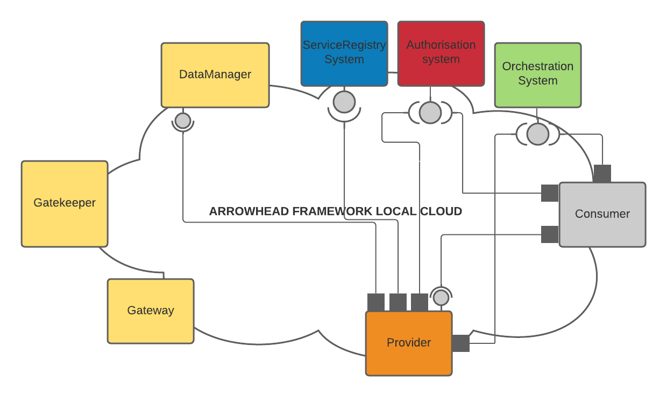

2. wm-data service

A wm-data service is the service that provides the sensor data from the windmill.

It implements a simple REST api to allow other actors to get the next data point from the data the service has.

The service also need to employ a way to keep the history of all the sensor data that has been fetched from the service. This is done by the use of the DataManager’s historian service.

This historian service is consumed each time a data point is fetched from the service. It results in that every data point fetched is stored in the DataManager’s database.

Example of a data point represented as JSON when sent by the service to a consumer:

{“timeStamp” : 0.002435123,

“speed” : 754.0,

“acceleration” : 0.0243123,

.

.

.

“acceleration” : -0.0434123

}

3. Security

The Windmill Arrowhead local cloud will be needed to be setup in secure mode to ensure data security.

4. Proposed SoSD

This section covers a SoSD that would better fit the Project proposal give better.

The wind turbine has 10 sensors that is connected to a condition-monitoring box.

* 1 Speed sensor
* 1 Load sensor
* 8 Accelerometers

Sensor data needs to be collected for all of them.

The data is collected by providers for each of the sensors. When a new measurement is sent by the wind turbine’s condition-monitoring box the providers encode the sensor data into SenML jsons and send them to the historian service of the DataManager.

This data can then be accessed by other actors to make predictions and calculations about the wind turbine’s performance and health. This can be done by having a consumer that can be requested by systems/applications from outside the local cloud via the Gatekeeper/Gateway core systems.

