**System Description (SysD) Temp****late – Black Box Design**

**Abstract**

This document provides a black box design overview of the Windmill local cloud system. The system consists of one provider and one consumer.

System Description (SysD) Template – Black Box Design 1

* 1. System Description Overview 3

1. Use-cases 3
   1. Behaviour Diagrams 4
2. System services 4
   1. Produced Services 4
   2. Consumed Services 5
   3. Sequence Diagrams 5
3. Security 5
   1. Security Objectives 5
   2. Assets 6
   3. Non-technical Security Requirements 6
4. References 6
5. Revision history 6
   1. Amendments 6
   2. Quality Assurance 7

# System Description Overview

The system provides one service wm-data.

# Use-cases

Describe typical use cases e.g. using UML use cases diagrams, which can be realised by the system. Only add this section if relevant in relation to SoSD document. Each use-case description should follow the structure defined in Table 1.

Table 1 Use-case description

|  |
| --- |
| Name of the Use-case: Provider stores data requested by consumer in DataManager |
| **Brief description**:  The provider gets request from consumer and sends the data to both the DataManager and the consumer |
| **Primary actors**:  Provider, Consume, DataManager |
| **Secondary actors**:  None |
| **Preconditions**:  Request from the consumer |
| **Main flow**:  -Provider receives request from a consumer  -Provider performs a request to DataManager’s historian services  -Sensor data gets stored in the DataManager database  -Sensor data gets sent to the consumer |
| **Postconditions**:  None |
| **Alternative flows**:  Eliminating the consumer from the flow. E.g make the process driven by the provider instead when it receives new data from the windmill. (Since I got the data as a whole csv file I choose to have a consumer drive the process instead.) |

# Behaviour Diagrams

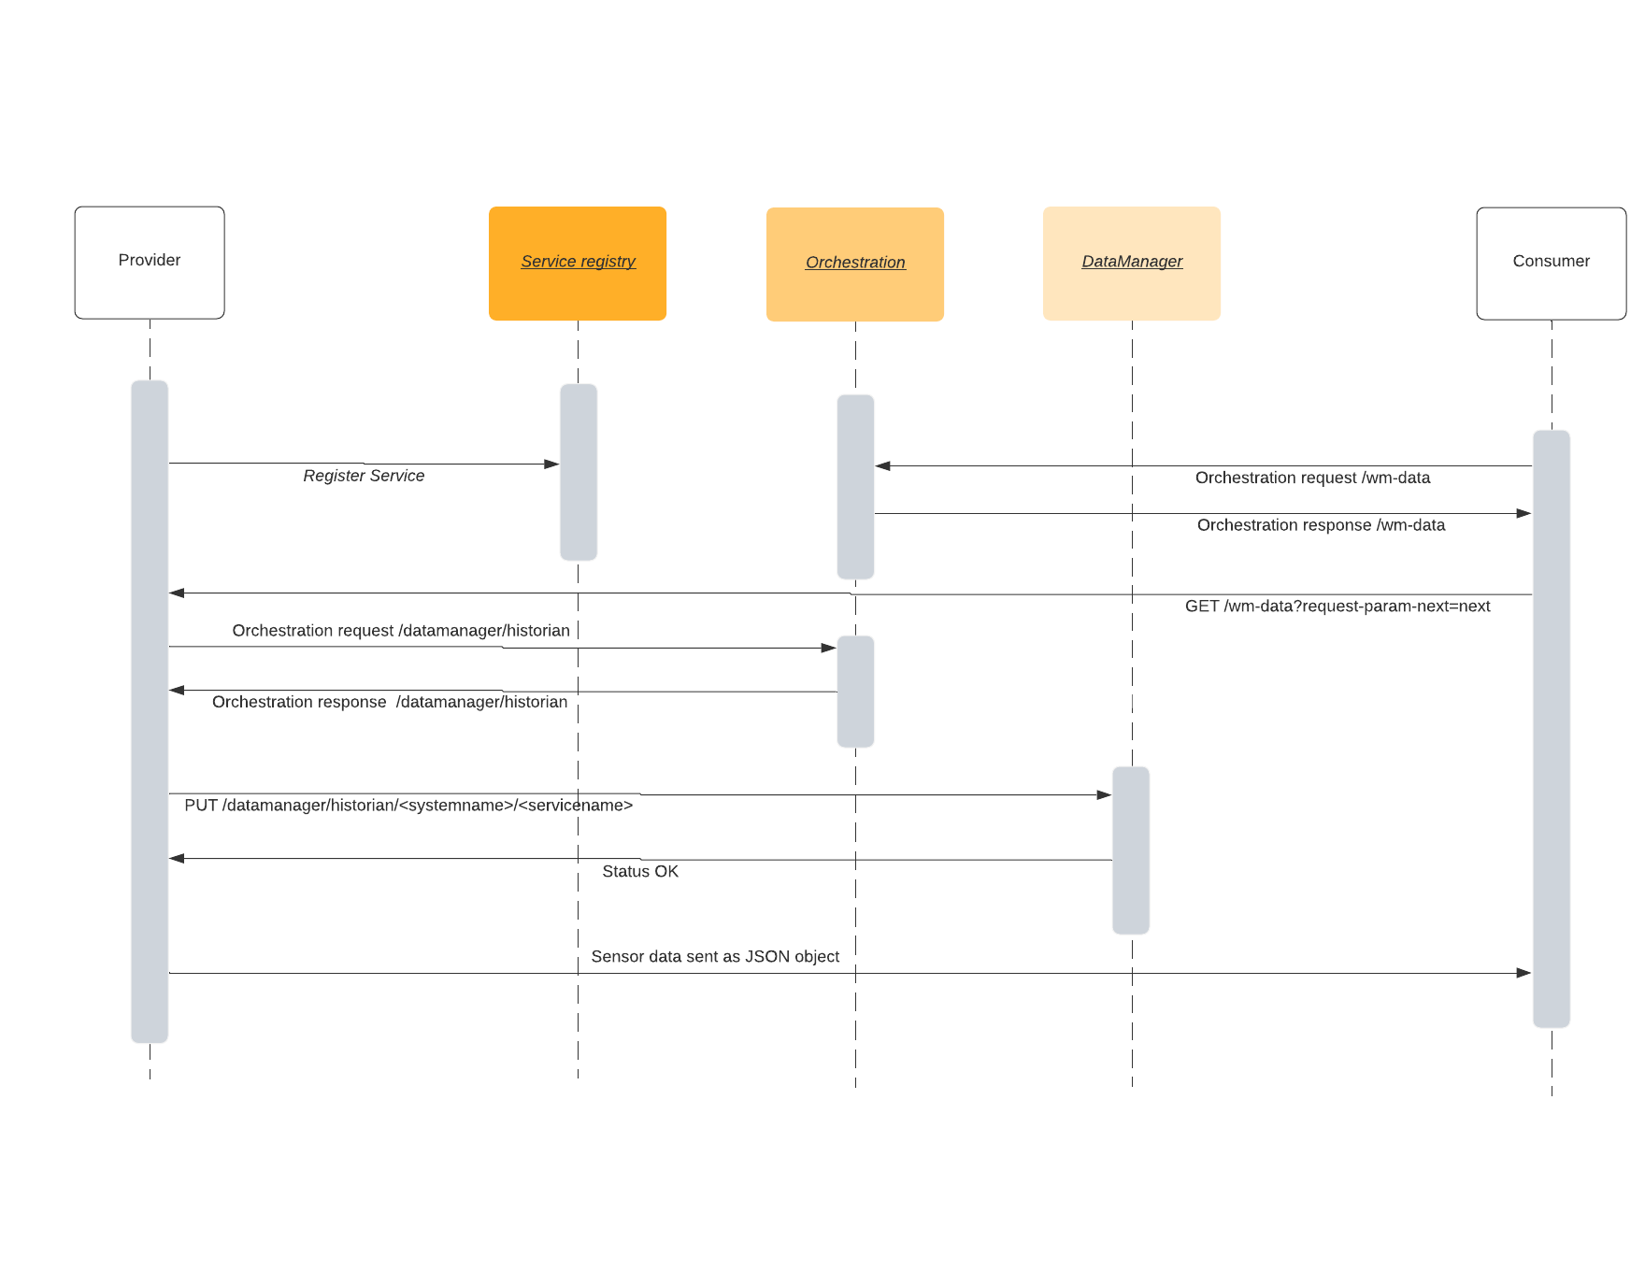

# System services

# Produced Services

Table 2 Pointers to IDD documents

|  |  |  |
| --- | --- | --- |
| Service | SD Document Reference | IDD Document Reference |
| wm-data | Windmill SD path: \documentation\SD_windmill v4.3.docx | Windmill IDD path: \documentation\IDD_windmill v4.3.docx |

A description of the provided services should also be included.

# Consumed Services

Table 3 Pointers to IDD documents

|  |  |  |
| --- | --- | --- |
| Service | SD Document Reference | IDD Document Reference |
| wm-data | Windmill SD path: \documentation\SD_windmill v4.3.docx | Windmill IDD path: \documentation\IDD_windmill v4.3.docx |

# Sequence Diagrams

See 2.1

# Security

# Security Objectives

The system uses HTTP over TLS to encrypt the requests and transmission. No other payload encryption is implemented currently.

In terms of availability, the system stores the data in the DataManager which ensures the availability of data at all times. As long as the Arrowhead core services aren’t compromised.

Integrity, data can not be altered as the system is designed right now. There is a possibility of data loss if an authorized system deletes data from the DataManager, in that case though the system deleting data needs to have the proper security credentials.

Confidentiality, the system relies on TLS for communication between the different services/systems which ensures that data can only be read by authorized subjects.

# Assets

# Non-technical Security Requirements

In this section the defined security objectives are applied on the assets to be protected. Please note that the technical security requirements are defined in the SysDD documentation.

Non-technical security requirements shall be collected using a table with the following format.

Table 4 Non-technical security requirements

|  |  |  |  |
| --- | --- | --- | --- |
| ***Number*** | **Objective** | **Asset** | **Requirement description** |
| *Sys_NSR1* | Refer to defined objective  A|I|C|Other | Refer to defined asset |  |
| *Sys_NSR2* |  |  |  |
| *Sys_NSR…n* |  |  |  |

# References

Windmill IDD path: \documentation\IDD_windmill v4.3.docx

Windmill SD path: \documentation\SD_windmill v4.3.docx

# Revision history

# Amendments

|  |  |  |  |  |
| --- | --- | --- | --- | --- |
| No. | Date | Version | Subject of Amendments | Author |
| 1 | 2020-05-27 | 1.0 |  | Jerker Delsing |
| 2 | 2020-08-18 | 4.2 | Minor updates | Jerker Delsing |
| 3 | 2021-01-25 | 4.3 | Added Windmill text | Robin Jonsson |
|  |  |  |  |  |
|  |  |  |  |  |
|  |  |  |  |  |

# Quality Assurance

|  |  |  |  |
| --- | --- | --- | --- |
| No. | Date | Version | Approved by |
| 1 |  |  |  |
| 2 |  |  |  |