**HOME**

KNOWING ME!!!

FAZELIN ZAINI

**Independent Youngest Sister**

"Sometimes it just takes a little reminder that helps us to realize the incredible potential that lies within us. As a woman, you do not only provide the necessary essentials for life, but you also have the power to create life. Without you, the circle would be far from closed. Aside from that, the quote empowers you to be confident in becoming the strong woman you want to be. You are able to transform and to change, which allows you to leave all negativity behind. Don’t allow others to decide about your life, but instead seize the power that lies within you."

“The power you have is to be the best version of yourself you can be, so you can create a better world.” ~ Ashley Rickards

BACKBONE

**BIODATA**

* NOR FAZELIN BINTI MOHD ZAINI
* 23 YEARS OLD
* LIVES IN KAMPUNG PAK BADOL, MELOR KOTA BHARU KELANTAN
* LOVE TO PHOTOGRAPH SKY PICTURE

EDUCATION

* UPSR 2011 SK PAK BADOL
* SPM 2016 SMK PAK BADOL
* DIPLOMA IN ACCOUNTANCY, UiTM KELANTAN (2017 – 2020)
* BACHELOR IN BUSINESS MANAGEMENT AND ADMINISTRATIVE (HONS.) FINANCE, UiTM KELANTAN (2020 – PRESENT)

**EXPERIENCE**

* ASSISTANT COACH FOR PBSM UITMCK (2017 – 2020)

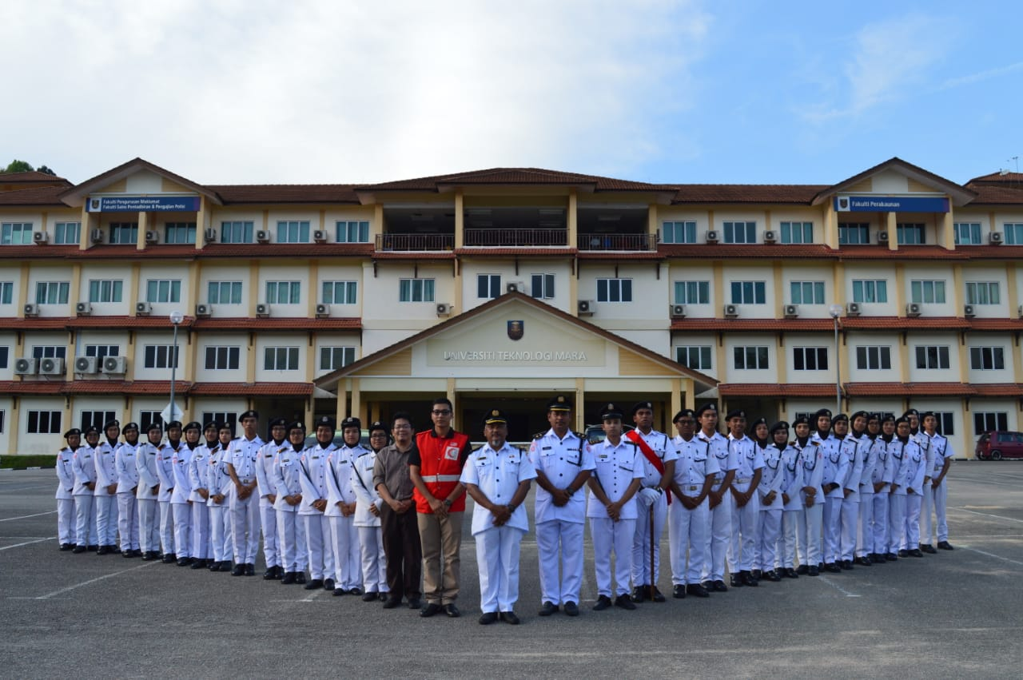

* KFC DAMANSARA DAMAI (MARCH 2020 – JULY 2020)

* TAKAFUL ADVISOR (MARCH 2021 – PRESENT)

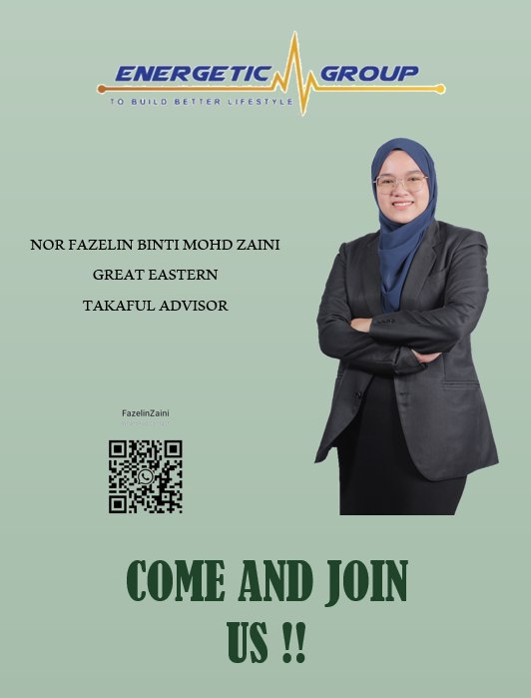

**GALLERY**

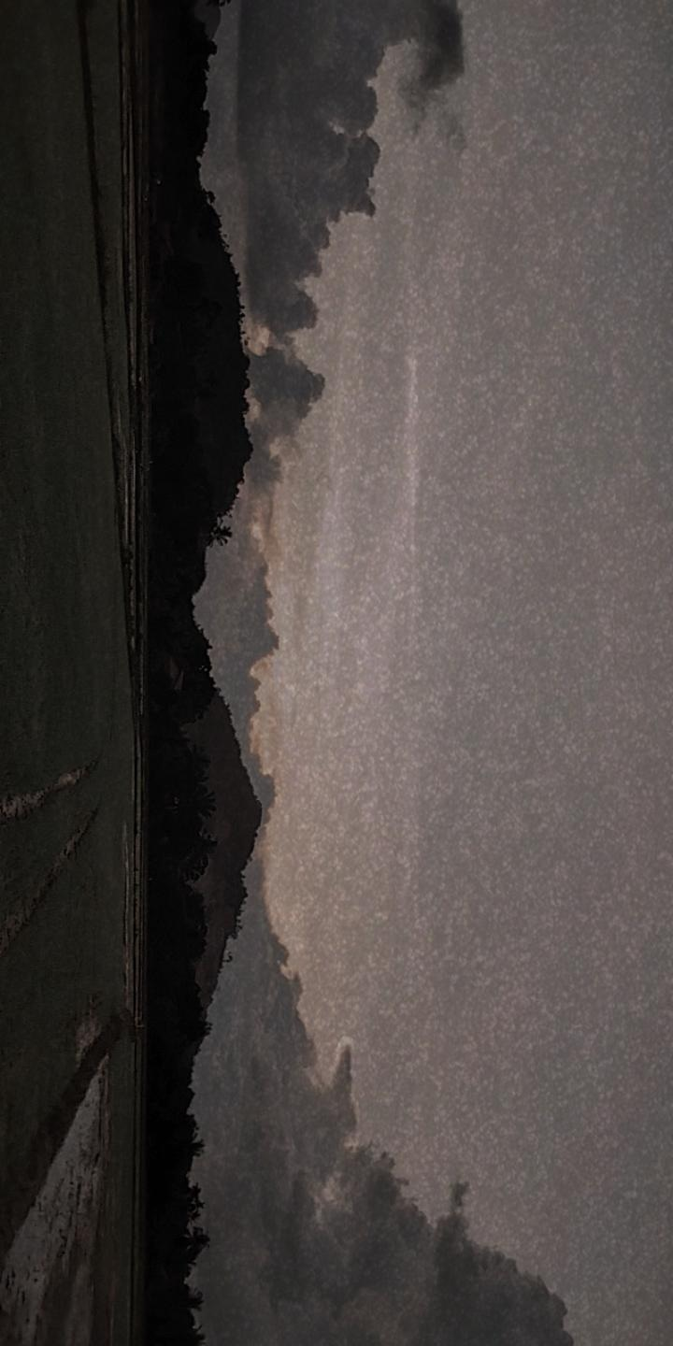

**FACEBOOK:** [**https://web.facebook.com/fazlin.olyn/**](https://web.facebook.com/fazlin.olyn/)

**INSTAGRAM:** [**https://instagram.com/fazelinzaini?utm_medium=copy_link**](https://instagram.com/fazelinzaini?utm_medium=copy_link)

**LINKEDIN:** [**https://www.linkedin.com/in/fazelin-zaini-0538aa225/**](https://www.linkedin.com/in/fazelin-zaini-0538aa225/)

**GMAIL:** [**fazzaipb@gmail.com**](mailto:fazzaipb@gmail.com)