DAD 220 Project One Template

Complete these steps as you work through the directions for Project One. Replace the bracketed text with your screenshots and brief explanations of the work they capture. Each screenshot and its explanation should be sized to approximately one-quarter of the page with the description written below the screenshot. Follow these rules for each of the prompts and questions below. Review the example document in the Supporting Materials section of the Project One Guidelines and Rubric for assistance.

Step One: Create a Database

- In your online IDE (Codio), create a database schema called QuantigrationUpdates that will hold tables by using SQL commands.
  - List out the database name on the screen.
  - Provide the SQL commands you ran against MySQL to complete this step.

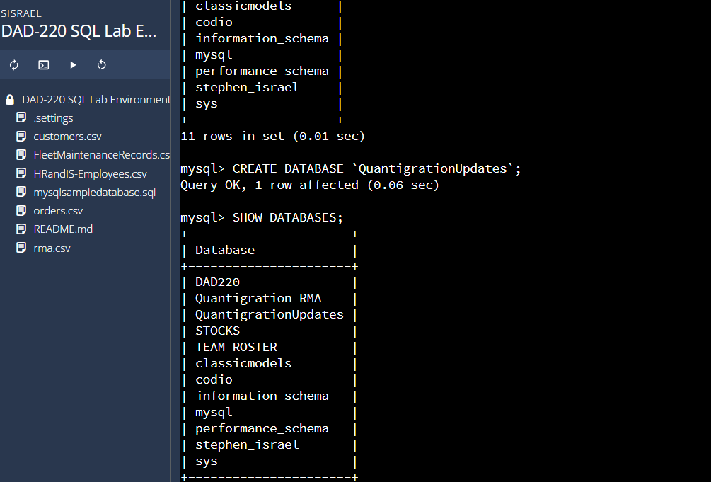

SQL : CREATE DATABASE `QuantigrationUpdates`;
SHOW DATABASES;

- Connect to the QuantigrationUpdates schema. Using the ERD as a reference, write SQL commands to create the following tables with the appropriate attributes and keys to demonstrate relationships based on the ERD.
  - A table named Customers to store customer information with a primary key of Customer ID. Provide the SQL commands you ran against MySQL to complete this step.

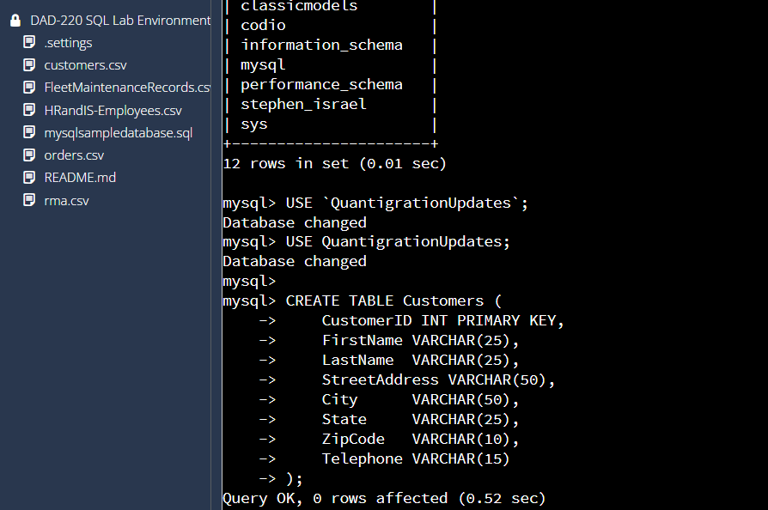
SQL : USE QuantigrationUpdates;

CREATE TABLE Customers (
CustomerID INT PRIMARY KEY,
FirstName VARCHAR(25),
LastName VARCHAR(25),
StreetAddress VARCHAR(50),
City VARCHAR(50),
State VARCHAR(25),
ZipCode VARCHAR(10),
Telephone VARCHAR(15)
);

  - A table named Orders to store order information with a primary key of Order ID and a foreign key of Customer ID. Provide the SQL commands you ran against MySQL to complete this step.

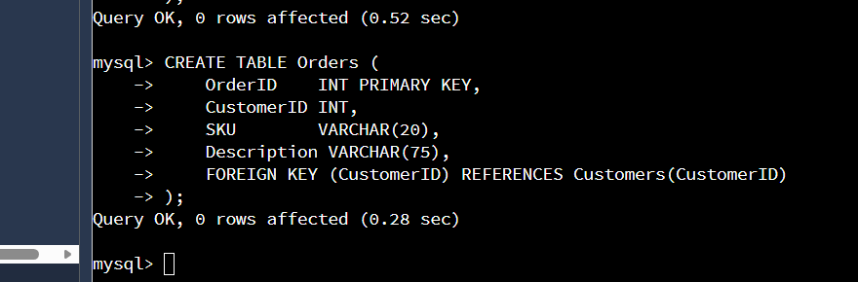

SQL : CREATE TABLE Orders (
OrderID INT PRIMARY KEY,
CustomerID INT,
SKU VARCHAR(20),
Description VARCHAR(75),
FOREIGN KEY (CustomerID) REFERENCES Customers(CustomerID)
);

  - A table named RMA to store RMA information with a primary key of RMA ID and a foreign key of Order ID. Provide the SQL commands you ran against MySQL to complete this step.

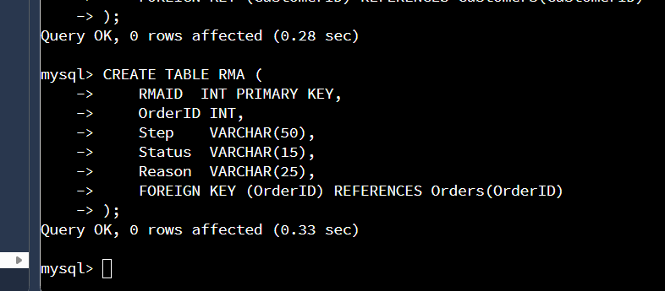

SQL : CREATE TABLE RMA (
RMAID INT PRIMARY KEY,
OrderID INT,
Step VARCHAR(50),
Status VARCHAR(15),
Reason VARCHAR(25),
FOREIGN KEY (OrderID) REFERENCES Orders(OrderID)
);

Step Two: Load and Query the Data

- Import the data from each file into tables.
  - Use the QuantigrationUpdates database, the three tables you created, and the three CSV files preloaded into Codio.
  - Use the import utility of your database program to load the data from each file into the table of the same name. Perform this step three times, once for each table.
  - Provide the SQL commands you ran against MySQL to complete this step.

Customers :
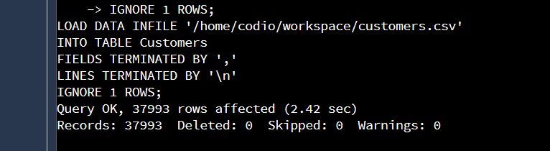
LOAD DATA INFILE '/home/codio/workspace/customers.csv'
INTO TABLE Customers
FIELDS TERMINATED BY ','
LINES TERMINATED BY '\n'
IGNORE 1 ROWS;

Orders:
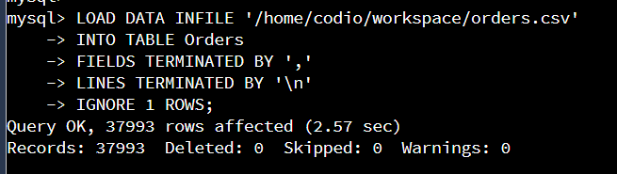
SQL : LOAD DATA INFILE '/home/codio/workspace/orders.csv'
INTO TABLE RMA
FIELDS TERMINATED BY ','
LINES TERMINATED BY '\n'
IGNORE 1 ROWS;

RMA :
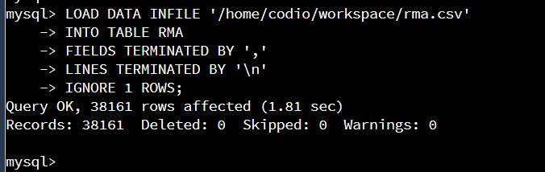

SQL : LOAD DATA INFILE '/home/codio/workspace/rma.csv'
INTO TABLE RMA
FIELDS TERMINATED BY ','
LINES TERMINATED BY '\n'
IGNORE 1 ROWS;

- Write basic queries against the imported tables to organize and analyze the targeted data. For each query, replace the bracketed text with a screenshot of the query and its output. Also, include a one- to three-sentence description of the output.
  - Write a SQL query that returns the count of orders for customers located only in Framingham, Massachusetts.
    - This query will use a table join between the Customers and Orders tables. The query will also use a WHERE clause.
    - How many records were returned? 505

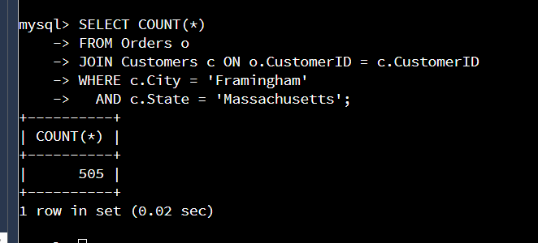

SQL: SELECT COUNT(*)
FROM Orders o
JOIN Customers c ON o.CustomerID = c.CustomerID
WHERE c.City = 'Framingham'
AND c.State = 'Massachusetts';

This query joins the Orders and Customers tables and filters results to only customers located in Framingham, Massachusetts. The output shows the total number of orders from that location.

  - Write a SQL query to select all of the customers located in Massachusetts.
    - Use a WHERE clause to limit the number of records in the Customers table to only those who are located in Massachusetts.
    - How many records were returned? 982

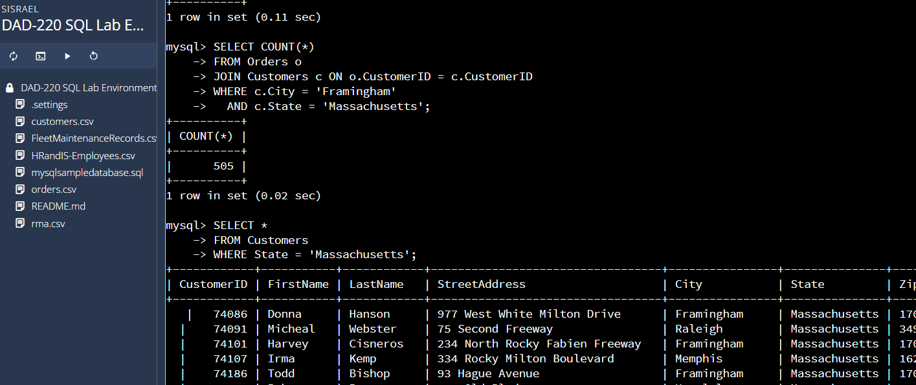

SQL: SELECT *
FROM Customers
WHERE State = 'Massachusetts';

This query filters the Customers table to return only those whose state value is ‘Massachusetts’. The number of records returned equals the number of customers in this state.

  - Write a SQL query to insert four new records into the Orders and Customers tables using the data below:

Customers Table
CustomerID | FirstName | LastName | StreetAddress | City | State | ZipCode | Telephone
100004 | Luke | Skywalker | 15 Maiden Lane | New York | NY | 10222 | 212-555-1234
100005 | Winston | Smith | 123 Sycamore Street | Greensboro | NC | 27401 | 919-555-6623
100006 | MaryAnne | Jenkins | 1 Coconut Way | Jupiter | FL | 33458 | 321-555-8907
100007 | Janet | Williams | 55 Redondo Beach Blvd | Torrence | CA | 90501 | 310-555-5678

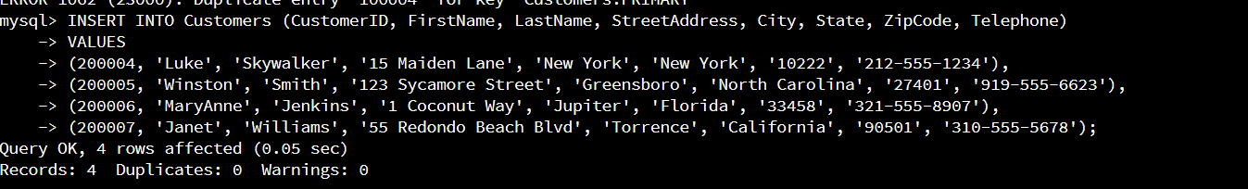

Orders Table
OrderID | CustomerID | SKU | Description
1204305 | 100004 | ADV-24-10C | Advanced Switch 10GigE Copper 24 port
1204306 | 100005 | ADV-48-10F | Advanced Switch 10 GigE Copper/Fiber 44 port copper 4 port fiber
1204307 | 100006 | ENT-24-10F | Enterprise Switch 10GigE SFP+ 24 Port
1204308 | 100007 | ENT-48-10F | Enterprise Switch 10GigE SFP+ 48 port

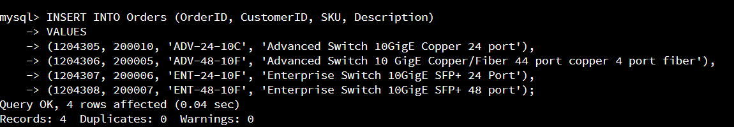

  - In the Customers table, perform a query to count all records where the city is Woonsocket and the state is Rhode Island.
    - How many records are in the Customers table where the field "city" equals "Woonsocket"? 7

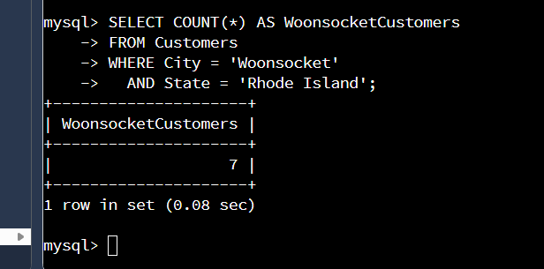
SQL : SELECT COUNT(*) AS WoonsocketCustomers
FROM Customers
WHERE City = 'Woonsocket'
AND State = 'Rhode Island';

This query counts how many customer records match the city "Woonsocket" and the state "Rhode Island." It uses a simple WHERE filter on the Customers table. The output displays the total number of matching customers.

  - In the RMA database, update a customer's records.
    - Write a SQL statement to select the current fields of status and step for the record in the RMA table with an OrderID value of "5175".
      - What are the current status and step? Pending | Awaiting Customer Decison

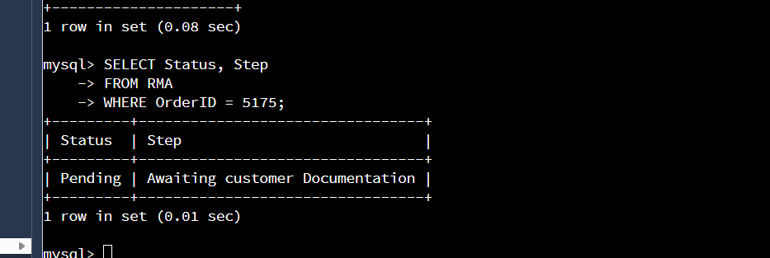

SELECT Status, Step
FROM RMA
WHERE OrderID = 5175;

This query retrieves the current Status and Step for the RMA record associated with OrderID 5175. It filters the RMA table using a WHERE clause to locate this specific record. The output shows the existing workflow status for that order before any updates are applied.

    - Write a SQL statement to update the status and step for the OrderID, 5175 to status = "Complete" and step = "Credit Customer Account".
      - What are the updated status and step values for this record?
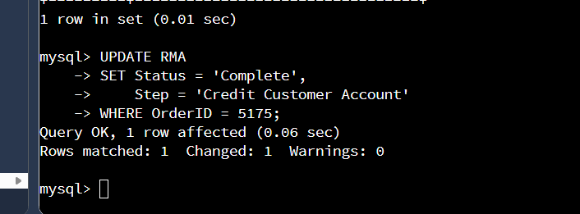

UPDATE RMA
SET Status = 'Complete',
Step = 'Credit Customer Account'
WHERE OrderID = 5175;
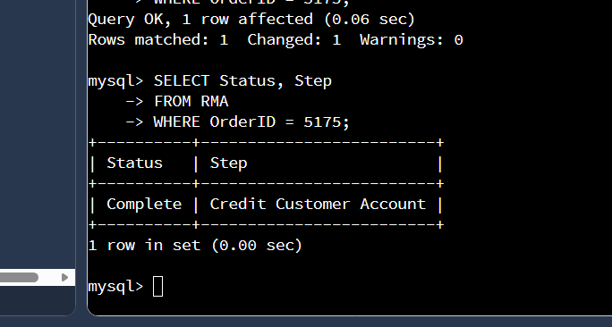
The UPDATE statement modifies the RMA record for OrderID 5175, setting the status to "Complete" and the step to "Credit Customer Account." The follow-up SELECT query confirms that the update was successful. The final output should display the new status and step values.

  - Delete RMA records.
    - Write a SQL statement to delete all records with a reason of "Rejected".
      - How many records were deleted? 595

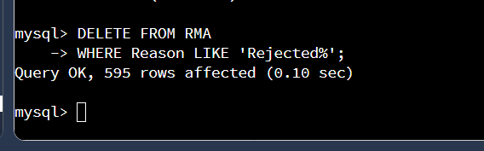

SQL : DELETE FROM RMA
WHERE Reason LIKE 'Rejected%';

I deleted all RMA records where the reason contained the word “Rejected” by using a LIKE statement with one % wildcard. This allowed the delete to work even if there were extra spaces in the data. The output showed how many rows were removed.

- Update your existing tables from "Customer" to "Collaborator" using SQL based on this change in requirements. Copy and paste the SQL you write to do the following action:
  - Rename all instances of "Customer" to "Collaborator".
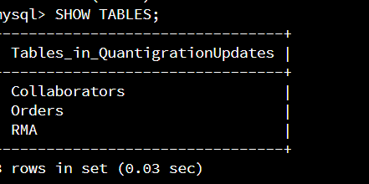

RENAME TABLE Customers TO Collaborators;

This SQL command renames the Customers table to Collaborators to meet the new requirement. It updates the table name throughout the schema so all future queries use Collaborators instead of Customers
- Create an output file of the required query results. Write a SQL statement to list the contents of the Orders table and send the output to a file that has a CSV extension.

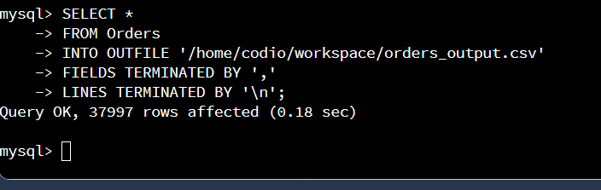
SQL: SELECT *
FROM Orders
INTO OUTFILE '/home/codio/workspace/orders_output.csv'
FIELDS TERMINATED BY ','
LINES TERMINATED BY '\n';

This SQL exports all rows from the Orders table into a CSV file named orders_output.csv. The INTO OUTFILE command writes the query results to a file using comma-separated values.”

