DAD 220 Project Two Template

Overview
Review the scenario for this activity in the guidelines and rubric. Then complete the steps below as you work through the directions for this activity. Replace the bracketed text with your screenshots and responses to the prompts. Size each screenshot and its explanation to fit approximately one-quarter of the page with the description written below the screenshot. Review the Template Screenshot Example linked in the guidelines and rubric for this assignment to see an example of how screenshots for your assignment should look.

RMA Report
Write a report to respond to the manager’s requests. In the report, you should complete the following actions:

- Summarize the data you’ve been working with.
- Identify key information that will help the company streamline operations.

Your report should explain your findings in a way nontechnical stakeholders can understand and use.

Use the steps below to capture the required data and produce the analysis report.

- Begin by writing SQL commands to capture specific usable data for your analysis. You already preloaded the data you need into Codio.
- Specifically, the product manager wants you to complete the following analysis:

  - Analyze the number of returns by state and describe findings to include in your report.

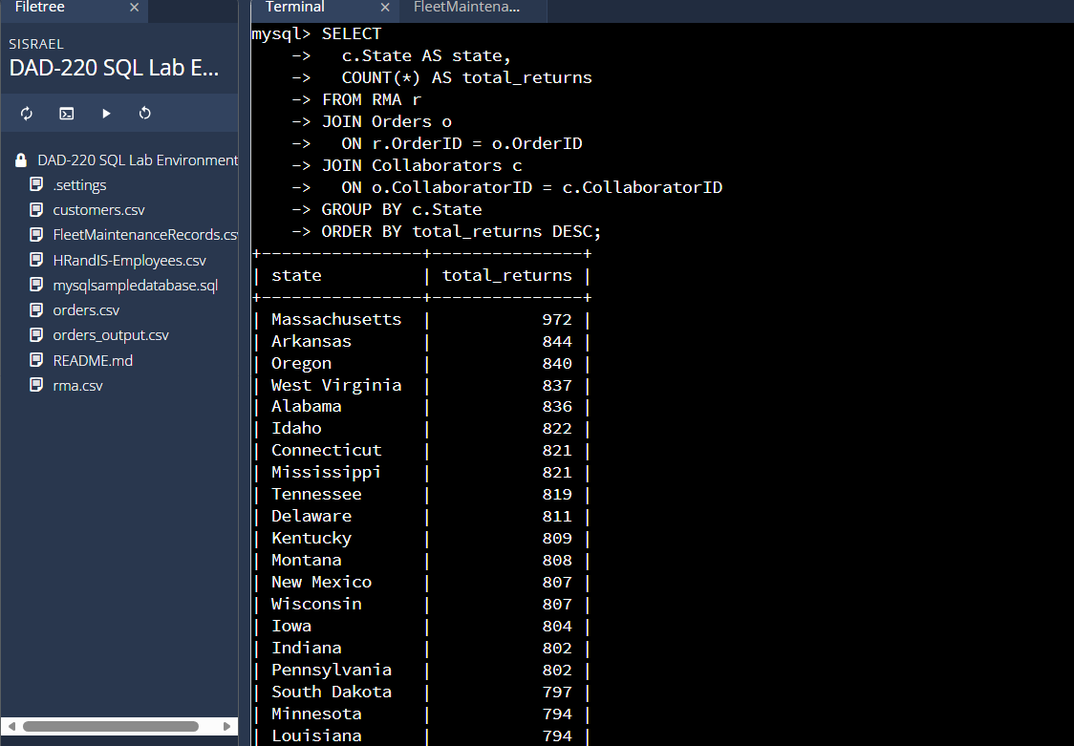
This query determines the number of returns by state by linking the RMA table to the Orders table and then to the Collaborators table. This allows return records to be associated with customer locations. Grouping by state highlights which states generate the highest number of returns, helping the company focus operational improvements geographically.
  - Analyze the percentage of returns by product type and describe findings to include in your report.

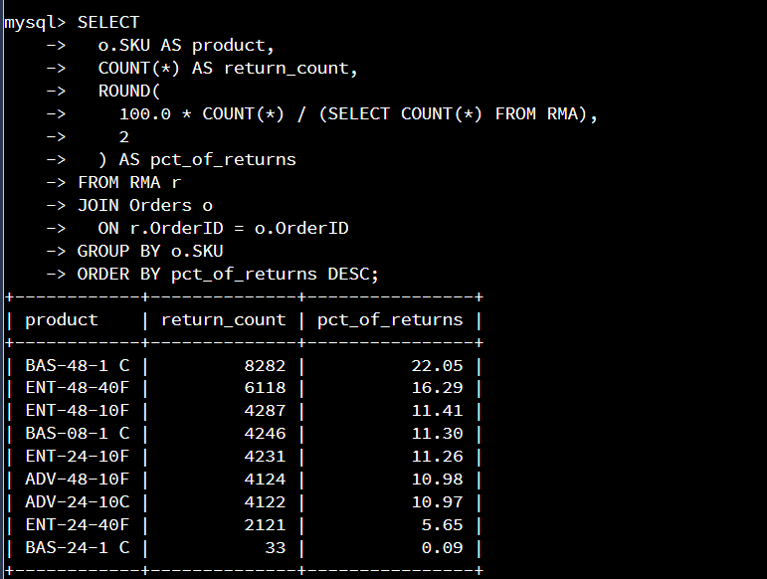
This query analyzes product returns by SKU, where each SKU represents a unique product. It shows both the total number of returns and the percentage of overall returns for each product, helping identify which products contribute most to return volume.

- Write a report to clearly summarize your RMA data analysis for stakeholders. When you summarize the results, consider the following questions:

  - How does the data provide the product manager with usable information?
  - What are the potential flaws in the data that has been presented?
  - Are there any limitations on your conclusions or any other ways of looking at your findings that you haven’t considered? Clearly communicate your findings to stakeholders.

The RMA data analysis provides actionable insight by identifying where returns are coming from and which products contribute most to overall return volume. By examining returns by state, the data helps the product manager focus attention on geographic areas that may require operational improvements, such as shipping processes or customer support. Analyzing returns by product using SKU and product descriptions highlights specific items that are most frequently returned, allowing the company to prioritize quality improvements, packaging changes, or clearer product descriptions. However, the data has limitations, as it does not include return reasons or defect details, making it difficult to determine why products are returned. Additionally, higher return counts may reflect higher sales volume rather than poor product performance, and state-level data does not account for differences in order volume across regions. While these factors limit definitive conclusions, the analysis still offers valuable direction by identifying high-impact areas for further investigation. Future analysis incorporating sales volume, return reasons, and time-based trends would strengthen insights and support more precise decision-making.

