

Developer: Stephen Israel

Date: 06/01/2025

IT 145 Global Rain Summary Report Template

Pseudocode

Start
Prompt user for pet type (dog or cat)
Check if space is available:
If dog, check if dogSpaces > 0
If cat, check if catSpaces > 0
If space is available:
Collect pet name and pet age
Ask for length of stay (daysStay)
If dog and daysStay >= 2:
Ask if owner wants grooming service
Assign pet to a space (reduce dogSpaces or catSpaces by 1)
Confirm check-in and display updated details
Else:
Display message: No available spaces for this pet type
End

Flowchart
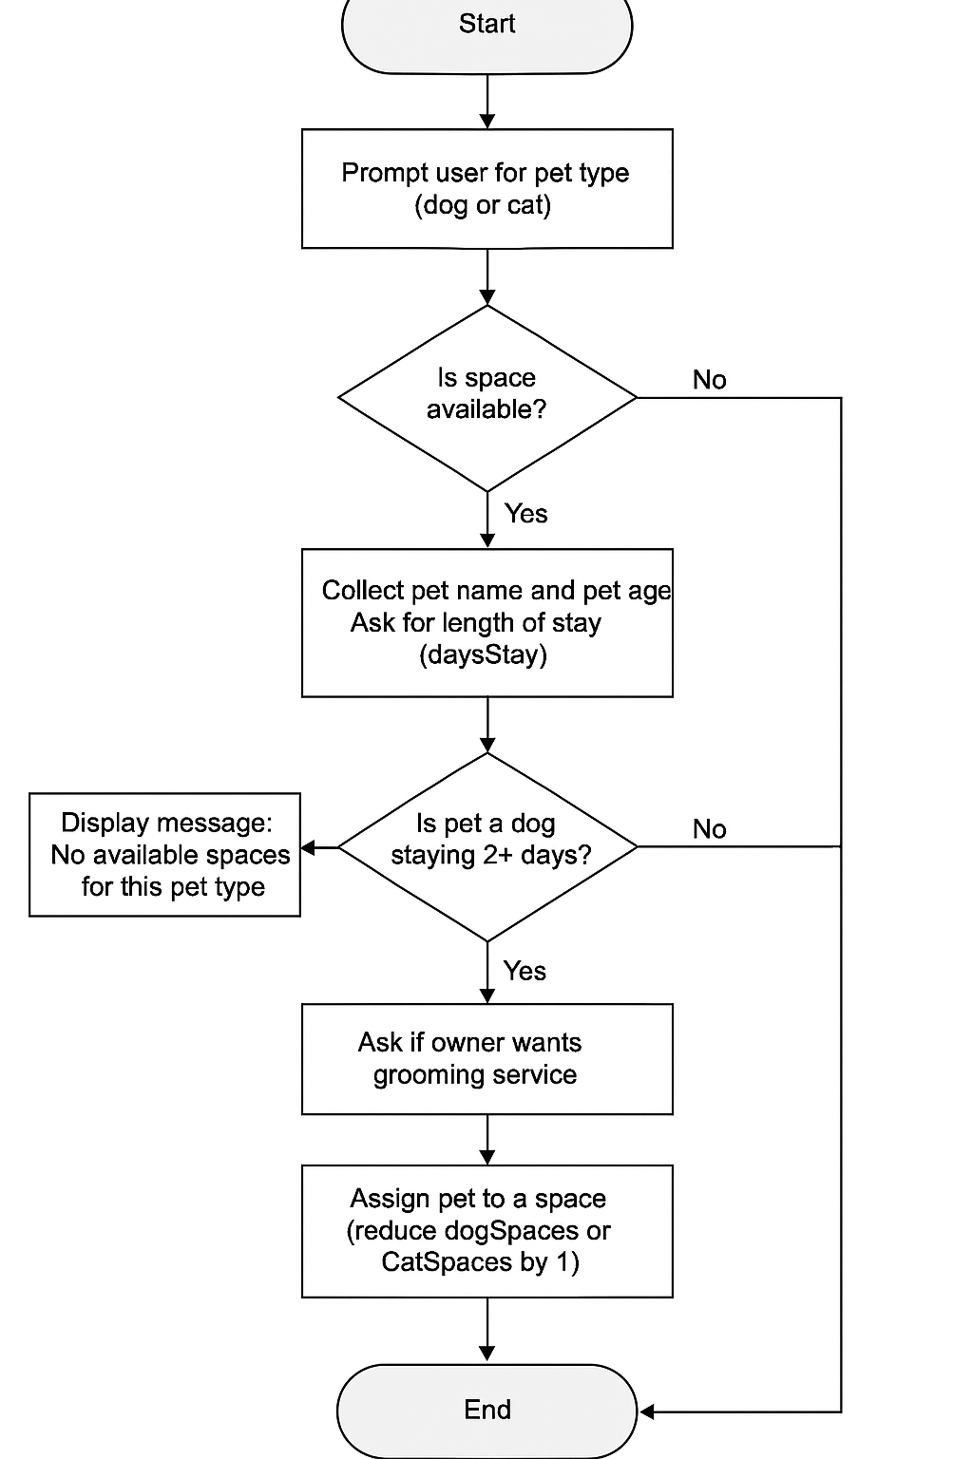

OOP Principles Explanation

In my software development work, I applied the object-oriented programming principle of encapsulation by grouping all related attributes and methods within the Pet class, keeping the data secure and only accessible through getters and setters. I recognized inheritance by designing the Pet class in a way that could serve as a parent class for more specific classes like Dog and Cat in the future. This structure promotes code reuse, allowing common behaviors to be shared across related classes. By following OOP principles, I ensured that the code is modular, easier to maintain, and adaptable for future enhancements. These concepts make the system more organized and efficient as it scales with the client’s needs.

