Newton’s Second Law
Stephen Israel

April 5, 2026

Activity 1: Newton’s Second Law Data Table 1
Suspended Mass (kg) | Weight of Suspended Mass (mass x 9.8 m/s²), Newtons | Time (sec) | Average Time | Average Time² | d (m) | 2d (m) | Acceleration = 2d/t²
0.016 | 0.1568 | 2.24 | 2.237 | 5.0027 | 0.80 | 1.60 | 0.3198
 |  | 2.20
 |  | 2.27
0.021 | 0.2058 | 1.97 | 1.950 | 3.8025 | 0.80 | 1.60 | 0.4208
 |  | 1.93
 |  | 1.95
0.026 | 0.2548 | 1.77 | 1.753 | 3.0742 | 0.80 | 1.60 | 0.5205
 |  | 1.74
 |  | 1.75
0.031 | 0.3038 | 1.63 | 1.610 | 2.5921 | 0.80 | 1.60 | 0.6173
 |  | 1.59
 |  | 1.61
0.036 | 0.3528 | 1.51 | 1.490 | 2.2201 | 0.80 | 1.60 | 0.7207
 |  | 1.47
 |  | 1.49
Mass of the system | 0.490 |  |  |  | Slope of the Line (kg) | 0.4908

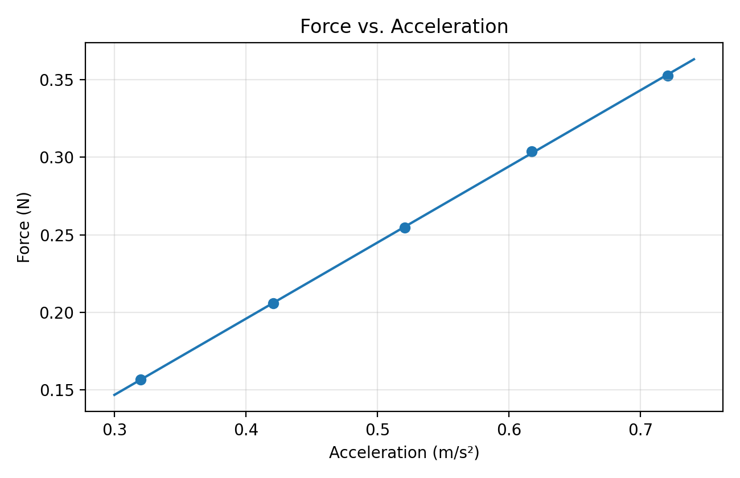

Activity 1: Questions for Newton’s Second Law
Question 1:
According to Newton’s Second Law F = ma.
If the force applied to an object is doubled, what happens to the acceleration?
If the mass stays constant, doubling the applied force doubles the acceleration. Since F = ma, acceleration changes in direct proportion to force when mass does not change.

Question 2:
You observe a vehicle traveling on a highway. The vehicle is maintaining a constant velocity. What can you determine about the forces on the vehicle?
If the vehicle is moving at a constant velocity, the net force on it is zero. The forward force from the engine is balanced by opposing forces such as friction and air resistance.

Question 3:
What are some error sources in the Second Law experiment?
Some error sources in this experiment include human reaction time with the stopwatch, friction between the cart and the surface, friction in the pulley, slack in the string, and slight differences in how the cart was released each trial. A surface that is not perfectly level could also affect the results.

Question 4:
In the Second Law experiment, the acceleration is calculated by measuring the time for the cart to move from the start point to the end point and applying the kinematics equation:
The equation starts with s = 1/2at^2, where s is the displacement of the cart and t is the measured time.
By rearranging the equation, acceleration can be found using a = 2s / t^2.
In this experiment, the measured distance from the start point to the end point is used for s, and the average of the three trial times is used for t. After squaring the average time and substituting the values into a = 2s / t^2, the acceleration of the cart is found.

