A&L ENGINEERING
Roller Coaster Design Report

Coaster Design Diagram
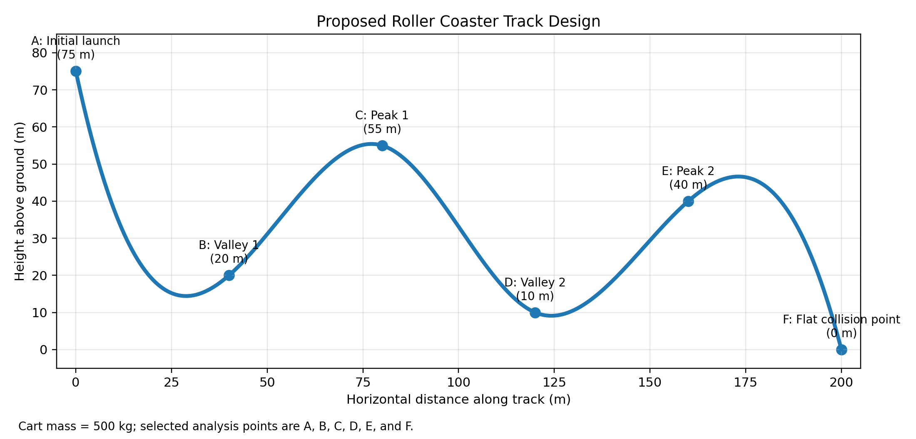
Figure 1. Roller coaster design used for the analysis. The ride begins at 75 m, includes two valleys (20 m and 10 m) and two peaks (55 m and 40 m), and ends on a flat section used for the collision model.

Kinetic Energy, Potential Energy, and Momentum Calculations
Assumptions and Given Values
• Cart mass, m = 500 kg
• Acceleration due to gravity, g = 9.81 m/s²
• Friction is ignored for the moving coaster until the final stopping section.
• Total mechanical energy is set by the initial height of 75 m.
• Total mechanical energy: E = mgh = (500 kg)(9.81 m/s²)(75 m) = 367,875 J
Equations Used
Potential energy: PE = mgh
Kinetic energy: KE = E_total − PE
Velocity from kinetic energy: v = √(2KE/m)
Momentum: p = mv
Work done by gravity from the starting point: W = ΔKE
Point-by-Point Calculations
A – Initial launch at h = 75 m
PE = mgh = (500)(9.81)(75) = 367,875 J
KE = E_total − PE = 367,875 − 367,875 = 0 J
v = √(2KE/m) = √(2 × 0 / 500) = 0.00 m/s
p = mv = (500)(0.00) = 0.00 kg·m/s
Work done by gravity from A to A: W = ΔKE = 0 − 0 = 0 J
B – Valley 1 at h = 20 m
PE = mgh = (500)(9.81)(20) = 98,100 J
KE = E_total − PE = 367,875 − 98,100 = 269,775 J
v = √(2KE/m) = √(2 × 269,775 / 500) = 32.85 m/s
p = mv = (500)(32.85) = 16,424.83 kg·m/s
Work done by gravity from A to B: W = ΔKE = 269,775 − 0 = 269,775 J
C – Peak 1 at h = 55 m
PE = mgh = (500)(9.81)(55) = 269,775 J
KE = E_total − PE = 367,875 − 269,775 = 98,100 J
v = √(2KE/m) = √(2 × 98,100 / 500) = 19.81 m/s
p = mv = (500)(19.81) = 9,904.54 kg·m/s
Work done by gravity from A to C: W = ΔKE = 98,100 − 0 = 98,100 J
D – Valley 2 at h = 10 m
PE = mgh = (500)(9.81)(10) = 49,050 J
KE = E_total − PE = 367,875 − 49,050 = 318,825 J
v = √(2KE/m) = √(2 × 318,825 / 500) = 35.71 m/s
p = mv = (500)(35.71) = 17,855.67 kg·m/s
Work done by gravity from A to D: W = ΔKE = 318,825 − 0 = 318,825 J
E – Peak 2 at h = 40 m
PE = mgh = (500)(9.81)(40) = 196,200 J
KE = E_total − PE = 367,875 − 196,200 = 171,675 J
v = √(2KE/m) = √(2 × 171,675 / 500) = 26.20 m/s
p = mv = (500)(26.20) = 13,102.48 kg·m/s
Work done by gravity from A to E: W = ΔKE = 171,675 − 0 = 171,675 J
Summary Table
Point | Height (m) | PE (J) | KE (J) | Speed (m/s) | Momentum (kg·m/s) | Work by Gravity from A (J)
A (Initial launch) | 75 | 367,875 | 0 | 0.00 | 0.00 | 0
B (Valley 1) | 20 | 98,100 | 269,775 | 32.85 | 16,424.83 | 269,775
C (Peak 1) | 55 | 269,775 | 98,100 | 19.81 | 9,904.54 | 98,100
D (Valley 2) | 10 | 49,050 | 318,825 | 35.71 | 17,855.67 | 318,825
E (Peak 2) | 40 | 196,200 | 171,675 | 26.20 | 13,102.48 | 171,675

Energy Descriptions
The cart begins at Point A with a height of 75 m. At that moment it has maximum gravitational potential energy and essentially no kinetic energy because it starts from rest. Using PE = mgh, the cart begins with 367,875 J of potential energy. As soon as the cart descends the first hill, gravity converts that stored potential energy into kinetic energy, which is the energy of motion.
At Valley 1 (Point B), the cart is much lower, so its potential energy drops to 98,100 J. Because friction is ignored, the lost potential energy becomes kinetic energy, so the cart’s kinetic energy increases to 269,775 J and its speed rises to 32.85 m/s. When the cart climbs from Valley 1 to Peak 1 (Point C), some of that kinetic energy is transferred back into potential energy. At Point C the cart slows to 19.81 m/s because more of the total energy is stored as height again.
The same pattern happens again between Peak 1, Valley 2, and Peak 2. At Valley 2 (Point D), the cart reaches its lowest selected point, so potential energy is at its minimum (49,050 J) and kinetic energy is near its maximum (318,825 J). As the cart rises to Peak 2 (Point E), part of that motion energy is converted back into stored gravitational energy, so the speed drops to 26.20 m/s.
Throughout the ride, the total mechanical energy remains constant at approximately 367,875 J because the problem states that friction can be ignored. In other words, energy is not created or destroyed; it is only converted between potential and kinetic forms. This is a direct application of the principle of conservation of energy (OpenStax, 2023). The coaster is a good model of an ideal mechanical system: when height decreases, speed increases; when height increases, speed decreases; and the sum of KE + PE remains constant.

Collision Calculations
Collision Setup
The cart reaches Point F on a flat surface at h = 0 m. The moving 500 kg cart then collides inelastically with an identical 500 kg cart at rest. After impact, the carts stick together and move as one 1,000 kg system.
Equations Used
Momentum before collision: p = mv
Conservation of momentum: m₁v₁ + m₂v₂ = (m₁ + m₂)v_f
Kinetic energy: KE = 1/2 mv²
Speed of moving cart just before collision from energy conservation: v = √(2gh)
Before the Collision
Speed of moving cart: v = √(2gh) = √(2 × 9.81 × 75) = 38.36 m/s
Momentum of moving cart: p = mv = (500)(38.36) = 19,180.07 kg·m/s
Kinetic energy of moving cart: KE = 1/2 mv² = 0.5(500)(38.36)² = 367,875 J
Second cart at rest: p = 0 kg·m/s and KE = 0 J
Total system momentum before collision = 19,180.07 kg·m/s
Total system kinetic energy before collision = 367,875 J
After the Collision
Use momentum conservation: (500)(38.36) + (500)(0) = (1000)v_f
v_f = 19.18 m/s
Momentum after collision: p = (1000)(19.18) = 19,180.07 kg·m/s
Kinetic energy after collision: KE = 1/2 (1000)(19.18)² = 183,937.5 J
Change in kinetic energy during collision: ΔKE = 183,937.5 − 367,875 = -183,937.5 J
System State | Momentum (kg·m/s) | Kinetic Energy (J) | Speed (m/s)
Before collision | 19,180.07 | 367,875 | 38.36 (moving cart)
After collision | 19,180.07 | 183,937.5 | 19.18 (combined carts)

Collision Descriptions
Just before the collision, only the first cart is moving, so it has 367,875 J of kinetic energy. The second cart is sitting still, so its kinetic energy is 0 J. After the inelastic collision, the two carts stick together and move at 19.18 m/s. At that point, the combined cart system has 183,937.5 J of kinetic energy.
The system’s total momentum is conserved: it is 19,180.07 kg·m/s before the collision and the same 19,180.07 kg·m/s after the collision. However, kinetic energy is not conserved in an inelastic collision. The system loses 183,937.5 J of kinetic energy because some of the mechanical energy is transferred into other forms such as sound, heat, vibration, and deformation of the carts during impact (The Physics Classroom, n.d.).
The total energy of the full system is still conserved. The important point is that not all of the energy remains as useful motion energy. Some of it is converted into nonmechanical forms during the crash. This is how conservation of energy applies here: momentum stays constant for the collision, while the total energy remains constant only when all forms of energy are considered.

Friction Calculations
Tip: The work-energy theorem tells us that change in kinetic energy is equal to work done on the system.
Stopping on a Frictional Section
After the inelastic collision, the two carts form a single 1,000 kg object moving at 19.18 m/s. A frictional section 20 m long brings the joined carts to rest.
Equations Used
Work-energy theorem: W = ΔKE = KE_final − KE_initial
Work done by friction: W_f = F_f d cos(180°) = −F_f d
Average friction force magnitude: |F_f| = |W_f| / d
Calculations
Initial kinetic energy of the combined carts: KE_i = 183,937.5 J
Final kinetic energy after stopping: KE_f = 0 J
Work done by friction: W_f = ΔKE = 0 − 183,937.5 = -183,937.5 J
Because friction acts opposite the motion, the work is negative.
W_f = −F_f d → -183,937.5 = −F_f(20)
F_f = 9,196.87 N opposite the direction of motion
Quantity | Value
Work due to friction | -183,937.5 J
Average friction force magnitude | 9,196.87 N

Energy Transfers
Before the carts enter the friction section, the combined system is still moving and has 183,937.5 J of kinetic energy. After traveling 20 m through the rough stopping zone, the carts come fully to rest, so the final kinetic energy is 0 J.
To a nontechnical audience, the easiest way to think about this is that the motion energy does not just disappear. The track and wheels rub against each other, and that rubbing changes the energy of motion into heat, sound, and small vibrations. So even though the carts stop moving, the energy is still present in a different form.
The work done by friction is -183,937.5 J, which exactly matches the loss in kinetic energy of the carts. This is an application of the work-energy theorem (OpenStax, 2023). The total energy of the system is conserved because the 183,937.5 J of motion energy is transferred out of kinetic energy and into thermal and sound energy. Conservation of energy still holds; the form of the energy changes, but the total amount does not.

References
OpenStax. (2023). College physics 2e. OpenStax, Rice University. https://openstax.org/details/books/college-physics-2e
The Physics Classroom. (n.d.). Momentum and collisions. https://www.physicsclassroom.com/class/momentum
The Physics Classroom. (n.d.). Work, energy, and power. https://www.physicsclassroom.com/class/energy

