## Product Introduction for SnapMemo

## Outline

As the **mobile Internet** getting more and more prosperous, people tend to handle more tasks on their cell phones, tablets and laptops. But sometimes you can’t note it down right away. Every time we meet this situation, we may try to open a TODO app and make a great effort to fill in the date, time and the task description. Things get **worse** if you are **typing** on a small screen of the cellphone. Undoubtedly, this job is **dull, complex** and should be done in an elegant way. Now, we believe our team has found the way. Instead of typing everything letter by letter, users only need to **snap a screenshot** and **circle the zone** where they want to generate a **memo, or a TODO item**. After this simple and user-friendly operation, our app will upload the data to our server end. In the back-end, we will process the picture with **OCR** (Optical Character Recognition) and **NLP** (Natural Language Process) techniques and finally the generated memo data will be pushed to the all client end with different platforms. We used **Java Servlet** to develop and deploy our server end, meanwhile we developed our app on **Android and UWP**. With a single account, users can synchronize their tasks or memo on different devices. We used Visual Studio 2015 Community as our IDE. **UWP** technique will be used as a solution so that we can finish the windows and windows phone ends at the same time.

## Based on the Regulation and Even Better

#### Microsoft Product

During the process of designing and development, massive Microsoft Products and platforms are adopted. In fact, it’s our plan to use **project-oxford** as the core module of our product and a powerful platform to perform cutting-edge machine learning algorithms. Equal importantly, we choose **UWP (Universal Windows Platform)** as the main mobile end. In the phase of designing, we found that **OneNote** is a very useful item for demonstrating our ideas and exchanging ideas. During the process of development, **Visual Studio** was widely used to perform the development on the UWP end and we find it very convenient. On the server end, we adopted **Windows Azure** as the server entity and adopted **OCR** and **NLP** **(Luis) interface** from **Project-Oxford** and impressed by the accuracy and speed of the background service of Project-Oxford. Actually, we trained our own **LUIS Model** for our product.

#### Third Party Tools and Platforms

Apart from the Microsoft platforms and products, some third party tools were also evaluated and adopted by us. For example, we used **Tomcat** to deploy our server end of the product as industrial standard and convention for **Java Servlet**. We also developed the **Android** App as another platform for Android devices and their users, extending our product’s influence to a broader range as well as benefiting more users. **Eclipse** and **GitHub** were also used to assist our development.

## Perfect Match for the Competition Spirit

#### Concept

Our product has **no prerequisites** on our users, thus anyone can use it to help them make memos in an easier way, but we put more weight on those who have to manage a heavy schedule, such as **businessmen** and **students**. Hence, we do more related work in our **LUIS train set**. And for those who have to do mechanical typing job for every **date**, every **time** and every **event** again and again, our application is undoubtedly a **timely savior**. In terms of business market, we can choose to charge for the subscription of our app like what other tools do, or we can also add advertisements to it, provide free use and charge for no-ads version or advanced functions in the future. Finally, it is quite simple to get familiar with our new interaction way because it is so natural and matches our instincts. And this is our goal, to help people attain their expectation **with the minimum job**, **leaving the background complexity to us**.

#### Innovative Ability

I won’t claim that our product absolutely has not similar products, but I believe that we are thinking and performing from a whole new perspective. In another word, we are using a **brand new technique** to **review** the conventional jobs and **finding a better solution**. Before our product, memos are either written down with keyboard or recorded as recordings, however, neither of these two methods can really get the idea of the user, or namely, interpret or perceive. Nevertheless, our product gives a solution **with a brand new perspective**, shortly concluded as two words: **Fast** and **Smart**.

**Fast**. We did our survey and found that **speed or convenience** is the key factor for a TODO app. Users want to take down memos as simple as possible and do not want anyone’s attention. That’s why they **hate** the keyboard and the microphone to do the input. So we began to think: is it possible that a single touch of the screen can complete the WHOLE process of input? And we found our answer: **SNAP**. Snap and screen shot are among the fundamental functions of smart phones and this simple action saves massive information. There is no action on the phone as simple as snap, so we achieved our objective in our plan: **Five Touches of the Screen**. That’s all. We gave the users **an incredible experience** which they never had: take a snap and everything gets easier.

**Smart**. We all know that the phones we are using today are called smart phones. Are they really smart? Not so much. We are still doing too much; we are still using apps as **tools** rather than **assistants**. Voice assistants such as Cortana make us wonder, is it possible that an app can also be smart as Cortana or Siri? The answer is **YES**. What we achieved can be concluded into one sentence: **Sees what we see, knows what we need**. We use **OCR** to extract the information from the screen shot image and use **NLP** to interpret the entities in it, including time, intention, location and so on. For one time, an app can **see**; an app can **understand**; an app can be **smart**. They can see what we are seeing by snapshot, understand the sentences and be smart enough to identify the intentions and entities.

We did not just build an app; we found a way on how machine learning can step outside of the box and be used to **make common people’s lives better**. And that’s what we believe to be the nature of technology.

#### Executive Ability

Our product is fairly easy to get started and easy to use. As for the **interaction** **design**, we’ve approached what we guaranteed. The whole process of getting a memo requires less than **5 taps** —— snapshot, confirm to generate, select preferred memo area(Optional), confirm the selection and confirm the memo generated. It’s a fascinating experience **without any keyboard input**. Moreover, to keep listening to users’ screenshot action, **background service** has been deployed to improve the experience (Applying in Android app). The performance, however, is not influenced by the service and can present in a decent way——≤10Mb memory is occupied when our app is running. At present, we’ve developed SnapMemo for Windows phone and Android and both applications show their own specialty. Referring to SnapMemo for Windows phone, it’s a useful tool on any Windows device. Since SnapMemo for Windows is developed on **UWP**, it will be suitable for all the devices using Windows operation system. Also, the **Android** part has shown its excellence in background service and user interface. Not only the **visual section** has been designed in an exquisite way, but the **sensor detectors** can be adapted to the future development easily as well. Considering that our product is running on different platforms, we’ve also built a server based on Java servlet. The transition of data is smoothly processed under **RESTful framework** and a complete API of all the **HTTP requests** can be applied to any other platforms wanted. As a consequence, our product has been fairly comprehensive in this section.

#### Feasibility

## Product Demonstration

Here we show how our app does the job.

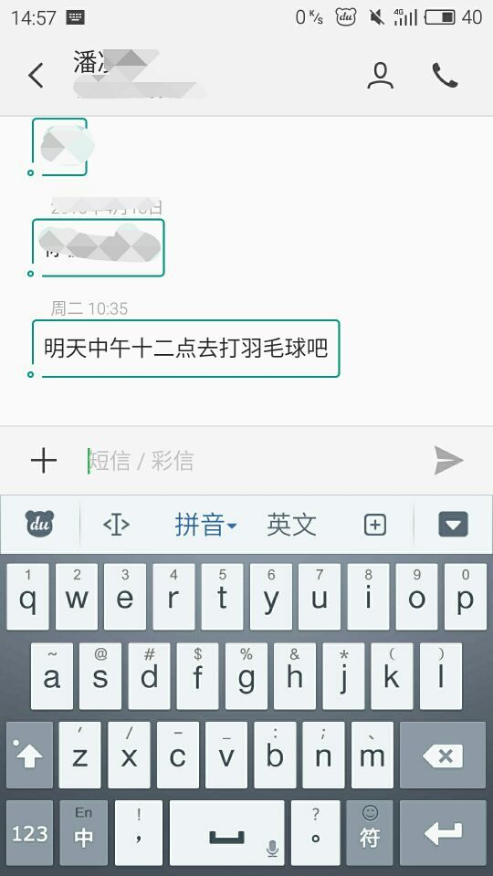 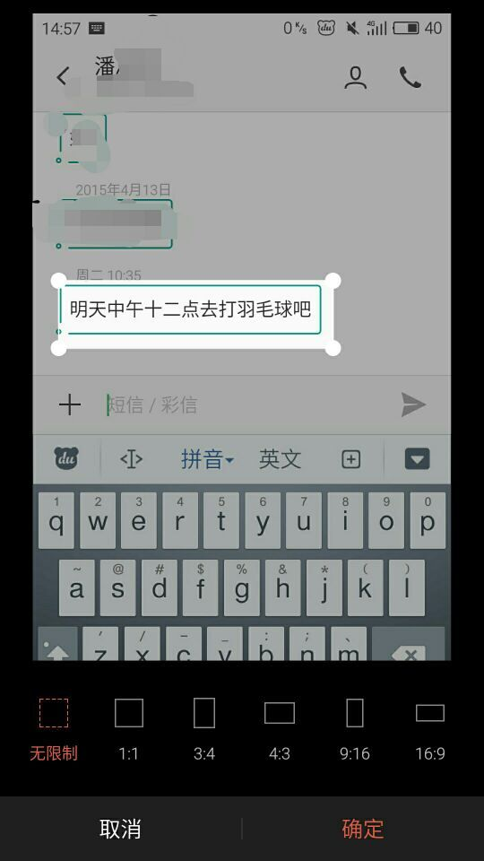

Figure 1 Figure 2

1. First, suppose we got a message from our friends (Figure 1)
2. We simply snap and our app pops up, then we circle the area we want the app to see. (Figure 2)

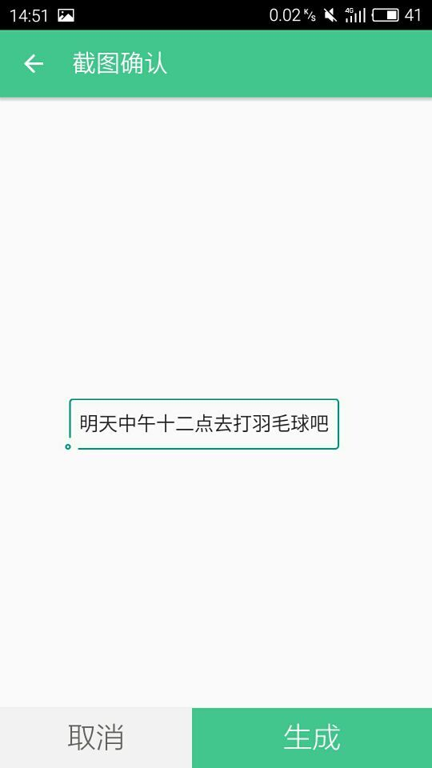 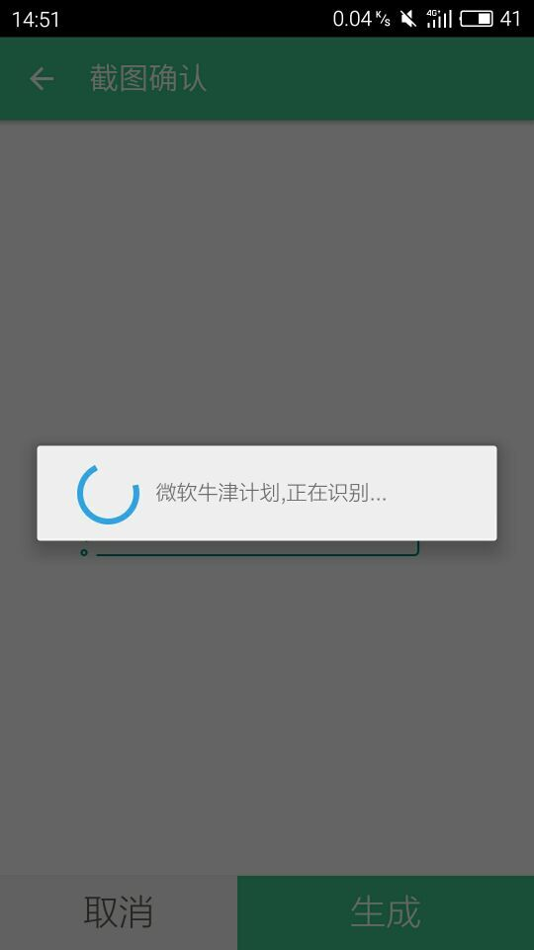

Figure 3 Figure 4

1. The app asks for confirm. (Figure 3)
2. Snapshot being sent to the server to do OCR and NLP.

(Figure 4)

1. The result Memo was sent back with the recognized topic, time and content. (Figure 5)
2. We save the memo to cloud server in order to synchronize on all platforms as Windows Phone, Windows Desktop, Android Devices. (Figure 6)

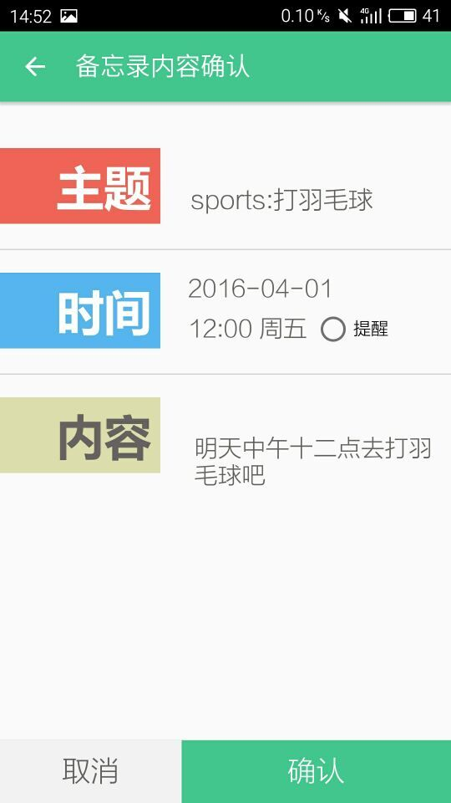 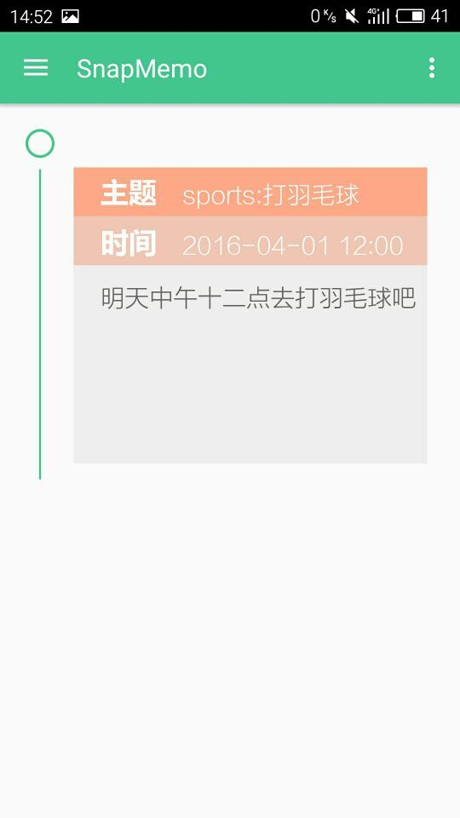

Figure 5 Figure 6

## Summary