NEPv Lens
Installation, Deployment & Operation Manual
Version: 0.1.x (UI refresh — intro band, lab shell, centered AI tutor)
Date: 2026-05-21
Screenshots: 47 (English UI)
Teaching demo: nonlinear eigenvalue problems with eigenvector dependency
AI-assisted, human-verified

Part I — Installation & Deployment

1. Purpose
This manual is for administrators, reviewers, and learners. It explains how to install, deploy, verify, and troubleshoot NEPv Lens on Windows, macOS, or Linux. The product is a static front-end web app (Vite 8 + React 18); there is no backend database.

2. System requirements (pinned versions)
Item | Version / requirement
Operating system | Windows 10/11, macOS 12+, mainstream Linux
Node.js | ≥ 18.17.0 (.nvmrc / engines)
React | 18.2.0 (package.json)
Vite | 8.x (@vitejs/plugin-react 6.x)
Package manager | npm (bundled with Node)
Browser | Chrome / Edge / Firefox (last two major versions)
Optional: Docker | Docker Desktop or Engine + Compose
Manual screenshot tooling | Python 3 + python-docx + playwright (chromium)
Disk space | ≥ 500 MB (including node_modules)

3. Obtain source code
Unpack or clone the project. The root must contain package.json, src/, docs/, and Dockerfile.

4. Local Node.js workflow
npm install
npm run dev # http://localhost:5173
npm run build && npm run preview

5. Docker deployment
docker-compose up --build

6. Acceptance checklist
Check | Command / action | Pass criterion
Dependencies | npm install | No errors
Unit tests | npm test | Residual baseline tests pass (≤ 1e-6 error)
Type check | npx tsc --noEmit | No errors
Production build | npm run build | dist/ created
Bundle size | inspect dist/assets | Main JS gzip ≲ 150 KB
UI smoke test | open localhost:5173 | Intro band + lab interactive
Freeze pitfall | check “Pitfall: freeze A” | ⚠ badge + frozen spectrum column
AI tutor | ask a preset question | Rule-based answer from live state
Manual screenshots | python scripts/capture_manual_screenshots.py | docs/manual-screenshots/ has 45+ PNG

7. Regenerate this manual
From the project root:
npm run build
python scripts/capture_manual_screenshots.py
python scripts/generate_manual_docx.py

Part II — Operation manual (with screenshots)

1. Product overview
NEPv Lens is a teaching demo for eigenvector-dependent nonlinear eigenvalue problems: A(x)·x = λ·x with A depending on x. It does not claim industrial global NEPv solving.

2. Page map
- Definition & Compare — side-by-side intro band (read-only).
- Lab — compass, heatmap/spectrum, polar residual plot, iteration lab, setup drawer.
- AI Math Tutor — full-width section under the lab (status, presets, Q&A).
- Pitfalls — freeze-A pitfall card and FAQ grid.
- References — collapsible bibliography.
- Locale — English (default for this manual), Simplified Chinese, Traditional Chinese.

3. Control inventory
The table lists 47 UI regions and controls captured for version 0.1.x. Screenshots follow the teaching flow top-to-bottom.
# | Control / region | Type | Section | Summary
1 | Top navigation bar | Region | Global navigation | Fixed header: brand, section anchors (Definition through References), and locale selector.
2 | Definition | Link | Global navigation | Click to scroll smoothly to the “Definition” section (#hero).
3 | Compare | Link | Global navigation | Click to scroll smoothly to the “Compare” section (#compare).
4 | Lab | Link | Global navigation | Click to scroll smoothly to the “Lab” section (#playground).
5 | AI Tutor | Link | Global navigation | Click to scroll smoothly to the “AI Tutor” section (#ai-tutor).
6 | Pitfalls | Link | Global navigation | Click to scroll smoothly to the “Pitfalls” section (#pitfalls).
7 | References | Link | Global navigation | Click to scroll smoothly to the “References” section (#references).
8 | Locale selector | Region | Global navigation · Locale | Choose English, Simplified Chinese, or Traditional Chinese; UI strings update immediately.
9 | English | Dropdown | Global navigation · Locale | Set #locale-select to “English”; persisted in localStorage key nepv-lens-locale.
10 | Simplified Chinese (zh-CN) | Dropdown | Global navigation · Locale | Set #locale-select to zh-CN; persisted in localStorage key nepv-lens-locale.
11 | Traditional Chinese (zh-TW) | Dropdown | Global navigation · Locale | Set #locale-select to zh-TW; persisted in localStorage key nepv-lens-locale.
12 | Definition & Compare (side-by-side) | Region | Intro | Read-only: NEPv definition (left) and linear EVP vs NEPv comparison (right), separated by …
13 | Definition (Hero) | Display | Intro · Definition | Read-only: problem statement, formula, and teaching notes.
14 | Linear EVP vs NEPv | Display | Intro · Compare | Read-only: two concept panels and footnote; no interactive controls.
15 | Interactive lab (overview) | Region | Lab | Two-column shell: compass, heatmap/spectrum, polar plot, iteration lab (left); setup drawe…
16 | Lab workspace (compass + observe + controls) | Region | Lab | Main teaching surface: vector compass, residual banner, observe zone, polar plot, iteratio…
17 | Relative residual formula banner | Display | Lab | Read-only: TeX and plain-text definition of r_rel(x, λ).
18 | Model & controls drawer | Collapsible panel | Lab · Setup | Expand/collapse the right-hand setup drawer (model, parameters, λ guess, freeze pitfall, r…
19 | Toy model (Model A — rank-one 2×2) | Dropdown | Lab · Model | Select Model A; resets x and parameters and turns off freeze pitfall.
20 | Physical background (expanded) | Collapsible | Lab · Model | Expand the model details block under the setup drawer for physical context and analytic no…
21 | α (coupling strength) | Slider | Lab · Model A parameters | Drag #alpha (approx. −1.5…1.5); numeric field syncs; A(x) and spectrum update live.
22 | λ guess (residual probe) | Slider | Lab · Residual | Drag #lambda (−1…4); changes displayed r(x, λ) without changing A(x).
23 | Pitfall: freeze A at current x (unchecked) | Checkbox | Lab · Pitfall | Check #freeze to freeze A(x₀), show frozen heatmap/spectrum, and highlight the pitfall.
24 | Pitfall: freeze A (checked) | Checkbox + badge | Lab · Pitfall | Shows inline ⚠ badge and frozen-spectrum column; reminds that linear EVP ≠ NEPv.
25 | Relative & absolute residual | Display | Lab · Residual | Read-only metrics; color hints for low/high residual; Reset all restores defaults.
26 | Vector compass (||x|| = 1) | Drag surface | Lab · Vector | Drag the blue handle on the unit circle; out-of-circle drags project back with a toast.
27 | Heatmap & instantaneous spectrum | Display | Lab · Visualization | A(x) heatmap and eigenvalue bars; extra column when freeze pitfall is on.
28 | Polar residual plot r(θ) | Display | Lab · Visualization | Residual on the unit circle; red marker at θ = 0; updates with parameters.
29 | Iteration lab | Region | Lab · Iteration | Mode selector, Play, Step, Reset far, Reset to reference; convergence summary below.
30 | Eigenvalue pick mode | Dropdown | Lab · Iteration | Choose max / min / closest eigenvalue for the fixed-point map.
31 | Play | Button | Lab · Iteration | Auto-iterate from the PRD reference initial guess (up to 200 steps).
32 | Step | Button | Lab · Iteration | One fixed-point step; disabled after non-convergence limit.
33 | Reset (far) | Button | Lab · Iteration | Jump to a deliberately poor initial vector to demonstrate sensitivity.
34 | Reset to reference | Button | Lab · Iteration | Restore baseline x and k = 0; clears non-convergence warning.
35 | Toy model (Model B — diagonal 3×3) | Dropdown | Lab · Model | Switch to Model B; exposes β₁–β₃ sliders and x₃ control.
36 | β₁ | Slider | Lab · Model B parameters | Adjust #beta1 (diagonal scaling); eigenvalues track diagonal entries.
37 | β₂ | Slider | Lab · Model B parameters | Adjust #beta2 (diagonal scaling); eigenvalues track diagonal entries.
38 | β₃ | Slider | Lab · Model B parameters | Adjust #beta3 (diagonal scaling); eigenvalues track diagonal entries.
39 | x₃ (unit sphere) | Slider | Lab · Vector (3D) | Set third component; works with compass x₁, x₂ under ||x|| = 1.
40 | AI Math Tutor | Region | AI Tutor | Status chips, preset questions, and compose row; rule-based answers grounded in current r,…
41 | Preset questions | Buttons | AI Tutor | One-click prompts (e.g. why not converging, explain freeze pitfall).
42 | Pitfalls & FAQ | Region | Pitfalls | Horizontal layout: main pitfall card (freeze A) and FAQ grid; Try pitfall jumps to lab wit…
43 | References (collapsed) | Collapsible | References | Click summary to expand bibliography and teaching notes.
44 | References (expanded) | Collapsible | References | Numbered citation list and intro paragraph.
45 | Footer disclaimer | Display | Footer | Read-only teaching-demo disclaimer.
46 | x₁ / x₂ numeric fields (mobile) | Number inputs | Lab · Mobile | Shown at viewport ≤ 375px; edits normalize x to the unit sphere.
47 | Mobile lab (375px) | Viewport | Mobile | Touch-friendly compass, stacked observe zone, drawer setup controls.

4. Step-by-step (one screenshot per control)
Each subsection matches a button, input, or display region with a live UI capture (English UI).

Global navigation

1. Top navigation bar
Property | Details
ID / selector | nav-bar (.site-nav)
Type | Region
How to use | Fixed header: brand, section anchors (Definition through References), and locale selector.

Figure 1: Top navigation bar

2. Definition
Property | Details
ID / selector | nav.home (nav.site-nav a[href="#hero"])
Type | Link
How to use | Click to scroll smoothly to the “Definition” section (#hero).

Figure 2: Definition

3. Compare
Property | Details
ID / selector | nav.compare (nav.site-nav a[href="#compare"])
Type | Link
How to use | Click to scroll smoothly to the “Compare” section (#compare).

Figure 3: Compare

4. Lab
Property | Details
ID / selector | nav.playground (nav.site-nav a[href="#playground"])
Type | Link
How to use | Click to scroll smoothly to the “Lab” section (#playground).

Figure 4: Lab

5. AI Tutor
Property | Details
ID / selector | nav.aiTutor (nav.site-nav a[href="#ai-tutor"])
Type | Link
How to use | Click to scroll smoothly to the “AI Tutor” section (#ai-tutor).

Figure 5: AI Tutor

6. Pitfalls
Property | Details
ID / selector | nav.pitfalls (nav.site-nav a[href="#pitfalls"])
Type | Link
How to use | Click to scroll smoothly to the “Pitfalls” section (#pitfalls).

Figure 6: Pitfalls

7. References
Property | Details
ID / selector | nav.references (nav.site-nav a[href="#references"])
Type | Link
How to use | Click to scroll smoothly to the “References” section (#references).

Figure 7: References

Global navigation · Locale

8. Locale selector
Property | Details
ID / selector | lang.switcher (.lang-switcher)
Type | Region
How to use | Choose English, Simplified Chinese, or Traditional Chinese; UI strings update immediately.

Figure 8: Locale selector

9. English
Property | Details
ID / selector | locale-select.en (#locale-select)
Type | Dropdown
How to use | Set #locale-select to “English”; persisted in localStorage key nepv-lens-locale.

Figure 9: English

10. Simplified Chinese (zh-CN)
Property | Details
ID / selector | locale-select.zh-CN (#locale-select)
Type | Dropdown
How to use | Set #locale-select to zh-CN; persisted in localStorage key nepv-lens-locale.

Figure 10: Simplified Chinese (zh-CN)

11. Traditional Chinese (zh-TW)
Property | Details
ID / selector | locale-select.zh-TW (#locale-select)
Type | Dropdown
How to use | Set #locale-select to zh-TW; persisted in localStorage key nepv-lens-locale.

Figure 11: Traditional Chinese (zh-TW)

Intro

12. Definition & Compare (side-by-side)
Property | Details
ID / selector | intro.band (.intro-band)
Type | Region
How to use | Read-only: NEPv definition (left) and linear EVP vs NEPv comparison (right), separated by a vertical divider.

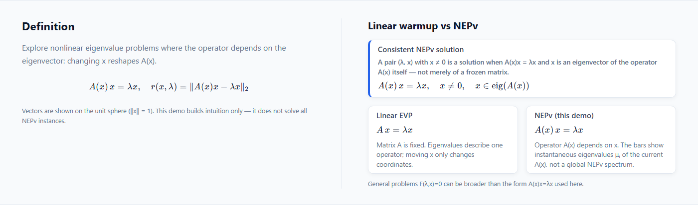
Figure 12: Definition & Compare (side-by-side)

Intro · Definition

13. Definition (Hero)
Property | Details
ID / selector | section.hero (#hero)
Type | Display
How to use | Read-only: problem statement, formula, and teaching notes.

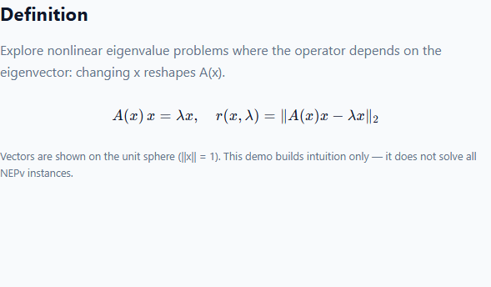
Figure 13: Definition (Hero)

Intro · Compare

14. Linear EVP vs NEPv
Property | Details
ID / selector | section.compare (#compare)
Type | Display
How to use | Read-only: two concept panels and footnote; no interactive controls.

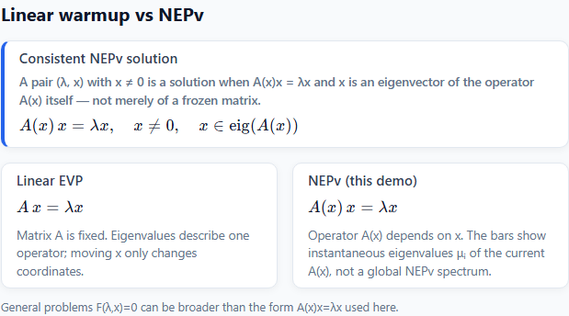
Figure 14: Linear EVP vs NEPv

Lab

15. Interactive lab (overview)
Property | Details
ID / selector | section.playground (#playground)
Type | Region
How to use | Two-column shell: compass, heatmap/spectrum, polar plot, iteration lab (left); setup drawer with model, sliders, freeze pitfall (right). AI Tutor sits below the shell.

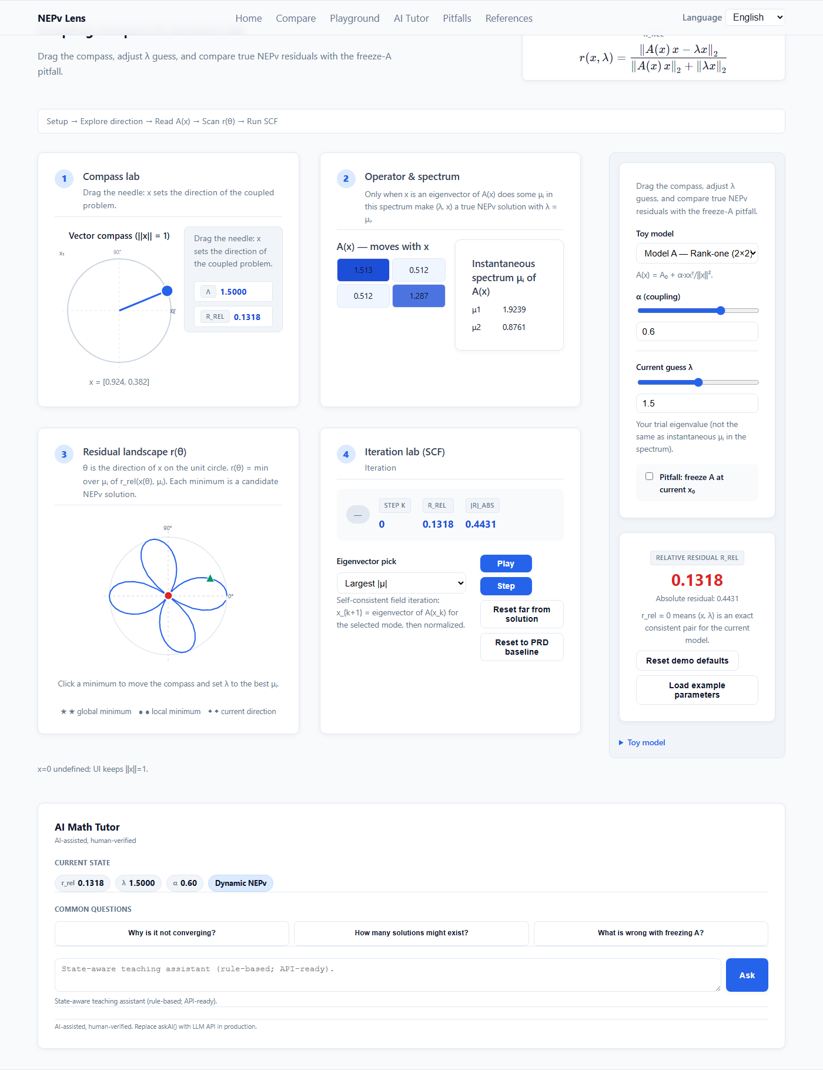
Figure 15: Interactive lab (overview)

16. Lab workspace (compass + observe + controls)
Property | Details
ID / selector | lab.shell (.lab-shell)
Type | Region
How to use | Main teaching surface: vector compass, residual banner, observe zone, polar plot, iteration controls, and collapsible setup drawer.

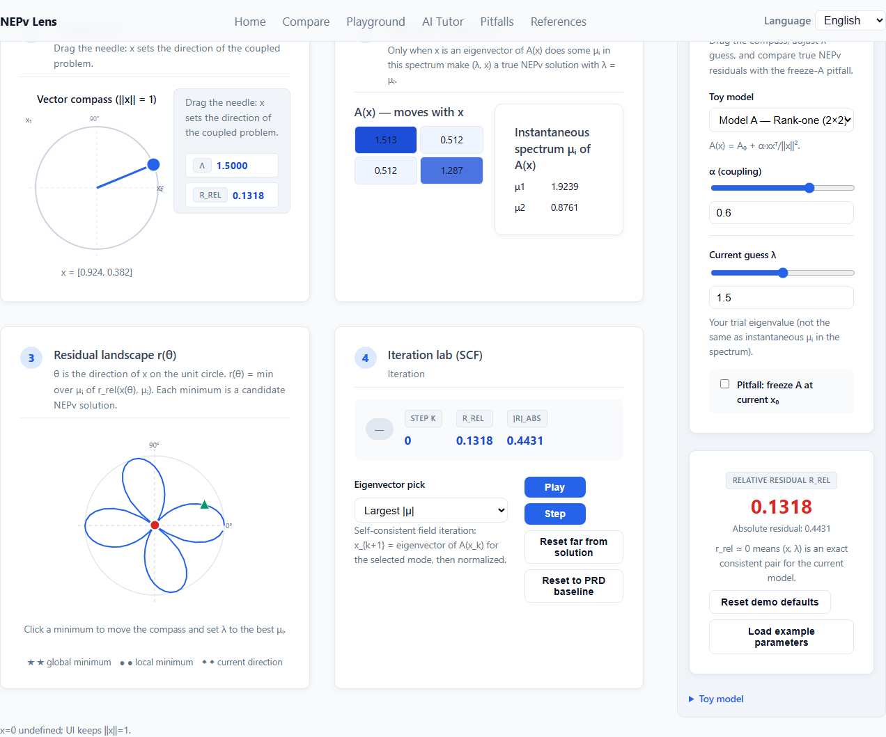
Figure 16: Lab workspace (compass + observe + controls)

17. Relative residual formula banner
Property | Details
ID / selector | playground.residualFormula (.residual-formula-banner)
Type | Display
How to use | Read-only: TeX and plain-text definition of r_rel(x, λ).


Figure 17: Relative residual formula banner

Lab · Setup

18. Model & controls drawer
Property | Details
ID / selector | lab.sidebarDrawer (.lab-sidebar-drawer)
Type | Collapsible panel
How to use | Expand/collapse the right-hand setup drawer (model, parameters, λ guess, freeze pitfall, residual readout, reset).

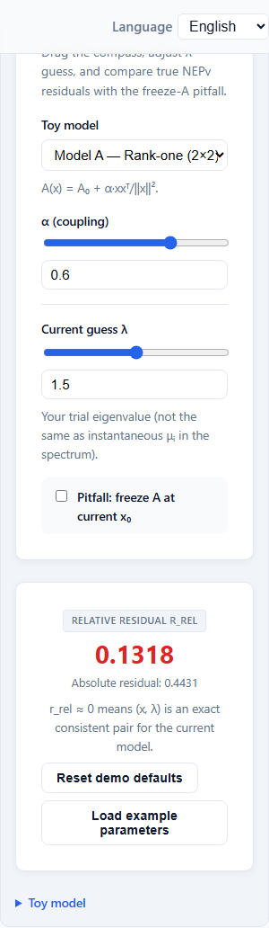
Figure 18: Model & controls drawer

Lab · Model

19. Toy model (Model A — rank-one 2×2)
Property | Details
ID / selector | model-select (#model-select)
Type | Dropdown
How to use | Select Model A; resets x and parameters and turns off freeze pitfall.

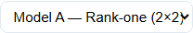
Figure 19: Toy model (Model A — rank-one 2×2)

20. Physical background (expanded)
Property | Details
ID / selector | model.physical (.lab-details[open])
Type | Collapsible
How to use | Expand the model details block under the setup drawer for physical context and analytic notes.

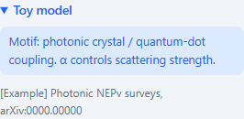
Figure 20: Physical background (expanded)

Lab · Model A parameters

21. α (coupling strength)
Property | Details
ID / selector | alpha (#alpha)
Type | Slider
How to use | Drag #alpha (approx. −1.5…1.5); numeric field syncs; A(x) and spectrum update live.

Figure 21: α (coupling strength)

Lab · Residual

22. λ guess (residual probe)
Property | Details
ID / selector | lambda (#lambda)
Type | Slider
How to use | Drag #lambda (−1…4); changes displayed r(x, λ) without changing A(x).

Figure 22: λ guess (residual probe)

Lab · Pitfall

23. Pitfall: freeze A at current x (unchecked)
Property | Details
ID / selector | freeze (.lab-freeze-row)
Type | Checkbox
How to use | Check #freeze to freeze A(x₀), show frozen heatmap/spectrum, and highlight the pitfall.


Figure 23: Pitfall: freeze A at current x (unchecked)

24. Pitfall: freeze A (checked)
Property | Details
ID / selector | freeze.checked (.lab-freeze-row.is-active)
Type | Checkbox + badge
How to use | Shows inline ⚠ badge and frozen-spectrum column; reminds that linear EVP ≠ NEPv.

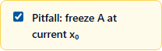
Figure 24: Pitfall: freeze A (checked)

Lab · Residual

25. Relative & absolute residual
Property | Details
ID / selector | residual.metric (.lab-status-card)
Type | Display
How to use | Read-only metrics; color hints for low/high residual; Reset all restores defaults.

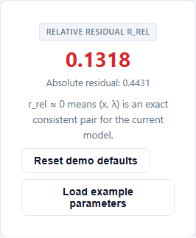
Figure 25: Relative & absolute residual

Lab · Vector

26. Vector compass (||x|| = 1)
Property | Details
ID / selector | compass.svg (#lab-compass .vector-compass)
Type | Drag surface
How to use | Drag the blue handle on the unit circle; out-of-circle drags project back with a toast.

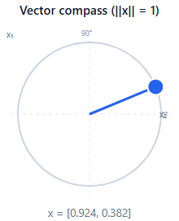
Figure 26: Vector compass (||x|| = 1)

Lab · Visualization

27. Heatmap & instantaneous spectrum
Property | Details
ID / selector | viz.observe (#lab-observe)
Type | Display
How to use | A(x) heatmap and eigenvalue bars; extra column when freeze pitfall is on.

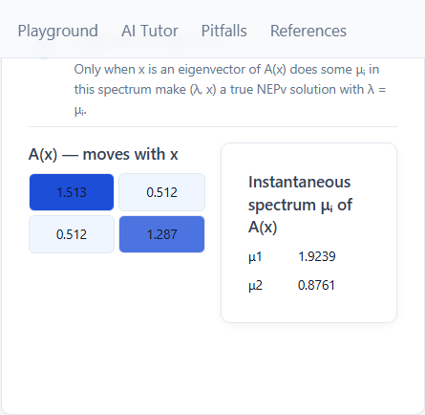
Figure 27: Heatmap & instantaneous spectrum

28. Polar residual plot r(θ)
Property | Details
ID / selector | polar-plot (#lab-polar .polar-plot)
Type | Display
How to use | Residual on the unit circle; red marker at θ = 0; updates with parameters.

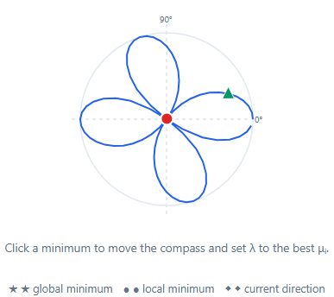
Figure 28: Polar residual plot r(θ)

Lab · Iteration

29. Iteration lab
Property | Details
ID / selector | iteration.lab (#lab-iteration .iteration-lab)
Type | Region
How to use | Mode selector, Play, Step, Reset far, Reset to reference; convergence summary below.

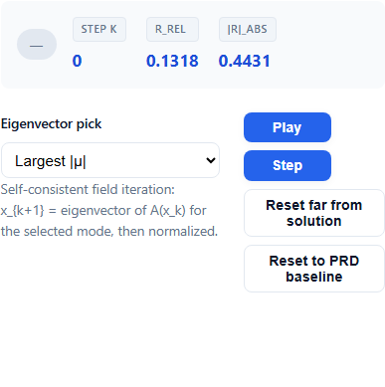
Figure 29: Iteration lab

30. Eigenvalue pick mode
Property | Details
ID / selector | iter-mode (#iter-mode)
Type | Dropdown
How to use | Choose max / min / closest eigenvalue for the fixed-point map.

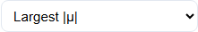
Figure 30: Eigenvalue pick mode

31. Play
Property | Details
ID / selector | iteration.play (.iteration-lab .iteration-btn-group--primary button:nth-of-type(1))
Type | Button
How to use | Auto-iterate from the PRD reference initial guess (up to 200 steps).


Figure 31: Play

32. Step
Property | Details
ID / selector | iteration.step (.iteration-lab .iteration-btn-group--primary button:nth-of-type(2))
Type | Button
How to use | One fixed-point step; disabled after non-convergence limit.

Figure 32: Step

33. Reset (far)
Property | Details
ID / selector | iteration.resetFar (.iteration-lab .iteration-btn-group--secondary button:nth-of-type(1))
Type | Button
How to use | Jump to a deliberately poor initial vector to demonstrate sensitivity.


Figure 33: Reset (far)

34. Reset to reference
Property | Details
ID / selector | iteration.resetRef (.iteration-lab .iteration-btn-group--secondary button:nth-of-type(2))
Type | Button
How to use | Restore baseline x and k = 0; clears non-convergence warning.


Figure 34: Reset to reference

Lab · Model

35. Toy model (Model B — diagonal 3×3)
Property | Details
ID / selector | model-select.b (#model-select)
Type | Dropdown
How to use | Switch to Model B; exposes β₁–β₃ sliders and x₃ control.

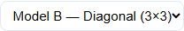
Figure 35: Toy model (Model B — diagonal 3×3)

Lab · Model B parameters

36. β₁
Property | Details
ID / selector | beta1 (#beta1)
Type | Slider
How to use | Adjust #beta1 (diagonal scaling); eigenvalues track diagonal entries.

Figure 36: β₁

37. β₂
Property | Details
ID / selector | beta2 (#beta2)
Type | Slider
How to use | Adjust #beta2 (diagonal scaling); eigenvalues track diagonal entries.

Figure 37: β₂

38. β₃
Property | Details
ID / selector | beta3 (#beta3)
Type | Slider
How to use | Adjust #beta3 (diagonal scaling); eigenvalues track diagonal entries.

Figure 38: β₃

Lab · Vector (3D)

39. x₃ (unit sphere)
Property | Details
ID / selector | x3 (#x3)
Type | Slider
How to use | Set third component; works with compass x₁, x₂ under ||x|| = 1.

Figure 39: x₃ (unit sphere)

AI Tutor

40. AI Math Tutor
Property | Details
ID / selector | ai-tutor (#ai-tutor .ai-tutor--centered)
Type | Region
How to use | Status chips, preset questions, and compose row; rule-based answers grounded in current r, λ, α, freeze, and iteration state.

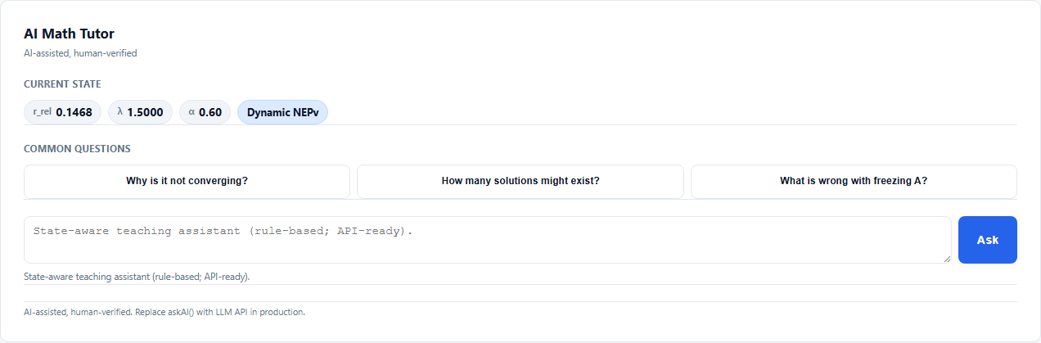
Figure 40: AI Math Tutor

41. Preset questions
Property | Details
ID / selector | ai.presets (.ai-presets)
Type | Buttons
How to use | One-click prompts (e.g. why not converging, explain freeze pitfall).

Figure 41: Preset questions

Pitfalls

42. Pitfalls & FAQ
Property | Details
ID / selector | section.pitfalls (#pitfalls)
Type | Region
How to use | Horizontal layout: main pitfall card (freeze A) and FAQ grid; Try pitfall jumps to lab with freeze on.

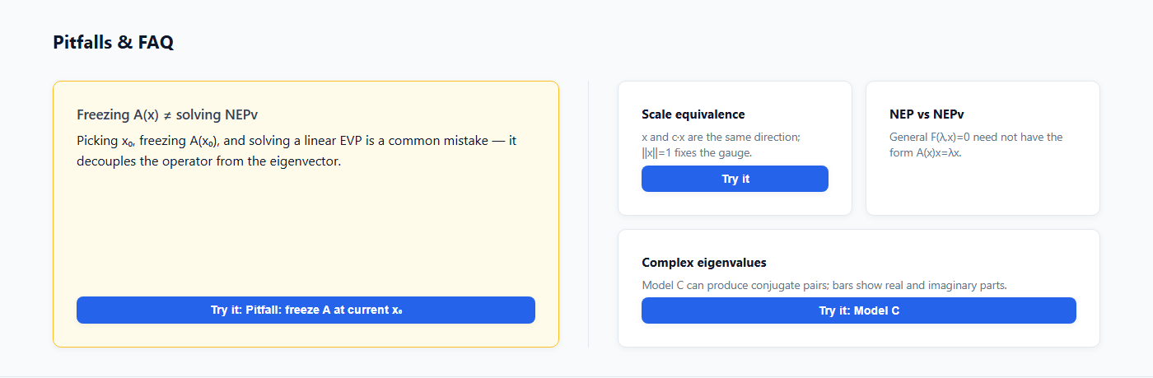
Figure 42: Pitfalls & FAQ

References

43. References (collapsed)
Property | Details
ID / selector | references.collapsed (#references .refs-collapsible)
Type | Collapsible
How to use | Click summary to expand bibliography and teaching notes.

Figure 43: References (collapsed)

44. References (expanded)
Property | Details
ID / selector | references.open (#references .refs-collapsible[open])
Type | Collapsible
How to use | Numbered citation list and intro paragraph.

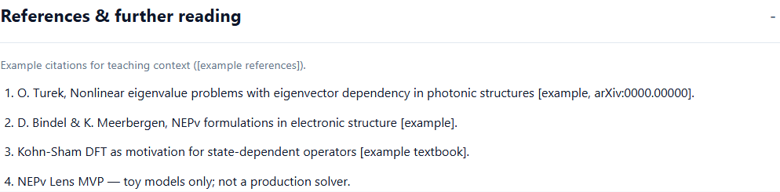
Figure 44: References (expanded)

Footer

45. Footer disclaimer
Property | Details
ID / selector | footer (footer)
Type | Display
How to use | Read-only teaching-demo disclaimer.


Figure 45: Footer disclaimer

Lab · Mobile

46. x₁ / x₂ numeric fields (mobile)
Property | Details
ID / selector | compass.numeric (.compass-numeric.mobile-numeric)
Type | Number inputs
How to use | Shown at viewport ≤ 375px; edits normalize x to the unit sphere.

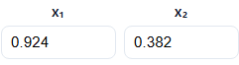
Figure 46: x₁ / x₂ numeric fields (mobile)

Mobile

47. Mobile lab (375px)
Property | Details
ID / selector | viewport.mobile
Type | Viewport
How to use | Touch-friendly compass, stacked observe zone, drawer setup controls.

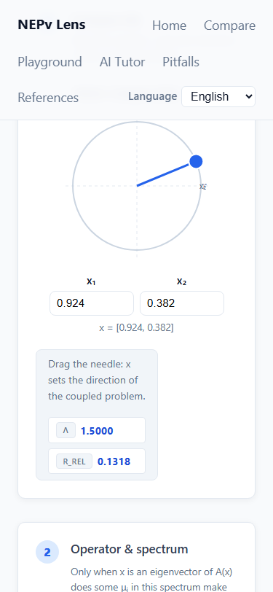
Figure 47: Mobile lab (375px)

5. Recommended learning path
- Read Definition & Compare (~3 min) to contrast linear EVP and NEPv.
- In the lab, pick Model A; drag the compass and α; watch heatmap, polar plot, and spectrum (~5 min).
- Enable “Pitfall: freeze A” and compare frozen vs true A(x) (~2 min).
- Switch to Model B; tune β₁–β₃ and x₃; use Play / Step / Reset in the iteration lab (~5 min).
- Open AI Tutor presets and ask why iteration stalls (~2 min).
- Expand References; switch locale to verify i18n (~2 min).

6. Mathematical notes & interaction
- Relative residual banner: r_rel(x,λ) = ||A(x)x − λx||₂ / (||A(x)x||₂ + ||λx||₂).
- Toy models include verified baselines (error ≤ 1e-6 in unit tests).
- Compass enforces ||x|| = 1; singular x = 0 disables controls.
- Complex eigenvalues appear as conjugate pairs in the spectrum bars.
- Freeze mode is labeled as a pitfall (linear EVP at fixed x₀, not true NEPv).
- Auto-iteration stops after 200 steps if r > 1e-3; use Reset to reference.
- Mobile (≤ 375px): numeric x₁/x₂ fields and stacked observe layout.

7. Limitations & disclaimer
- Small toy models only (n ≤ 4); not a production NEPv solver.
- Iteration may fail to converge — intentional teaching point.
Spectra show instantaneous linear eigenvalues of the current A(x), not a global NEPv spectrum. AI responses are rule-based templates (AI-assisted, human-verified), not a certified LLM backend.

8. AI tutor verification checklist
Case | Expected behavior | Status
High residual, many steps | Suggest lower α, change x, turn off freeze | Verified
Freeze on | State clearly: solving a linear EVP at x₀ | Verified
Large α and r > 0.05 | Suggest α ≈ 0.4–0.6 | Verified
x near zero | Warn that x cannot be zero | Verified

— End of document —

