

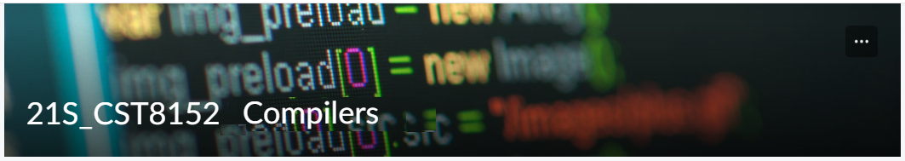

MODEL TASK FOR ASSIGNMENT 2.1 – YOUR LANGUAGE

Language: [Ray]
Team - [Student Name] - Id: [Student Id] / [Haocheng Jiang] - Id: [041051597]

- Note: This task is part of the Assignment 2 from Compilers Course. Any problem, contact your lab professor.

PART 1: RE – Regular Expression (1.5 mark)

Lexeme Classes: Define the classes to be used in your regular expression:

Answer:

NUM: [0-9]
ULT: [A-Z]
LLT: [a-z]
SYM: [+ - * / < > % & | ! = ?]
QUO: [“ ‘]
OTH: other symbols like ^, .

Define the RE to be used for: variables, literals and keywords:

Answer:

* Comments:

* Variables:

* Methods:

* Literals:
- Numbers
- Strings

* Keywords:

PART 2: TD – Transition Diagram (1.5 marks)

Activity: Starting from the previous lexeme classes and obeying the RE, it is possible to define the automata for your language:

Answer (draw / copy image of the automata):

PART 3: TT – Transition Table (2 marks)

Activity: Now, it is possible to define the TT for these lexemes:

Answer (Transition Table):

Update: Feb 3rd 2023.

Adapted from resources developed by Prof. Svillen Ranev (Algonquin College, 2019)

