**CHapter 3: Touch Typing course Part1**

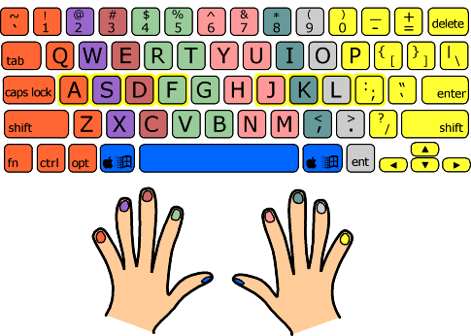

.

­­­­

* Each finger rests on a particular key in the home row of the keyboard when not typing, in order to keep "grounded" and oriented at all times. The home keys (ASDF JKL; ) are outlined in yellow on the above diagram. The thumbs remain in the air, or very gently in contact with the keys below.
* Each finger is responsible for a vertical column of keys, which you can think of as a "home column". The column is not straight up and down, but rather slopes up to the left.
* Both index fingers are responsible for an additional column, the one next to their home columns towards the middle of the keyboard.
* The thumbs are used for the space bar, and depending on the shape of your keyboard can also be used for the "command" (Apple computers) or "Windows" (PCs) key.
* The left-hand pinky is also responsible for all the keys to the left of its home column, including the left shift key, caps lock, tab, tilde, escape and others.
* The right-hand pinky is a real workhorse, covering everything to the right of its home column. Take a look - there's a lot of stuff there.

Note: Print in color and delete this note before print!