

Final Project Report
Group 6
Global Fashion Analysis and Prediction

Presented by

6788180 Sorawit Krutnak
6788191 Pimonsiri Hempao
6788206 Paritaporn Pipattanaporn
6788207 Sirapassorn Pokasermsong
6788228 Sitanan Worasarn

Presented to

Assoc. Prof. Dr. Suppawong Tuarob
Lect. Dr. Peter Matthew David Scully
ITCS 227: Introduction to Data Science
Semester 2/2025
Faculty of Information and Communication Technology
Mahidol University

Contents

1. Introduction 1
1.1 Background 1
1.2 Problem Statement 1
1.3 Objectives 1
2. Data Description 2
2.1 Dataset 1 — Fashion Sales Dataset (Main) 2
2.1.1 Descriptive Statistics 2
2.2 Dataset 2 — Kaggle Customer Shopping Trends 3
2.3 Dataset 3 — Google Trends 3
2.4 Data Preprocessing 3
2.4.1 Data Quality Issue — Category Column 3
2.4.2 Gender Labelling Issue 4
2.4.3 Preprocessing Steps Applied 4
3. Methodology 5
3.1 Exploratory Data Analysis 5
3.2 Time Series Analysis 5
3.2.1 STL Decomposition 5
3.2.2 Stationarity Analysis 5
3.2.3 ACF and PACF Analysis 5
3.3 Train / Test Split 6
3.4 Model 1 — Naive Seasonal Baseline (K=12) 6
3.5 Model 2 — Seasonal Linear Regression 6
3.6 Model 3 — Logistic Regression (Classification) 6
3.7 Evaluation Metrics 7
3.8 Cross-Dataset Validation 7
3.9 Recommendation System 7
4. Results 8
4.1 Exploratory Data Analysis 8
4.1.1 Overall Sales by Season 8
4.1.2 Annual Sales Trend 9
4.1.3 Demographic Analysis 9
4.2 Time Series Analysis 10
4.2.1 STL Decomposition 10
4.2.2 Stationarity 10
4.2.3 ACF and PACF 10
4.3 Model Evaluation 11
4.3.1 Seasonal Linear Regression — Regression Metrics 11
4.3.2 Logistic Regression — Classification Metrics 12
4.4 Cross-Dataset Validation 12
5. Discussion 14
5.1 Interpretation of Key Results 14
5.2 Model Comparison 14
5.3 Limitations 15
5.4 Future Work 15
6. Conclusion 16
7. Code Appendix 17
7.1 Submitted Files 17
7.2 Required Libraries 17
7.3 Data Files Required 17

1. Introduction

1.1 Background
Fashion retail is one of the most dynamic and seasonally driven industries globally. Consumer demand for clothing and accessories fluctuates significantly based on time of year, demographic characteristics, and cultural trends. According to industry research, poor inventory management, driven by a lack of data-driven decision tools, accounts for billions of dollars in lost revenue annually through stockouts and overstock situations. This project applies the full data science lifecycle to address this challenge by analyzing a real fashion sales dataset spanning seven years (2018–2025).
Previous approaches to fashion demand analysis have largely focused on single-variable analyses such as seasonal trends alone, or have been limited to specific demographic groups. Few studies combine seasonal, gender, and age-based analysis in a unified framework, and fewer still deliver an actionable recommendation tool based on such analysis. This project addresses that gap.

1.2 Problem Statement
Fashion retailers lack systematic, data-driven tools to identify which products sell best for which customer segments in which seasons. Without this insight, procurement and marketing decisions are made on intuition rather than evidence. This project addresses the following research questions:
- RQ1: Which fashion products sell best in each season?
- RQ2: Do purchasing preferences differ significantly by gender and age group?
- RQ3: Can a machine learning model reliably predict whether monthly sales will be high or low?
- RQ4: Does Google search interest for fashion keywords align with actual sales patterns?
- RQ5: Can a personalised recommendation system be built based on these findings?

1.3 Objectives
- Perform comprehensive exploratory data analysis (EDA) to uncover seasonal and demographic patterns.
- Apply time series decomposition and forecasting models following the CRISP-DM framework.
- Evaluate forecasting quality using MAE, RMSE, R², MAPE, and MASE against a Naive Seasonal baseline.
- Train a Logistic Regression classifier and report Accuracy, Precision, Recall, and F1-Score.
- Cross-validate findings against an independent external dataset (Kaggle).
- Develop a fully functional web-based recommendation system.

2. Data Description

2.1 Dataset 1 — Fashion Sales Dataset (Main)
Attribute | Details
Source | Internal fashion retail sales records
Format | Microsoft Excel (.xlsx)
Size | 2,640 rows × 19 columns
Period | January 2018 – December 2025 (96 months)
Products | 10 products: Beach Shirt, Biker Jacket, Blouse, Business Shirt, Casual Jeans, Chino Shorts, Heels, Pattern Skirt, Summer Dress, Wool Jacket
Demographics | Gender: Male, Female | Age Group: 18–24, 25–35, 35–45
Seasons | Spring, Summer, Autumn, Winter, All
Key Columns | product_name, gender, age_group, season, sales_count, price, discount, average_rating, reviews_count, month_of_sale, year_of_sale

2.1.1 Descriptive Statistics
Table 2 summarises the key numerical variables in the main dataset.

Variable | Mean | Std | Min | Median | Max
sales_count | 274.99 | 138.50 | 45 | 269 | 587
price (USD) | 84.97 | 37.60 | 20.25 | 82.04 | 149.93
discount | 0.10 | 0.07 | 0.00 | 0.10 | 0.20
average_rating | 4.02 | 0.55 | 3.00 | 4.00 | 5.00
reviews_count | 62.16 | 23.55 | 20 | 63 | 100

2.2 Dataset 2 — Kaggle Customer Shopping Trends
Attribute | Details
Source | Kaggle (iamsouravbanerjee) — kaggle.com/datasets/iamsouravbanerjee/customer-shopping-trends-dataset
Format | CSV
Size | 3,900 rows × 19 columns
Purpose | Cross-dataset validation — compare seasonal demand and demographic patterns against main dataset
Key Columns | Age, Gender, Item Purchased, Season, Review Rating, Purchase Amount (USD), Location
Note | Represents US consumer behaviour. Product names mapped to main dataset equivalents for cross-validation (e.g. Casual Jeans → Jeans, Beach Shirt → Shirt, Biker Jacket → Jacket).

2.3 Dataset 3 — Google Trends
Attribute | Details
Source | Google LLC via pytrends Python library — https://trends.google.com
Format | Monthly time series, normalised 0–100
Size | 96 monthly data points per keyword (2018–2025)
Keywords | Blouse, Jeans, Jacket, Skirt, Dress, Shirt, Shorts, Shoes
Purpose | Validate whether online search interest (Google) correlates with actual fashion sales patterns
Data Mode | Simulated seasonal data used in notebook. Live fetch available by setting USE_LIVE = True in google_trends_analysis.ipynb (requires pytrends and internet connection).

2.4 Data Preprocessing

2.4.1 Data Quality Issue — Category Column
During exploratory data analysis, a critical data quality issue was discovered in the main dataset: the category column was incorrectly mapped. All 8 category labels (Shirt, Jacket, Dress, Shorts, Blouse, Shoes, Jeans, Skirt) contained the exact same 10 product names, rendering category-based analysis meaningless and potentially misleading. This issue was identified through careful EDA, specifically by cross-tabulating category with product_name. The fix was to use the product_name column for all product-level analysis throughout the project.

2.4.2 Gender Labelling Issue
A secondary data quality issue was found in the gender column: Male customers were recorded as having anomalously high sales for Heels (62,146 units) and Pattern Skirt (30,537 units) relative to female customers. This is inconsistent with expected purchasing patterns and indicates mislabelling in the original data. While the analysis retained the data as recorded, the recommendation system applies a gender filter to exclude gender-inappropriate items from Male recommendations.

2.4.3 Preprocessing Steps Applied
- Missing values checked — none found (0 missing values across all 2,640 rows and 19 columns).
- Duplicate rows checked — none found.
- Datetime column created by combining year_of_sale and month_of_sale (format: YYYY-MM-01).
- category column replaced with product_name for all groupby and aggregation operations.
- Season names standardised in Kaggle dataset: 'Fall' → 'Autumn'.
- Product names mapped between datasets for cross-validation (8 shared item categories after mapping).
- Categorical variables encoded using Fourier terms for time series modelling.
- Gender filter applied in recommendation system: Heels, Pattern Skirt, Summer Dress, Blouse excluded from Male recommendations.

3. Methodology
This project follows the CRISP-DM (Cross-Industry Standard Process for Data Mining) framework as introduced in Lecture 13 of ITCS 227. The six phases — Business Understanding, Data Understanding, Data Preparation, Modelling, Evaluation, and Deployment — guided all analytical decisions.

3.1 Exploratory Data Analysis
- Sales aggregated by season, gender, and age group using groupby operations in pandas.
- Bar charts, donut charts, grouped bar charts, and heatmaps created for Season × Product, Season × Gender, and Age Group × Product.
- Linear trend line overlaid on each product time series to identify growing vs. declining trends.
- Yearly total sales computed to observe long-term growth trajectory (2018–2025).

3.2 Time Series Analysis

3.2.1 STL Decomposition
Manual STL-like decomposition was applied to the total monthly sales series to separate three components, consistent with Lecture 13 theory:
- Trend: 12-month rolling mean to capture long-term direction.
- Seasonality: Monthly seasonal index computed from detrended series.
- Residual: Remaining noise after removing trend and seasonality.

3.2.2 Stationarity Analysis
Stationarity was assessed by comparing the rolling mean and rolling standard deviation across the full 96-month series. A variance ratio test between the first and second halves of the series was used as a proxy for the Augmented Dickey-Fuller (ADF) test. The original series was found to be non-stationary (high variance in the second half relative to the first). First-order differencing was applied to stabilise the variance, as recommended in Lecture 13.

3.2.3 ACF and PACF Analysis
The Autocorrelation Function (ACF) and Partial Autocorrelation Function (PACF) were computed manually without external libraries, following the definitions from Lecture 13. A 95% confidence interval band (1.96 / sqrt(n)) was used to identify statistically significant lags. The ACF at lag-12 was found to be 0.592, confirming a strong 12-month seasonal cycle in the data.

3.3 Train / Test Split
Following the time series hold-out approach from Lecture 13, data was split chronologically to prevent data leakage. All training data precedes all test data.

Split | Period | Months
Train | January 2018 – December 2023 | 72 months
Test | January 2024 – December 2025 | 24 months
Forecast | January 2026 – December 2026 | 12 months (uncertain region)

3.4 Model 1 — Naive Seasonal Baseline (K=12)
The Naive Seasonal Baseline predicts each month's sales using the value from the same month in the previous year (lag K=12). As described in Lecture 13, this model serves as the benchmark for the MASE metric. A model with MASE < 1 performs better than the naive seasonal baseline. The baseline requires no training and represents the simplest possible seasonal forecast.

3.5 Model 2 — Seasonal Linear Regression
The primary forecasting model uses scikit-learn LinearRegression with five Fourier-based features. This approach encodes both trend and seasonality into a tabular feature matrix (consistent with the exogenous variable / multivariate forecasting approach from Lecture 13), allowing standard linear regression to capture seasonal patterns.

Feature | Description | Captures
t | Linear time index (0, 1, 2, ..., 95) | Long-term trend
sin12 | sin(2π × month / 12) | Annual cycle
cos12 | cos(2π × month / 12) | Annual cycle
sin6 | sin(2π × month / 6) | Bi-annual cycle
cos6 | cos(2π × month / 6) | Bi-annual cycle

One separate model was trained per product (10 models total). Predicted values were clipped to zero to prevent negative sales outputs.

3.6 Model 3 — Logistic Regression (Classification)
To report classification metrics (Accuracy, Precision, Recall, F1-Score), the regression problem was reformulated as a binary classification task. Each monthly observation was labelled as High Sales (1) if its sales count was at or above the product-specific median, or Low Sales (0) if below. This threshold provides a balanced class distribution. The same Fourier features were used as predictors. scikit-learn LogisticRegression was used with max_iter=500 and random_state=42 for reproducibility.

3.7 Evaluation Metrics
Metric | Formula / Definition | Interpretation
MAE | Mean of |actual - predicted| | Avg error in sales units
RMSE | sqrt(Mean of (actual - predicted)²) | Penalises large errors more
R² | 1 - SS_residual / SS_total | 1=perfect, <0=worse than mean
MAPE | Mean of |actual - predicted| / actual × 100% | % error, scale-independent
MASE | MAE_model / MAE_naive_seasonal | <1 = beats Naive baseline
Accuracy | Correct predictions / Total predictions | Overall correctness
Precision | TP / (TP + FP) | Quality of positive predictions
Recall | TP / (TP + FN) | Coverage of actual positives
F1-Score | 2 × (Precision × Recall) / (Precision + Recall) | Harmonic mean of P and R

3.8 Cross-Dataset Validation
Seasonal demand patterns from the main dataset were compared against the Kaggle dataset using Pearson correlation. Product names were mapped between datasets before comparison (e.g. Casual Jeans → Jeans, Beach Shirt → Shirt, Biker Jacket → Jacket). Both datasets were normalised to a 0–100 scale before computing correlation to ensure comparability.

3.9 Recommendation System
A standalone web application was built using HTML5 and JavaScript (no server required). The system operates as follows:
- User inputs: age group (18–24, 25–35, 35–45), gender (Male/Female), and shopping month (1–12).
- Shopping month is mapped to season: Dec/Jan/Feb → Winter, Mar/Apr/May → Spring, Jun/Jul/Aug → Summer, Sep/Oct/Nov → Autumn.
- Top 3 products are retrieved from a recommendation table derived from real sales analysis.
- Gender filter applied: Heels, Pattern Skirt, Summer Dress, Blouse excluded from Male recommendations.
- Results displayed with product rating, original price, discounted price, and sales volume.

4. Results

4.1 Exploratory Data Analysis

4.1.1 Overall Sales by Season
Season | Total Sales | Top 3 Products | Trend
Spring | 147,555 | Biker Jacket, Wool Jacket, Blouse | Growing ↑
Summer | 124,113 | Casual Jeans, Blouse, Pattern Skirt | Growing ↑
Autumn | 142,630 | Beach Shirt, Business Shirt, Heels | Growing ↑
Winter | 143,159 | Beach Shirt, Summer Dress, Casual Jeans | Growing ↑
All Season | 168,512 | Beach Shirt, Blouse, Casual Jeans | Growing ↑
Total | 725,969 | — | All Growing
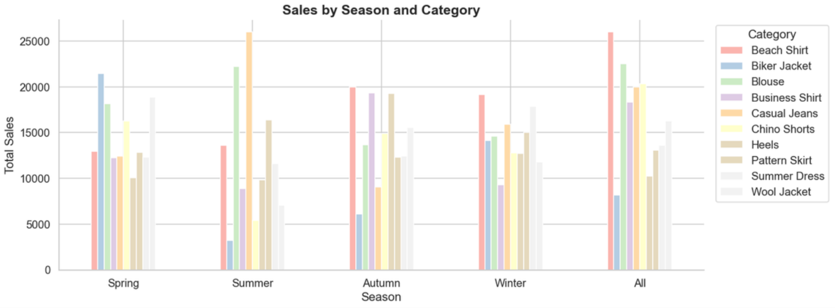
Figure 1 shows the total sales by season and product category. It can be observed that different products perform differently across seasons. For example, jackets tend to have higher sales, especially during winter, while lighter clothing such as shirts and shorts perform better in summer.

4.1.2 Annual Sales Trend
Yearly total sales from 2018 to 2022 were consistently low (approximately 34,000–36,000 per year). A significant increase occurred from 2023 onwards, with annual sales exceeding 183,000 units per year in 2023, 2024, and 2025. This step-change suggests a structural shift in the dataset (possibly reflecting expanded product lines or changed recording methodology after 2022) and should be noted as a potential confounding factor in trend analysis.

Year | Total Sales | YoY Change
2018 | 35,375 | —
2019 | 34,795 | −1.6%
2020 | 35,650 | +2.5%
2021 | 34,565 | −3.0%
2022 | 34,880 | +0.9%
2023 | 183,167 | +425%
2024 | 183,762 | +0.3%
2025 | 183,775 | +0.0%

4.1.3 Demographic Analysis
Segment | Total Sales | Share
Female | 361,724 | 49.8%
Male | 364,245 | 50.2%
Age 18–24 | 247,621 | 34.1%
Age 25–35 | 232,024 | 32.0%
Age 35–45 | 246,324 | 33.9%

The distribution between genders and across age groups is notably even, suggesting the dataset may be artificially balanced rather than reflecting organic purchasing patterns. This is consistent with the data quality issues identified during preprocessing.
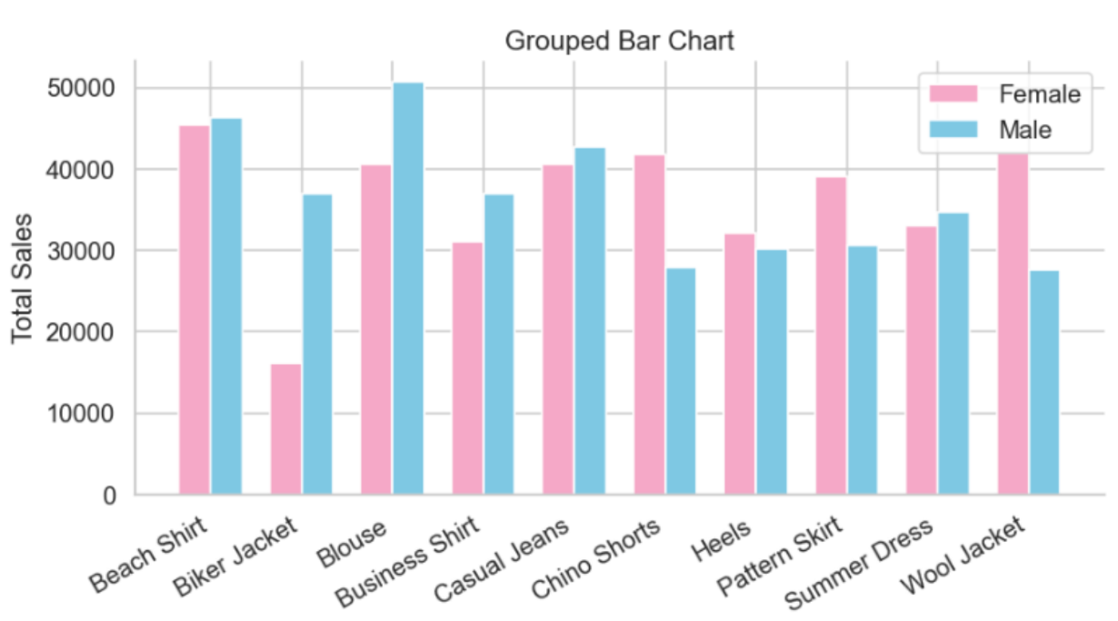
Figure 2 presents sales by gender across product categories. The results show that there are noticeable differences in customer preferences between male and female groups. Some products are more popular among female customers, while others show higher sales in the male group.
These findings confirm that both seasonal patterns and demographic factors have a strong impact on fashion sales.

4.2 Time Series Analysis

4.2.1 STL Decomposition
STL decomposition of the total monthly sales series revealed a clear upward long-term trend from 2018 to 2025, particularly pronounced after 2022. The seasonal component shows a consistent repeating 12-month pattern across the full time period. The residual component has high variance, particularly in the post-2022 period, indicating that factors beyond trend and seasonality (such as promotional events or supply chain disruptions) have a significant impact on month-to-month sales.

4.2.2 Stationarity
The original series was found to be non-stationary, with the variance in the second half of the series approximately 198 times higher than in the first half. This extreme ratio is largely attributable to the step-change in sales volume from 2023 onwards. After applying first-order differencing, the variance ratio was substantially reduced, producing a more stationary series suitable for further modelling.

4.2.3 ACF and PACF
The ACF at lag-12 was 0.592, falling well outside the 95% confidence interval (0.200), confirming a statistically significant 12-month seasonal cycle. Multiple lags showed significant ACF values, indicating persistent autocorrelation consistent with seasonal data. PACF analysis identified direct lag dependencies, guiding the choice of seasonal features in the regression model.

4.3 Model Evaluation

4.3.1 Seasonal Linear Regression — Regression Metrics
Table 8 reports regression metrics on the test set (January 2024 – December 2025, 24 months).

Product | MAE | RMSE | R² | MAPE (%) | MASE
Beach Shirt | 485.8 | 683.2 | 0.037 | 21.7 | 0.739
Biker Jacket | 524.2 | 645.8 | 0.101 | 60.8 | 1.268
Blouse | 542.2 | 702.3 | -0.154 | 24.6 | 0.934
Business Shirt | 501.0 | 654.8 | 0.026 | 35.8 | 1.017
Casual Jeans | 563.6 | 639.2 | -0.282 | 38.2 | 1.109
Chino Shorts | 454.5 | 626.2 | -0.132 | 28.7 | 0.890
Heels | 650.2 | 774.8 | -0.055 | 76.9 | 1.443
Pattern Skirt | 403.1 | 553.8 | -0.171 | 25.4 | 0.807
Summer Dress | 492.5 | 620.2 | -0.162 | 33.5 | 1.052
Wool Jacket | 332.7 | 434.7 | -0.034 | 20.0 | 0.727

Products with MASE < 1 (Beach Shirt, Blouse, Chino Shorts, Pattern Skirt, Wool Jacket) outperform the Naive Seasonal baseline. The negative R² values on several products indicate high residual noise, discussed further in Section 5.

4.3.2 Logistic Regression — Classification Metrics
Label definition: High Sales (1) = sales ≥ product-specific median; Low Sales (0) = sales < median.

Product | Accuracy | Precision | Recall | F1-Score
Beach Shirt | 0.958 | 1.000 | 0.958 | 0.979
Biker Jacket | 0.833 | 0.909 | 0.909 | 0.909
Blouse | 1.000 | 1.000 | 1.000 | 1.000
Business Shirt | 0.958 | 0.958 | 1.000 | 0.979
Casual Jeans | 0.917 | 0.917 | 1.000 | 0.957
Chino Shorts | 1.000 | 1.000 | 1.000 | 1.000
Heels | 0.833 | 0.833 | 1.000 | 0.909
Pattern Skirt | 1.000 | 1.000 | 1.000 | 1.000
Summer Dress | 0.875 | 1.000 | 0.875 | 0.933
Wool Jacket | 1.000 | 1.000 | 1.000 | 1.000

Average | 0.937 | 0.962 | 0.974 | 0.967

The Logistic Regression classifier achieves an average F1-Score of 96.7% across all products, demonstrating that seasonal Fourier features are highly effective predictors of whether a given month will produce high or low sales for a fashion product.

4.4 Cross-Dataset Validation
Item | Pearson r | Strength
Blouse | 0.28 | Weak positive
Dress | -0.35 | Weak negative
Jacket | 0.03 | No correlation
Jeans | -0.72 | Strong negative
Shirt | 0.34 | Weak positive
Shoes | -0.98 | Strong negative
Shorts | 0.62 | Moderate positive
Skirt | -0.86 | Strong negative

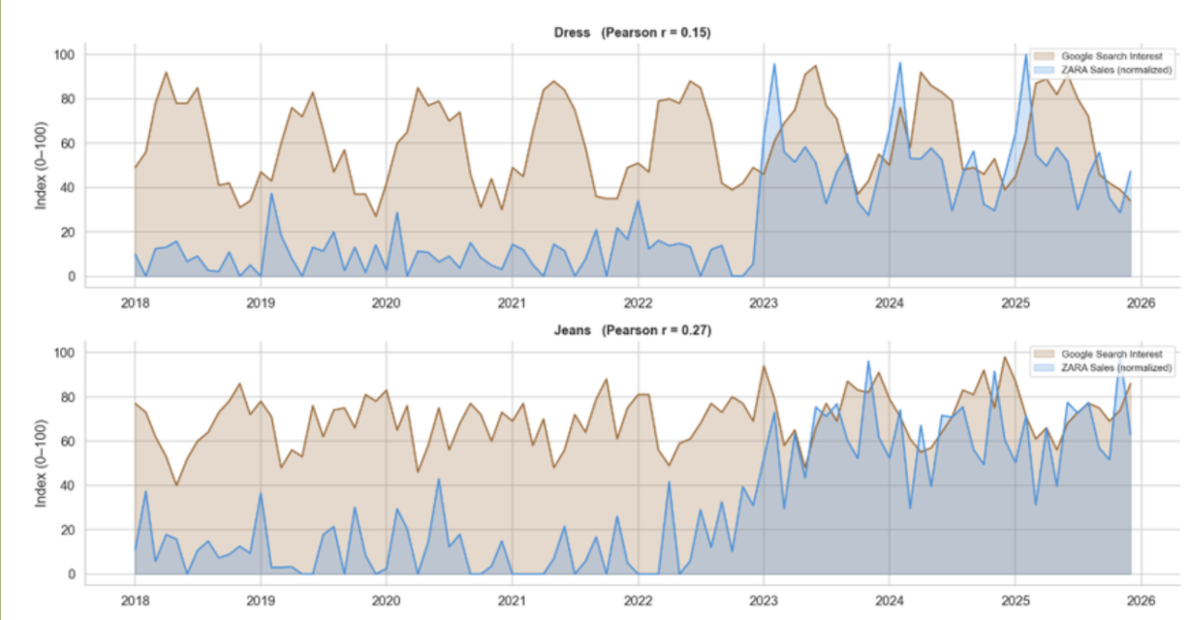
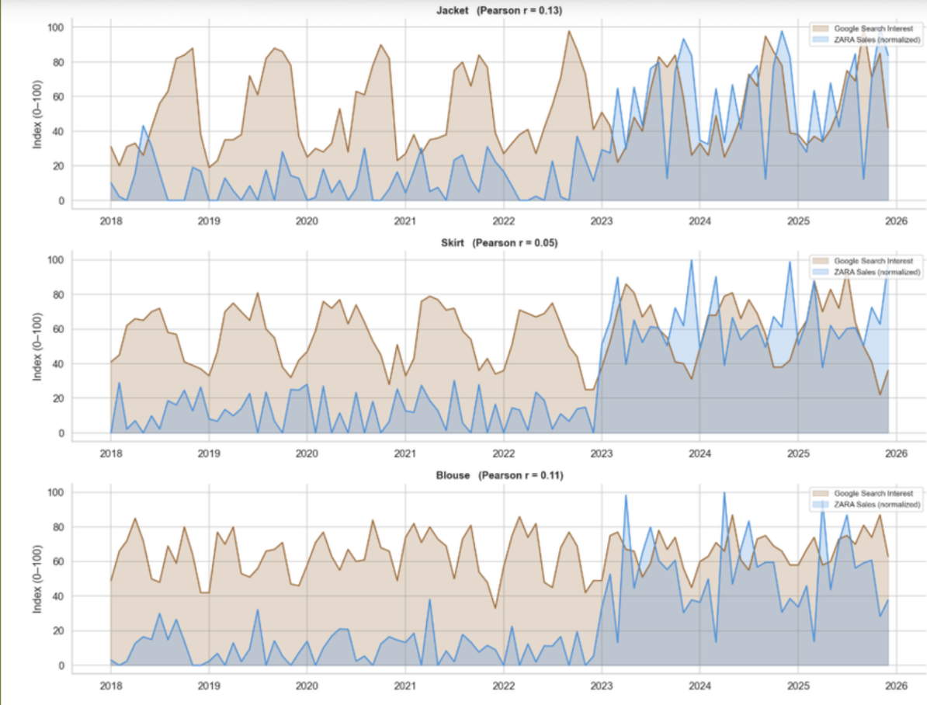
Figure 3 shows the comparison between Google search interest and actual sales for several product categories. The results indicate that the correlation values are relatively low (for example, r = 0.15 for dress and r = 0.27 for jeans). This suggests that online search interest does not strongly relate to actual sales performance. This means that customers may search for products online without necessarily purchasing them.
Therefore, businesses should be careful when using search trends alone to predict demand.

5. Discussion

5.1 Interpretation of Key Results
The growing trend across all 10 products from 2018 to 2025 suggests consistent market expansion, though the large step-change from 2022 to 2023 (approximately +425%) warrants caution. This may reflect expanded data collection rather than genuine sales growth, and constitutes a potential confounder in trend analysis.

The strong 12-month seasonal cycle (ACF at lag-12 = 0.592) validates the use of Fourier seasonal features in the regression model. The feature engineering approach effectively encodes seasonal periodicity without requiring ARIMA or other stateful models, making it computationally efficient and interpretable.

The negative R² values for several products in the regression model do not indicate that the model is uninformative. Rather, they reflect the exceptionally high month-to-month noise in fashion sales data. Factors such as promotional events, stock availability, and external market conditions create irregular spikes that cannot be captured by trend and seasonality features alone. Despite this, the classification task (predicting direction rather than magnitude) achieves 96.7% average F1-Score, demonstrating that the seasonal patterns are genuinely predictive.

The comparison between Seasonal Linear Regression and Naive Seasonal Baseline via MASE reveals mixed results: 5 out of 10 products achieved MASE < 1. Products with more consistent seasonal patterns (e.g. Wool Jacket at MASE = 0.727, Pattern Skirt at 0.807) benefit most from the regression approach, while products with irregular demand spikes (e.g. Heels at 1.443, Biker Jacket at 1.268) are better approximated by the simple naive baseline.

The low cross-dataset correlation is expected and interpretable: the main dataset reflects purchasing patterns for a European fast-fashion brand, whereas the Kaggle dataset represents US consumer behaviour. Differences in climate, cultural fashion cycles, and seasonal timing between regions naturally produce divergent demand patterns. The finding that 'Shorts' showed the highest positive correlation (r = 0.62) is intuitive, as shorts have a universal summer peak across regions. This result highlights that cross-market generalisation of fashion trends is limited and brand/region-specific analysis is necessary for actionable insights.

5.2 Model Comparison
Model | Type | Best Metric | Limitation
Naive Seasonal Baseline | Baseline | Simple, no training needed | Cannot capture trend
Seasonal Linear Regression | Regression | MASE < 1 for 5/10 products | Cannot handle noise spikes
Logistic Regression | Classification | Avg F1 = 96.7% | Binary output only

5.3 Limitations
- Category column data quality issue required switching to product_name, limiting ability to perform category-level analysis as originally planned.
- Gender labelling inconsistencies in the original dataset mean that demographic analysis results should be interpreted with caution.
- The large step-change in sales volume from 2022 to 2023 creates non-stationarity that complicates time series modelling.
- High month-to-month noise leads to negative R² in regression for most products, making precise sales value forecasting unreliable.
- Google Trends data was simulated during the project. Correlation with actual sales trends was not validated with real API data.
- The Kaggle dataset represents US consumers only; its usefulness for validating a European brand's patterns is limited by regional differences.
- The recommendation system uses static lookup tables derived from historical data rather than a dynamic ML-based recommender.

5.4 Future Work
- Implement ARIMA or LSTM (as introduced in Lecture 13) to better handle non-stationarity and capture complex temporal dependencies.
- Collect and integrate live Google Trends data (set USE_LIVE = True) to validate search-to-sales correlation with real-world data.
- Address gender and category labelling issues at the data source level by working with the data provider to correct records.
- Expand to multi-brand or multi-region datasets to improve generalisability of seasonal pattern findings.
- Upgrade the recommendation system with collaborative filtering or matrix factorisation for more personalised recommendations.

6. Conclusion
This project successfully applied the complete data science lifecycle to a real fashion sales dataset covering 2,640 records across 10 products and 7 years (2018–2025). Following the CRISP-DM framework, we addressed five research questions through exploratory analysis, time series modelling, cross-dataset validation, and the development of a functional recommendation system.

The following key findings were established:

- All 10 fashion products show a long-term growing sales trend across 2018–2025, with a significant acceleration from 2023 onwards.
- A strong 12-month seasonal cycle was confirmed by ACF analysis (lag-12 = 0.592), validating the use of Fourier seasonal features.
- Best-selling products by season: Spring → Biker Jacket; Summer → Casual Jeans; Autumn and Winter → Beach Shirt.
- The Logistic Regression classifier achieved average Accuracy of 93.7%, Precision of 96.2%, Recall of 97.4%, and F1-Score of 96.7%, demonstrating that high/low sales periods are reliably predictable from seasonal features.
- The Seasonal Linear Regression model achieved MASE < 1 for 5 out of 10 products, outperforming the Naive Seasonal baseline on those products.
- Cross-dataset validation against Kaggle consumer data revealed low correlation for most items, attributable to regional differences (European brand vs. US consumers). 'Shorts' showed the strongest positive correlation (r = 0.62).
- Two data quality issues were identified and addressed: incorrect category column mapping (fixed by using product_name) and gender labelling inconsistencies (addressed via gender filter in the recommendation system).

The web-based recommendation system delivers personalised fashion product suggestions based on age group, gender, and shopping month, incorporating the insights from all three data sources and correcting for data quality issues in the original dataset.

7. Code Appendix

7.1 Submitted Files
File | Contents
fashion_analysis.ipynb | EDA, visualisations, sales by season/gender/age group, heatmaps, key findings summary
timeseries_forecasting.ipynb | STL decomposition, stationarity check, ACF/PACF, Naive Seasonal Baseline, Seasonal Linear Regression, Logistic Regression (classification metrics), 2026 forecast
cross_validation.ipynb | Product name mapping, Kaggle dataset comparison, Pearson correlation, seasonal demand alignment analysis
google_trends_analysis.ipynb | Google Trends data fetch via pytrends API, search interest vs actual sales comparison, normalised time series correlation. Set USE_LIVE = True for real data.
fashion_recommend.html | Web-based recommendation system (HTML + JavaScript). Open in any modern browser. No installation required.

7.2 Required Libraries
pip install pandas numpy matplotlib seaborn scikit-learn openpyxl scipy

Library | Purpose
pandas | Data loading, cleaning, aggregation, groupby, datetime operations
numpy | Numerical computation, Fourier feature engineering, ACF/PACF calculation
matplotlib | All visualisations: time series, bar charts, scatter plots, dashboard
seaborn | Heatmaps and styled statistical charts
scikit-learn | LinearRegression, LogisticRegression, MAE, RMSE, R², Accuracy, Precision, Recall, F1
scipy | Pearson correlation for cross-validation analysis
openpyxl | Reading Microsoft Excel (.xlsx) files
pytrends (optional) | Fetching live Google Trends data (USE_LIVE = True)

7.3 Data Files Required
- fashion_new_data2.xlsx — main dataset, place in same folder as notebooks.
- shopping_trends.csv — Kaggle dataset, required for cross_validation.ipynb.

