INTRODUCTION

AGCS Claims Department seeks to leverage innovative technologies to improve the current operational end-to-end claims handling process. The following two sections have been identified as focus areas on this context:

- e-FNOL (First Notice of Loss), also a prerequisite for Section 2.
- Light-touch & augmented processing

The goal of this RFP is to identify either a single vendor capable of delivering all the technologies or multiple vendors who can collaborate to provide technological solutions for individual sections.

The expectation is that a single vendor may submit a proposal to fulfill all requirements, provided they meet all necessary qualifications and capabilities. Alternatively, if a vendor determines that they are unable to provide services for all requirements, the proposal can include the involvement of separate vendors, each addressing distinctive requirements. In this case, the vendors will be expected to collaborate seamlessly to deliver the services as outlined, ensuring full integration and cohesion of the overall solution.
Vendors are required to provide a detailed breakdown of costs for each individual requirement, ensuring clear transparency in pricing for all services. The vendor or collaborative vendors must demonstrate the capacity to work together effectively, proactively ensuring that all service requirements are met in a timely, efficient, and high-quality manner.
The solution must be scalable to all Lines of Business (LoBs) and regions of AGCS as well as to other Allianz OEs, if need be. It must fit into the existing architectural model of Allianz.
The selected vendor is expected to work in close collaboration with Allianz IT and should be able to deliver in a rapid manner, i.e., follow a structured sprint rhythm with rapid release & test cycles (e.g., every 2 weeks) and ensure full realization of quick wins.

SECTION 1: e-FNOL

- PROBLEM STATEMENT

AGCS’ claims handling process often starts with unstructured information sent via email. This information includes several correspondences and documents that need to be read, understood, and structured so it can be captured systematically and be further processed. This is currently being done manually by the claims handler / FNOL team that enter the information into the front-end system.

This process is time consuming, inconsistent, and error-prone: Average time needed to file a single claim varies from 20 to 40 minutes; information entered for attributes such as cause of loss or loss location is often incomplete, inconsistent, or incorrect, and cannot be used/evaluated meaningfully.

A meaningful automation of this process promises several benefits, among which are productivity gains in operational claims handling (efficiency & effectiveness), increased motivation & engagement of claims handlers as they do not have to spend their time with filling in fields in IT systems but can focus on review of such, increased broker & customer NPS due to faster processing times and more time spend on the right cases (vs. any), data quality improvements in the risk information captured allowing loss trend analyses, e.g., wrt cause of loss – resulting in improved product, pricing, and underwriting strategies.

FNOL current state:


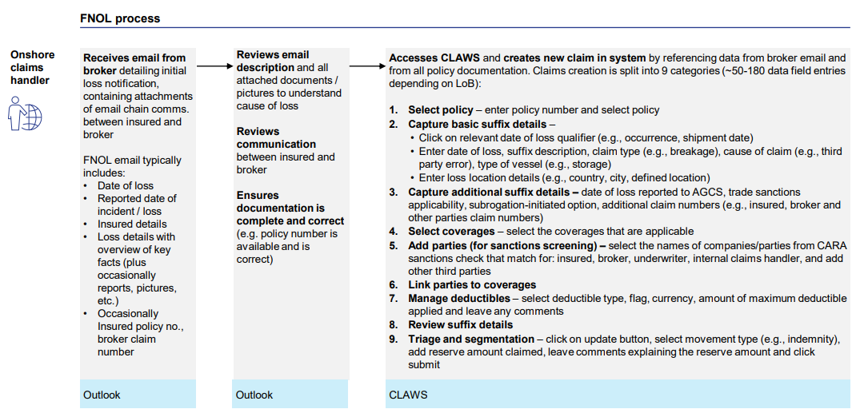

- SCOPE AND SERVICE DESCRIPTION

The objective is to meaningfully automate the FNOL process as described above by leveraging state-of-the-art technology such as Gen AI. For this investment for AGCS to be meaningful, the new solution needs to deliver a significant reduction of current manual operational effort as well as an improvement of the quality of the data captured. The solution needs to be implemented globally for all AGCS Regions (UK & IE, Germany & CH, CEE, North America, Benelux & Nordics, France & SA, Iberia, LatAM) and for all AGCS Lines of Business (Property, Natural Resources, Construction, Liability, Financial Lines, Marine, Entertainment, Aviation). In the following, requirements to meet this goal are described in further detail.
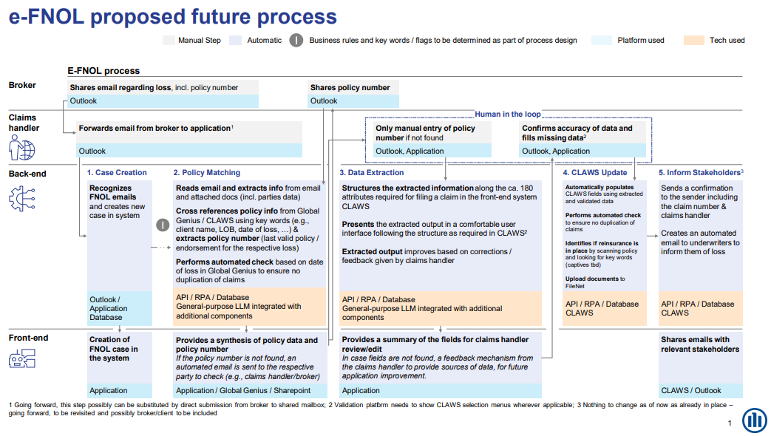

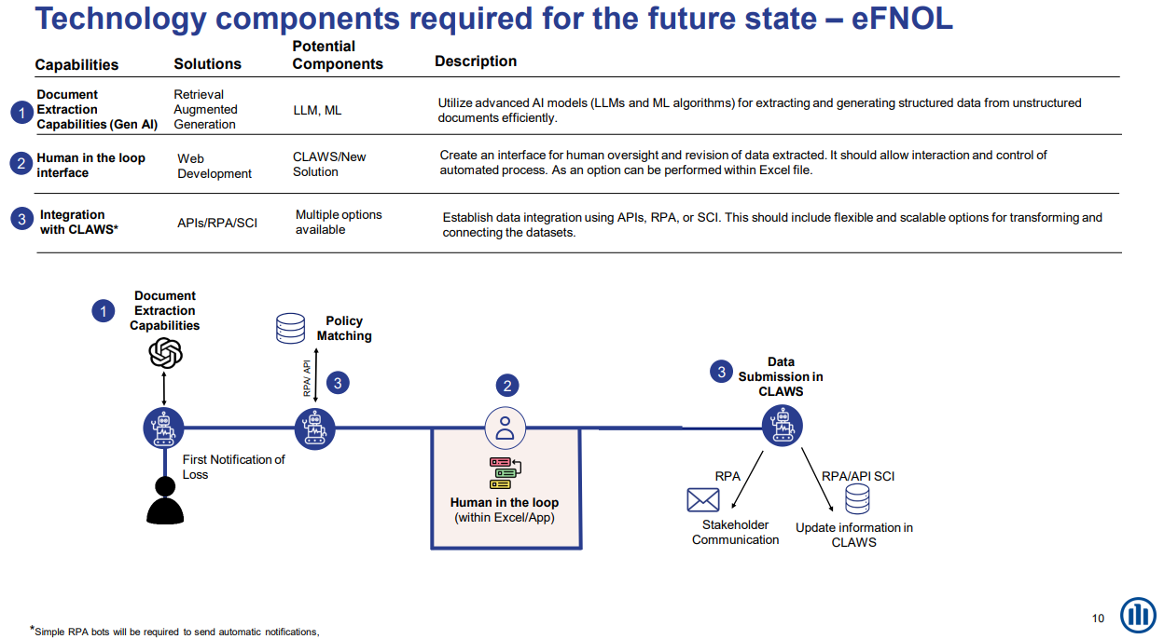

- Solution Acceptance Criteria

The following points describe the required solution in further detail. The outlined acceptance criteria ensure that not only functional requirements are met but also tangible business value is delivered by improving efficiency as well as user satisfaction.

  - Accurate and Consistent Extraction of Information
    - Requirement:
- The solution needs to extract relevant information from incoming FNOL emails – from both the email body as well as any attached documents.
    - Acceptance Criteria:
- The solution needs to achieve a minimum extraction accuracy of 95% for all attributes required in CLAWS. The required attributes are described in the file 01042025_BMP_CLAWS_EFNOL.xlsx as Attachment 1. To achieve the required accuracy, it is advised to include a user interface where business users can provide (e.g., LoB-specific) business descriptions for the information that the model needs to extract (see also 3.3).
- The solution needs to ensure 100% consistency in extracted output formats (e.g., dates, names, application of selection menus, etc.). Outputs deviating from predefined format standards must return "no value" or "unknown." These cases will count as errors in the 95% accuracy calculation.
- The solution needs to be able to handle various document formats (PDF, DOCX, XLSX, JPEG, PNG, MSG) as well as multiple languages (English, German, Spanish, Italian, French), identify and flag potential typos and spelling errors and extract information consistently by applying Optical Character Recognition (OCR), Natural Language Processing (NLP), as well as Generative AI (Gen AI) capabilities.
      - The solution needs to be able to adapt to regional settings such as date formats, currencies, and time zones.
- The solution must not require use case specific training (zero-shot prompting) but have continuous learning mechanisms in place to improve extraction accuracy over time (i.e., moving from zero-shot to few-shot prompting).

  - Proper Structuring of Information
    - Requirement:
      - The extracted information needs to be structured to match the entry fields in CLAWS (Claims Workflow System).
    - Acceptance Criteria:
      - Extracted data must be mapped correctly to the corresponding fields in CLAWS with no manual intervention required.
      - The solution must validate the structured information to ensure completeness, correctness, and consistency before submission. Any errors, missing values, or inconsistencies must be flagged and reported for manual review (see also 3.1.2).
      - Manual review should be organized through an according user interface that immediately loops the feedback back to the model ensuring its continuous learning and improvement.

  - Human in the Loop Interface
    - Requirement:
      - The solution needs to include a user interface (UI) allowing human oversight of the AI model output and revision of data extracted. This interface should allow control of and interaction with all process steps.
    - Acceptance Criteria:
      - The UI needs to allow claims handlers to review the extracted data and to confirm or make changes where relevant.
      - Highlight data points/fields where the model faces ambiguity.
      - A confidence level should be displayed against each case to determine to which degree human intervention is required.

  - Transfer of information into company front-end system CLAWS
    - Requirement:
      - The extracted information needs to be automatically transferred into CLAWS. This involves copy/paste of all attributes, automatic duplication check, attachment of reinsurance information, as well as the document upload into FileNet.
    - Acceptance Criteria:
      - Data is complete and accurate.
      - Data formats are correct (e.g., text fields, numbers, dates).
      - The duplicate claims check has been performed and considered.
      - All fields are completed.

  - API-Interface for future system integration
    - Requirement:
- The solution shall expose a robust, secure, and well-documented API interface that supports seamless integration with existing systems and is flexible enough for future use cases such as data analytics, ad hoc batch processing, and additional integrations. The API must follow industry-standard REST principles, employ state-of-the-art security measures, support comprehensive versioning, and be designed for scalability and continuous monitoring.
    - Acceptance Criteria:
- The API must provide detailed, up-to-date documentation that includes endpoint descriptions, supported parameters, sample request/response payloads, error codes, and migration guidelines for version changes. All endpoints should be versioned to ensure backward compatibility.
- All API communication must occur over HTTPS and employ robust authentication and authorization mechanisms (e.g., OAuth2, API keys). The API should handle a target load (e.g., 100 requests per second) with a 95% success rate and maintain a minimum uptime of 99.9%.
- The API must ensure that data adheres to predefined formats and standards, with built-in mechanisms for duplicate checking and rollback on failures. Standardized error messages, comprehensive logging, and a health-check endpoint should be provided to facilitate monitoring and rapid issue resolution.
  - Reduction in Processing Time
    - Requirement:
      - The solution needs to demonstrate a reduction in the time required to process and file claims.
    - Acceptance Criteria:
      - Processing performance: Measure the average time taken to process and file claims before and after the implementation of the new system. Measured against existing manual average handling time (AHT), the system should reduce the AHT by at least 30% within the first four months of deployment.
      - Response time: The system should process and respond to claims inquiries within 2 seconds for 95% of requests.
      - Throughput: The system should handle concurrent users without performance degradation.
      - Scalability: The system should scale horizontally to support concurrent users during peak times.
      - Measurements: The application should provide a visible representation of its performance against a defined set of KPIs.
      - Monitor key performance indicators (KPIs) to ensure the system maintains or improves its efficiency over time and scales to handle peak loads without degrading performance.

  - Data Quality
    - Requirement:
- The solution needs to demonstrate a significant improvement in the consistency of cause of loss, date of loss, and location of loss, claim/event descriptions – utilizing user validations in 3.3 but also NLP-based KPIs such as word count, complexity, named entity recognition (NER), semantic similarity, sentiment analysis, topic modeling, and information density.
    - Acceptance Criteria:
- The correct ratio of the following KPIs should be increased by 90%:
  - Claim status code should not be null or empty
  - Currency attribute should not be null or empty
  - LOB should not be null or empty
  - SUBLOB should not be null or empty
  - Type of loss code should be acceptable (similar to cause of loss)

  - Reliability
    - Requirement:
- The solution needs to demonstrate reliability and stability measurements.
    - Acceptance Criteria:
      - Uptime: The solution needs to have an uptime of 96% over a year.
      - Error Handling: The solution should gracefully handle errors and provide meaningful error messages to users.
      - Data Integrity: The solution must ensure that all processed claims data remains accurate and consistent.
      - Business Continuity Plan (BCP): The solution must include a comprehensive Business Continuity Plan. This plan should define the strategies, processes, and tools that ensure the solution can continue to operate during and after an unexpected disruption, minimizing downtime and maintaining essential services.
      - Disaster recovery: The Gen AI solution must include a robust Disaster Recovery (DR) plan, enabling quick recovery of operations in the event of a catastrophic failure, data breach, or natural disaster.

  - Data Security
    - Requirement:
      - The solution ensures the protection of AGCS data and application integrity.
    - Acceptance Criteria:
      - Data Encryption: All data in transit and at rest must be encrypted using industry-standard encryption protocols.
      - Access Control: Implement role-based access control (RBAC) to ensure only authorized personnel can access the application.
      - Audit Logging: All access and changes to claims data must be logged and auditable.
      - Data Deletion / Retention: no storage outside Allianz system landscape allowed
      - Solution is signed off by AGCS-COO-IT and AGCS-CEO-Legal.

  - Interoperability
    - Requirement:
      - The solution needs to demonstrate the ability to interact with the other applications within the AGCS IT estate.
    - Acceptance Criteria:
      - Ensure compatibility with existing claims processing systems including CLAWS, FileNet, Global Genius and third-party tools where necessary.

  - Compliance
    - Requirement:
      - The solution needs to be compliant with data protection regulations as well as Allianz internal data security guidelines.
    - Acceptance Criteria:
    - Regulatory Compliance: The system must comply with relevant regulations (such as GDPR and Allianz IT security standards, EU AI ACT).
    - Data Retention: Implement data retention policies that comply with legal and business requirements including GDPR, Allianz IT security standards and EU AI ACT.
    - Solution is signed off by AGCS-COO-IT and AGCS-CEO-Legal.

  - Logging and Monitoring
    - Requirement:
      - Ensure the solution can be managed effectively within production.
    - Acceptance Criteria:
    - Real-time Monitoring: Implement real-time monitoring to track system performance and health.
    - Alerting: Set up automated alerts for critical issues such as system outages or performance bottlenecks.
    - Log Management: Ensure all logs are stored securely and are easily accessible for troubleshooting and analysis.

  - Positive Feedback from Claims Handling Teams
    - Requirement:
      - The structured information and associated user interfaces need to be accurate and user-friendly, leading to positive feedback from the claims handling teams.
    - Acceptance Criteria:
      - Conduct a survey among claims handlers to gather feedback on the ease of use and accuracy of the structured information.
      - Achieve a minimum satisfaction score of 4 out of 5 from the claims handling teams.
      - Implement a feedback loop to address any issues or suggestions for improvement from the Claim handlers.

- TIMELINE

Refer to attachment 01042025_Claims_RP_Rollout_Plan.pdf (Attachment 3)

SECTION 2: LIGHT-TOUCH AND AUGMENTED PROCESSING

- PROBLEM STATEMENT

The current AGCS’ claims assessment process requires extensive time spent reading and reviewing complex documents and report updates (such as Loss Adjuster reports and legal documents), verifying information, determining next steps, and identifying changes between iterations. It is a time-intensive task that AGCS is looking to optimize in particular for high-volume, low-expertise claims.

This process is time consuming and inconsistent based on unstructured input: Average time needed to assess a single claim varies from 30 to >1,000 minutes and offers minimal return on time invested in the massive portion of small, low complexity claims.

A meaningful automation of this process promises several benefits, among which are 1 productivity gains in operational claims handling (efficiency & effectiveness), 2 increased motivation & engagement of claims handlers as they do not have to spend their time with filling in fields in IT systems and complete extensive documentation but can focus on the review of critical claims, 3 increased broker & customer NPS due to faster processing times and more time spend on the right cases (vs. any) incl. claims of larger monetary value, and 4 data quality improvements.

Current loss assessment process:
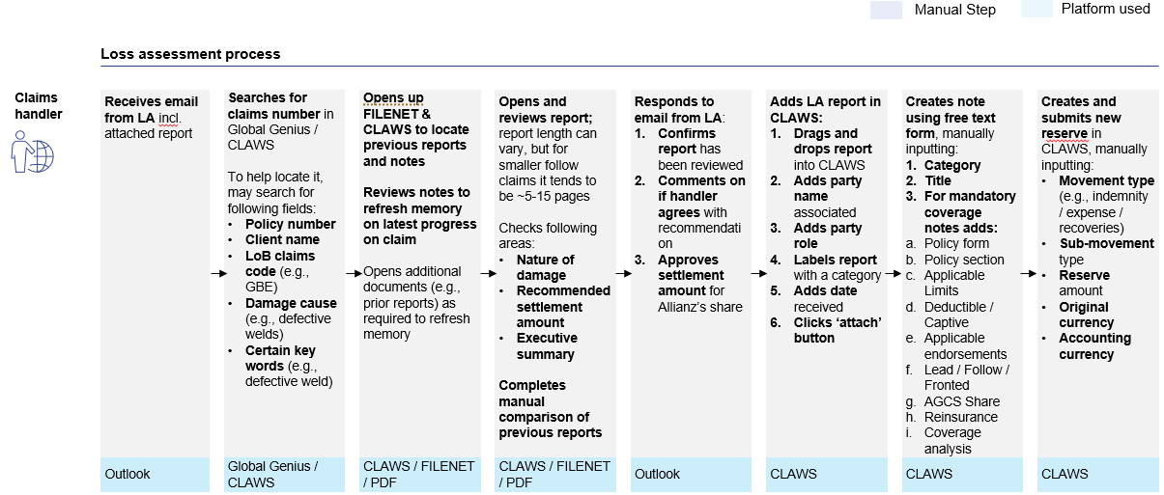

- SCOPE AND SERVICE DESCRIPTION

The objective is to make use of Gen AI & Large Language Models to meaningfully automate and reduce human intervention where possible – particularly for a sizable portion of small, low complexity (that require low expertise) claims. This includes synthesizing reports, suggesting reserve estimates, and populating CLAWS (Claims Workflow System) for review by claims handler.

This light-touch/augmented claims process will differ by pre-defined claim segments that are defined based on criteria such as Line of Business, Lead/Follow, direct/indirect, claim size, etc. The model should be able to identify the claim segment and apply the corresponding automation process.

The model should be able to automatically extract documents from emails, store them based on a given filing and naming logic, provide recommendations for claim handlers, and execute tasks across a variety of claim types (e.g., synthesize and input suggested notes, attach/upload documentation to CLAWS, etc.). The model should also be able to draft an email response to Loss Adjusters and recommend the next steps.

The solution needs to be implemented globally for all AGCS Regions (UK & IE, Germany & CH, CEE, North America, Benelux & Nordics, France & SA, Iberia, LatAM) and for all AGCS Lines of Business (Property, Natural Resources, Construction, Liability, Financial Lines, Marine, Entertainment, Aviation). In the following, requirements to meet this goal are described in further detail. With this automation, the role of the Claims Handler should be limited to confirming the accuracy of the data where relevant and to edit/approve AI actions. The results should be qualitatively meaningful to us as an organization.

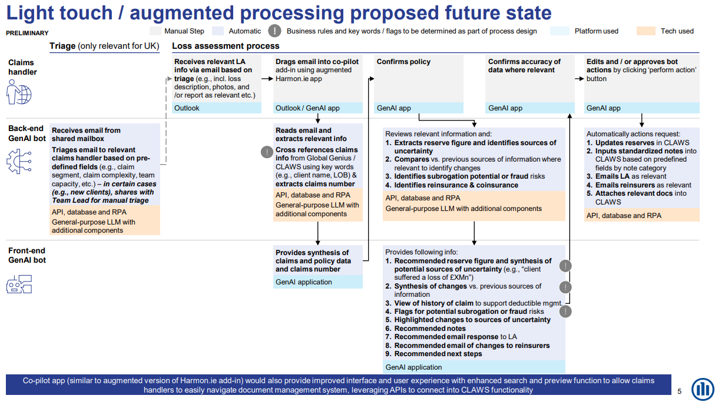

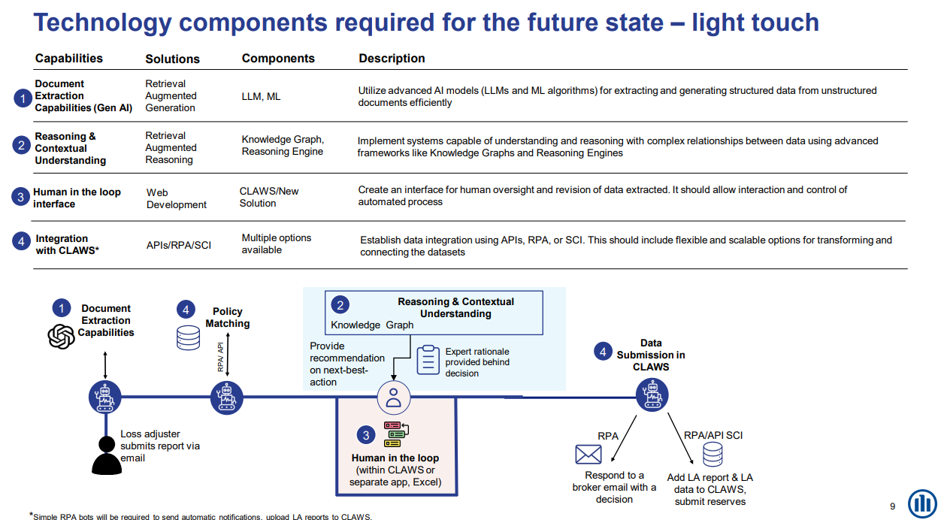

- Solution Acceptance Criteria

The following points describe the required solution in further detail. The outlined acceptance criteria ensure that not only functional requirements are met but also tangible business value is delivered by improving efficiency as well as user satisfaction.

  - Document Reading and Extraction Capabilities
    - Requirement:
      - The solution needs to extract relevant information from incoming emails, from Allianz systems (CLAWS, Global Genius, FileNet) as well as London market systems (LIRMA/CLASS/ECF2) – including the history of the claim/claimant.
    - Acceptance Criteria:
      - The solution needs to achieve a minimum extraction accuracy of 95% for all attributes specified in file 01042025_Claim Segmentations_LTP.pdf as Attachment 2. The solution should be able to identify and consider all relevant information to make meaningful recommendations assisting claim handlers in their decision making. To achieve the required accuracy, it is advised to include a user interface where business users can provide (e.g., LoB-specific) business descriptions for the information that the model needs to extract.
      - See Section 1, 3.1.

  - Reasoning Capabilities
    - Requirement:
      - The solution needs to have reasoning capabilities – providing insights and recommendations – while processing large volumes of data. Reasoning patterns need to improve continually based on new data and trends.
    - Acceptance Criteria:
      - The solution should identify the claims segment based on pre-defined criteria and apply the automation process that suits the segment – Light touch/Augmented or Light Touch + Augmented or Augmented with human oversight or Manual with AI Assist.
      - The solution should provide reserve estimates and synthesis of potential sources of uncertainty.
      - The solution should produce a synthesis of changes in current reports vs. their previous versions.
      - The solution should be able to identify reinsurance / coinsurance where relevant.
      - The solution should be able to recommend the next steps/action plan.
      - Solution should be able to draft claims notes.
      - The solution should be able to draft email responses to any stakeholder/party linked to the claim.
      - The solution should be able to draft emails informing Reinsurers/Coinsurers about changes as relevant.
      - The solution should also be able to archive documents.

  - Human in the Loop Interface
    - Requirement:
      - The solution needs to include a user interface (UI) allowing human oversight of the AI model output and revision of data extracted. This interface should allow control of and interaction with all process steps.
    - Acceptance Criteria:
      - See Section 1, 3.3.
      - The UI needs to summarize the extracted data in a way that facilitates decision making for the claim handlers.

See Section 1, 3.4-3.12.

- TIMELINE

Refer to attachment 01042025_Claims_RP_Rollout_Plan.pdf (Attachment 3)

