**Test Yourself: HDFS Command Line**

Problem Statement: Using Command line of HDFS, perform following tasks.

1. Create a directory /hadoop/hdfs/ in HDFS

Ans- hadoop fs -mkdir -p /hadoop/hdfs



1. Create a temp directory in Hadoop. Run HDFS command to delete “temp” directory.

Ans – hadoop fs -mkdir -p /hadoop/temp – To create the Dir.

Hadoop fs -rm -r /Hadoop/temp – To remove the temp



1. List all the files/directories for the given hdfs destination path.

Ans - /hadoop/hdfs/



1. Command that will list the directories in /hadoop folder.

Ans – Hadoop fs -ls /Hadoop

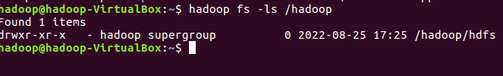

1. Command to list recursively all files in hadoop directory and all subdirectories in hadoop directory

Ans – Hadoop fs -ls -R /Hadoop



1. List all the files inside /hadoop/hdfs/ directory which starts with 'dir'.
2. Create a temp.txt file. Copies this file from local file system to HDFS

Ans – nano temp.txt

hadoop fs -copyFromLocal temp.txt /



1. Copies the file from HDFS to local file system.

Ans – hadoop fs -copyToLocal / temp.txt

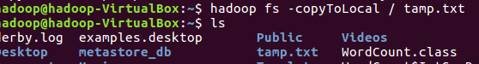

1. Command to copy from local directory with the source being restricted to a local file reference.
2. Command to copies to local directory with the source being restricted to a local file reference.
3. Command to move from local directory source to Hadoop directory.

Ans –we can use hadoop fs -moveFromLocal

1. Deletes the directory and any content under it recursively.

Ans – hadoop fs -rmr /hadoop



1. List the files and show Format file sizes in a human-readable fashion.

Ans – hadoop fs -stat %b /file name

1. Take a source file and outputs the file in text format on the terminal.
2. Display the content of the HDFS file test on your /user/hadoop2 directory.

Ans – hadoop fs -cat /user/hadoop2/test.txt

1. Append the content of a local file test1 to a hdfs file test2.

Ans – hadoop fs -appendToFile test1.txt /test2.txt



1. Show the capacity, free and used space of the filesystem

Ans – hadoop fs -df -h /

1. Shows the capacity, free and used space of the filesystem. Add parameter Formats the sizes of files in a human-readable fashion.

Ans -hadoop fs -du -h / 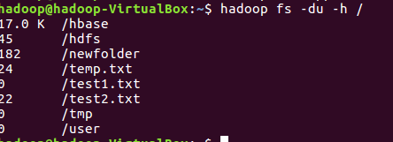

1. Show the amount of space, in bytes, used by the files that match the specified file pattern.

Ans – hadoop fs -du -s /test.txt

1. Show the amount of space, in bytes, used by the files that match the specified file pattern. Formats the sizes of files in a human-readable fashion.
2. Check the health of the Hadoop file system.

Ans - hadoop fsck /test.txt

1. Command to turn off the safemode of Name Node.

Ans – hdfs dfsadmin -safemode leave

1. HDFS command to format NameNode.

Hadoop fs namenode -format

1. Create a file named hdfstest.txt and change it number of replications to 3.

Ans – hadoop fs -setrep 3 /hdfstest.txt

1. Write command to display number of replicas for hdfstest.txt file.

Ans – hadoop fs stat %r /test.txt

1. Write command to Display the status of file “hdfstest.txt” like block size, filesize in bytes.

Ans – hadoop fsck /test.txt

1. Write HDFS command to change file permission from   
    rw – r – r to rwx-rw-x for hdfstest.txt.

Ans – hadoop fs -chmod 755 /test.txt