1) The power consumption increased from 2W to around 5 w
the steady state value is around 5w
2) 10 packet in 15 seconds, 0.67 events per second. Use dcpdump to generate a report, calculate the time interval between first packet and last packet
3)It affects the energy consumption
Pi send: 5.1W
Pi received 4.7W
This is because more power is required to drive the signal to send
4) when there is a large rate of data transfer from the network, the power consumption of Raspberry Pi might be significantly higher.

as UDP client 5.7W

as UDP server 5.7W
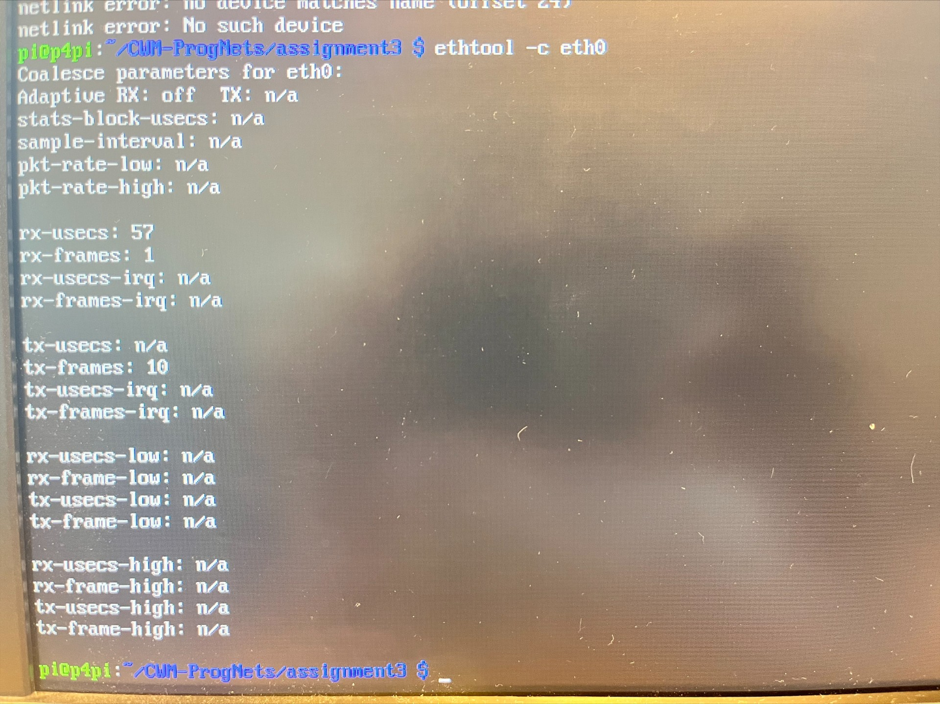

the time between receive interrupt events is 57ms

After setting interrupt time to 0:
as UDP server: the average is 5.8W and peak at 6.3W
as UDP client the average is 5.7W and peak at 6.1W

The power consumption should be higher as CPU is interrupted more frequently and increase power consumption. There are about 0.2W difference when the parameter is set to 0

CPU activity:
in stress test, the power consumption maintained at 6.3w and peak at 6.6w. With respect to previous finding, 6.3w correspond to highest power consumption by CPU

France: carbon intensity 19g /kWh
power consumption: assuming an average 5.7w consumption, 20.52kWh
CF = 389.88g co2

2) 1.169e12 g
it is a significant number
it is not a fair estimate, not all device is working at all time, and there are more energy efficient device being invented and utilized

