Before adding the mac address to droop to the table:
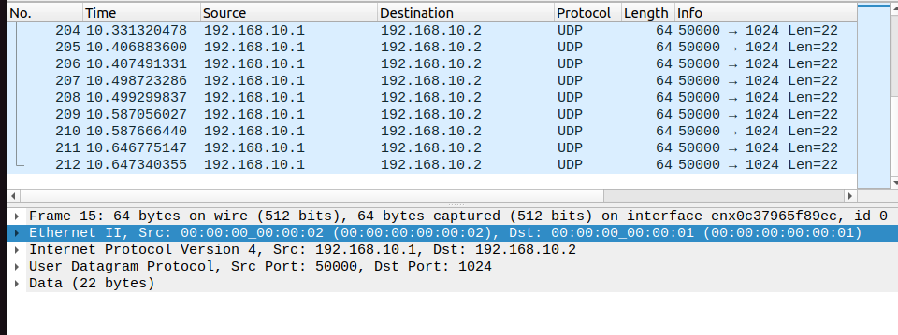
The packet from lab machine is dropped:
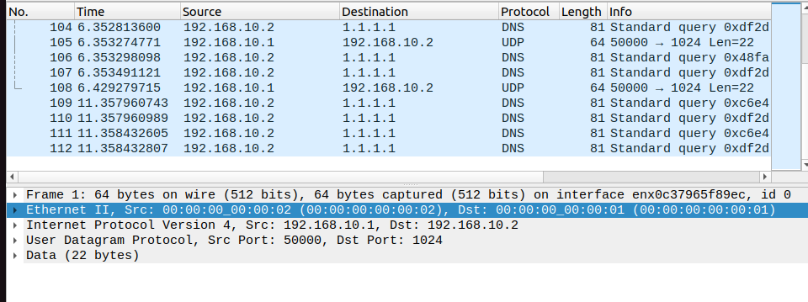
mac address to drop 00:00:00:00:00:02

