Homework 6

Due Date: Sunday, May 20, 2018

1. Shortest Paths using LP: **(7 points)**

Shortest paths can be cast as an LP using distances dv from the source s to a particular vertex v as variables.

* We can compute the shortest path from s to t in a weighted directed graph by solving.

max dt

subject to

ds = 0

dv – du ≤ w(u,v) for all (u,v)∈E

* We can compute the single-source by changing the objective function to

Use linear programming to answer the questions below. Submit a copy of the LP code and output.

1. Find the distance of the shortest path from G to C in the graph below.
2. Find the distances of the shortest paths from G to all other vertices.

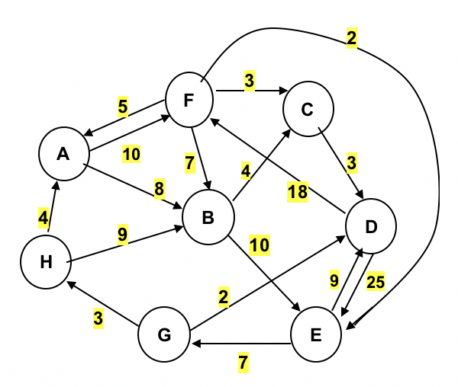

**ANSWERS:**

1. **The distance of the shortest path from G to C in the graph above is 16.**

**Shortest Path Distance: 16 ()**

**LINDO Code:**

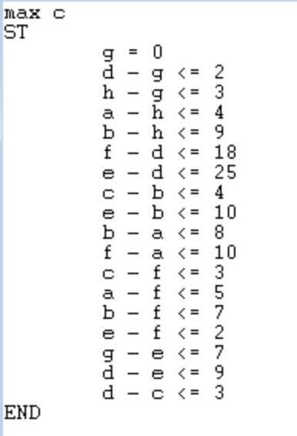

**Results:**

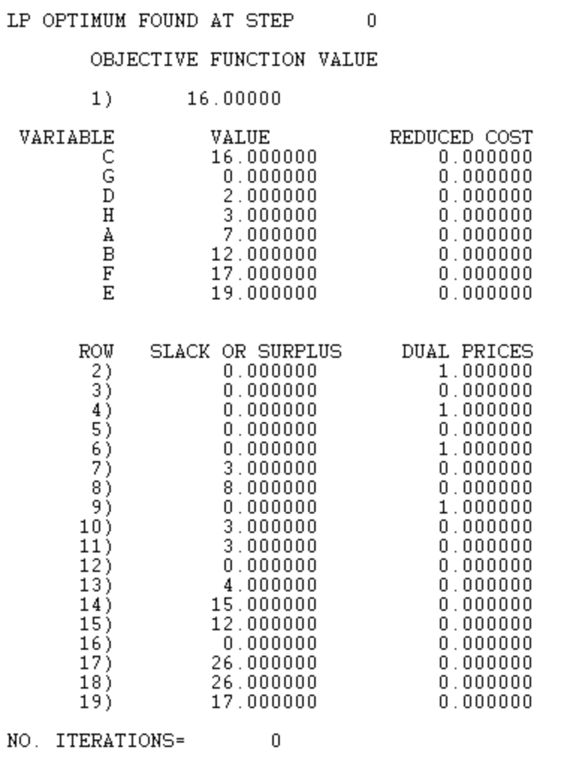

1. **The distance of the shortest paths from G to all other vertices are listed below**

**LINDO Code:**

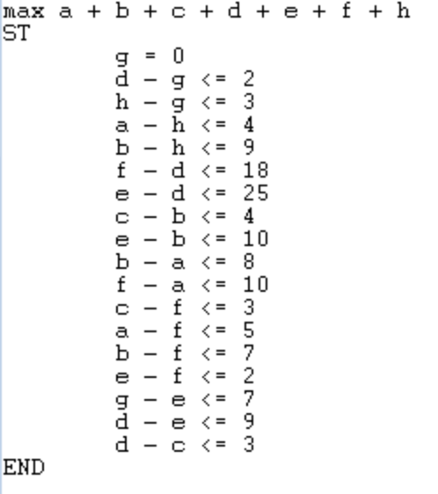

**Results:**

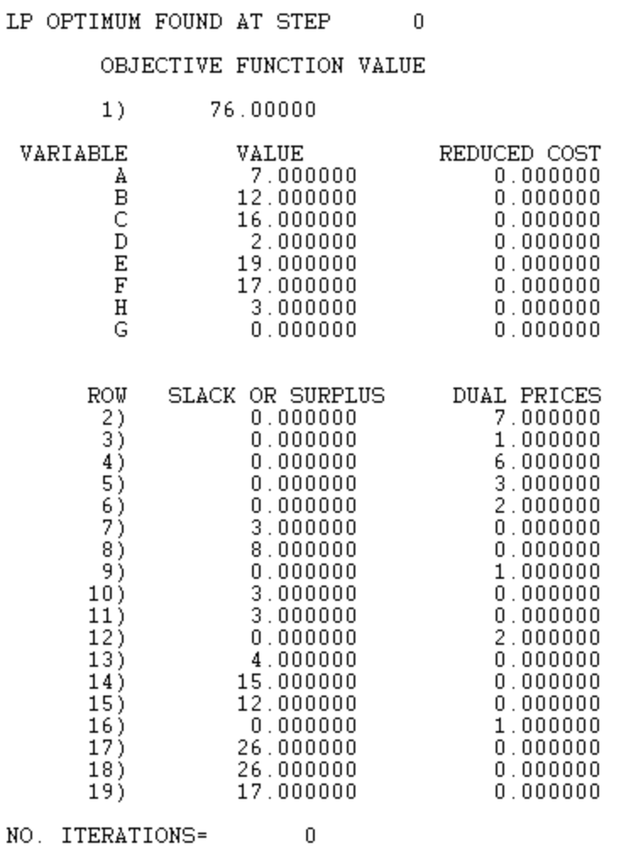

1. Product Mix: **(7 points)**

Acme Industries produces four types of men’s ties using three types of material. Your job is to determine how many of each type of tie to make each month. The goal is to maximize profit, profit per tie = selling price - labor cost – material cost. Labor cost is $0.75 per tie for all four types of ties. The material requirements and costs are given below.

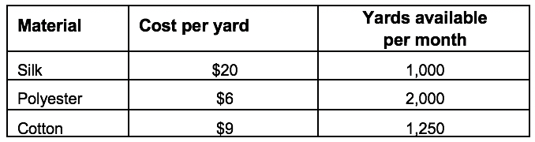

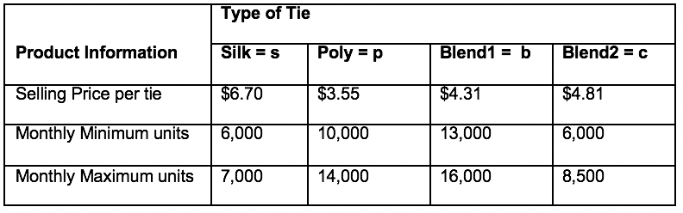

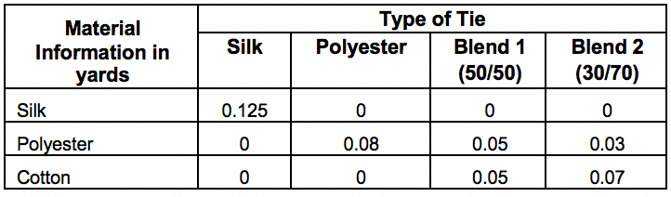

Formulate the problem as a linear program with an objective function and all constraints. Determine the optimal solution for the linear program using any software you want. Include a copy of the code and output. What are the optimal numbers of ties of each type to maximize profit?

**ANSWER:**

**Maximum Profit: $120,196.00**

**Optimal Numbers of Ties of Each Type**

* **Silk Ties: 7,000**
* **Polyester Ties: 13,625**
* **Blend 1 (50/50) Ties: 13,100**
* **Blend 2 (30/70) Ties: 8,500**

**LINDO Code:**

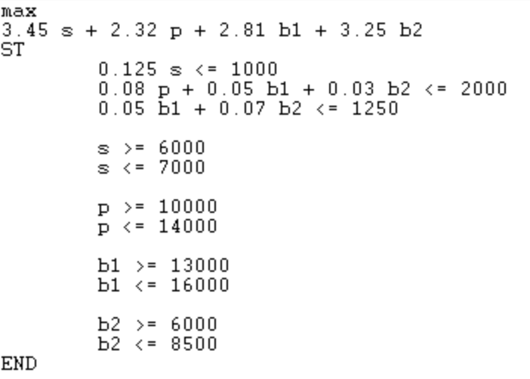

**Results:**

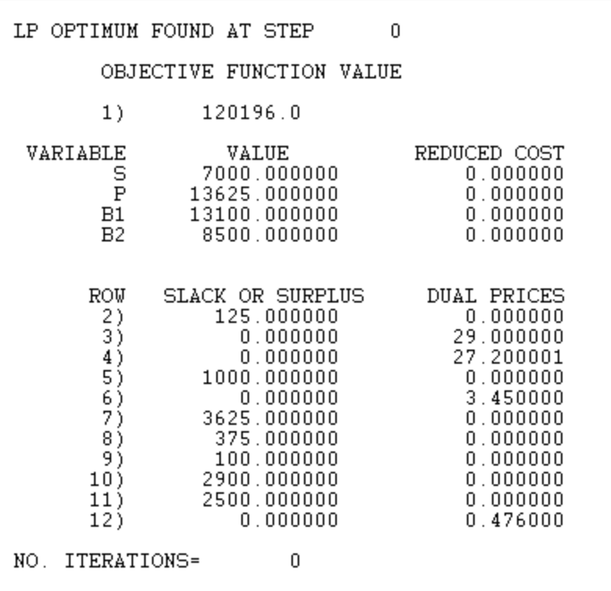

1. Transshipment Model **(10 points)**

This is an extension of the transportation model. There are now intermediate transshipment points added between the sources (plants) and destinations (retailers). Items being shipped from a Plant (*pi*) must be shipped to a Warehouse (*wj*) before being shipped to the Retailer (*rk*). Each Plant will have an associated supply (*si*) and each Retailer will have a demand (*dk*). The number of plants is n, number of warehouses is q and the number of retailers is m. The edges (*i,j*) from plant (*pi*)to warehouse (*wj*) have costs associated denoted cp(*i,j*). The edges (*j,k*) from a warehouse (*wj*)to a retailer (*rk*) have costs associated denoted cw(*j,k*).

The graph below shows the transshipment map for a manufacturer of refrigerators. Refrigerators are produced at four plants and then shipped to a warehouse (weekly) before going to the retailer.

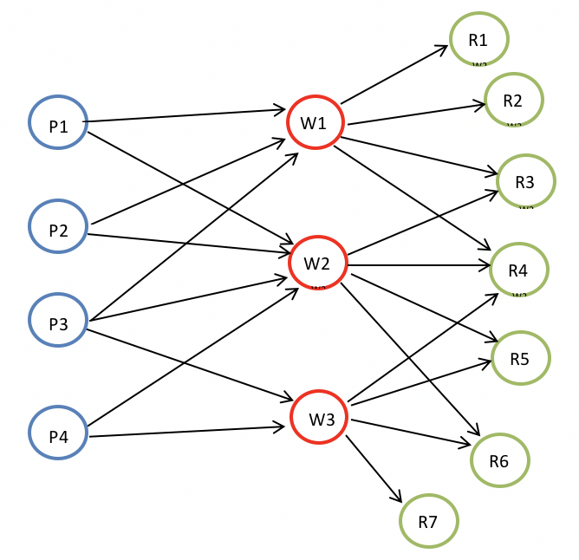

Below are the costs of shipping from a plant to a warehouse and then a warehouse to a retailer. If it is impossible to ship between the two locations an X is placed in the table.

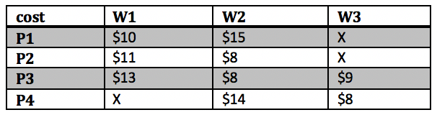

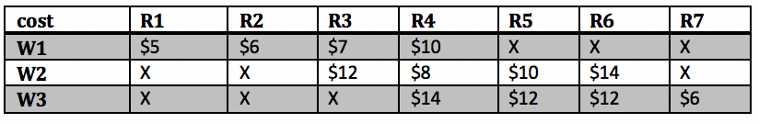

The tables below give the capacity of each plant (supply) and the demand for each retailer (per week).

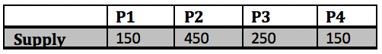



**Part A**: Determine the number of refrigerators to be shipped from the plants to the warehouses and then warehouses to retailers to minimize the cost. Formulate the problem as a linear program with an objective function and all constraints. Determine the optimal solution for the linear program using any software you want. What are the optimal shipping routes and minimum cost?

**Part B**: Due to old infrastructure Warehouse 2 is going to close eliminating all of the associated routes. What is the optimal solution for this modified model? Is it feasible to ship all the refrigerators to either warehouse 1 or 3 and then to the retailers without using warehouse 2? Why or why not?

**Part C**: Instead of closing Warehouse 2 management has decide to keep a portion of it open but limit shipments to 100 refrigerators per week. Is this feasible? If so what is the optimal solution when warehouse 2 is limited to 100 refrigerators?

***Note:*** *Include a copy of the code for all parts of the problem.*

**ANSWERS:**

**PART A**

**Minimum Cost: $17,100.00**

**Optimal Shipping Routes**

**LINDO Code:**

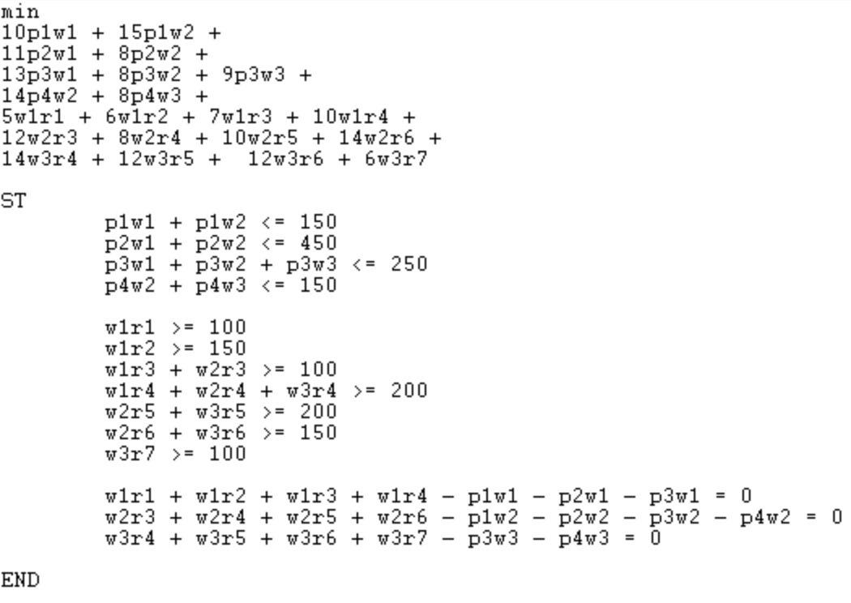

**Results:**

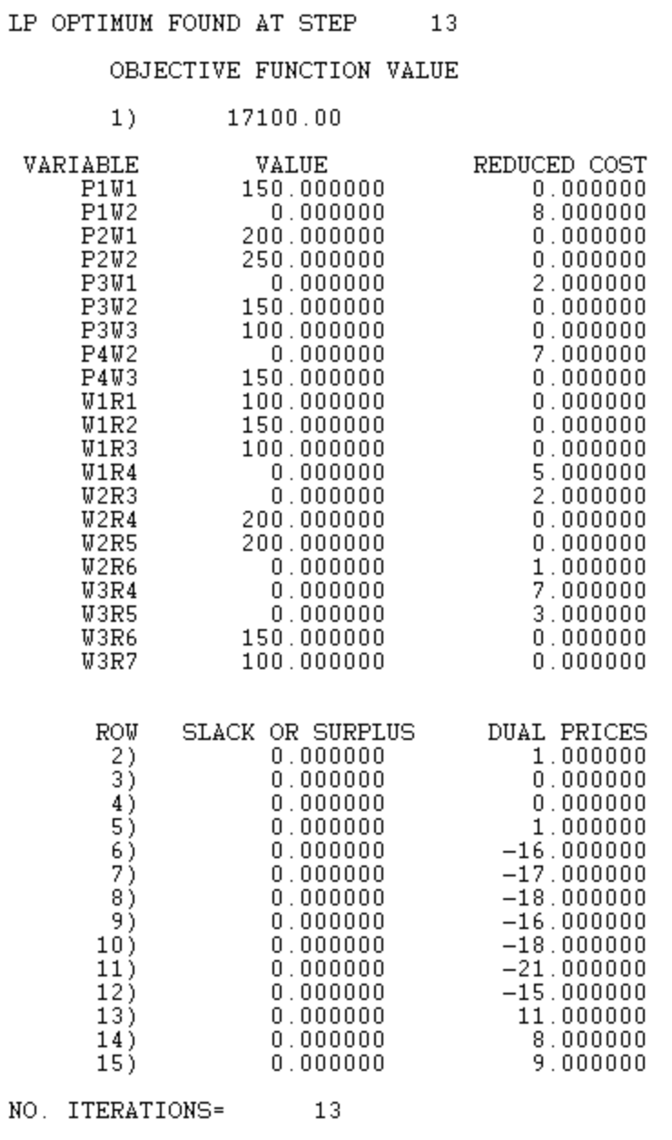

**PART B**

**It is NOT feasible to ship all the refrigerators to either warehouse 1 or 3 and then to the retailers without using warehouse 2. Closing Warehouse 2 and eliminating all of the associated routes generates a scenario where the constraints do not allow for an applicable solution. This is attributed to the requirement that a minimum of 450 refrigerators be shipped to retailers r4, r5, r6, and r7 from warehouse 3. Unfortunately, the only manufacturing plants with connections to warehouse 3 (p3 and p4) can only produce a maximum of 400 refrigerators. This results in a deficit of 50 refrigerators from warehouse 3 to its associated retailers. When executing the code below in LINDO, we’re greeted with an error message that says “No Feasible solution…Violated rows have negative slack”**

**LINDO Code:**

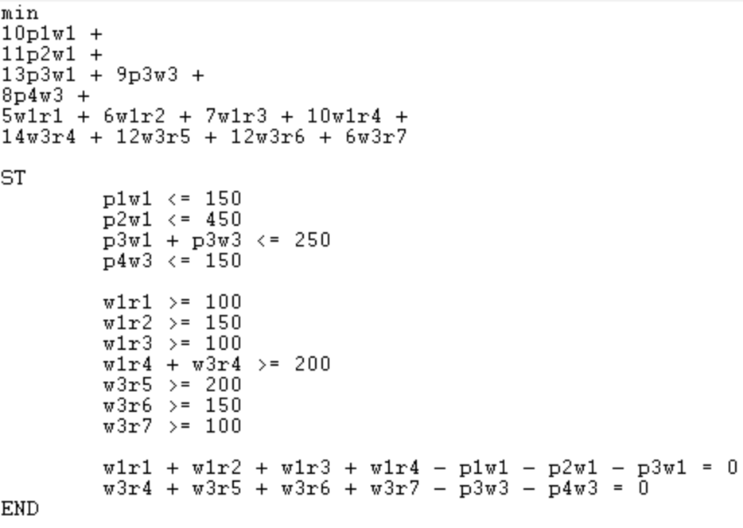

**Results:**

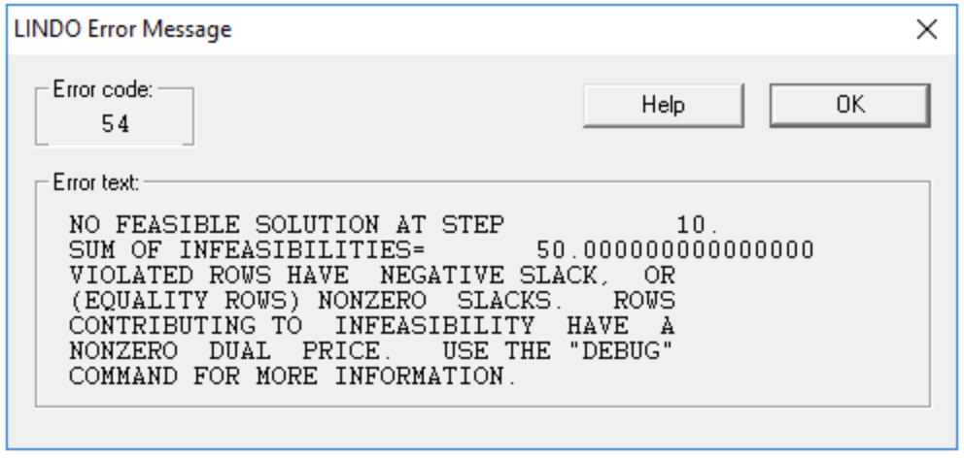

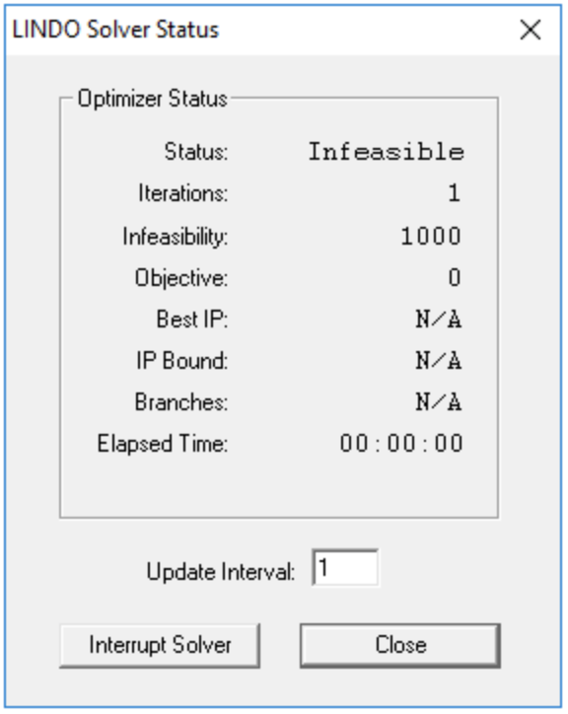

**PART C**

**If we limit the plant shipments to warehouse 2 to a maximum of 100 refrigerator the optimal minimum cost is $18,300.00. LINDO Code and corresponding results have been included below.**

**LINDO Code:**

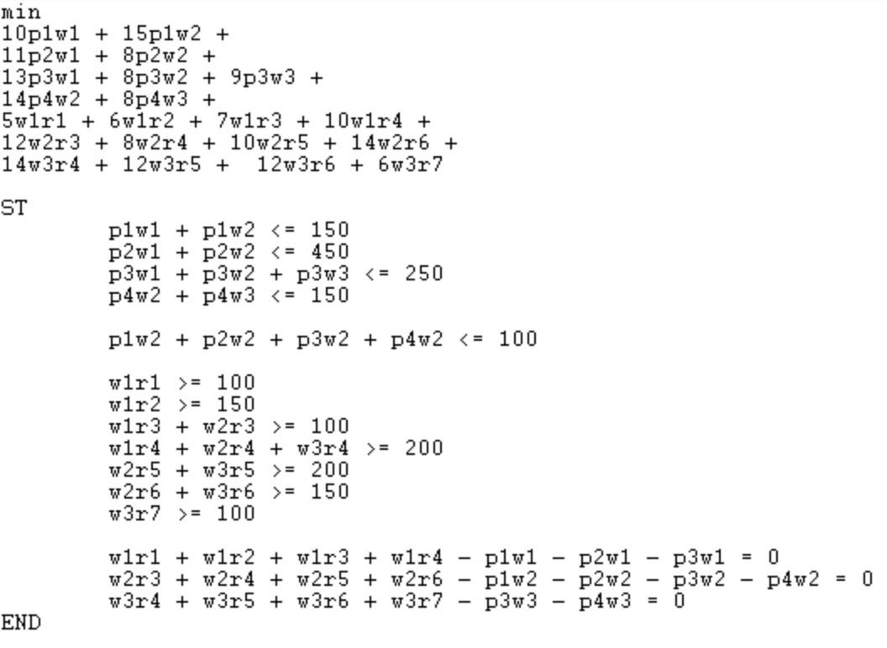

**Results:**

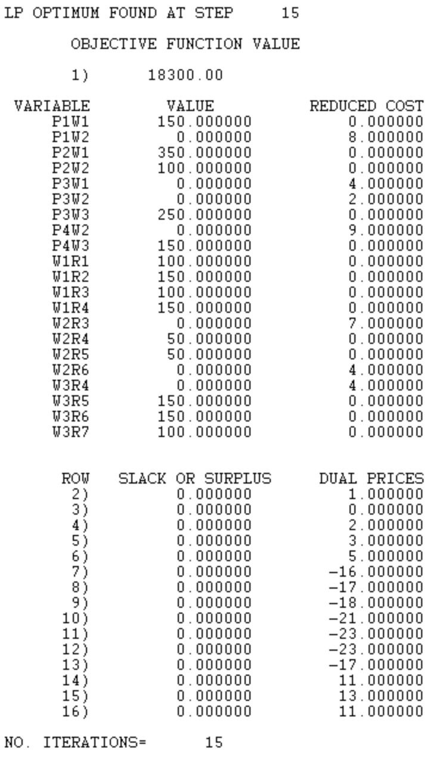

1. Making Change Revisited **(6 points)**

Given coins of denominations (value) 1 = v1 < v2< … < vn, we wish to make change for an amount A using as few coins as possible.  Assume that vi’s and A are integers.   Since v1= 1 there will always be a solution.  Solve the coin change problem from HW 3 using integer programming. For each the following denomination sets and amounts formulate the problem as an integer program with an objective function and constraints, determine the optimal solution using LINDO, MATLAB or Excel. What is the minimum number of coins used in each case and how many of each coin is used? Include a copy of your code.

1. V = [1, 5, 10, 25] and A = 202.
2. V = [1, 3, 7, 12, 27] and A = 293

**ANSWERS:**

**I used Excel rather than LINDO for these problems as this was the example provided in the “Coin Change Problem Revisited” Document. The Linear Programming functionality was implemented in the Solver Add-In.**

1. **V = [1, 5, 10, 25] and A = 202.**

**Minimum Number of Coins Used: 10 [2, 0, 0, 8]**

**Excel Solver Equation:**

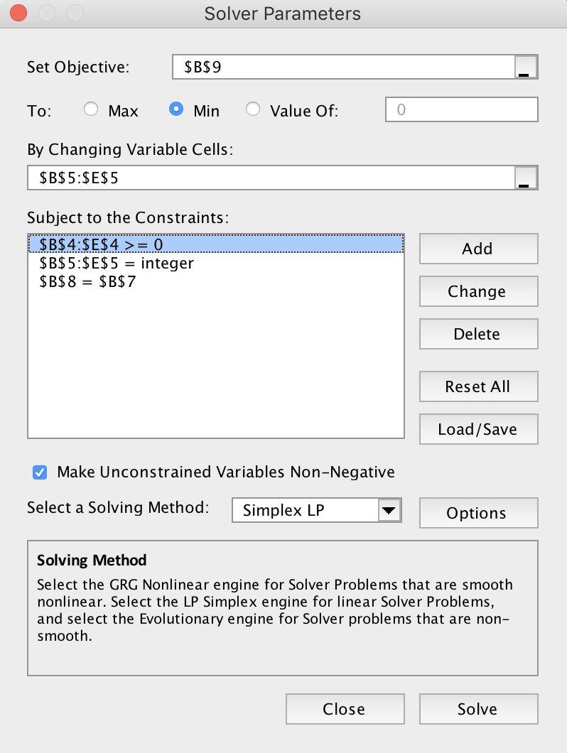

**Excel Results:**

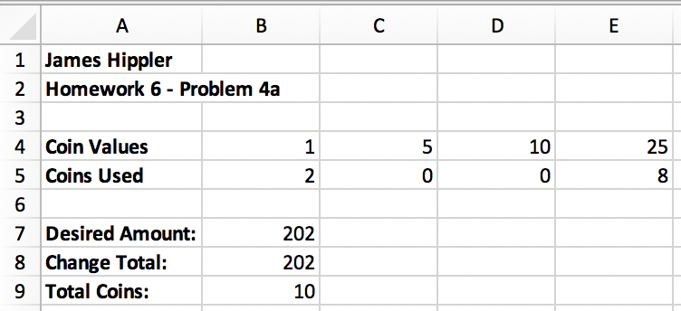

1. **V = [1, 3, 7, 12, 27] and A = 293**

**Minimum Number of Coins Used: 14 [0, 0, 2, 3, 9]**

**Excel Solver Equation:**

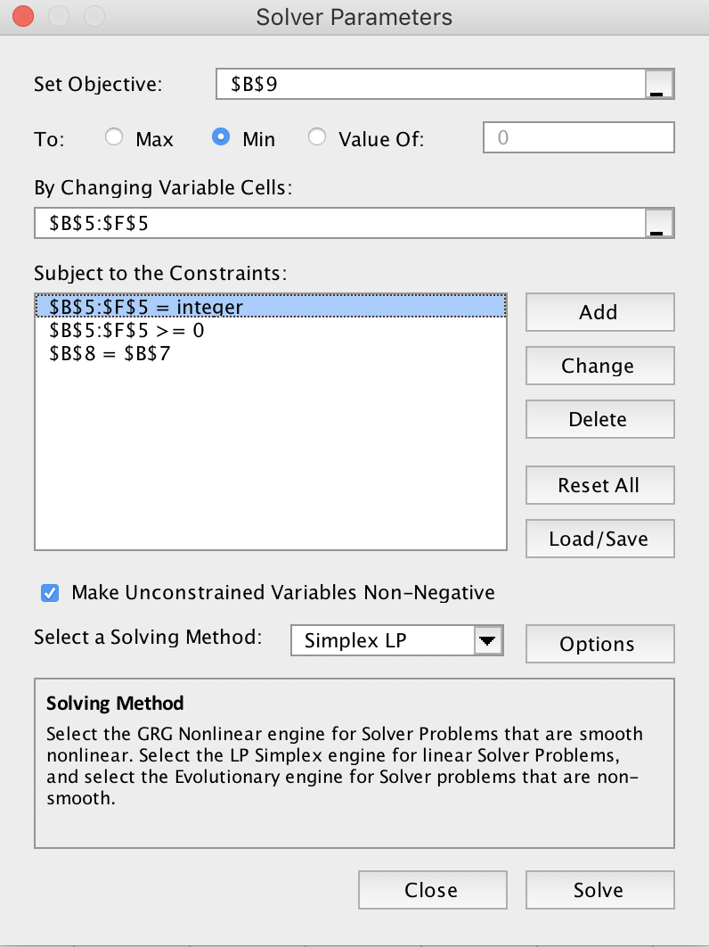

**Excel Results:**

