SiteSee Real Estate Website Hierarchy
Six public pages form the real estate website. Platform has its own page, and real estate pricing uses its own request process and protected result. Company information and legal pages remain on the corporate site.
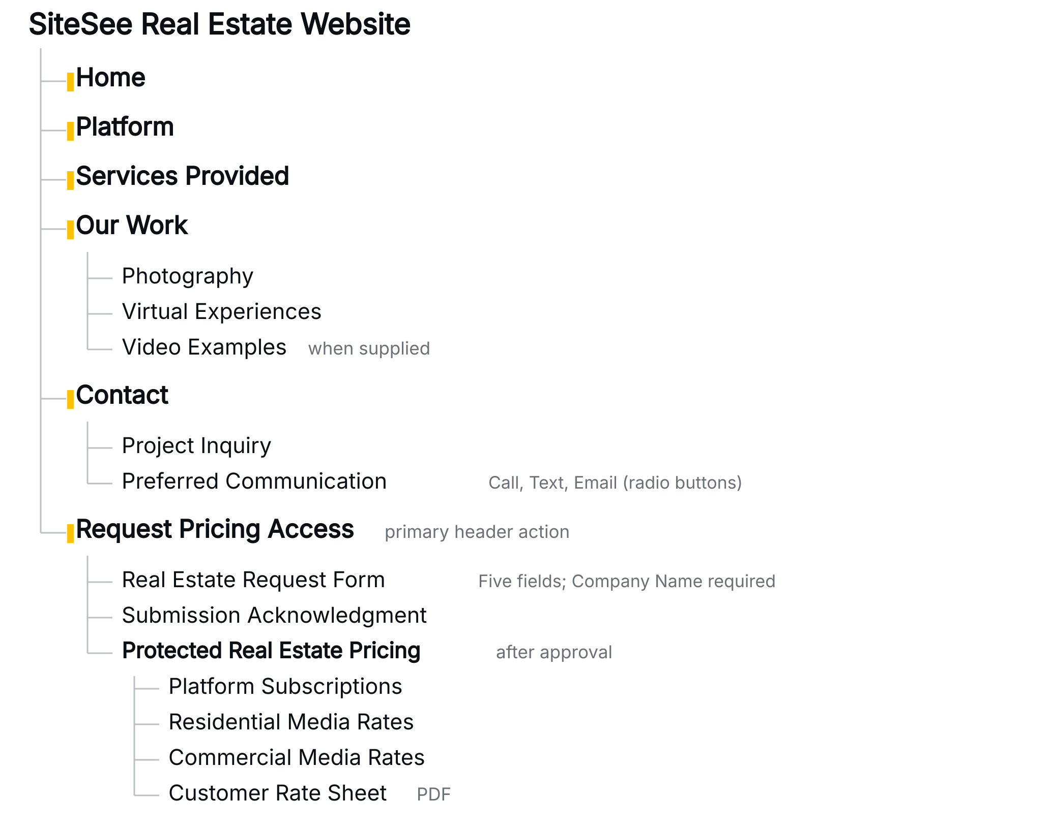

Page Section Hierarchy
These branches are sections within Home, Platform and Services Provided. The corporate hero structure and shared real estate header and footer apply throughout.
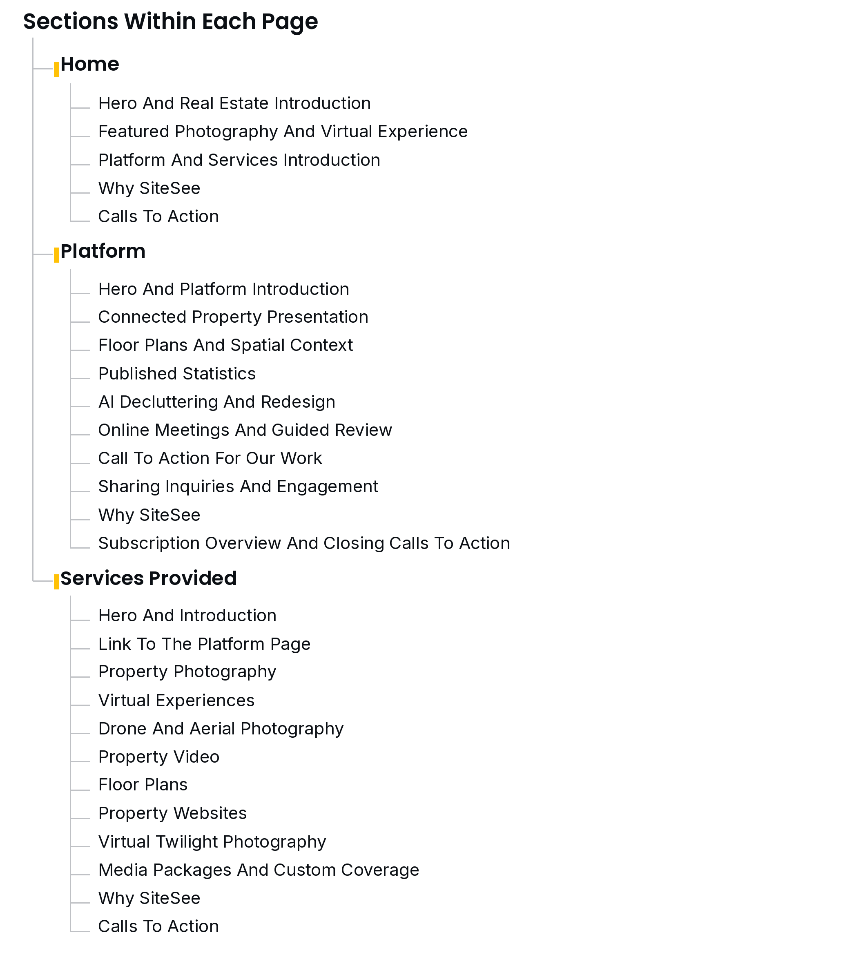

Shared Footer Hierarchy
The footer appears across the real estate website. Corporate and copyright links open in a new tab or window. Division navigation and service links remain within the real estate website.
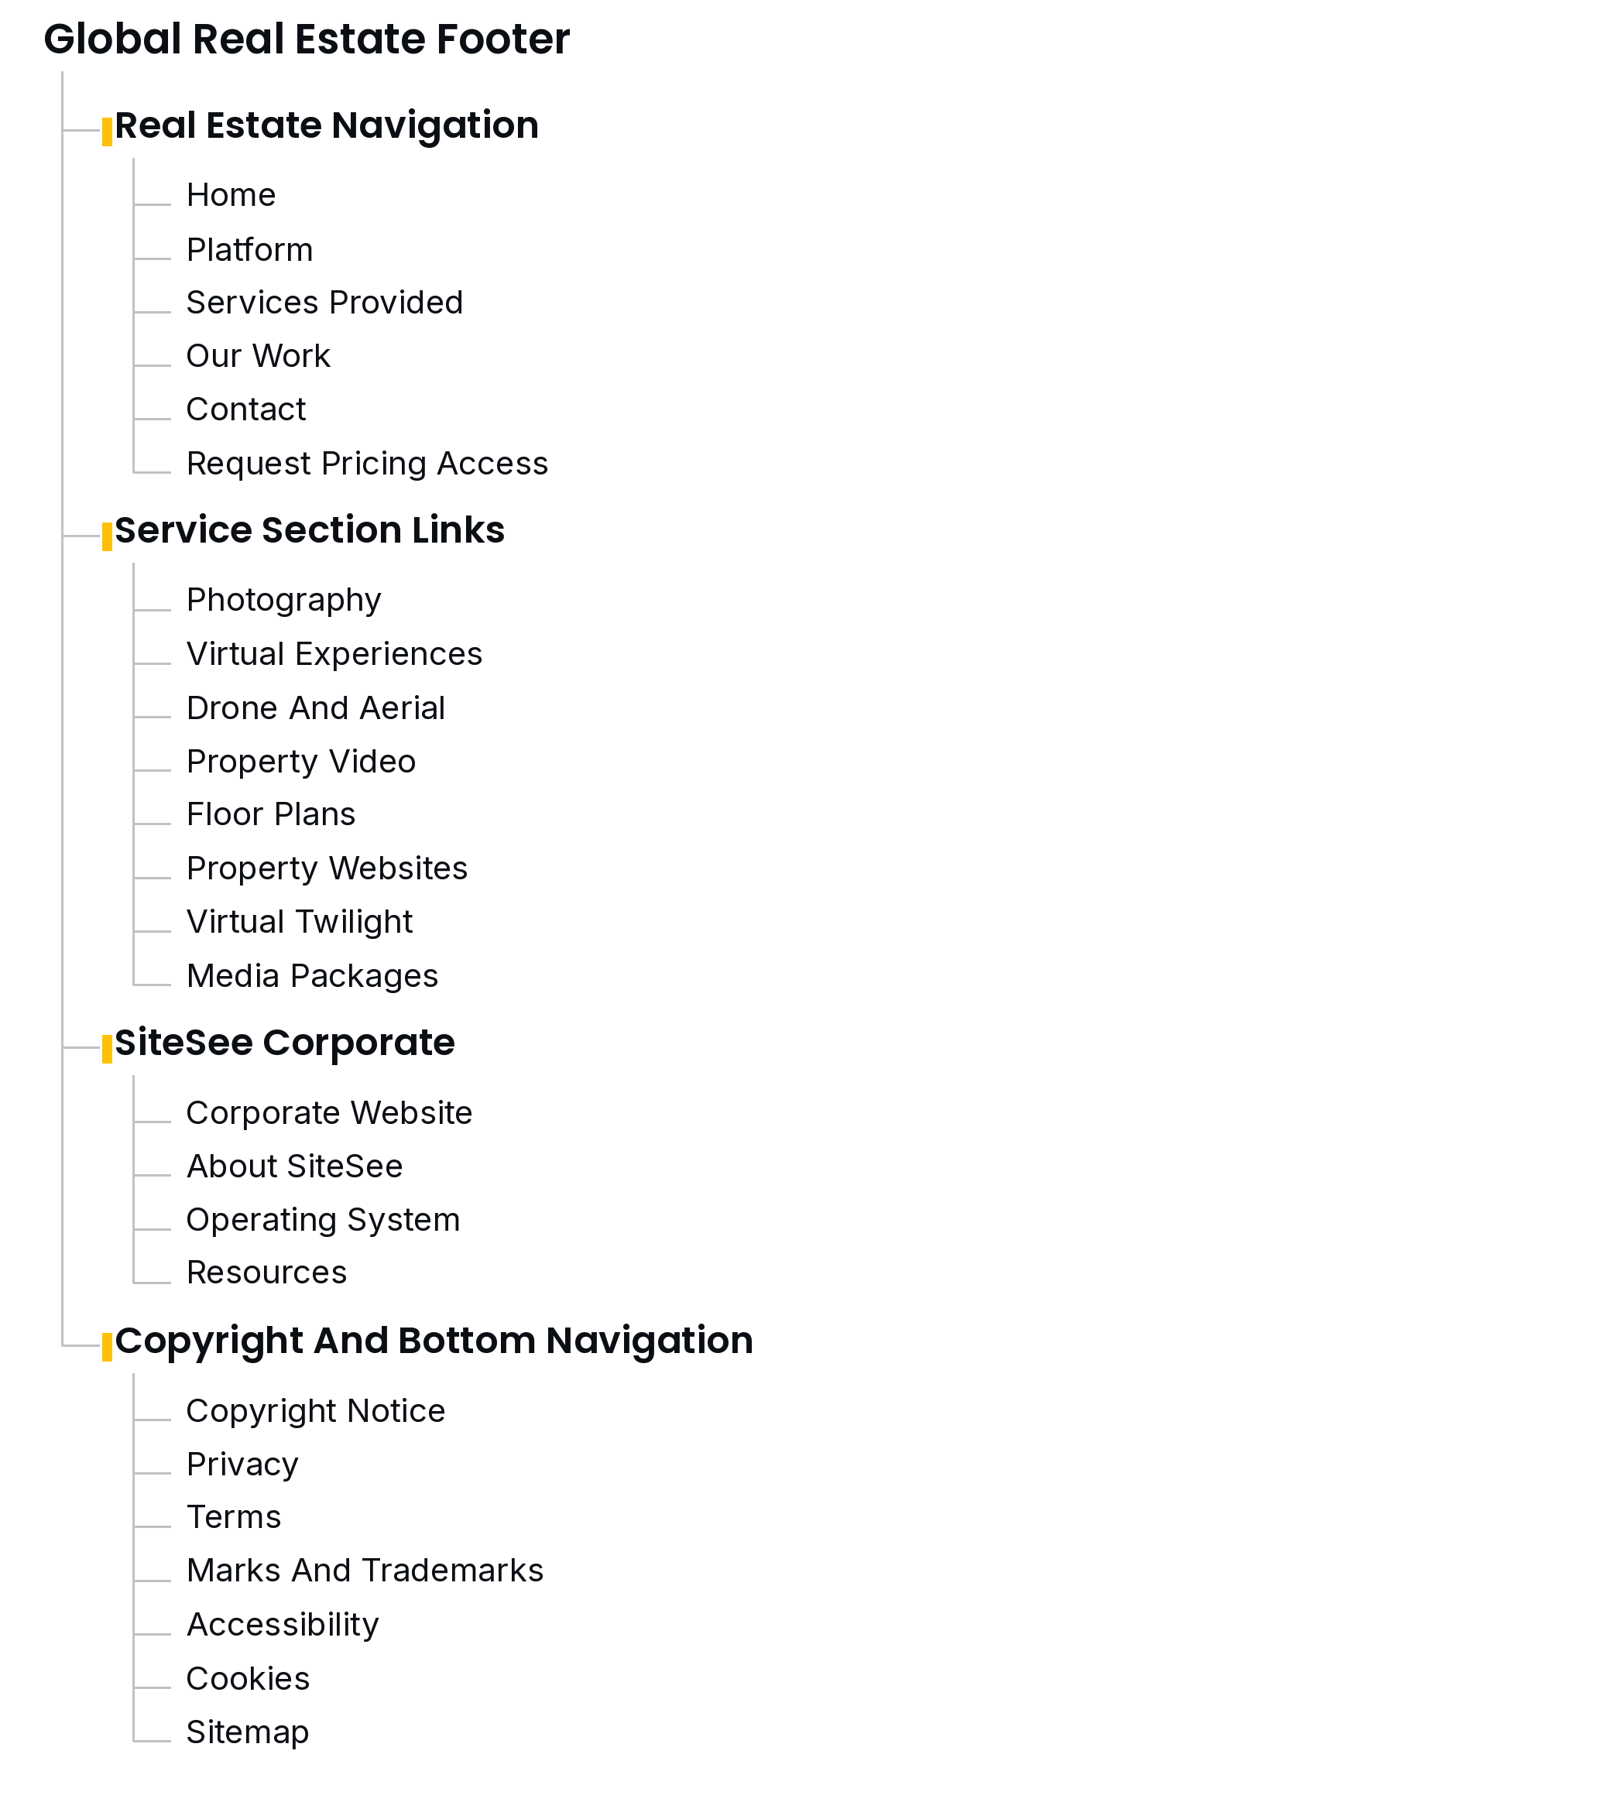

Form Specifications
The pricing request uses five contact fields, with Company Name as the only required field. The Contact form records the sender’s preferred communication method.

Pricing Request
Order | Field | Required
1 | First Name | No
2 | Last Name | No
3 | Company Name | Yes
4 | Email Address | No
5 | Phone Number | No
Mailing-list opt-out: Please exclude me from all mailing lists.
Use a separate optional checkbox, initially unchecked. Save the selection with the request. A checked box excludes the sender from all mailing lists while allowing a response to this pricing request.
Fixed subject: Real Estate Div. - Pricing request.
Accept a Company Name-only submission with the other four fields blank. Show an on-page acknowledgment. The subject is set automatically; there is no additional subject or pricing-category field.

Contact Form
Preferred Communication: Call · Text · Email
Use one optional radio-button group with no default selection. Allow one choice at a time and save the selected value with the inquiry.
Remove Discovery Call and its scheduling prompt from the Contact form. Contact-directed actions use “Discuss Your Property.”

