1、 配置环境变量
(1)JAVA_HOME E:\jdk1.7.0_03
(2)CLASSPATH:.;%JAVA_HOME%\lib;%JAVA_HOME%\lib\tools.jar;
(3)Path:%JAVA_HOME%\bin;%PATH%;
2、 /ofbiz/framework/base/config/ofbiz-containers.xml
注释掉:(1) commons-vfs-container
(2) webslinger-container
(3) rmi-dispatcher
(4) birt-container
3 、eclipse 中build path 中
- 加入framework下的三个目录:base\config,base\cert,base\dtd
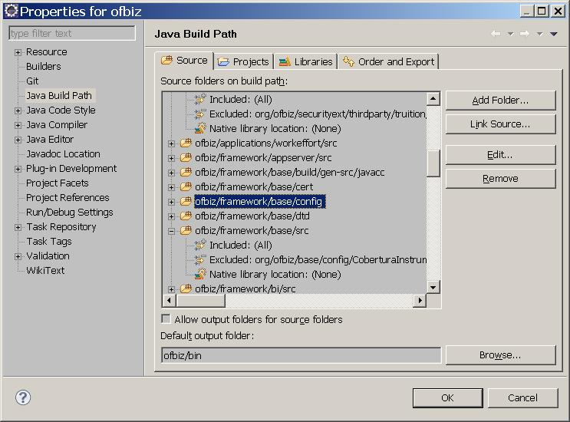
- Libraries->add jars-> Derby-10.7.1.1.jar
- Classpath 文件中加<classpathentry kind="con" path="org.eclipse.pde.core.requiredPlugins"/>
如图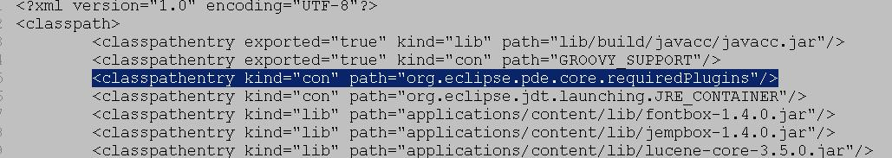
- .project文件中加入如图<nature>org.eclipse.pde.PluginNature</nature>
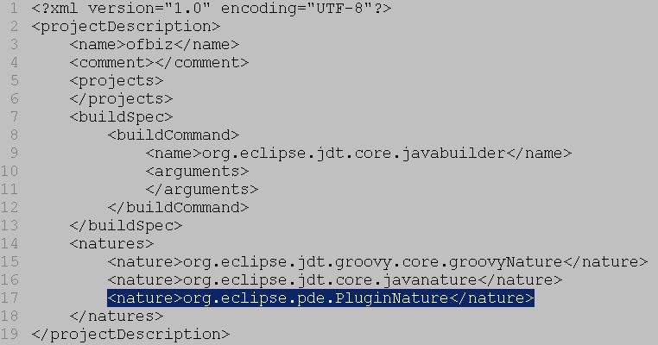
4、 org\ofbiz\common\UrlServletHelper.java 的乱码的问题的函数invalidCharacter() 替换为
str = str.replace("&", "-");
str = str.replace("\"", "-");
str = str.replace("×", "-");
str = str.replace("÷", "-");
str = str.replace(" ", "-");
str = str.replace("!", "-");
str = str.replace("#", "-");
str = str.replace("$", "-");
str = str.replace("%", "-");
str = str.replace("'", "-");
str = str.replace("(", "-");
str = str.replace(")", "-");
str = str.replace("*", "-");
str = str.replace("+", "-");
str = str.replace(",", "-");
str = str.replace(".", "-");
str = str.replace("/", "-");
str = str.replace(":", "-");
str = str.replace(";", "-");
str = str.replace("<", "-");
str = str.replace("=", "-");
str = str.replace(">", "-");
str = str.replace("?", "-");
str = str.replace("@", "-");
str = str.replace("[", "-");
str = str.replace("\\", "-");
str = str.replace("]", "-");
str = str.replace("^", "-");
str = str.replace("_", "-");
str = str.replace("`", "-");
str = str.replace("{", "-");
str = str.replace("|", "-");
str = str.replace("}", "-");
str = str.replace("~", "-");
str = str.replace("￠", "-");
str = str.replace("￡", "-");
str = str.replace("¤", "-");
str = str.replace("§", "-");
5添加文件 参见 “META-INF”文件夹 和 build.properties和plugin.xml
6 eclipse中打开plugin.xml 程序添加classpath,需要手动重新添加如图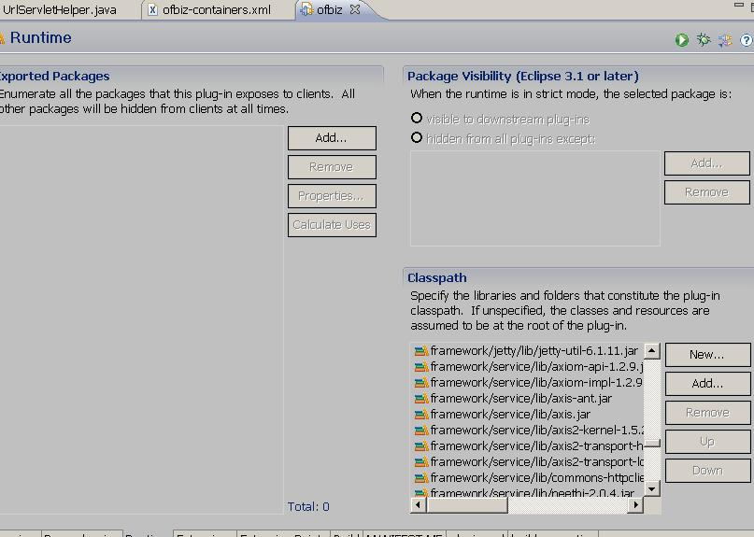

7 针对osgi代码调整
- Config.java 加入代码
1两个函数public static String getPathFromClass(Class cls)\ private static URL getClassLocationURL(final Class cls)
2 readConfig(String config)函数中加入代码
Boolean selfstart=false;
if(selfstart)
{
// set the ofbiz.home
if (ofbizHome == null) {
ofbizHome = props.getProperty("ofbiz.home", ".");
// get a full path
if (ofbizHome.equals(".")) {
ofbizHome = System.getProperty("user.dir");
ofbizHome = ofbizHome.replace('\\', '/');
System.out.println("Set OFBIZ_HOME to - " + ofbizHome);
}
}
System.setProperty("ofbiz.home", ofbizHome);
}else
{
String packageName = this.getClass().getResource("").getPath();
packageName = packageName.replace("/", "\\");
String projectPath = null;
try {
String packageFullName = Config.getPathFromClass(this.getClass());
ofbizHome = packageFullName.substring(0,
packageFullName.indexOf(packageName));
System.setProperty("ofbiz.home",ofbizHome);
System.out.println("ofbizHome:"+ofbizHome);
} catch (IOException e1) {
projectPath = null;
e1.printStackTrace(); } }
(2) ServerHitBin.java 把 import com.ibm.icu.util.Calendar; 换成 import java.util.Calendar;
(3) CatalinaContainer.java 函数createConnector 加
if(prop.name.equals("keystoreFile"))
{String ofb_home_jks= System.getProperty("ofbiz.home")+"/"+prop.value;
connector.setProperty(prop.name,ofb_home_jks);
}else
connector.setProperty(prop.name, prop.value);
- 换了 icu4j-4_4.jar

8 调试如图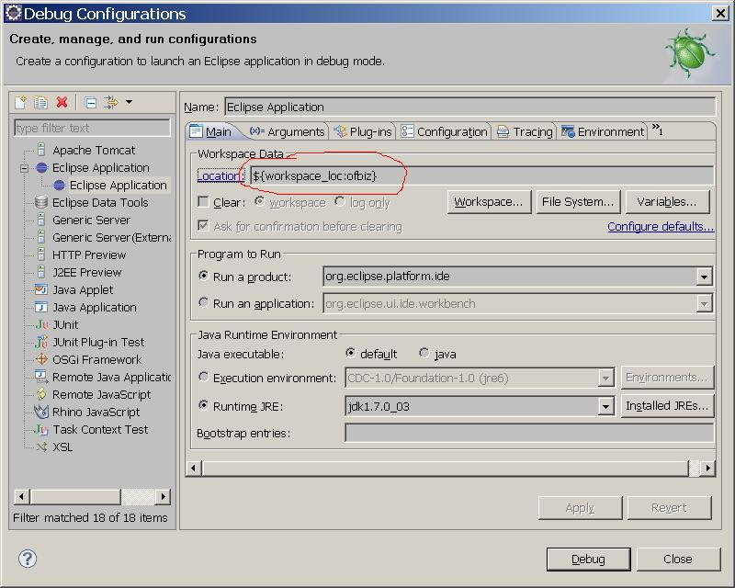
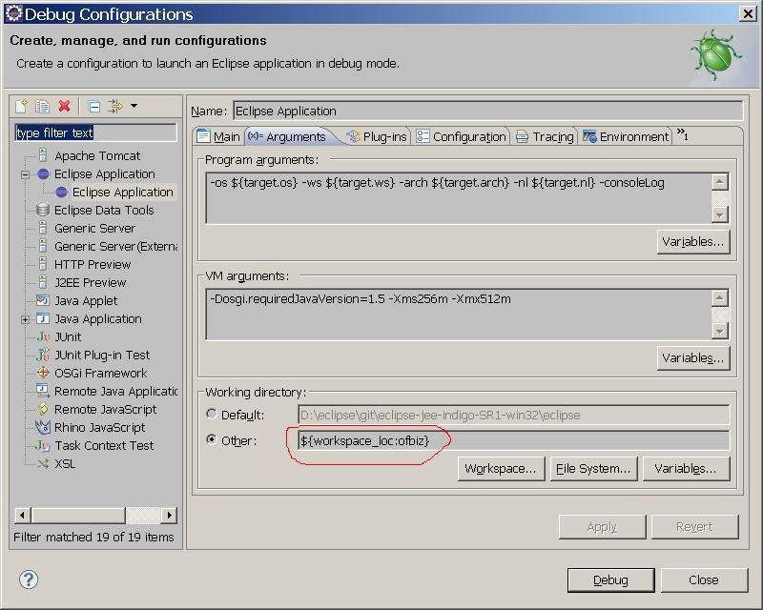
红线部分都设置为你的工作目录
运行后选择ofbiz
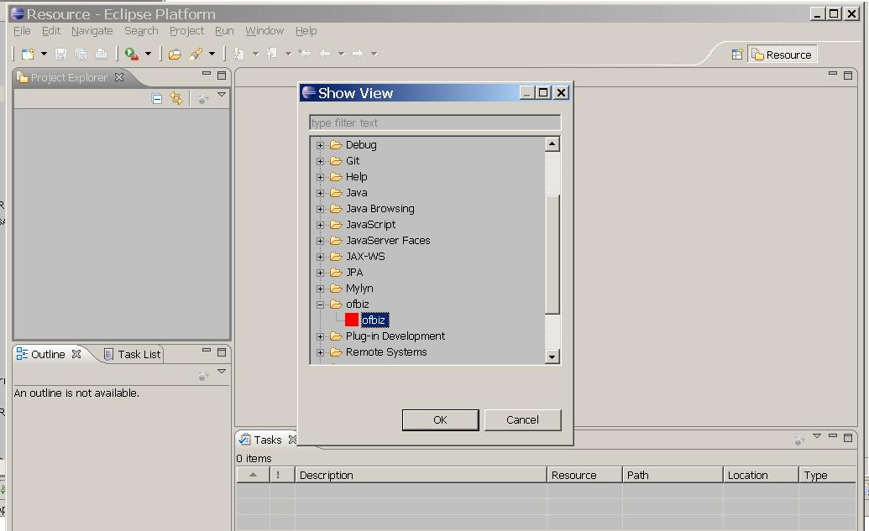
Eclipse 版本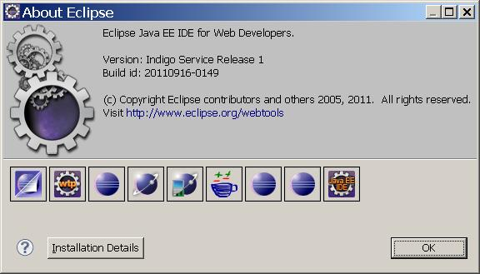
9
(1) start.java 方式运行 设置config.java 文件中selfstart=true;
(2) osgi 方式运行 设置config.java 文件中selfstart=false;

