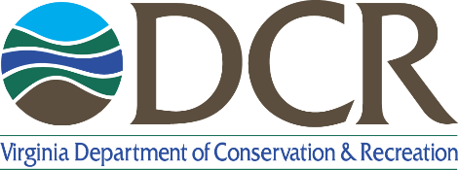

Land and Water Conservation Fund   
Virginia 2022 Project Timeline

*Please read the* ***Virginia LWCF******2022 Application Manual*** *before inserting the project timeline.*

| **2022 Project Timeline** |
| --- |
| **Insert a timeline for completion of the proposed LWCF project on the following pages.** |
| **Important dates to remember:**   * Project sponsors will be notified of DCR selection in April 2022. * NEPA-level environmental review must be completed by June 2022 for earliest submission to NPS. Project unable to complete requirements by June will be withheld until NPS opens another grant round, estimated to be winter 2022/23. * For projects submitted to NPS by July 2022, NPS authorization date of October 2022 to January 2023 is expected. * Projects will be authorized for 3 years from NPS authorization date. * Development projects must break ground within one year of NPS authorization date.   **Sample tasks/milestones to include:**  *Indicate which steps have been completed within the timeline as well as noting a timeline for actions that need to be completed.*  **All Projects** *(as applicable)*   * Environmental Review Compliance data collection (NEPA). See <https://www.dcr.virginia.gov/recreational-planning/lwcf> for DCR Environmental Review guidance. * Historic/Cultural Resources Compliance data collection (Section 106). * Indicate when committed funds will be secured. * Time to complete/resolve any easement/lease/ownership etc. issues. * Date open to public   **Acquisition**   * Proposal and planning process * Appraisals (UASFLA Standards) and appraisal review * Negotiations/Purchase offer with landowners if necessary   **Development - Include all that apply**   * Survey work * Preliminary design development * Final plan development * Construction drawing preparation * City/County/Other - Reviews/Approvals * Bidding process * Permitting * Construction period * Date open to public |

[insert timeline on following pages]