Sitecore Hackathon AAA Team.

# Hackathon Category:

# Enhancement to Sitecore Commerce Business Tools UI.

# Advanced breadcrumbs for Merchandising Dashboard.

**Problem**: When using merchandising dashboard, the navigation between Catalogs, Categories, Sellable items, Variants is very confusing. The default breadcrumbs component shows links to the ecommerce site root (Commerce) and to the current item, no matter where you have navigated to:

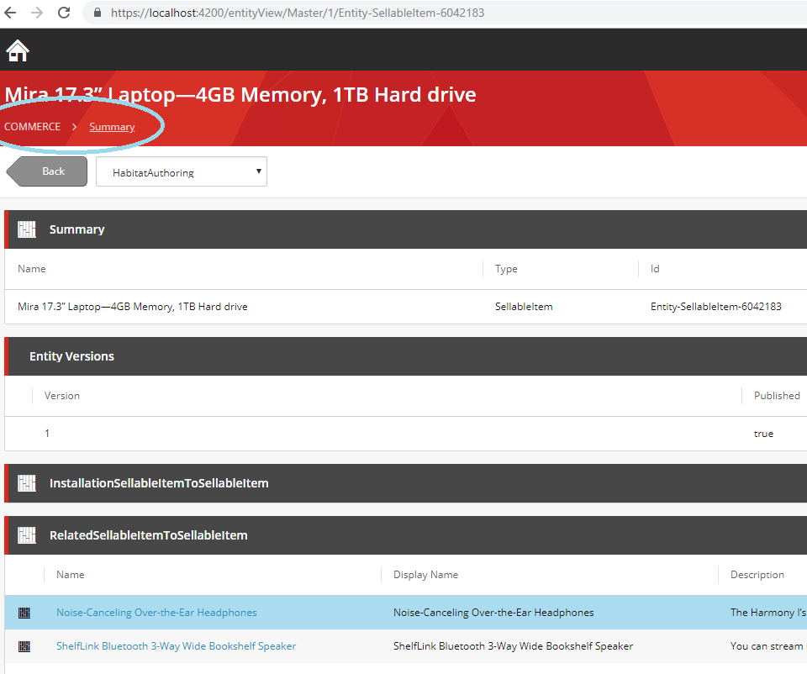

**Purpose of this module:** Advanced BizFx breadcrumbs component to help navigate in the Merchandising Dashboard. This component will show full hierarchical path to the current item + plus will be links to the over items on each hierarchical level (to switch catalogs, categories etc.), so the end user can easily navigate between items of the merchandising dashboard and can easily understand where he is located.

Installation Instructions.

Environment prerequisites: Installed Sitecore Ecommerce 9.0.3.

The solution contains 2 parts to be deployed:

1. **The Copy of the BizFx Sitecore Commerce Business Tools SDK with new component added for the advanced breadcrumbs (sc-bizfx-breadcrumbs-new): Sitecore.BizFx git folder.**

This SDK should be deployed according to the regular Sitecore installation instructions (copy located in the git path: \Sitecore.BizFx\README.md):

*# Sitecore Commerce Business Tools SDK*

*## Setup*

*Before start developing make sure you have the Sitecore feed in your user's npm config.*

*Go to `C:\Users\[your user]\.npmrc` and add the following lines to the file:*

*`@speak:registry=https://sitecore.myget.org/F/sc-npm-packages/npm/`*

*`@sitecore:registry=https://sitecore.myget.org/F/sc-npm-packages/npm/`*

*If the file doesn't exists, run*

*```npm*

*npm config set @speak:registry=https://sitecore.myget.org/F/sc-npm-packages/npm/*

*npm config set @sitecore:registry=https://sitecore.myget.org/F/sc-npm-packages/npm/*

*```*

*Install the SPEAK and BizFx packages, run*

*\*\*You can find the SPEAK tarball files at the root of the Sitecore.Commerce.[version].zip file.\*\**

*\*\*When installing the `@sitecore/bizfx` package, make sure you are installing the version that shipped with `Sitecore Experience Commerce` that you are using.\*\**

*```npm*

*​​​​​​​npm install speak-ng-bcl-0.8.0.tgz*

*npm install speak-styling-0.9.0-r00078.tgz*

*npm install @sitecore/bizfx*

*```*

*Run `npm install`*

*## Build*

*Run `ng build` to build the project. The build artifacts will be stored in the `dist/` directory. Use the `-prod` flag for a production build.*

Copy files from \Sitecore.BizFx\dist\ to your SitecoreBizFx web site (C:\inetpub\wwwroot\SitecoreBizFx for example)

1. **Visual Studio Helix based solution Hackathon.AAATeam.sln in the git root folder.**

Publish Sitecore.Commerce.Engine solution to the CommerceAuthoring web site (C:\inetpub\wwwroot\CommerceAuthoring for example).

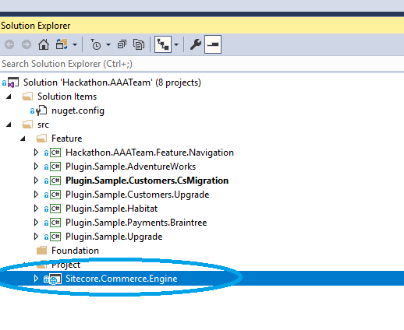

After solution publish, please clean by postman habitat environment and then initialize environment (because we need new fields in the catalog items).