## **Sitecore Content Language Translation by Addact Lions**

## **Document Version: 1.0**



**User Guide - Sitecore**

1. From System > Languages > Add new language following its subsequent steps as per below screen.

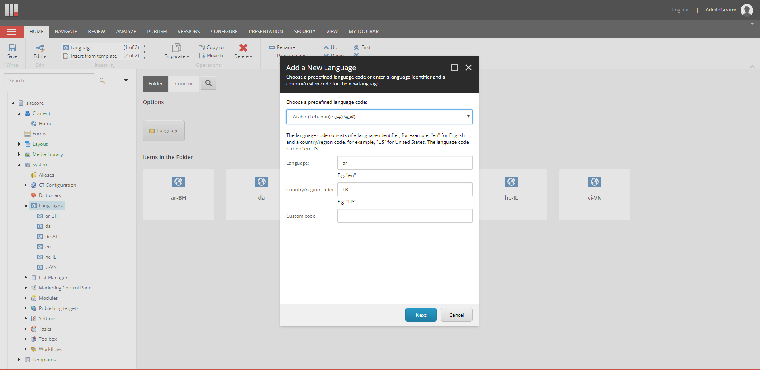

1. After successfully creation of language it will be displayed in listing as per below screen.

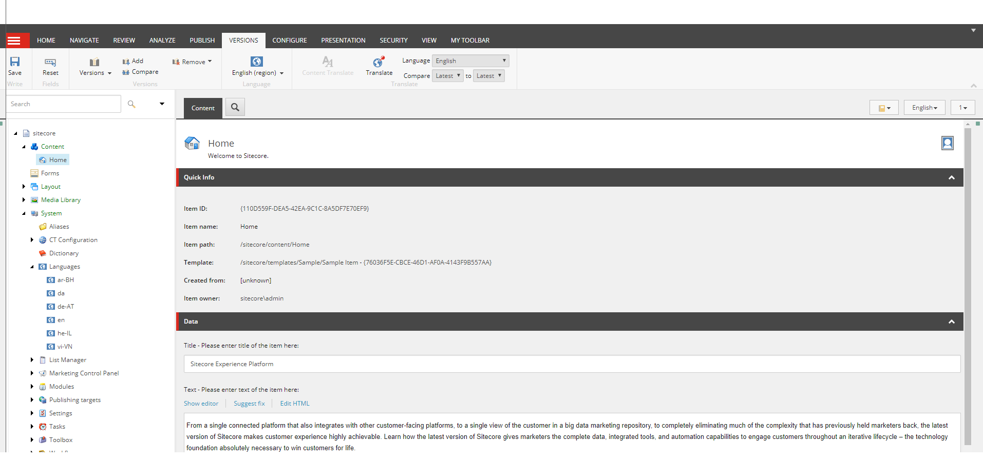

1. From System > CT Configuration > Configuration > Insert your Access Key provided by Google for translation.
2. Check EnableCT checkbox as per screen below.

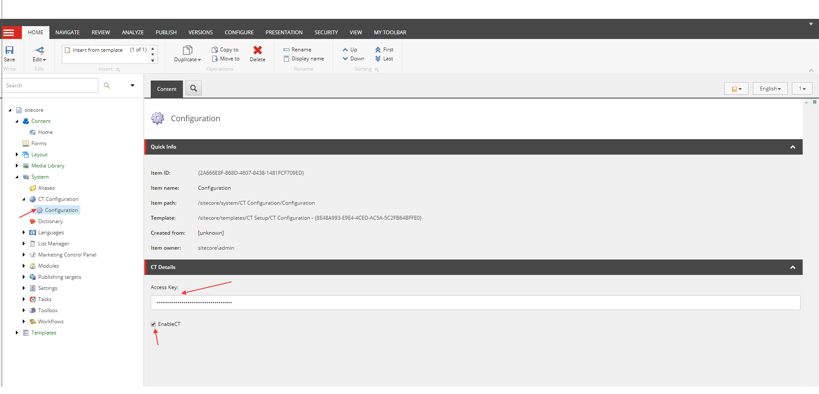

1. From Content > Home > List of languages will be available which are added previously.

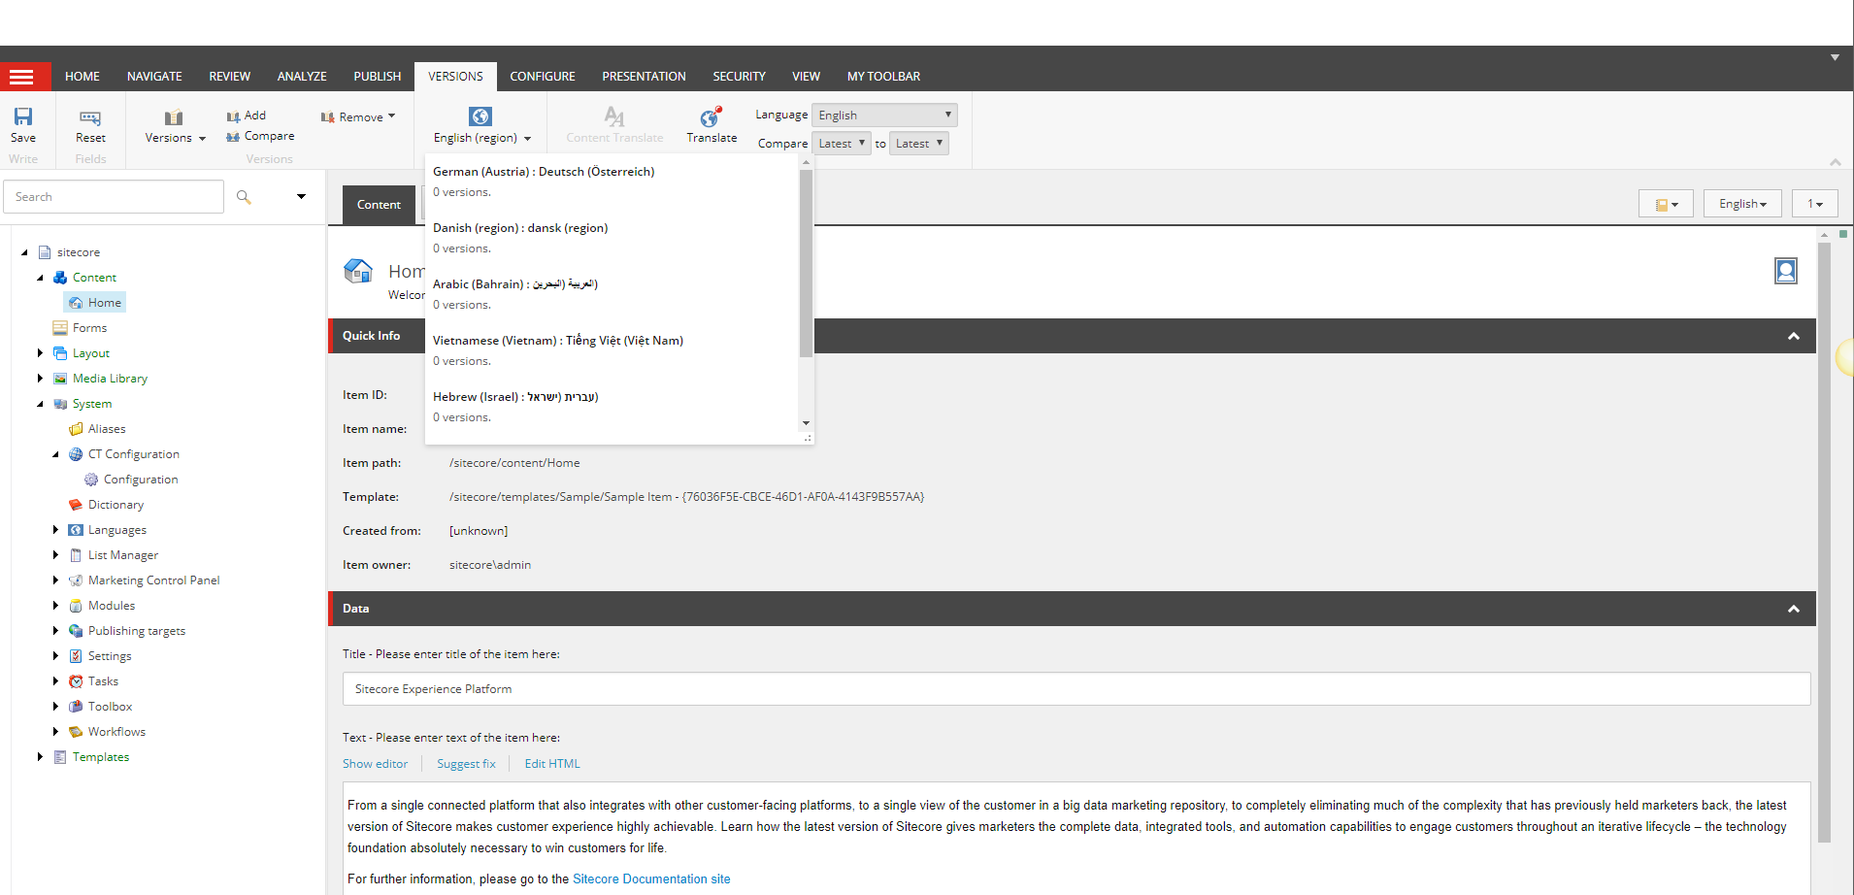

1. From Content > Home > choose any available language from list except English which is shown in above screen.
2. Once language will be chosen then option for “Content Translate” will be enabled with two options as per screen below.

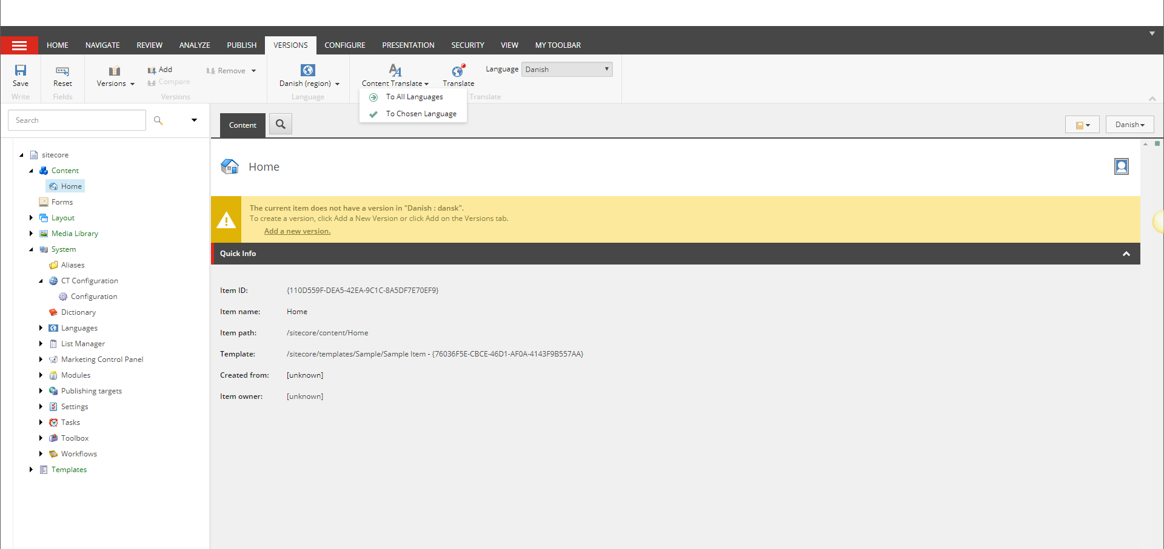

Note:

* if EnableCT is left unchecked then “Content Translate” option will not be visible.
* “Content Translate” option will be enabled only for content items for rest of option it will be disabled.
* “Content Translate” option will be enabled only for Non-English languages.

1. When option “To All Languages” chosen it will translate all Html Editor and simple text field’s content to all languages except English which are available in list and will create separate version of each language.

Note:

* While translating using this option if any non-supported language found it will automatically translated into English version.

1. When option “To Chosen Language” chosen it will translate all Html Editor and simple text field’s content to selected language and will create separate version for that language.

**Probable warning may come while translation:**

1. While translating content choosing “To All Languages” option if no languages available in listing except English it may prompt below warning message.

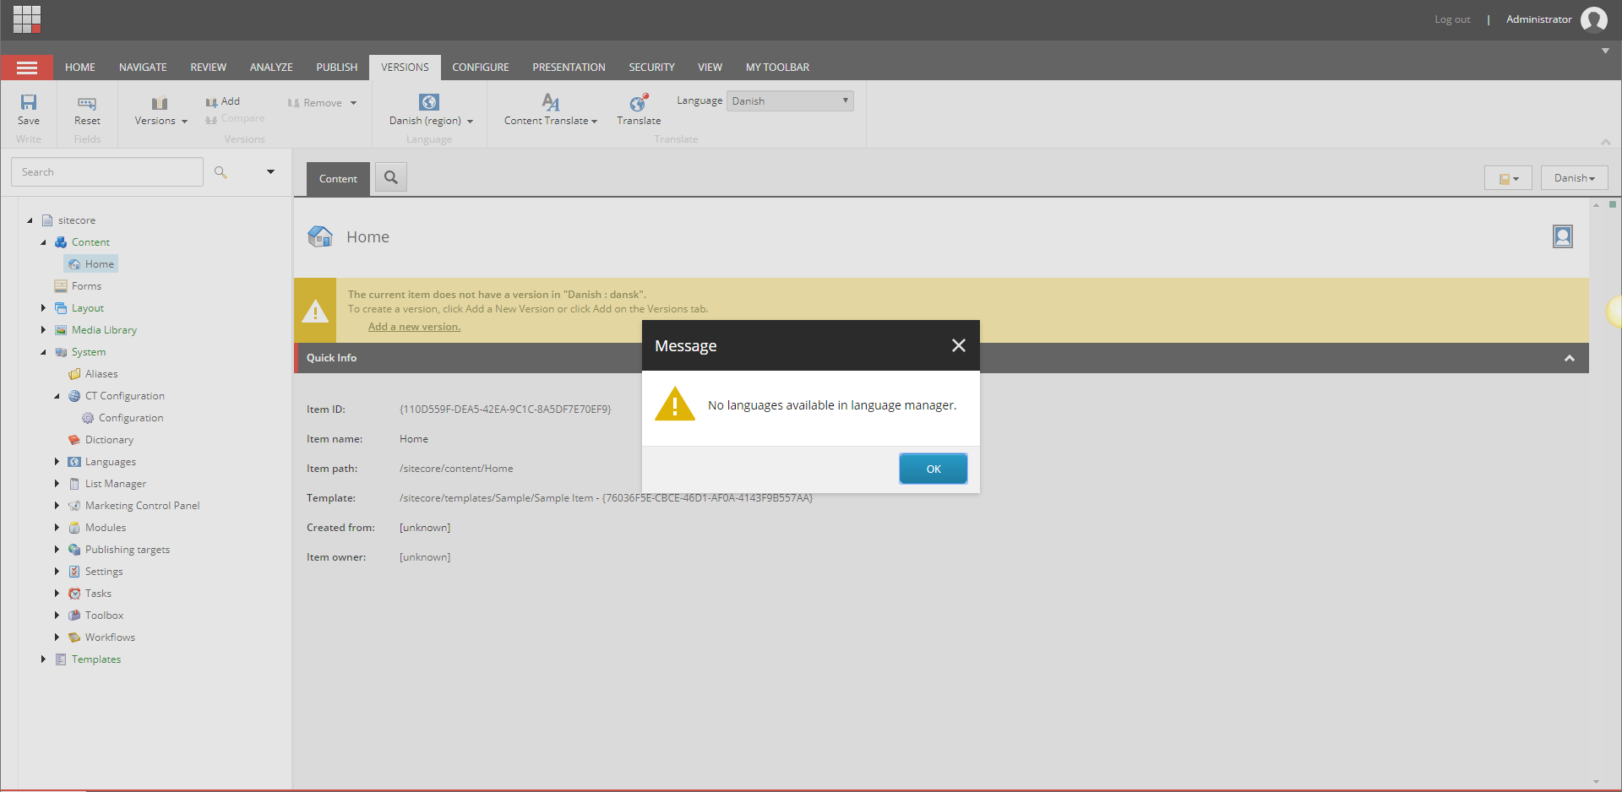

1. While translating content choosing “To Chosen Language” option if language selected which is not supported by google translation it may prompt below warning message.

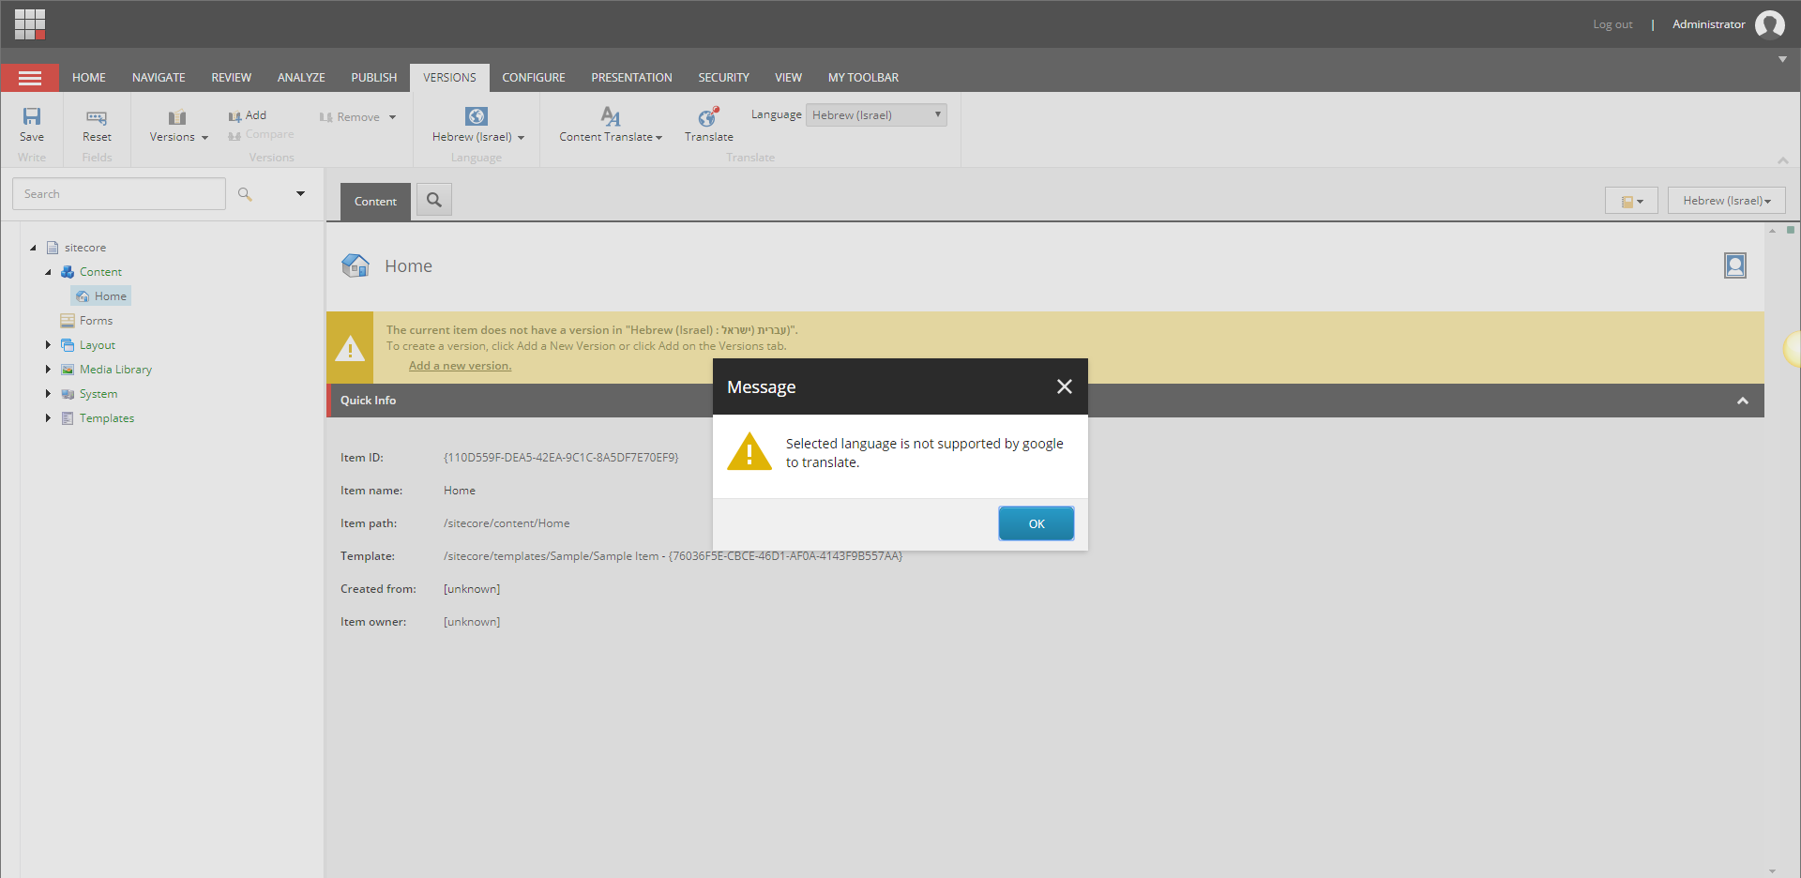

1. If no “Access Key” field left blank or wrong entered it may prompt below warning message.

