# Sitecore Hackathon 2019

**Team Pwned the Experience**

**Andy Fitzpatrick**

**Doug Schaffer**

Hackathon Category: Best enhancement to the Sitecore Admin (XP) UI for Content Editors & Marketers

## Module Name: Locksmith

#### Purpose

In Sitecore environments that have multiple authors making changes to the same items authors are generally required to lock items before making edits to ensure there are no collisions between authors. One common downside with this approach is that authors need to remember to unlock their items once editing is complete, because if they don’t then no other users can lock and edit that item until the original editor or an admin logs in and unlocks it.

Our module (codename *Locksmith*) gives editors the ability to review changes field by field or in page context via a modal in the Sitecore admin so items left locked by other users after a period of time can be safely unlocked by any other user. This functionality will be accessed via a yellow notification bar on the locked item which appears only if the item is locked and:

- the lock owner has logged out or their session has expired

- the lock owner is not admin (can be extended to specific roles as well)

- the item is normally editable/lockable during the current workflow state

- the user normally has write access to the item

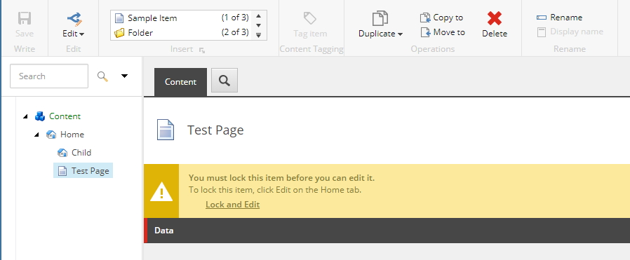

#### How To Use

If the 'Review Changes and Unlock' link in the yellow notification bar is clicked a Lock Summary modal is displayed that looks and feels like the Sitecore Validation Summary which should be familiar to most authors. Each row in the modal represents a field on the item that was edited, with the old value on the left and the new value on the right. The author then selects via radio buttons in either column which value to take when unlocking.

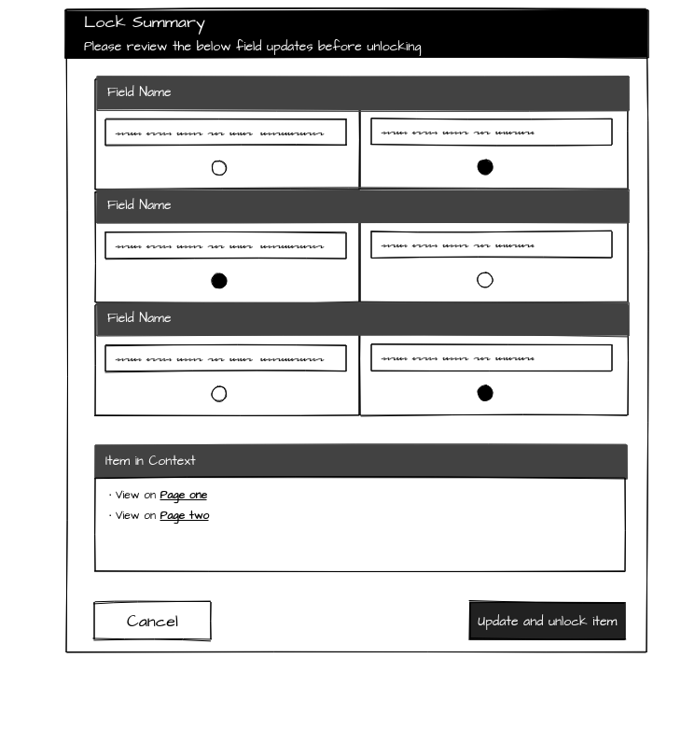

Also in the modal, below the field changes summary, will be a list of other Sitecore items that refer to the locked item in their Presentation Details. Clicking on one of these links will open a new tab showing that associated item in Experience Editor mode if the associated item has a layout. Old and new field values can also be reviewed and selected via the Experience Editor UI.

When an editor’s review is complete and clicks "Update and unlock item" the item will be unlocked and saved with the selected field values. The original lock owner will be notified via email that their item has been unlocked and see a summary of the changed field values.

#### Future Iterations

Functionality we’d like to add to future releases:

* Add support for more Sitecore field types (droplist, multiline text, checkbox, etc.)
* Allow original lock owner to revert individual field changes or the entire item
* Add icon to Review ribbon that launches the Lock Summary modal
* Create super role that can’t have its locks overridden