1. Pre-requisites: Sitecore 9.1. Make sure Analytics is enable and xconnect service is up
2. Xamarin SDK is installed in Visual studio and emulator is setup. We have verified the application with Android 8.1 – API 27.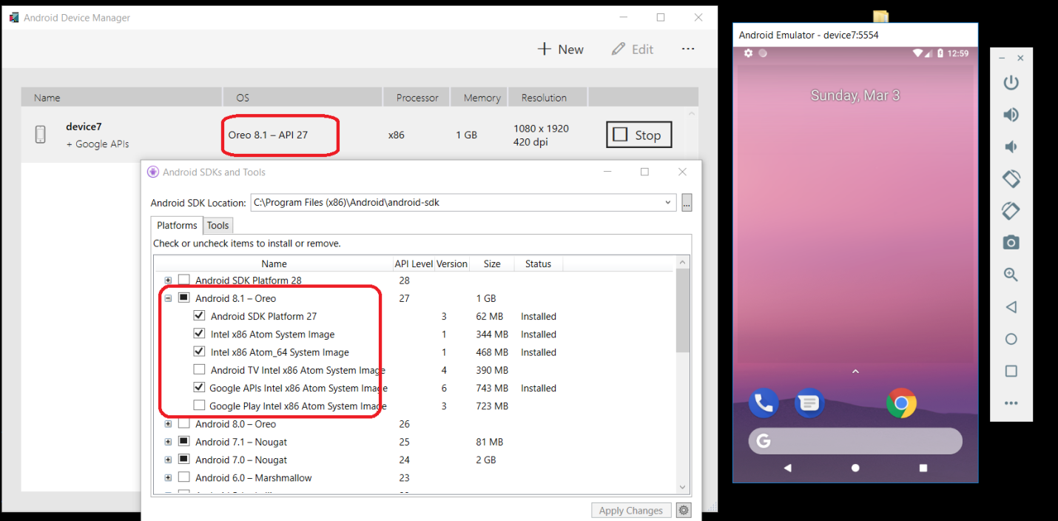
3. Install Sitecore Universal Tracker 1.0.0
4. Make sure that the emulator host file has sitecore9.1 host name and collection service url. You can refer <https://android.stackexchange.com/questions/190627/edit-hosts-file-on-android-studio-messed-up-my-emulator>
5. Make sure <https://sitecore.tracking.collection.service/status/> and <https://sitecore.tracking.processing.service/status> are green 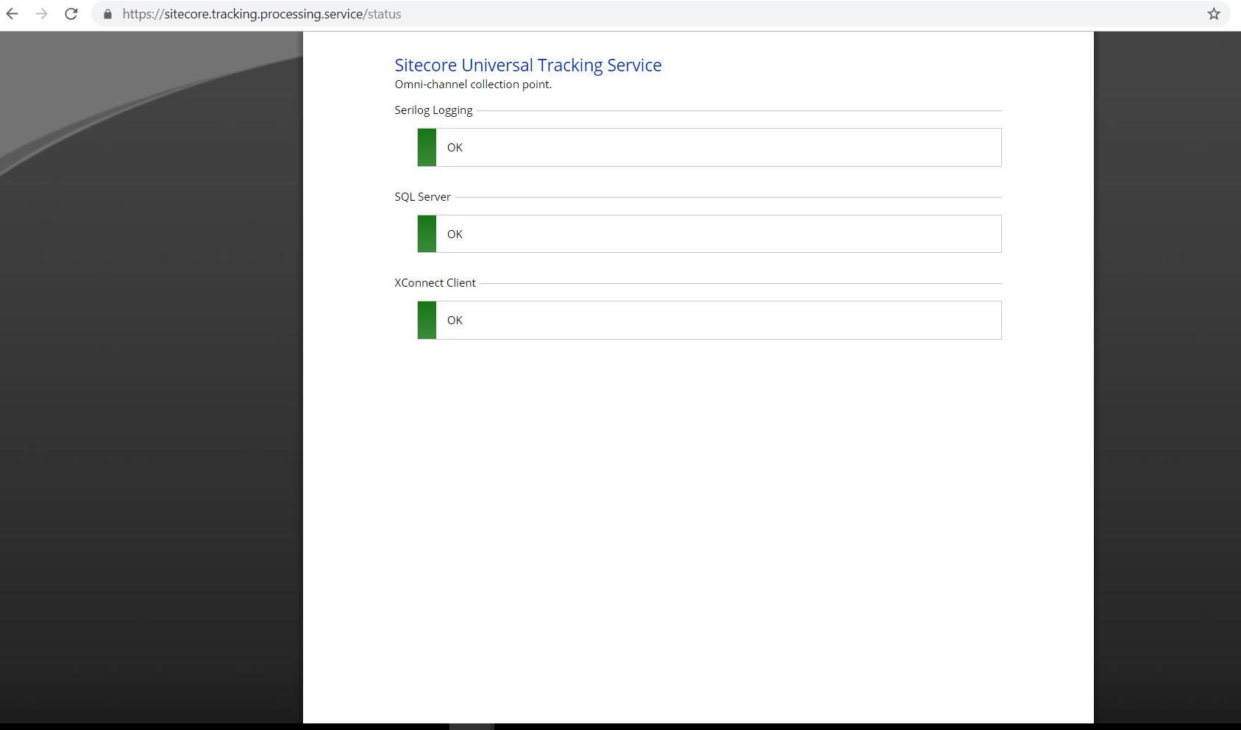 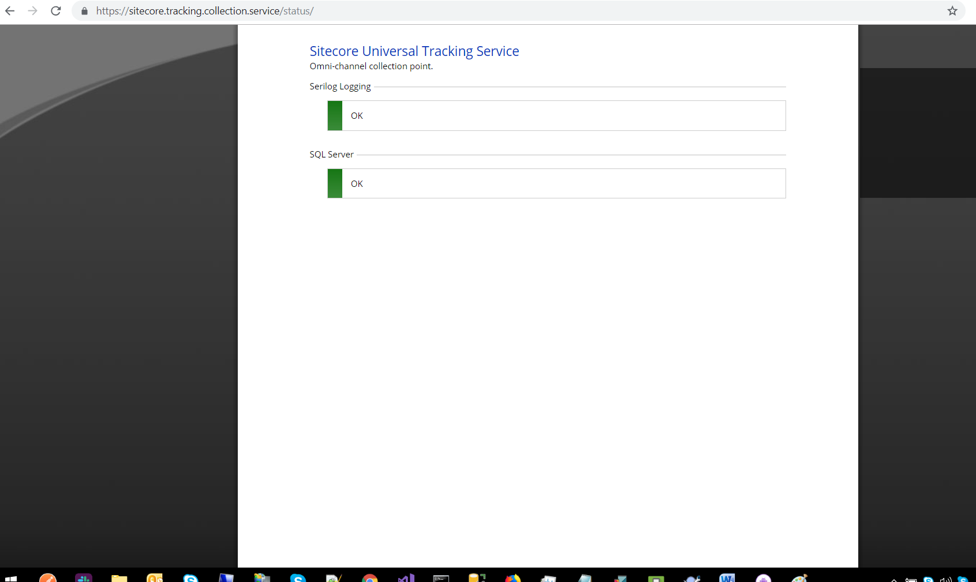
6. Install Sitecore package which includes:
7. Feature tracking project templates
8. Foundation tracking project templates
9. Project Templates
10. Marketing items
11. Tracking settings Item
12. Content tree with home item and few child items
13. Navigate to /sitecore/system/Settings/Foundation/Tracker/Tracker Setting Items/Tracker Settings Mobile App. Here you can select the goal, event and channel. If ‘Is Tracking enabled’ is un-checked then no event or goal will be triggered.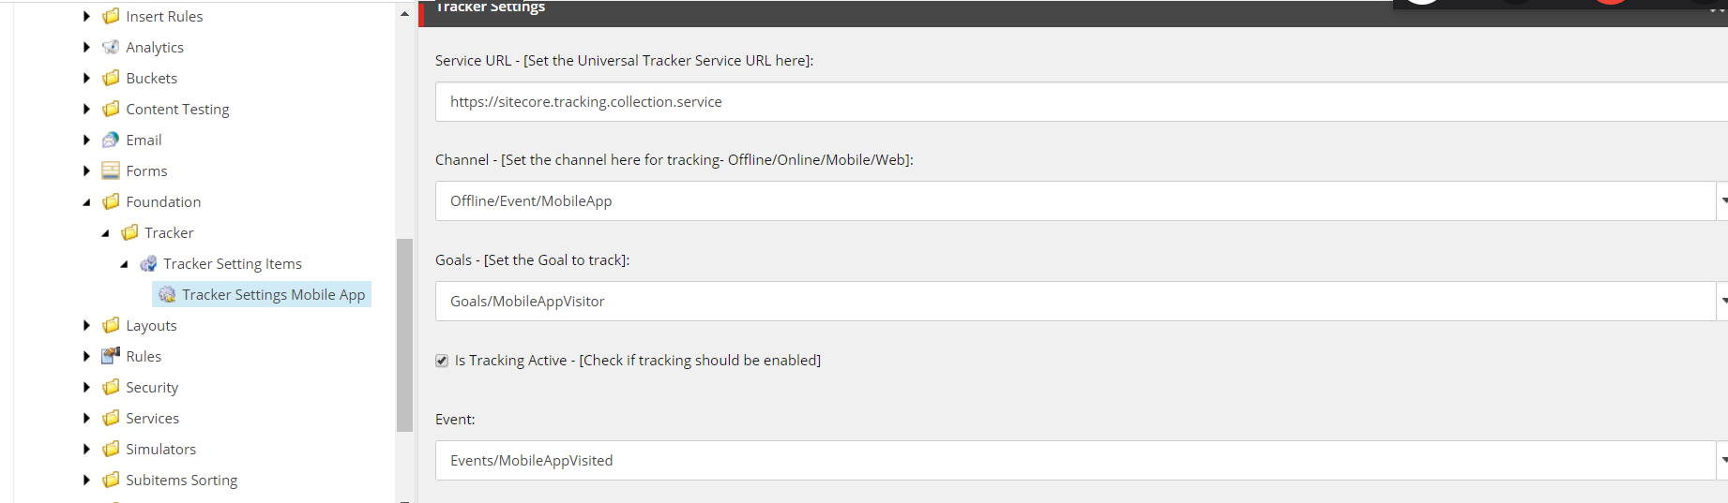
14. Add the channel selected to \Sitecore.Tracking.Processing.Service\sitecore\Sitecore.Tracking.Processing.ChannelManagement\PipelinesConfig\channelTypes.json file
15. Once you run the mobile app you will be able to see records on Universal Tracker db 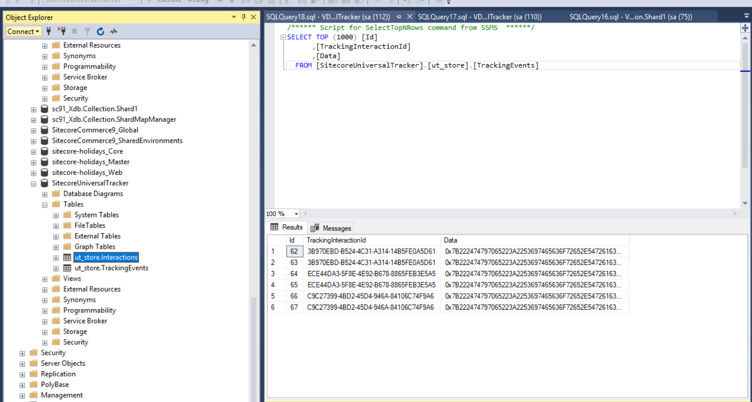
16. Also, you will be able to see data in Experience profile and experience analytics