**Content Report Module**

|  |  |  |
| --- | --- | --- |
| |  | | --- | |  | |  |

Content Report Module is built to help Content Authors and Marketers to generate the report on number of pages created, updated and archived in Sitecore for specific date range.

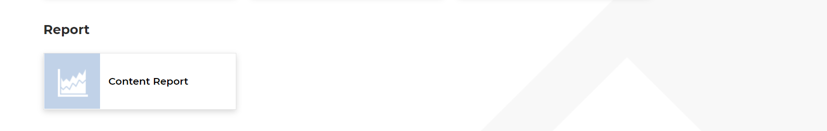

The module will provide following stats for the specific date range.

* Pages updated during this time period
* Pages created during this time period.
* Pages archived during this time period.

**Rule for adding the pages in Report**

The numbers of page creation and updates is counted only when a new page or a change to a page is approved/published to the live site. For example, when multiple versions of a page are edited during the drafting process and only one version is approved/published, it is counting as one update. Similarly, when a page is created and multiple versions (including components) are then created/edited, it is not counted as a page creation until it is approved/published.

**Input Fields**

* Start Date – Mandatory
* End Date - Mandatory

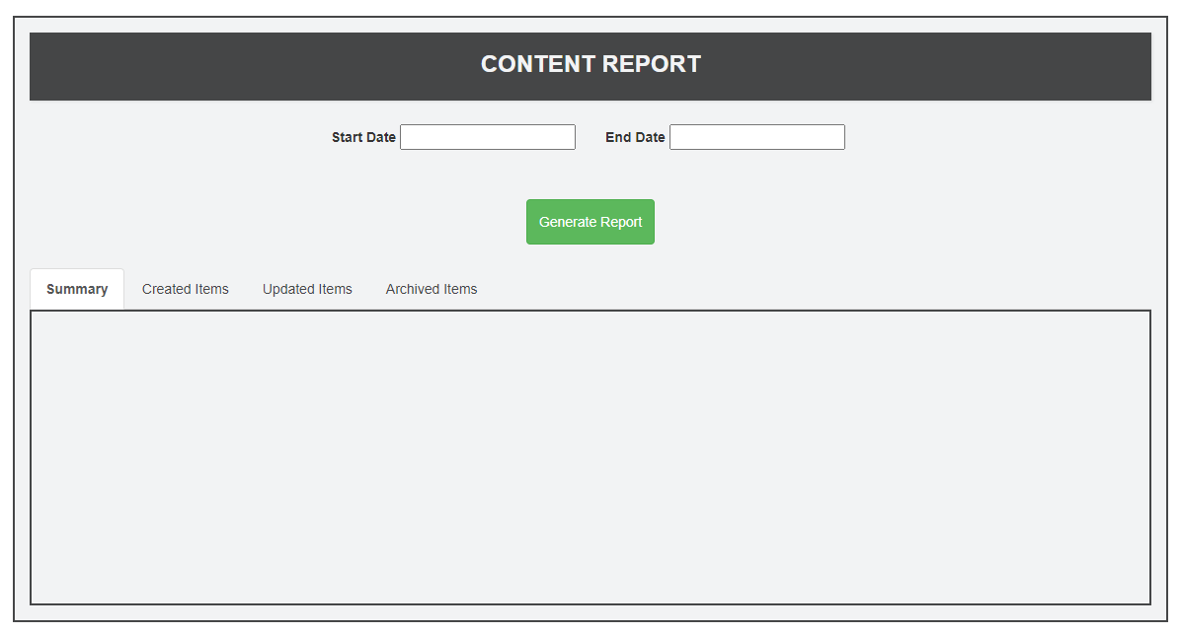

**Response**

On clicking on Generate Report the Summary tab will be loaded with details

**Summary Tab**

* Shows the total number of pages created, updated and archived.

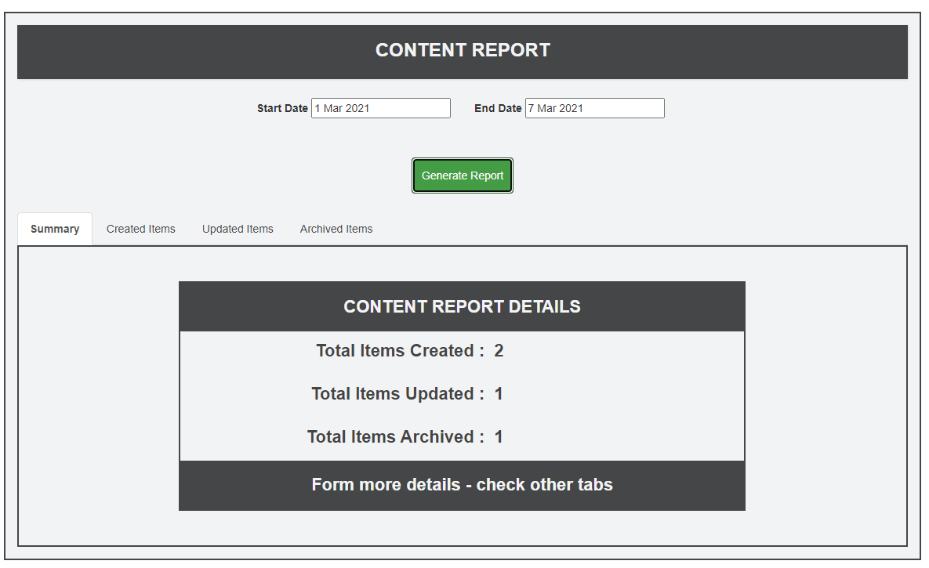

**Created Items Tab**

* Shows detailed information about created items such as item id, item name, item path, item updated by, item version, item language in a grid.
* This grid allows Pagination.
* The data in the grid can be sorted.
* Clicking on “Download Created Items Report” button will download the created items list in csv.

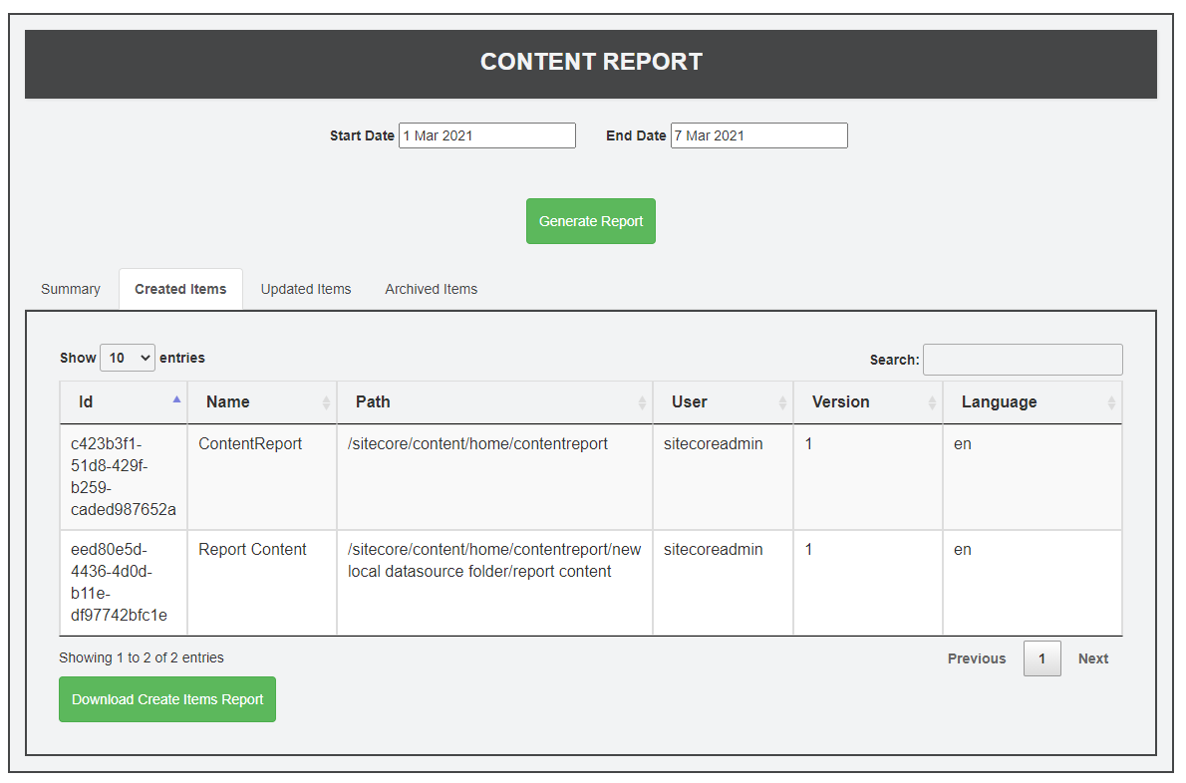

**Updated Items Tab**

* Shows detail information about updated items such as item id, item name, item path, item updated by, item version, item language in a grid.
* This grid allows Pagination.
* The data in the grid can be sorted.
* Clicking on “Download Updated Items Report” button will download the updated items list in csv.

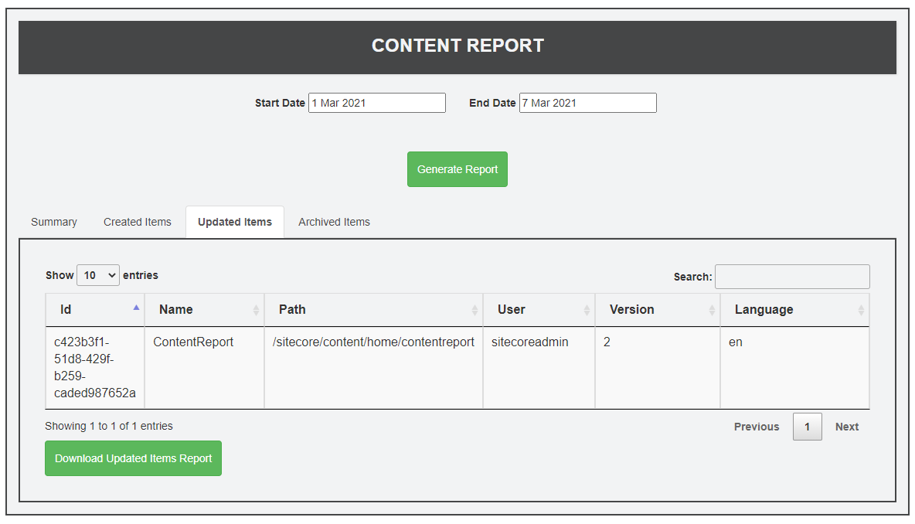

**Archived Items Tab**

* Shows detail information about archived items such as item id, item name, item updated by, item updated date, full path in a grid.
* This grid allows Pagination.
* The data in the grid can be sorted.
* Clicking on “Download Archived Items Report” button will download the archived items list in csv.

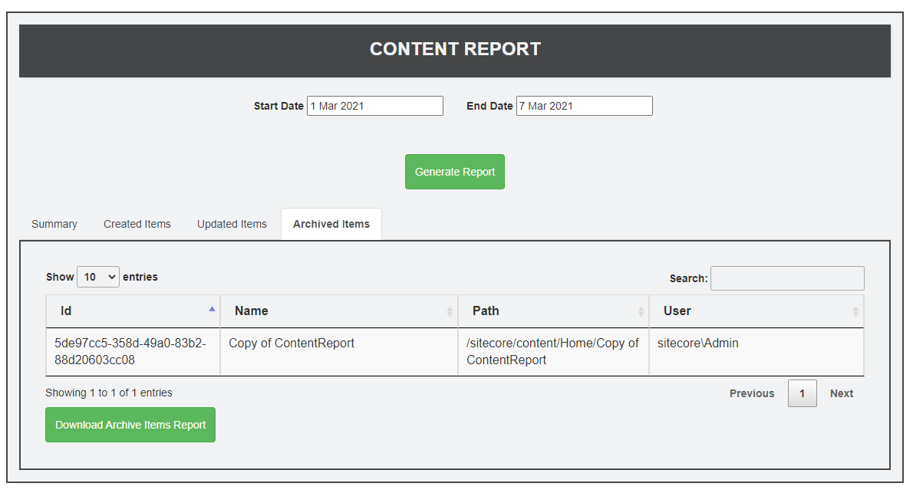

**Steps to generate content report**

* Login to the Sitecore and go to the Launchpad.
* In Section “Report”, click on Content Report.
* Select Start Date, End Date and click on “Generate Report” button.
* In Summary, it will show the total number of created, updated and archived pages/item.
* Other tabs will give more information about item name, path, version details etc.
* Tabs has buttons to download the specific report in csv format.
* We can also sort the results based on table columns.

Note: To test the archive, please go to Content Editor and select any page under Home example - /sitecore/content/Home/Sample Item 1, go to Review tab, Archive and Archive item now.

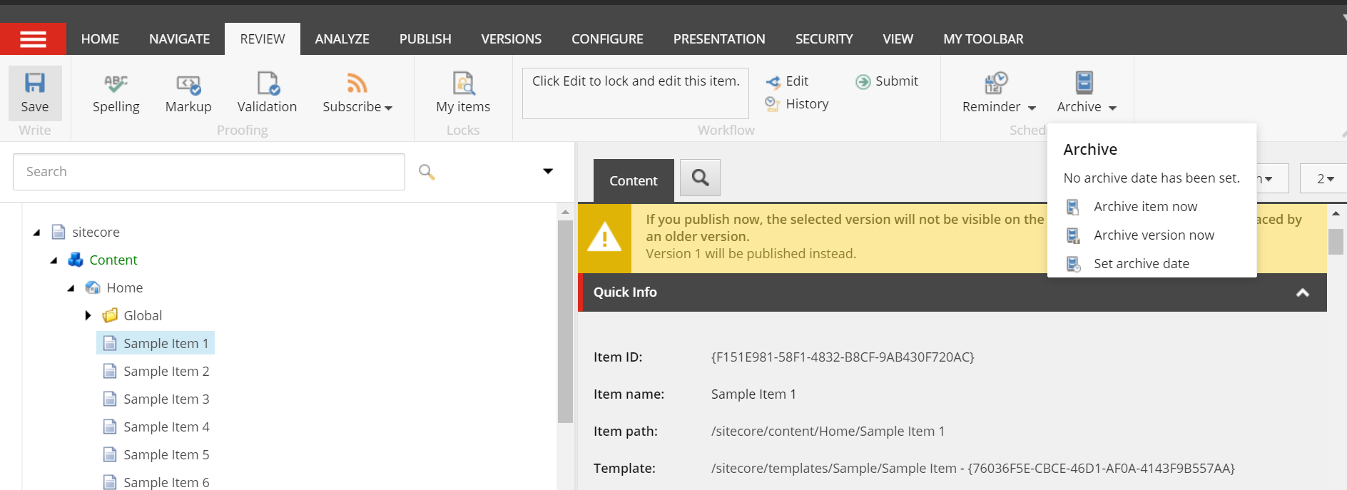

**Enhancements**

Future improvement could include

* Adding more fields and filters based on page templates etc.
* Getting labels content from Sitecore
* Moving the report page in launchpad as Speak component