**Content Editor Tools and Services**

## Summary

**Category:** Best use of SPE to help Content authors and Marketers

## Installation

* Go to Development Tools -> Installation Wizard.
* Upload the .zip package.
* Click on Install and wait for the installation process to finish.
* Make sure you restart the Sitecore client after installation is finished.

## Configuration

No additional configuration is needed for these tools and reports to work.

## Usage

After installing the package, go to Desktop mode and verify the reports were created under Reporting Tools -> PowerShell Reports -> Content Editor Tools and services

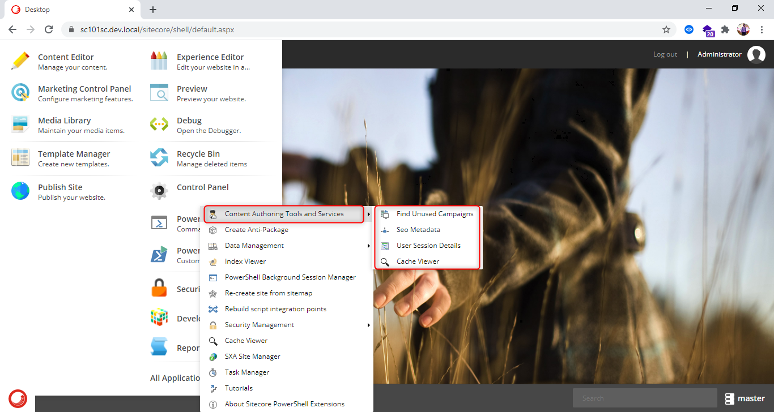

**SEO Metadata: -**

This module gives Content editors/marketers info metadata fields on the page. This module generates the list of pages which have Meta keywords or Meta Description empty

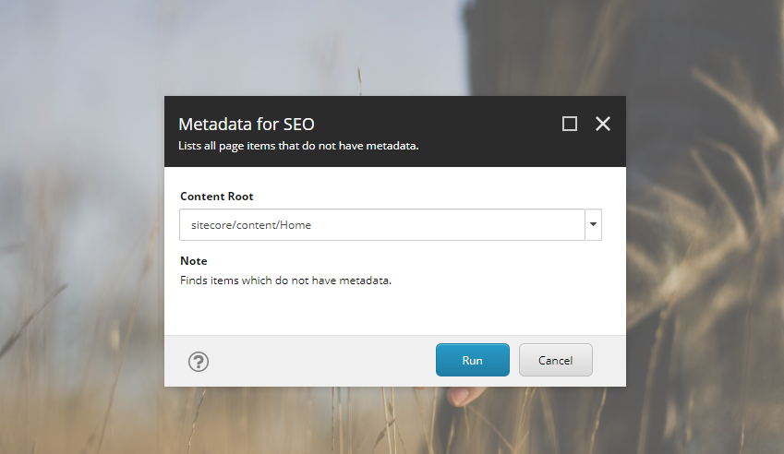

Step 1: content authors must select a node whose child items are to be verified.

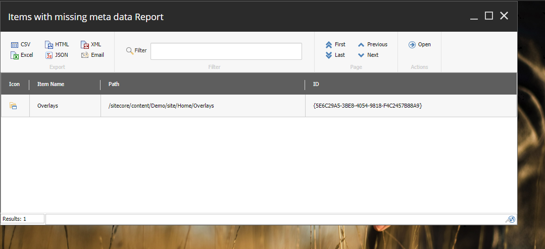

Step 2: Once clicked on run button, a report is generated with the list of items which have meta data fields empty

**Find Unused Campaigns: -**

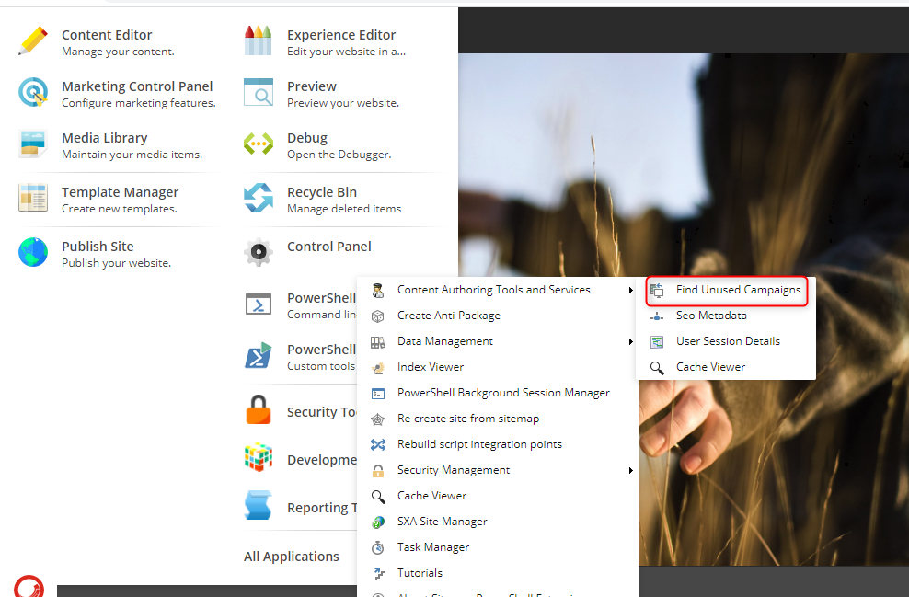

This module can be executed against each campaign to find out any unused Campaigns

Step 1: select the Campaign and root item path

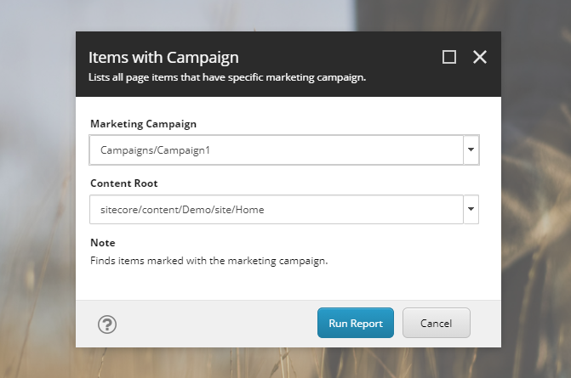

Step 2: click on run and then you should be able to see the list of items associated with that campaign.

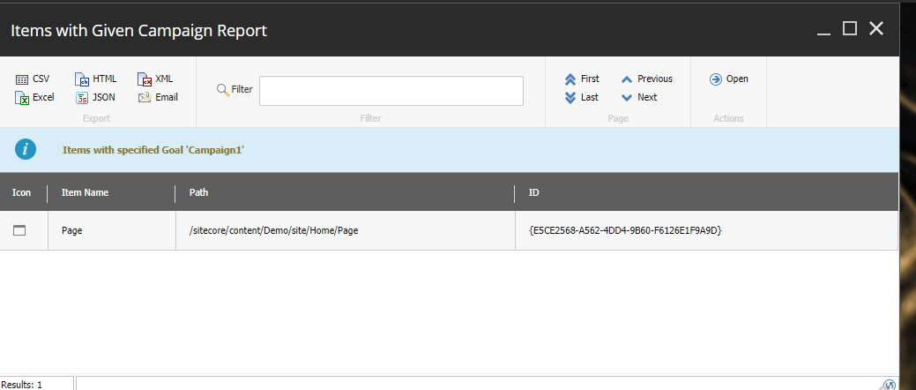

**User Session Details: -**

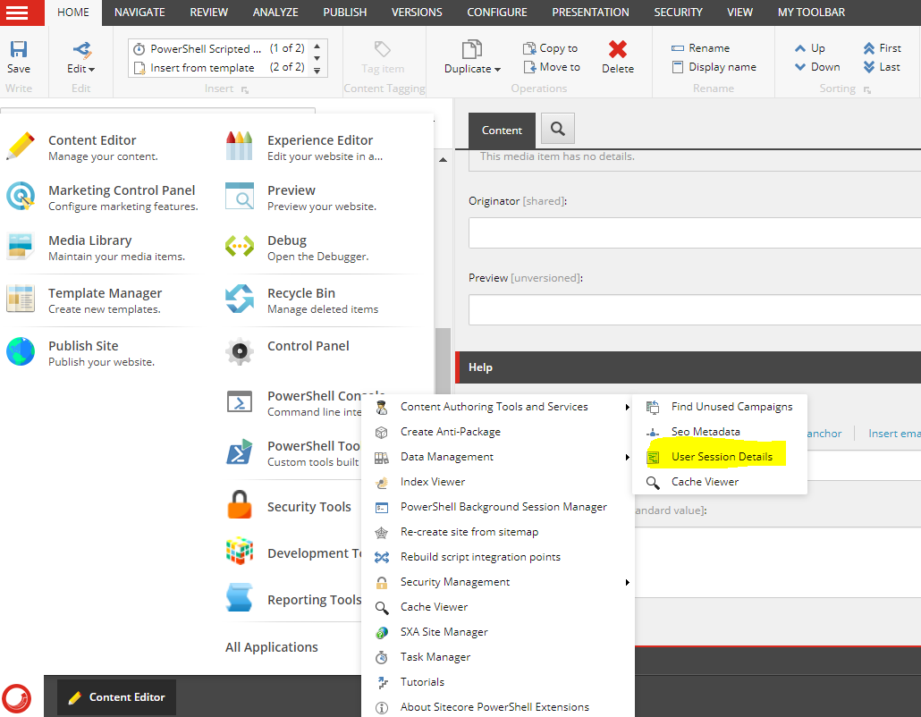

This module can be executed to find all user details who logged into CMS.

Step 1: select the date and time filter from when you want to run the report

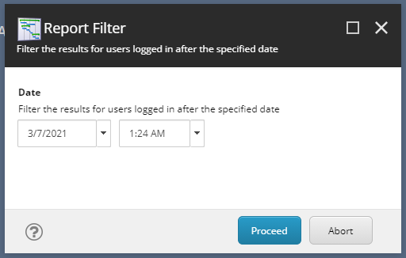

Step 2: click on run and then you should be able to see the list of users logged and there last activity time.

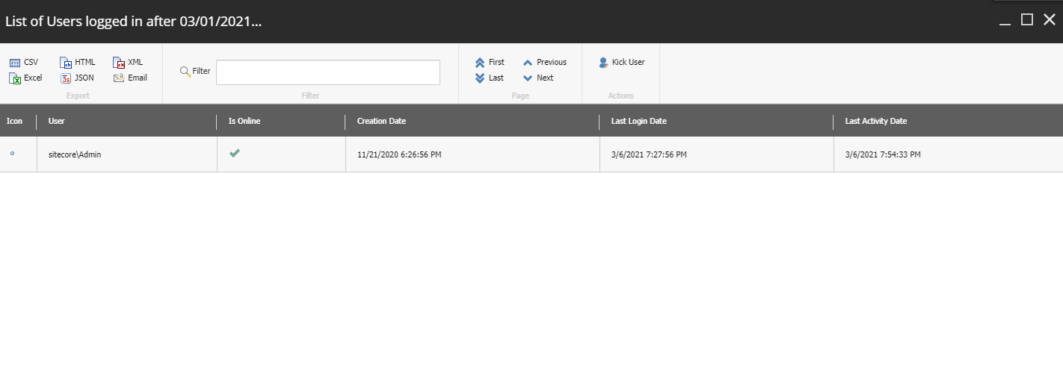

**Cache Viewer: -**

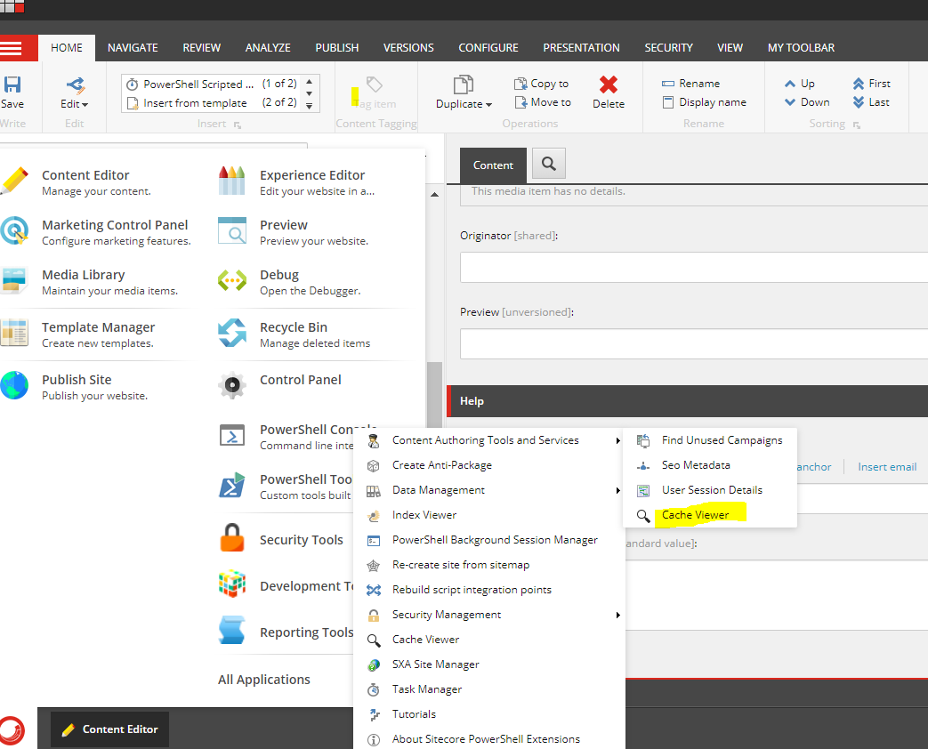

This module can be executed to find all cache details of the website within the CMS instead of going to aspx page.

Step 1: click on run and then you should be able to see the list of all cache in the website

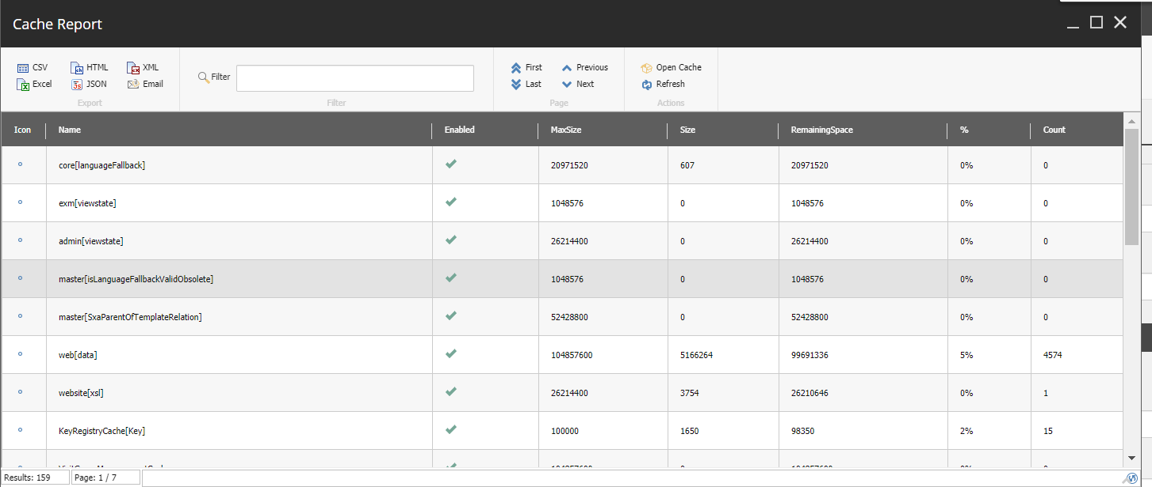

Selecting specific row and clicking open cache button on ribbon will open the specific cache where user can delete the cache and see details.