**BYOD Appliaction Configuration guide**

**Step 1: Azure Configuration**

* **Create an Azure Blob Storage**

To use this app User should requires the Azure Blob Storage

Follow the below link to create the Azure blob storage.

<https://docs.microsoft.com/en-us/azure/storage/blobs/storage-quickstart-blobs-portal>

* **Create Trainer Container (to store the images from Sitecore)**

After creation of Azure blob storage, as the next step the user must create the Container to store the images, the examples provided below as screenshots.

To create a Trainer container, open the storage account, click on the container under the Overview section.

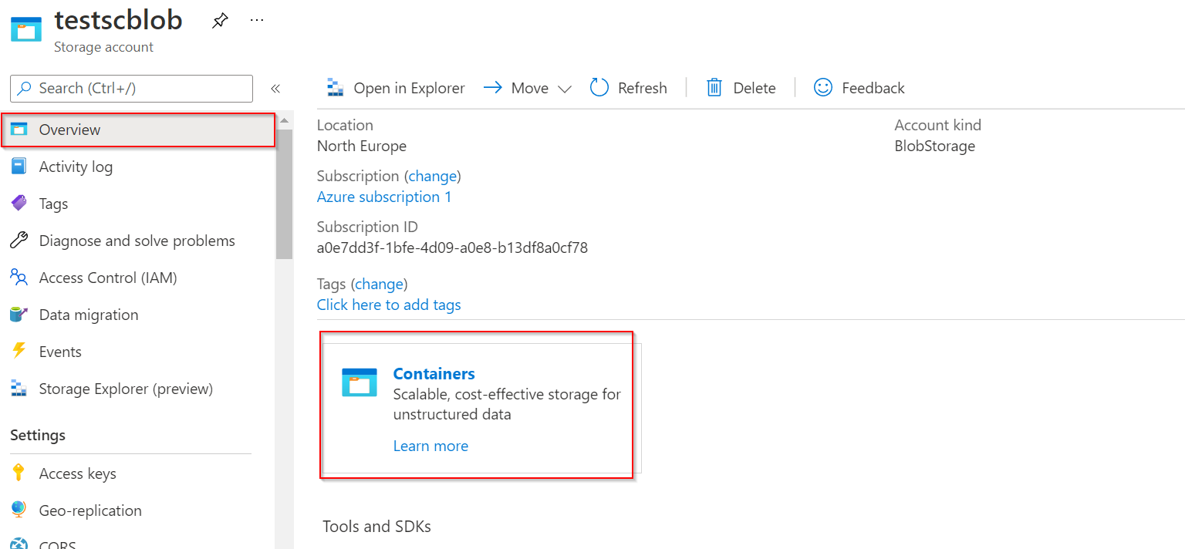

* **Create a Training Images and Training Output images container,**

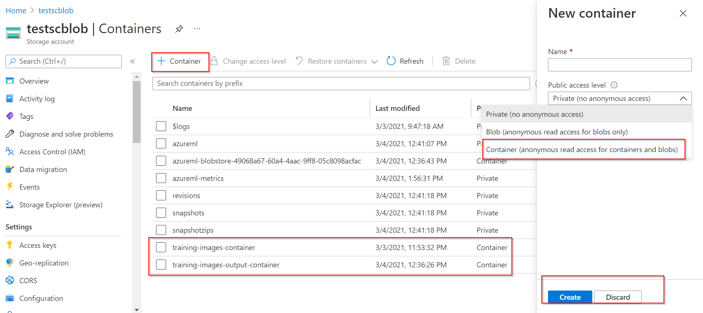

Once Container Is created and start to store the images, the container looks like below,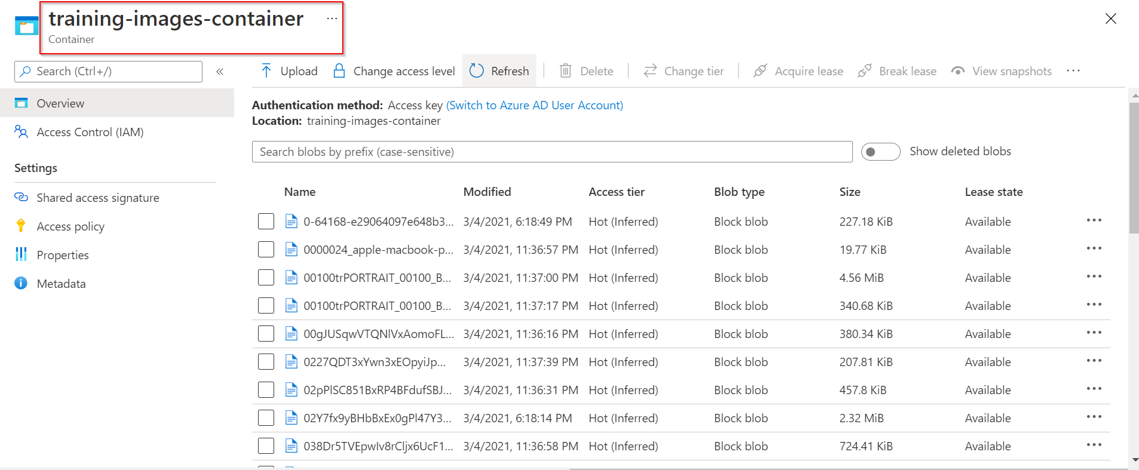

* **Generate and Copy SAS Token**

Once container created follow the below steps to generate the SAS token this token and connection strings will be used in the Sitecore to store the images in blob and train

The Fields must be checked and filled as shown below.

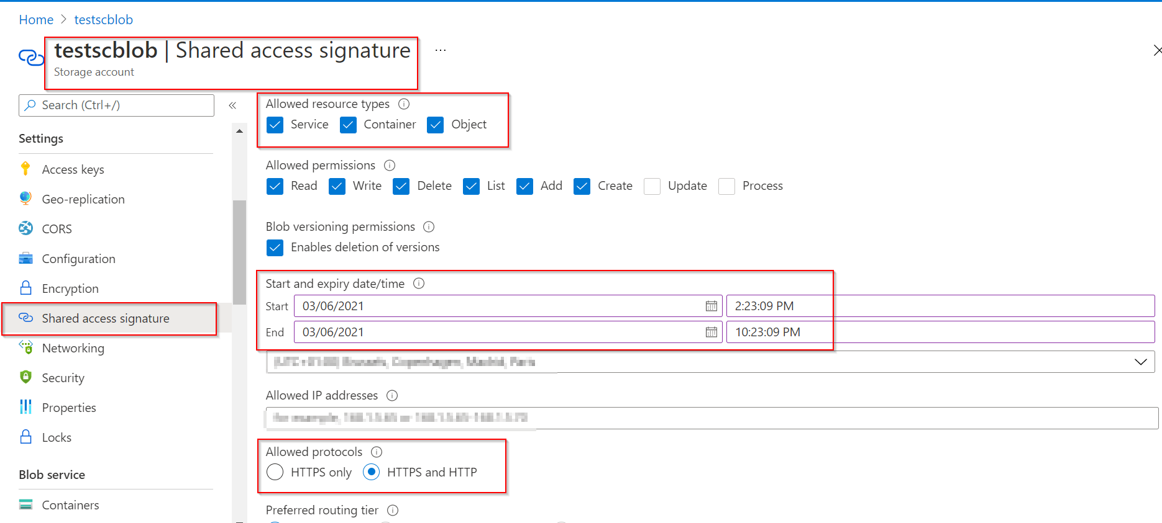

After setting up the values, click on the Generate SAS and Connection String button to generate the SAS token.

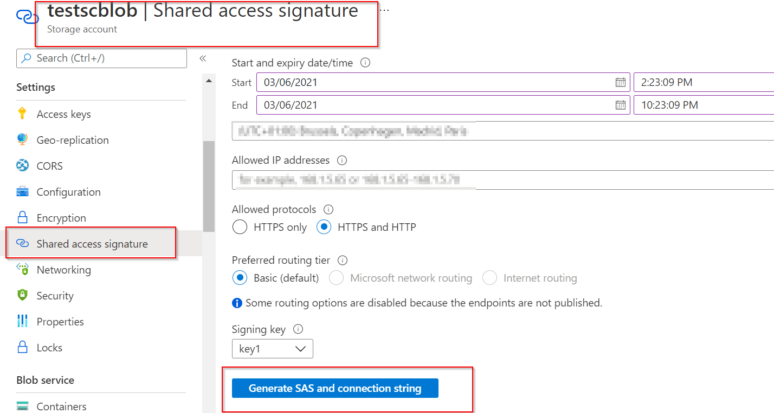

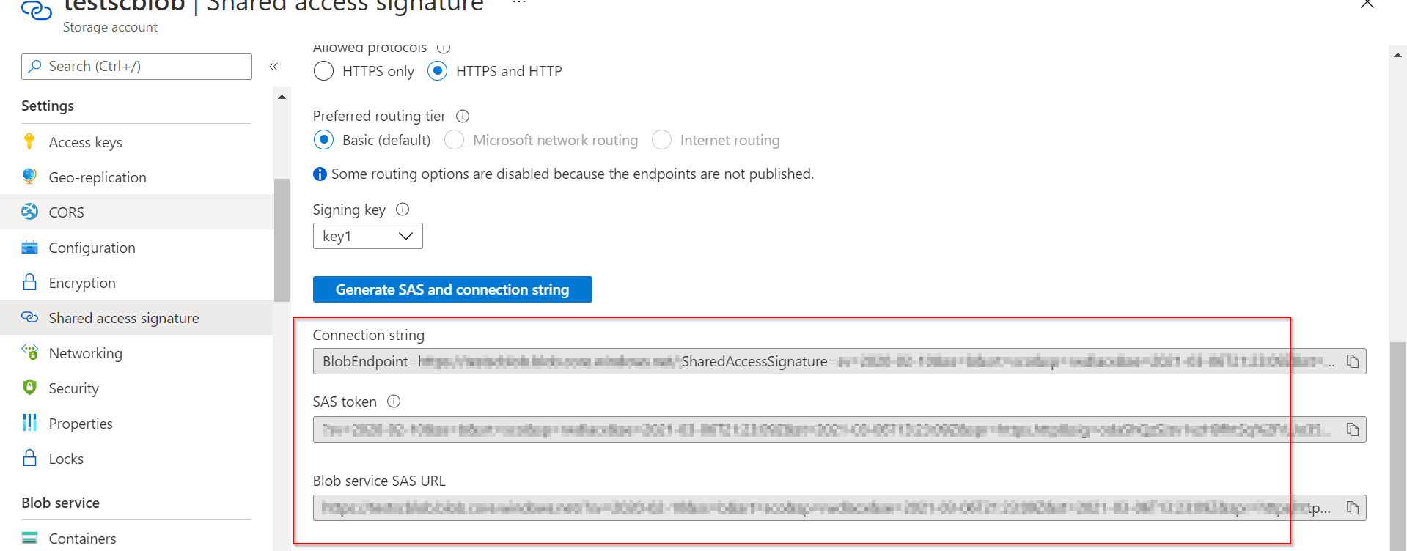

* **Copy the Connection String**

After the creation of container, we can copy the connection string from the Access Key as shown below, and this can be used in sitecore, which as explained in following steps.

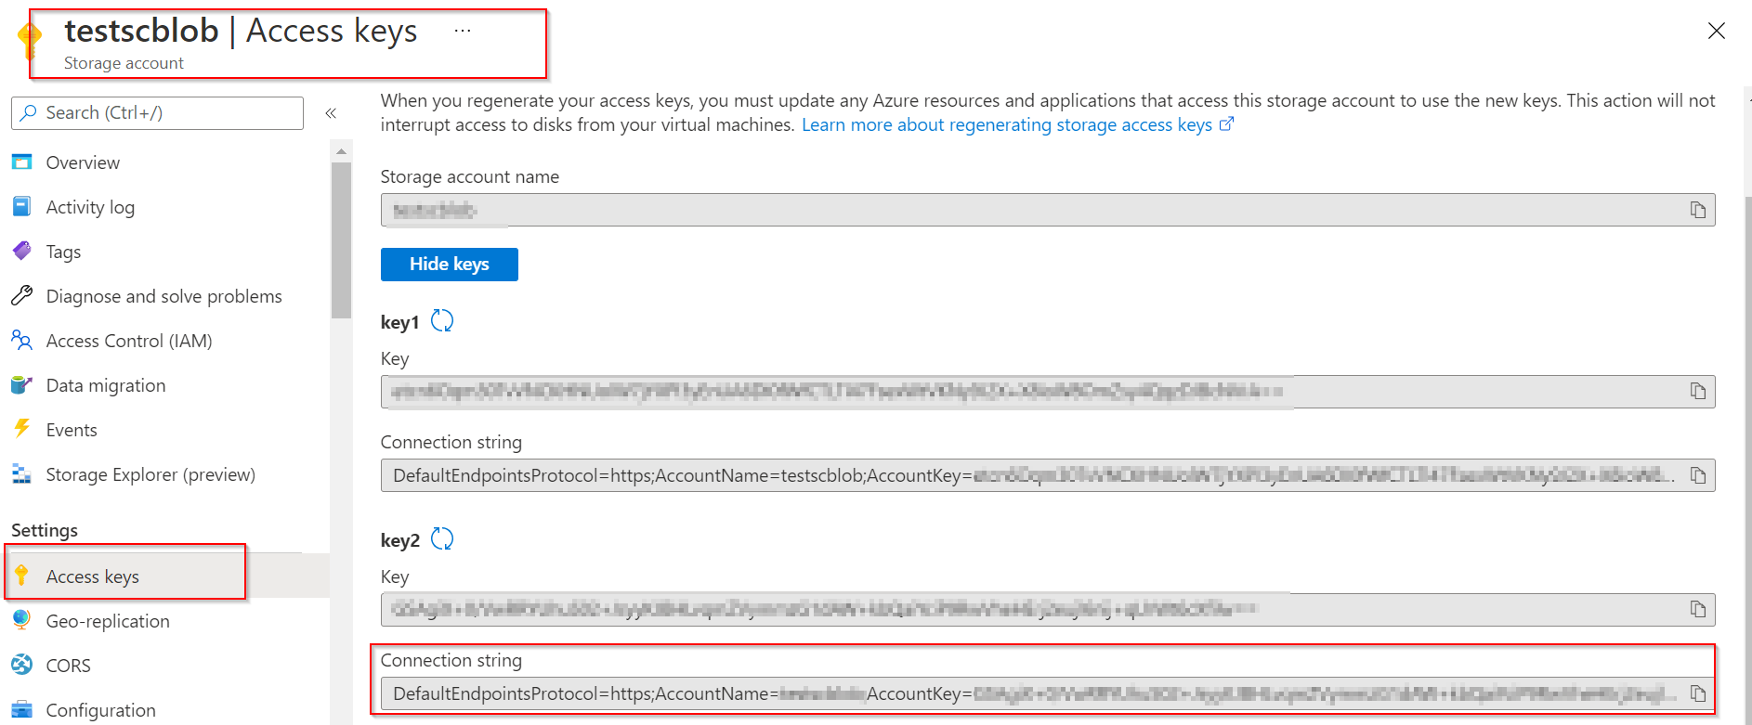

**Step 2: Custom Vision**

* **Create a Project with Object Detection / General Compact**

Use the following link with the valid credentials (This is same credential which we use for Portal Azure) to access the custom vision azure app <https://www.customvision.ai/>  
  
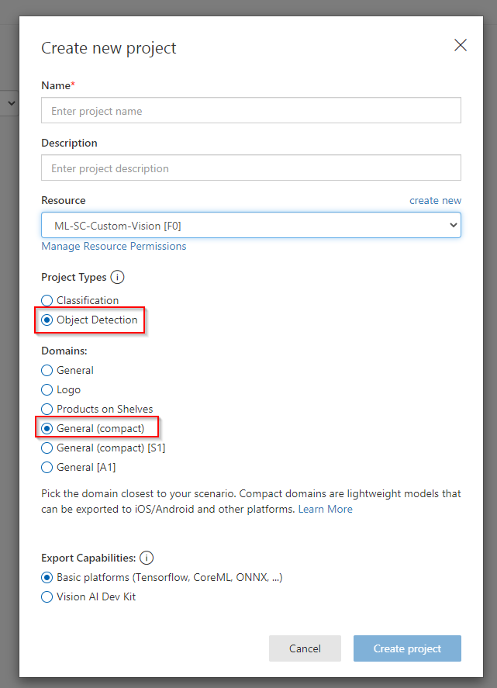

* Copy PredictionEndpoint , PredictionKey, TrainingEndpoint , TrainingKey, PredictionResourceId & ProjectId which should be applied in appsettings.json/appsettings.development.json in Rendering Host Project  
    
  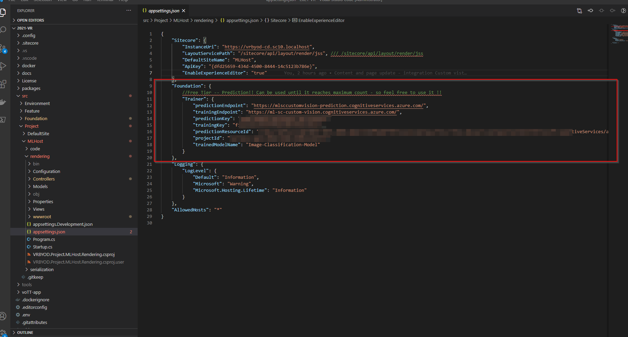

Click on the Settings icon to redirect to the Prediction resource page.

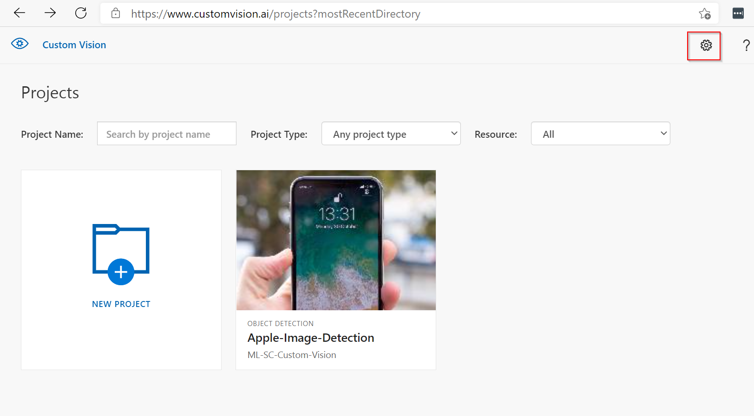

Click on the highlighted fields as shown in the below picture to copy the Prediction source data.

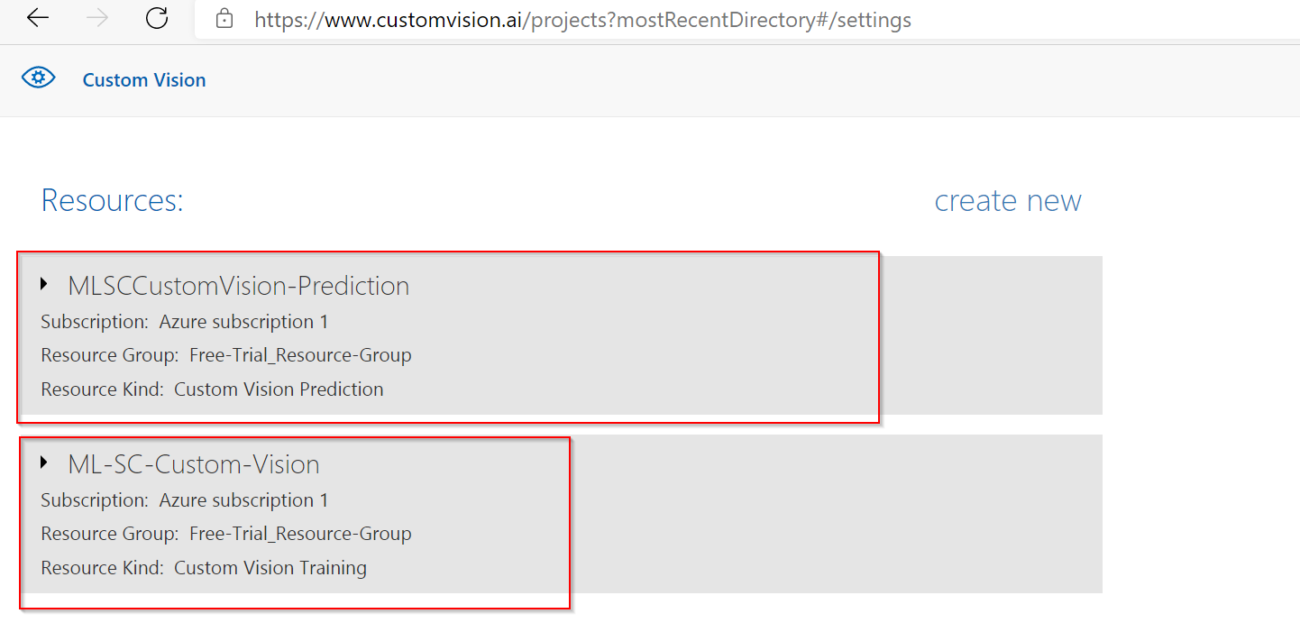

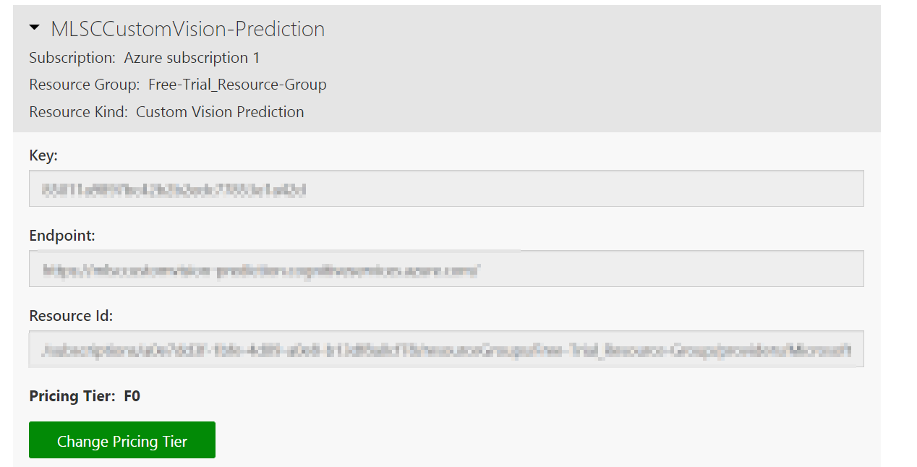

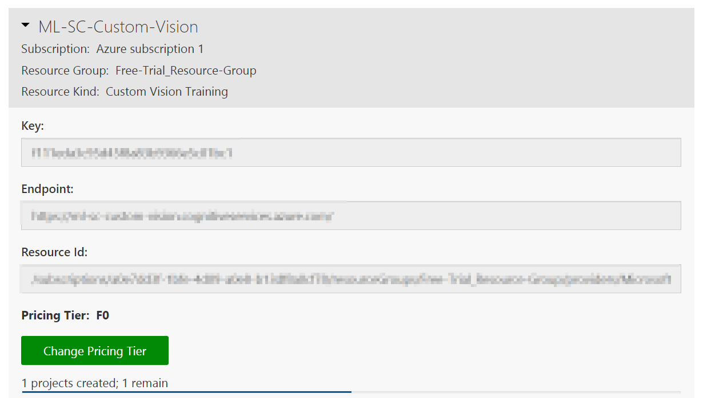

**Step 3: Docker Setup**

After all the steps completed on the Azure level, now its time to Install the Sitecore application,

* Clone APP : Use the below link to Clone the repository from the Git,

<https://github.com/Sitecore-Hackathon/2021-VR>

* Init

The repository contains an initialization script to setup the Sitecore platform on your machine.

.\init.ps1 -LicenseXmlPath "<<License Path>>"

* Start

The repository contains another powershell script to get the Docker containers, that are needed to run the Sitecore platform, build and running.

.\start.ps1

**Result**

If all went well, the services related to the project will start to run, following are the URL of the service...

* <https://vrbyod-id.sc10.localhost/>
* <https://vrbyod-cm.sc10.localhost/>
* <https://vrbyod-cd.sc10.localhost/>
* <https://mlhost-rh.sc10.localhost/>

The Final pages will be loaded in the Rendering host URL <https://mlhost-rh.sc10.localhost/>

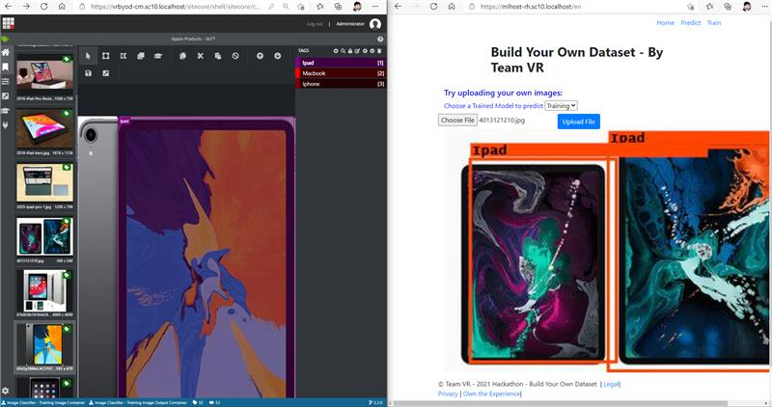

**Step 4: Adding Connection in the Sitecore**

Add the Azure training container details (Container Name) in the sitecore, as shown in the below images,



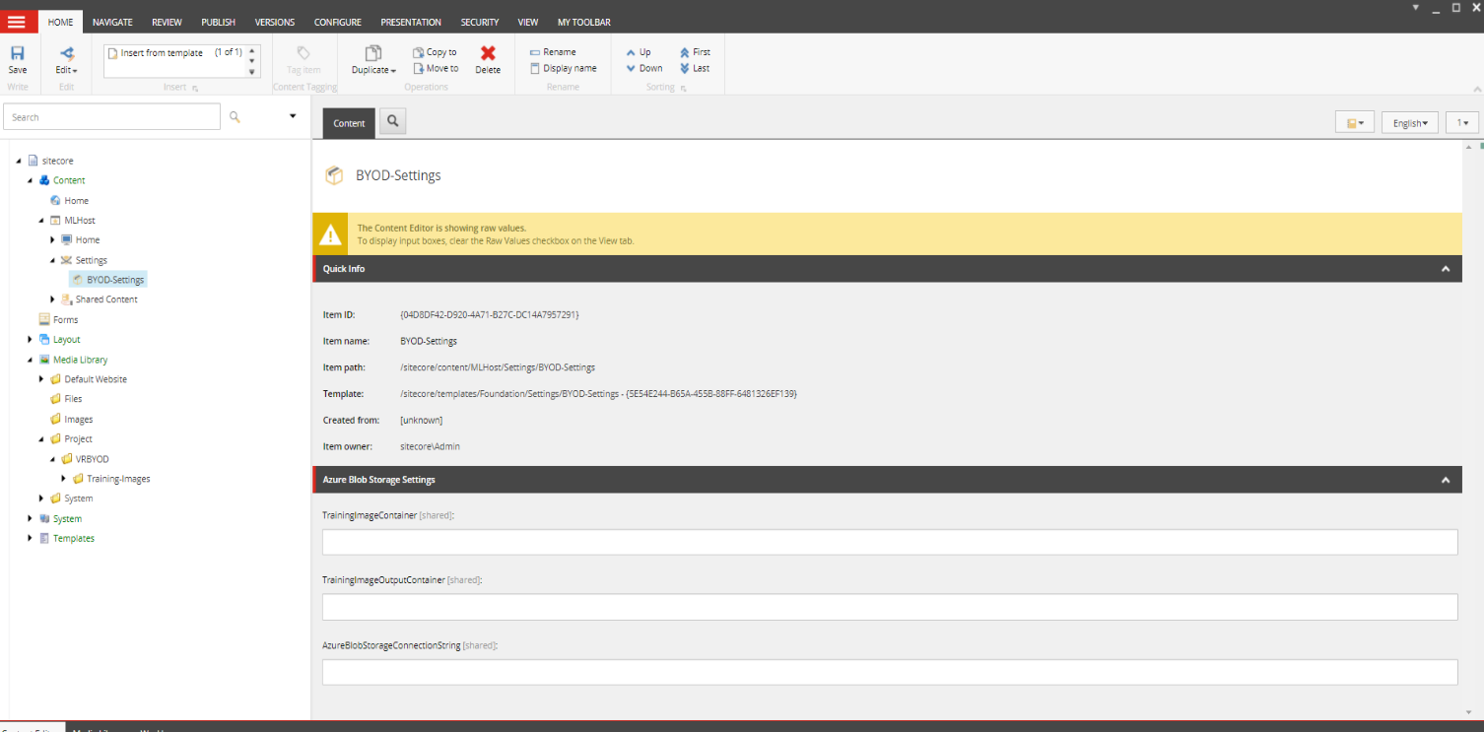

**Step 5: Vott App Sitecore Configuration – For Tagging Images**

Connection Configuration Should be done at Sitecore Level.

As we mentioned in the Azure configuration section the connections string and SAS key should be copied from there and it must use in sitecore

**Input Container**

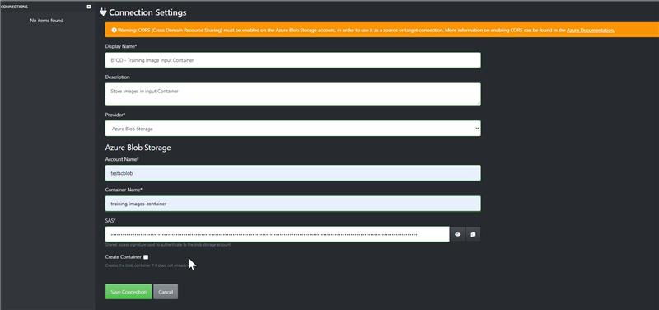

**Image output container**

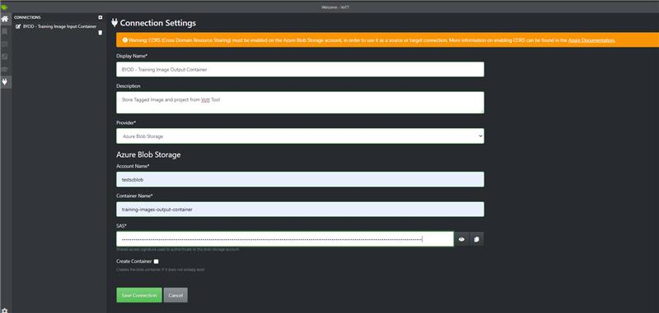

**Custom Vision API Export Settings**

