Sitecore Migration package – Traditional .NET-MVC to JSS

When we plan for migration, we need to consider below aspects,

* Sitecore side: This means all the Sitecore item, template, placeholder, data source.
* Code side: This is programming side .Net to JS(React/Angular/Vue)

# Sitecore side

In Sitecore side below things covered by the tool. Sitecore item, all renderings, layouts, template, placeholder, data source.

# Pre-requisite

* Sitecore XP/XM required
* You should have the MVC website. If you don’t have any, use below,
  + use my package.
  + Use the code.
* Install headless service in your XP/XM

# Video Tutorial

<https://youtu.be/lUHVD_B2S7E>

# Setup

* Install Sitecore package. Available here:
* Open the URL. https://{Your-domain}/MVCToJSS/DashBoard.

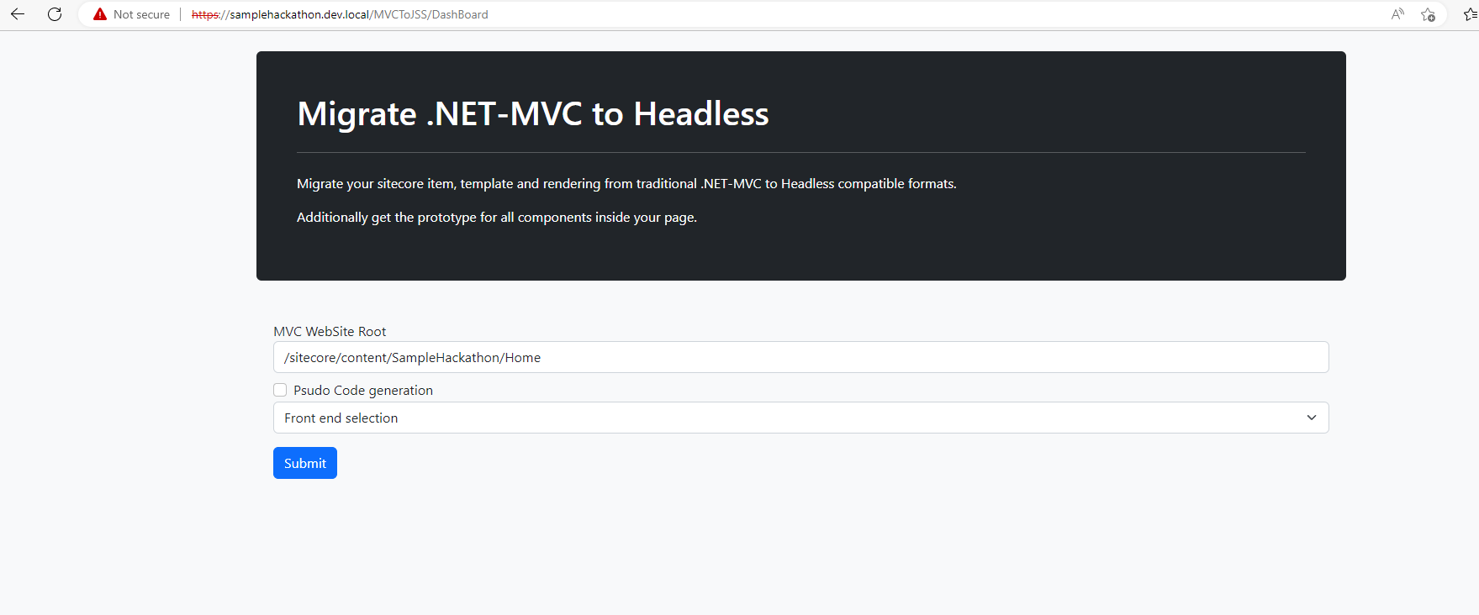

* Enter the MVC website Root item home page you want to migrate.

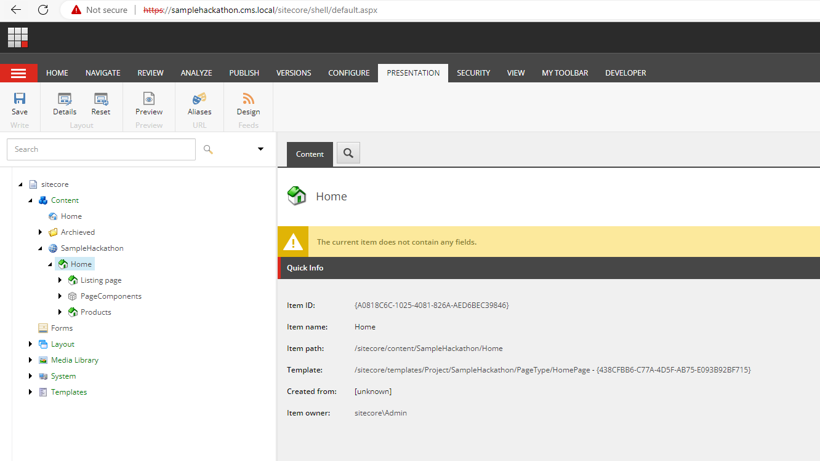

* Before update.
  + Layouts are MVC layout.
  + All renderings are MVC View rendering/ Controller renderings.
  + Page items not referred the JSS route items

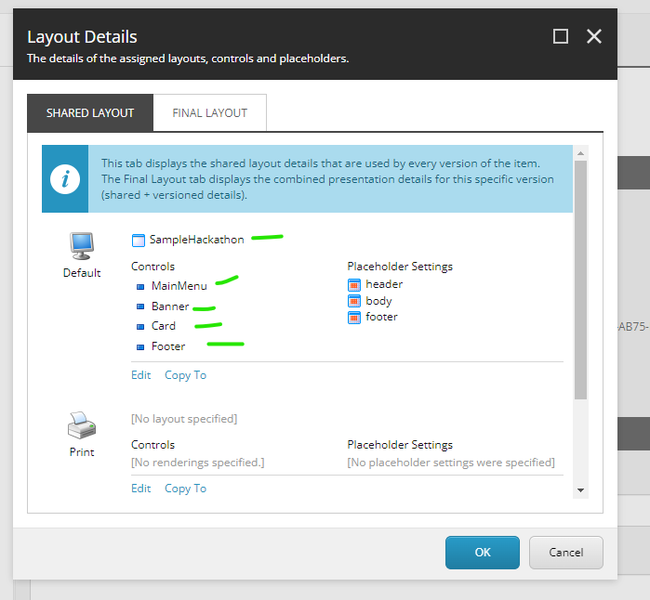

* Post update
  + New JSS layout will create and point
  + Both shared and final layout will get updated with the new JSON rendering
  + Pages will inherit JSS base route templates
  + All the actions are one time execution, If rendering created it will re use the same.

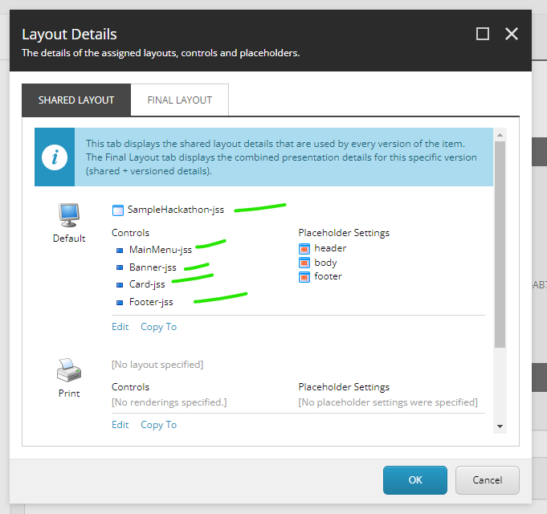

If you create sample jss get started template and point your MVC layout service. It can expose layout service as showed below.

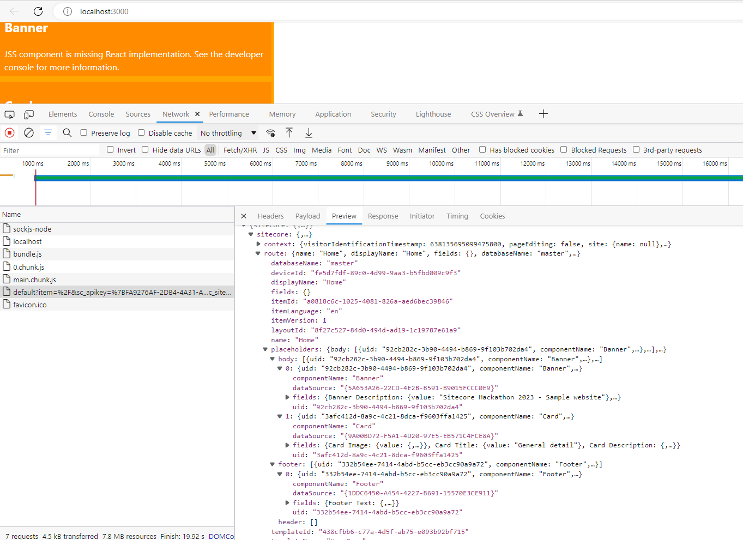

# Tool UI and how to use.