Lab 2 Bài 1.2
Tạo project mới
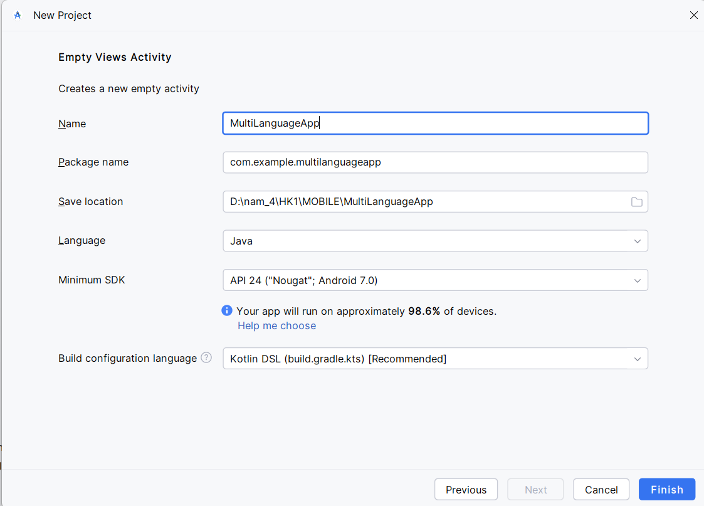
Tạo layout màn hình login
app/src/main/res/layout/activity_main.xml
<?xml version="1.0" encoding="utf-8"?>
<androidx.constraintlayout.widget.ConstraintLayout xmlns:android="http://schemas.android.com/apk/res/android"
xmlns:app="http://schemas.android.com/apk/res-auto"
android:layout_width="match_parent"
android:layout_height="match_parent"
android:background="#1A237E">
<TextView
android:id="@+id/tvTitle"
android:layout_width="wrap_content"
android:layout_height="wrap_content"
android:text="@string/title"
android:textSize="32sp"
android:textStyle="bold"
android:textColor="@android:color/white"
app:layout_constraintTop_toTopOf="parent"
app:layout_constraintStart_toStartOf="parent"
app:layout_constraintEnd_toEndOf="parent"
android:layout_marginTop="80dp" />
<EditText
android:id="@+id/etEmail"
android:layout_width="0dp"
android:layout_height="wrap_content"
android:hint="@string/email_hint"
android:inputType="textEmailAddress"
android:textColor="@android:color/white"
android:textColorHint="@android:color/darker_gray"
android:background="@android:color/transparent"
android:padding="10dp"
app:layout_constraintTop_toBottomOf="@id/tvTitle"
android:layout_marginTop="40dp"
android:layout_marginHorizontal="32dp"
app:layout_constraintStart_toStartOf="parent"
app:layout_constraintEnd_toEndOf="parent" />

<View
android:layout_width="0dp"
android:layout_height="1dp"
android:background="@android:color/white"
app:layout_constraintTop_toBottomOf="@id/etEmail"
app:layout_constraintStart_toStartOf="@id/etEmail"
app:layout_constraintEnd_toEndOf="@id/etEmail" />
<EditText
android:id="@+id/etPassword"
android:layout_width="0dp"
android:layout_height="wrap_content"
android:hint="@string/password_hint"
android:inputType="textPassword"
android:textColor="@android:color/white"
android:textColorHint="@android:color/darker_gray"
android:background="@android:color/transparent"
android:padding="10dp"
android:layout_marginTop="24dp"
android:layout_marginHorizontal="32dp"
app:layout_constraintTop_toBottomOf="@id/etEmail"
app:layout_constraintStart_toStartOf="parent"
app:layout_constraintEnd_toEndOf="parent" />

<View
android:layout_width="0dp"
android:layout_height="1dp"
android:background="@android:color/white"
app:layout_constraintTop_toBottomOf="@id/etPassword"
app:layout_constraintStart_toStartOf="@id/etPassword"
app:layout_constraintEnd_toEndOf="@id/etPassword" />

<!-- Nút đăng nhập -->
<Button
android:id="@+id/btnLogin"
android:layout_width="0dp"
android:layout_height="wrap_content"
android:text="@string/btn_login"
app:layout_constraintTop_toBottomOf="@id/etPassword"
android:layout_marginTop="32dp"
android:layout_marginHorizontal="32dp"
app:layout_constraintStart_toStartOf="parent"
app:layout_constraintEnd_toEndOf="parent" />

<!-- Text "Chưa có tài khoản?" -->
<TextView
android:id="@+id/tvFooter"
android:layout_width="wrap_content"
android:layout_height="wrap_content"
android:text="@string/footer"
android:textColor="@android:color/white"
android:layout_marginTop="24dp"
app:layout_constraintTop_toBottomOf="@id/btnLogin"
app:layout_constraintStart_toStartOf="parent"
<LinearLayout
android:id="@+id/llLanguage"
android:layout_width="wrap_content"
android:layout_height="wrap_content"
android:orientation="horizontal"
android:layout_marginBottom="32dp"
app:layout_constraintBottom_toBottomOf="parent"
app:layout_constraintStart_toStartOf="parent"
app:layout_constraintEnd_toEndOf="parent">

<TextView
android:id="@+id/tvVi"
android:layout_width="wrap_content"
android:layout_height="wrap_content"
android:text="Tiếng Việt"
android:textColor="@android:color/white"
android:padding="8dp" />

<TextView
android:id="@+id/tvEn"
android:layout_width="wrap_content"
android:layout_height="wrap_content"
android:text="English"
android:textColor="@android:color/white"
android:padding="8dp" />

<TextView
android:id="@+id/tvFr"
android:layout_width="wrap_content"
android:layout_height="wrap_content"
android:text="Français"
android:textColor="@android:color/white"
android:padding="8dp" />
</LinearLayout>

</androidx.constraintlayout.widget.ConstraintLayout>

Tạo file strings.xml cho 3 ngôn ngữ
Tiếng Anh
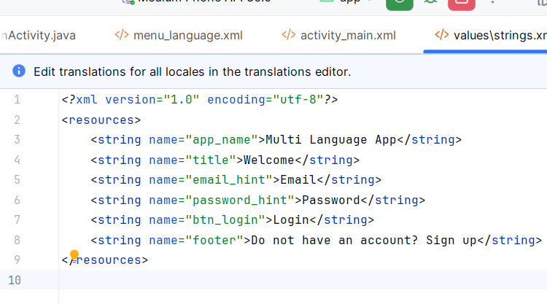
Tiếng Việt
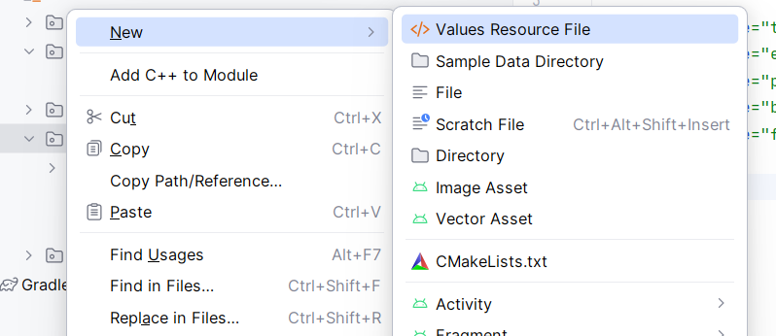
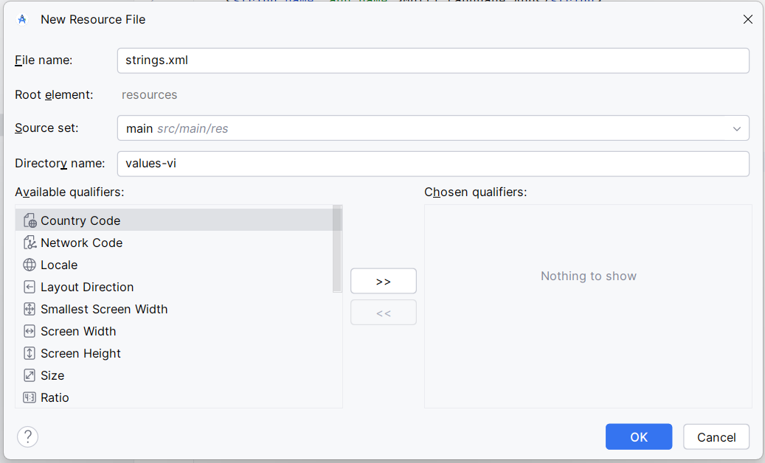
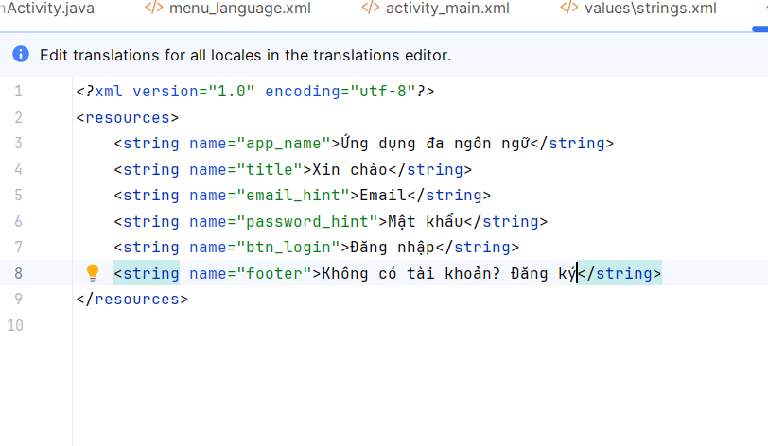
Tiếng Pháp
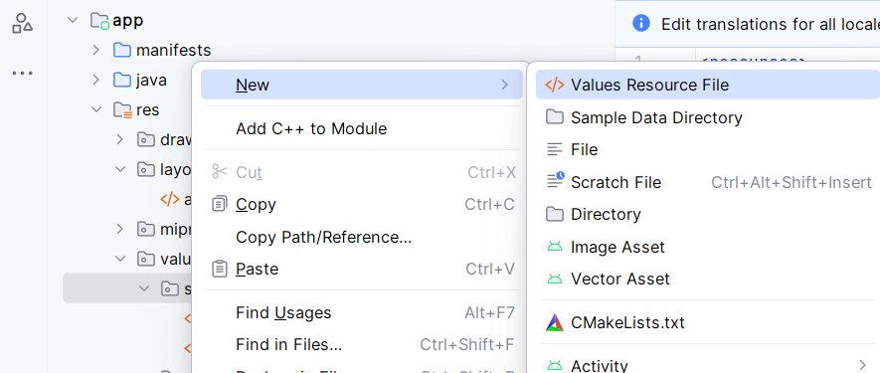
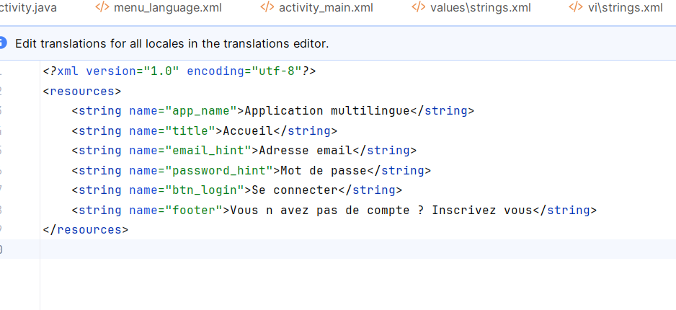
LocalHelper (Lớp hỗ trợ đổi ngôn ngữ)
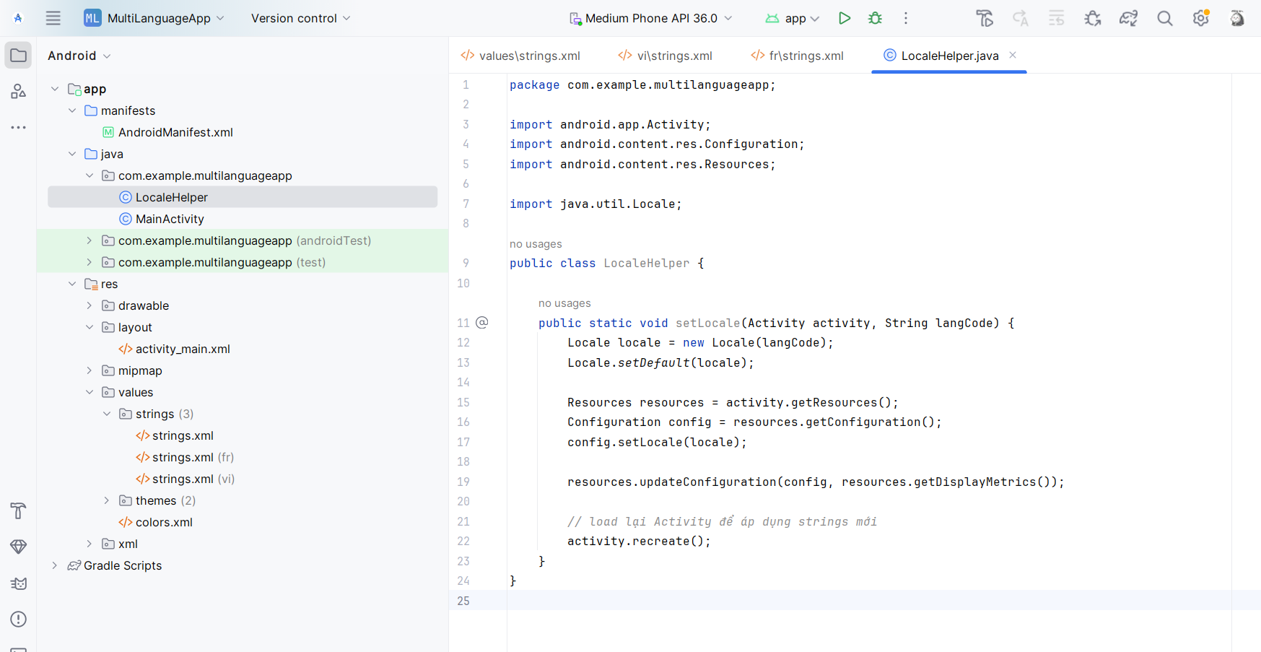
Sửa lại MainActivity.java
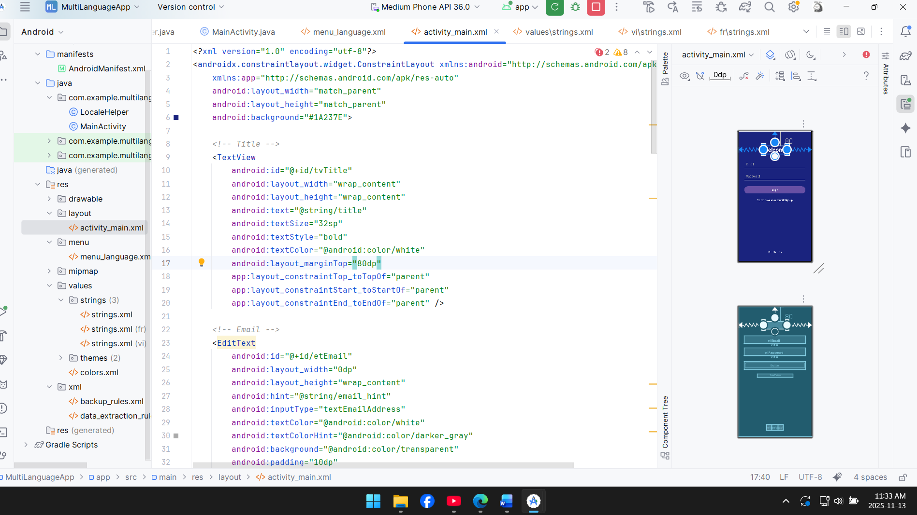
Tạo file Option Menu chọn ngôn ngữ
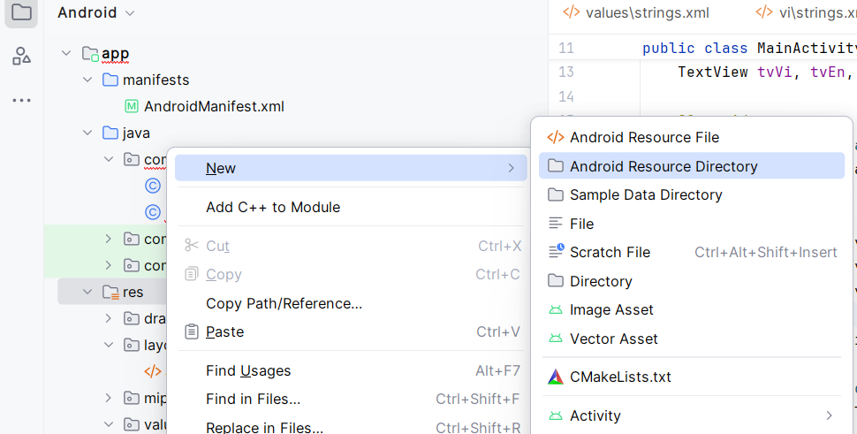
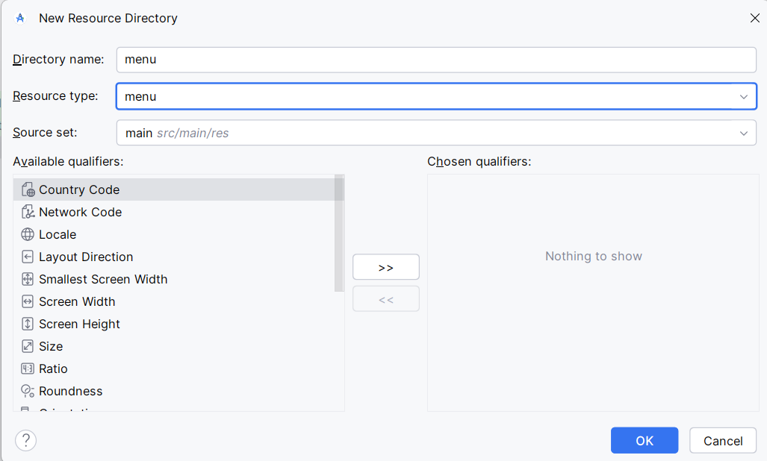
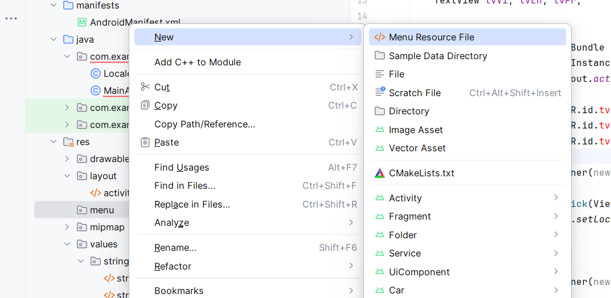
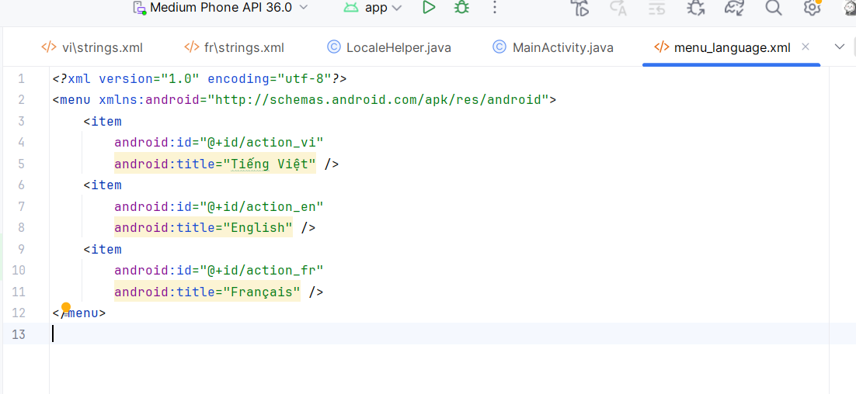
Kết quả

