LAB2: Bài 1
BÀI TẬP 1
Chuẩn bị tài nguyên cho dự án
Tài nguyên hình ảnh
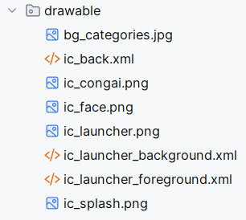
- Tài nguyên chuỗi
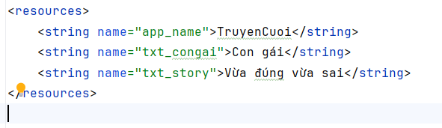
Tài nguyên màu sắc
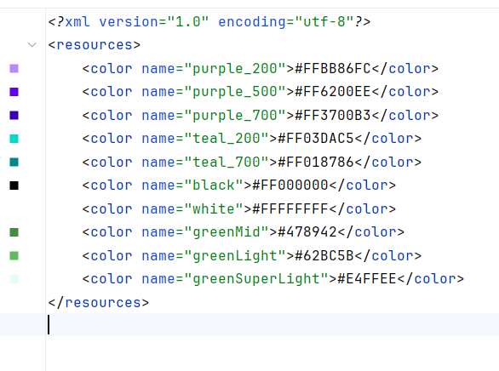
Tài nguyên về theme

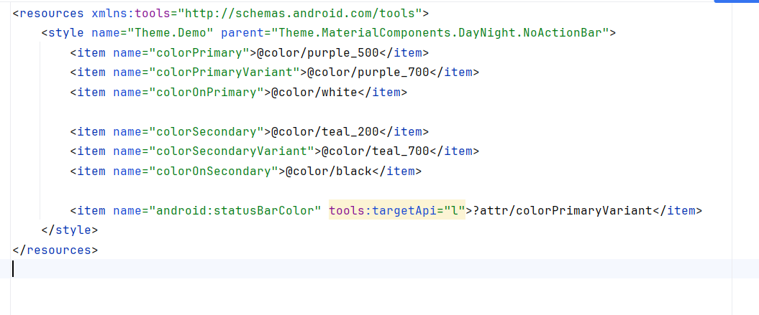
Khởi tạo các Entity danh mục truyện

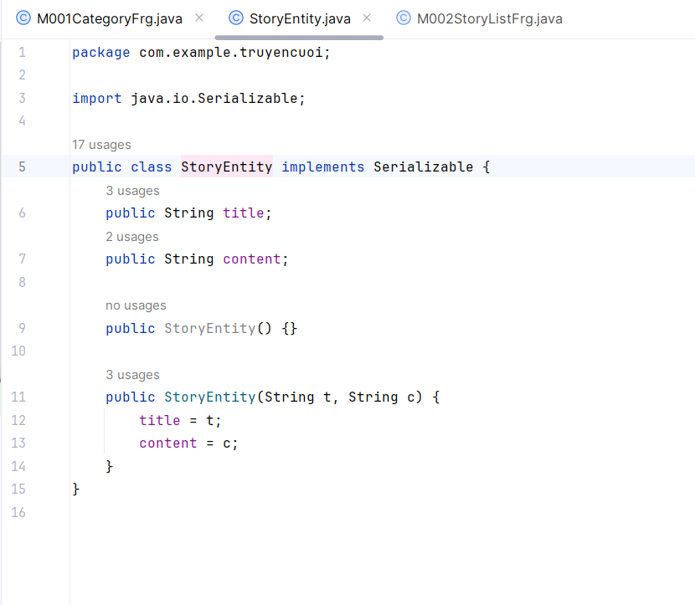
Code Java
MainActivity
package com.example.truyencuoi;
import android.content.pm.ActivityInfo;
import android.os.Bundle;
import androidx.appcompat.app.AppCompatActivity;
import androidx.fragment.app.Fragment;
import androidx.fragment.app.FragmentTransaction;
import java.util.ArrayList;
public class MainActivity extends AppCompatActivity {
private boolean allowRotate = false;
private String topicName;
@Override
protected void onCreate(Bundle savedInstanceState) {
super.onCreate(savedInstanceState);
setContentView(R.layout.activity_main);
showFrg(new M000SplashFrg(), false);
}
private void showFrg(Fragment frg, boolean addToBackStack) {
FragmentTransaction ft = getSupportFragmentManager()
.beginTransaction()
.replace(R.id.ln_main, frg, frg.getClass().getSimpleName());
if (addToBackStack) ft.addToBackStack(null);
ft.commit();
}
public void gotoM001Screen() {
showFrg(new M001CategoryFrg(), false);
}
public void gotoM002Screen(String topicName) {
this.topicName = topicName;
showFrg(M002StoryListFrg.newInstance(topicName), true);
}
public void gotoM003Screen(ArrayList<StoryEntity> listStory, StoryEntity story) {
showFrg(M003StoryDetailFrg.newInstance(listStory, story), true);
}
public void backToM002Screen() {
getSupportFragmentManager().popBackStack();
}
public void backToM001Screen() {
getSupportFragmentManager().popBackStack();
}
public void setAllowRotate(boolean allow) {
allowRotate = allow;
if (allowRotate) {
setRequestedOrientation(ActivityInfo.SCREEN_ORIENTATION_UNSPECIFIED);
} else {
setRequestedOrientation(ActivityInfo.SCREEN_ORIENTATION_PORTRAIT);
}
}
public boolean getAllowRotate() {
return allowRotate;
}
}

M000SplashFrg.java
package com.example.truyencuoi;
import android.content.pm.ActivityInfo;
import android.os.Bundle;
import androidx.appcompat.app.AppCompatActivity;
import androidx.fragment.app.Fragment;
import androidx.fragment.app.FragmentTransaction;
import java.util.ArrayList;
public class MainActivity extends AppCompatActivity {
private boolean allowRotate = false;
private String topicName;
@Override
protected void onCreate(Bundle savedInstanceState) {
super.onCreate(savedInstanceState);
setContentView(R.layout.activity_main);
showFrg(new M000SplashFrg(), false);
}
private void showFrg(Fragment frg, boolean addToBackStack) {
FragmentTransaction ft = getSupportFragmentManager()
.beginTransaction()
.replace(R.id.ln_main, frg, frg.getClass().getSimpleName());
if (addToBackStack) ft.addToBackStack(null);
ft.commit();
}
public void gotoM001Screen() {
showFrg(new M001CategoryFrg(), false);
}
public void gotoM002Screen(String topicName) {
this.topicName = topicName;
showFrg(M002StoryListFrg.newInstance(topicName), true);
}
public void gotoM003Screen(ArrayList<StoryEntity> listStory, StoryEntity story) {
showFrg(M003StoryDetailFrg.newInstance(listStory, story), true);
}
public void backToM002Screen() {
getSupportFragmentManager().popBackStack();
}
public void backToM001Screen() {
getSupportFragmentManager().popBackStack();
}
public void setAllowRotate(boolean allow) {
allowRotate = allow;
if (allowRotate) {
setRequestedOrientation(ActivityInfo.SCREEN_ORIENTATION_UNSPECIFIED);
} else {
setRequestedOrientation(ActivityInfo.SCREEN_ORIENTATION_PORTRAIT);
}
}
public boolean getAllowRotate() {
return allowRotate;
}
}

M001CategoryFg.java
package com.example.truyencuoi;
import android.os.Bundle;
import android.view.LayoutInflater;
import android.view.View;
import android.view.ViewGroup;
import android.widget.Switch;
import androidx.annotation.NonNull;
import androidx.annotation.Nullable;
import androidx.fragment.app.Fragment;
import androidx.recyclerview.widget.LinearLayoutManager;
import androidx.recyclerview.widget.RecyclerView;
import java.util.Arrays;
import java.util.List;
public class M001CategoryFrg extends Fragment implements CategoryAdapter.ICategory {
private RecyclerView rv;
private Switch swRotate;
@Nullable
@Override
public View onCreateView(@NonNull LayoutInflater inflater,
@Nullable ViewGroup container,
@Nullable Bundle savedInstanceState) {
View v = inflater.inflate(R.layout.m001_frg_category, container, false);
rv = v.findViewById(R.id.rv_categories);
swRotate = v.findViewById(R.id.sw_rotate);
if (getActivity() instanceof MainActivity) {
boolean allow = ((MainActivity) getActivity()).getAllowRotate();
swRotate.setChecked(allow);
swRotate.setOnCheckedChangeListener((btn, isChecked) ->
((MainActivity) getActivity()).setAllowRotate(isChecked)
);
}
initList();
return v;
}
private void initList() {
List<String> data = Arrays.asList(
"Con gái", "Công nghệ", "Việc học",
"Bạn bè", "Gia đình", "Tin nhắn",
"Vợ chồng", "Hài hước 18+"
);
rv.setLayoutManager(new LinearLayoutManager(getContext()));
rv.setAdapter(new CategoryAdapter(data, this));
}
@Override
public void onCategoryClick(String topicName) {
if (getActivity() instanceof MainActivity) {
((MainActivity) getActivity()).gotoM002Screen(topicName);
}
}
}
M002StoyListFrg.java
package com.example.truyencuoi;
import android.os.Bundle;
import android.view.LayoutInflater;
import android.view.View;
import android.view.ViewGroup;
import android.widget.ImageView;
import android.widget.Switch;
import android.widget.TextView;
import androidx.annotation.NonNull;
import androidx.annotation.Nullable;
import androidx.fragment.app.Fragment;
import androidx.recyclerview.widget.LinearLayoutManager;
import androidx.recyclerview.widget.RecyclerView;
import java.util.ArrayList;
public class M002StoryListFrg extends Fragment implements StoryAdapter.IStory {
private static final String KEY_TOPIC = "topicKey";
private TextView tvTitle;
private RecyclerView rv;
private ImageView btnBack;
private Switch swRotate;
private ArrayList<StoryEntity> listStory;
private String topicName;
public static M002StoryListFrg newInstance(String topicName) {
M002StoryListFrg frg = new M002StoryListFrg();
Bundle b = new Bundle();
b.putString(KEY_TOPIC, topicName);
frg.setArguments(b);
return frg;
}
@Nullable
@Override
public View onCreateView(@NonNull LayoutInflater inflater,
@Nullable ViewGroup container,
@Nullable Bundle savedInstanceState) {
View v = inflater.inflate(R.layout.m002_frg_story_list, container, false);
tvTitle = v.findViewById(R.id.tv_title_topic);
rv = v.findViewById(R.id.rv_story_list);
swRotate = v.findViewById(R.id.sw_rotate);
btnBack = v.findViewById(R.id.btn_back_detail);
topicName = getArguments().getString(KEY_TOPIC, "");
tvTitle.setText("Chủ đề: " + topicName);
initData();
initList();
// ================= BACK BUTTON =================
btnBack.setOnClickListener(view -> {
if (getActivity() instanceof MainActivity) {
((MainActivity) getActivity()).backToM001Screen();
}
});
// ================= ROTATION SWITCH =================
if (getActivity() instanceof MainActivity) {
boolean allow = ((MainActivity) getActivity()).getAllowRotate();
swRotate.setChecked(allow);
swRotate.setOnCheckedChangeListener((btn, isChecked) ->
((MainActivity) getActivity()).setAllowRotate(isChecked)
);
}
return v;
}
private void initData() {
listStory = new ArrayList<>();
listStory.add(new StoryEntity("Vừa đúng vừa sai", "Nội dung truyện 1..."));
listStory.add(new StoryEntity("Lợi hại", "Nội dung truyện 2..."));
listStory.add(new StoryEntity("Cô gái thông minh", "Nội dung truyện 3..."));
}
private void initList() {
rv.setLayoutManager(new LinearLayoutManager(getContext()));
rv.setAdapter(new StoryAdapter(listStory, this));
}
@Override
public void onStoryClick(StoryEntity story) {
if (getActivity() instanceof MainActivity) {
((MainActivity) getActivity()).gotoM003Screen(listStory, story);
}
}
}

M003StoyDetailFrg
package com.example.truyencuoi;
import android.os.Bundle;
import android.view.GestureDetector;
import android.view.LayoutInflater;
import android.view.MotionEvent;
import android.view.View;
import android.view.ViewGroup;
import android.widget.ImageView;
import android.widget.Switch;
import android.widget.TextView;
import androidx.annotation.NonNull;
import androidx.annotation.Nullable;
import androidx.fragment.app.Fragment;
import java.util.ArrayList;
public class M003StoryDetailFrg extends Fragment {
private static final String KEY_LIST = "keyListStory";
private static final String KEY_STORY = "keyStory";
private ArrayList<StoryEntity> listStory;
private StoryEntity currentStory;
private int index;
private TextView tvTitle, tvContent;
private ImageView btnBack;
private Switch swRotate;
private GestureDetector gestureDetector;
public static M003StoryDetailFrg newInstance(ArrayList<StoryEntity> list, StoryEntity selected) {
M003StoryDetailFrg frg = new M003StoryDetailFrg();
Bundle b = new Bundle();
b.putSerializable(KEY_LIST, list);
b.putSerializable(KEY_STORY, selected);
frg.setArguments(b);
return frg;
}
@Nullable
@Override
public View onCreateView(@NonNull LayoutInflater inflater,
@Nullable ViewGroup container,
@Nullable Bundle savedInstanceState) {
View v = inflater.inflate(R.layout.m003_frg_story_detail, container, false);
tvTitle = v.findViewById(R.id.tv_detail_title);
tvContent = v.findViewById(R.id.tv_detail_content);
btnBack = v.findViewById(R.id.btn_back_detail);
swRotate = v.findViewById(R.id.sw_rotate);
listStory = (ArrayList<StoryEntity>) getArguments().getSerializable(KEY_LIST);
currentStory = (StoryEntity) getArguments().getSerializable(KEY_STORY);
index = listStory.indexOf(currentStory);
showStory();
// ================= BACK =================
btnBack.setOnClickListener(view -> {
if (getActivity() instanceof MainActivity) {
((MainActivity) getActivity()).backToM002Screen();
}
});
// ================= ROTATION =================
if (getActivity() instanceof MainActivity) {
boolean allow = ((MainActivity) getActivity()).getAllowRotate();
swRotate.setChecked(allow);
swRotate.setOnCheckedChangeListener((btn, isChecked) ->
((MainActivity) getActivity()).setAllowRotate(isChecked)
);
}
setupSwipe(v);
return v;
}
private void showStory() {
tvTitle.setText(currentStory.title);
tvContent.setText(currentStory.content);
}
private void setupSwipe(View root) {
gestureDetector = new GestureDetector(getContext(),
new GestureDetector.SimpleOnGestureListener() {
private static final int DIST = 150;
private static final int VEL = 150;
@Override
public boolean onFling(MotionEvent e1, MotionEvent e2, float vX, float vY) {
float dx = e2.getX() - e1.getX();
if (Math.abs(dx) > DIST && Math.abs(vX) > VEL) {
if (dx < 0) nextStory();
else previousStory();
return true;
}
return false;
}
});
root.setOnTouchListener((v, ev) -> gestureDetector.onTouchEvent(ev));
}
private void nextStory() {
if (index < listStory.size() - 1) {
index++;
currentStory = listStory.get(index);
showStory();
}
}
private void previousStory() {
if (index > 0) {
index--;
currentStory = listStory.get(index);
showStory();
}
}
}

Code Layout
M000_frg_splash.xml
<?xml version="1.0" encoding="utf-8"?>
<FrameLayout xmlns:android="http://schemas.android.com/apk/res/android"
xmlns:tools="http://schemas.android.com/tools"
android:layout_width="match_parent"
android:layout_height="match_parent"
android:background="@color/greenMid">
<ImageView
android:layout_width="200dp"
android:layout_height="100dp"
android:layout_gravity="center"
android:src="@drawable/ic_splash"
tools:ignore="ContentDescription"/>
</FrameLayout>

m001_frg_category.xml
<?xml version="1.0" encoding="utf-8"?>
<LinearLayout xmlns:android="http://schemas.android.com/apk/res/android"
xmlns:tools="http://schemas.android.com/tools"
android:orientation="vertical"
android:layout_width="match_parent"
android:layout_height="match_parent"
android:padding="16dp"
android:background="@color/greenSuperLight">
<TextView
android:id="@+id/tv_title_category"
android:layout_width="match_parent"
android:layout_height="wrap_content"
android:text="Truyện cười 😁😁😁"
android:textSize="24sp"
android:textStyle="bold"
android:textColor="@color/black"
android:gravity="center"/>
<Switch
android:id="@+id/sw_rotate"
android:layout_width="wrap_content"
android:layout_height="wrap_content"
android:text="Cho phép xoay màn hình"
android:paddingBottom="12dp" />
<androidx.recyclerview.widget.RecyclerView
android:id="@+id/rv_categories"
android:layout_width="match_parent"
android:layout_height="match_parent"
android:layout_marginTop="12dp"/>
</LinearLayout>

m002_frg_story_list.xml
<?xml version="1.0" encoding="utf-8"?>
<LinearLayout xmlns:android="http://schemas.android.com/apk/res/android"
xmlns:tools="http://schemas.android.com/tools"
android:orientation="vertical"
android:layout_width="match_parent"
android:layout_height="match_parent"
android:padding="16dp"
android:background="@color/greenSuperLight">
<TextView
android:id="@+id/tv_title_topic"
android:layout_width="match_parent"
android:layout_height="wrap_content"
android:text="Danh sách truyện"
android:textSize="22sp"
android:textStyle="bold"
android:gravity="center"
android:paddingBottom="10dp" />
<ImageView
android:id="@+id/btn_back_detail"
android:layout_width="30dp"
android:layout_height="30dp"
android:src="@drawable/ic_back"
android:padding="4dp"/>
<Switch
android:id="@+id/sw_rotate"
android:layout_width="wrap_content"
android:layout_height="wrap_content"
android:text="Cho phép xoay màn hình"
android:paddingBottom="12dp" />
<androidx.recyclerview.widget.RecyclerView
android:id="@+id/rv_story_list"
android:layout_width="match_parent"
android:layout_height="match_parent" />
</LinearLayout>

m003_frg_story_detail.xml
<?xml version="1.0" encoding="utf-8"?>
<LinearLayout xmlns:android="http://schemas.android.com/apk/res/android"
xmlns:tools="http://schemas.android.com/tools"
android:layout_width="match_parent"
android:layout_height="match_parent"
android:orientation="vertical"
android:padding="16dp"
android:background="@color/greenSuperLight">
<!-- Nút Back -->
<ImageView
android:id="@+id/btn_back_detail"
android:layout_width="30dp"
android:layout_height="30dp"
android:src="@drawable/ic_back"
android:padding="4dp"/>
<Switch
android:id="@+id/sw_rotate"
android:layout_width="wrap_content"
android:layout_height="wrap_content"
android:text="Cho phép xoay màn hình"
android:paddingBottom="12dp" />
<!-- Tựa truyện -->
<TextView
android:id="@+id/tv_detail_title"
android:layout_width="match_parent"
android:layout_height="wrap_content"
android:text="Tiêu đề truyện"
android:textSize="22sp"
android:textStyle="bold"
android:textColor="@color/black"
android:paddingTop="10dp"
android:paddingBottom="16dp"/>
<!-- Nội dung truyện, dùng ScrollView -->
<ScrollView
android:layout_width="match_parent"
android:layout_height="match_parent">
<TextView
android:id="@+id/tv_detail_content"
android:layout_width="match_parent"
android:layout_height="wrap_content"
android:text="Nội dung lâu..."
android:textSize="17sp"
android:lineSpacingExtra="6dp"
android:textColor="@color/black"/>
</ScrollView>
</LinearLayout>

ROTATION ON thì cho phép xoay màn hình còn nếu OFF thì chỉ có thể đứng

Kết quả:

