**JOINS :**

SQL JOIN is a clause that is used to combine multiple tables and retrieve data based on a common field in relational databases.

**INNER JOIN :**

Inner join combines records from two tables whenever there are matching values in a field common to both tables. Returns only the matching rows between both the tables, non-matching rows are eliminated.

**OUTER JOIN :**

All the content from both the table is integrated together. Returns unmatched rows from both tables, as well as matched rows in both tables.

Example :

Table: E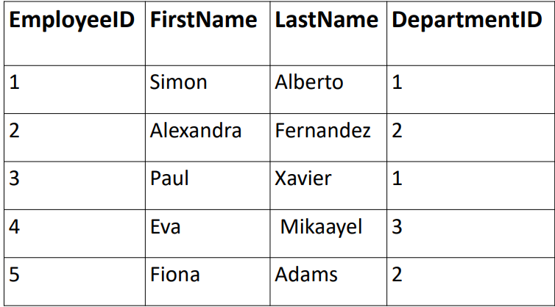mployees Table : Departments

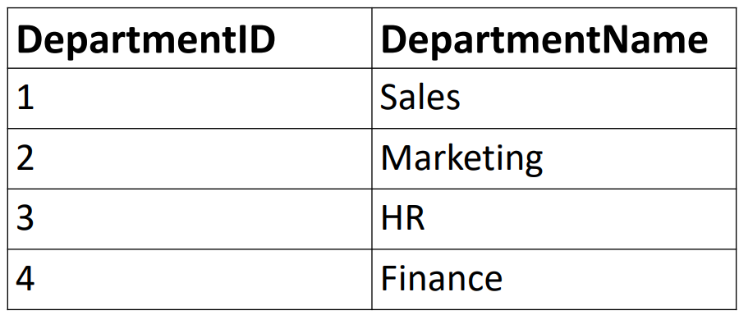

**INNER JOIN:**

When performing an inner join on the “Employees” and “Departments” tables using the common field “DepartmentID”, the result will include only the employees who are associated with the department.

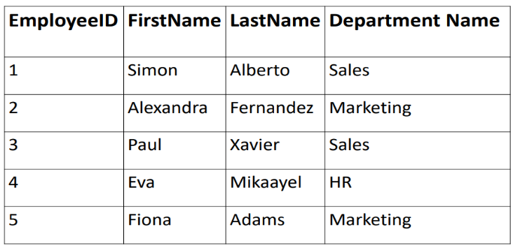

**OUTER JOIN:**

When performing a full outer join on the “Employees” and “Departments” tables using the common field “DepartmentID” , the result will include all employees from the “Employees” table and all departments from the “Departments” table. NULL values will be filled in for the nom-matching columns.

