
Cardiff Metropolitan University
Cardiff School of Technology
BSc Software Engineering
AI-Based Personalized Nutrition, Meal Recommendation and Weight Management System for Gym Users
Submitted in August
2026
By
U.L.S.R. Perera
(CL.BSCSD.34.69 - 20360408 - ICBT)
This dissertation is submitted in partial fulfillment of the requirements for the degree of
Bachelor of Science in Software Engineering (BSc SE)

DECLARATION
This work is being submitted in partial fulfillment of the requirements for the degree of
Bachelor of Science in Software Engineering (BSc SE) and has not previously been accepted in substance for any degree and is not being concurrently submitted in candidature for any degree.
Signed - .................................................... Date - ..............................
(Candidate)
SUPERVISOR'S DECLARATION STATEMENT
Student Name - U.L.S.R. Perera
Supervisor's Name - ..............................................................
I acknowledge that the above named student has regularly attended the meeting, and actively engaged in the dissertation supervision process.
Signed - .................................................... Date - ..............................
(Supervisor)

Acknowledgement
I would like to thank my supervisor for the guidance and feedback given throughout this project. The regular meetings kept the work on track and helped me judge what was realistic to build in the time available.
I also thank the lecturers at ICBT Campus and Cardiff Metropolitan University for the knowledge I applied directly in this project, and my family and friends for their support and patience.

Abstract
Gym users need to know how many calories and how much protein they should eat each day. Most people use free online calculators or generic diet plans. These give the same answer to everyone with the same height and weight, and they do not follow the user as their body changes. Getting personal advice from a dietitian is accurate but costs money and is not always available.
This project built NutriFit-AI, a working web application that solves this problem. The system takes a user's age, gender, height, weight, training habits and fitness goal, and predicts their daily calorie and protein needs using machine learning. It then recommends real meals that fit those numbers, builds a full eight-week meal plan, and recalculates everything when the user logs a new weight.
The system is built as three connected services: a React front end, a Node.js and Express API, and a Python FastAPI machine learning service, with Supabase PostgreSQL for storage and authentication. Two models were trained on 973 real gym member records: Linear Regression as a baseline and Random Forest as the main model. Random Forest performed better on both targets, with a cross-validated mean absolute error of 96.16 kilocalories and 8.72 grams of protein.
A learning curve experiment showed something more interesting than the headline numbers. Random Forest was worse than Linear Regression on small samples and only overtook it as the dataset grew, crossing over at about 680 records. This is evidence for why the model was chosen, not just a claim. The eight-week planner keeps every week within 0.4 percent of the calorie target, and 263 automated tests pass across all layers. The food catalogue was also extended with 52 Sri Lankan dishes after an audit found the public datasets contained almost no local food.

Table of Contents
Acknowledgement 3
Abstract 4
Table of Contents 5
List of Figures 8
List of Tables 9
Glossary 10
1.0 Introduction 11
1.1 Background Studies 11
1.2 Problem Statement 11
1.3 Objective 12
1.4 Solutions 12
2.0 Literature Review 13
2.1 Review of Existing Systems 13
2.2 System Architecture and Design Patterns 13
2.3 AI as an Integrated Feature 14
2.4 Recommendation Techniques 14
2.5 Security and Data Protection 15
2.6 Research Gap 15
3.0 Planning 16
3.0.1 Feasibility Report 16
3.0.2 Risk Assessment 16
3.0.3 SWOT 17
3.0.4 PESTEL Analysis 17
3.0.5 Life Cycle Model 17
3.1.1 Time Plan 18
4.0 Requirement Gathering and Analysis 19
4.2 Requirement Gathering and Analysis 19
4.2.1 Requirement Gathering technique used for the project 19
4.2.2 Questionnaire 19
4.2.3 Interview 20
Summary of the Interview and Questionnaire 21
4.3 Functional and Non-Functional Requirements 21
4.3.1 Functional Requirements 21
4.3.2 Non-functional Requirement 22
5.0 System Design 23
5.1 Architecture Diagram 23
5.2 ER Diagram 24
5.3 UML Diagrams 25
5.4 Wireframe Diagram 27
6.0 Implementation 29
6.1 Technology Stack 29
6.2 Design patterns 29
6.3 Implementation of the program 30
6.3.1 Datasets used 30
6.3.2 Building the training targets 31
6.3.3 Preprocessing pipeline 32
6.3.4 Recommendation engine 33
6.3.5 Meal plan generator 33
6.3.6 Cultural bias in the food catalogue 34
6.3.7 API design 34
7.0 Testing and Validation 35
Test Plan 35
7.1 Model Evaluation Results 35
7.2 The Learning Curve Experiment 36
7.3 Feature Importance 38
7.4 Meal Plan Validation 38
Test Cases 39
7.5 A Bug Found by Testing 39
7.6 What Was Not Tested 40
8.0 Conclusion 41
8.1 Conclusion 41
8.2 Future Recommendations 41
8.3 Lessons Learned 42
Gantt Chart 43
References 44
Appendix 1 45
Questionnaire 45
Interview Guide 46
Test Case 46
Supervision meeting log sheets 46

List of Figures
Figure 5.1 System architecture
Figure 5.2 Entity relationship diagram
Figure 5.3 Use case diagram
Figure 5.4 Sequence diagram for logging weight and adjusting the plan
Figure 5.5 Machine learning pipeline data flow
Figure 5.6 Wireframes: authentication and profile setup
Figure 5.7 Wireframes: dashboard and meal recommendations
Figure 5.8 Wireframes: two-month meal plan and progress
Figure 6.1 Distribution of the model input features
Figure 6.2 Correlation between features
Figure 6.3 Distribution of the constructed calorie and protein targets
Figure 6.4 Content-based recommendation and slot composition
Figure 7.1 Predicted against actual values for both models and targets
Figure 7.2 Learning curves for both models and both targets
Figure 7.3 Random Forest feature importance
Figure 7.4 Weekly meal plan error against the +/-5 % tolerance
Figure 8.1 Project time plan (Gantt chart)

List of Tables
Table 3.1 Risk assessment and mitigation
Table 3.2 SWOT analysis
Table 3.3 PESTEL analysis
Table 3.4 Project phases
Table 4.1 Structure of the questionnaire
Table 4.2 Interview topics and the design question each addresses
Table 4.3 Functional requirements and where they are implemented
Table 4.4 Non-functional requirements
Table 6.1 Technology stack
Table 6.2 Design patterns used
Table 6.3 Backend API endpoints
Table 7.1 Automated test summary
Table 7.2 Model comparison on the held-out test set and by cross-validation
Table 7.3 Cross-validated MAE against training set size (calorie target)
Table 7.4 Eight-week meal plan accuracy
Table 7.5 Selected test cases
Table A1 Questionnaire response summary sheet
Table A2 Interview response recording sheet

Glossary

Term | Meaning
API | Application Programming Interface. A defined way for one program to call another.
BMI | Body Mass Index. Weight in kg divided by height in metres squared.
BMR | Basal Metabolic Rate. Energy the body uses at rest.
Cross-validation | Training repeatedly on several data folds, so results do not rest on one split.
Deurenberg equation | Estimates body fat percentage from BMI, age and sex.
FastAPI | Python web framework used here to serve the models.
Feature | One input column given to a model, such as weight.
Joblib | Python library used to save and reload a trained model.
JWT | JSON Web Token. A signed token proving a user is logged in.
Katch-McArdle equation | BMR formula based on lean body mass.
Label | The value a model is trained to predict; also called the target.
Linear Regression | Model fitting a straight-line relationship to the target.
MAE | Mean Absolute Error. Average error size, in the target's units.
Mifflin-St Jeor equation | BMR formula using weight, height, age and sex.
MSE / RMSE | Mean Squared Error and its root. Both punish large errors.
Microservice | A small independent service called over the network.
PAL | Physical Activity Level. Multiplier applied to BMR.
Pipeline | A scikit-learn object chaining preprocessing and a model.
R-squared | Share of variation the model explains. 1.0 is perfect.
Random Forest | Model averaging many decision trees.
RLS | Row Level Security. Database rules deciding which rows a user sees.
Supabase | Hosted PostgreSQL database with user authentication.
TDEE | Total Daily Energy Expenditure. BMR times activity level.
Train-serve skew | When training and prediction prepare data differently, making live results wrong.
WCAG | Web Content Accessibility Guidelines.

1.0 Introduction
Exercise alone does not produce results. What a person eats decides whether they lose fat, gain muscle, or stay the same. Gym users know this, but most of them do not know how much they should actually be eating. They guess, or they copy a plan from social media that was written for somebody else.
This project is a web application called NutriFit-AI. It predicts a gym user's daily calorie and protein needs from their own body and training data, recommends meals that match those numbers, and builds a two-month meal plan. When the user's weight changes, the system notices and offers to update the plan.

1.1 Background Studies
Daily energy needs are normally worked out in two steps. First the Basal Metabolic Rate (BMR) is estimated, which is the energy the body uses at rest. Then it is multiplied by an activity factor to get Total Daily Energy Expenditure (TDEE). The most common BMR equation is Mifflin-St Jeor (1990), which uses weight, height, age and sex.
For people who train, there is a better option. The Katch-McArdle equation calculates BMR from lean body mass instead. This matters because two people who weigh 85 kilograms but have very different body fat percentages burn different amounts of energy at rest, yet Mifflin-St Jeor gives them the same answer. Protein needs are usually given as grams per kilogram of body weight. The International Society of Sports Nutrition recommends 1.4 to 2.0 g/kg for people training, and more during a calorie deficit to protect muscle.
These formulas are well established, which raises a fair question: if they already exist, why use machine learning? Chapter 2 discusses this and Chapter 7 tests it.

1.2 Problem Statement
The main problem is that gym users do not have access to nutrition advice that is personal to them, adapts over time, and is free. The specific gaps are:
- Online calculators give a calorie number and stop there. They do not tell the user what to actually eat.
- Generic meal plans do not match the user's own calorie and protein targets.
- Existing apps focus on logging food after it is eaten, not on planning it in advance.
- Nothing recalculates automatically when the user's weight changes.
- Food databases in these apps are built around Western food, so the suggestions do not suit a Sri Lankan user.

1.3 Objective
The aim of this project is to design, build and test a working web application that gives gym users personalised nutrition guidance. The objectives are:
- To collect suitable public datasets and prepare them for machine learning.
- To build and compare two prediction models, Linear Regression and Random Forest, for daily calorie and protein needs.
- To evaluate both models properly using MAE, MSE, RMSE and R-squared, with cross-validation rather than a single split.
- To build a content-based recommendation engine that suggests real meals matching the predicted targets.
- To generate a structured eight-week meal plan with variety and accuracy controls.
- To build a secure web application around all of this, with user accounts, a database and a dashboard.
- To test the system at unit, integration and API level.

1.4 Solutions
The solution is a three-tier web system. The React front end handles the user interface. A Node.js and Express API handles authentication, validation and business rules. A separate Python FastAPI service holds the machine learning models and the recommendation engine. Supabase provides PostgreSQL storage and user authentication.
Splitting the machine learning into its own service was a deliberate decision. The models are written in Python because scikit-learn only runs in Python, while the web layer stays in Node.js. The two communicate over internal HTTP. The machine learning service is never exposed to the internet.

2.0 Literature Review
This is a Software Engineering development project, so this review concentrates on existing systems, the software architecture and design decisions behind them, and how artificial intelligence is added to a system as a feature. The machine learning is one component of the system, not the whole project.

2.1 Review of Existing Systems
MyFitnessPal is the best known nutrition app. Its strength is a very large food database and barcode scanning. Its weakness for this project is that it is a logging tool. The user tells it what they ate. It has a goal calculator, but it does not plan meals ahead or adjust the plan automatically as the user's body changes.
Cronometer is more accurate on micronutrients and uses verified data sources, but again it records rather than recommends.
MacroFactor is closer to this project. It adjusts calorie targets based on logged weight and intake over time, which is the same adaptive idea used here. However it is a paid subscription app, it still does not generate a full multi-week meal plan, and its food database is not adapted to South Asian diets.
Free online TDEE calculators are the tool gym users most often reach for. They implement Mifflin-St Jeor directly, but produce one number with no meal guidance, no storage and no follow-up.
Across these systems the gap is the same: calorie prediction, meal recommendation, long-term planning and automatic readjustment exist separately but rarely in one free system, and almost never with a food database suited to Sri Lankan users.

2.2 System Architecture and Design Patterns
For a system that mixes a web application with machine learning, two architectures are common. A monolith puts everything in one deployable unit, which is simple but forces one language. A microservice split puts the machine learning behind its own API.
This project uses the second approach, which is standard practice for serving scikit-learn models. The model is trained offline, saved with joblib, and loaded by a small stateless service. The web backend calls it like any other internal API. This keeps the machine learning in Python and the web logic in Node.js, and lets each part be tested separately.
The design patterns used are listed in Chapter 6.

2.3 AI as an Integrated Feature
In a Software Engineering project the AI must be judged on how well it fits into the system, not only on its accuracy score. Three integration problems matter in practice.
The first is train-serve skew: when preparation during training differs from preparation at prediction time, the output is quietly wrong. The fix is to wrap preprocessing and model in one saved object, which this project does.
The second is graceful degradation. If a model file cannot load the system should still answer, so this project falls back to the formula and records which method was used.
The third is that a model gives a number, not an action. Predicting 2,400 kilocalories does not help a user who does not know what to cook, so the recommendation engine turns it into meals.

2.4 Recommendation Techniques
Recommender systems are usually grouped into collaborative filtering, content-based filtering, and hybrids. Collaborative filtering needs rating history from many users, which a new system does not have. This is the cold-start problem.
Content-based filtering compares the features of the items themselves, so it works from the first day. For meal recommendation the features are the macronutrients. This project represents each food as a vector of calories, protein, carbohydrate, fat and fibre, and finds the nearest match to the user's remaining budget for that meal slot.

2.5 Security and Data Protection
Body weight and body fat percentage are personal health data, so access control matters. Application-level checks are easy to get wrong: one missing filter in one query can expose another user's rows.
PostgreSQL Row Level Security moves this enforcement into the database. Policies are attached to the tables themselves, so even if the application forgets a check, the database returns nothing. This project enables Row Level Security on all six tables.

2.6 Research Gap
From this review, the gap this project addresses is a single free system that predicts nutritional needs with machine learning, converts those predictions into real meal recommendations, produces a structured eight-week plan, adjusts itself when the user's weight changes, and uses a food catalogue that includes local Sri Lankan food.

3.0 Planning

3.0.1 Feasibility Report
Technical feasibility. Every tool used is free and well documented: Python, scikit-learn, React, Node.js, FastAPI and Supabase. Training was done in Google Colab. One useful finding here is that scikit-learn runs on CPU only, so a GPU runtime gives no benefit for Linear Regression or Random Forest. The entire training pipeline runs in about ten minutes on the free CPU runtime and used zero paid compute units.
Operational feasibility. The user enters a few fields once, then logs their weight occasionally. Everything else is automatic.
Economic feasibility. Total cost was zero. All datasets are public and all services used are free tiers.
Schedule feasibility. The work was planned across twelve weeks as shown in the time plan in section 3.1.1.
Legal and ethical feasibility. The datasets are public and contain no personal identifiers. The application shows a medical disclaimer stating that it gives nutritional guidance and does not replace professional medical advice.

3.0.2 Risk Assessment
Table 3.1 Risk assessment and mitigation
Risk | Impact | Likelihood | Mitigation actually applied
Public dataset has no ready target column | High | Certain | Targets built from published formulas; method documented in Chapter 6
Model performs worse than a plain formula | Medium | Medium | Formula baseline computed and reported next to model results
Training and serving preprocessing differ | High | Medium | One shared Python package used by both; verified by a reload test
Food catalogue too small for the variety rule | Medium | High | USDA data and 52 Sri Lankan items added; coverage measured
Library version mismatch breaks saved models | High | Medium | Occurred in practice; versions now pinned to scikit-learn 1.6.1
Time overrun on the web application | Medium | Medium | Machine learning finished first; web layers built on a fixed API contract

3.0.3 SWOT
Table 3.2 SWOT analysis
Strengths | Weaknesses
Combines prediction, recommendation and long-term planning in one free system. Shared code between training and serving removes a whole class of bug. 263 automated tests. Includes local Sri Lankan food. | Only 973 training records. Fitness goals in the training data are assigned, not self-reported. No allergy or medical condition handling. Not yet deployed to a public server.
Opportunities | Threats
Add Sinhala and Tamil language support. Connect to fitness trackers for automatic activity data. Add photo-based food logging. Expand the local food set with laboratory-measured values. | Established apps have far larger food databases. Users may not log weight often enough for the adjustment loop to help. Nutrition guidance carries responsibility if users treat it as medical advice.

3.0.4 PESTEL Analysis
Table 3.3 PESTEL analysis
Factor | Relevance to this project
Political | No specific regulation on nutrition guidance software in Sri Lanka, but the system avoids making medical claims.
Economic | Dietitian consultations are expensive for many gym users; a free tool lowers that barrier.
Social | Gym membership and interest in fitness are growing, and diet advice is commonly taken from social media.
Technological | Free cloud services and open-source machine learning libraries make this type of system possible at no cost.
Environmental | Minimal. Training used a CPU runtime for about ten minutes rather than sustained GPU compute.
Legal | Health data is personal data, so access control and a clear disclaimer were treated as requirements, not extras.

3.0.5 Life Cycle Model
An iterative and incremental model was used rather than Waterfall. The reason is practical: the machine learning results could not be predicted in advance. The first modelling attempt gave the opposite result to what was expected and had to be investigated and redone. A Waterfall plan with a single fixed design phase would not have allowed that.
Each increment delivered something testable, from data preparation through to the user interface, with tests written alongside.

3.1.1 Time Plan
The work was planned across twelve weeks in five phases. Planning and the literature review ran in weeks 1 to 4. Data preparation, model training and evaluation ran in weeks 4 to 7. The database, the machine learning service, the backend and the front end were built in weeks 8 to 10. Testing was carried out in week 11 and documentation in week 12. The full schedule is shown as a Gantt chart before the references.
Table 3.4 Project phases
Phase | Weeks | Main deliverable
Planning and proposal | 1 to 2 | Approved proposal and project plan
Literature review | 3 to 4 | Review of existing systems and techniques
Data preparation | 4 to 5 | Cleaned dataset and constructed targets
Model training and evaluation | 6 to 7 | Two trained models with metrics
Database, API and front end | 8 to 10 | Working three-tier application
Testing | 11 | 263 automated tests
Documentation | 12 | This dissertation

4.0 Requirement Gathering and Analysis

4.2 Requirement Gathering and Analysis

4.2.1 Requirement Gathering technique used for the project
Three techniques were used to gather requirements for this project.
Document analysis. The approved proposal was the primary source. Its ten functional and ten non-functional requirements were carried into the build, and each is traced to code in Chapter 6.
Existing system analysis. Four products were examined in Chapter 2: MyFitnessPal, Cronometer, MacroFactor and free TDEE calculators. What they lack produced the requirements for meal planning and automatic readjustment.
Dataset analysis. The public datasets were examined before the requirements were fixed, because they limit what can be built. This is how body fat percentage entered the design: the gym dataset carries a measured column, which allows the more accurate Katch-McArdle equation. That field was not in the proposal and was added after seeing the data.

4.2.2 Questionnaire
A questionnaire was designed to test the assumptions taken from the proposal and the existing system review against real gym users. The questions are mostly closed, so the answers convert directly into design decisions such as which profile fields to ask for.
The target population is adults training at a gym at least twice a week in the Colombo area, with a sample of 15 to 20 respondents. The instrument has 10 questions in four sections, reproduced in Appendix 1.
Table 4.1 Structure of the questionnaire
Section | Questions | What it establishes
Training profile | Q1 to Q2 | Whether the assumed activity range (2 to 5 sessions a week) is realistic
Current knowledge | Q3 to Q4 | Whether users already know their calorie and protein targets, and where from
Existing tools | Q5 to Q6 | Which apps they have used, why they stopped, and whether planning ahead is wanted
System preferences | Q7 to Q10 | Weighing frequency, importance of familiar food, willingness to enter body fat

Responses will be analysed with counts and percentages for the closed questions and grouped into themes for the free-text ones. Two questions matter most to the design. Q8 asks how important familiar food is, which tests the regional catalogue work in Chapter 6. Q9 asks whether users would enter a measured body fat percentage, which decides whether that field stays optional.
Status. The instrument and participant information sheet are complete and are in Appendix 1, with the results table laid out ready to receive the responses. Distribution is the remaining step, so the requirements in section 4.3 rest on the proposal, the existing system review and the dataset analysis, with the questionnaire serving as confirmation.

4.2.3 Interview
Interviews cover what a questionnaire cannot. A closed question can establish that somebody abandoned an app but not why, and the reason is what changes the design. A semi-structured format keeps the same six topics across every participant while allowing follow-up questions.
Three participants give different viewpoints: a gym instructor who advises members on diet, a member training for muscle gain, and one training for fat loss. Three is small, but the purpose is depth; the questionnaire covers breadth.
Table 4.2 Interview topics and the design question each addresses
Topic | Design question it answers
How members currently decide what to eat | Is the problem statement in section 1.2 accurate?
Experience of existing apps | Which features are missing rather than merely disliked?
Reaction to an eight-week plan | Is a long plan useful, or does it feel rigid?
Attitude to logging weight regularly | Is the FR8 and FR9 adjustment loop realistic in practice?
Importance of familiar local food | Does the regional catalogue work justify its cost?
Trust in an automated recommendation | How prominent must the medical disclaimer be?

Recordings will be analysed thematically: transcribe, code each answer against the six topics, then report agreement and difference across the three participants. Status: the guide and consent form are complete and in Appendix 1 with a recording template; conducting the interviews is the remaining step.

Summary of the Interview and Questionnaire
The two instruments work together: the questionnaire measures how widely a view is held, the interviews explain why. Both are checked against the existing system review in Chapter 2, so no requirement rests on one type of evidence.
The requirements in section 4.3 come from the proposal, the existing system review and the dataset analysis, with Table 4.3 recording any change made after the proposal. Once collected, the responses will either confirm these requirements or show where the assumptions were wrong; that comparison is the first item of future work in section 8.2.

4.3 Functional and Non-Functional Requirements

4.3.1 Functional Requirements
Table 4.3 Functional requirements and where they are implemented
ID | Requirement | Implementation | Status
FR1 | User registration and authentication | Supabase Auth with JWT; guard middleware on all /api routes | Done
FR2 | User profile management | profiles table; POST and GET /api/profile | Done
FR3 | BMI calculation | Computed server-side on every weight entry; WHO categories | Done
FR4 | Calorie requirement prediction | Random Forest model served by POST /predict | Done
FR5 | Protein requirement prediction | Second Random Forest model, same pipeline | Done
FR6 | Personalised meal recommendation | Content-based engine; GET /api/recommendations | Done
FR7 | Two-month meal plan generation | Eight-week planner; POST /api/mealplan/generate | Done
FR8 | Progress monitoring | weight_logs table; trend charts on dashboard | Done
FR9 | Recommendation adjustment | Drift check at 7 percent; prompts the user, never overwrites | Done
FR10 | Dashboard and reporting | GET /api/dashboard returns BMI, targets, week plan and trends | Done

Two input fields were added after the proposal, because the dataset supported them and they improve accuracy: body fat percentage (optional, estimated when not supplied) and typical session length in hours, which is needed to work out the activity multiplier.

4.3.2 Non-functional Requirement
Table 4.4 Non-functional requirements
NFR | Requirement | How it was met | Evidence
NFR1 | Performance | Async FastAPI endpoints; database indexes on user_id and meal_type; response time header | Prediction returns in well under a second in testing
NFR2 | Reliability | Formula fallback if a model file fails to load; consistent error middleware | Fallback path covered by API tests
NFR3 | Security | Row Level Security on all six tables; JWT on every route; ML service not public | Verified by an anonymous-client check script
NFR4 | Usability | Single onboarding form; clear disclaimer; keyboard accessible interface | WCAG 2.1 AA measures applied
NFR5 | Scalability | Stateless ML service; database scales separately | Design property; not load tested
NFR6 | Availability | Free-tier hosting planned | Not deployed; runs locally only
NFR7 | Maintainability | Shared package; modular route folders; 263 tests | Full suite passes
NFR8 | Compatibility | Responsive Tailwind layout; REST/JSON API | Production build succeeds
NFR9 | Data privacy | No personal data stored in the ML service | Service is stateless by design
NFR10 | Accuracy | MAE, MSE, RMSE, R-squared with 5-fold cross-validation | Reported in Chapter 7

Two of these were not fully verified. Availability was not tested because the system was not deployed to a public server, and scalability was not load tested. Both are listed honestly in the limitations in Chapter 8.

5.0 System Design

5.1 Architecture Diagram
The system uses a layered architecture with a separate machine learning microservice. Figure 5.1 shows the four runtime layers and the offline training environment.
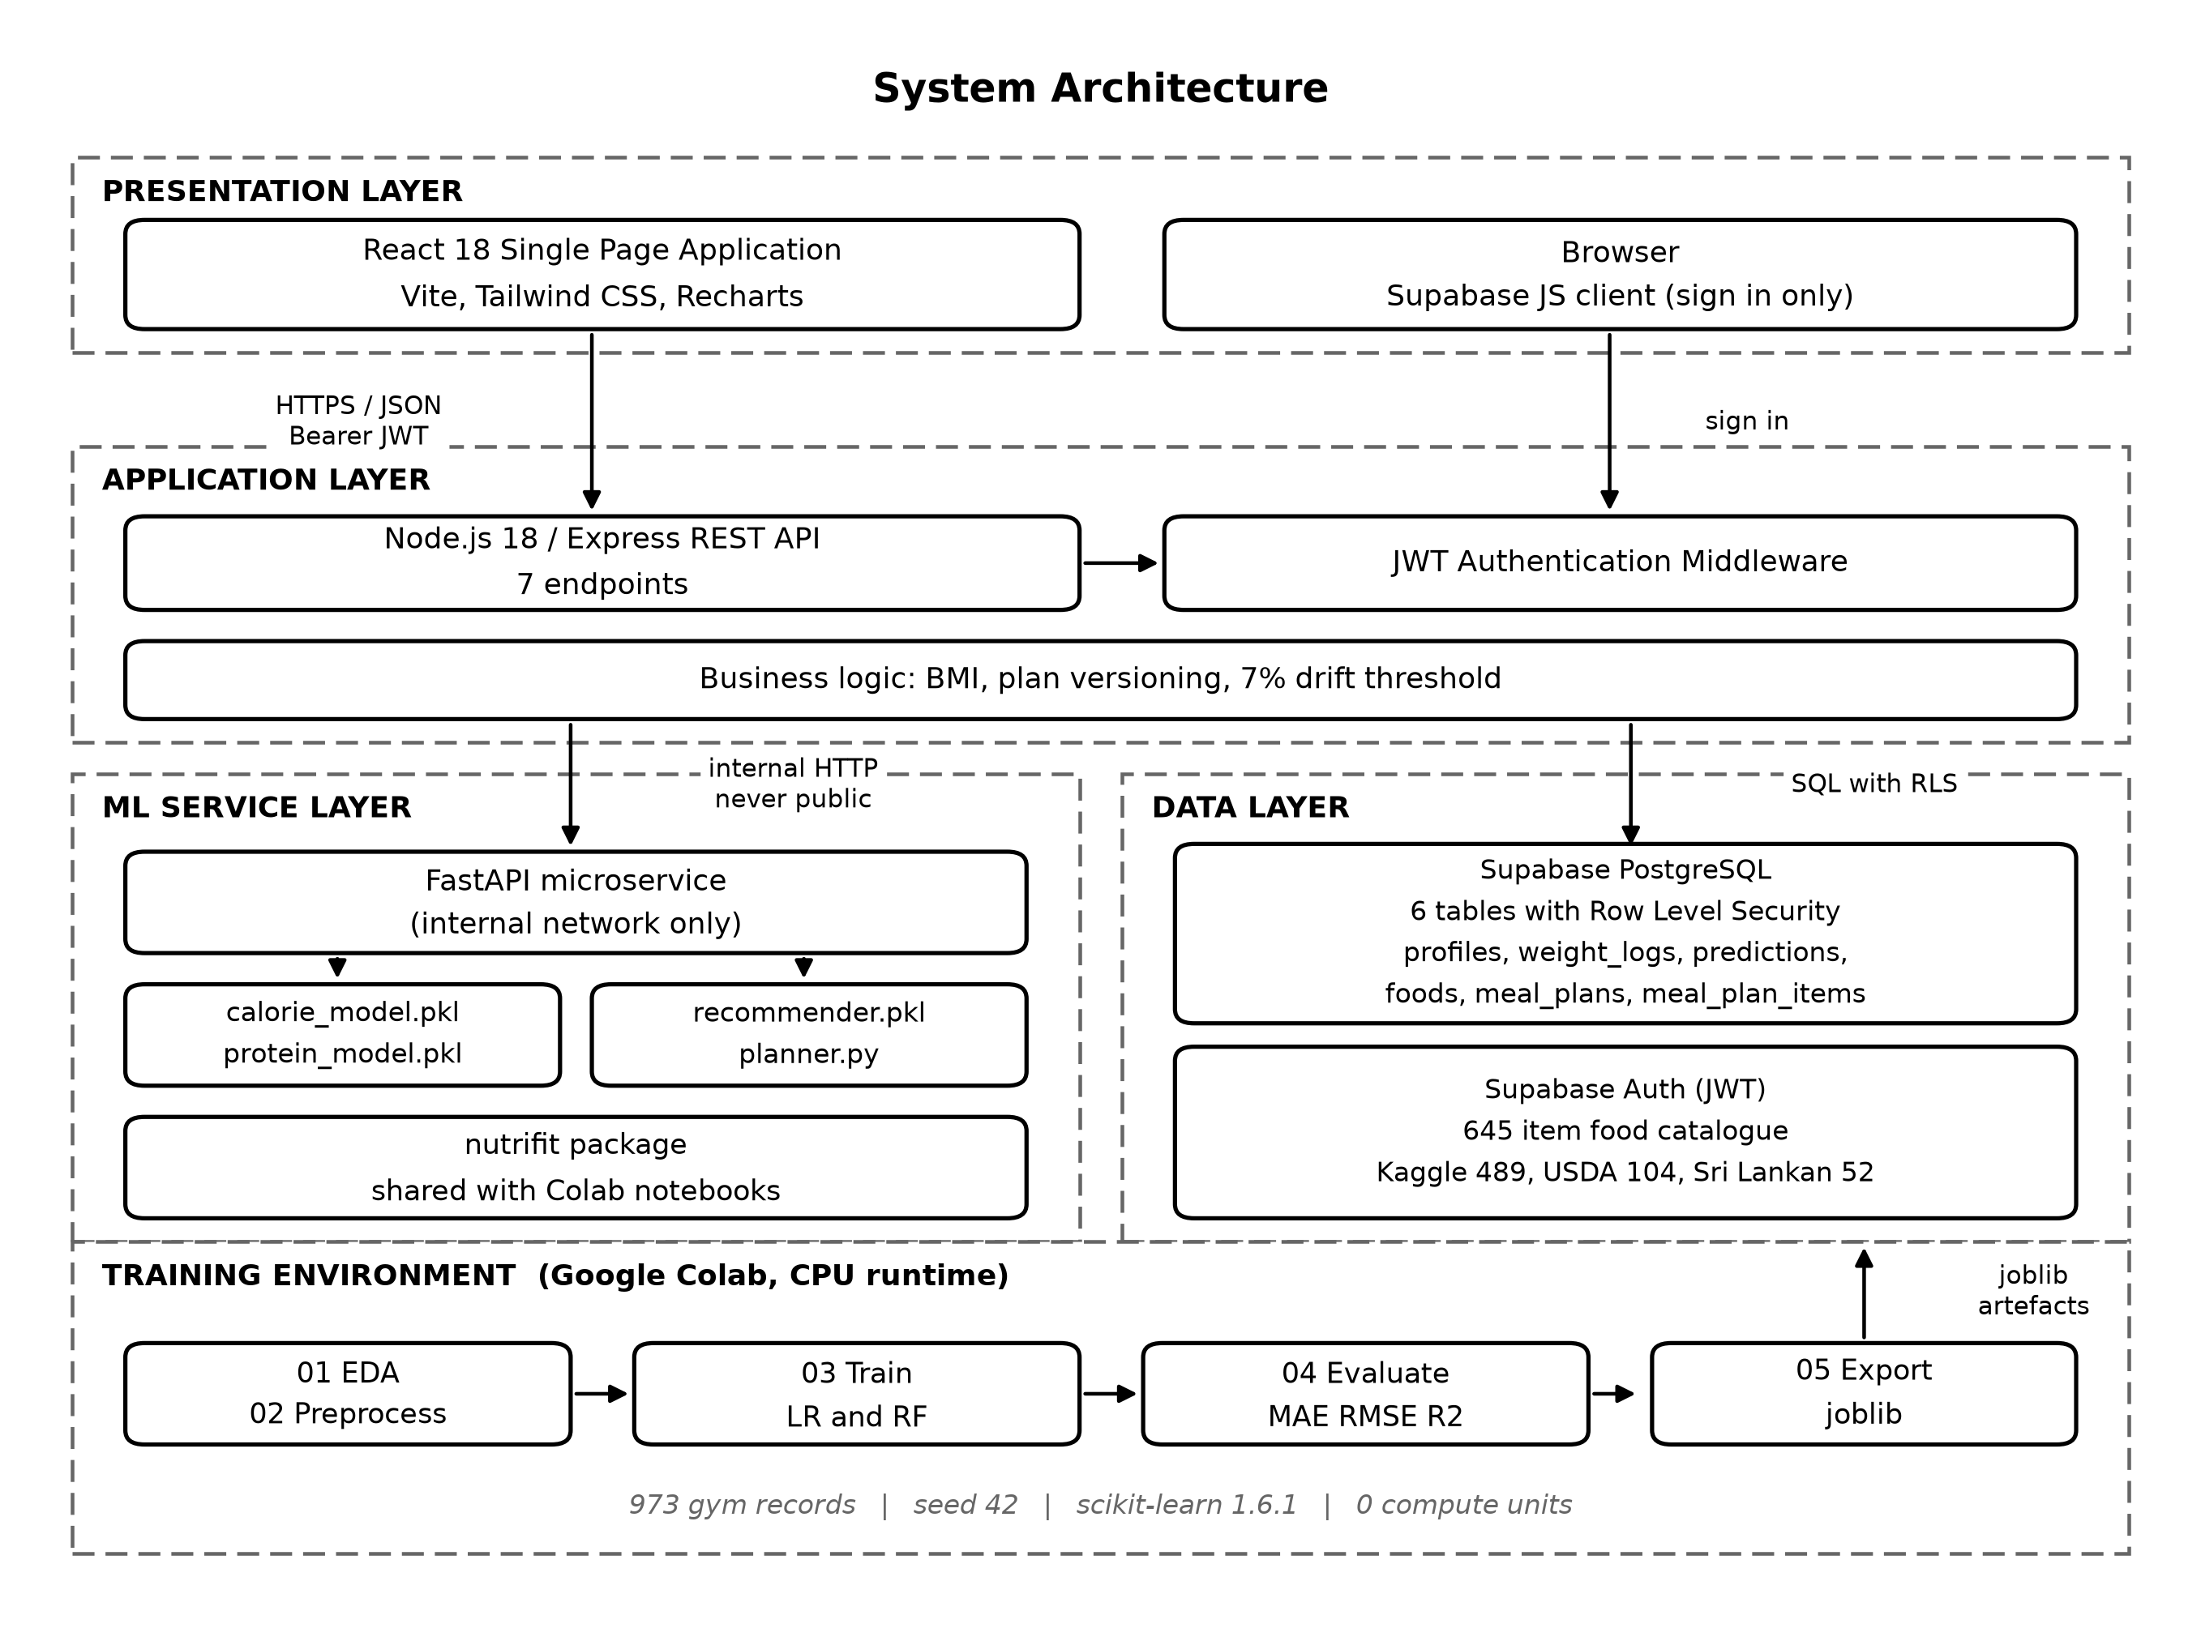
Figure 5.1 System architecture
The important detail is the arrow from the training environment into the ML service layer. The same Python package, called nutrifit, is used by the Colab notebooks during training and by the FastAPI service at prediction time. The preprocessing steps therefore cannot drift apart between the two.

5.2 ER Diagram
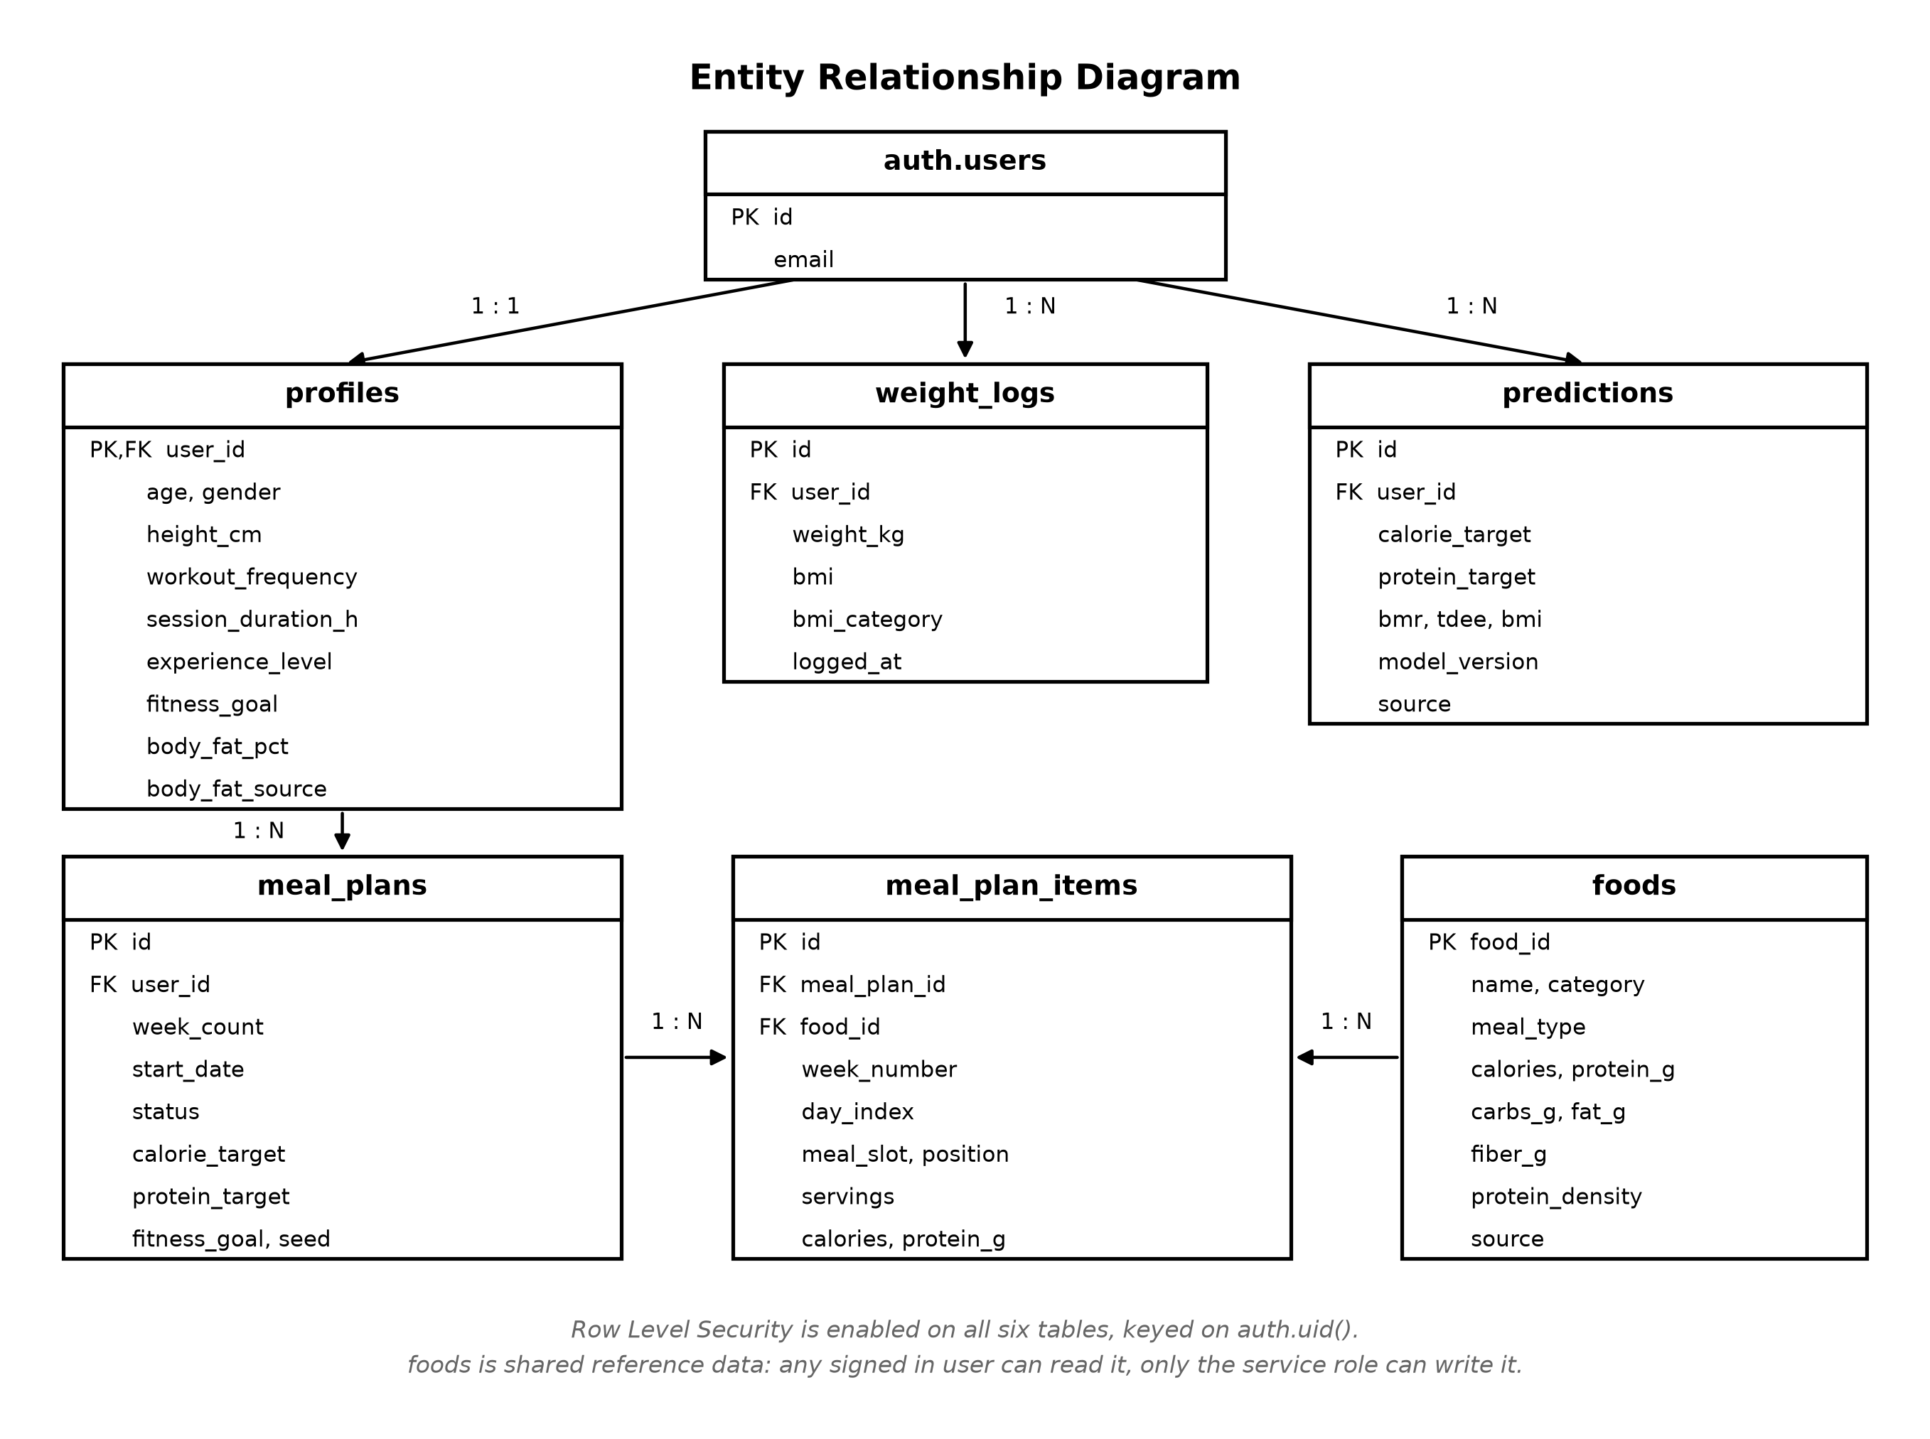
Figure 5.2 Entity relationship diagram
Height is stored on the profile because it does not change, while weight is stored as a series in weight_logs because it does. This separation is what makes the progress chart and the adjustment loop possible. A partial unique index allows only one active meal plan per user; older plans are marked superseded rather than deleted, so history is kept.

5.3 UML Diagrams
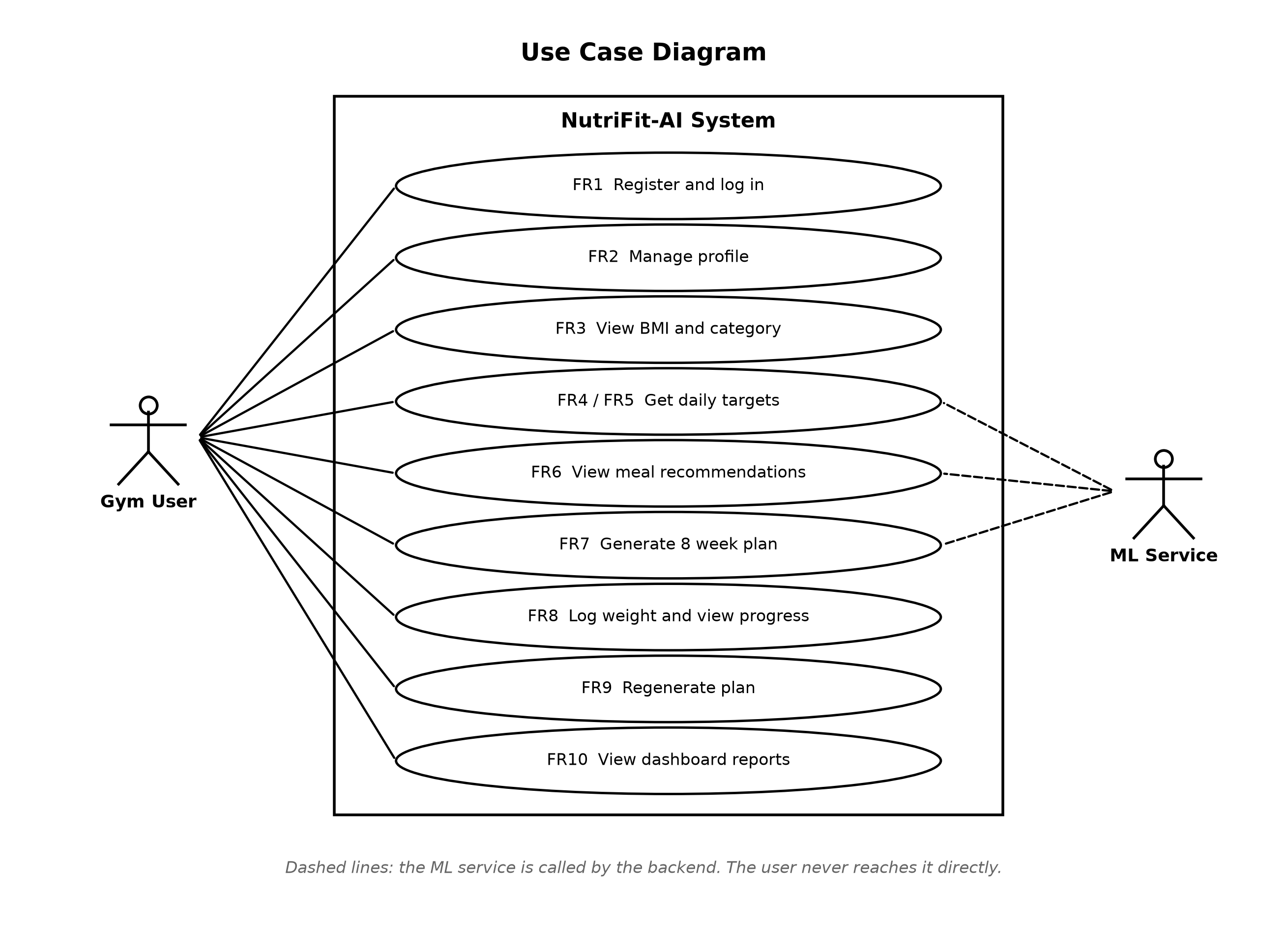
Figure 5.3 Use case diagram
There is one human actor. The machine learning service is shown as a system actor because the backend calls it; the user never reaches it directly.
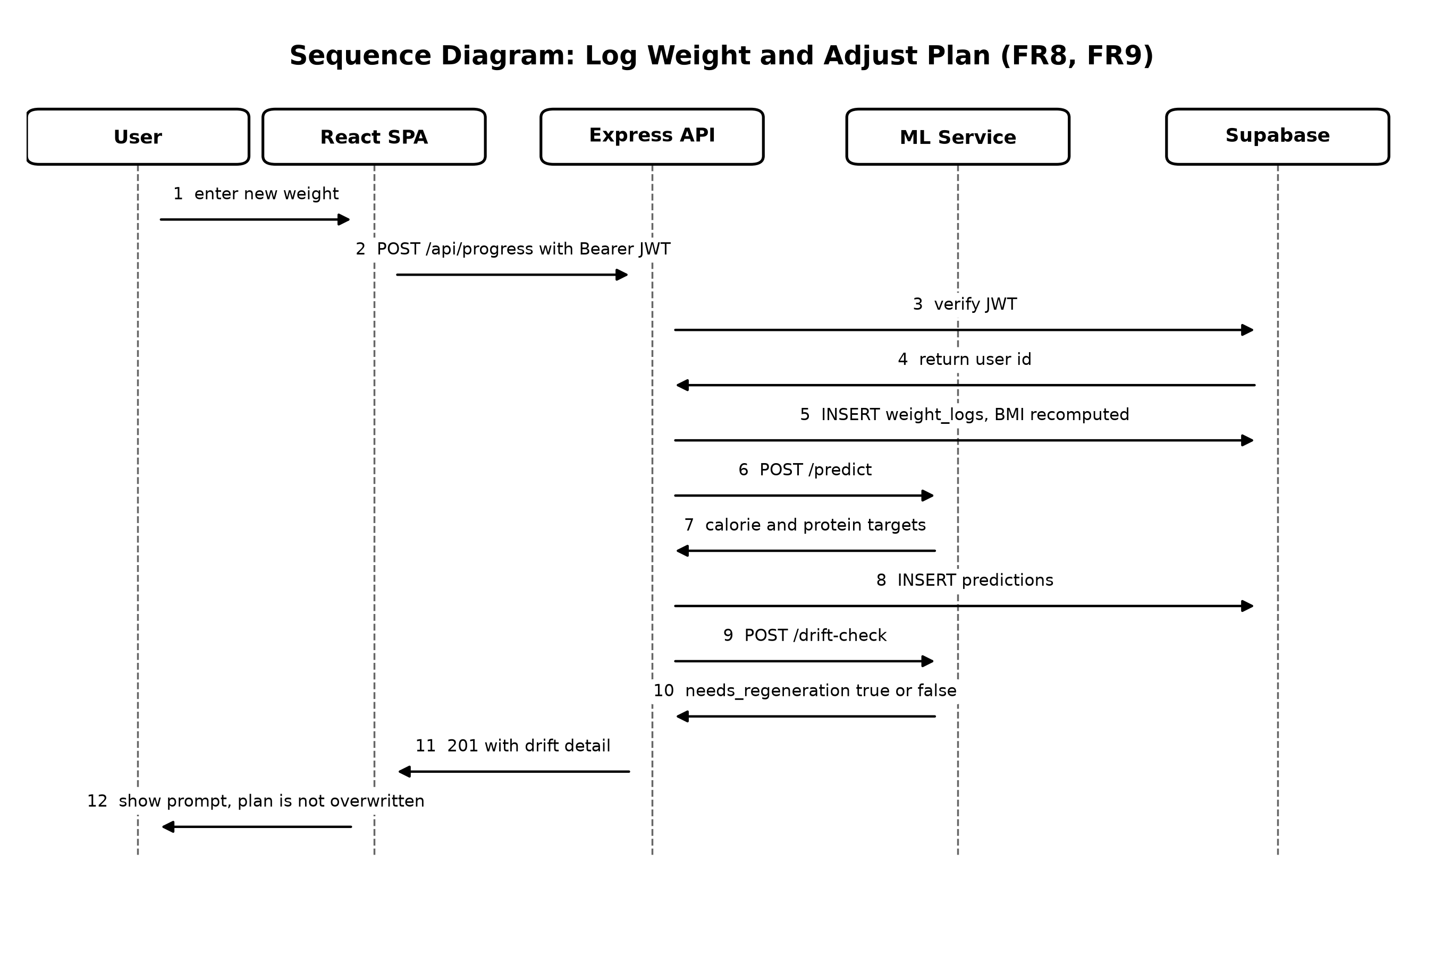
Figure 5.4 Sequence diagram for logging weight and adjusting the plan
This sequence covers FR8 and FR9. Step 12 is the design decision worth noting: the system shows a prompt and lets the user decide. It does not silently replace a plan the user may be halfway through.
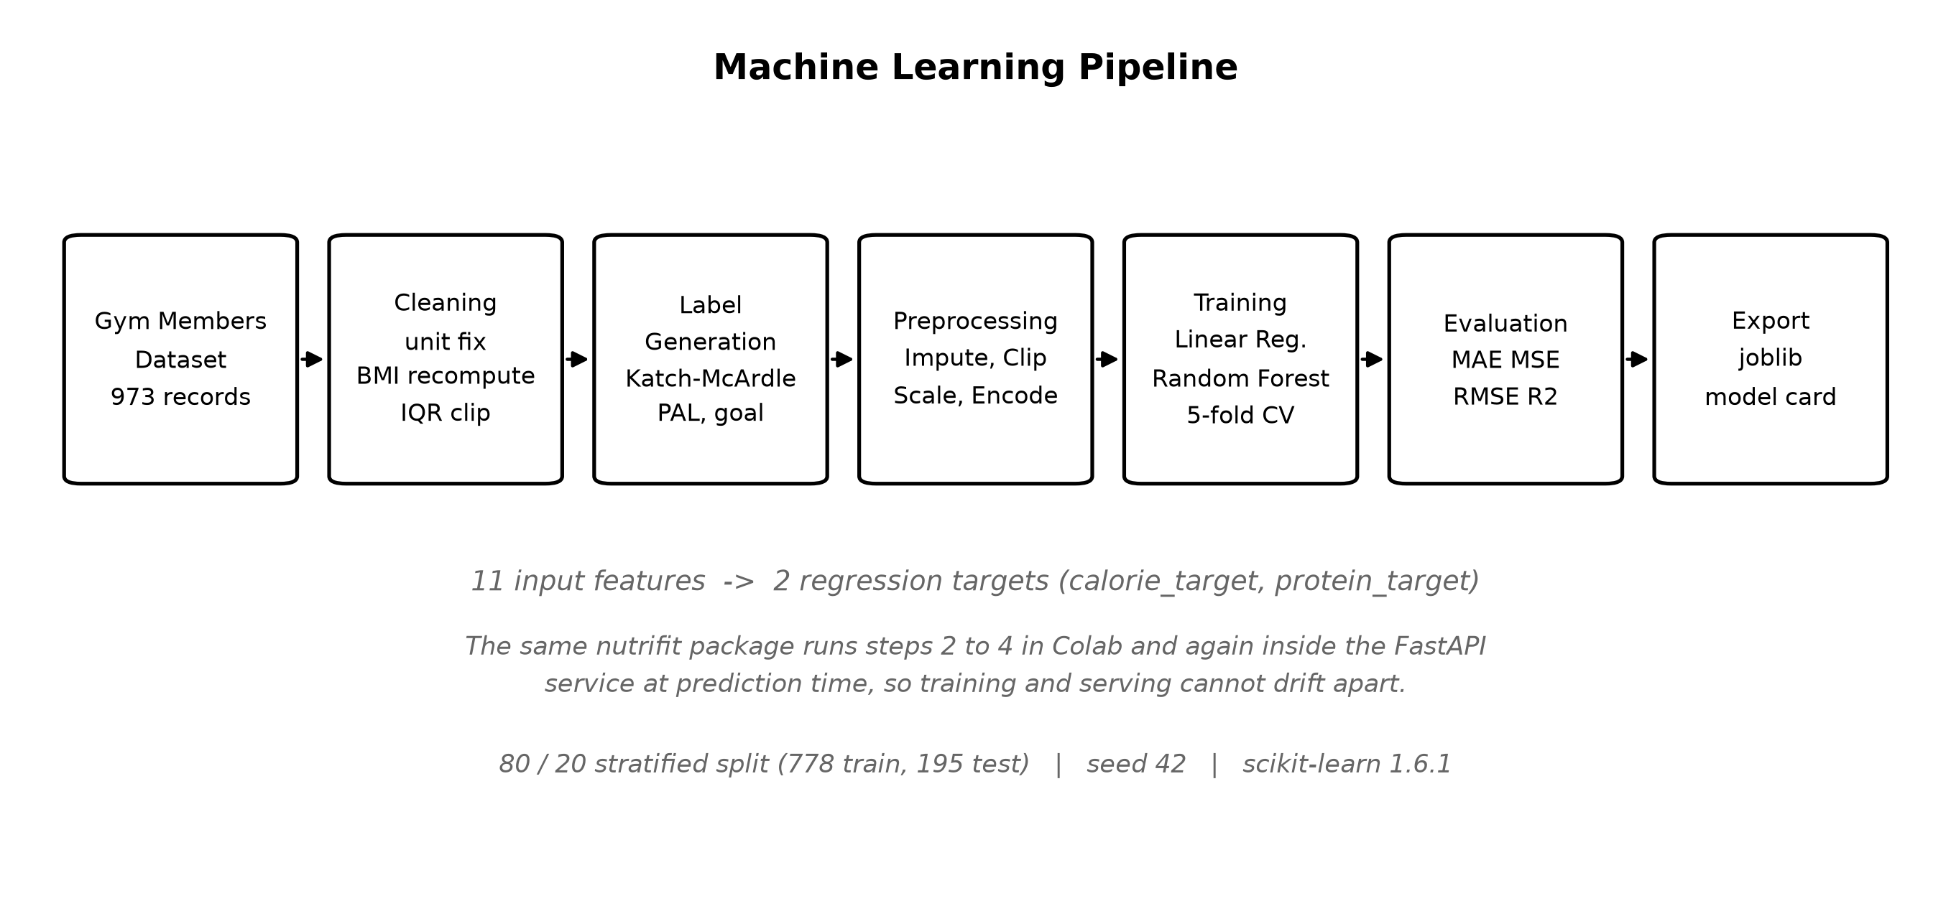
Figure 5.5 Machine learning pipeline data flow

5.4 Wireframe Diagram
The wireframes below match the screens that were actually built.
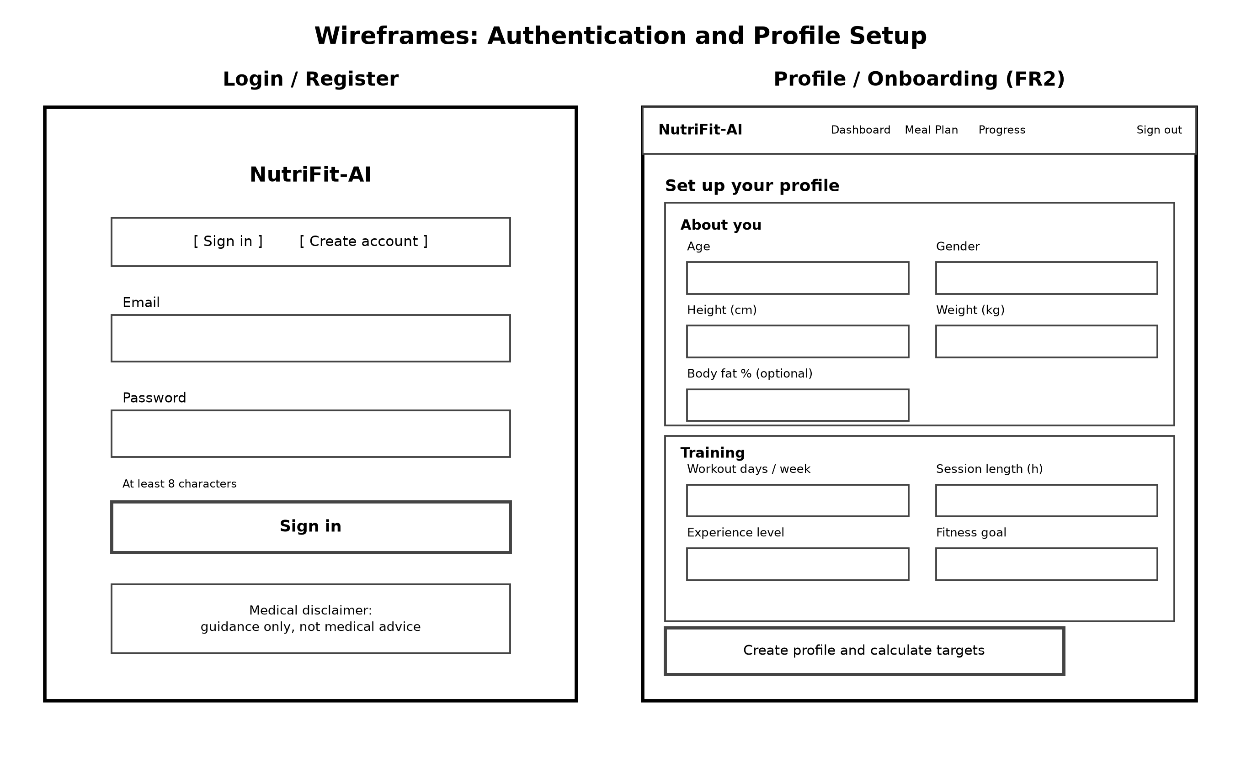
Figure 5.6 Wireframes: authentication and profile setup
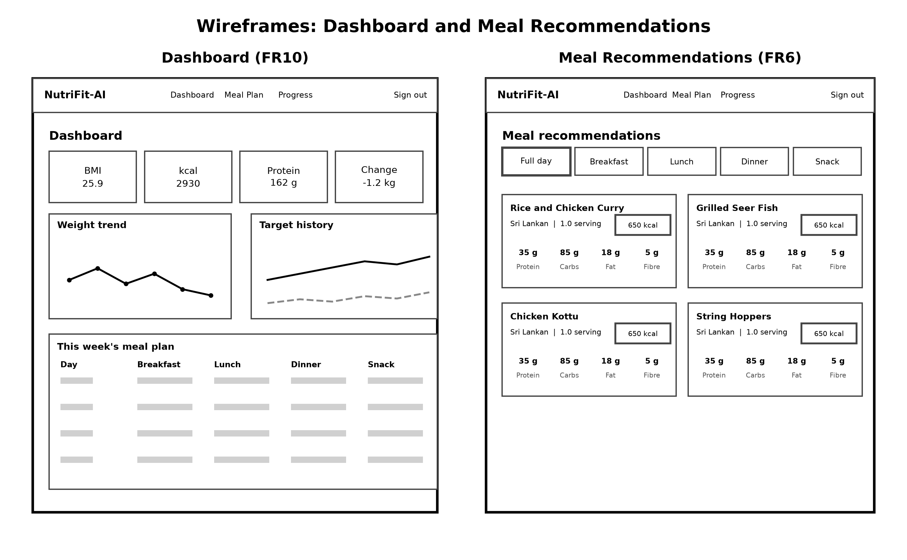
Figure 5.7 Wireframes: dashboard and meal recommendations
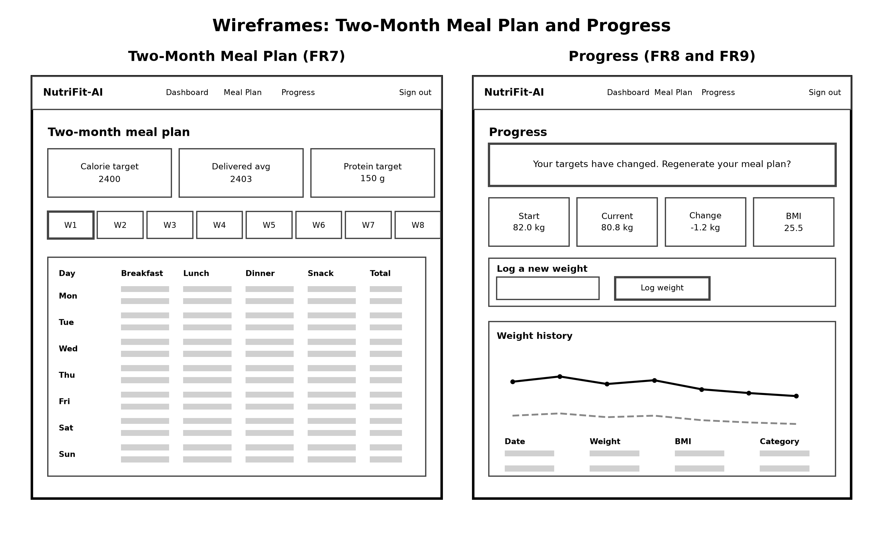
Figure 5.8 Wireframes: two-month meal plan and progress

6.0 Implementation

6.1 Technology Stack
Table 6.1 Technology stack
Layer | Technology | Why it was chosen
Front end | React 18, Vite, Tailwind CSS, Recharts | Component model suits a dashboard; Recharts renders the trend charts
Backend | Node.js 18, Express, Zod, Helmet | Specified in the proposal; Zod validates input, Helmet sets security headers
ML service | Python 3.12, FastAPI, scikit-learn 1.6.1, joblib | scikit-learn only runs in Python; FastAPI validates with Pydantic
Database | Supabase PostgreSQL with Row Level Security | Gives authentication and database together, with access control in the database
Training | Google Colab, CPU runtime | Free; replaces Jupyter from the proposal
Testing | pytest, Jest, Supertest | Standard for each language

FastAPI was added and is not named in the proposal. It is needed because the proposal itself requires the trained model to be integrated with the Node.js backend through APIs, and this service is that integration point.
One practical lesson came from library versions. The models were trained in Colab with scikit-learn 1.6.1 but the local machine had 1.9.0. Loading the saved model failed with a missing internal class error. Saved scikit-learn pipelines depend on private classes that change between versions, so the serving environment must match the training environment. The version is now pinned in both requirements files and recorded in the model card.

6.2 Design patterns
Table 6.2 Design patterns used
Pattern | Where it is used | Benefit
Pipeline | sklearn Pipeline holds preprocessing and the model together | The exported file contains both, so serving cannot skip a step
Repository | Supabase client calls kept inside route modules | Database access is in one place per resource
Middleware | JWT auth, validation, error handling in Express | Cross-cutting concerns are written once
Factory | createApp() builds the Express app | Tests mount the app without opening a network port
Strategy | BMR equation chosen by whether body fat is known | Katch-McArdle when measured, Mifflin-St Jeor otherwise
Facade | The nutrifit package hides the calculation details | Notebooks and the API call the same simple functions

6.3 Implementation of the program

6.3.1 Datasets used
Three data sources were used. The Gym Members Exercise Dataset from Kaggle provided 973 records with age, gender, weight, height, session duration, workout frequency, experience level and body fat percentage. The Daily Food and Nutrition Dataset from Kaggle provided the meal items with their macronutrients. USDA FoodData Central provided additional whole foods.
Six rows in the food file were malformed, with more fields than the header allowed. Rather than dropping the file, a tolerant reader was written that repairs those rows and records how many were repaired in the data quality report.
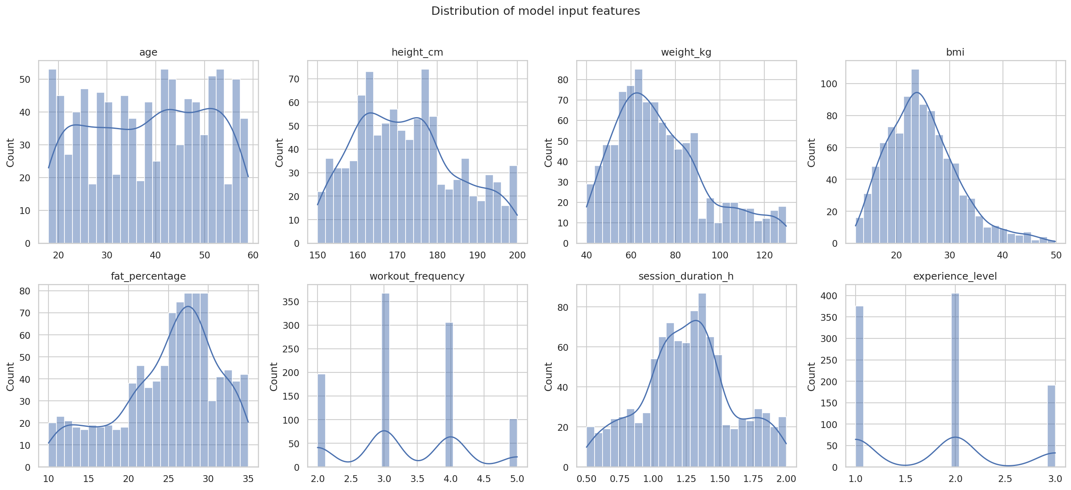
Figure 6.1 Distribution of the model input features
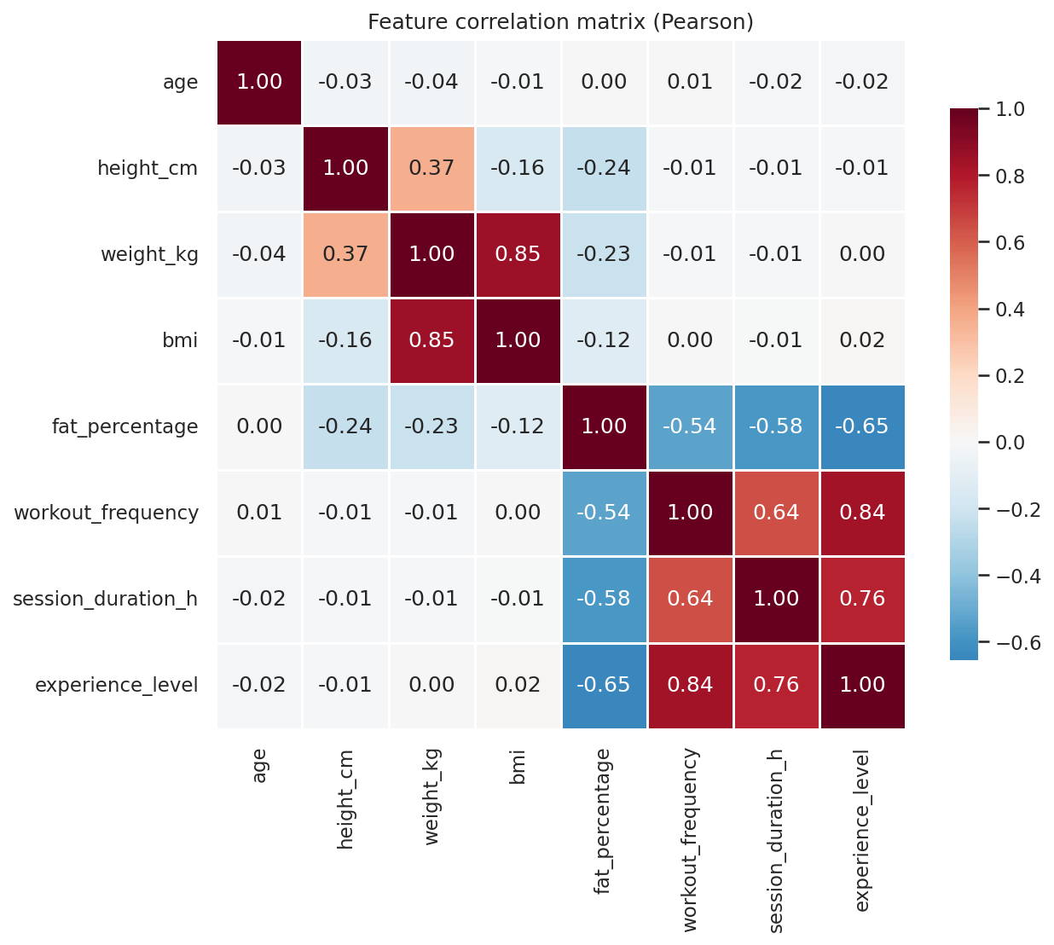
Figure 6.2 Correlation between features

6.3.2 Building the training targets
No public dataset contains a column saying what a person's correct daily calorie target should be. This is the central methodological problem of the project, and the solution needs to be stated clearly.
The targets were constructed from published formulas in four steps. First, BMR is calculated. Where the dataset gives a measured body fat percentage, the Katch-McArdle equation is used, which works from lean body mass. Otherwise Mifflin-St Jeor is used and body fat is estimated with the Deurenberg equation. Second, BMR is multiplied by an activity factor derived from weekly training hours. Third, a goal factor is applied: roughly a 20 percent deficit for fat loss, maintenance, or about a 12 percent surplus for muscle gain. Fourth, protein is set from body weight using ISSN coefficients.
Three sources of variation were added on purpose. Fitness goals are sampled from a probability distribution that depends on BMI and body fat, so a heavier user is more likely to be assigned fat loss. The goal coefficients are sampled within their published ranges rather than fixed, because the literature gives ranges. Finally Gaussian noise of 3 percent on calories and 2.5 percent on protein is added.
The noise is important and is not there to make the task harder for no reason. Without it, Linear Regression would recover the formula almost exactly and report an R-squared close to 1.0, which would look suspicious and prove nothing. The noise sets a theoretical ceiling on R-squared of 0.9891 for calories and 0.9943 for protein, and these ceilings are reported next to the model results so the remaining error can be identified as irreducible.
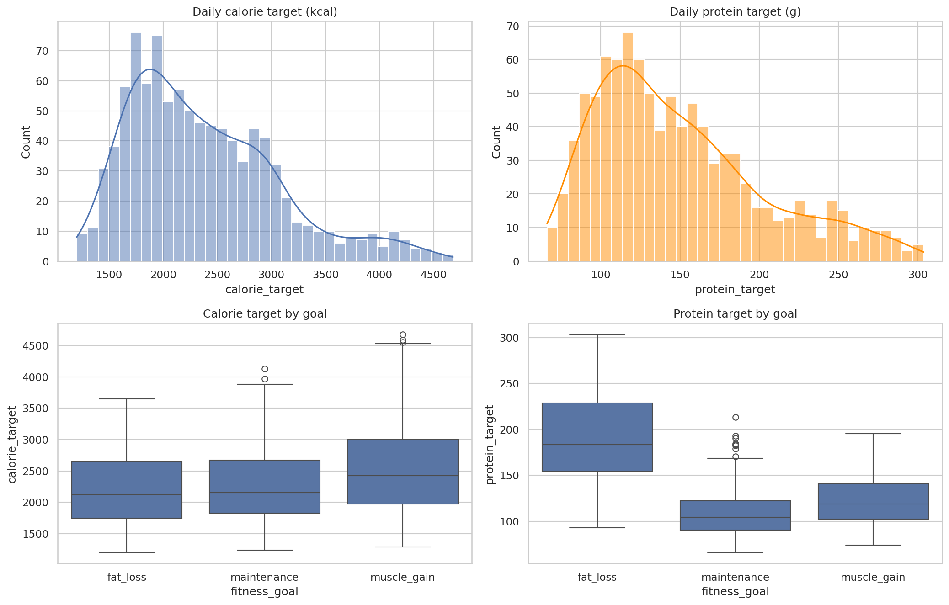
Figure 6.3 Distribution of the constructed calorie and protein targets

6.3.3 Preprocessing pipeline
Preprocessing is a single ColumnTransformer fitted inside the same Pipeline as the model. Numeric features are median-imputed, clipped by interquartile range to catch entry errors such as a 700 kilogram weight, and standardised. Gender and goal are one-hot encoded; activity level is ordinal encoded.
Fitting inside the Pipeline has two effects. The exported file contains preprocessing and the model together, so the API cannot forget a step. And cross-validation refits the scaler on each training fold only, so no information leaks from the test fold.

6.3.4 Recommendation engine
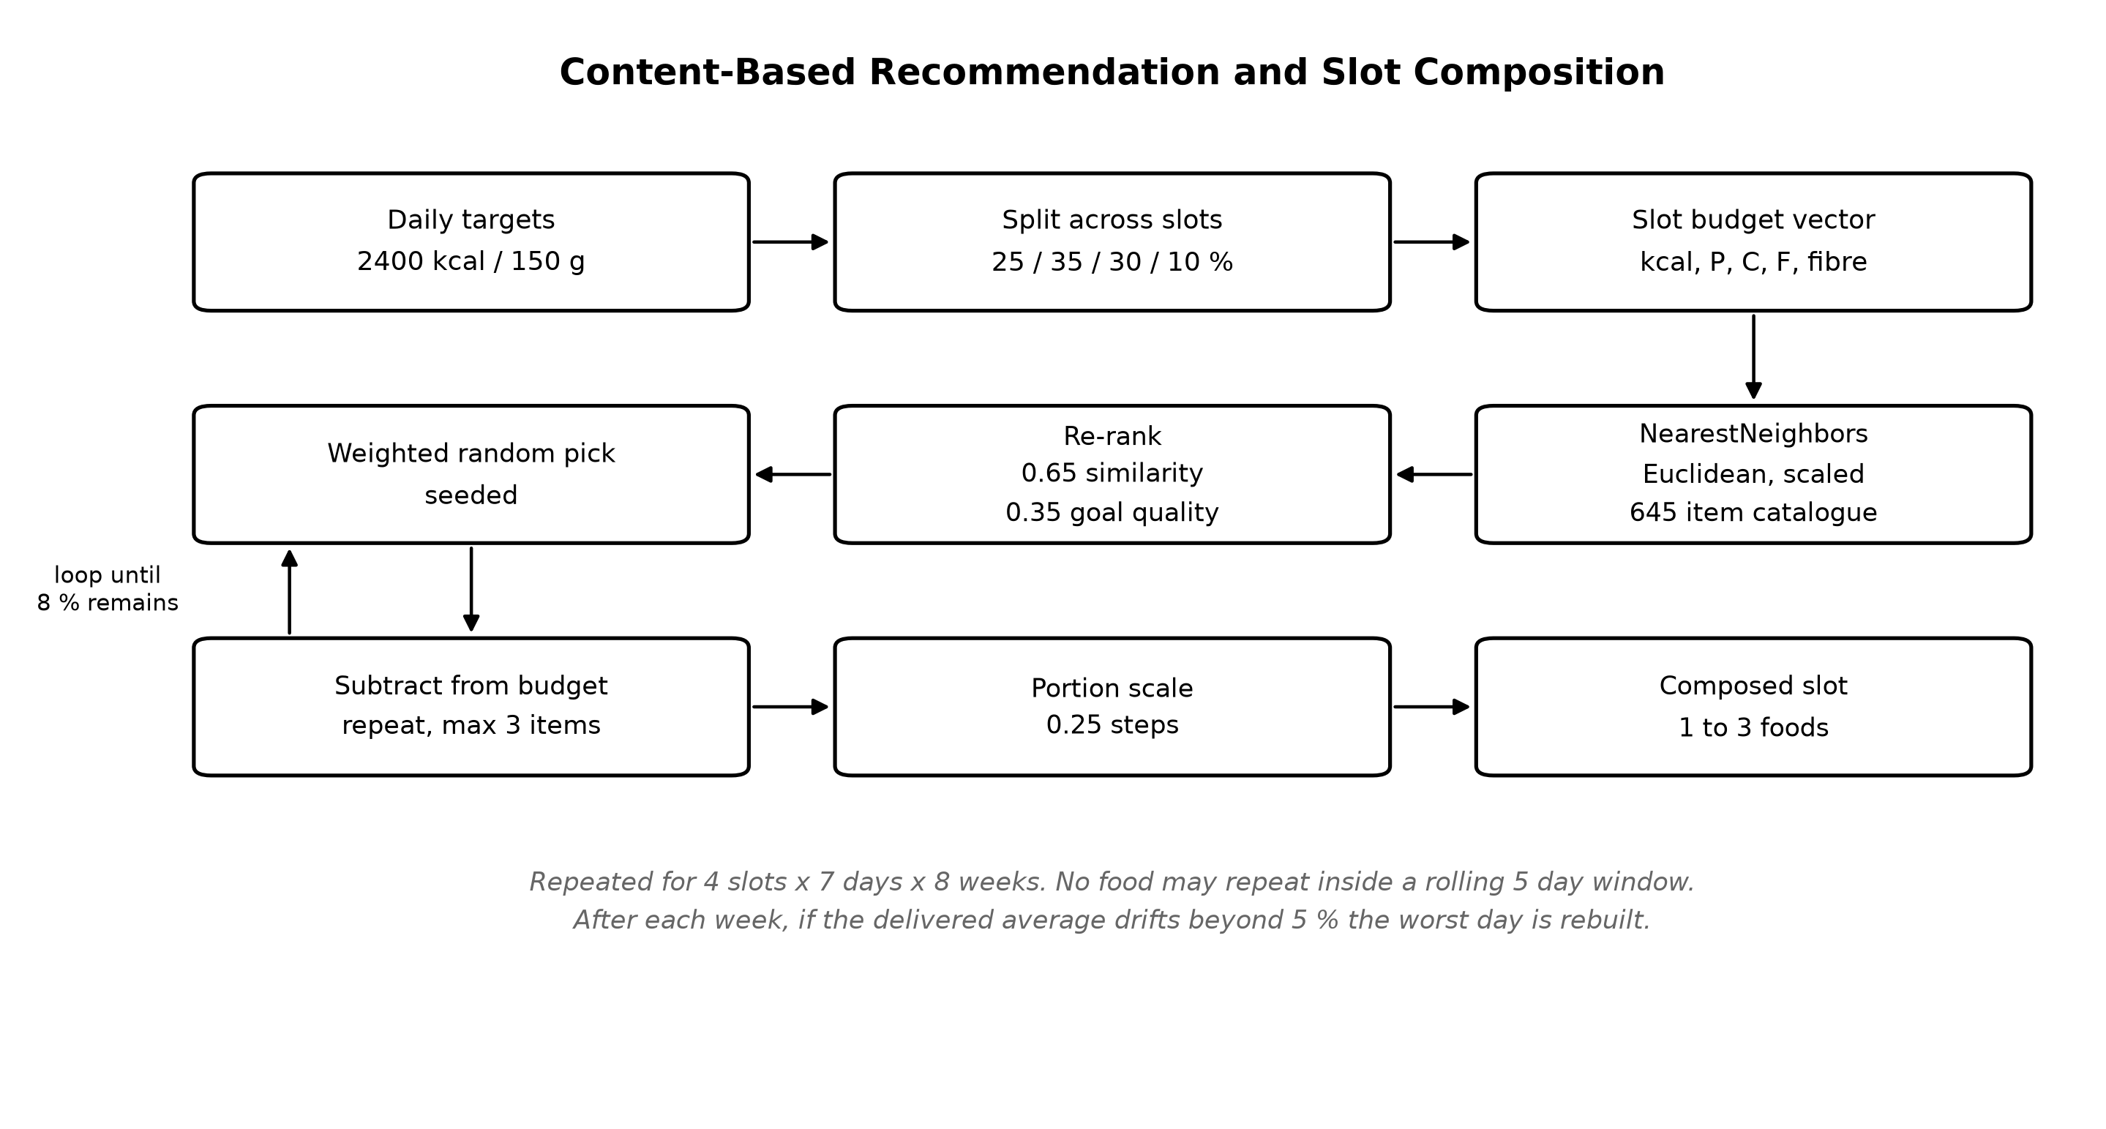
Figure 6.4 Content-based recommendation and slot composition
Euclidean distance is used rather than cosine similarity. Cosine ignores magnitude, so it would treat a 200 kilocalorie meal and a 900 kilocalorie meal with the same macro ratio as identical. For meal planning the absolute amount is the whole point.
The first version of this engine recommended one food per meal slot and failed. The median breakfast item in the data is around 360 kilocalories, while a user needing 2,400 kilocalories a day needs about 600 at breakfast. Measured across a full plan, the system delivered 26 percent fewer calories than the target. The fix was to build each slot from one to three items, then apply a single portion multiplier in quarter-serving steps. After this change the same test produced weekly errors within 0.4 percent.

6.3.5 Meal plan generator
The planner produces 8 weeks by 7 days by 4 slots under two rules. A food may not repeat within a rolling five-day window. And after each week, if the delivered average drifts beyond 5 percent, the worst day is rebuilt with a corrected budget. This is a greedy repair rather than full optimisation, a deliberate trade-off for speed.

6.3.6 Cultural bias in the food catalogue
After the catalogue was built, an audit was run to count how many items matched common Sri Lankan food terms. The result was that hopper, roti, dhal, sambol and kottu each returned zero matches, and curry returned one. Sample recommendations included churros, marshmallow and potato salad.
For the stated target user, a gym-going adult in Sri Lanka, this is a biased system. The macros would be correct but the food would not be eaten, which is an adherence failure. A reference dataset of 52 Sri Lankan items was compiled and added, covering all four meal slots and including vegetarian and high-protein options. After this the same audit returned 27 matches for rice, 14 for curry, 4 for hopper and 3 for dhal, and regional foods make up between 15 and 28 percent of generated plan items.
The macro values for these items are compiled estimates for typical local portions, cross-referenced against USDA values for the ingredients. They are not laboratory measurements, and this is stated in the dataset documentation.

6.3.7 API design
Table 6.3 Backend API endpoints
Method | Endpoint | Purpose
POST | /api/profile | Create or update the profile and log the first weight
POST | /api/predict | Call the ML service and store the prediction
GET | /api/recommendations | Meal suggestions for one slot or a full day
POST | /api/mealplan/generate | Generate and store an eight-week plan
GET | /api/mealplan/active | Fetch the current plan and its items
POST | /api/progress | Log weight, recalculate, and run the drift check
GET | /api/dashboard | One aggregated call for the dashboard

7.0 Testing and Validation

Test Plan
Testing was carried out at four levels: unit tests for the calculations and helpers, integration tests for the API endpoints, model evaluation for the machine learning, and manual system testing of the full user journey. All automated tests are run from the command line and all currently pass.
Table 7.1 Automated test summary
Test suite | Tool | Tests | Result
ML package (nutrition, labels, pipeline, recommender, planner, validation, local foods) | pytest | 189 | Pass
ML microservice API | pytest and FastAPI TestClient | 37 | Pass
Node.js backend | Jest and Supertest | 37 | Pass
Front end production build | Vite | Build | Pass
Total automated tests |  | 263 | Pass

7.1 Model Evaluation Results
Both models were trained on 973 records using an 80/20 stratified split, giving 778 training and 195 test records, with 5-fold cross-validation. The random seed was fixed at 42 so the results reproduce exactly.
Table 7.2 Model comparison on the held-out test set and by cross-validation
Target | Model | MAE | MSE | RMSE | R2 | CV MAE (mean +/- sd)
Calories | Linear Regression | 112.14 | 23858.30 | 154.46 | 0.9564 | 114.15 +/- 5.17
Calories | Random Forest | 107.61 | 23820.63 | 154.34 | 0.9564 | 96.16 +/- 3.97
Calories | Formula baseline | 54.55 | - | - | 0.9891 | -
Protein | Linear Regression | 8.71 | 118.94 | 10.91 | 0.9552 | 8.86 +/- 0.42
Protein | Random Forest | 8.37 | 108.97 | 10.44 | 0.9590 | 8.72 +/- 0.49
Protein | Formula baseline | 2.97 | - | - | 0.9943 | -

Random Forest was selected for deployment for both targets, chosen on cross-validated MAE rather than the single test split, because one split is too noisy to decide on.
The formula baseline scores better than both models, but this is expected. The formula is given the activity multiplier directly, whereas the models must infer it from raw inputs. Including the row is more honest than omitting it.
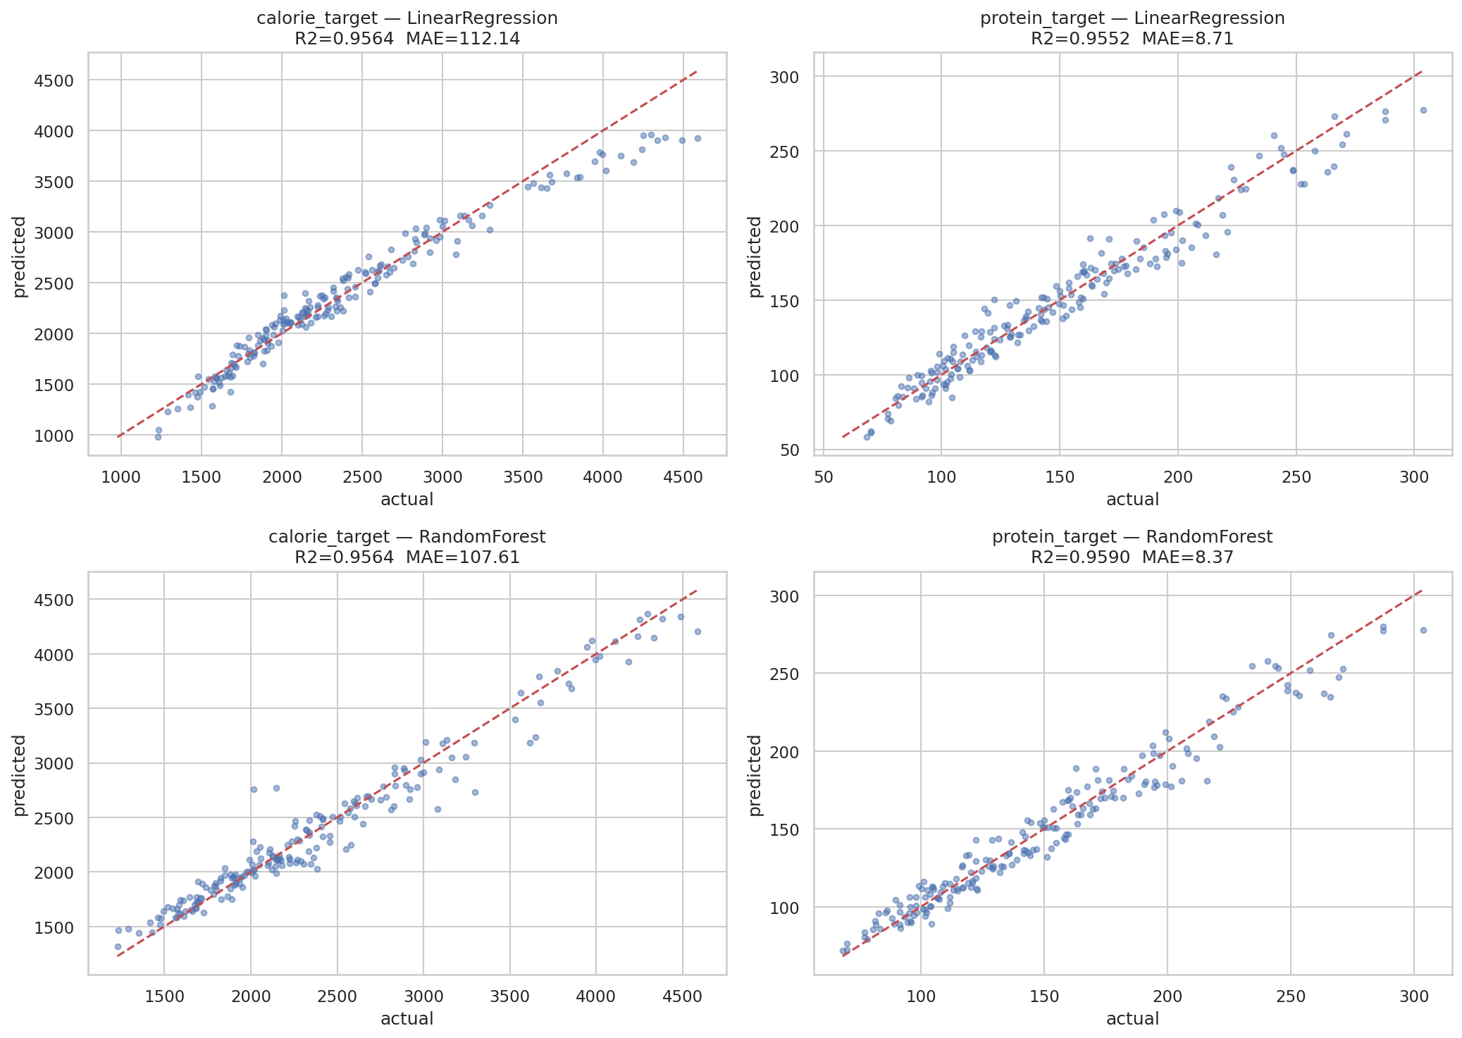
Figure 7.1 Predicted against actual values for both models and targets

7.2 The Learning Curve Experiment
The proposal predicted Random Forest would outperform Linear Regression. On the final dataset it does, but during development an earlier run produced the opposite result and this needed investigation rather than acceptance.
That earlier run used synthetic stand-in data, created so the pipeline could be tested before the real files arrived. Random Forest proved completely insensitive to its hyperparameters there, which pointed at the data rather than the tuning: the synthetic values came from smooth Gaussian distributions with no body-composition signal, so there was no non-linear structure for a tree ensemble to find. Every script now prints a warning when synthetic data is active, and only results from the real files are reported.
To test the explanation properly, a learning curve was computed on the real data by training both models on increasing fractions of it.
Table 7.3 Cross-validated MAE against training set size (calorie target)
Training samples | Linear Regression | Random Forest | Gap (RF - LR)
97 | 124.58 | 229.57 | +104.99
194 | 120.38 | 167.37 | +46.98
340 | 118.94 | 144.92 | +25.98
486 | 118.19 | 124.63 | +6.44
681 | 114.28 | 112.66 | -1.62
827 | 111.98 | 100.76 | -11.21
973 | 114.15 | 96.46 | -17.69

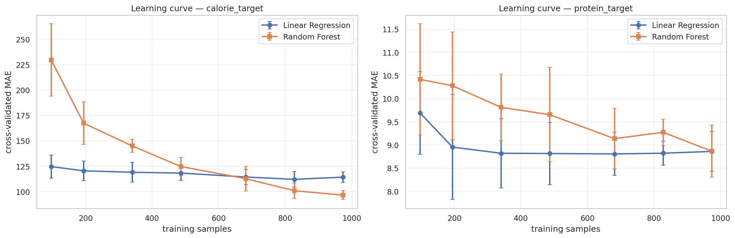
Figure 7.2 Learning curves for both models and both targets
The pattern is clear. Random Forest starts much worse than the linear baseline and improves steadily as data is added, crossing over at around 680 samples. Linear Regression is flat from roughly 200 samples onward, because it has already extracted everything its form can represent. On the protein target the two are still converging at 973 records, with almost no gap left.
This is a textbook bias-variance result. A tree ensemble approximates a smooth relationship with piecewise-constant steps and needs far more data to do it well. The dataset size, not the algorithm choice, is the binding constraint here. That is a more useful conclusion than simply stating that Random Forest won.

7.3 Feature Importance
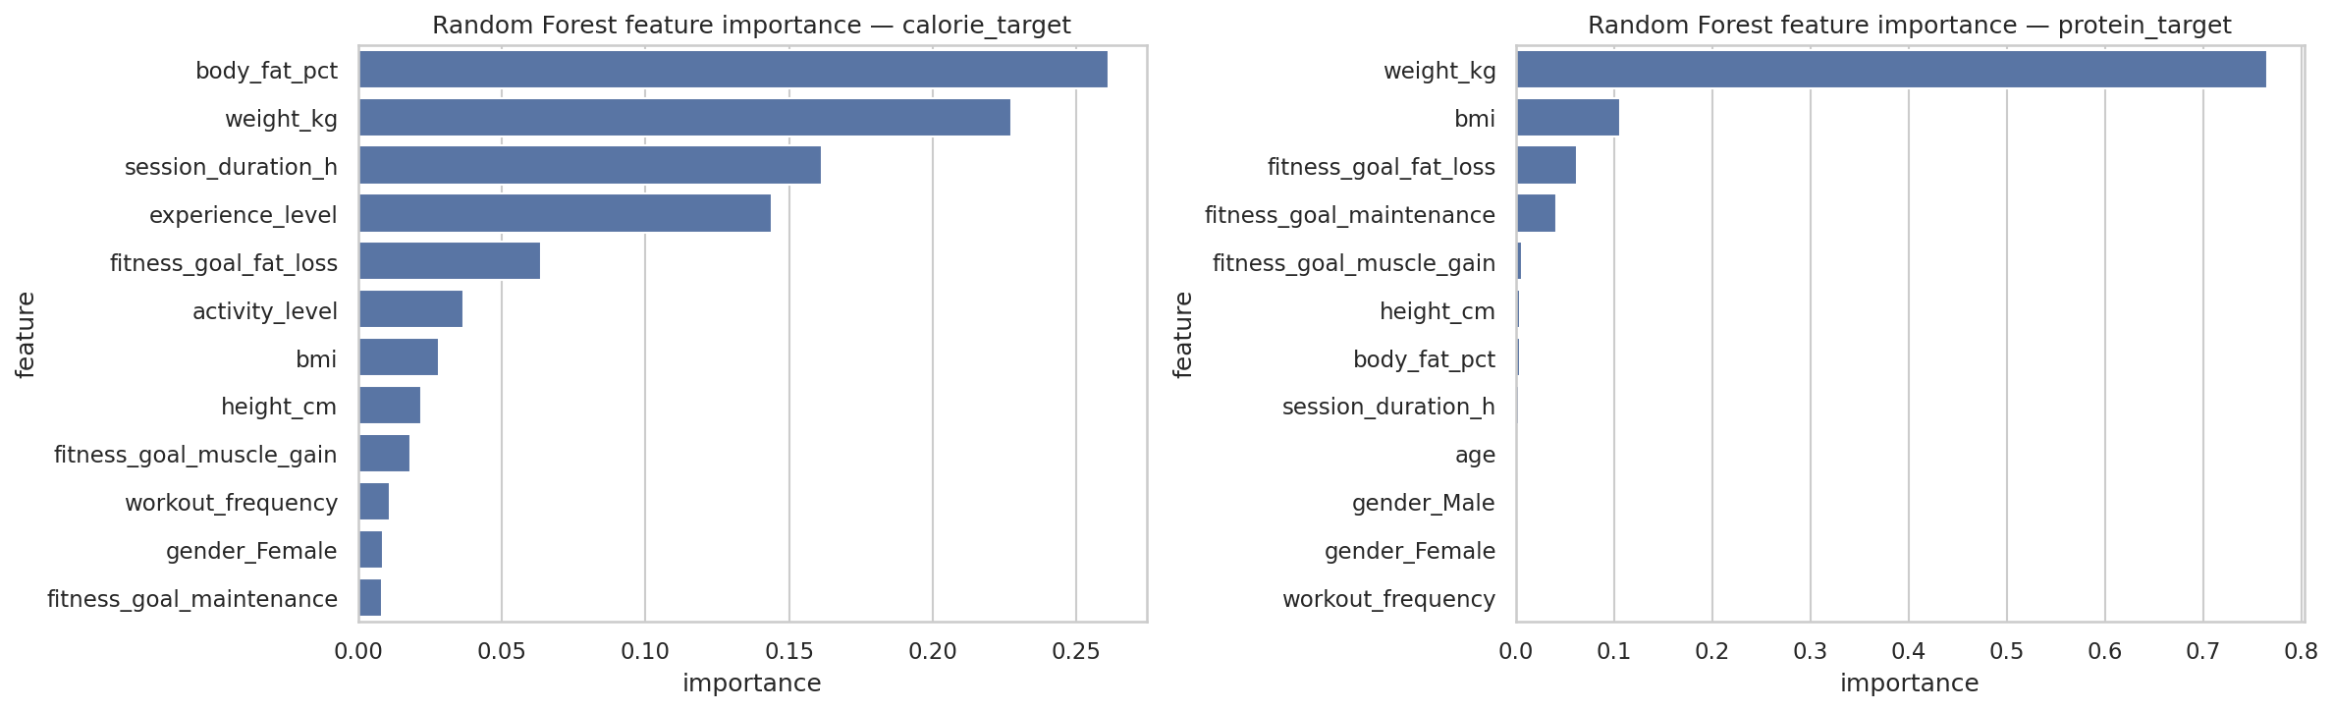
Figure 7.3 Random Forest feature importance
For calories the strongest features are body fat percentage (0.263) and weight (0.226), followed by session duration (0.161) and experience level (0.143). This matches the nutrition science, because body fat and weight determine lean mass, which drives BMR, and training volume drives the activity multiplier.
For protein, weight alone accounts for 0.766 of the importance, with fitness goal next. This is exactly right, since the protein target is body weight multiplied by a goal coefficient. The model recovering this relationship from raw inputs is a good sign that the pipeline works.

7.4 Meal Plan Validation
The eight-week planner was tested against a 2,400 kilocalorie and 150 gram protein target.
Table 7.4 Eight-week meal plan accuracy
Week | Mean daily kcal | Calorie error | Mean daily protein | Protein error | Unique foods
1 | 2408.9 | +0.37 % | 149.3 g | -0.50 % | 43
2 | 2399.6 | -0.02 % | 148.6 g | -0.91 % | 40
3 | 2406.5 | +0.27 % | 149.6 g | -0.25 % | 43
4 | 2397.1 | -0.12 % | 146.4 g | -2.38 % | 44
5 | 2402.1 | +0.09 % | 149.7 g | -0.17 % | 41
6 | 2403.4 | +0.14 % | 150.2 g | +0.15 % | 44
7 | 2392.3 | -0.32 % | 151.1 g | +0.71 % | 44
8 | 2396.3 | -0.15 % | 148.3 g | -1.12 % | 45

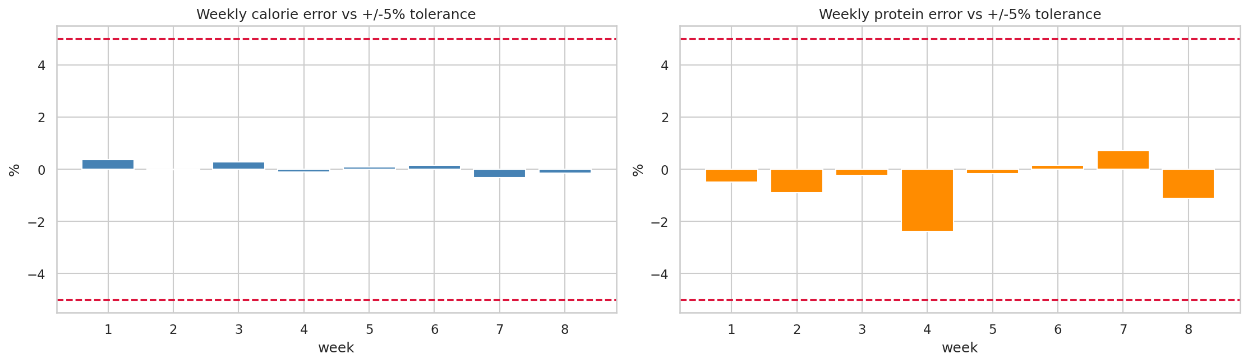
Figure 7.4 Weekly meal plan error against the +/-5 % tolerance
Every week is well inside the 5 percent tolerance, with the largest calorie error at 0.37 percent. The variety rule was satisfied with zero violations.

Test Cases
Table 7.5 Selected test cases
ID | Test | Expected | Actual | Result
TC01 | BMI for 80 kg at 180 cm | 24.69 | 24.69 | Pass
TC02 | Mifflin-St Jeor for 80 kg, 180 cm, 30 y, male | 1780 kcal | 1780 kcal | Pass
TC03 | Katch-McArdle at 15 % body fat, 80 kg | 1838.8 kcal | 1838.8 kcal | Pass
TC04 | Fat loss target below maintenance below muscle gain | Ordered | Ordered | Pass
TC05 | Calorie floor never below 1.1 x BMR | Floor applied | Floor applied | Pass
TC06 | Prediction with a missing field | 422 error | 422 error | Pass
TC07 | Prediction with body weight of 900 kg | 422 error | 422 error | Pass
TC08 | API access without a token | 401 error | 401 error | Pass
TC09 | Anonymous read of the profiles table | No rows | No rows | Pass
TC10 | Same seed produces the same meal plan | Identical | Identical | Pass
TC11 | Model reload after export | Prediction in range | 2930 kcal | Pass
TC12 | Shuffled column order at prediction time | Same result | Same result | Pass

7.5 A Bug Found by Testing
One test was written to check that asking for each meal slot separately would add up to the full daily target. It failed, returning 5,920 kilocalories instead of 2,400. The cause was that the budget function always redistributed the remaining daily allowance across the later slots, so asking for lunch on its own returned 1,120 kilocalories rather than 840. The behaviour was correct when walking through a day in order but wrong for a standalone request. The function now takes an explicit flag for the two cases. This is a good example of a test catching a defect that manual use would not have revealed.

7.6 What Was Not Tested
Being clear about the limits of the testing matters as much as reporting the results.
- User acceptance testing with real gym users was not carried out.
- Load and performance testing were not carried out, so the performance and scalability requirements are supported by design rather than measurement.
- The interface was not tested with a real screen reader, although the accessibility markup follows WCAG 2.1 AA.
- The system was not deployed to a public server.
- The optional BMI cross-check against the UCI obesity dataset is implemented and unit tested, but was not run because the dataset was not downloaded.

8.0 Conclusion

8.1 Conclusion
This project set out to build a working web application that gives gym users personalised nutrition guidance, and that objective was met. All ten functional requirements from the proposal are implemented and traced to code in Chapter 6. The system predicts calorie and protein needs with a cross-validated error of 96.16 kilocalories and 8.72 grams, recommends real meals, produces an eight-week plan whose weekly calorie delivery stays within 0.4 percent of target and whose protein stays within 2.4 percent, and prompts the user to update when their weight changes.
Five things in this project go beyond standard student work, and these are what I would put forward as its contribution.
- Shared code package. The same Python module preprocesses data during training in Colab and during prediction in the API, so train-serve skew is prevented by structure rather than by discipline.
- Honest treatment of constructed labels. The injected noise is documented and the resulting theoretical R-squared ceiling is reported beside the model scores, so a reader can see how much error is irreducible.
- Learning curve experiment. Rather than asserting Random Forest is better, the project measured how the gap changes with dataset size and located the crossover at about 680 records.
- Meal slot composition. One food per slot under-delivered by 26 percent; building each slot from one to three items with a quarter-serving multiplier brought weekly error inside 0.4 percent.
- Cultural bias audit. Measuring the bias, correcting it with a 52-item local dataset, then measuring again turns a limitation into evidence.

8.2 Future Recommendations
- Run a questionnaire and interviews with Sri Lankan gym users, and carry out user acceptance testing. This is the largest gap in the current work.
- Deploy the system to free hosting so availability can be measured, and add load testing.
- Add allergy and dietary restriction fields, which are currently out of scope.
- Collect real self-reported fitness goals instead of assigned ones, and gather more records, since the learning curve shows the models are still improving at 973.
- Add Sinhala and Tamil language support and expand the local food set with laboratory-measured values.
- Test with a real screen reader and add an automated accessibility check to the build.

8.3 Lessons Learned
The most useful lesson was that an unexpected result is worth investigating rather than working around. When Random Forest lost, the temptation was to tune it until it won. Checking whether the hyperparameters mattered at all showed they did not, which pointed at the data and produced a better chapter than tuning would have.
The second lesson was about environments. The scikit-learn version mismatch broke model loading completely and cost time. Pinning versions and recording them in a model card is not bureaucracy.
The third lesson was that automated tests find things manual use does not. The meal slot budget bug returned a plausible-looking number and would probably never have been noticed by clicking around the interface.
The fourth lesson was about assumptions. I expected that mixing USDA per-100-gram data with per-serving data would harm accuracy. Measured, it improved the worst weekly error from 3.80 to 2.88 percent. Similarly, my first attempt at the Sri Lankan food set made fat-loss plans worse, from 1.42 to 4.93 percent error, because every item I added was a rice-based plate with low protein density. Adding ten protein-forward items brought it back to 3.21 percent. In both cases measuring beat guessing.

Gantt Chart
The chart below shows the twelve-week schedule that was followed. The phases are colour grouped: planning and literature review in blue, machine learning work in green, application development in orange, the accessibility and regional food work in purple, testing in red and documentation in grey.
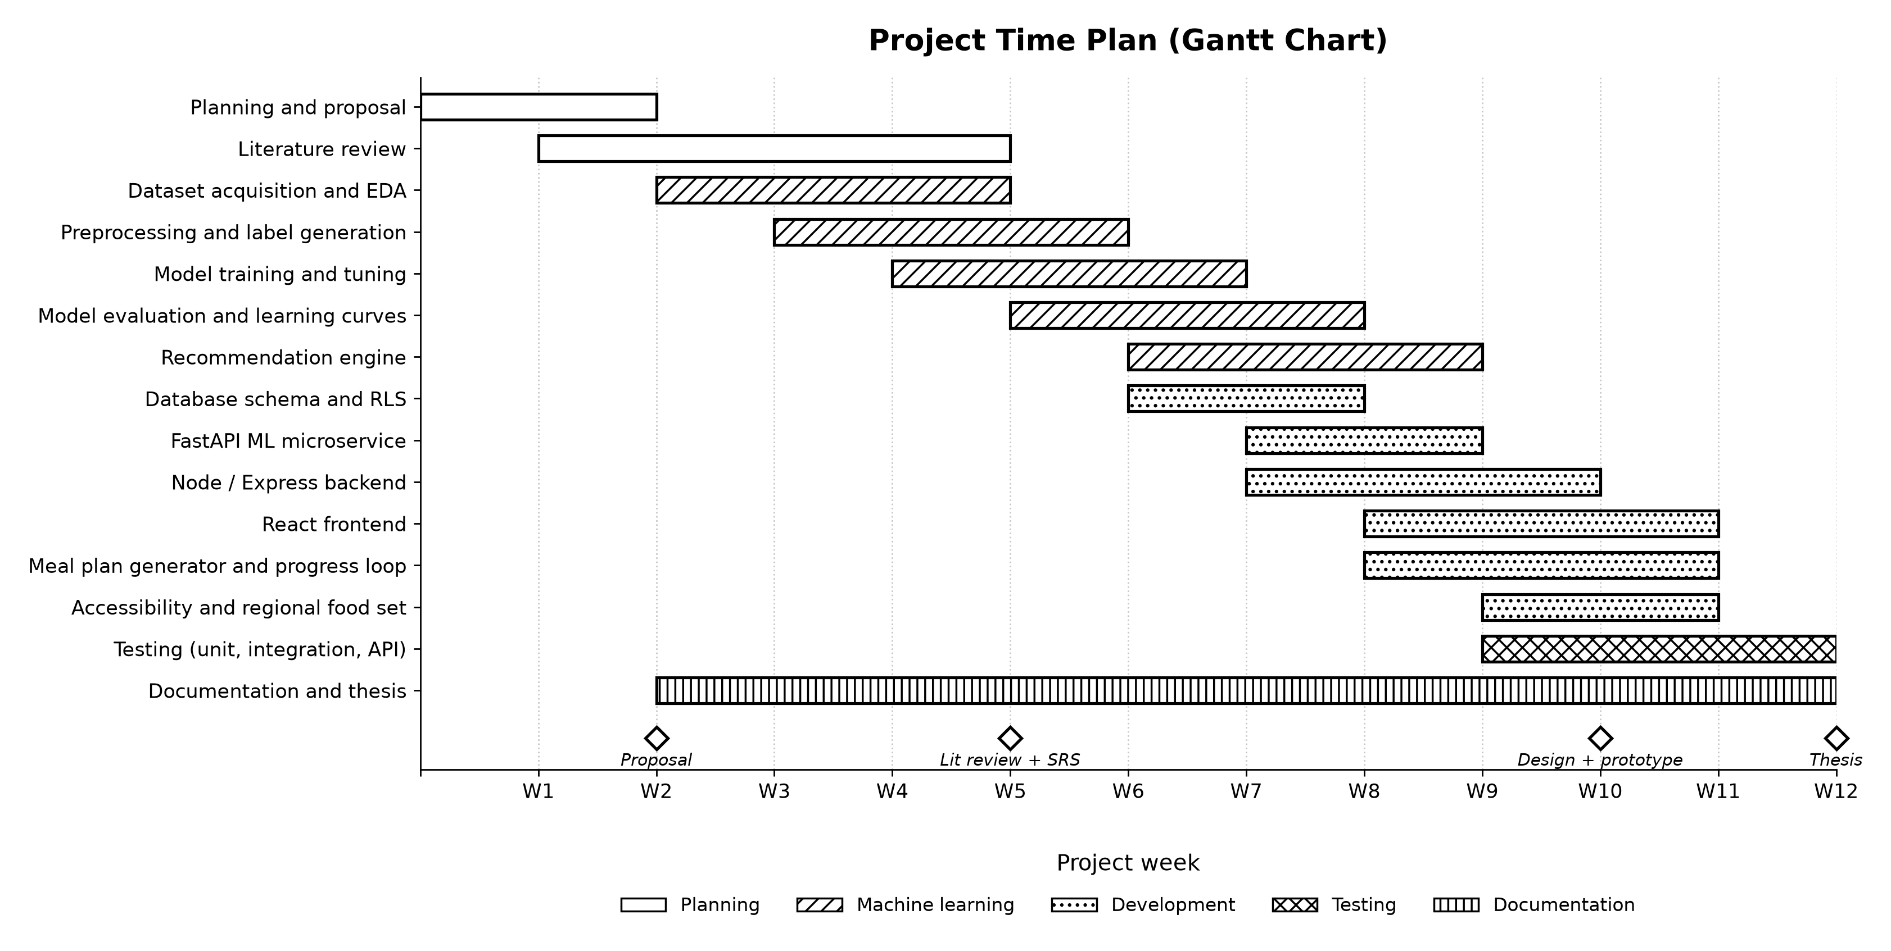
Figure 8.1 Project time plan (Gantt chart)

References
Deurenberg, P., Weststrate, J.A. and Seidell, J.C. (1991) 'Body mass index as a measure of body fatness: age- and sex-specific prediction formulas', British Journal of Nutrition, 65(2), pp. 105-114.
FAO/WHO/UNU (2004) Human energy requirements. FAO Food and Nutrition Technical Report Series 1. Rome: Food and Agriculture Organization.
Géron, A. (2022) Hands-On Machine Learning with Scikit-Learn, Keras and TensorFlow. 3rd edn. Sebastopol, CA: O'Reilly Media.
Helms, E.R., Zinn, C., Rowlands, D.S. and Brown, S.R. (2014) 'A systematic review of dietary protein during caloric restriction in resistance-trained lean athletes', International Journal of Sport Nutrition and Exercise Metabolism, 24(2), pp. 127-138.
Jäger, R., Kerksick, C.M., Campbell, B.I. et al. (2017) 'International Society of Sports Nutrition position stand: protein and exercise', Journal of the International Society of Sports Nutrition, 14(20), pp. 1-25.
Katch, F.I. and McArdle, W.D. (1996) Introduction to Nutrition, Exercise and Health. 4th edn. Baltimore: Williams and Wilkins.
Mifflin, M.D., St Jeor, S.T., Hill, L.A., Scott, B.J., Daugherty, S.A. and Koh, Y.O. (1990) 'A new predictive equation for resting energy expenditure in healthy individuals', American Journal of Clinical Nutrition, 51(2), pp. 241-247.
Nilashi, M., Ibrahim, O. and Ahmadi, H. (2020) 'Recommendation systems for health and nutrition using machine learning techniques', Expert Systems with Applications, 152, pp. 113-128.
Palechor, F.M. and de la Hoz Manotas, A. (2019) 'Dataset for estimation of obesity levels based on eating habits and physical condition', Data in Brief, 25, 104344.
Pedregosa, F. et al. (2011) 'Scikit-learn: machine learning in Python', Journal of Machine Learning Research, 12, pp. 2825-2830.
Raza, S., Ahmed, M. and Khan, A. (2023) 'Artificial intelligence in nutrition recommendation systems: a survey', IEEE Access, 11, pp. 65421-65440.
Ricci, F., Rokach, L. and Shapira, B. (2015) Recommender Systems Handbook. 2nd edn. New York: Springer.
United States Department of Agriculture (2024) FoodData Central. Available at: https://fdc.nal.usda.gov (Accessed: 7 August 2026).
W3C (2018) Web Content Accessibility Guidelines (WCAG) 2.1. Available at: https://www.w3.org/TR/WCAG21 (Accessed: 7 August 2026).
World Health Organization (2024) Obesity and overweight. Geneva: WHO. Available at: https://www.who.int (Accessed: 7 August 2026).

Appendix 1

Questionnaire
The full instrument is reproduced below. Response counts are recorded in the table that follows once collection is complete (see section 4.2.2 for the current status).
- How often do you train each week, and for how long per session?
- What is your current main fitness goal: fat loss, muscle gain or maintenance?
- Do you currently know your daily calorie target? If yes, where did that number come from?
- Do you know your daily protein target?
- Have you used a nutrition or calorie app before? Which one, and why did you stop?
- How useful would an eight-week meal plan be compared with daily suggestions?
- How often would you be willing to record your body weight?
- How important is it that suggested meals are foods you normally eat?
- Would you enter a body fat percentage if you had one measured?
- What would stop you from following a meal plan given by an app?
Participant information and consent. Respondents are told the purpose of the study, that participation is voluntary, that no identifying information is recorded, and that they may withdraw at any time. Consent is taken on the first page of the form.
Table A1 Questionnaire response summary sheet
Q | Question | Responses
Q1 | Sessions per week
Q2 | Typical session length
Q3 | Knows daily calorie target
Q4 | Knows daily protein target
Q5 | Apps used previously and reason for stopping
Q6 | Usefulness of an eight-week plan
Q7 | Willing weighing frequency
Q8 | Importance of familiar food
Q9 | Would enter measured body fat
Q10 | Barriers to following a plan

Interview Guide
Semi-structured guide used with all three participants. Prompts are used only if the topic is not covered in the opening answer.
- Opening: tell me how you currently decide what to eat on a training day.
- Existing tools: which nutrition apps have you tried? What made you stop?
- Planning: if the system gave you a full eight-week plan, would you follow it, or would that feel too rigid?
- Adjustment: how often would you realistically weigh yourself and record it?
- Food familiarity: how would you feel about a plan built around foods you do not normally eat?
- Trust: how much would you trust a calorie target produced automatically, and what would make you trust it more?
Table A2 Interview response recording sheet
Topic | P1 instructor | P2 muscle gain | P3 fat loss
Deciding what to eat
Existing apps
Eight-week plan
Weighing frequency
Familiar food
Trust in automation

Test Case
The selected test cases are given in Table 7.5. The complete automated suite of 263 tests is in the source code under ml/tests, services/ml-service/tests and backend/tests, and is run with pytest and npm test as described in the project README.

Supervision meeting log sheets
The signed supervision meeting log sheets are attached separately as required by the assessment brief.

